

Experiment No. 11
15 puzzle problem
Date of Performance:
Date of Submission:

ExperimentNo.11

Title:15 Puzzle

Aim:To study and implement 15 puzzle problem

Objective:To introduce Backtracking and Branch-Bound methods

Theory:
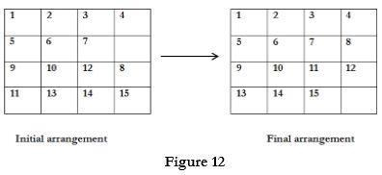

The 15 puzzle problem is invented by sam loyd in 1878.

● In this problem there are 15 tiles, which are numbered from 0 – 15.

● The objective of this problem is to transform the arrangement of tiles from initial

arrangement to a goal arrangement.

● The initial and goal arrangement is shown by following figure.

● There is always an empty slot in the initial arrangement.

● The legal moves are the moves in which the tiles adjacent to ES are moved to either

left, right, up or down.

● Each move creates a new arrangement in a tile.

● These arrangements are called as states of the puzzle.

● The initial arrangement is called as initial state and goal arrangement is called as goal

state.

● The state space tree for 15 puzzle is very large because there can be 16! Different arrangements.
● A partial state space tree can be shown in figure.

● In state space tree, the nodes are numbered as per the level. ● Each next move is generated based on empty slot positions.
● Edges are label according to the direction in which the empty space moves. ● The root node becomes the E – node.
● The child node 2, 3, 4 and 5 of this E – node get generated.

● Out of which node 4 becomes an E – node. For this node the live nodes 10, 11, 12 gets generated.
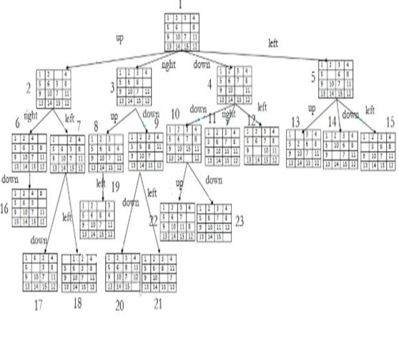

● Then the node 10 becomes the E – node for which the child nodes 22 and 23 gets

generated.

● Finally we get a goal state at node 23.

● We can decide which node to become an E – node based on estimation formula.

Example:

Code :

#include <stdio.h>
#include <stdbool.h>

#define N 8

// Function to check if a queen can be placed at board[row][col]
bool isSafe(int board[N][N], int row, int col) {
int i, j;

// Check this row on the left side
for (i = 0; i < col; i++) {
if (board[row][i]) {
return false;
}
}

// Check upper diagonal on left side
for (i = row, j = col; i >= 0 && j >= 0; i--, j--) {
if (board[i][j]) {
return false;
}
}

// Check lower diagonal on left side
for (i = row, j = col; j >= 0 && i < N; i++, j--) {
if (board[i][j]) {
return false;
}
}

return true;
}

// Recursive function to solve N-Queens problem using branch and bound
bool solveNQueensUtil(int board[N][N], int col) {
// If all queens are placed then return true
if (col >= N) {
return true;
}

// Consider this column and try placing this queen in all rows one by one
for (int i = 0; i < N; i++) {
// Check if the queen can be placed on board[i][col]
if (isSafe(board, i, col)) {
// Place this queen in board[i][col]
board[i][col] = 1;

// Recur to place the rest of the queens
if (solveNQueensUtil(board, col + 1)) {
return true;
}

// If placing queen in board[i][col] doesn't lead to a solution then backtrack
board[i][col] = 0; // Backtrack
}
}

// If the queen cannot be placed in any row in this column, then return false
return false;
}

// Function to solve N-Queens problem using branch and bound
void solveNQueens() {
int board[N][N] = { {0, 0, 0, 0, 0, 0, 0, 0},
{0, 0, 0, 0, 0, 0, 0, 0},
{0, 0, 0, 0, 0, 0, 0, 0},
{0, 0, 0, 0, 0, 0, 0, 0},
{0, 0, 0, 0, 0, 0, 0, 0},
{0, 0, 0, 0, 0, 0, 0, 0},
{0, 0, 0, 0, 0, 0, 0, 0},
{0, 0, 0, 0, 0, 0, 0, 0} };

if (solveNQueensUtil(board, 0) == false) {
printf("Solution does not exist");
return;
}

// Print the solution
printf("Solution:\n");
for (int i = 0; i < N; i++) {
for (int j = 0; j < N; j++) {
printf(" %d ", board[i][j]);
}
printf("\n");
}
}

int main() {
solveNQueens();
return 0;
}

Output :

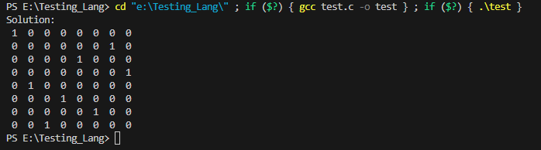

Conclusion:The 15 Puzzle problem has been implemented.

