

Experiment No. 5
Fractional Knapsack using Greedy Method
Date of Performance:
Date of Submission:

ExperimentNo.5

Title:Fraction Knapsack

Aim:To study and implement Fraction Knapsack Algorithm

Objective:To introduce Greedy based algorithms

Theory:

Greedy method or technique is used to solve Optimization problems. A solution that can be

maximized or minimized is called Optimal Solution.

The knapsack problem or rucksack problem is a problem in combinatorial optimization: Given a set of items, each with a mass and a value, determine the number of each item to include in a collection so that the total weight is less than or equal to a given limit and the total value is as large as possible. It derives its name from the problem faced by someone who is constrained by a fixed size knapsack and must fill it with the most valuable items. The most common problem being solved is the 0-1 knapsack problem, which restricts the number xi of copies of each kind of item to zero or one.

In Knapsack problem we are given:1) n objects 2) Knapsack with capacity m, 3) An object i is associated with profit Wi , 4) An object i is associated with profit Pi , 5) when an object i is placed in knapsack we get profit Pi Xi .

Here objects can be broken into pieces (Xi Values) The Objective of Knapsack problem is to maximize the profit.

Example:

In this version of Knapsack problem, items can be broken into smaller pieces. So, the thief may take only a fraction xi of ith item.

0⩽xi⩽1

The ith item contributes the weight xi.wi to the total weight in the knapsack and profit xi.pi to

the total profit.
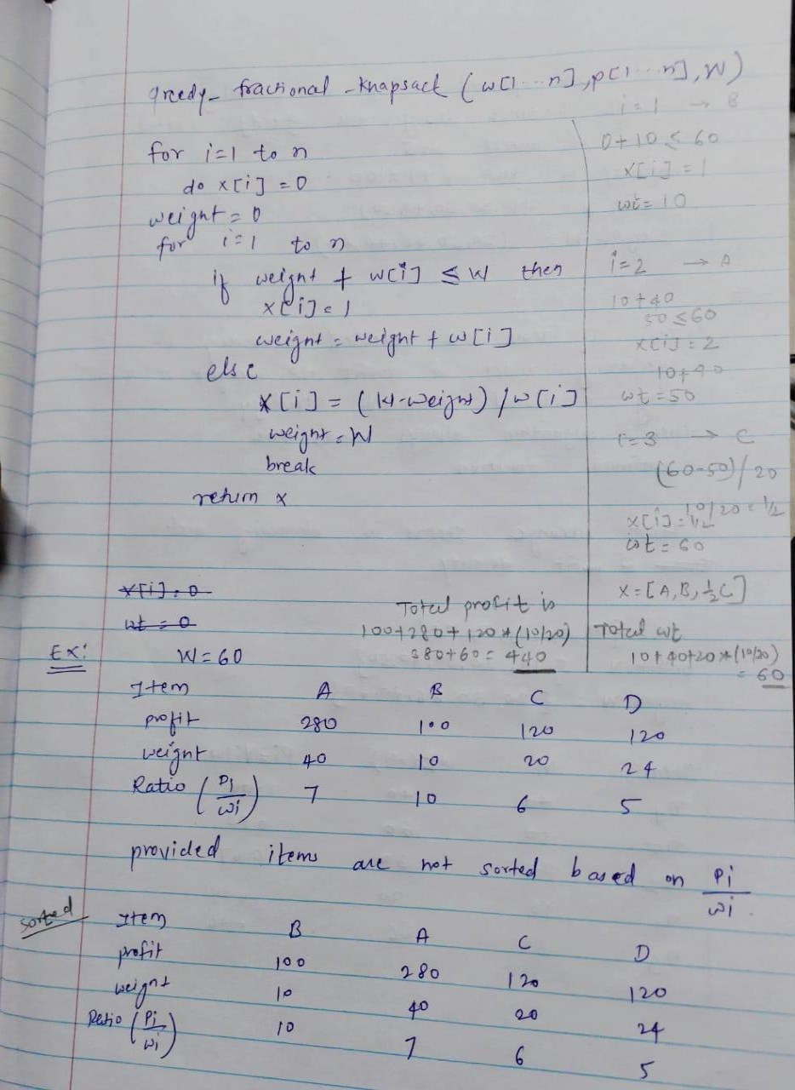

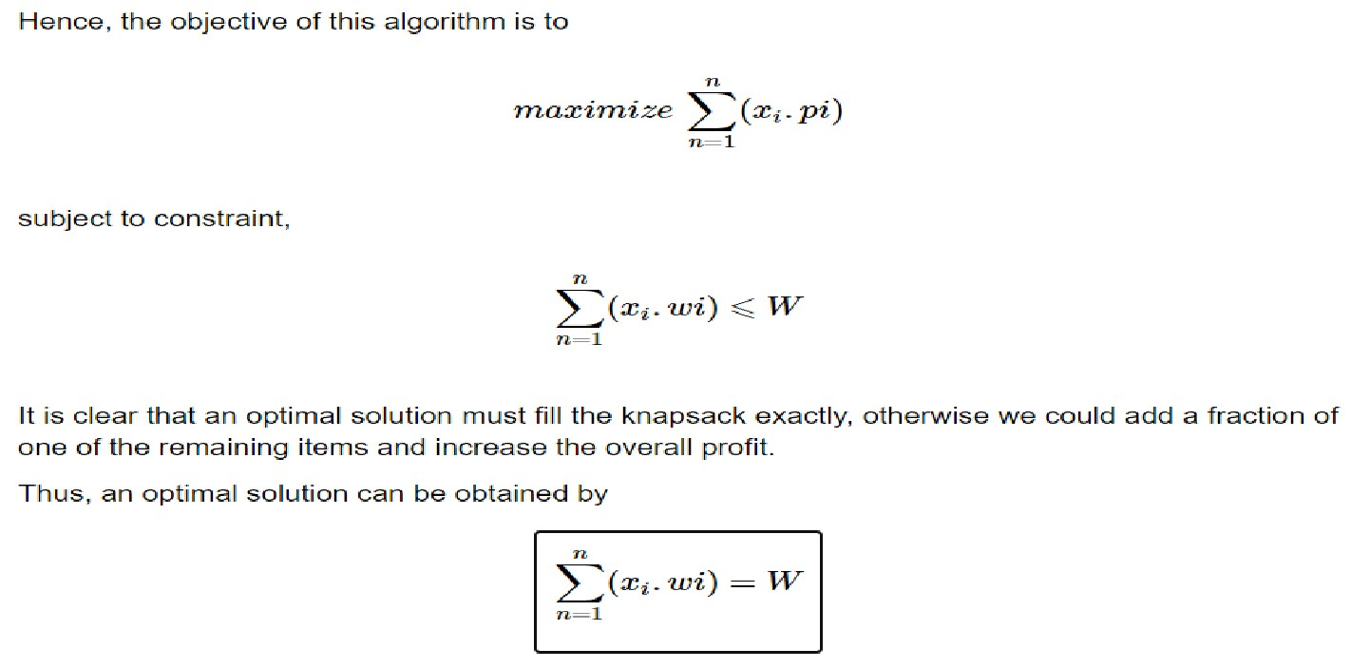
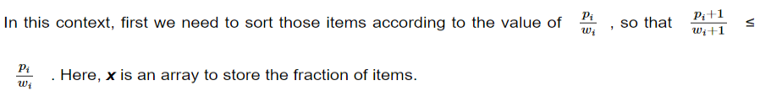
Algorithm:
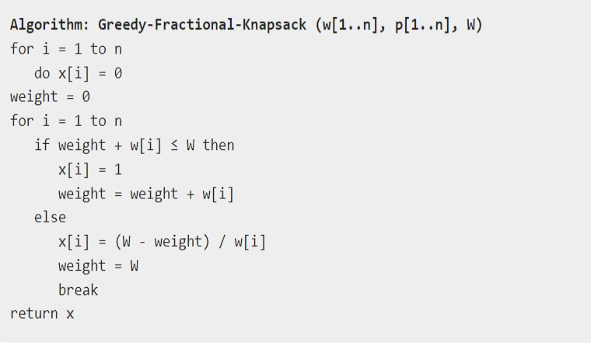

Code :
#include <stdio.h>
#include <stdlib.h>

// Structure to represent an item
struct Item {
int value; // Value of the item
int weight; // Weight of the item
};

// Function to compare items based on their value-to-weight ratio
int compare(const void *a, const void *b) {
double ratio1 = ((struct Item *)a)->value / (double)((struct Item *)a)->weight;
double ratio2 = ((struct Item *)b)->value / (double)((struct Item *)b)->weight;
return ratio2 > ratio1 ? 1 : -1;
}

// Function to solve Fractional Knapsack problem
void fractionalKnapsack(struct Item items[], int n, int capacity) {
// Sort items based on their value-to-weight ratio
qsort(items, n, sizeof(struct Item), compare);

int curWeight = 0; // Current weight in knapsack
double finalValue = 0.0; // Final value of items selected

// Loop through sorted items and add to knapsack until capacity is reached
for (int i = 0; i < n; i++) {
// If adding the entire item exceeds capacity, add fractional part
if (curWeight + items[i].weight <= capacity) {
curWeight += items[i].weight;
finalValue += items[i].value;
} else {
int remaining = capacity - curWeight;
finalValue += items[i].value * ((double)remaining / items[i].weight);
break;
}
}

// Print the final value of items selected
printf("Maximum value in knapsack = %.2lf\n", finalValue);
}

int main() {
int n, capacity;

printf("Enter the number of items: ");
scanf("%d", &n);

struct Item items[n];

// Input values and weights of items
for (int i = 0; i < n; i++) {
printf("Enter value and weight of item %d: ", i + 1);
scanf("%d %d", &items[i].value, &items[i].weight);
}

printf("Enter the capacity of knapsack: ");
scanf("%d", &capacity);

// Solve Fractional Knapsack problem
fractionalKnapsack(items, n, capacity);

return 0;
}

Output :

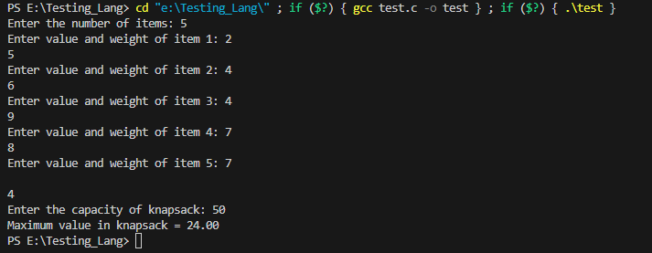

Conclusion:

This program prompts the user to enter the number of items, their values, weights, and the capacity of the knapsack. It then solves the Fractional Knapsack problem using the Greedy method and prints the maximum value that can be obtained in the knapsack.

In the Fractional Knapsack problem, items can be taken in fractional amounts, so the greedy approach is to always select the item with the maximum value-to-weight ratio first. This ensures that the value obtained per unit of weight is maximized.

