

Experiment No. 6
Prim’s Algorithm
Date of Performance:

Date of Submission:

ExperimentNo.6

Title:Prim’s Algorithm.

Aim:To study and implement Prim’s Minimum Cost Spanning Tree Algorithm.

Objective:To introduce Greedy based algorithms

Theory:

Prim's algorithm is a greedy algorithm that finds a minimum spanning tree for a weighted undirected graph. This means it finds a subset of the edges that forms a tree that includes every vertex, where the total weight of all the edges in the tree is minimized. The algorithm operates by building this tree one vertex at a time, from an arbitrary starting vertex, at each step adding the cheapest possible connection from the tree to another vertex.

Example:
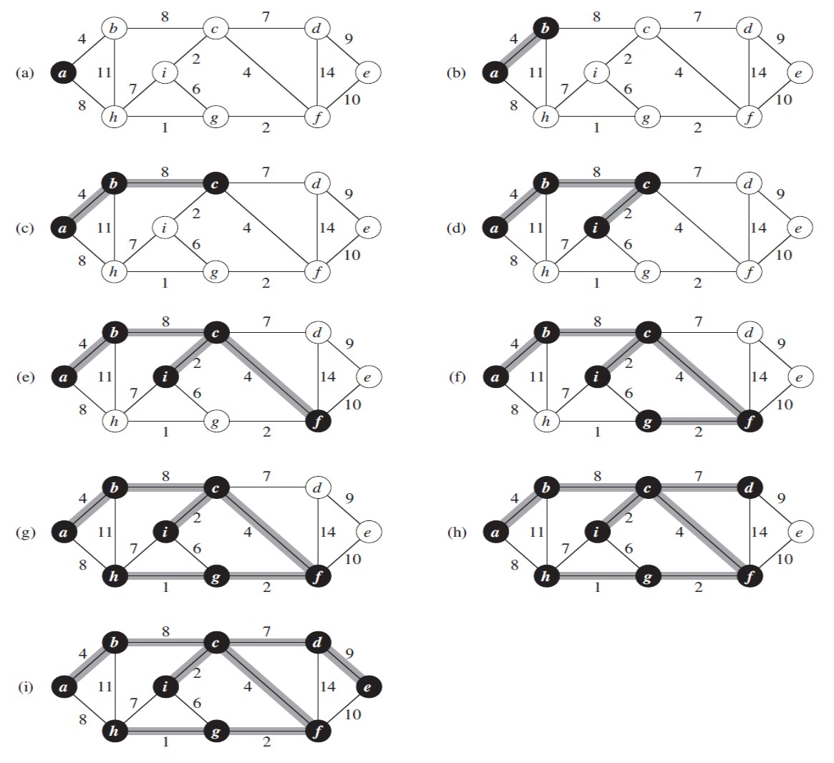

AlgorithmandComplexity:
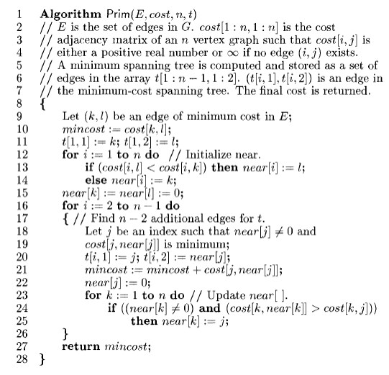

Time Complexity is O( n2 ), Where, n = number of vertices Theory:

Code :
#include <stdio.h>
#include <limits.h>

#define V 5 // Number of vertices in the graph

// Function to find the vertex with the minimum key value
int minKey(int key[], int mstSet[]) {
int min = INT_MAX, min_index;
for (int v = 0; v < V; v++) {
if (mstSet[v] == 0 && key[v] < min) {
min = key[v];
min_index = v;
}
}
return min_index;
}

// Function to print the MST
void printMST(int parent[], int graph[V][V]) {
printf("Edge Weight\n");
for (int i = 1; i < V; i++) {
printf("%d - %d %d \n", parent[i], i, graph[i][parent[i]]);
}
}

// Function to construct and print MST for a graph represented using adjacency matrix
void primMST(int graph[V][V]) {
int parent[V]; // Array to store constructed MST
int key[V]; // Key values used to pick minimum weight edge in cut
int mstSet[V]; // To represent set of vertices not yet included in MST

// Initialize all keys as INFINITE
for (int i = 0; i < V; i++) {
key[i] = INT_MAX;
mstSet[i] = 0;
}

// Always include first vertex in MST.
key[0] = 0; // Make key 0 so that this vertex is picked as first vertex
parent[0] = -1; // First node is always root of MST

// The MST will have V vertices
for (int count = 0; count < V - 1; count++) {
// Pick the minimum key vertex from the set of vertices not yet included in MST
int u = minKey(key, mstSet);

// Add the picked vertex to the MST set
mstSet[u] = 1;

// Update key value and parent index of the adjacent vertices of the picked vertex.
// Consider only those vertices which are not yet included in MST
for (int v = 0; v < V; v++) {
// graph[u][v] is non zero only for adjacent vertices of m
// mstSet[v] is false for vertices not yet included in MST
// Update the key only if graph[u][v] is smaller than key[v]
if (graph[u][v] && mstSet[v] == 0 && graph[u][v] < key[v]) {
parent[v] = u;
key[v] = graph[u][v];
}
}
}

// Print the constructed MST
printMST(parent, graph);
}

int main() {
/* Let us create the following graph
2 3
(0)--(1)--(2)
| / \ |
6| 8/ \5 |7
| / \ |
(3)-------(4)
9 */
int graph[V][V] = {{0, 2, 0, 6, 0},
{2, 0, 3, 8, 5},
{0, 3, 0, 0, 7},
{6, 8, 0, 0, 9},
{0, 5, 7, 9, 0}};

// Print the solution
primMST(graph);

return 0;
}

Output :

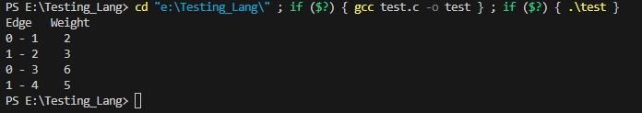

Conclusion:

This program implements Prim's MST algorithm using the Greedy method for a given graph represented using an adjacency matrix. It constructs and prints the Minimum Spanning Tree (MST) of the graph.

Prim's algorithm works by starting from an arbitrary vertex and repeatedly adding the minimum-weight edge that connects a vertex in the MST to a vertex outside the MST. It continues this process until all vertices are included in the MST.

