

Experiment No. 7
Kruskal’s Algorithm
Date of Performance:
Date of Submission:

ExperimentNo.7

Title:Kruskal’s Algorithm.

Aim:To study and implement Kruskal’s Minimum Cost Spanning Tree Algorithm.

Objective:To introduce Greedy based algorithms.

Theory:

Kruskal's algorithm finds a minimum spanning forest of an undirected edge-weighted graph.

If the graph is connected, it finds a minimum spanning tree. (A minimum spanning tree of a connected graph is a subset of the edges that forms a tree that includes every vertex, where the sum of the weights of all the edges in the tree is minimized. For a disconnected graph, a minimum spanning forest is composed of a minimum spanning tree for each connected component.) It is a greedy algorithm in graph theory as in each step it adds the next lowest-weight edge that will not form a cycle to the minimum spanning forest.

Example:

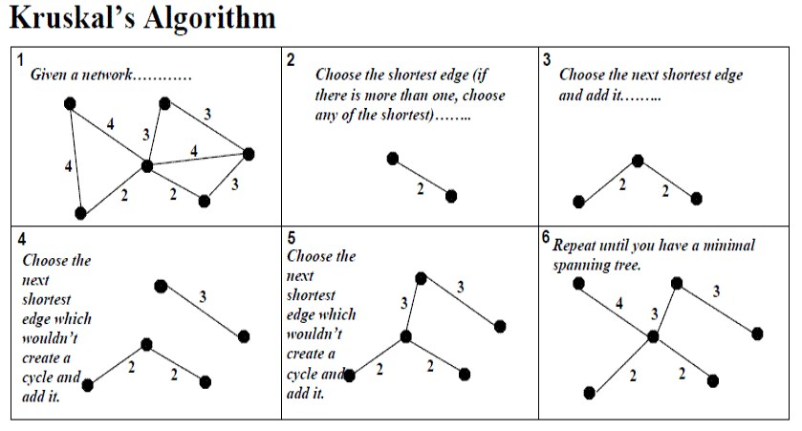

AlgorithmandComplexity:
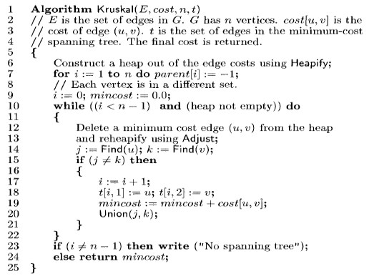

Time Complexity is O(nlog n), Where, n = number of Edges

Code :

#include <stdio.h>
#include <stdlib.h>

// Structure to represent an edge in the graph
struct Edge {
int src, dest, weight;
};

// Structure to represent a subset for union-find
struct Subset {
int parent;
int rank;
};

// Function to find set of an element i
int find(struct Subset subsets[], int i) {
if (subsets[i].parent != i)
subsets[i].parent = find(subsets, subsets[i].parent);
return subsets[i].parent;
}

// Function that does union of two sets of x and y
void Union(struct Subset subsets[], int x, int y) {
int xroot = find(subsets, x);
int yroot = find(subsets, y);

// Attach smaller rank tree under root of high rank tree (Union by Rank)
if (subsets[xroot].rank < subsets[yroot].rank)
subsets[xroot].parent = yroot;
else if (subsets[xroot].rank > subsets[yroot].rank)
subsets[yroot].parent = xroot;
else {
subsets[yroot].parent = xroot;
subsets[xroot].rank++;
}
}

// Comparator function to sort edges based on weight
int compare(const void *a, const void *b) {
struct Edge *a1 = (struct Edge *)a;
struct Edge *b1 = (struct Edge *)b;
return a1->weight > b1->weight;
}

// Function to construct and print MST using Kruskal's algorithm
void KruskalMST(struct Edge edges[], int V, int E) {
struct Edge result[V]; // Store the result MST
int e = 0; // An index variable used for result[]
int i = 0; // An index variable used for sorted edges

// Step 1: Sort all the edges in non-decreasing order of their weight
qsort(edges, E, sizeof(edges[0]), compare);

// Allocate memory for creating V subsets
struct Subset *subsets = (struct Subset *)malloc(V * sizeof(struct Subset));

// Create V subsets with single elements
for (int v = 0; v < V; v++) {
subsets[v].parent = v;
subsets[v].rank = 0;
}

// Number of edges to be taken is equal to V-1
while (e < V - 1 && i < E) {
// Step 2: Pick the smallest edge. And increment the index for next iteration
struct Edge next_edge = edges[i++];

int x = find(subsets, next_edge.src);
int y = find(subsets, next_edge.dest);

// If including this edge doesn't cause cycle, include it in result and increment the index
// of result for next edge
if (x != y) {
result[e++] = next_edge;
Union(subsets, x, y);
}
}

// Print the constructed MST
printf("Following are the edges in the constructed MST:\n");
for (i = 0; i < e; ++i)
printf("%d -- %d == %d\n", result[i].src, result[i].dest, result[i].weight);
}

int main() {
/* Let us create the following graph
10
0--------1
| \ |
6| 5\ |15
| \ |
2--------3
4 */
int V = 4; // Number of vertices in graph
int E = 5; // Number of edges in graph
struct Edge edges[] = {{0, 1, 10}, {0, 2, 6}, {0, 3, 5}, {1, 3, 15}, {2, 3, 4}};

// Function call to construct and print MST
KruskalMST(edges, V, E);

return 0;
}

Output :

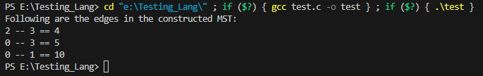

Conclusion:

This program implements Kruskal's MST algorithm using the Greedy method for a given graph represented using an array of edges. It constructs and prints the Minimum Spanning Tree (MST) of the graph.

Kruskal's algorithm works by sorting all the edges in non-decreasing order of their weight and selecting edges one by one in this sorted order, adding the edge to the MST if it doesn't create a cycle. It continues this process until all vertices are included in the MST.

