

Experiment No. 8
Single Source Shortest Path using Dynamic Programming (Bellman-Ford Algorithm)
Date of Performance:
Date of Submission:

ExperimentNo:8

Title:Single Source Shortest Path: Bellman Ford

Aim: To study and implement Single Source Shortest Path using Dynamic Programming:

Bellman Ford
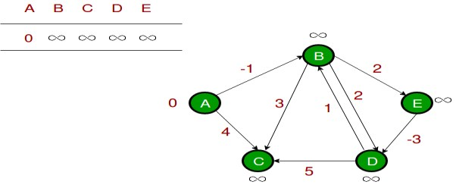

Objective:To introduce Bellman Ford method

Theory:

Given a graph and a source vertex source in graph, find shortest paths from src to all vertices

in the given graph. The graph may contain negative weight edges.We have discussed

Dijkstra’s algorithm for this problem. Dijkstra’s algorithm is a Greedy algorithm and time complexity is O(VLogV) (with the use of Fibonacci heap). Dijkstra doesn’t work for Graphs with negative weight edges, Bellman-Ford works for such graphs. Bellman-Ford is also simpler than Dijkstra and suites well for distributed systems. But time complexity of Bellman-Ford is O(VE), which is more than Dijkstra.

Example:

Let the given source vertex be 0. Initialize all distances as infinite, except the distance to the

source itself. Total number of vertices in the graph is 5, so all edges must be processed 4 times.

Let all edges are processed in the following order: (B, E), (D, B), (B, D), (A, B), (A, C), (D,

C), (B, C), (E, D). We get the following distances when all edges are processed the first time.

The first row shows initial distances. The second row shows distances when edges (B, E), (D, B), (B, D) and (A, B) are processed. The third row shows distances when (A, C) is processed. The fourth row shows when (D, C), (B, C) and (E, D) are processed.
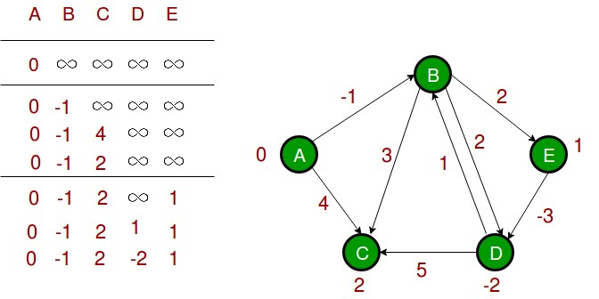
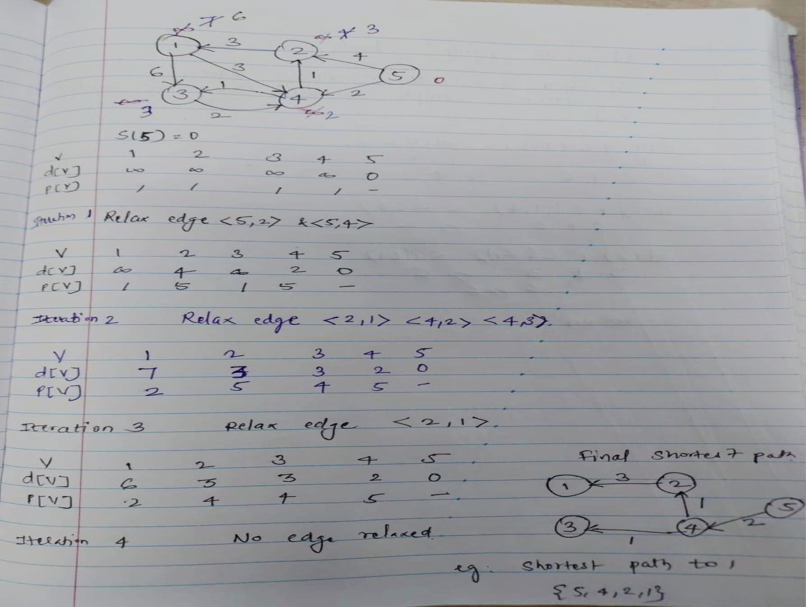

The second iteration guarantees to give all shortest paths which are at most 2 edges long. The algorithm processes all edges 2 more times. The distances are minimized after the second iteration, so third and fourth iterations don’t update the distances.

Algorithm:

function Bellman_Ford(list vertices, list edges, vertex source, distance[], parent[])

// Step 1 – initialize the graph. In the beginning, all vertices weight of
// INFINITY and a null parent, except for the source, where the weight is 0

for each vertex v in vertices distance[v] = INFINITY parent[v] = NULL

distance[source] = 0
// Step 2 – relax edges repeatedly
for i = 1 to V-1 // V – number of vertices for each edge (u, v) with weight w
if (distance[u] + w) is less than distance[v] distance[v] = distance[u] + w
parent[v] = u

// Step 3 – check for negative-weight cycles for each edge (u, v) with weight w
if (distance[u] + w) is less than distance[v]
return “Graph contains a negative-weight cycle”

return distance[], parent[]

Output:

Shortest path from source (5)

Vertex 5 -> cost=0 parent=0

Vertex 1-> cost=6 parent=2

Vertex 2-> cost=3 parent=4

Vertex 3-> cost =3 parent =4

Vertex 4-> cost =2 paren=5

Code :

#include <stdio.h>
#include <stdlib.h>
#include <limits.h>

// Structure to represent an edge in the graph
struct Edge {
int src, dest, weight;
};

// Structure to represent a graph
struct Graph {
int V, E;
struct Edge *edge;
};

// Function to create a graph with V vertices and E edges
struct Graph* createGraph(int V, int E) {
struct Graph* graph = (struct Graph*) malloc(sizeof(struct Graph));
graph->V = V;
graph->E = E;
graph->edge = (struct Edge*) malloc(graph->E * sizeof(struct Edge));
return graph;
}

// Function to find the shortest path from source to all other vertices using Bellman-Ford algorithm
void BellmanFord(struct Graph* graph, int src) {
int V = graph->V;
int E = graph->E;
int dist[V];

// Initialize distances from source to all other vertices as INFINITE
for (int i = 0; i < V; i++)
dist[i] = INT_MAX;
dist[src] = 0;

// Relax all edges |V| - 1 times
for (int i = 1; i <= V - 1; i++) {
for (int j = 0; j < E; j++) {
int u = graph->edge[j].src;
int v = graph->edge[j].dest;
int weight = graph->edge[j].weight;
if (dist[u] != INT_MAX && dist[u] + weight < dist[v])
dist[v] = dist[u] + weight;
}
}

// Check for negative-weight cycles
for (int i = 0; i < E; i++) {
int u = graph->edge[i].src;
int v = graph->edge[i].dest;
int weight = graph->edge[i].weight;
if (dist[u] != INT_MAX && dist[u] + weight < dist[v]) {
printf("Graph contains negative weight cycle.\n");
return;
}
}

// Print the shortest distances
printf("Vertex Distance from Source\n");
for (int i = 0; i < V; i++)
printf("%d \t\t %d\n", i, dist[i]);
}

int main() {
int V, E, src;
printf("Enter number of vertices and edges: ");
scanf("%d %d", &V, &E);

struct Graph* graph = createGraph(V, E);

printf("Enter source vertex: ");
scanf("%d", &src);

printf("Enter edges (src dest weight):\n");
for (int i = 0; i < E; i++)
scanf("%d %d %d", &graph->edge[i].src, &graph->edge[i].dest, &graph->edge[i].weight);

BellmanFord(graph, src);

return 0;
}

Output :

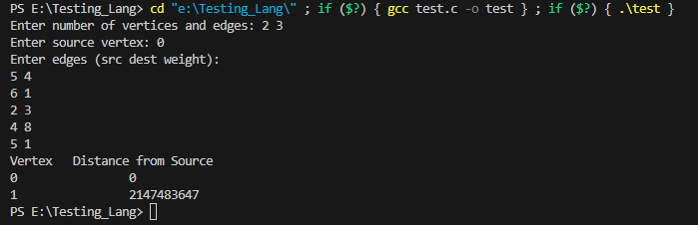

Conclusion:
This program prompts the user to input the number of vertices and edges of the graph, the source vertex, and the details of each edge (source, destination, and weight). It then uses the Bellman-Ford algorithm to find the shortest path from the source vertex to all other vertices in the graph and prints the shortest distances. If the graph contains a negative-weight cycle, it will detect and print a message indicating that.

