NED University of Engineering & Technology
Department of Computer Science & Information Technology

Complex Computing Problem (CCP) Report
Mapped to Course Outcome C1 — Knowledge & Understanding of OOP Concepts
Design and Development of an Object-Oriented Online Food Delivery System
Course | Object-Oriented Programming
Course Code | CT-260
Semester | 2nd Semester — Spring 2026
Language / Tools | C++ — Dev C++ / VS Code
Submission Date | 2 August 2026

Submitted By
# | Name | Roll No | Role
1 | Mohib Ahmed Khan | CT-25178 | Lead Developer
2 | Syed Rahim Ali | CT-25191 | OOP & UML Design
3 | Fahad | CT-25180 | Testing
4 | Ali Adnan | CT-25182 | Code Integration & Debugging
5 | Rabeet | CT-25197 | Documentation

TABLE OF CONTENTS
TABLE OF CONTENTS 2
1. PROBLEM STATEMENT 3
1.1 Significance 3
2. OOP PRINCIPLES IDENTIFICATION 3
2.1 Encapsulation 3
2.2 Inheritance 4
2.3 Polymorphism 4
2.4 Abstraction 4
2.5 Summary Table 5
3. SYSTEM DESIGN & UML 5
3.1 Class Responsibilities 5
3.2 Relationships and Data Flow 6
4. SOLUTION DEFINITION 6
4.1 High-Level Pseudocode 6
4.2 Step-by-Step Explanation 7
5. DESIGN PATTERN APPLICATION 7
5.1 Strategy Pattern — Payment Methods 7
5.2 Template-Method Opportunity — User Roles 8
5.3 Factory-Method Opportunity — Payment Creation 8
6. LIMITATIONS & FUTURE WORK 8
6.1 Limitations of the Current OOP Design 8
6.2 Suggested Improvements 9
7. TEAM CONTRIBUTION TABLE 9
REFERENCES 9

1. PROBLEM STATEMENT
The e-commerce and food-service industries increasingly depend on software platforms that connect three independent parties in real time: customers who browse and order food, restaurants that prepare and manage menus, and delivery partners who transport orders to the customer's location. Coordinating these parties manually, or through a monolithic, procedural program, quickly becomes unmanageable as the number of restaurants, menu items, users, and payment options grows.
This report analyses the design and implementation of a simplified Online Food Delivery System (OFDS) — an e-commerce domain problem — using Object-Oriented Programming (OOP). The system allows a Customer to log in, browse a Restaurant's menu, add FoodItem objects to a Cart, place an Order, pay through one of several interchangeable payment methods (Cash, Card, or Wallet), and have the order delivered by a DeliveryPartner.
The computing challenge is non-trivial because it involves several interacting real-world entities with distinct responsibilities and shared behaviour (e.g., both customers and delivery partners are "users" of the platform, but only customers can place orders and only delivery partners can deliver). A purely procedural approach — using disconnected functions and global data — would tightly couple these responsibilities, make the code difficult to extend (e.g., adding a new payment method), and obscure the natural real-world structure of the problem. OOP allows the problem to be decomposed into cohesive, reusable, and independently extensible classes that mirror the real-world entities they represent, which is why it is the natural and appropriate paradigm for this problem.

1.1 Significance
A well-structured OOP solution for this domain directly benefits maintainability and scalability: new restaurants, food categories, payment gateways, or user roles (e.g., a restaurant-admin role) can be added with minimal disruption to existing code, because responsibilities are encapsulated in separate classes rather than scattered across the program.

2. OOP PRINCIPLES IDENTIFICATION
All four pillars of Object-Oriented Programming from the CT-260 course plan — Encapsulation, Inheritance, Polymorphism, and Abstraction — are present in the Online Food Delivery System. Each is identified below with its justification and a direct reference to the implementation.

2.1 Encapsulation
Encapsulation is demonstrated throughout the system by declaring internal state as private or protected and exposing controlled access through public methods. In the FoodItem class, the name and price data members are private; they can only be read through the getName() and getPrice() accessor methods, and can only be set through the constructor. Likewise, the User class keeps userID, name, and email as protected members, accessible to derived classes but hidden from outside code.
Justification: encapsulation is essential here because it prevents external code (e.g., the ordering logic or the UI layer represented by main()) from directly manipulating an item's price or a user's identity, which protects the integrity of billing and account data — a critical requirement in any e-commerce system.

2.2 Inheritance
Inheritance models the "is-a" relationship between general and specialised platform users. The abstract concept of a User (with common attributes such as userID, name, and email, and common behaviour such as login() and logout()) is factored into a base class. Customer and DeliveryPartner both inherit publicly from User, reusing its data and behaviour while adding their own specialised members: Customer adds a Cart, an address, placeOrder(), and trackOrder(); DeliveryPartner adds a deliver() method.
Justification: without inheritance, login() and logout() would need to be duplicated in both Customer and DeliveryPartner, violating the "don't repeat yourself" principle and increasing the risk of inconsistent behaviour if the login logic ever changed. Inheritance also captures the real-world taxonomy of the domain directly in the class hierarchy, which improves readability and maintainability.

2.3 Polymorphism
Polymorphism is realised through the Payment class hierarchy. Payment declares a pure virtual method, pay(double amount), and Cash, Card, and Wallet each override it with their own implementation. In main(), a single base-class pointer, Payment *payment, is used to invoke payment->pay(order.getTotal()) without the calling code knowing — or needing to know — which concrete payment method was selected at runtime; the correct overridden version executes automatically through dynamic dispatch.
Justification: polymorphism allows the checkout logic to remain unchanged regardless of how many payment methods the platform supports. Adding a new method (e.g., a BankTransfer class) requires no modification to the existing order/payment logic, satisfying the Open/Closed Principle.

2.4 Abstraction
Abstraction is expressed in two ways. First, the Payment class itself is an abstract class (it contains a pure virtual function and can never be instantiated directly), which defines a contract — "a payment method must be able to pay an amount" — without specifying how. Second, every class in the system presents a simplified public interface that hides internal detail: a Restaurant exposes addFood(), showMenu(), getFood(), and receiveOrder() without revealing how the menu vector is stored or iterated internally, and an Order exposes confirmOrder() and getTotal() without exposing how the total is accumulated.
Justification: abstraction reduces cognitive load for anyone using these classes (including the code in main()) by letting them think in terms of "what a restaurant/order/payment does" rather than "how it does it", which is exactly the separation of concerns OOP is intended to provide.

2.5 Summary Table
Principle | Where Applied | Why it Fits the Problem
Encapsulation | FoodItem, User — private/protected fields with public accessors | Protects price and identity data from uncontrolled modification
Inheritance | Customer, DeliveryPartner extend User | Reuses shared login/logout behaviour; models real-world roles
Polymorphism | Cash, Card, Wallet override Payment::pay() | Lets checkout code handle any payment method uniformly
Abstraction | Abstract class Payment; simplified public interfaces | Hides implementation detail behind a stable contract

3. SYSTEM DESIGN & UML
The system is composed of nine classes organised around three real-world roles (platform user, restaurant, and order-processing) plus a payment sub-system. Figure 1 presents the UML class diagram of the complete design, colour-coded by role (abstract base, platform users, catalogue/order data, and the payment family), with a legend and design notes included directly on the diagram.

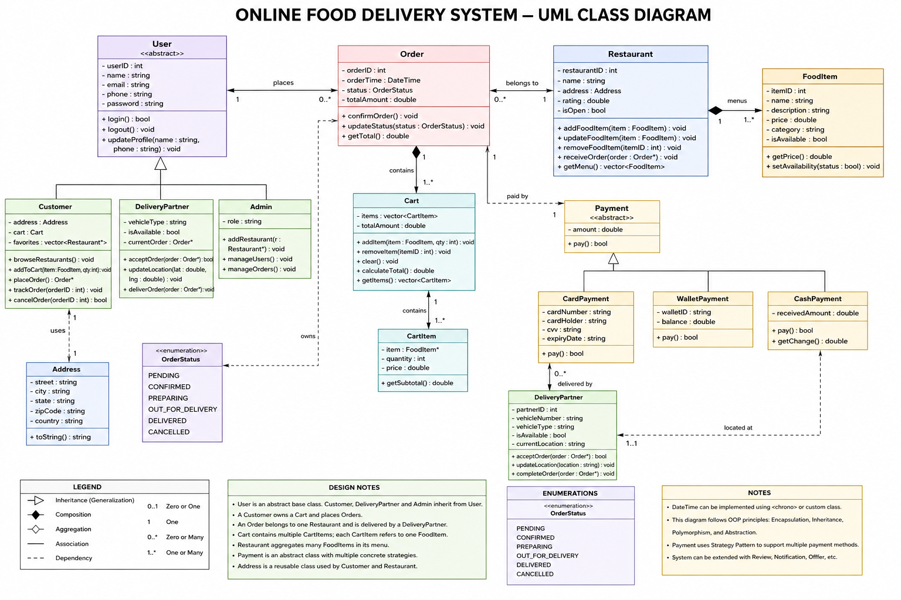
Figure 1: UML Class Diagram of the Online Food Delivery System

3.1 Class Responsibilities
- User — base class holding shared identity data (userID, name, email) and shared behaviour (login(), logout()).
- Customer — a specialised User who owns a Cart, has a delivery address, and can placeOrder() / trackOrder().
- DeliveryPartner — a specialised User responsible only for deliver().
- FoodItem — a menu entry with a name and price; immutable once constructed, exposed through getters.
- Cart — a temporary collection of FoodItem objects a customer intends to purchase; supports addItem() and removeItem().
- Restaurant — owns a menu (a collection of FoodItem) and can addFood(), showMenu(), and receiveOrder().
- Order — captures the confirmed transaction: it computes and stores the total and status for a set of cart items.
- Payment (abstract) — declares the pay() contract implemented by Cash, Card, and Wallet.

3.2 Relationships and Data Flow
- Inheritance: Customer and DeliveryPartner inherit from User; Cash, Card, and Wallet inherit from the abstract class Payment.
- Composition: a Customer owns exactly one Cart for the lifetime of the customer object — the cart has no independent existence outside its owning customer.
- Aggregation: a Cart holds FoodItem entries copied from a Restaurant's menu, and a Restaurant aggregates the FoodItem objects that form its menu — items conceptually belong to the menu, not exclusively to any one cart.
- Association: a Customer places an Order, a Restaurant receives that Order, the Order is settled by a Payment, and a Customer's order is fulfilled by an assigned DeliveryPartner.
Data flows in one direction through the system: the Restaurant supplies FoodItem data → the Customer collects items in a Cart → the Cart's contents are passed to an Order, which computes the total → a concrete Payment subtype settles that total → a DeliveryPartner completes the transaction by delivering the order.

4. SOLUTION DEFINITION
The OOP-based solution follows the sequence of operations implemented in main(), which acts as the driver/orchestration layer that exercises the class model end to end. The high-level logic is as follows:

4.1 High-Level Pseudocode
BEGIN
customer := new Customer(id, name, email, address)
customer.login()
restaurant := new Restaurant(name, rating)
FOR each item IN predefined menu list:
restaurant.addFood(item)
restaurant.showMenu()
// Customer selects items from the menu
customer.getCart().addItem( restaurant.getFood(index) )
... (repeat for each selected item)
customer.placeOrder()
restaurant.receiveOrder()
order := new Order()
order.confirmOrder( customer.getCart().getItems() )
// total := SUM(item.getPrice() for item in items)
// status := "Confirmed"
// Runtime polymorphism: any Payment subtype can be bound
paymentChoice := promptUser("Cash / Card / Wallet")
payment := SELECT Cash | Card | Wallet BASED ON paymentChoice
payment.pay( order.getTotal() ) // dynamic dispatch
rider := new DeliveryPartner(id, name, email)
rider.deliver()
customer.trackOrder()
customer.logout()
END

4.2 Step-by-Step Explanation
- Step 1 — Registration/Login: a Customer object is instantiated (inheriting login()/logout() from User) and logs in.
- Step 2 — Menu Setup: a Restaurant is created and populated with FoodItem objects, each encapsulating a name and a price.
- Step 3 — Cart Building: the customer selects items; each selected FoodItem is copied into the Customer's Cart via addItem().
- Step 4 — Order Placement: placeOrder() and receiveOrder() model the hand-off between customer and restaurant; an Order object then aggregates the cart's items and computes the total through confirmOrder().
- Step 5 — Payment (polymorphic step): a Payment pointer is bound at runtime to a Cash, Card, or Wallet object based on user choice; pay() is invoked polymorphically on the base-class pointer.
- Step 6 — Fulfilment: a DeliveryPartner (also a User) completes the transaction by delivering the order, after which the customer can trackOrder() and logout().

5. DESIGN PATTERN APPLICATION

5.1 Strategy Pattern — Payment Methods
The Payment hierarchy (Payment, Cash, Card, Wallet) is a direct application of the Strategy design pattern. Payment defines a common interface (pay()), and each concrete subclass encapsulates one interchangeable algorithm/behaviour for settling a transaction. The client code in main() selects a concrete strategy at runtime and invokes it through the abstract interface, without any conditional logic (if/else on payment type) appearing anywhere outside the single selection point.
Justification: the Strategy pattern is appropriate because the number of payment options is expected to grow (e.g., bank transfer, digital wallets, buy-now-pay-later), and this design allows each new option to be added as a new subclass with zero changes to Order or to the checkout flow — directly satisfying the Open/Closed Principle.

5.2 Template-Method Opportunity — User Roles
The User base class already provides a shared skeleton of behaviour (login(), logout()) that subclasses such as Customer and DeliveryPartner extend with role-specific operations. While the current implementation does not use virtual dispatch for these methods, the structure is well positioned to evolve into a Template Method pattern if role-specific hooks (e.g., a virtual onLogin() step) are later required — for example, notifying a delivery partner of pending orders immediately after login.

5.3 Factory-Method Opportunity — Payment Creation
Currently, the concrete Payment object is selected using an if/else chain directly inside main(). This is a reasonable simplification for a small program, but as a design improvement a Factory Method (e.g., PaymentFactory::create(choice)) would remove object-creation logic from the client code entirely, centralising it in one place and making the checkout flow depend only on the abstract Payment interface, never on any concrete subclass name.

6. LIMITATIONS & FUTURE WORK

6.1 Limitations of the Current OOP Design
- No persistence layer: all objects (users, menus, orders) exist only in memory for the duration of program execution; nothing is saved to a file or database, so no order history survives a restart.
- Weak validation: FoodItem, Order, and payment amounts are not validated (e.g., negative prices, empty carts, invalid menu indices are not guarded against), which could cause runtime errors or incorrect totals.
- Payment selection is not fully encapsulated: the if/else chain that creates a Cash, Card, or Wallet object lives inside main() rather than being hidden behind a factory, so the client code still has partial knowledge of concrete payment types.
- No concurrency handling: the design assumes a single customer interacting with a single restaurant sequentially; it does not address multiple simultaneous customers, race conditions on a shared menu, or thread safety.
- Limited role hierarchy: a real platform would likely need a RestaurantAdmin or Rider-availability model; the current two-subclass hierarchy under User is a simplification.
- Manual memory management: the Payment pointer is created with new and manually deleted, which is error-prone compared to using a smart pointer (e.g., std::unique_ptr).

6.2 Suggested Improvements
- Introduce a data-access layer (file-based or database) so Order and User records persist across sessions.
- Add input validation and exception handling around cart, order, and payment operations.
- Apply a Factory Method for Payment creation to fully decouple main() from concrete payment classes.
- Replace raw pointers with smart pointers (std::unique_ptr<Payment>) to remove manual delete calls and prevent memory leaks.
- Extend the Restaurant class to support order history and multiple simultaneous carts, and introduce an Observer pattern so a Customer can be notified automatically as an Order's status changes, rather than polling trackOrder().

7. TEAM CONTRIBUTION TABLE
The table below records each member's individual contribution to this report and its accompanying source-code analysis, consistent with the roles listed on the cover page.
Member Name | Roll No. | Role | Contribution
Mohib Ahmed Khan | CT-25178 | Lead Developer | Implemented and reviewed the C++ class model; coordinated the overall solution structure and final code walkthrough
Syed Rahim Ali | CT-25191 | OOP & UML Design | Mapped OOP principles to the code, designed the UML class diagram and class relationships
Fahad | CT-25180 | Testing | Traced program execution (main()), verified class interactions, and validated the solution's pseudocode
Ali Adnan | CT-25182 | Code Integration & Debugging | Reviewed the payment polymorphism logic and consolidated code references used across the report
Rabeet | CT-25197 | Documentation | Compiled and formatted the report, wrote the limitations/future-work section and references

REFERENCES
[1] E. Gamma, R. Helm, R. Johnson, and J. Vlissides, Design Patterns: Elements of Reusable Object-Oriented Software. Addison-Wesley, 1994.
[2] B. Stroustrup, The C++ Programming Language, 4th ed. Addison-Wesley, 2013.
[3] G. Booch, R. A. Maksimchuk, M. W. Engle, B. J. Young, J. Conallen, and K. A. Houston, Object-Oriented Analysis and Design with Applications, 3rd ed. Addison-Wesley, 2007.
[4] Object Management Group, "OMG Unified Modeling Language (UML), Version 2.5.1," 2017. [Online]. Available: https://www.omg.org/spec/UML/
[5] NED University of Engineering & Technology, CT-260 Object Oriented Programming Course Plan, Department of CS & IT, Summer 2026.

