

**KABARAK UNIVERSITY**

**SCHOOL OF SCIENCE ENGINEERING AND TECHNOLOGY**

**DEPARTMENT OF COMPUTER SCIENCE**

**BACHELOR OF SCIENCE IN INFORMATION TECHNOLOGY**

**INTE 324: TEAM PROJECT**

**MKULIMA INFORMATION SYSTEM**

**BY**

**KORIR JAPHETH KIBET- INTE/M/3158/09/18**

**MATHEW RONOH-INTE/MG/3088/09/20**

**VINCENT KIPKIRUI-INTE/MG/2277/05/18**

**A Research Study Submitted to the School of Science, Engineering and Technology in Partial Fulfilment of the Requirements for the Award of the Degree of Bachelor of Science in Information Technology**

**2023**

# DECLARATION

We hereby declare that this project documentation is our original work and has not been submitted for any academic award in any other university or institution. All sources used in this project have been duly acknowledged.

Sign: ________________________ Date: ________________________

# RECOMMENDATION

This research study entitled **Mkulima Information System** written by Korir Japheth Kibet, Mathew Ronoh and Vincent Kipkirui is presented to the School of Science, Engineering and Technology of Kabarak University. We have reviewed this project and recommended it be accepted in partial fulfillment of the requirements for the Degree of Bachelor of Science in Information Technology.

Sign: ________________________ Date: ________________________

**Mr. Chrispus Alukwe, CEH**

**School of Science, Engineering and Technology**

**Department of Computer Science and Information Technology**

**Kabarak University**

# COPYRIGHT

 No part of this project may be reproduced or transmitted in any form or by any means, electronic or mechanical, including photocopying, recording, or any information storage and retrieval system, without permission in writing from the author.

All Rights Reserved

©2023

Sign: ________________________ Date: ________________________

# ACKNOWLEDGEMENT

We are grateful to each and every individual who has been part of the success of this project. In particular, we would like to extend our sincere gratitude to Mr. Chrispus Alukwe, CEH, whom without, this project would never have seen the light of day. Supreme of all, we would like to thank The Almighty God, who has seen us through in each and every step that we undertook in this project. All Glory and Honor belongs to You.

# DEDICATION

We dedicate this project to all farmers who embrace technology in their day to day activities.

Contents

DECLARATION 2

RECOMMENDATION 3

COPYRIGHT 4

ACKNOWLEDGEMENT 5

DEDICATION 6

ABBREVIATIONS 9

CHAPTER ONE 10

Introduction 10

1.1 Background of the study 10

1.2Problem statement 11

1.3 Objectives 12

1.3.1 General objective 12

1.3.2 Specific Objectives 12

1.4 Research Questions 12

1.5 Significance of the Study 13

1.6 Scope and Limitation of study 13

CHAPTER TWO 14

2.1 Introduction 14

2.2 Overview of the current system 14

2.2.1 Challenges facing Irish potato farmers during production 14

2.3 Overview of the shortcomings of the current system 16

2.3.1 Effects of mistiming spraying and weeding times 16

2.3.2 Effects of lack of weather information 17

2.4 Concept Map 18

CHAPTER THREE 19

3.1 Introduction 19

3.2 Research design used 19

3.3 Data collection methods 19

3.4 Design Diagrams 20

3.4.1 Context Diagram 20

3.4.2 Level 1 DFD 21

3.4.3 Use Case Diagram 22

3.5 Research Ethics 23

CHAPTER FOUR 24

4.1 Introduction 24

4.2 System Architecture 24

4.3 Frontend development 25

4.4 User Interface Design 25

4.5 User interface modules. 26

4.5.1 Registration module 26

4.5.2 Login Module 27

4.5.3 Details module 28

4.5.4 Activity Module 29

4.5.5 Weather module 30

4.6 Backend Development 31

4.6.1 Database design model 31

4.6.2 Tables 31

4.7 Deployment methods 32

4.8 Conclusion and future work 32

CHAPTER FIVE 33

REFERENCES 33

# ABBREVIATIONS

CIDP County Integrated Development Plan

VCC Value Chain Crop

# CHAPTER ONE

# Introduction

Mkulima information system is a system that will be used by farmers to access information regarding their choice of crop intended for cultivation. This study will focus on the production of Irish Potatoes in Bomet County.

The farmers in the county do not earn optimal prices from their produce due to the poor quality of crops. This is brought about by poor farming practices e.g. mistiming of the weeding period and poor control of pests and diseases. This is because the farmers do not have the necessary information regarding on when these activities are to be carried out. (MoALF. 2017)

Lack of agro-meteorological information is also a major setback to the farmers. Oftentimes, the farmers rely on only their intuition before performing certain practices such a spraying of herbicides and pesticides. When this is done and abrupt rains occur, the chemicals are washed away by the rain water and thus become ineffective. It may be too costly for the farmer to reapply the same thus leaving the crops susceptible to the weeds and pests.

The Mkulima Information System intends to be a solution to the mistiming of crucial periods by regularly notifying the farmer on when to carry out weeding as well as application of pesticides. It will do this through the provision of an automated checklist where the farmer checks an activity off once it is completed.

The Mkulima Information System will also provide the solution to the lack of agro-meteorological information by including weather and climate prediction services in the farmer’s portal. This will be achieved by incorporating the OpenWeatherMap API.

# 1.1 Background of the study

Potato farming is one of the most valuable and lucrative form of farming globally. Potatoes are the third most important human consumable crop just behind rice and wheat. The production of potatoes surpasses 300 million metric tons annually. This underscores how valuable the crop is. It is produced by over 100 countries globally. (CIP, 2017)

In Kenya, potatoes are the second most consumed crop after maize. This almost qualifies it as a stable food. Its economic importance in the country cannot be undermined either. It is grown by over 800,000 small scale farmers. This makes it a very crucial crop in the agricultural sector. Potato farming provides direct and indirect employment to almost 2.5 million people countrywide along its value chain. These include the farmers, sellers of farm inputs, transporters, sales and marketing agents as well as those that provide other services such as storage. (CIP, 2020)

In Bomet County, Irish potato farming was identified as one of the VCCs in the county’s CIDP. This is due to the fact that the Irish potato has several great characteristics such as its fast rate of growth, high productivity which results to higher profitability as compared to other crops. As such 41%-61% of the county’s population are directly involved in Irish potato farming.

Irish potato farming in Bomet County is however faced by several challenges. One of this challenges is the prevalence of pests and diseases which include bacterial wilt and potato cyst nematode. (MoALF. 2017)

Another challenge is the loss of crops due to unpredictable weather patterns. Due to the shift in climate patterns, farmers sometimes plant crops only following their intuition without any data to back up their intuitions. This sometimes led them to plant crops just before a prolonged period of rain failure. A majority of the small scale farmers do not practice irrigation thus automatically resulting in crop loss.

# 1.2Problem statement

The prevalence of pests and diseases such as the bacterial wilt and potato cyst nematode can be directly attributed to poor farm practices. An example of the poor farm practice is the irregular and mistimed application of herbicides and pesticides. The produce harvested after the crops have been affected by these pests and diseases are of poor quality. The crops also do not produce the optimum produce as expected. This usually occurs because farmers use outdated methods to time when to carry out these activities or most of the times lack a system at all. As such, the farmers will carry out weeding or herbicide and pesticide spraying once they see that the crops have been affected. When this is carried out, the crops will be too affected to make sufficient recovery and thus productivity is hampered. This leads to poor quality and diminished quantity of the crops.

Farmers also experience losses arising from lack of weather prediction services. Sometimes farmers carry out activities at predetermined times not putting into consideration the climate change which affects weather patterns. For example, a farmer who ten years ago used to plant his Irish potatoes in February of each year and they would do well may continue to do so in these years. This will result in losses because in the recent years, rain patterns in the county have shifted and rain may never be experienced up to April in the case of this year, 2023. By the time rains fall, the potatoes would have dried up thus leading to losses.

Due to this lack of weather prediction services, some farmers may also apply pesticides and herbicides just before rain falls. This will result in losses since they will be washed away by the rain water.

# 1.3 Objectives

## 1.3.1 General objective

The general objective of this study is to develop an information system that will guide farmers’ activities and provide crucial weather information. This system will be developed using HTML, CSS and JavaScript languages at the client-side as well as PHP language at the server-side.

## 1.3.2 Specific Objectives

1. To review the current system in use by Irish potatoes farmers in Bomet County.
2. To identify the specific shortcomings of the current system in use by Irish potatoes farmers in Bomet County.
3. To develop an information system that will help farmers keep track of crucial farm activities and weather pattern information.

# 1.4 Research Questions

1. What is the current system in use by the Irish potato farmers in Bomet County?
2. What are the shortcomings of the current system in use by the Irish potato farmers in Bomet County?
3. What are the ideal characteristics of a system that will help farmers to keep track of crucial farm activities?

# 1.5 Significance of the Study

Once the Mkulima information system is developed, it will lead to several favorable outcomes for the Irish potato farmers in Bomet County who will utilize it.

Major of these outcomes is that it will reduce losses incurred by farmers due to unpredicted weather patterns. Farmers will be able to carry out farm activities with prior knowledge of how the weather will be for a certain period of time. This will almost eliminate losses due to planting before long dry spells. Pesticide and herbicide wastage will also be limited since the farmers will apply them in the correct weather.

There will also be an increased quality and quantity of Irish potato produce. This will be due to the fact that herbicides and pesticides will be applied in time before they get a chance to adversely affect the crops. This will lead to increased yields. This will consequently lead to improved earnings and increased profit margins for the Irish potato farmers in Bomet County.

# 1.6 Scope and Limitation of study

This study will be carried out in Bomet County among the Irish potato farmers and potential Irish potato farmers. This study will target farmers who have web enabled devices e.g. smartphones, desktops, laptops.

A limitation to this study is the large number of farmers who use feature phones without web capabilities.

# CHAPTER TWO

# 2.1 Introduction

Irish potato farmers in Bomet County do not get optimum returns for their produce. This literature review will cover the broader aspect of challenges that face the Irish potato farmers in the whole country as well as specifically in Bomet County. Some of the topics that will be covered include how lack of a particular order in administering farm chemicals may lead to loses as well as how lack of weather information may also lead to loses for the farmer.

# 2.2 Overview of the current system

The current system in use by Irish potato farmers is marred by a myriad of challenges. These challenges if not addressed have the potential to cause serious losses to the farmer. The challenges are as discussed below.

## 2.2.1 Challenges facing Irish potato farmers during production

Irish potato farmers in Kenya in general and Bomet County in particular are faced with a lot of challenges especially in the production stage. Some of the challenges include poor growing practices, low use of farm inputs, poor control of diseases and insect pests as well as climatic change.

The farmers realize low yields due to poor growing practices. These practices mostly stem from lack of information regarding potato farming. This leads the farmers to only do what they know which in most cases is not what is recommended for potato planting. The most rampant poor growing [practice is the lack of crop rotation. The farmers plant potatoes successively in the same farm. This is detrimental to the realization of better yields. This is occasioned by the fact that this practice leaves the crop vulnerable to diseases such as cyst nematode which can to some extent be controlled by practicing crop rotation. (Greenlife, 2023)

Most of the farmers also do not use the recommended amount of farm inputs. These inputs include fertilizers, manure herbicides and pesticides. Due to the high cost of these inputs, the farmers sometimes opt to use less than the recommended amounts of inputs and thus the crops end up lacking the necessary nutrients to viably develop or end up being infested by weeds and pests thus reducing the crop quality which leads to sub-optimal returns for the farmer. (Greenlife, 2023)

Another challenge facing Irish potato farmers is the lack of quality seeds. This challenge oftentimes lead farmers to plant any seeds made available to them. In most cases, the seeds planted are not certified. This poor practice leads to poor quality of produce for the farmer. When a produce is of poor quality, there is no way that it can fetch the optimum prices in the market thus leading to farmer frustrations. (Greenlife, 2023)

One of the major challenges that face the Irish potato farmers is the poor control of insect pests and diseases. This is mostly experienced when a farmer mistimes when to apply pesticides and herbicides. Some pesticides also have to be applied at regular intervals in order for optimum efficacy to be realized. If a farmer does not follow a given schedule, then there are higher chances of the pests and weeds overpowering the crops. This has adverse effects as will be discussed in the subsequent section. (Ahmadu et al., 2021)

While the above mentioned challenges are within the power of the Irish potato farmers to correct, climatic change isn’t. The change in climatic conditions is another major challenge that faces Irish potato farmers. This change has led to a departure from the normal weather patterns and seasons that farmers used to know. Farmers who rely on their previous knowledge regarding seasons and weather patterns find themselves incurring unfathomable losses. The effects of the change in climatic conditions on the farmers will be discussed in the subsequent section. (Gyan, 2022)

# 2.3 Overview of the shortcomings of the current system

As outlined above, the current system has a lot of shortcomings that directly affect the earnings of an Irish potato farmer. In this section, the literature review will aim to highlight the effects that the shortcomings have on the farmers and their production of the crop.

## 2.3.1 Effects of mistiming spraying and weeding times

In order for the optimum yields to be realized in Irish potato farming, the crop has to be maintained in a very healthy state. This is usually achieved through the application of various farm chemicals. The application of these chemicals have to be very precise. This is due to the fast growing nature of the Irish potatoes and thus if an application window is missed, the effects will be far reaching.

Some of the chemicals include fertilizer used in the top dressing of the crops once they have reached a certain stage. The top dressing fertilizer gives nutrients that help in the development of tubers as well as stems and leaves. When this is not done sufficiently or in time, the crop does not grow to its maximum potential. (Greenlife, 2023)

Irish potatoes are prone to various pests. Some of the pests that are a bane to Irish potato farming include the potato tuber moth, thrips, aphids as well as white grubs. Apart from the pests, certain diseases are also prevalent in Irish potato farming. These diseases can be caused by certain types of fungi, bacteria and even viruses. Some of the diseases that majorly attack Irish potatoes include late blight, early blight, powdery scab, bacterial wilt as well as potato ring rot. If these pests and diseases are not controlled in time, they have adverse effects on the Irish potato yields as they directly affect the plants. (Ahmadu et al., 2021)

The most common effect of the mistimed application of chemicals is the slowing down of tuber development or complete stoppage at some point of the attack. This is often manifested in stunted tubers of poor quality. The number of tubers produced may also decrease from the expected number and sometimes there are no tubers at all. This definitely leads to a reduction in the expected yields per acreage. When this happens, studies show that it can lead to 30% to as high as 70% reduction in the total expected yields. This is detrimental to the farmer as they may even end up making overall loses. (Ahmadu et al., 2021)

## 2.3.2 Effects of lack of weather information

Lack of weather information is very detrimental to the farmer. One of the major needs for weather prediction is on the application of fertilizer. This should be done when the ground is moist enough to absorb the fertilizer but not too wet so that fertilizer is washed away. The ground should also not be too dry since the fertilizer would then be hindered from penetrating the soil. When there is no weather information in advance, the farmer may incur huge loses if rain becomes too much and there is runoff or rain fails to fall thus the fertilizer not being absorbed.

In the control of pests and diseases, lack of weather information also causes a lot of losses tp the farmer. When there is lack of wind information, the farmer may end up wasting a lot of pesticides and herbicides. This is due to the fact that if there is a considerable amount of wind, chemicals sprayed will be off target. If it also rains within a certain time of application, some chemicals may be washed away. This leave the crops susceptible to the pests and diseases that were being targeted. (Gyan, 2022)

# 2.4 Concept Map

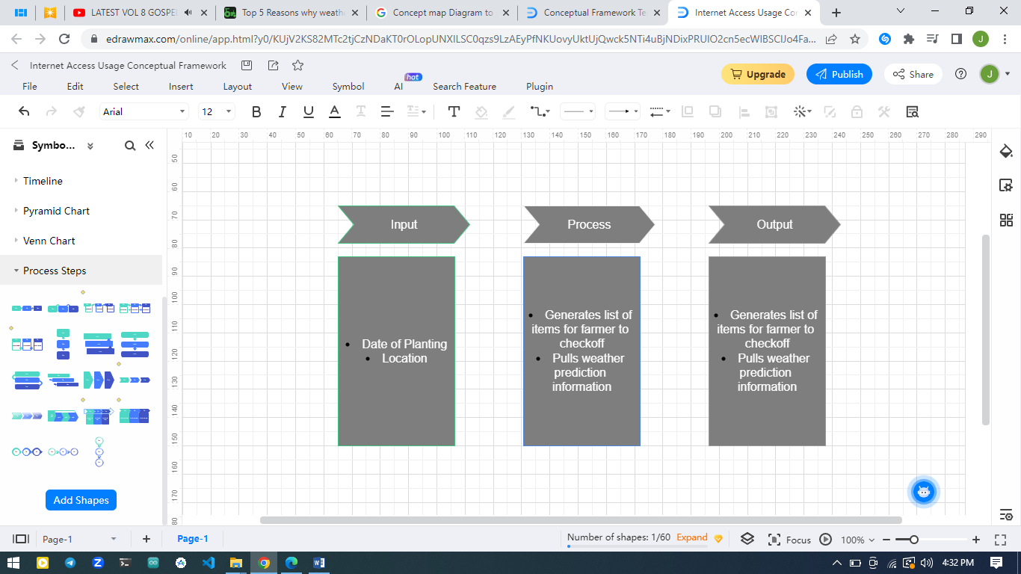

# CHAPTER THREE

# 3.1 Introduction

This chapter will focus on several key issues that will be instrumental in developing the final solution. One of such issues is the methodology employed. Here, it will discuss the methodology that will be employed to achieve the given end. It will also highlight the various methods that will be used to collect the data that is to be used for the study. It will also include several diagrams that will show how the solution interacts with various entities.

# 3.2 Research design used

This study aims to use the prototype design. This design will be used to implement the final solution of this study.

Prototype design is an incremental model of development. In this design, a first product known as the prototype is developed with some of the features that are intended. Once this is developed, the product is passed to a sample of identified users to use and assess it. The users do all sorts of testing as they use the prototype.

Feedback from users is collected and this feedback helps the developer to rework the product. The product is modified so as to include the features that users suggest. Corrections are also made to the functionalities.

This process is repeated until a final product that is acceptable to the user is accepted.

The advantage of this design is that once the developer has the system requirements, they can start its development. Modifications are easy to implement since it does not entail the overhaul of the whole system but rather specific parts depending on the analysis of the users who determine the strengths and weaknesses which are then corrected.

# 3.3 Data collection methods

This study will employ the use of questionnaires to get the feedback from the sample of identified users. The questionnaires will be administered electronically by the use of Google Forms. This method is convenient to both the researcher and the sample user. This is because it will minimize logistics involved in the conventional questionnaire method. There will be no costs for the printing of the physical questionnaires. Transport costs will also be eliminated. This will enable the researcher to reach a higher amount of study sample as compared to if it could have been done physically.

# 3.4 Design Diagrams

## 3.4.1 Context Diagram

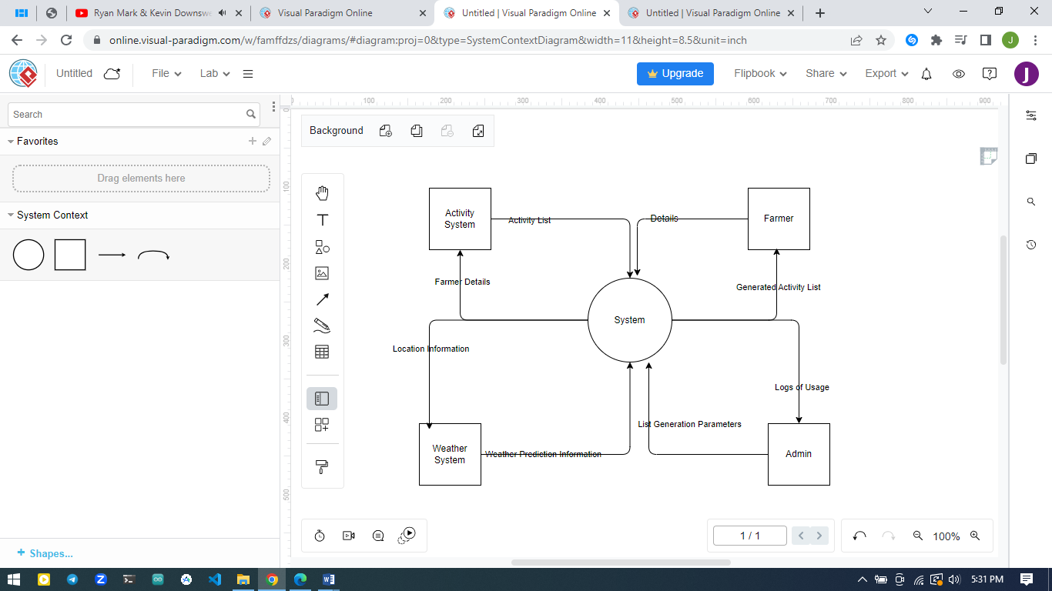

## 3.4.2 Level 1 DFD

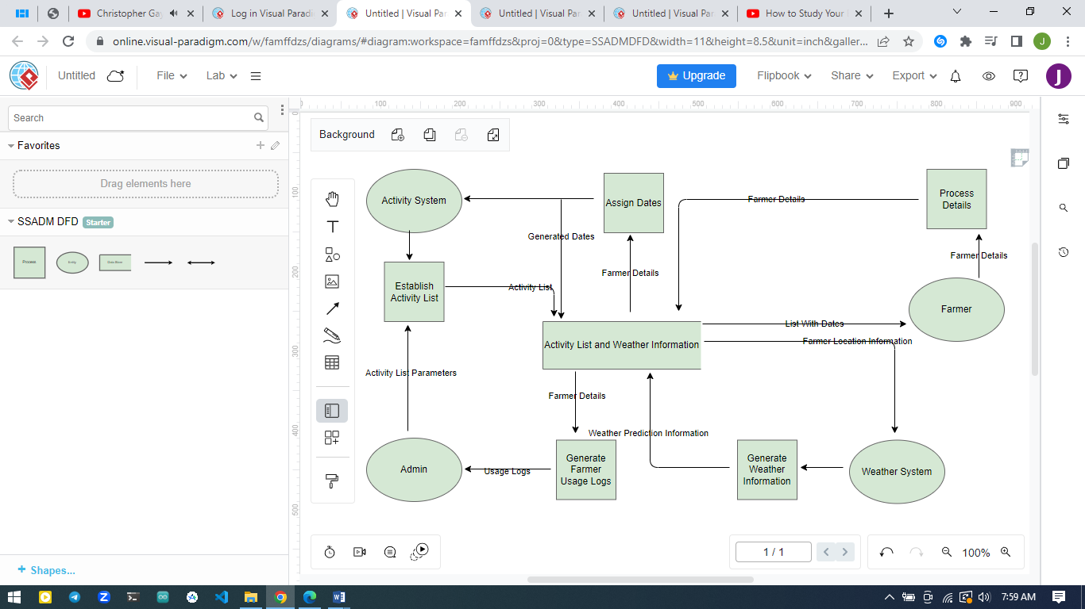

## 3.4.3 Use Case Diagram

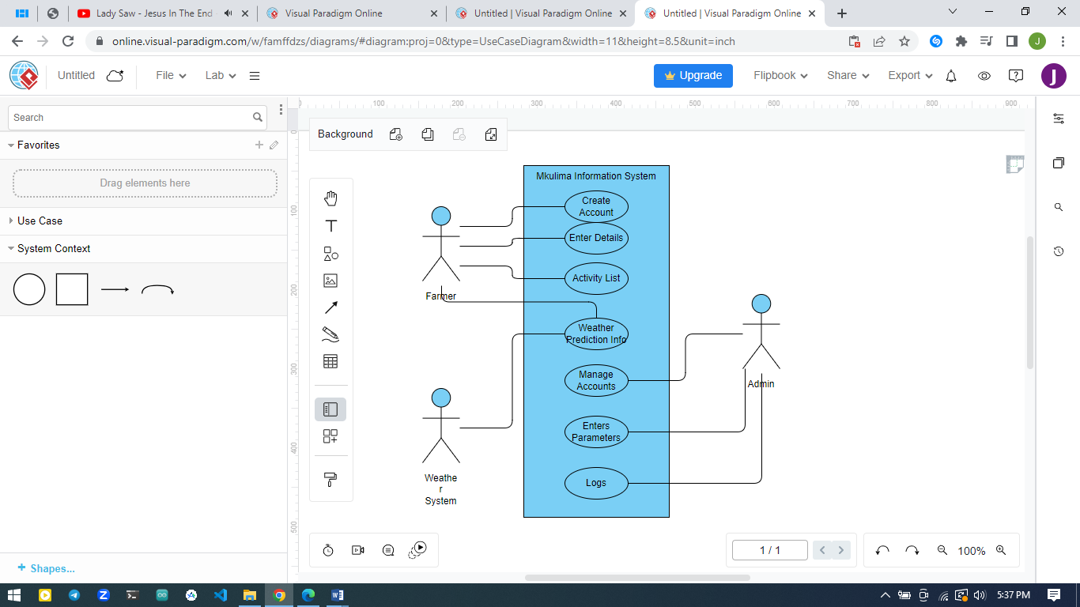

# 3.5 Research Ethics

This research aims to adhere to research ethics in its entirety. This study will be guided by the Kabarak University Research Policies by the Kabarak University Scientific and Ethics Review Committee. This committee has been accredited by the National Commission for Science, Technology & Innovation (NACOSTI) which is the body in charge of the research ethics in the country.

This study will ensure the tenets of research are upheld. Any and all information disclosed by consenting participants will be held in confidentiality unless where otherwise expressly permitted to disclose.

This study will aim to ensure that no human or animal rights are infringed upon in the course of the study. Due diligence will be done to ascertain that this is adhered to. Dignity of participants will be ensured in all circumstances. There will be complete transparency regarding every aspect of this study.

This study upon its completion will be brought to the public domain for the benefit of the society at large. Where assistance has been provided, the providers will be duly acknowledged. This study will also aim to eliminate any bias or impartiality and ensure for complete independence.

# CHAPTER FOUR

**SYSTEM IMPLEMENTATION AND DEPLOYMENT**

# 4.1 Introduction

This chapter will cover the solution provided according to the objectives of this study. It shows how the farmers will access the system and how they will utilize it. The system includes a dashboard that shows the exact dates in which the farmer is supposed to carry out specific farm activities. The system also includes a weather prediction service that covers a period of 6 days to help the farmer in fore planning.

# 4.2 System Architecture

This system includes the frontend and backend. The frontend is the interface where the farmer accesses the system. The farmer interacts with the system by inputting some data as prompted by the system. The backend is composed of a database and its connection to the frontend. The data provided by the farmer is stored in the database and retrieved when necessary.

# 4.3 Frontend development

This is the code for the output of the user registration form.

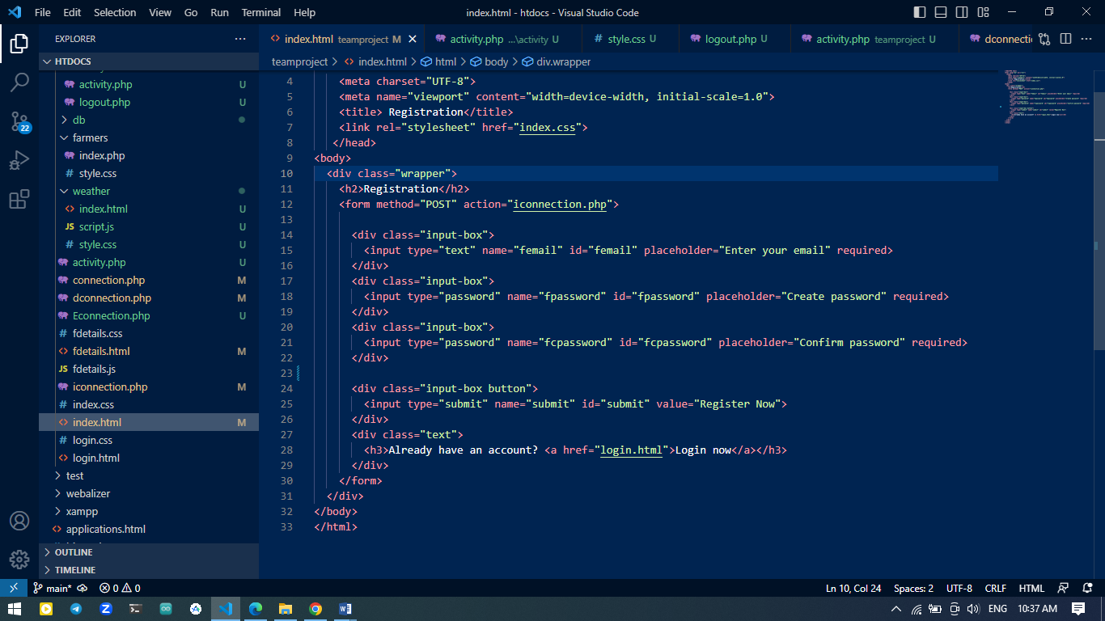

# 4.4 User Interface Design

This system implements that graphical user interface design. In this design the user interacts with the system by clicking on buttons and links. Once clicked, the user is able to either save data or navigate the system.

# 4.5 User interface modules.

## 4.5.1 Registration module

This allows for a new farmer to register in to the system.

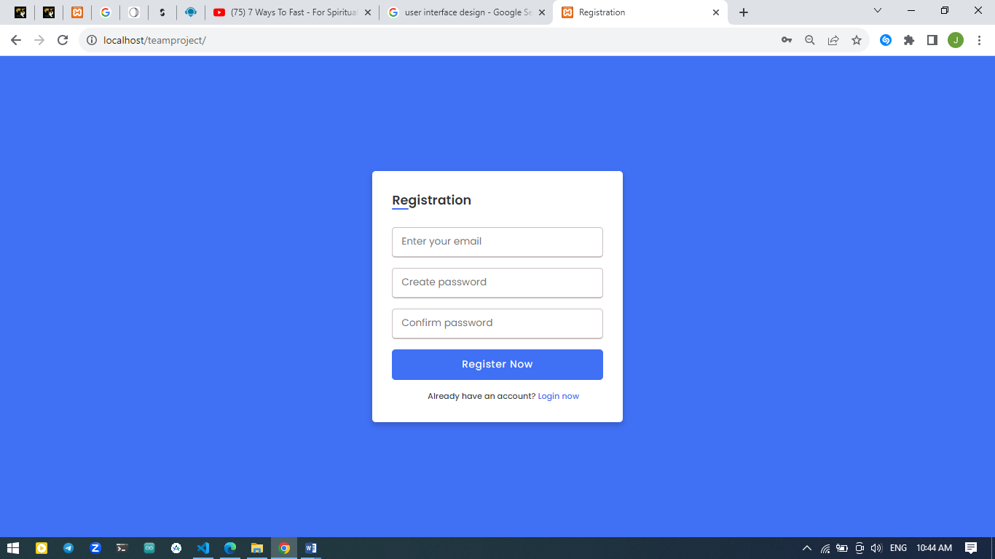

## 4.5.2 Login Module

This allows a registered farmer to login and thereby utilize the system.

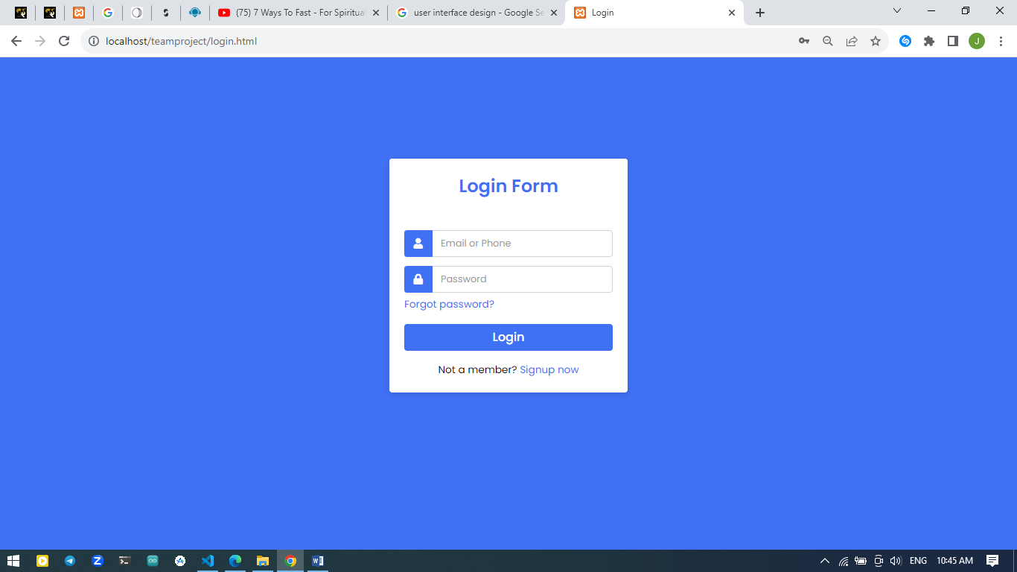

## 4.5.3 Details module

This module allows for the farmer to enter certain details regarding themselves and their activity. Such details include; their full name, phone number, email address, gender and the date of planting of the potato crop.

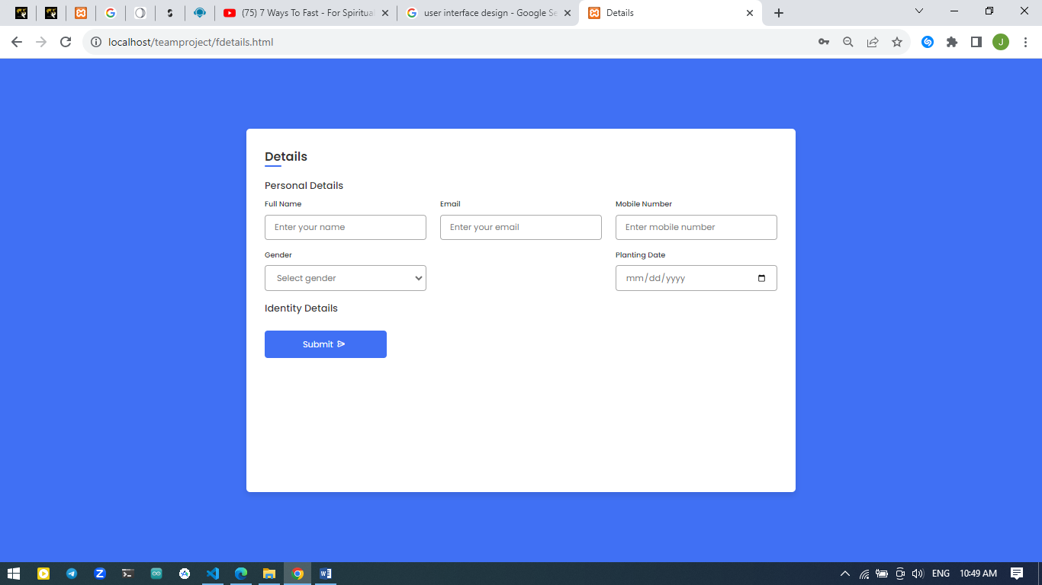

## 4.5.4 Activity Module

This module allows for the farmer to view the exact dates that certain farm activities are to be carried out. These dates are dynamically generated by the system in regards to the planting dates given by the farmer. From this module also, the farmer can choose to view the weather prediction or logout.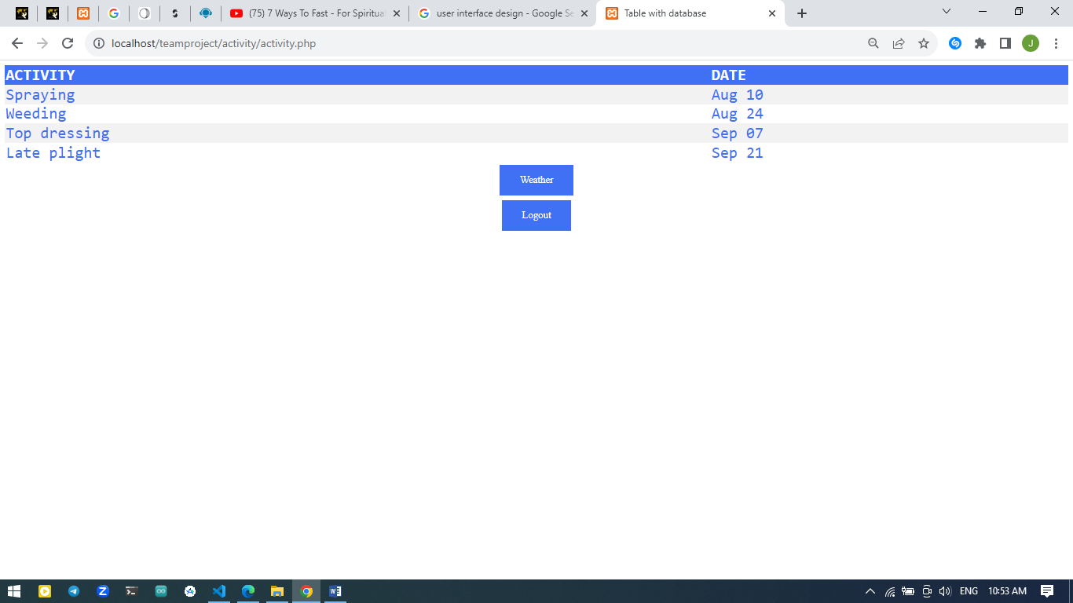

## 4.5.5 Weather module

This module provides the farmer with weather prediction data. The data is provided according to the farmers location or of a location that the farmer is interested in. 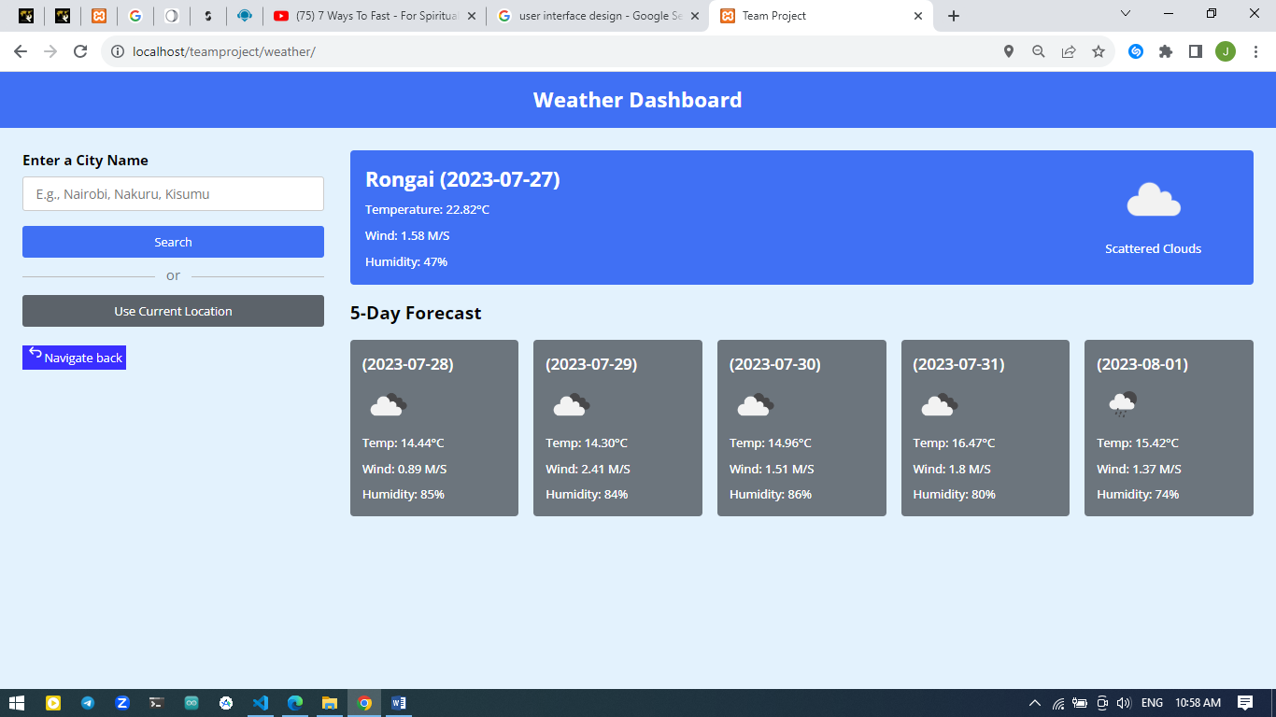

# 4.6 Backend Development

## 4.6.1 Database design model

This study used the realational database model. This model sorts data into tables which consists of columns and rows.In this system, the email entered by the afrmer was chosen as the primary key.

## 4.6.2 Tables

This table stores the farmer details data.

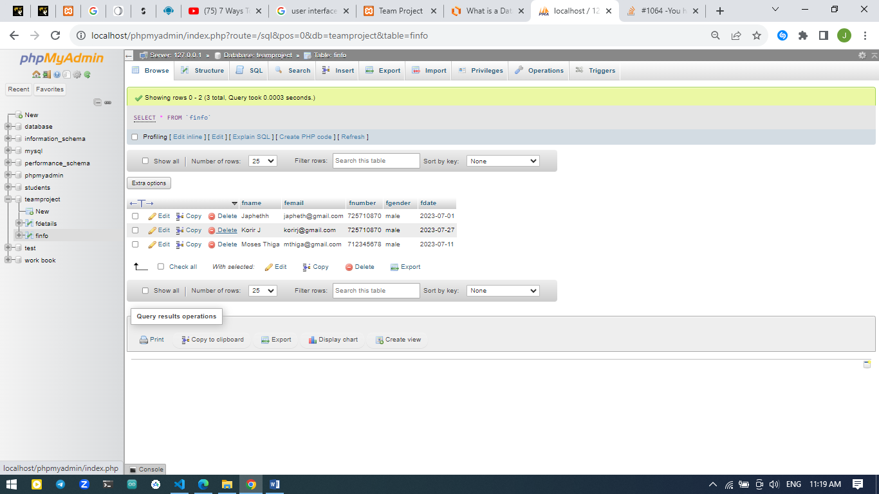

This table stores the farmer email and password. 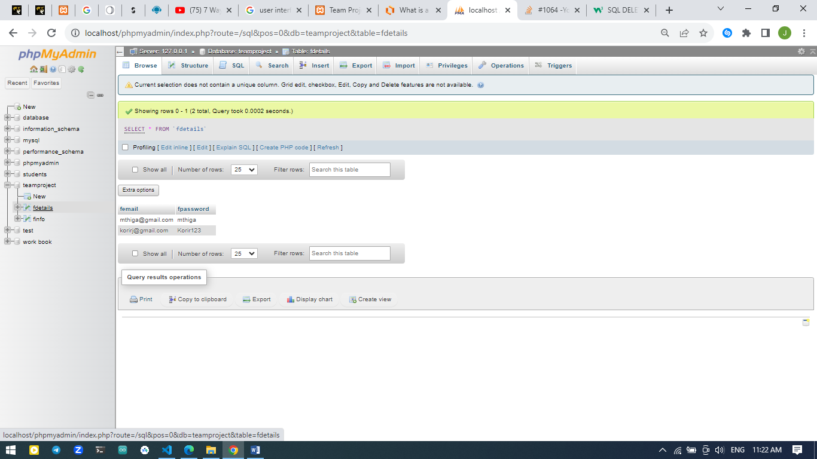

# 4.7 Deployment methods

This system has been deployed on the localhost server of the current development computer.

# 4.8 Conclusion and future work

Having confirmed that the system is fully functional, it can be deployed into production. This will be highly beneficial to all potato farmers in the County.

Due to the robustness of the system, other modules can be integrated in the future to provide more functionality.

# CHAPTER FIVE

# REFERENCES

Greenlife. (2023, March 8). *Potato farming: Greenlife: 2023 update*. Greenlife Crop Protection Africa. <https://www.greenlife.co.ke/potato-farming/>

Ahmadu, T., Abdullahi, A., & Ahmad, K. (2021, December 22). *The role of crop protection in sustainable potato (solanum tuberosum L.) production to alleviate global starvation problem: An overview*. IntechOpen. <https://www.intechopen.com/chapters/78618>

Gyan, T. (2022, April 26). *Top 5 reasons why weather forecasting is important for farming?*. Tractorgyan. <https://tractorgyan.com/tractor-industry-news-blogs/887/5-reasons-why-weather-forecasting-is-important-for-farming#:~:text=Weather%20forecasting%20helps%20the%20farming,rate%20and%20type%20of%20fertilizer>.

MoALF. 2017. Climate Risk Profile for Bomet County. Kenya County Climate Risk Profile Series. The Ministry of Agriculture, Livestock and Fisheries (MoALF), Nairobi, Kenya.

CIP. (2017, November 2). *Potato facts and figures*. International Potato Center. <https://cipotato.org/potato/potato-facts-and-figures>

CIP. (2020, July 24). *Potatoes for prosperity*. CIP Annual Report 2019. <https://cipotato.org/annualreport2019/stories/potatoes-for-prosperity>