***Abstract:***

The purpose of this project is to create an interface where people can draw the graphs of their model easily and can edit anytime. In short, people can make an ontology very effectively. On many websites, we can see the graphs but we cannot edit the graph any time we want. Even once we draw a graph later we cannot add other classes or subclasses. In that case, we have to redraw the full graph again. By protege, we can easily edit the graph according to the requirements.

**Introduction:**

The present is the age of information technology. Now the most valuable resource in the world is information or data. The world's largest tech companies rely on this information to make money. The most interesting thing is that the information is linked to one way or another. For example, when we say cancer, we understand that it is related to medical, any algorithm means related to computer science, processor update means related to electrical engineering, etc. These data are stored in the database in a static format. Which we do not directly understand which is associated with which. Ontology is used for a visual representation of data in dynamic form. We know that some software is already being used to create data ontology (such as protege) and it has some minor problems. So we initially want to create an ontology UI, so that the user can easily add, delete, rename data as class, sub-classes, or sub sub-classes. We plan to create it using web technology so that the user can use it very easily, so we don't need any PC configuration; anyone can take this facility only with the browser through the internet.

**Methodology:**

Protégé is a free open source ontology editor. It is used for drawing many graphs and easily can be edited at any time. Anyone can download this software from its official website because it is free. After installing this software we saw many libraries in this. They work differently while making the graph. We can create classes, subclasses, and sub subclasses. We can choose many types of viewing options as well. We create classes and add sub-classes in other sections (mentioned in the list of figures section). But at the very beginning when we tried to use this software, we faced many problems. And because this software is used in biomedicine, e-commerce, and organizational modeling, we rarely find any tutorial videos on the internet. Also, we read some papers according to our faculty’s advice, but we could not find anything helpful. So it took a few weeks more than our expectations. But by the time we could figure it out by ourselves how this software works. Now we can create the graphs of any model we want. We can save a file and edit the graph anytime we want. Also, we can add or delete classes and subclasses anytime according to our choices. By ontology-graph active ontology tab, we can show the model in graphs. The rest part will be completed in the 499B.

**Results and discussion:**

As mentioned earlier, we can draw the graphs of the models. That means if we have information about the divisions, cities of a country, we can draw this information graph by the protégé software. Protégé creates dynamic graphs. Now we are facing a new problem to connect this software in a website. There are no such libraries which can connect protégé to a website. As we cannot have access to protégé privacy so also it is not possible to create a library framework by raw codes. We have given the pictures below. As our project is not completed so the final result will be added in 499B.

**Acknowledgment:**

By the kindness of the Almighty, we have completed our senior design project entitled “XYZ”

Our deep gratitude goes first to my faculty advisor Dr. Mohammad Ashrafuzzaman Khan, Assistant Professor of North South University for giving this project idea and having faith in us with this project**.** Our faculty expertly guided us in our senior design project A throughout the whole CSE499A. His guidance helped us in all types of research, writings, and completing the first part of this project.

Our sincere thanks also go to North South University, Dhaka, Bangladesh for giving us such a platform where we can have an industrial level experience as a part of our academics.

This part of our project is completed by Mohammad Raihan Sarker Razu (1520079042), Tamim Ahmed (1520698642), and Arona Dorin Chowdhry (1520045642). Each has contributed to this project equally by completing their part.

Last but not the least, we would like to thank our family as their inspiration and guidance kept us focused and motivated.

.

**References:**

1. Domain Ontologies in Software Engineering: Use of Protégé with the EON Architecture

<https://www.thieme-connect.com/products/ejournals/html/10.1055/s-0038-1634543>

1. Ontology-Driven Software Development in the Context of the Semantic Web: An Example Scenario with Prot´eg´e/OWL people.cis.ksu.edu/~abreed/CIS890/References/ontologydrivensoftwaredevelopment.pdf
2. VM-in-Protégé: A Study of Software Reuse <https://www.researchgate.net/profile/Mark_Musen/publication/12913738_VM-in-protege_A_study_of_software_reuse/links/0912f511538eb238c4000000.pdf>
3. The protégé project: a look back and a look forward <https://dl.acm.org/doi/abs/10.1145/2757001.2757003>

List of figures:

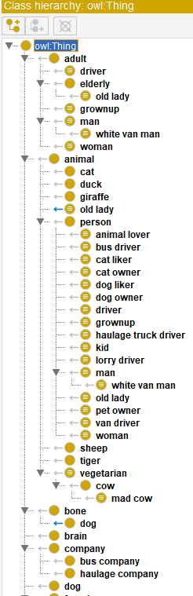

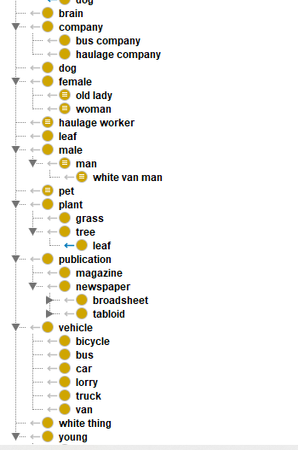

Figure 1: This figure shows the classes and sub-classes. This is the class hierarchy.

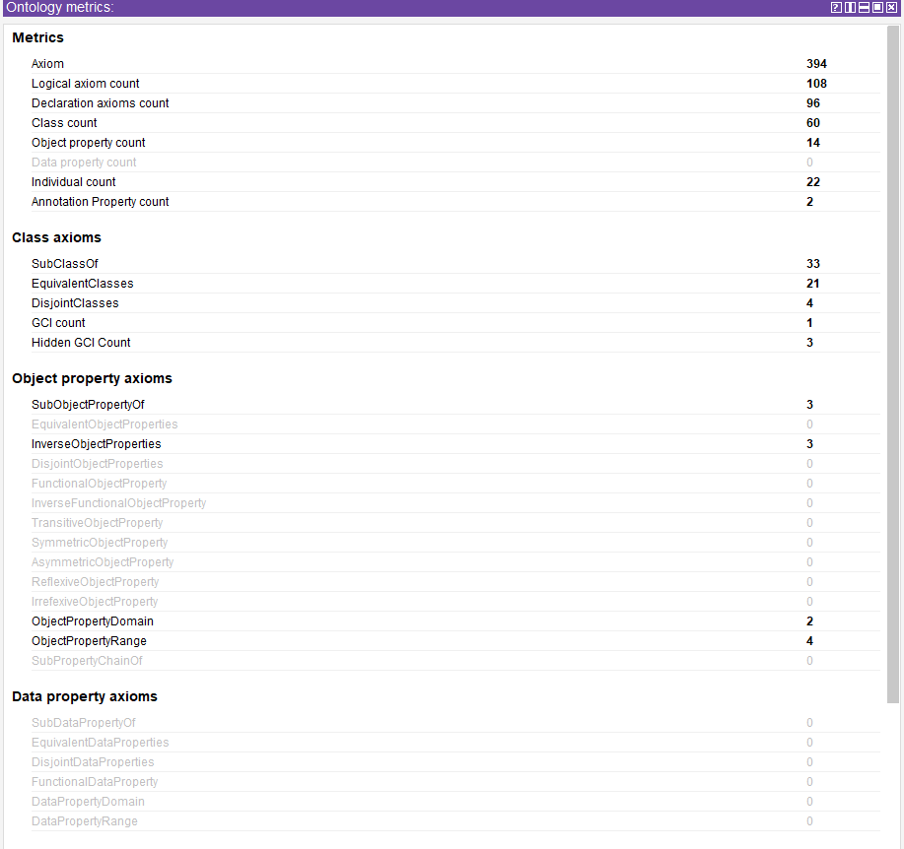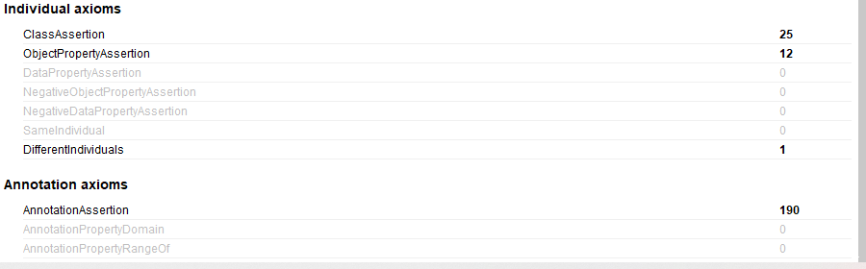

Figure 2: This figure shows the ontology matrix. It includes the properties and axioms.

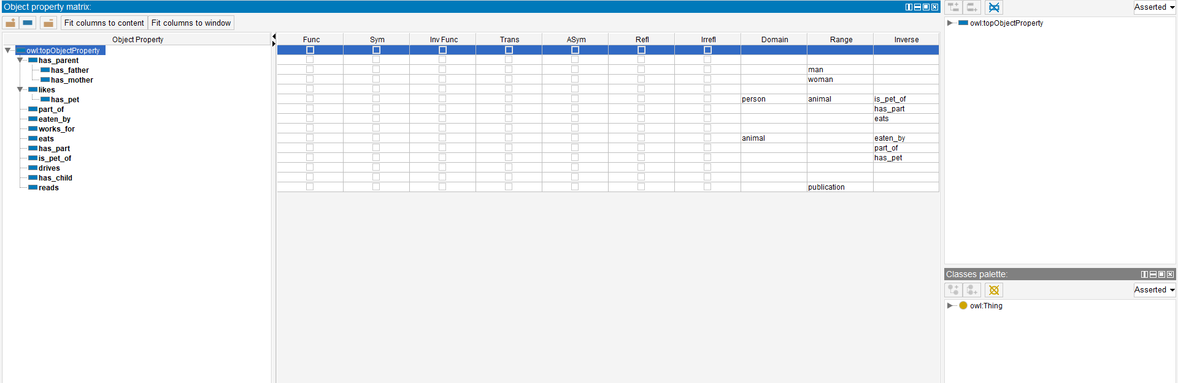

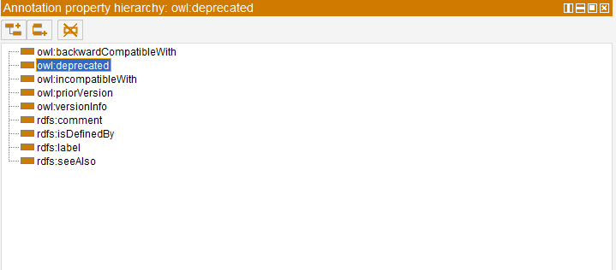Figure 3: This figure shows the object property matrix.

Figure 4: This figure shows the annotation property hierarchy.

Figure 5: People ontology graph.

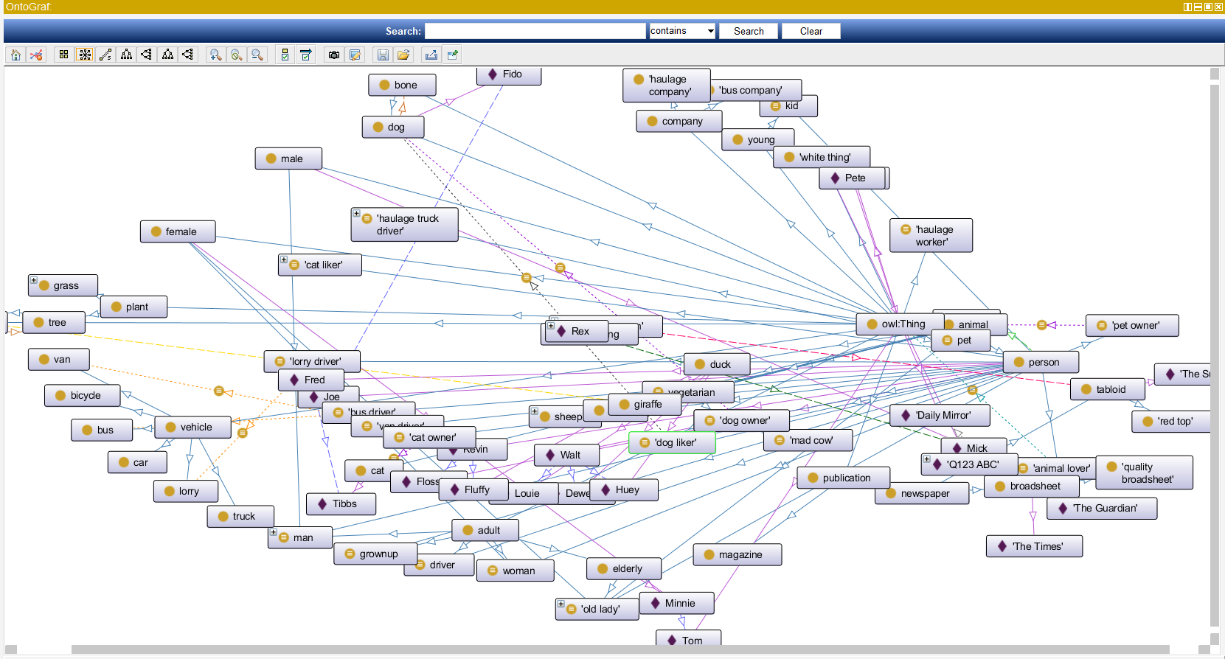Here we created a people graph. In this graph, we can see some name of the people which is ta class. And the sub-classes show what they have.

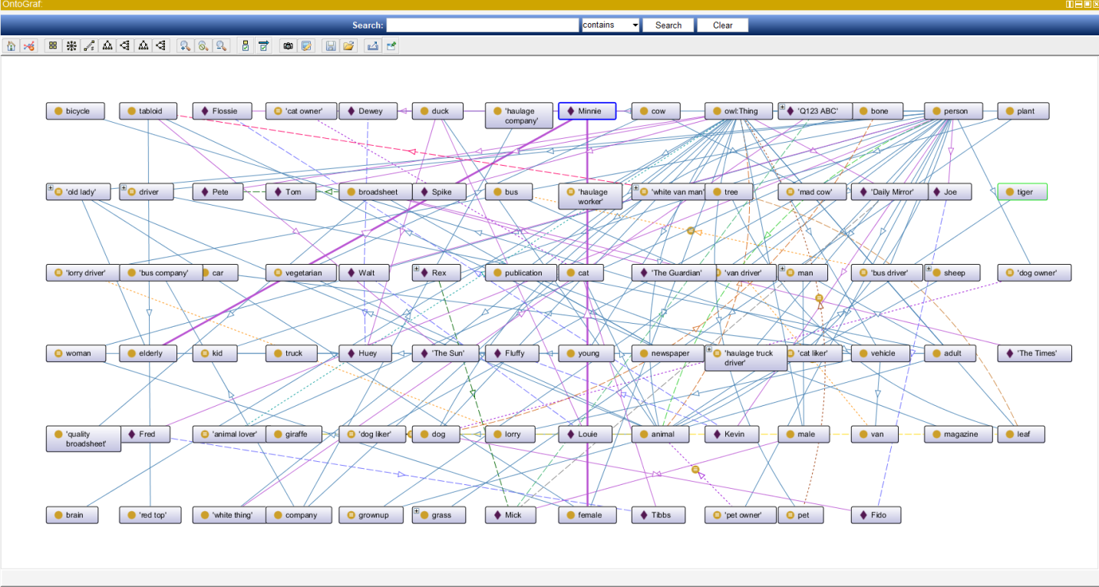Figure 6: This is the people ontology graph in different viewing design.