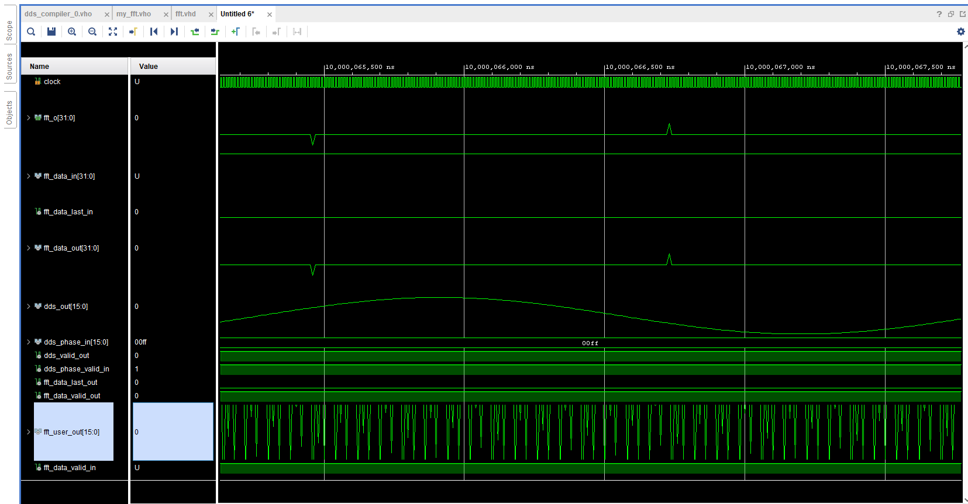

**FFT TOP MODULE**

library IEEE;

use IEEE.STD_LOGIC_1164.ALL;

use IEEE.STD_LOGIC_SIGNED.ALL;

use IEEE.NUMERIC_STD.ALL;

entity fft is

Port (

clock : in std_logic;

-- reset : in std_logic;

--fft_start_i : in std_logic;

fft_o : out std_logic_vector(31 downto 0)

);

end fft;

architecture Behavioral of fft is

COMPONENT dds_compiler_0

PORT (

aclk : IN STD_LOGIC;

s_axis_config_tvalid : IN STD_LOGIC;

s_axis_config_tdata : IN STD_LOGIC_VECTOR(15 DOWNTO 0);

m_axis_data_tvalid : OUT STD_LOGIC;

m_axis_data_tdata : OUT STD_LOGIC_VECTOR(15 DOWNTO 0)

);

END COMPONENT;

COMPONENT my_fft

PORT (

aclk : IN STD_LOGIC;

s_axis_config_tdata : IN STD_LOGIC_VECTOR(23 DOWNTO 0);

s_axis_config_tvalid : IN STD_LOGIC;

s_axis_config_tready : OUT STD_LOGIC;

s_axis_data_tdata : IN STD_LOGIC_VECTOR(31 DOWNTO 0);

s_axis_data_tvalid : IN STD_LOGIC;

s_axis_data_tready : OUT STD_LOGIC;

s_axis_data_tlast : IN STD_LOGIC;

m_axis_data_tdata : OUT STD_LOGIC_VECTOR(31 DOWNTO 0);

m_axis_data_tuser : OUT STD_LOGIC_VECTOR(15 DOWNTO 0);

m_axis_data_tvalid : OUT STD_LOGIC;

m_axis_data_tready : IN STD_LOGIC;

m_axis_data_tlast : OUT STD_LOGIC;

event_frame_started : OUT STD_LOGIC;

event_tlast_unexpected : OUT STD_LOGIC;

event_tlast_missing : OUT STD_LOGIC;

event_status_channel_halt : OUT STD_LOGIC;

event_data_in_channel_halt : OUT STD_LOGIC;

event_data_out_channel_halt : OUT STD_LOGIC

);

END COMPONENT;

----------------fft signal-------------------

signal fft_data_in : std_logic_vector(31 downto 0);

signal fft_data_valid_in : std_logic;

signal fft_data_last_in : std_logic;

signal fft_data_out : std_logic_vector(31 downto 0);

signal fft_user_out : std_logic_vector(15 downto 0);

signal fft_data_valid_out : std_logic;

signal fft_data_last_out : std_logic;

--------------dds signal-----------------------

signal dds_phase_in :std_logic_vector(15 downto 0) := x"00FF";

signal dds_phase_valid_in : std_logic := '1';

signal dds_valid_out : std_logic;

signal dds_out : std_logic_vector(15 downto 0);

------------------------------------------

begin

fft_o <= fft_data_out;

-------------------fft--------------------

fft : my_fft

PORT MAP (

aclk => clock,

s_axis_config_tdata =>(others => '0'),

s_axis_config_tvalid => '0',

s_axis_config_tready => open,

s_axis_data_tdata => fft_data_in,

s_axis_data_tvalid => fft_data_valid_in,

s_axis_data_tready => open,

s_axis_data_tlast => fft_data_last_in,

m_axis_data_tdata => fft_data_out,

m_axis_data_tuser => fft_user_out,

m_axis_data_tvalid => fft_data_valid_out,

m_axis_data_tready => '1',

m_axis_data_tlast => fft_data_last_out,

event_frame_started => open,

event_tlast_unexpected => open,

event_tlast_missing => open,

event_status_channel_halt => open,

event_data_in_channel_halt => open,

event_data_out_channel_halt => open

);

--------------------------------------------

---------------------dds--------------------

dds : dds_compiler_0

PORT MAP (

aclk => clock,

s_axis_config_tvalid => dds_phase_valid_in ,

s_axis_config_tdata => dds_phase_in ,

m_axis_data_tvalid => dds_valid_out ,

m_axis_data_tdata => dds_out

);

fft11 : process (clock)

--variable fft_counter : integer range 0 to 1024 ;

begin

if (rising_edge (clock)) then

if fft_counter < 1024 then

fft_data_valid_in <= '1' ;

fft_data_in <= x"0000" & dds_out ;

fft_counter := fft_counter + 1 ;

end if;

-else

-fft_data_last_in <= '0';

end if;

end process;

end Behavioral;

