High-Frequency Market Making via Reinforcement Learning under Different Volatility Regimes

MSc Thesis / Technical Report

Field | Value
Author | Onur Emiroglu
Programme | Financial Engineering MSc
Institution | Karlsruhe Institute of Technology
Supervisor | [SUPERVISOR FULL NAME]
Matriculation No. | [MATRICULATION NUMBER]
Submission date | 2026-06-06
Git Repository | https://github.com/OnurEmiroglu/THESIS
Course / Module | MSc Thesis
Advisor / Co-supervisor | Not applicable

In the tested controlled synthetic HFMM environment, explicit categorical volatility-regime labels do not provide robust incremental value once sigma_hat is already observed by the PPO policy. The results are consistent with signal redundancy.
Contents
Abstract 5
Symbols, Abbreviations, and Glossary 5
1 Introduction 7
1.1 Problem Statement and Motivation 7
1.2 Research Objective 7
1.3 Background and Related Work 7
1.4 Contributions 8
1.5 Scope and Limitations 9
1.6 Report Structure 9
2 Mathematical Formulation 9
2.1 Synthetic Mid-Price Process 9
2.2 Markov Volatility-Regime Process 9
2.3 Realized Volatility Signal and Regime Detection 9
2.3.1 Illustrative Synthetic Environment Path 10
2.4 Limit-Order Fill Model 11
2.5 Quote Parameterization 11
2.6 Inventory, Cash, Equity, and Reward 11
2.7 Avellaneda-Stoikov Baseline 12
2.8 PPO Objective 12
3 Use-Case Scenario 12
3.1 Synthetic HFMM Scenario 12
3.2 Trading Agents and Strategy Variants 13
3.3 Information-Design Question 13
4 System Architecture 13
4.1 Run Lifecycle and Reproducibility Layer 13
4.2 Synthetic Market and Detector Layer 13
4.3 Gymnasium Environment Layer 13
4.4 Strategy and Training Layer 14
4.5 Evaluation and Evidence Layer 14
4.6 Methodology Pipeline Illustration 14
5 Layered Experimental Model 14
5.1 Layer 1: Market State Generation 14
5.2 Layer 2: Signal Construction 14
5.3 Layer 3: Observation Encoding 15
5.4 Layer 4: Action and Execution 15
5.5 Layer 5: Learning and Evaluation 15
6 Algorithm Specification and Pseudocode 15
6.1 Plain-Language Overview 15
6.2 Synthetic Market and Regime Generation 15
6.3 Market-Making Environment Step 15
6.4 PPO Training and OOS Evaluation Protocol 15
6.5 Experiment 5: Signal-Informativeness Sweep 16
6.6 Reference Implementation Map 16
6.7 Complexity Analysis 16
6.8 Executable Example Commands 17
Commands 17
7 Experimental Setup 17
7.1 Canonical Configuration Protocol 17
7.2 Data Generation and Preprocessing 17
7.3 Train/Test Split 17
7.4 Strategy Variants 17
7.5 Detector Variants 18
7.6 PPO Hyperparameters 18
7.6.1 Hyperparameter Selection Protocol 18
7.7 Protected Evidence and No-Rerun Policy 19
8 Results and Visualisation 19
8.1 Experiment 1: Main Out-of-Sample Evaluation 19
8.2 Experiment 2: Five-Variant Ablation 20
8.3 Experiment 3: Detector Robustness 22
8.4 Experiment 4: Reward-Shaping and Misspecification Checks 23
8.5 Experiment 5: Signal-Informativeness Sweep 24
9 Evaluation Metrics 27
9.1 Final Equity 27
9.2 Sharpe-Like Ratio 27
9.3 Inventory Tail Risk 28
9.4 Fill Rate 28
9.5 Paired t-Tests 28
9.6 TOST Equivalence Tests 28
10 Discussion 28
10.1 Main Interpretation: Signal Redundancy 28
10.2 Why the Result Is Not a Weak Null 29
10.3 Synthetic-Market Boundary 29
10.4 Risks to Interpretation 29
10.5 Future Work 30
11 Reproducibility Checklist 30
12 Conclusion 32
References 32
Appendix A Code Appendix 33
Canonical commands 34
Appendix B Unit Tests and Validation Checks 35
Appendix C Extended Evidence Tables 36
Appendix D Author Contribution Statement 39

Abstract
This report studies whether explicit volatility-regime information improves a Proximal Policy Optimization (PPO)-based high-frequency market-making (HFMM) agent in a controlled synthetic limit-order-book (LOB) environment. The simulator uses an arithmetic Brownian-motion mid-price, a sticky Markov volatility-regime process, rolling realized-volatility detection, and Poisson-arrival fills. The PPO agent chooses bid and ask quotes through a discrete half-spread and skew parameterization, and it is compared with a fixed-spread strategy and an Avellaneda-Stoikov analytical baseline.
In the tested controlled synthetic HFMM environment, explicit categorical volatility-regime labels do not provide robust incremental value once sigma_hat is already observed by the PPO policy. The results are consistent with signal redundancy. The evidence comes from the canonical frozen experiments: out-of-sample evaluation, detector robustness, oracle-label ablations, regime-conditional reward shaping, mild model misspecification, and a signal-informativeness sweep. In the five-variant ablation, sigma_only achieved the highest mean Sharpe-like value (0.753), while oracle_full did not provide a statistically significant or practically meaningful improvement over sigma_hat alone (paired t-test p = 0.115; two one-sided tests (TOST) ±0.10 p = 0.00067; 90% confidence interval (CI) [-0.001, +0.063]). The strongest interpretation is therefore conditional and synthetic-market bounded: the explicit regime label mostly repackages volatility information already present in the continuous signal. The report makes no production-deployment claim and does not claim to prove the internal PPO mechanism.

Symbols, Abbreviations, and Glossary
Symbol | Meaning
S_t | Mid-price at time step t.
q_t | Inventory after step t.
X_t | Cash account after step t.
W_t | Marked-to-market wealth or equity, W_t = X_t + q_t S_t.
sigma_hat | Rolling realized-volatility estimate observed by the PPO policy.
R_t | Reward at time t.
h | Quoted half-spread in ticks.
m | Quote skew in ticks.
A, k | Poisson fill-intensity scale and decay parameters.
eta | Inventory penalty coefficient.
gamma | Avellaneda-Stoikov inventory-risk aversion parameter.
tau | Remaining horizon.
lambda(delta) | Poisson fill intensity at quote distance delta.
delta, delta_bid, delta_ask | Quote distance variables.
rho_t(theta) | PPO probability ratio.
A_hat_t | Advantage estimate.
epsilon_t | Standard-normal innovation in the mid-price process.
z_t | Latent volatility regime.
P_ij | Markov transition probability.

Abbreviation | Meaning
ABM | Arithmetic Brownian motion.
AS | Avellaneda-Stoikov baseline.
HFMM | High-frequency market making.
OOS | Out-of-sample evaluation.
PPO | Proximal Policy Optimization.
RV | Realized volatility.
TOST | Two One-Sided Tests equivalence procedure.
WP | Work package.

Term | Definition
Regime-aware PPO | PPO policy variant that receives a categorical regime one-hot channel.
Regime-blind PPO | PPO policy variant that omits the regime one-hot but still observes sigma_hat.
sigma_only | Ablation variant using the continuous volatility signal without categorical regime labels.
combined | Ablation variant using sigma_hat and estimated categorical regime labels.
oracle_full | Ablation variant using sigma_hat and the true regime label.

1 Introduction

1.1 Problem Statement and Motivation
Market makers continuously choose bid and ask quotes while balancing spread capture against inventory risk. When volatility changes, the same quote width can become either too passive or too exposed. A natural response is to provide a learning agent with regime labels such as low, medium, and high volatility. The central question is whether that categorical label adds decision-relevant information when the policy already observes a continuous volatility estimate.

1.2 Research Objective
The objective is to test the incremental value of explicit categorical volatility-regime labels in PPO market making under a controlled synthetic environment. The comparison is intentionally information-design focused: the regime label is evaluated against a continuous sigma_hat signal, not against an observation space with no volatility information.

1.3 Background and Related Work
The literature relevant to this thesis falls into four connected strands: classical inventory-aware market making, reinforcement-learning market making, volatility regimes and non-stationarity, and statistical interpretation of small or practically negligible differences. The purpose of the review is not to claim a new analytical quoting rule or a new reinforcement-learning algorithm. It is to locate a narrower information-design question inside an established market-making literature.
Classical market-making models provide the inventory-risk and quote-placement foundation. A market maker earns spread income by posting bid and ask quotes, but stochastic execution creates inventory exposure whose value changes with the mid-price. Avellaneda and Stoikov (2008) formalize this tradeoff through a reservation price and spread term that depend on inventory, risk aversion, volatility, remaining horizon, and order-arrival intensity. Gueant, Lehalle and Fernandez-Tapia (2013) extend this inventory-control view and provide tractable approximations for optimal quotes under inventory constraints.
This analytical literature motivates the thesis design in two direct ways: it explains why inventory, volatility, quote distance, and fill intensity are central state variables, and it supplies the Avellaneda-Stoikov baseline used as a non-learning comparator. Related preprints by Fodra and Labadie (2012, 2013) are useful additional context for inventory-constrained and state-dependent market-making models, but they are treated cautiously as preprints. The thesis does not attempt to derive a new closed-form quoting rule; it uses the analytical tradition to frame the simulation and benchmark design.
A second strand replaces closed-form rules with learned policies. Spooner et al. (2018) demonstrate that reinforcement learning can learn market-making behavior in a simulated limit-order-book setting and show why reward design and inventory control matter. Spooner and Savani (2020) extend the discussion toward robustness under adversarially varied market conditions. These studies support the use of simulator-based evaluation for learned quoting policies, while also showing that market-making performance can be sensitive to the assumptions used to generate training and evaluation episodes.
Deep reinforcement-learning studies with market signals are closest to the present information-design question. Gasperov and Kostanjcar (2021) study market making with signals through deep reinforcement learning; Gasperov et al. (2021) review reinforcement-learning approaches to optimal market making; and Gasperov and Kostanjcar (2022) train agents in a richer Hawkes-process limit-order-book simulator. This literature motivates learned quoting, state representation, reward shaping, robustness checks, and simulator-based evidence. The present thesis is narrower: PPO is used as a controlled testbed for whether one additional volatility-regime channel has incremental value, not as a claim of algorithmic optimality.
Volatility regimes and non-stationarity are economically meaningful. A high-volatility state can increase inventory risk, change fill-risk tradeoffs, and make a quote width that was appropriate in a calm period too aggressive in a turbulent period. The thesis therefore models a latent three-state Markov volatility process and a causal rolling realized-volatility detector. This design should not be read as a claim that volatility regimes are irrelevant. The tested question is more specific: whether categorical regime labels add incremental value once the policy already observes a continuous realized-volatility estimate.
The key state-representation issue is redundancy. The continuous signal sigma_hat gives the PPO policy a graded estimate of recent realized volatility. A low/medium/high label derived from related volatility information may help if it summarizes latent structure that sigma_hat does not expose, but it may add little if the continuous signal already contains the useful variation for quote placement. This gives the exact gap addressed by the thesis: When a PPO market-making policy already observes a continuous realized-volatility estimate, does adding an explicit categorical volatility-regime label improve out-of-sample performance in a controlled synthetic HFMM environment?
Finally, the empirical interpretation requires care because the thesis evaluates an incremental signal, not the existence of volatility effects in general. Lakens (2017) and Lakens, Scheel and Isager (2018) motivate equivalence testing as a way to distinguish a merely non-significant difference from evidence that a difference is small relative to a pre-specified practical bound. The TOST framing is therefore used as background for the later statistics section; it does not by itself prove that labels contain no information.

1.4 Contributions
- A controlled HFMM simulator with Poisson-arrival fills, fees, latency, and Markov volatility regimes.
- A Gymnasium environment in which PPO controls quote half-spread and skew.
- An OOS comparison of fixed-spread, Avellaneda-Stoikov, regime-aware PPO, and regime-blind PPO strategies.
- A five-variant ablation separating continuous volatility information from estimated and oracle regime labels.
- Detector, reward-shaping, misspecification, and signal-informativeness checks that bound the interpretation.

1.5 Scope and Limitations
The thesis is a controlled synthetic-market study. It does not claim production deployment viability, real-order-book external validity, or a proven PPO representation mechanism. The result is conditional on the simulator, signal design, PPO hyperparameters, and degradation calibration tested here.

1.6 Report Structure
Sections 2-6 define the mathematical model, use case, architecture, layered model, and algorithms. Sections 7-9 describe the experimental setup, results, and metrics. Sections 10-12 discuss the interpretation, reproducibility, and conclusion. Appendices provide code maps, sanity checks, and extended evidence.

2 Mathematical Formulation

2.1 Synthetic Mid-Price Process
(1) Sₜ₊₁ = Sₜ + σₜ√Δt εₜ, εₜ ∼ N(0, 1)
Here S_t is the mid-price, sigma_t is the step volatility in ticks or price units according to the simulator configuration, dt is the time step, and epsilon_t is an independent standard-normal shock.

2.2 Markov Volatility-Regime Process
(2) P(zₜ₊₁ = j | zₜ = i) = Pᵢⱼ, zₜ ∈ {L, M, H}
Here z_t is the latent volatility regime at step t, L/M/H denote low, medium, and high volatility, and P_ij is the sticky transition probability from regime i to regime j.
(2a) P = [[0.9967, 0.0023, 0.0010], [0.0042, 0.9917, 0.0041], [0.0010, 0.0030, 0.9960]]
Rows correspond to the current regime L/M/H, and columns correspond to the next regime L/M/H. The large diagonal probabilities make the regimes persistent, or sticky, so volatility states tend to last for many steps rather than switching erratically.
This persistence matters because rolling realized-volatility detection is only meaningful when regime-dependent volatility differences last long enough to be observed through a finite window.
The regime controls the volatility multiplier applied to the base sigma parameter. The canonical full experiments use sigma multipliers [0.6, 1.0, 1.8] for L, M, and H.

2.3 Realized Volatility Signal and Regime Detection
(3) σ̂ₜ = √[(1/w) Σᵗᵢ₌ₜ₋w₊₁ (ΔSᵢ)²]
Here sigma_hat_t is the rolling realized-volatility signal, w is the rolling window length, and Delta S_i is the mid-price increment over step i.
Estimated regime labels are assigned by thresholding sigma_hat after a warmup period. The main reported training and evaluation pipelines use the causal rv_baseline detector. The rv_dwell detector is retained only as an auxiliary/offline robustness comparison, while the HMM detector is an additional robustness variant.

2.3.1 Illustrative Synthetic Environment Path
This subsection visualizes one deterministic synthetic path generated under the canonical HFMM environment configuration. The figure is included to make the simulated market environment transparent: the mid-price evolves under a regime-switching arithmetic Brownian-motion process, the realized-volatility signal is computed from rolling mid-price changes, and the latent Markov regime switches between low, medium, and high volatility states. The dashed vertical line marks the chronological 70/30 train-test split used in the out-of-sample protocol. The figure is illustrative of the methodology only and is not a new performance result.
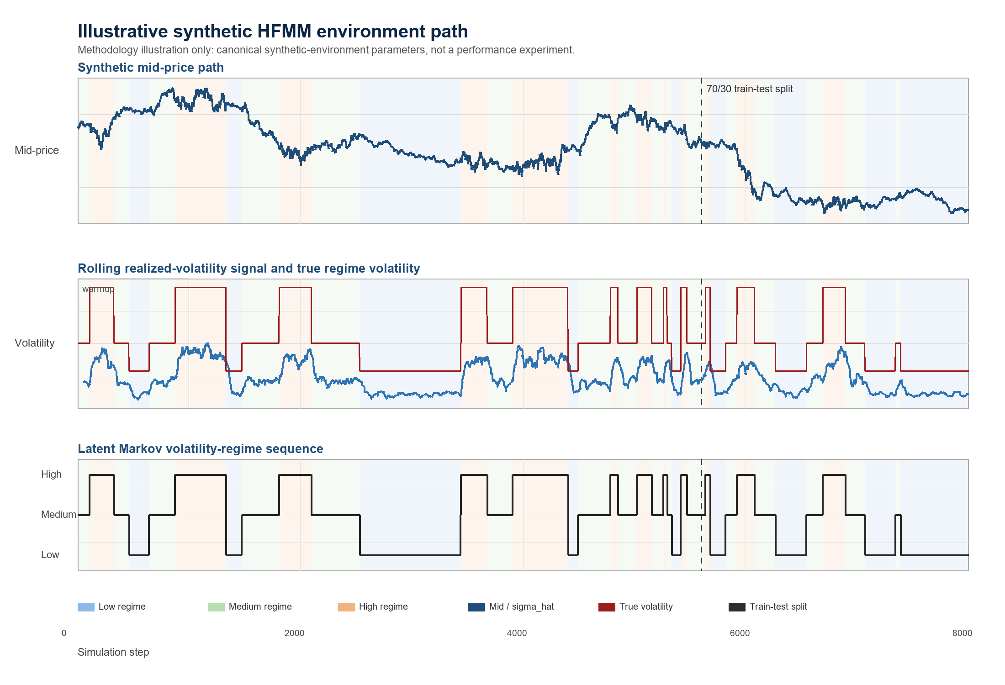
Figure 2.1. Illustrative synthetic HFMM environment path. The upper panel shows the generated mid-price path. The middle panel compares the rolling realized-volatility signal observed by the policy with the true regime-dependent volatility level. The lower panel shows the latent Markov volatility-regime sequence. The dashed vertical line marks the chronological 70/30 train-test split used for out-of-sample evaluation. This figure is generated by scripts/figures/gen_synthetic_environment_figure.py and is a methodology illustration, not a regenerated performance artifact.

2.4 Limit-Order Fill Model
(4) λ(δ) = A exp(−kδ)
Here lambda(delta) is the fill intensity at quote distance delta, A is the baseline arrival scale, and k controls the exponential decay as quotes move farther from the mid-price.
Intuitively, quotes closer to the mid-price fill more often because they are more attractive to incoming market orders. Quotes farther away earn more spread if they fill, but the exponential intensity makes those fills less likely.
(5) P(fill | δ) = 1 − exp[−λ(δ)Δt]
Here P(fill | delta) is the per-step fill probability and dt is the simulator step length.

2.5 Quote Parameterization
(6) h = hᵢₙₓ + 1, m = mᵢₙₓ − 2
Here h_idx and m_idx are the two discrete PPO action components, h is the half-spread in ticks, and m is the quote skew in ticks.
The half-spread h controls quote width and aggressiveness: small h is more aggressive and large h is more passive. The skew m shifts the bid and ask distances asymmetrically, allowing the policy to lean against inventory or other state pressure while still quoting both sides.
(7) δᵦᵢ𝒹 = max(1, h + m), δₐₛₖ = max(1, h − m)
Here delta_bid and delta_ask are the bid and ask quote distances in ticks. The max operator enforces a minimum quote distance of one tick.

2.6 Inventory, Cash, Equity, and Reward
(8) qₜ₊₁ = qₜ + Fᵇⁱᵈₜ − Fᵃˢᵏₜ
Here q_t is inventory, F_t^{bid} is the bid-side fill indicator or count, and F_t^{ask} is the ask-side fill indicator or count.
(9) Xₜ₊₁ = Xₜ − FᵇⁱᵈₜPᵇⁱᵈₜ + FᵃˢᵏₜPᵃˢᵏₜ − feesₜ
Here X_t is cash, P_t^{bid} and P_t^{ask} are the executed bid and ask prices, and fees_t denotes transaction costs.
(10) Wₜ = Xₜ + qₜSₜ
Here W_t is mark-to-market wealth or equity, X_t is cash, q_t is inventory, and S_t is the mid-price.
The equity measure is marked to the mid-price for consistency across simulated strategies. This is an evaluation convention inside the controlled simulator and should not be interpreted as immediately liquidatable wealth in a real limit-order book. In practice, liquidating inventory would generally require crossing the spread, facing queue priority and available depth, and potentially incurring additional adverse-selection or market-impact costs. These effects are part of the real-market boundary discussed later, not part of the current controlled experiment.
(11) Rₜ = Wₜ₊₁ − Wₜ − ηq²ₜ₊₁
Here R_t is the reward and eta is the inventory-penalty coefficient. Fees are included in the cash update and are not counted a second time in the reward.
The eta q^2 term discourages the agent from earning apparent PnL by accumulating large directional inventory. It connects the learning objective to market-making risk control rather than pure speculation on the mid-price path.

2.7 Avellaneda-Stoikov Baseline
(12) rₜ = Sₜ − qₜγσ²τ
Here r_t is the reservation price, gamma is inventory-risk aversion, sigma is volatility, and tau is remaining horizon.
(13) δAS = 0.5γσ²τ + (1/γ) ln(1 + γ/k)
Here delta_AS is the AS half-spread and k is the same fill-intensity decay parameter used in the execution model. The implemented deltas are clipped to configured minimum and maximum bounds.

2.8 PPO Objective
(14) ρₜ(θ) = πθ(aₜ | sₜ) / πθold(aₜ | sₜ)
Here rho_t(theta) is the PPO probability ratio, pi_theta is the current policy, pi_theta_old is the behavior policy used to collect the rollout, a_t is the action, and s_t is the state.
(15) LCLIP(θ) = Eₜ[min(ρₜ(θ)Âₜ, clip(ρₜ(θ), 1−ε, 1+ε)Âₜ)]
Here theta denotes policy parameters, rho_t(theta) is the PPO probability ratio, A_hat_t is the advantage estimate, and eps is the clipping parameter. The report uses this only as a concise training-objective reference.
PPO is used because the thesis needs a stable, widely used policy-gradient algorithm for stochastic sequential control, not because it claims PPO is the best possible market-making RL algorithm. The action is discrete but two-dimensional MultiDiscrete: the agent chooses half-spread h and skew m, which together form a 25-action quote grid. DQN would require value-based handling of this grid and is less natural for the policy-gradient control framing used here; SAC is more naturally aligned with continuous actions and would expand the scope; and A2C is simpler but often less stable or sample-efficient than PPO. PPO therefore provides a reliable baseline algorithm for controlled ablation of the observation channels.

3 Use-Case Scenario

3.1 Synthetic HFMM Scenario
The use case is a synthetic market maker posting one bid and one ask quote at each step. The environment supplies mid-price dynamics, volatility estimates, and regime labels; the agent receives stochastic fills and is evaluated on wealth, risk-adjusted performance, inventory tails, and fill behavior.

3.2 Trading Agents and Strategy Variants
Table 3.1 Strategy variants
Strategy or variant | Observed information | Purpose
Naive | No learned state dependence | Fixed-spread baseline.
Avellaneda-Stoikov | Inventory, volatility, horizon | Analytical inventory-risk baseline.
ppo_aware | sigma_hat and estimated regime one-hot | Original regime-aware PPO.
ppo_blind | sigma_hat without regime one-hot | Original regime-blind PPO.
sigma_only | Continuous sigma_hat only | Tests whether sigma_hat alone carries the signal.
combined | sigma_hat and estimated regime one-hot | Tests estimated categorical incremental value.
oracle_full | sigma_hat and true regime one-hot | Tests perfect-label incremental value.
regime_only / oracle_pure | Categorical labels without sigma_hat | Anchor label-only variants.

3.3 Information-Design Question
In the tested controlled synthetic HFMM environment, explicit categorical volatility-regime labels do not provide robust incremental value once sigma_hat is already observed by the PPO policy. The results are consistent with signal redundancy.

4 System Architecture

4.1 Run Lifecycle and Reproducibility Layer
`run.py` dispatches jobs from JSON configuration files, creates a timestamped run directory, snapshots the config, records git metadata, writes logs and metrics, and finalizes run status. Long WP6 jobs support resume validation against the saved config snapshot.

4.2 Synthetic Market and Detector Layer
`src/wp1/sim.py` implements the fill and inventory simulator. `src/wp2/synth_regime.py` generates synthetic regime paths, mid-prices, rolling realized volatility, and detector outputs.

4.3 Gymnasium Environment Layer
`src/wp3/env.py` wraps the simulator as a Gymnasium environment. The observation vector is [q_norm, sigma_hat, tau, regime_L, regime_M, regime_H]. Warmup, invalid, or disabled regime labels produce a zero one-hot vector rather than an artificial medium label.

4.4 Strategy and Training Layer
The training layer fits PPO policies, the main evaluation layer compares strategies and ablations, and the signal-informativeness layer tests whether regime labels gain value as sigma_hat is degraded. The fixed-spread and AS baselines provide non-learning comparators.

4.5 Evaluation and Evidence Layer
Evaluation writes CSV metrics, figures, and summaries. The final thesis_39 manuscript embeds existing figures and quotes frozen numerical evidence; it does not regenerate protected evidence artifacts.

4.6 Methodology Pipeline Illustration
Figure 4.1 summarizes the evidence pipeline at a methodological level. A synthetic path generates the latent volatility regime and mid-price sequence; rolling realized volatility and detector labels form the observed signals; the Gymnasium environment converts these signals, inventory, time, quotes, and fills into sequential observations and rewards; PPO variants and analytical baselines are then evaluated on held-out out-of-sample metrics. The figure is included only to clarify the workflow and is not a regenerated performance artifact.
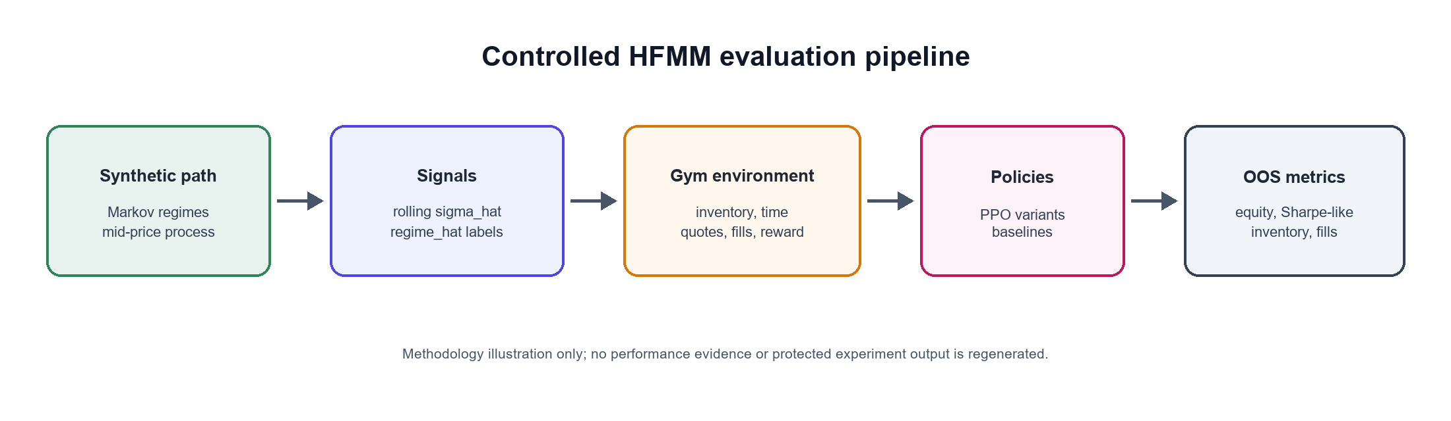
Figure 4.1. Methodology-only HFMM evaluation pipeline. Synthetic market paths produce sigma_hat and regime_hat signals, which feed the Gymnasium environment, PPO variants, baselines, and out-of-sample metrics. Generated by scripts/figures/gen_pipeline_architecture_figure.py; this illustration is not performance evidence.

5 Layered Experimental Model
Section 4 describes the software/evidence architecture, while this section restates the same workflow as a conceptual layered experimental model.

5.1 Layer 1: Market State Generation
Generate Markov regimes and mid-price paths under controlled volatility multipliers.

5.2 Layer 2: Signal Construction
Construct sigma_hat from rolling realized volatility and derive estimated regime labels.

5.3 Layer 3: Observation Encoding
Encode inventory, volatility, time-to-horizon, and optional regime one-hot channels.

5.4 Layer 4: Action and Execution
Decode PPO actions into bid/ask quote distances and sample Poisson-arrival fills.

5.5 Layer 5: Learning and Evaluation
Train PPO on the chronological train segment and evaluate deterministic policies OOS.

6 Algorithm Specification and Pseudocode

6.1 Plain-Language Overview
The experiment creates a synthetic market path, estimates volatility signals, trains policies on the first 70% of the path, and evaluates all strategies on the held-out 30%. Ablations modify which volatility channels the PPO policy can observe.

6.2 Synthetic Market and Regime Generation
Algorithm 1: Synthetic market and regime generation
Input: seed, transition matrix P, base volatility, volatility multipliers, n_steps
Initialize z_0 and S_0
For t = 0 ... n_steps - 1:
sample z_{t+1} from P[z_t]
set sigma_t = base_sigma * multiplier[z_t]
sample mid-price increment and update S_{t+1}
Compute rolling sigma_hat after warmup window
Calibrate thresholds on warmup data and assign regime_hat
Output: exogenous table with mid, sigma_hat, regime_true, regime_hat

6.3 Market-Making Environment Step
Algorithm 2: Market-making environment step
Input: action (h_idx, m_idx), current simulator state, exogenous row
Decode h = h_idx + 1 and m = m_idx - 2
Set delta_bid = max(1, h + m), delta_ask = max(1, h - m)
Compute fill intensities and per-step fill probabilities
Sample bid and ask fills
Update inventory and cash, including fees
Advance mid-price and compute W_{t+1}
Return observation, reward = delta_equity - eta * inventory^2, done flag, info

6.4 PPO Training and OOS Evaluation Protocol
Algorithm 3: PPO training and OOS evaluation protocol
For each seed and variant:
generate one exogenous synthetic path
split path chronologically into train and test segments
configure observation channels for the variant
train PPO on the train segment for the configured timesteps
evaluate the deterministic policy on the test segment
log Sharpe-like ratio, final equity, inventory p99, fill rate, and per-regime metrics
Aggregate seed-paired statistics across variants

6.5 Experiment 5: Signal-Informativeness Sweep
Algorithm 4: Signal information-value sweep
For each degradation condition in {full, noisy, lagged, coarsened, none}:
transform sigma_hat according to the condition
for each valid variant and seed:
train PPO and evaluate OOS
Aggregate condition-variant means and paired comparisons
Test whether combined gains value as sigma_hat is degraded

6.6 Reference Implementation Map
Table 6.1 Reference implementation map
Component | Reference file
Run lifecycle | src/run_context.py, run.py
Simulator | src/wp1/sim.py
Regime generation and detectors | src/wp2/synth_regime.py
Gymnasium environment | src/wp3/env.py
PPO training | src/wp4/job_w4_ppo.py
WP5 evaluation | src/wp5/job_w5_eval.py
WP6 sweep | src/wp6/job_w6_sweep_full.py

6.7 Complexity Analysis
Simulation and deterministic evaluation are linear in the number of environment steps. PPO training cost is approximately linear in total timesteps, policy-network forward/backward passes, and the number of seed-variant cells. The WP6 full sweep is expensive because it multiplies conditions, variants, and seeds; this is why its outputs are treated as frozen evidence.
The implementation prioritizes reproducibility and auditability over maximum simulation throughput. Future versions could improve runtime through vectorized environments, parallel rollouts, or lower-level simulator components for the execution loop.

6.8 Executable Example Commands

Commands
python run.py --config config/w5_main.json
python run.py --config config/w5_detector_full.json
python run.py --config config/w5_eta_regime.json
python run.py --config config/w5_misspec_mild.json
python run.py --config config/w6_sweep_full.json
python run.py --config config/w6_sweep_full.json --resume <run_id>

7 Experimental Setup

7.1 Canonical Configuration Protocol
Canonical experiments are driven by JSON configs under `config/`. Shared parameters include mid0 = 100.0, tick_size = 0.01, dt = 0.2, baseline sigma_mid_ticks = 0.8, A = 5.0, k = 1.5, fee_bps = 0.2, and latency_steps = 1.
Market context. The simulator is asset-class agnostic and uses normalized price units. It should be read as a stylized liquid electronic limit-order-book market rather than as a calibrated model of a specific venue such as equities, futures, crypto, or BIST. The fee and latency parameters are controlled friction assumptions used to make strategy comparisons internally consistent. They are not intended to identify a particular exchange microstructure.

7.2 Data Generation and Preprocessing
Each run generates synthetic mid-price and regime paths, computes rolling realized volatility, and assigns detector labels. The main reported pipelines use causal rv_baseline labels.

7.3 Train/Test Split
The main out-of-sample evaluation and signal-informativeness sweep use a chronological 70/30 split on the exogenous series. PPO trains on the first segment and is evaluated deterministically on the held-out OOS segment.

7.4 Strategy Variants
Experiment 1, the Main Out-of-Sample Evaluation, evaluates naive, AS, ppo_aware, and ppo_blind. Experiment 2, the Five-Variant Signal Ablation, and Experiment 5, the Signal-Informativeness Sweep, use sigma_only, regime_only, combined, oracle_pure, and oracle_full.

7.5 Detector Variants
Table 7.1 Detector variants
Detector | Role | Caveat
rv_baseline | Main causal detector | Rolling RV threshold; used in main WP4/WP5/WP6 pipelines.
rv_dwell | Auxiliary robustness detector | Offline dwell smoothing; not the main causal detector.
hmm | Robustness detector | Higher classification accuracy but no reliable PPO advantage.

7.6 PPO Hyperparameters

7.6.1 Hyperparameter Selection Protocol
The thesis does not perform a broad hyperparameter optimization campaign. This is intentional because the central comparison is signal-channel design, not PPO tuning.
PPO hyperparameters are held fixed across PPO variants to avoid giving one information condition a tuning advantage.
eta = 0.001 is the canonical inventory-penalty scale selected after the earlier inventory-penalty ablation.
No separate validation set is introduced because the study uses a fixed train/OOS evaluation protocol; this should be treated as a limitation and a future extension if full tuning is pursued.
This is a methodological choice, not a claim that the PPO settings are globally optimal.
Table 7.2 PPO hyperparameters
Hyperparameter | Canonical full-run value
total_timesteps | 1,000,000
learning_rate | 3e-4
n_steps | 2048
batch_size | 256
n_epochs | 10
gamma | 0.999
clip_range | 0.2
ent_coef | 0.01 for full WP5/WP6 runs
eta | 0.001

7.7 Protected Evidence and No-Rerun Policy
The final thesis_39 manuscript reuses frozen performance results. It does not rerun PPO training, WP5/WP6 experiments, detector robustness, ablations, misspecification checks, protected CSV generation, or frozen performance-figure generation. The only newly generated visuals are methodology-only illustrations produced by `scripts/figures/gen_synthetic_environment_figure.py` and `scripts/figures/gen_pipeline_architecture_figure.py`.

8 Results and Visualisation

8.1 Experiment 1: Main Out-of-Sample Evaluation
Experiment 1, the 20-seed Main Out-of-Sample Evaluation, shows that PPO variants produce much higher risk-adjusted performance than the fixed-spread and AS baselines. AS can produce higher raw equity, but with substantially larger inventory exposure.
Table 8.1 Main OOS strategy metrics
Strategy | Sharpe-like | Final equity | inv_p99 | Fill rate
ppo_aware | 0.715 | 4.10 | 2.00 | 0.236
ppo_blind | 0.740 | 4.42 | 2.05 | 0.232
AS | 0.105 | 5.05 | 29.95 | 0.444
naive | 0.127 | 4.49 | 21.20 | 0.119

AS has higher raw equity but carries substantially larger inventory tail risk; therefore the main comparison is risk-adjusted performance and inventory control, not raw equity alone.
The AS implementation is used as a canonical analytical inventory-aware comparator rather than as an exhaustively optimized trading system. The PPO-versus-AS comparison establishes a reference point for learned quoting and inventory control, but the central thesis claim is the within-PPO signal-design comparison between sigma_hat, estimated labels, and oracle labels.
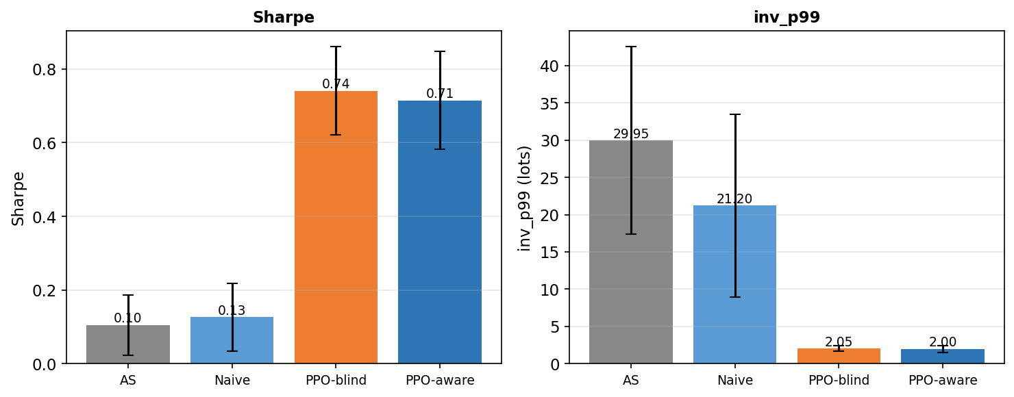
Figure 8.1. Experiment 1 main OOS results: PPO variants dominate naive and AS on risk-adjusted performance, while AS carries much larger inventory tail risk.
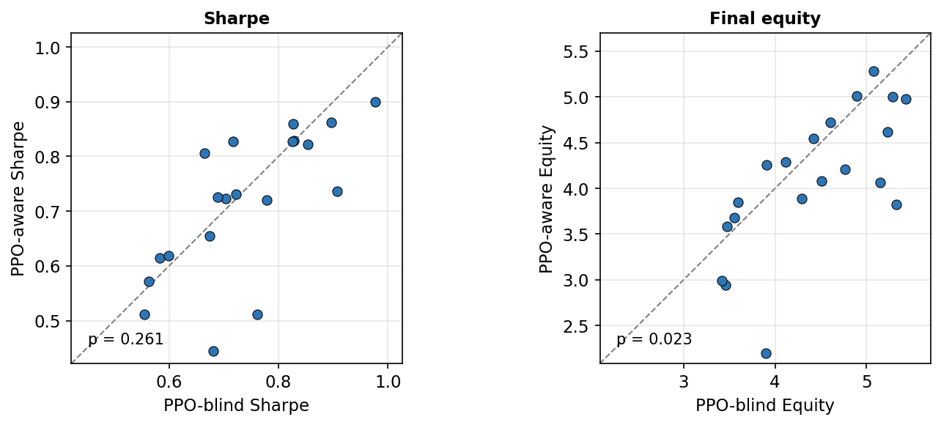
Figure 8.2. Seed-paired PPO-aware versus PPO-blind comparison: the estimated regime channel does not create a robust Sharpe-like advantage.
The paired-seed view shows that the aware policy does not dominate the blind policy seed by seed. The equity panel even favors the blind policy in the canonical paired test.

8.2 Experiment 2: Five-Variant Ablation
Table 8.2 Five-variant ablation metrics
Variant | Signals | Sharpe-like | Final equity | inv_p99
ppo_sigma_only | sigma_hat only | 0.753 | 4.548 | 1.950
ppo_oracle_full | sigma_hat + regime_true | 0.722 | 4.068 | 2.050
ppo_regime_only | regime_hat only | 0.698 | 4.005 | 2.150
ppo_combined | sigma_hat + regime_hat | 0.696 | 3.905 | 1.800
ppo_oracle_pure | regime_true only | 0.684 | 3.925 | 1.950

The strongest ablation result is that sigma_only has the highest mean Sharpe-like value, while oracle_full does not significantly beat it. TOST supports practical equivalence under the ±0.10 Sharpe-like bound.
The label-quality objection is also bounded by the oracle_pure result. oracle_pure receives the true categorical regime label but not sigma_hat, yet it remains below sigma_only in mean Sharpe-like performance in the five-variant ablation. This suggests that the limitation is not only detector noise: in this calibration, the continuous volatility signal is more useful for quote control than the discretized regime category.
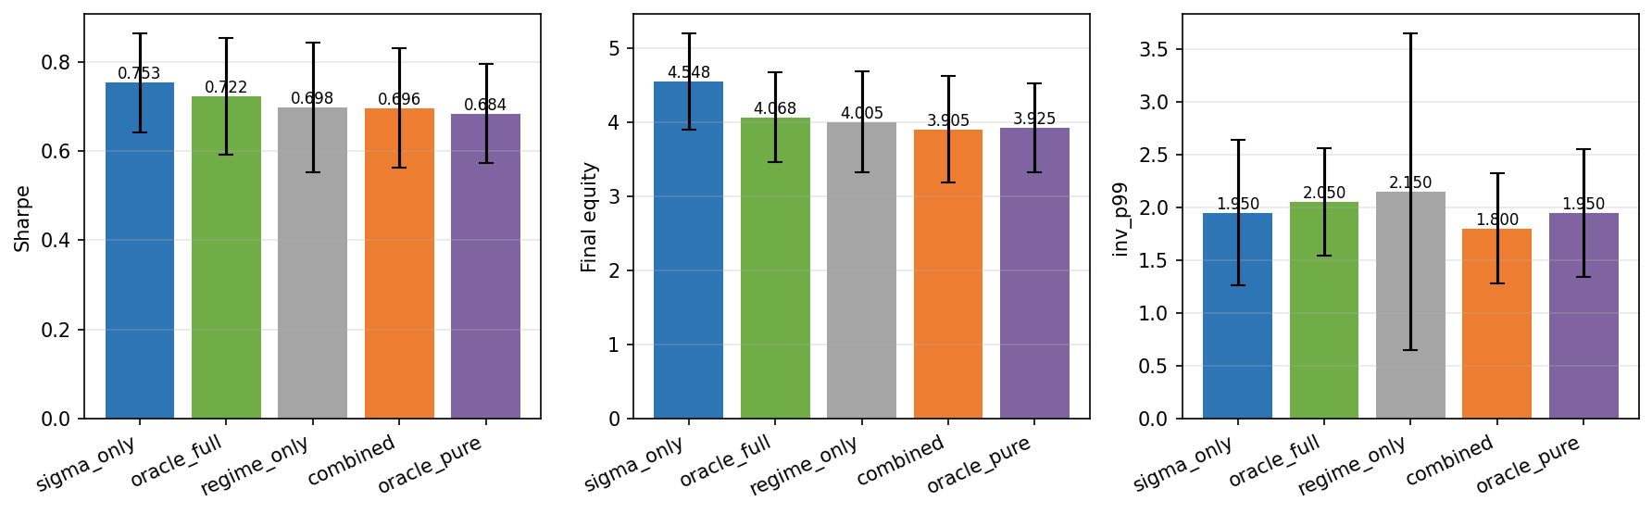
Figure 8.3. Five-variant ablation summary: sigma_only is the strongest mean Sharpe-like variant, and adding categorical labels does not improve it.
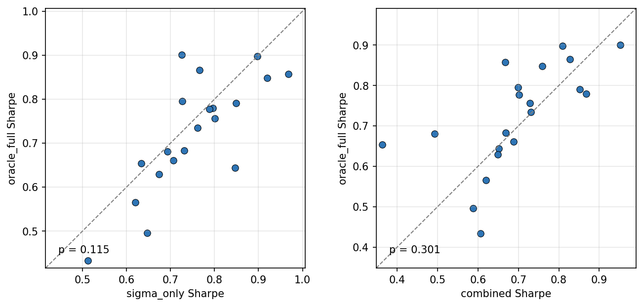
Figure 8.4. Oracle-label paired-seed comparison: even true regime labels do not reliably improve on sigma_hat alone.

The compact statistical summary below collects the canonical paired tests used to interpret the ablation and robustness results.
Table 8.3 Compact statistical summary
Comparison | Metric or test | Canonical result | Interpretation
PPO-aware vs PPO-blind | Sharpe-like paired t-test | p = 0.261 | No significant Sharpe improvement.
PPO-aware vs PPO-blind | Final equity paired t-test | p = 0.023 | Favors PPO-blind.
ppo_sigma_only vs ppo_oracle_full | Sharpe-like paired t-test | p = 0.115 | No oracle-label Sharpe improvement.
ppo_sigma_only vs ppo_oracle_full | TOST ±0.10 | p = 0.00067; 90% CI [-0.001, +0.063] | Practical equivalence supported.
HMM detector | Detector accuracy | 81.8% | Higher accuracy does not create advantage.
Detector robustness | ANOVA | p = 0.997 | Detector choice does not explain result.
Regime-conditional eta | sigma_only vs combined Sharpe | p = 0.0016 | Favors sigma_only.
Mild misspecification | sigma_only vs oracle_full Sharpe t-test | p = 0.881 | No significant Sharpe difference.
Mild misspecification | TOST ±0.05 | p = 0.042 | Practical equivalence supported.

The t-test results show no significant Sharpe improvement from explicit regime labels, while the TOST result provides positive evidence of practical equivalence under the stated bound.

8.3 Experiment 3: Detector Robustness
Table 8.4 Detector robustness summary
Detector | Aware vs blind conclusion | Key statistic
rv_baseline | No reliable aware Sharpe advantage | p = 0.1142
rv_dwell | No reliable aware Sharpe advantage | p = 0.1095
hmm | No reliable aware Sharpe advantage despite higher accuracy | p = 0.0822
ANOVA | Detector choice does not explain the result | F = 0.0034, p = 0.9966

The ANOVA statistic is retained as a descriptive robustness summary across detector-specific PPO-aware Sharpe values. Because the same seeds are shared across detector conditions, the primary inferential evidence remains the seed-paired detector-specific tests; the ANOVA should not be read as the sole formal test of a repeated-measures design.
The detector robustness table comes from Experiment 3, the Detector Robustness experiment (w5_detector_full), while the main OOS table in Section 8.1 comes from Experiment 1 (w5_main). Small differences in PPO-aware/blind means therefore reflect distinct frozen experiment batches, not an inconsistency.
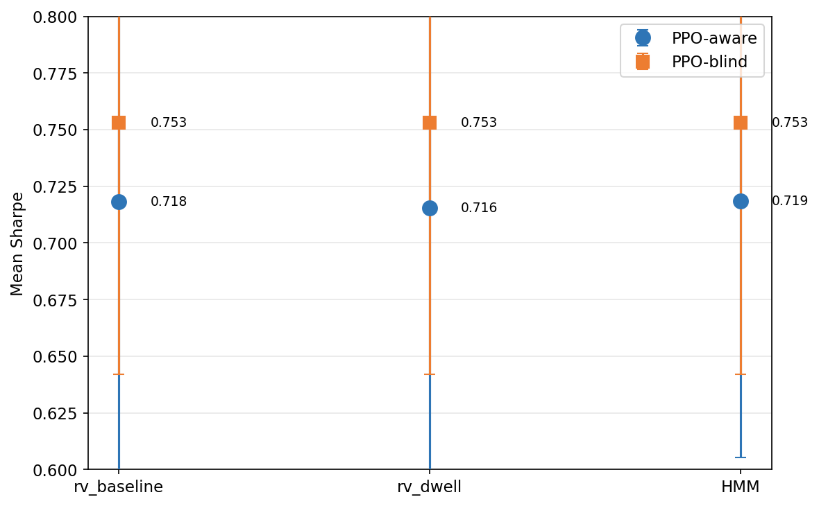
Figure 8.5. Detector robustness: rv_baseline, rv_dwell, and HMM all fail to create a reliable regime-aware PPO advantage.

8.4 Experiment 4: Reward-Shaping and Misspecification Checks
The regime-conditional eta run tests whether explicit labels become useful when the reward penalizes high-volatility inventory more strongly. sigma_only still beats combined on Sharpe-like performance (p = 0.0016). Under mild regime-dependent execution misspecification, sigma_only and oracle_full remain statistically indistinguishable and practically equivalent under the reported TOST bound.
In the misspecification check, the mean difference between sigma_only and oracle_full is very small, but the ±0.05 TOST result is close to the threshold; it should therefore be read as supportive but less decisive than the main five-variant ablation equivalence result.
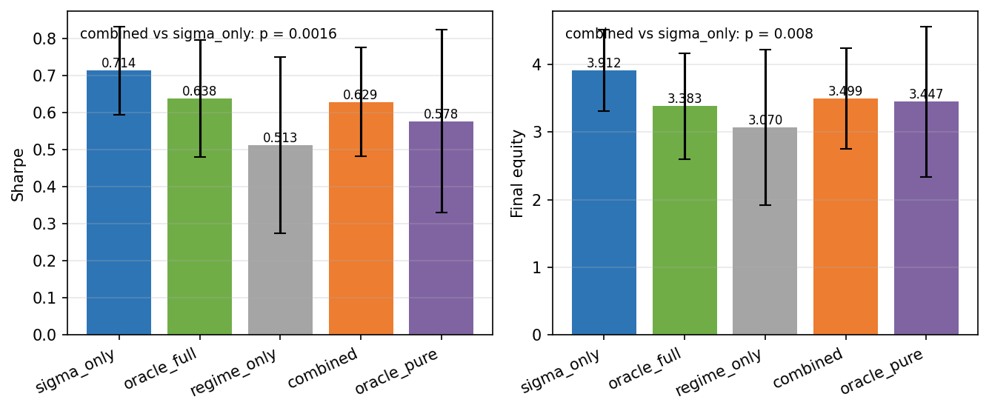
Figure 8.6. Regime-conditional eta summary: changing the reward channel by regime still favors sigma_only over combined.
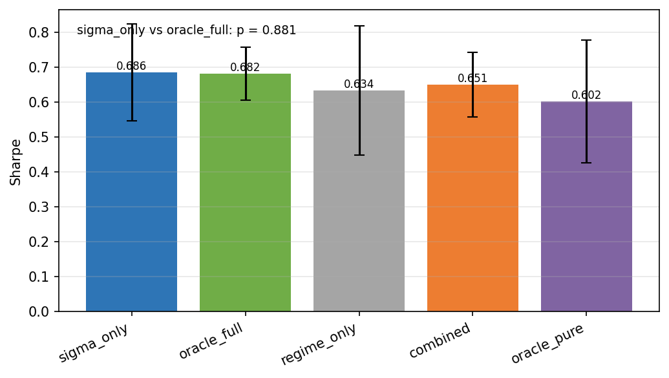
Figure 8.7. Mild model-misspecification summary: sigma_only and oracle_full remain close under regime-dependent execution parameters.

8.5 Experiment 5: Signal-Informativeness Sweep
Table 8.5 Signal information-value sweep
condition | sigma_only | combined | regime_only | oracle_full | oracle_pure
full | 0.7626 ± 0.0596 | 0.6898 ± 0.0607 | 0.6991 ± 0.0668 | 0.6811 ± 0.0697 | 0.6632 ± 0.0769
noisy | 0.7563 ± 0.0616 | 0.7125 ± 0.0628 | 0.6991 ± 0.0668 | 0.6736 ± 0.1013 | 0.6632 ± 0.0769
lagged | 0.7822 ± 0.0454 | 0.6812 ± 0.0536 | 0.6991 ± 0.0668 | 0.7264 ± 0.0686 | 0.6632 ± 0.0769
coarsened | 0.7827 ± 0.0533 | 0.6908 ± 0.0827 | 0.6991 ± 0.0668 | 0.7447 ± 0.0549 | 0.6632 ± 0.0769
none | undefined | 0.6991 ± 0.0668 | 0.6991 ± 0.0668 | 0.6632 ± 0.0769 | 0.6632 ± 0.0769

Entries are mean ± 95% confidence-interval half-width across 20 seeds, not standard deviations.
Experiment 5, the Signal-Informativeness Sweep, did not support the original informativeness-threshold hypothesis within the tested calibration band. sigma_only remained high under informative conditions, while combined was directionally below sigma_only.
The Signal-Informativeness Sweep figures should be read as a refinement of the main finding rather than a new mechanism proof: they show that the tested sigma_hat degradation path did not reveal a regime-label advantage.
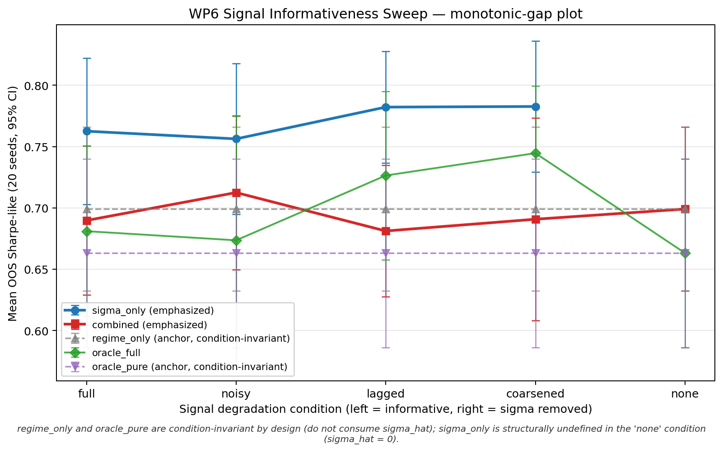
Figure 8.8. Experiment 5 monotonic-gap plot: the expected narrowing of the sigma_only versus combined gap does not appear in the tested calibration band.
One possible interpretation is that the degraded continuous signal still preserves enough ordinal volatility information for quote-width adaptation, whereas the categorical label is coarser and does not add useful variation in this calibration. In noisy or lagged settings, adding the label may also increase the observation dimension without improving the control-relevant signal. This should be read as a performance pattern in the tested calibration band, not as proof of the PPO policy's internal representation mechanism.
The strongest degradation pattern appears in the lagged condition, where combined is materially below sigma_only (mean difference about -0.101; Cohen's dz about -0.91). This suggests that a stale categorical channel can be harmful when it adds delayed/coarse state information rather than control-relevant volatility information.
The paired-seed views below show whether aggregate differences are broad across seeds or driven by a few runs.
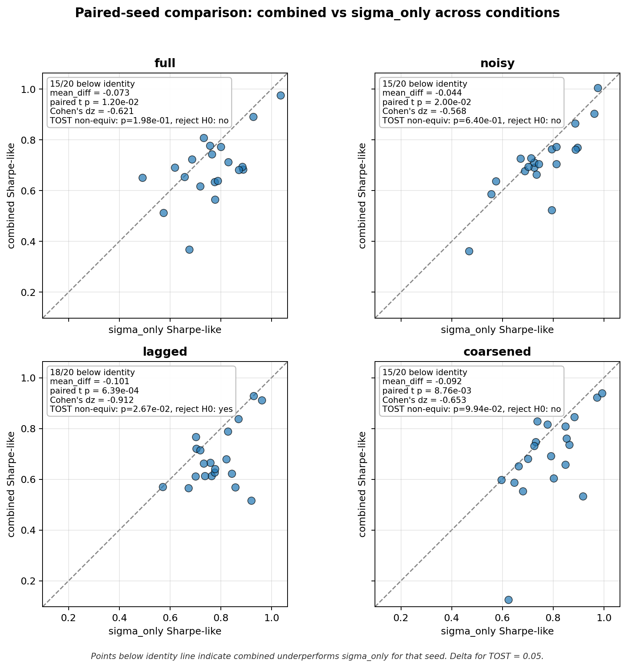
Figure 8.9. Experiment 5 paired-seed combined versus sigma_only: combined is directionally below sigma_only in informative conditions.
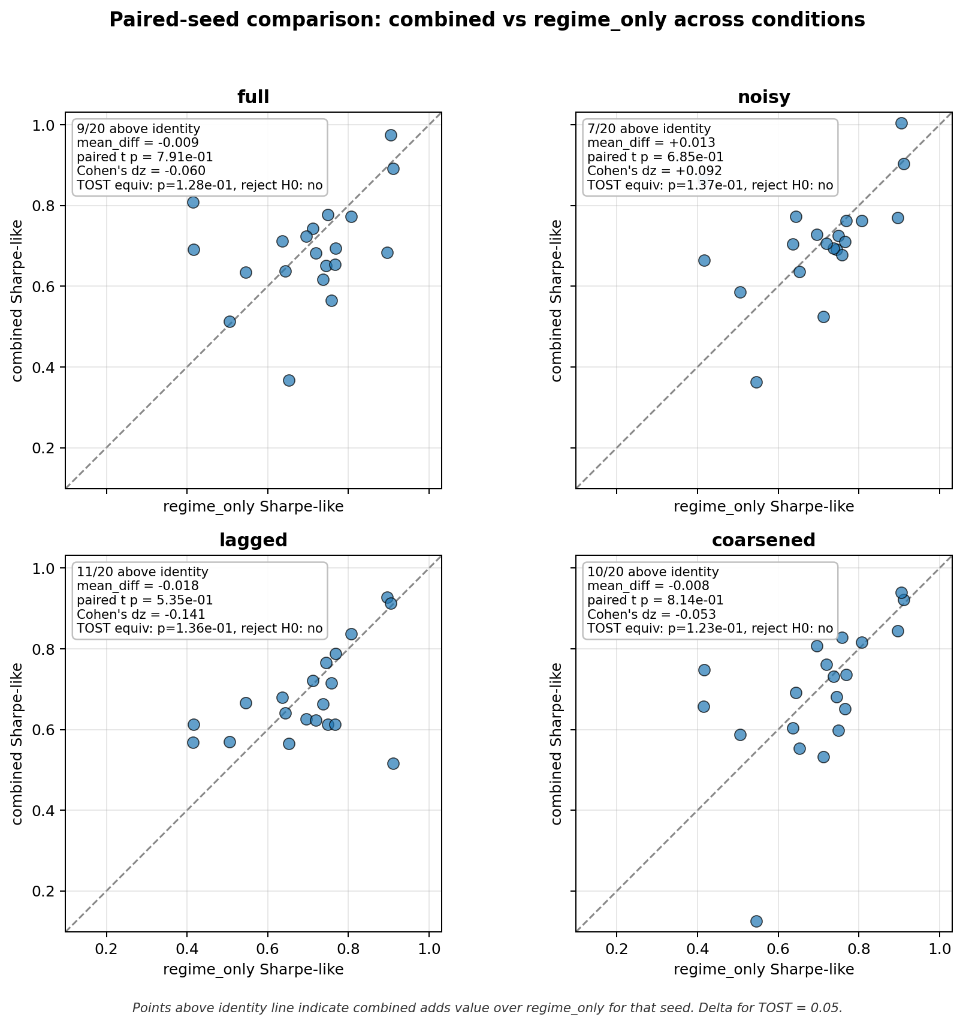
Figure 8.10. Experiment 5 paired-seed combined versus regime_only: this diagnostic bounds how much sigma_hat is used inside the combined variant.

9 Evaluation Metrics

9.1 Final Equity
Final equity is the terminal marked-to-market wealth. It is economically meaningful but not sufficient alone because high raw equity can be earned by taking large inventory risk.

9.2 Sharpe-Like Ratio
(16) Sharpe-like = mean(ΔWₜ) / std(ΔWₜ) × √(1/Δt)
Let Delta W_t = W_t - W_{t-1}. The reported Sharpe-like metric is computed as mean(Delta W_t) / std(Delta W_t), using the sample standard deviation with ddof = 1, multiplied by sqrt(1 / dt) when the standard deviation is positive; otherwise it is reported as 0. It is therefore a simulator-scale risk-adjusted PnL metric rather than an annualized market Sharpe ratio.

9.3 Inventory Tail Risk
(17) inv_p99 = percentile₉₉(|qₜ|)
Here q_t is inventory. inv_p99 is a practical tail-risk diagnostic for whether a strategy earns returns by carrying large inventory.

9.4 Fill Rate
(18) fill_rate = filled quote opportunities / total quote opportunities
The numerator and denominator follow the logged project convention. Fill rate is diagnostic rather than the primary thesis metric.

9.5 Paired t-Tests
(19) t = mean(dᵢ) / (sd(dᵢ) / √n)
Here d_i is the paired seed-level difference between two strategies, sd(d_i) is its sample standard deviation, and n is the number of paired seeds.
Because the manuscript reports several paired comparisons, isolated marginal p-values should be read descriptively rather than as a stand-alone familywise discovery claim. The main conclusion is based on the repeated pattern across the main OOS evaluation, detector robustness, oracle ablations, reward-shaping, misspecification, and signal-informativeness diagnostics.

9.6 TOST Equivalence Tests
TOST evaluates whether the plausible range of a paired difference lies inside a pre-specified practical-equivalence band. At alpha = 0.05, the corresponding equivalence reading uses the 90% confidence interval. The Five-Variant Signal Ablation uses TOST to support practical equivalence for sigma_only versus oracle_full; the Signal-Informativeness Sweep also uses related paired tests to examine non-equivalence and mean indistinguishability patterns.
The equivalence bounds should be read as practical smallest-effect-size thresholds for the Sharpe-like metric, not as universal constants. A wider ±0.10 band is used for the main five-variant ablation, where the question is whether oracle regime information creates a practically meaningful improvement over sigma_hat alone. Tighter ±0.05 bounds are used in narrower robustness or misspecification checks. The thesis therefore does not treat TOST as a stand-alone proof; it reports TOST together with paired tests, confidence intervals, and directional seed-level evidence.

10 Discussion

10.1 Main Interpretation: Signal Redundancy
In the tested controlled synthetic HFMM environment, explicit categorical volatility-regime labels do not provide robust incremental value once sigma_hat is already observed by the PPO policy. The results are consistent with signal redundancy.
The interpretation is that the continuous realized-volatility proxy already supplies the economically useful volatility information needed by the policy in this environment. The categorical label may be coarser or redundant when presented alongside sigma_hat.
The evidence should therefore be read slightly more precisely than pure redundancy. If a categorical label only repeated the useful information in sigma_hat, combined and sigma_only would be expected to be approximately indistinguishable. In several experiments, however, combined is directionally below sigma_only. This pattern is consistent with signal redundancy plus mild categorical-channel degradation: the label may be coarser than the continuous volatility estimate, may add observation dimensionality, or may interact with policy learning without adding control-relevant information. This is an interpretation of the observed performance pattern, not a proof of the PPO policy's internal mechanism.

10.2 Why the Result Is Not a Weak Null
The conclusion does not rest only on p > 0.05. It is supported by detector robustness, oracle labels, TOST equivalence, reward-channel checks, mild misspecification, and signal-degradation tests.

10.3 Synthetic-Market Boundary
The result is bounded to the tested synthetic HFMM simulator. The simulator deliberately isolates quote distance, Poisson-arrival fills, fees, latency, inventory, and volatility regimes so that the incremental information value of the regime channel can be tested cleanly.
Real limit-order books include additional mechanisms that are outside the main simulator: queue position, execution priority, adverse selection, order-book imbalance, richer latency effects, clustered or self-exciting order arrivals, non-stationary liquidity, and exchange-specific transaction-cost and microstructure rules. These mechanisms can change both the value of volatility information and the way a categorical regime label interacts with execution risk.
For that reason, the thesis should be read as controlled synthetic evidence, not as a real-market external validity claim. Richer LOB simulators, Hawkes-process LOB models, queue-reactive execution, and real-data evaluation are natural future work and could change the incremental value of regime labels.
The out-of-sample protocol should also be interpreted carefully. It is a chronological 70/30 temporal hold-out within the same synthetic data-generating process, not a distributional-shift test across fundamentally different markets. Multiple seeds improve robustness to simulation randomness, but they do not establish external validity beyond the controlled synthetic environment.

10.4 Risks to Interpretation
Table 10.1 Risks to interpretation
Risk | Mitigation
Overclaiming mechanism | Use signal-redundancy and categorical-channel degradation as interpretations, not proofs of PPO internals.
Detector causality confusion | State that rv_baseline is the main causal detector and rv_dwell is auxiliary/offline.
Synthetic external validity | Frame all claims as controlled synthetic-market claims.
Template over-compression | Keep the literature and evidence spine, but map it into template headings.
Mid-price mark-to-market assumption | Report it as a simulator evaluation convention; real liquidation would require spread/depth/queue/adverse-selection considerations.

10.5 Future Work
Evaluate stronger regime-dependent execution misspecification and richer non-stationary liquidity settings.
Test richer limit-order-book simulators with queue position, order-book imbalance, latency priority, adverse selection, and self-exciting order flow.
Use Hawkes-process LOB models and real-data evaluation after thesis scope, not as current claims of this report.
Run representation-level diagnostics only as future mechanism work.
Explore alternative observation encodings and policy architectures.

11 Reproducibility Checklist
The reproducibility path uses Python 3 with a local virtual environment created by python -m venv .venv; dependencies are installed from requirements.txt.
Exact reproducibility depends on the project repository, per-run config snapshots, fixed seeds, logged run metadata, and the protected evidence files recorded in EVIDENCE_MANIFEST.md. Main commands are documented in Table 11.3.
Protected evidence is verified by SHA256 against EVIDENCE_MANIFEST.md.
No Dockerfile or environment.yml is present, so this thesis does not claim Docker or Conda reproducibility.
No external continuous-integration service is claimed; validation is documented through local checks and protected evidence hashes.
No formal line-coverage percentage is claimed; the tests are targeted regression and reproducibility checks.
Repository and manuscript provenance: https://github.com/OnurEmiroglu/THESIS; final manuscript manuscript/thesis_39.pdf and .docx; source manuscript manuscript/thesis_38.pdf and .docx; frozen baseline manuscript/thesis_29.pdf at tag thesis-v29-frozen; decision log manuscript/decisions_log_13.pdf.
Repository license status: No open-source license is assigned in the repository at submission time.
Table 11.1 Reproducibility checklist
Item | Status in thesis_39
Frozen baseline | thesis-v29-frozen tag; commit 9681faa; thesis_29 remains untouched.
Final manuscript | thesis_39 is the final formatting-consistency pass built on thesis_38; frozen evidence remains unchanged.
Run ID structure | YYYYMMDD-HHMMSS_seed<S>_<TAG>_<COMMIT>.
Config snapshots | Every run snapshots config; config_snapshot_all.md inventories active config files.
Seeds | WP5 main uses seeds 1-20; WP6 full uses seeds 42-61.
Train/test split | 70/30 chronological split on exogenous synthetic series.
Evidence manifest | EVIDENCE_MANIFEST.md records protected evidence and remediation invariants.
Protected CSV hashes | Listed below and verified by file hash checks.
Codebase snapshot | docs/internal/codebase_snapshot.py.
No-rerun policy | No PPO/WP5/WP6 reruns and no frozen evidence-figure regeneration; only the methodology-only synthetic-environment illustration was generated.

Table 11.2 Protected artifact hash checks
Protected artifact | Expected SHA256 | Check
results/metrics_detector_compare.csv | 28E7AD40BB47... | MATCH
docs/internal/wp6_sweep_full/summary_condition_variant.csv | 6DD627E81637... | MATCH
docs/internal/wp6_sweep_full/summary_paired_combined_vs_sigma.csv | 4BABCAAACE1D... | MATCH
docs/internal/wp6_sweep_full/summary_paired_combined_vs_regime.csv | 2087FEFBE5DC... | MATCH

Table 11.3 Reproducibility commands
Reproducibility command | Purpose
python -m venv .venv | Create environment.
& .\.venv\Scripts\Activate.ps1 | Activate environment on Windows PowerShell.
pip install -r requirements.txt | Install dependencies.
python run.py --config config/w5_main.json | Run main WP5 evaluation.
python run.py --config config/w6_sweep_full.json | Run WP6 sweep.
python run.py --config config/w6_sweep_full.json --resume <run_id> | Resume WP6 sweep.
ruff check src/ | Lint source code.

These commands document reproducibility paths only; thesis_39 finalization did not rerun experiments.

12 Conclusion
This template-adapted report preserves the thesis finding while reorganizing the manuscript into the requested technical-report structure. PPO learns strong risk-adjusted quoting behavior in the synthetic HFMM simulator, but the explicit categorical regime channel does not provide robust incremental value beyond sigma_hat. The result is best defended as evidence consistent with signal redundancy in the tested controlled environment.

References
Avellaneda, M., & Stoikov, S. (2008). High-frequency trading in a limit order book. Quantitative Finance, 8(3), 217-224. https://doi.org/10.1080/14697680701381228
Gueant, O., Lehalle, C.-A., & Fernandez-Tapia, J. (2013). Dealing with the inventory risk: a solution to the market making problem. Mathematics and Financial Economics, 7, 477-507. https://doi.org/10.1007/s11579-012-0087-0
Fodra, P., & Labadie, M. (2012). High-frequency market-making with inventory constraints and directional bets. arXiv:1206.4810.
Fodra, P., & Labadie, M. (2013). High-frequency market-making for multi-dimensional Markov processes. arXiv:1303.7177.
Spooner, T., Fearnley, J., Savani, R., & Koukorinis, A. (2018). Market Making via Reinforcement Learning. Proceedings of the 17th International Conference on Autonomous Agents and MultiAgent Systems, 434-442.
Spooner, T., & Savani, R. (2020). Robust market making via adversarial reinforcement learning. Proceedings of the Twenty-Ninth International Joint Conference on Artificial Intelligence, 4590-4596. https://doi.org/10.24963/ijcai.2020/633
Gasperov, B., & Kostanjcar, Z. (2021). Market Making With Signals Through Deep Reinforcement Learning. IEEE Access, 9, 61611-61622. https://doi.org/10.1109/ACCESS.2021.3074782
Gasperov, B., Begusic, S., Posedel Simovic, P., & Kostanjcar, Z. (2021). Reinforcement Learning Approaches to Optimal Market Making. Mathematics, 9(21), 2689. https://doi.org/10.3390/math9212689
Gasperov, B., & Kostanjcar, Z. (2022). Deep Reinforcement Learning for Market Making Under a Hawkes Process-Based Limit Order Book Model. IEEE Control Systems Letters, 6, 2485-2490. https://doi.org/10.1109/LCSYS.2022.3166446
Schulman, J., Wolski, F., Dhariwal, P., Radford, A., & Klimov, O. (2017). Proximal Policy Optimization Algorithms. arXiv:1707.06347.
Lakens, D. (2017). Equivalence tests: A practical primer for t tests, correlations, and meta-analyses. Social Psychological and Personality Science, 8(4), 355-362. https://doi.org/10.1177/1948550617697177
Lakens, D., Scheel, A. M., & Isager, P. M. (2018). Equivalence testing for psychological research: A tutorial. Advances in Methods and Practices in Psychological Science, 1(2), 259-269. https://doi.org/10.1177/2515245918770963

Appendix A Code Appendix
Repository: https://github.com/OnurEmiroglu/THESIS. No open-source license is assigned in the repository at submission time.
Frozen-evidence policy: the commands below document provenance only. Do not rerun PPO/WP5/WP6 or regenerate protected CSVs or performance figures for documentation-only changes.
Reproducibility controls include fixed seeds, a chronological 70/30 train/test split, per-run config snapshots and metadata, stable CSV schemas, resume validation, and the four protected SHA256 entries in EVIDENCE_MANIFEST.md.
Configuration coverage includes baseline, synthetic-regime, sanity, PPO, OOS evaluation, ablation, detector, misspecification, WP5.5 audit/calibration, and WP6 sweep JSON files under config/.
Environment setup: python -m venv .venv; activate the environment; pip install -r requirements.txt. No Dockerfile, Conda environment.yml, or formal environment lockfile is present.
Repository structure: run.py dispatches JSON jobs; src/ contains WP1-WP6 implementation modules; config/ contains experiment configurations; tests/ contains the available regression tests; results/ and docs/internal/ contain run outputs and evidence summaries; manuscript/ contains report artifacts.
Appendix Table A.1 Code map
Area | Files
Run management | run.py; src/run_context.py
Simulation | src/wp1/sim.py; src/wp1/w1_as_baseline.py
Regimes | src/wp2/synth_regime.py; src/wp2/job_w2_synth.py
Environment | src/wp3/env.py; src/wp3/w3_sanity.py
PPO training | src/wp4/job_w4_ppo.py
Evaluation | src/wp5/job_w5_eval.py; src/wp5/job_w5_detector_compare.py
Signal audit and sweep | src/wp5_5/*; src/wp6/job_w6_sweep_full.py

Canonical commands
python run.py --config config/w5_main.json
python run.py --config config/w5_detector_full.json
python run.py --config config/w5_eta_regime.json
python run.py --config config/w5_misspec_mild.json
python run.py --config config/w6_sweep_full.json

Appendix B Unit Tests and Validation Checks
Appendix Table B.1 Unit test and validation checklist
Test or validation category | Purpose | Expected pass criterion | Status/type
tests/test_csv_metric_logger.py | Reject CSV metric schema drift and accept consistent rows. | pytest tests/test_csv_metric_logger.py -q; all 3 tests pass. | Automated pytest
tests/test_resume_validation.py | Validate matching, mismatched, forced, and legacy resume configurations. | pytest tests/test_resume_validation.py -q; all 5 tests pass. | Automated pytest
Source lint | Check source files for configured Ruff violations. | ruff check src/ exits successfully. | Automated local check
WP3 sanity configuration | Exercise naive, AS, and random policies through MMEnv. | Documented sanity run completes and emits expected artifacts. | Documented validation; not rerun for thesis_39
Protected SHA256 audit | Detect changes to the four canonical protected CSV evidence files. | All four hashes match EVIDENCE_MANIFEST.md. | Automated local hash check
Document artifact audit | Check captions, algorithms, placeholders, figures, and stale wording. | Requested document-generation checks pass; remaining placeholders are listed. | Automated/documented validation

No external CI service is claimed; validation is documented through local reproducibility checks and protected evidence hashes.
Formal line-coverage percentage is not claimed; the tests are targeted regression and reproducibility checks.
Pass/fail criteria: all pytest tests pass; generated artifacts exist and are non-empty; protected CSV hashes match EVIDENCE_MANIFEST.md; no forbidden overclaim phrases are detected; no experiment reruns are required for document generation.
Test categories include CSV metric logger schema stability, resume-mode config validation, WP3 environment sanity checks, figure/path existence checks, forbidden phrase or overclaim scans, and protected evidence SHA256 checks.
How to run tests: pytest -q; pytest tests/test_csv_metric_logger.py -q; pytest tests/test_resume_validation.py -q; python run.py --config config/w3_sanity.json.
No GitHub Actions workflow or other external continuous-integration (CI) service is claimed. Checks are run locally or recorded as documented validation.
Formal line-coverage percentage is not claimed; the tests are targeted regression and reproducibility checks.
The WP3 sanity configuration is an experiment-like validation path and is documented here for reproducibility; it was not rerun for this final thesis_39 generation.
Available automated tests are the two files listed in Appendix Table B.1. Run the complete suite with pytest -q, or run either file individually with pytest <path> -q.

Appendix C Extended Evidence Tables
This appendix contains diagnostic material demoted from the main body to keep the report template focused.
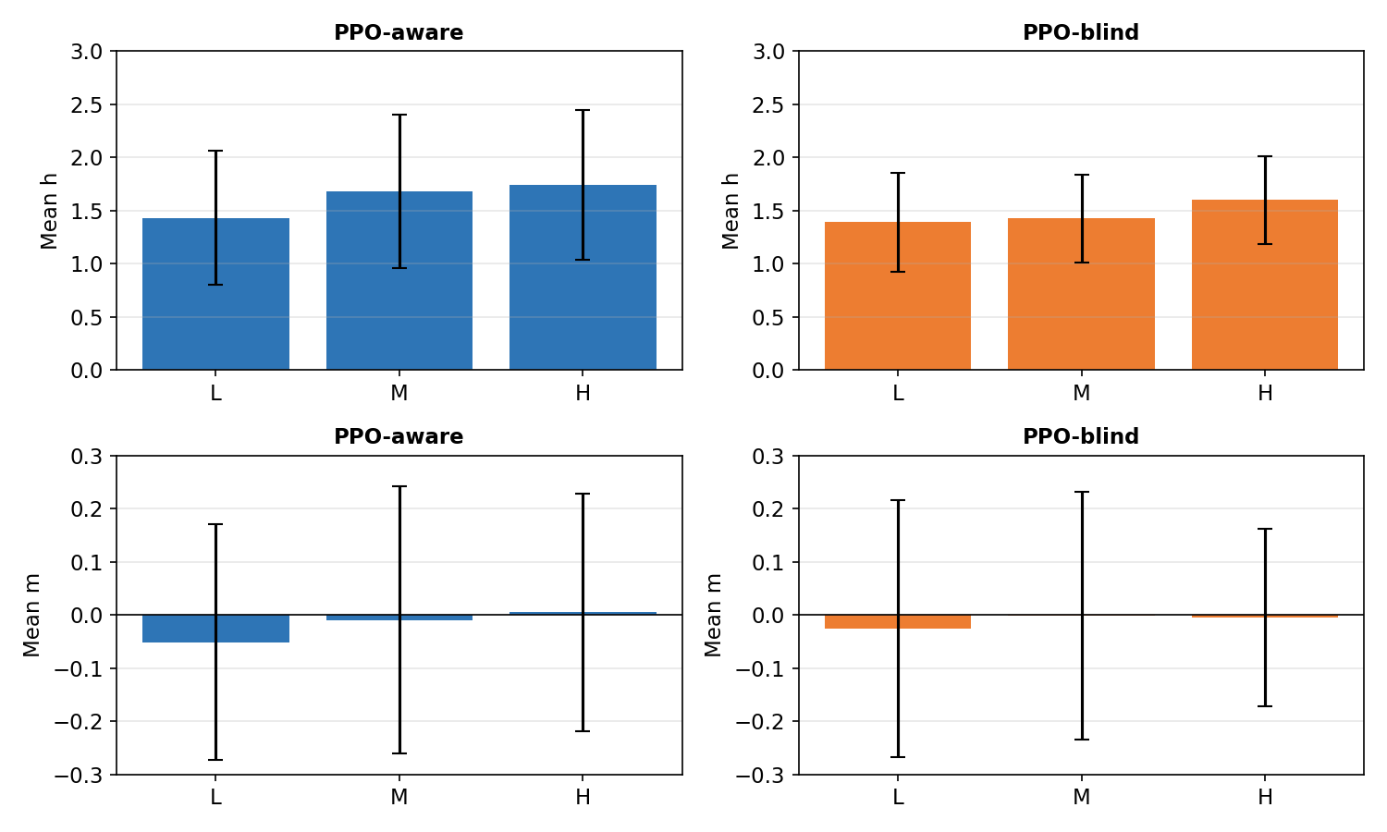
Appendix Figure C.1. Regime-wise action distribution diagnostic.
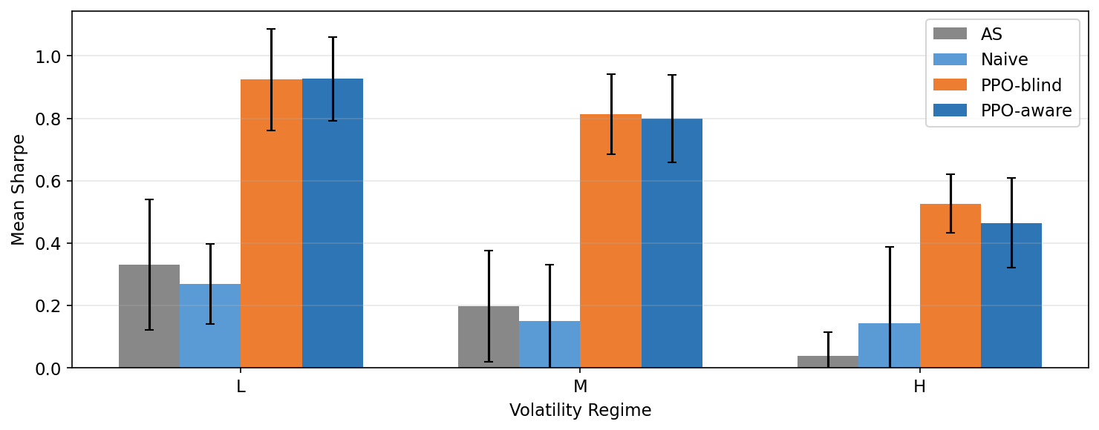
Appendix Figure C.2. Regime-wise Sharpe diagnostic.

The table below summarizes supporting diagnostics. These items support interpretation and provenance; they do not replace the canonical frozen evidence chain used for the main claims.
Appendix Table C.1 Supporting diagnostics
Diagnostic | Status | Interpretation
Post-hoc signal diagnostics | Supporting only | Consistent with signal redundancy but not primary evidence.
WP5.5 signal audit | Offline calibration | Supports WP6 degradation design; no PPO training.
Detector robustness statistics | Protected evidence | Addresses poor-detector objection without changing main detector caveat.
WP6 paired summaries | Protected evidence | Supports refined interpretation of the signal-informativeness sweep.

This separation keeps the appendix readable while preserving the boundary between primary experiment evidence and supporting diagnostics.

Appendix D Author Contribution Statement
This thesis is submitted as a single-author MSc thesis by Onur Emiroglu. The reported implementation, experiments, documentation, and interpretation are organized in the project repository and were prepared under normal thesis supervision. Supervisory feedback is reflected in the final framing and limitations, but no multi-author contribution matrix is required.

