High-Frequency Market Making via Reinforcement Learning under Different Volatility Regimes

Technical Report Template Adaptation / MSc Thesis Draft

Field | Value
Author | Onur Emiroglu
Programme | Financial Engineering MSc Programme
Institution | Karlsruhe Institute of Technology
Supervisor | [Supervisor to be inserted]
Matriculation No. | [Matriculation number to be inserted]
Submission / Draft date | May 2026
Git Repository | [Repository URL to be inserted]
Current draft | manuscript/thesis_32.pdf / .docx
Previous source draft | manuscript/thesis_31.pdf / .docx
Frozen baseline | manuscript/thesis_29.pdf, tag thesis-v29-frozen
Decision log | manuscript/decisions_log_13.pdf

Template-adapted draft; frozen evidence is not regenerated.
In the tested controlled synthetic HFMM environment, explicit categorical volatility-regime labels do not provide robust incremental value once sigma_hat is already observed by the PPO policy. The results are consistent with signal redundancy.

Abstract
This report studies whether explicit volatility-regime information improves a PPO-based high-frequency market-making agent in a controlled synthetic limit-order-book environment. The simulator uses an arithmetic Brownian-motion mid-price, a sticky Markov volatility-regime process, rolling realized-volatility detection, and Poisson-arrival fills. The PPO agent chooses bid and ask quotes through a discrete half-spread and skew parameterization, and it is compared with a fixed-spread strategy and an Avellaneda-Stoikov analytical baseline.
In the tested controlled synthetic HFMM environment, explicit categorical volatility-regime labels do not provide robust incremental value once sigma_hat is already observed by the PPO policy. The results are consistent with signal redundancy. The evidence comes from the canonical WP5/WP6 experiments: out-of-sample evaluation, detector robustness, oracle-label ablations, regime-conditional reward shaping, mild model misspecification, and a signal-informativeness sweep. The strongest interpretation is therefore conditional and synthetic-market bounded: the explicit regime label mostly repackages volatility information already present in the continuous signal. The report makes no live-trading deployment claim and does not claim to prove the internal PPO mechanism.

Symbols, Abbreviations, and Glossary
Symbol | Meaning
S_t | Mid-price at time step t.
q_t | Inventory after step t.
X_t | Cash account after step t.
W_t | Marked-to-market wealth or equity, W_t = X_t + q_t S_t.
sigma_hat | Rolling realized-volatility estimate observed by the PPO policy.
R_t | Reward at time t.
h | Quoted half-spread in ticks.
m | Quote skew in ticks.
A, k | Poisson fill-intensity scale and decay parameters.
eta | Inventory penalty coefficient.
gamma | Avellaneda-Stoikov inventory-risk aversion parameter.
tau | Remaining horizon.
lambda(delta) | Poisson fill intensity at quote distance delta.
delta, delta_bid, delta_ask | Quote distance variables.
rho_t(theta) | PPO probability ratio.
A_hat_t | Advantage estimate.
epsilon_t | Standard-normal innovation in the mid-price process.
z_t | Latent volatility regime.
P_ij | Markov transition probability.

Abbreviation | Meaning
ABM | Arithmetic Brownian motion.
AS | Avellaneda-Stoikov baseline.
HFMM | High-frequency market making.
OOS | Out-of-sample evaluation.
PPO | Proximal Policy Optimization.
RV | Realized volatility.
TOST | Two One-Sided Tests equivalence procedure.
WP | Work package.

Term | Definition
Regime-aware PPO | PPO policy variant that receives a categorical regime one-hot channel.
Regime-blind PPO | PPO policy variant that omits the regime one-hot but still observes sigma_hat.
sigma_only | Ablation variant using the continuous volatility signal without categorical regime labels.
combined | Ablation variant using sigma_hat and estimated categorical regime labels.
oracle_full | Ablation variant using sigma_hat and the true regime label.

1 Introduction

1.1 Problem Statement and Motivation
Market makers continuously choose bid and ask quotes while balancing spread capture against inventory risk. When volatility changes, the same quote width can become either too passive or too exposed. A natural response is to provide a learning agent with regime labels such as low, medium, and high volatility. The central question is whether that categorical label adds decision-relevant information when the policy already observes a continuous volatility estimate.

1.2 Research Objective
The objective is to test the incremental value of explicit categorical volatility-regime labels in PPO market making under a controlled synthetic environment. The comparison is intentionally information-design focused: the regime label is evaluated against a continuous sigma_hat signal, not against an observation space with no volatility information.

1.3 Background and Related Work
Classical market-making models provide the inventory-risk foundation for this thesis. A market maker earns spread income by posting bid and ask quotes, but execution imbalance creates inventory exposure whose value changes with the mid-price. The core control problem is therefore not raw spread capture alone; it is the tradeoff between execution probability, volatility risk, and inventory control.
Avellaneda and Stoikov (2008) give the canonical analytical reference point: quotes are adjusted through a reservation price and spread term that depend on inventory, risk aversion, volatility, horizon, and order-arrival intensity. Gueant, Lehalle and Fernandez-Tapia (2013) extend this inventory-control view with tractable market-making solutions. In this report, that literature motivates both the AS baseline and the squared-inventory penalty used in the PPO reward.
Reinforcement-learning market-making studies replace closed-form quote rules with learned policies trained through simulated interaction. Spooner et al. (2018) show how RL can learn market-making behavior and why reward design is central. Spooner and Savani (2020) extend the discussion toward robustness under adversarially varied conditions. These studies motivate learned quoting policies, but the present thesis is narrower: PPO is used as a controlled testbed for a state-representation question.
Deep reinforcement learning work with market signals is especially relevant. Gasperov and Kostanjcar (2021) study market making with signals through DRL, while Gasperov et al. (2021) summarize broader RL approaches to optimal market making. Gasperov and Kostanjcar (2022) use a richer Hawkes-process limit-order-book simulator. The thesis uses a simpler Poisson-fill simulator deliberately, because the goal is to isolate whether one added signal channel has incremental value.
Volatility regimes and non-stationarity are economically meaningful in market making. A higher-volatility state can increase inventory risk and change the appropriate quote aggressiveness. The thesis therefore includes a three-state Markov volatility process and rolling realized-volatility detector. However, the presence of regimes does not automatically imply that a categorical regime label improves a learned policy.
The key information-design issue is redundancy. The policy already observes sigma_hat, a continuous realized-volatility proxy. A low/medium/high label derived from related volatility information may help if it summarizes information not otherwise available, but it may add little if sigma_hat already carries the useful variation for quote placement.
This defines the thesis gap. The report does not ask whether volatility matters generally. It asks whether an explicit categorical volatility-regime label adds incremental value once sigma_hat is already observed by the PPO policy in the controlled synthetic HFMM environment.
Finally, the result requires careful null-result interpretation. Lakens (2017) and Lakens, Scheel and Isager (2018) motivate equivalence testing as a way to distinguish 'not statistically significant' from 'practically equivalent within a stated bound.' This is why the thesis reports both paired t-tests and TOST-style evidence where appropriate.

1.4 Contributions
- A controlled HFMM simulator with Poisson-arrival fills, fees, latency, and Markov volatility regimes.
- A Gymnasium environment in which PPO controls quote half-spread and skew.
- An OOS comparison of fixed-spread, Avellaneda-Stoikov, regime-aware PPO, and regime-blind PPO strategies.
- A five-variant ablation separating continuous volatility information from estimated and oracle regime labels.
- Detector, reward-shaping, misspecification, and signal-informativeness checks that bound the interpretation.

1.5 Scope and Limitations
The thesis is a controlled synthetic-market study. It does not claim live trading viability, real-order-book external validity, or a proven PPO representation mechanism. The result is conditional on the simulator, signal design, PPO hyperparameters, and degradation calibration tested here.

1.6 Report Structure
Sections 2-6 define the mathematical model, use case, architecture, layered model, and algorithms. Sections 7-9 describe the experimental setup, results, and metrics. Sections 10-12 discuss the interpretation, reproducibility, and conclusion. Appendices provide code maps, sanity checks, and extended evidence.

2 Mathematical Formulation

2.1 Synthetic Mid-Price Process
(1) S_{t+1} = S_t + sigma_t sqrt(dt) epsilon_t, epsilon_t ~ N(0, 1)
Here S_t is the mid-price, sigma_t is the step volatility in ticks or price units according to the simulator configuration, dt is the time step, and epsilon_t is an independent standard-normal shock.

2.2 Markov Volatility-Regime Process
(2) P(z_{t+1}=j | z_t=i) = P_ij, z_t in {L, M, H}
Here z_t is the latent volatility regime at step t, L/M/H denote low, medium, and high volatility, and P_ij is the sticky transition probability from regime i to regime j.
The regime controls the volatility multiplier applied to the base sigma parameter. The canonical full experiments use sigma multipliers [0.6, 1.0, 1.8] for L, M, and H.

2.3 Realized Volatility Signal and Regime Detection
(3) sigma_hat_t = sqrt((1 / w) sum_{i=t-w+1}^{t} (Delta S_i)^2)
Here sigma_hat_t is the rolling realized-volatility signal, w is the rolling window length, and Delta S_i is the mid-price increment over step i.
Estimated regime labels are assigned by thresholding sigma_hat after a warmup period. The main WP4/WP5/WP6 pipelines use the causal rv_baseline detector. The rv_dwell detector is retained only as an auxiliary/offline robustness comparison, while the HMM detector is an additional robustness variant.

2.3.1 Illustrative Synthetic Environment Path
This subsection visualizes one deterministic synthetic path generated under the canonical HFMM environment configuration. The figure is included to make the simulated market environment transparent: the mid-price evolves under a regime-switching arithmetic Brownian-motion process, the realized-volatility signal is computed from rolling mid-price changes, and the latent Markov regime switches between low, medium, and high volatility states. The dashed vertical line marks the chronological 70/30 train-test split used in the out-of-sample protocol. The figure is illustrative of the methodology only and is not a new performance result.
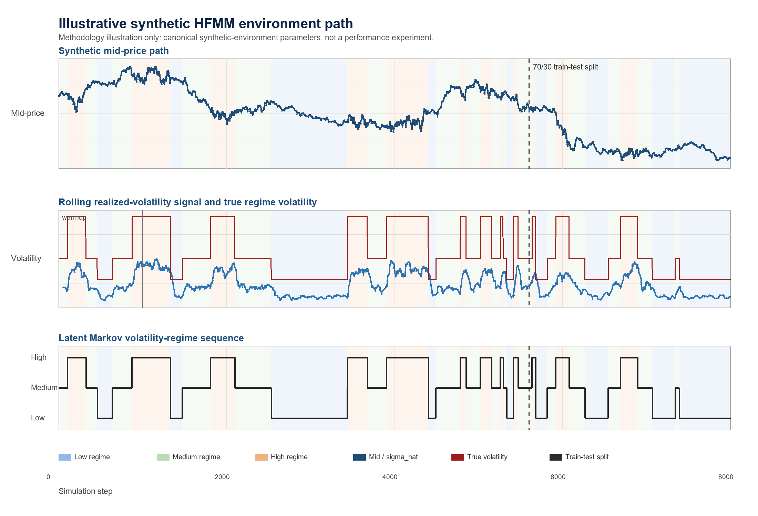
Figure 2.1. Illustrative synthetic HFMM environment path. The upper panel shows the generated mid-price path. The middle panel compares the rolling realized-volatility signal observed by the policy with the true regime-dependent volatility level. The lower panel shows the latent Markov volatility-regime sequence. The dashed vertical line marks the chronological 70/30 train-test split used for out-of-sample evaluation. This figure is generated by scripts/figures/gen_synthetic_environment_figure.py and is a methodology illustration, not a regenerated performance artifact.

2.4 Limit-Order Fill Model
(4) lambda(delta) = A exp(-k delta)
Here lambda(delta) is the fill intensity at quote distance delta, A is the baseline arrival scale, and k controls the exponential decay as quotes move farther from the mid-price.
(5) P(fill | delta) = 1 - exp(-lambda(delta) dt)
Here P(fill | delta) is the per-step fill probability and dt is the simulator step length.

2.5 Quote Parameterization
(6) h = h_idx + 1, m = m_idx - 2
Here h_idx and m_idx are the two discrete PPO action components, h is the half-spread in ticks, and m is the quote skew in ticks.
(7) delta_bid = max(1, h + m), delta_ask = max(1, h - m)
Here delta_bid and delta_ask are the bid and ask quote distances in ticks. The max operator enforces a minimum quote distance of one tick.

2.6 Inventory, Cash, Equity, and Reward
(8) q_{t+1} = q_t + F_t^{bid} - F_t^{ask}
Here q_t is inventory, F_t^{bid} is the bid-side fill indicator or count, and F_t^{ask} is the ask-side fill indicator or count.
(9) X_{t+1} = X_t - F_t^{bid} P_t^{bid} + F_t^{ask} P_t^{ask} - fees_t
Here X_t is cash, P_t^{bid} and P_t^{ask} are the executed bid and ask prices, and fees_t denotes transaction costs.
(10) W_t = X_t + q_t S_t
Here W_t is mark-to-market wealth or equity, X_t is cash, q_t is inventory, and S_t is the mid-price.
(11) R_t = W_{t+1} - W_t - eta q_{t+1}^2
Here R_t is the reward and eta is the inventory-penalty coefficient. Fees are included in the cash update and are not counted a second time in the reward.

2.7 Avellaneda-Stoikov Baseline
(12) r_t = S_t - q_t gamma sigma^2 tau
Here r_t is the reservation price, gamma is inventory-risk aversion, sigma is volatility, and tau is remaining horizon.
(13) delta_AS = 0.5 gamma sigma^2 tau + (1 / gamma) log(1 + gamma / k)
Here delta_AS is the AS half-spread and k is the same fill-intensity decay parameter used in the execution model. The implemented deltas are clipped to configured minimum and maximum bounds.

2.8 PPO Objective
(14) rho_t(theta) = pi_theta(a_t | s_t) / pi_theta_old(a_t | s_t)
Here rho_t(theta) is the PPO probability ratio, pi_theta is the current policy, pi_theta_old is the behavior policy used to collect the rollout, a_t is the action, and s_t is the state.
(15) L_CLIP(theta) = E_t[min(rho_t(theta) A_hat_t, clip(rho_t(theta), 1-eps, 1+eps) A_hat_t)]
Here theta denotes policy parameters, rho_t(theta) is the PPO probability ratio, A_hat_t is the advantage estimate, and eps is the clipping parameter. The report uses this only as a concise training-objective reference.

3 Use-Case Scenario

3.1 Synthetic HFMM Scenario
The use case is a synthetic market maker posting one bid and one ask quote at each step. The environment supplies mid-price dynamics, volatility estimates, and regime labels; the agent receives stochastic fills and is evaluated on wealth, risk-adjusted performance, inventory tails, and fill behavior.

3.2 Trading Agents and Strategy Variants
Strategy or variant | Observed information | Purpose
Naive | No learned state dependence | Fixed-spread baseline.
Avellaneda-Stoikov | Inventory, volatility, horizon | Analytical inventory-risk baseline.
ppo_aware | sigma_hat and estimated regime one-hot | Original regime-aware PPO.
ppo_blind | sigma_hat without regime one-hot | Original regime-blind PPO.
sigma_only | Continuous sigma_hat only | Tests whether sigma_hat alone carries the signal.
combined | sigma_hat and estimated regime one-hot | Tests estimated categorical incremental value.
oracle_full | sigma_hat and true regime one-hot | Tests perfect-label incremental value.
regime_only / oracle_pure | Categorical labels without sigma_hat | Anchor label-only variants.

3.3 Information-Design Question
In the tested controlled synthetic HFMM environment, explicit categorical volatility-regime labels do not provide robust incremental value once sigma_hat is already observed by the PPO policy. The results are consistent with signal redundancy.

4 System Architecture

4.1 Run Lifecycle and Reproducibility Layer
`run.py` dispatches jobs from JSON configuration files, creates a timestamped run directory, snapshots the config, records git metadata, writes logs and metrics, and finalizes run status. Long WP6 jobs support resume validation against the saved config snapshot.

4.2 Synthetic Market and Detector Layer
`src/wp1/sim.py` implements the fill and inventory simulator. `src/wp2/synth_regime.py` generates synthetic regime paths, mid-prices, rolling realized volatility, and detector outputs.

4.3 Gymnasium Environment Layer
`src/wp3/env.py` wraps the simulator as a Gymnasium environment. The observation vector is [q_norm, sigma_hat, tau, regime_L, regime_M, regime_H]. Warmup, invalid, or disabled regime labels produce a zero one-hot vector rather than an artificial medium label.

4.4 Strategy and Training Layer
WP4 trains PPO policies; WP5 evaluates strategies and ablations; WP6 runs the signal-informativeness sweep. The fixed-spread and AS baselines provide non-learning comparators.

4.5 Evaluation and Evidence Layer
Evaluation writes CSV metrics, figures, and summaries. The thesis_32 adaptation embeds existing figures and quotes frozen numerical evidence; it does not regenerate evidence artifacts.

5 Layered Experimental Model

5.1 Layer 1: Market State Generation
Generate Markov regimes and mid-price paths under controlled volatility multipliers.

5.2 Layer 2: Signal Construction
Construct sigma_hat from rolling realized volatility and derive estimated regime labels.

5.3 Layer 3: Observation Encoding
Encode inventory, volatility, time-to-horizon, and optional regime one-hot channels.

5.4 Layer 4: Action and Execution
Decode PPO actions into bid/ask quote distances and sample Poisson-arrival fills.

5.5 Layer 5: Learning and Evaluation
Train PPO on the chronological train segment and evaluate deterministic policies OOS.

6 Algorithm Specification and Pseudocode

6.1 Plain-Language Overview
The experiment creates a synthetic market path, estimates volatility signals, trains policies on the first 70% of the path, and evaluates all strategies on the held-out 30%. Ablations modify which volatility channels the PPO policy can observe.

6.2 Synthetic Market and Regime Generation
Input: seed, transition matrix P, base volatility, volatility multipliers, n_steps
Initialize z_0 and S_0
For t = 0 ... n_steps - 1:
sample z_{t+1} from P[z_t]
set sigma_t = base_sigma * multiplier[z_t]
sample mid-price increment and update S_{t+1}
Compute rolling sigma_hat after warmup window
Calibrate thresholds on warmup data and assign regime_hat
Output: exogenous table with mid, sigma_hat, regime_true, regime_hat

6.3 Market-Making Environment Step
Input: action (h_idx, m_idx), current simulator state, exogenous row
Decode h = h_idx + 1 and m = m_idx - 2
Set delta_bid = max(1, h + m), delta_ask = max(1, h - m)
Compute fill intensities and per-step fill probabilities
Sample bid and ask fills
Update inventory and cash, including fees
Advance mid-price and compute W_{t+1}
Return observation, reward = delta_equity - eta * inventory^2, done flag, info

6.4 PPO Training and OOS Evaluation Protocol
For each seed and variant:
generate one exogenous synthetic path
split path chronologically into train and test segments
configure observation channels for the variant
train PPO on the train segment for the configured timesteps
evaluate the deterministic policy on the test segment
log Sharpe-like ratio, final equity, inventory p99, fill rate, and per-regime metrics
Aggregate seed-paired statistics across variants

6.5 WP6 Signal-Informativeness Sweep
For each degradation condition in {full, noisy, lagged, coarsened, none}:
transform sigma_hat according to the condition
for each valid variant and seed:
train PPO and evaluate OOS
Aggregate condition-variant means and paired comparisons
Test whether combined gains value as sigma_hat is degraded

6.6 Reference Implementation Map
Component | Reference file
Run lifecycle | src/run_context.py, run.py
Simulator | src/wp1/sim.py
Regime generation and detectors | src/wp2/synth_regime.py
Gymnasium environment | src/wp3/env.py
PPO training | src/wp4/job_w4_ppo.py
WP5 evaluation | src/wp5/job_w5_eval.py
WP6 sweep | src/wp6/job_w6_sweep_full.py

6.7 Complexity Analysis
Simulation and deterministic evaluation are linear in the number of environment steps. PPO training cost is approximately linear in total timesteps, policy-network forward/backward passes, and the number of seed-variant cells. The WP6 full sweep is expensive because it multiplies conditions, variants, and seeds; this is why its outputs are treated as frozen evidence.

6.8 Executable Example Commands

Commands
python run.py --config config/w5_main.json
python run.py --config config/w5_detector_full.json
python run.py --config config/w5_eta_regime.json
python run.py --config config/w5_misspec_mild.json
python run.py --config config/w6_sweep_full.json
python run.py --config config/w6_sweep_full.json --resume <run_id>

7 Experimental Setup

7.1 Canonical Configuration Protocol
Canonical experiments are driven by JSON configs under `config/`. Shared parameters include mid0 = 100.0, tick_size = 0.01, dt = 0.2, baseline sigma_mid_ticks = 0.8, A = 5.0, k = 1.5, fee_bps = 0.2, and latency_steps = 1.

7.2 Data Generation and Preprocessing
Each run generates synthetic mid-price and regime paths, computes rolling realized volatility, and assigns detector labels. The main reported pipelines use causal rv_baseline labels.

7.3 Train/Test Split
WP5 and WP6 use a chronological 70/30 split on the exogenous series. PPO trains on the first segment and is evaluated deterministically on the held-out OOS segment.

7.4 Strategy Variants
The main WP5 comparison evaluates naive, AS, ppo_aware, and ppo_blind. The ablation and WP6 designs use sigma_only, regime_only, combined, oracle_pure, and oracle_full.

7.5 Detector Variants
Detector | Role | Defense-safe caveat
rv_baseline | Main causal detector | Rolling RV threshold; used in main WP4/WP5/WP6 pipelines.
rv_dwell | Auxiliary robustness detector | Offline dwell smoothing; not the main causal detector.
hmm | Robustness detector | Higher classification accuracy but no reliable PPO advantage.

7.6 PPO Hyperparameters
Hyperparameter | Canonical full-run value
total_timesteps | 1,000,000
learning_rate | 3e-4
n_steps | 2048
batch_size | 256
n_epochs | 10
gamma | 0.999
clip_range | 0.2
ent_coef | 0.01 for full WP5/WP6 runs

7.7 Protected Evidence and No-Rerun Policy
The thesis_32 adaptation reuses frozen performance results. It does not rerun PPO training, WP5/WP6 experiments, detector robustness, ablations, protected CSV generation, or frozen performance-figure generation. The only newly generated visual is the methodology-only synthetic-environment illustration produced by `scripts/figures/gen_synthetic_environment_figure.py`.

8 Results and Visualisation

8.1 Main WP5 OOS Results
The main 20-seed OOS evaluation shows that PPO variants produce much higher risk-adjusted performance than the fixed-spread and AS baselines. AS can produce higher raw equity, but with substantially larger inventory exposure.
Strategy | Mean Sharpe-like | Mean final equity | Mean inv_p99 | Mean fill rate
ppo_aware | 0.715 | 4.10 | 2.00 | 0.236
ppo_blind | 0.740 | 4.42 | 2.05 | 0.232
AS | 0.105 | 5.05 | 29.95 | 0.444
naive | 0.127 | 4.49 | 21.20 | 0.119

AS has higher raw equity but carries substantially larger inventory tail risk; therefore the main comparison is risk-adjusted performance and inventory control, not raw equity alone.
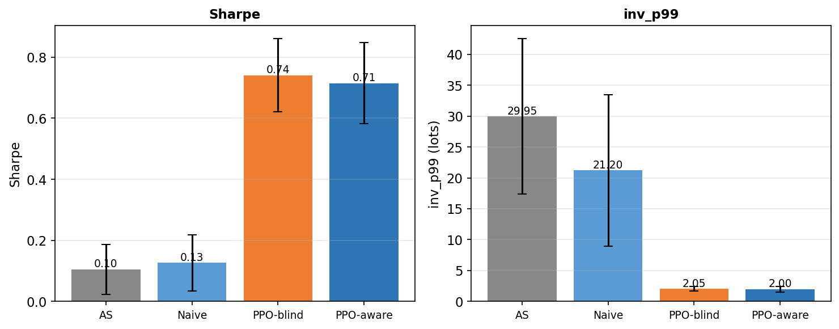
Figure 1. Main WP5 OOS results: PPO variants dominate naive and AS on risk-adjusted performance, while AS carries much larger inventory tail risk.
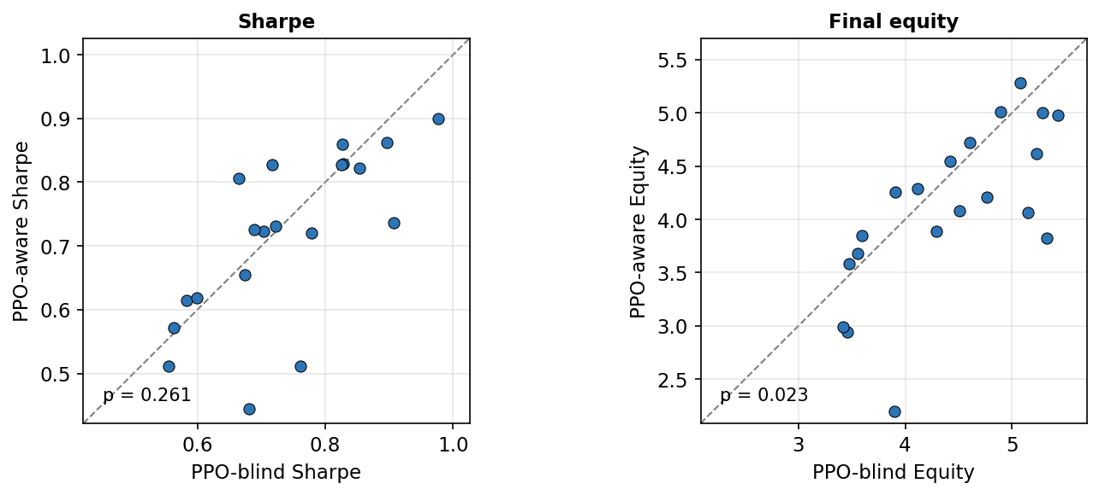
Figure 2. Seed-paired PPO-aware versus PPO-blind comparison: the estimated regime channel does not create a robust Sharpe-like advantage.
The paired-seed view shows that the aware policy does not dominate the blind policy seed by seed. The equity panel even favors the blind policy in the canonical paired test.

8.2 Five-Variant Ablation
Variant | Observation meaning | Mean Sharpe-like | Mean final equity | Mean inv_p99
ppo_sigma_only | continuous sigma_hat only | 0.752987 | 4.547923 | 1.950000
ppo_oracle_full | sigma_hat + true regime one-hot | 0.722443 | 4.067945 | 2.050000
ppo_regime_only | estimated regime one-hot only | 0.697552 | 4.005379 | 2.150000
ppo_combined | sigma_hat + estimated regime one-hot | 0.696182 | 3.905214 | 1.800000
ppo_oracle_pure | true regime one-hot only | 0.683829 | 3.925499 | 1.950000

The strongest ablation result is that sigma_only has the highest mean Sharpe-like value, while oracle_full does not significantly beat it. TOST supports practical equivalence under the +/-0.10 Sharpe-like bound.
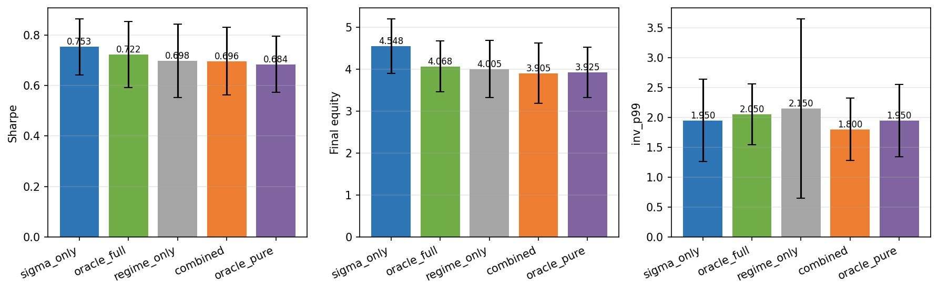
Figure 3. Five-variant ablation summary: sigma_only is the strongest mean Sharpe-like variant, and adding categorical labels does not improve it.
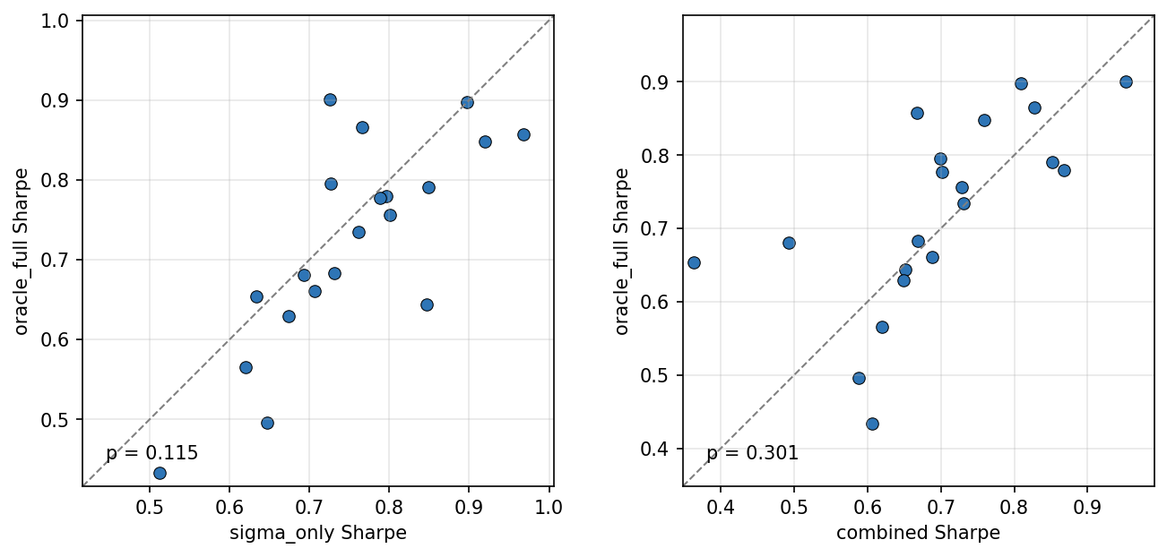
Figure 4. Oracle-label paired-seed comparison: even true regime labels do not reliably improve on sigma_hat alone.

The compact statistical summary below collects the canonical paired tests used to interpret the ablation and robustness results.
Comparison | Metric or test | Canonical result | Defense-safe reading
PPO-aware vs PPO-blind | Sharpe-like paired t-test | p = 0.261 | No significant Sharpe improvement.
PPO-aware vs PPO-blind | Final equity paired t-test | p = 0.023 | Favors PPO-blind.
ppo_sigma_only vs ppo_oracle_full | Sharpe-like paired t-test | p = 0.115 | No oracle-label Sharpe improvement.
ppo_sigma_only vs ppo_oracle_full | TOST +/-0.10 | p = 0.00067; 90% CI [-0.001, +0.063] | Practical equivalence supported.
HMM detector | Detector accuracy | 81.8% | Higher accuracy does not create advantage.
Detector robustness | ANOVA | p = 0.997 | Detector choice does not explain result.
Regime-conditional eta | sigma_only vs combined Sharpe | p = 0.0016 | Favors sigma_only.
Mild misspecification | sigma_only vs oracle_full Sharpe t-test | p = 0.881 | No significant Sharpe difference.
Mild misspecification | TOST +/-0.05 | p = 0.042 | Practical equivalence supported.

The t-test results show no significant Sharpe improvement from explicit regime labels, while the TOST result provides positive evidence of practical equivalence under the stated bound.

8.3 Detector Robustness
Detector | Aware vs blind conclusion | Key statistic
rv_baseline | No reliable aware Sharpe advantage | p = 0.1142
rv_dwell | No reliable aware Sharpe advantage | p = 0.1095
hmm | No reliable aware Sharpe advantage despite higher accuracy | p = 0.0822
ANOVA | Detector choice does not explain the result | F = 0.0034, p = 0.9966

The ANOVA statistic is retained as a descriptive robustness summary across detector-specific PPO-aware Sharpe values. Because the same seeds are shared across detector conditions, the primary inferential evidence remains the seed-paired detector-specific tests; the ANOVA should not be read as the sole formal test of a repeated-measures design.
The detector robustness table comes from the w5_detector_full robustness experiment, while the main WP5 OOS table in Section 8.1 comes from the w5_main experiment. Small differences in PPO-aware/blind means therefore reflect distinct frozen experiment batches, not an inconsistency.
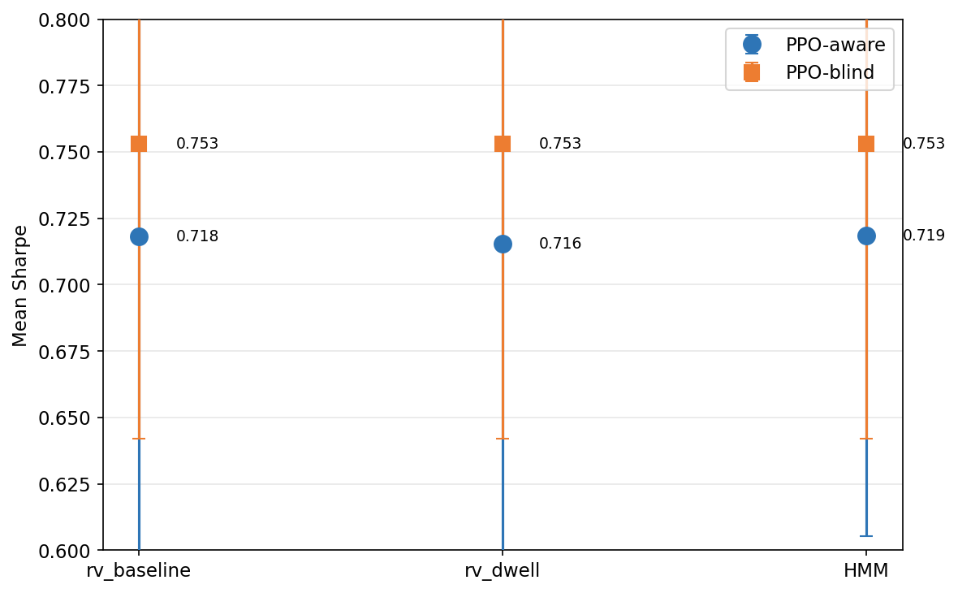
Figure 5. Detector robustness: rv_baseline, rv_dwell, and HMM all fail to create a reliable regime-aware PPO advantage.

8.4 Reward-Shaping and Misspecification Checks
The regime-conditional eta run tests whether explicit labels become useful when the reward penalizes high-volatility inventory more strongly. sigma_only still beats combined on Sharpe-like performance (p = 0.0016). Under mild regime-dependent execution misspecification, sigma_only and oracle_full remain statistically indistinguishable and practically equivalent under the reported TOST bound.
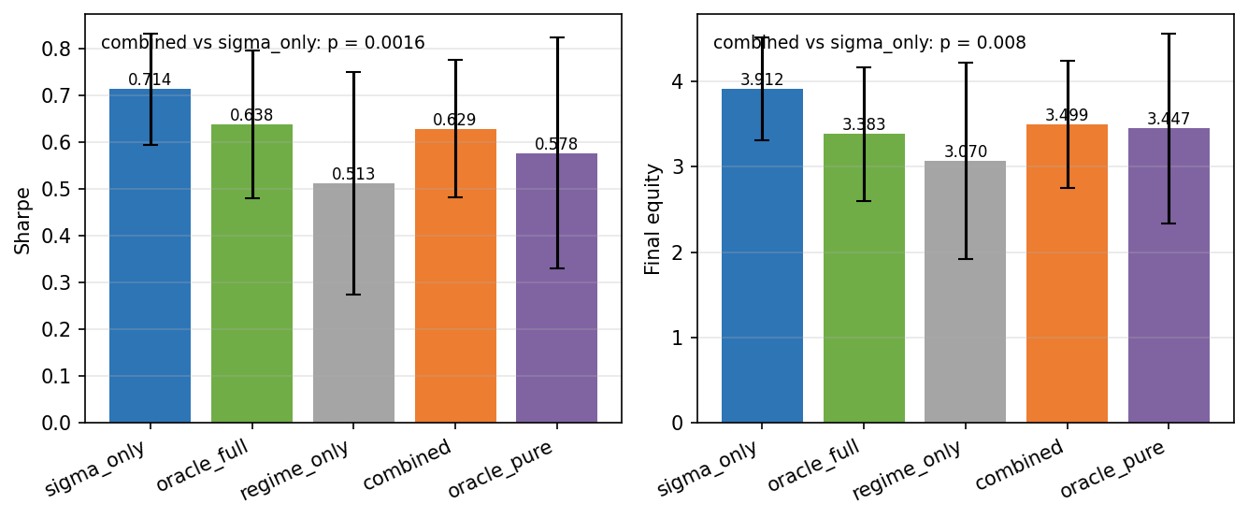
Figure 6. Regime-conditional eta summary: changing the reward channel by regime still favors sigma_only over combined.
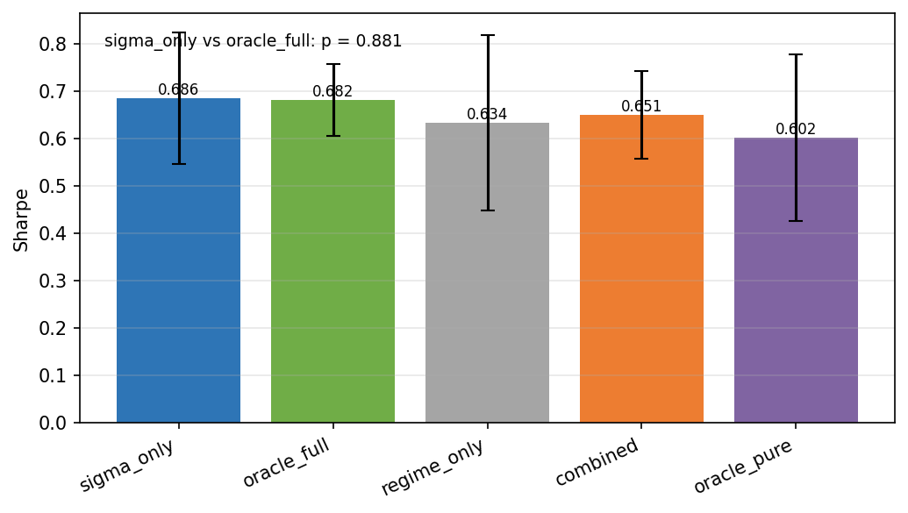
Figure 7. Mild model-misspecification summary: sigma_only and oracle_full remain close under regime-dependent execution parameters.

8.5 WP6 Signal-Informativeness Sweep
condition | sigma_only | combined | regime_only | oracle_full | oracle_pure
full | 0.7626 +/- 0.0596 | 0.6898 +/- 0.0607 | 0.6991 +/- 0.0668 | 0.6811 +/- 0.0697 | 0.6632 +/- 0.0769
noisy | 0.7563 +/- 0.0616 | 0.7125 +/- 0.0628 | 0.6991 +/- 0.0668 | 0.6736 +/- 0.1013 | 0.6632 +/- 0.0769
lagged | 0.7822 +/- 0.0454 | 0.6812 +/- 0.0536 | 0.6991 +/- 0.0668 | 0.7264 +/- 0.0686 | 0.6632 +/- 0.0769
coarsened | 0.7827 +/- 0.0533 | 0.6908 +/- 0.0827 | 0.6991 +/- 0.0668 | 0.7447 +/- 0.0549 | 0.6632 +/- 0.0769
none | undefined | 0.6991 +/- 0.0668 | 0.6991 +/- 0.0668 | 0.6632 +/- 0.0769 | 0.6632 +/- 0.0769

Entries are mean +/- 95% confidence-interval half-width across 20 seeds, not standard deviations.
WP6 did not support the original informativeness-threshold hypothesis within the tested calibration band. sigma_only remained high under informative conditions, while combined was directionally below sigma_only.
The WP6 figures should be read as a refinement of the main finding rather than a new mechanism proof: they show that the tested sigma_hat degradation path did not reveal a regime-label advantage.
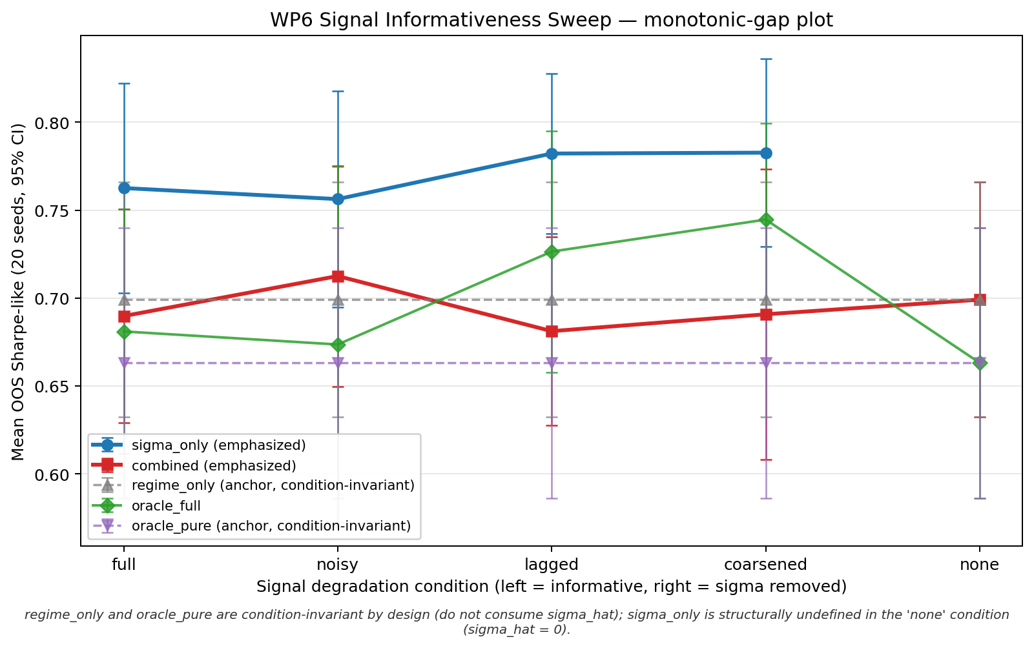
Figure 8. WP6 monotonic-gap plot: the expected narrowing of the sigma_only versus combined gap does not appear in the tested calibration band.
The paired-seed views below show whether aggregate differences are broad across seeds or driven by a few runs.
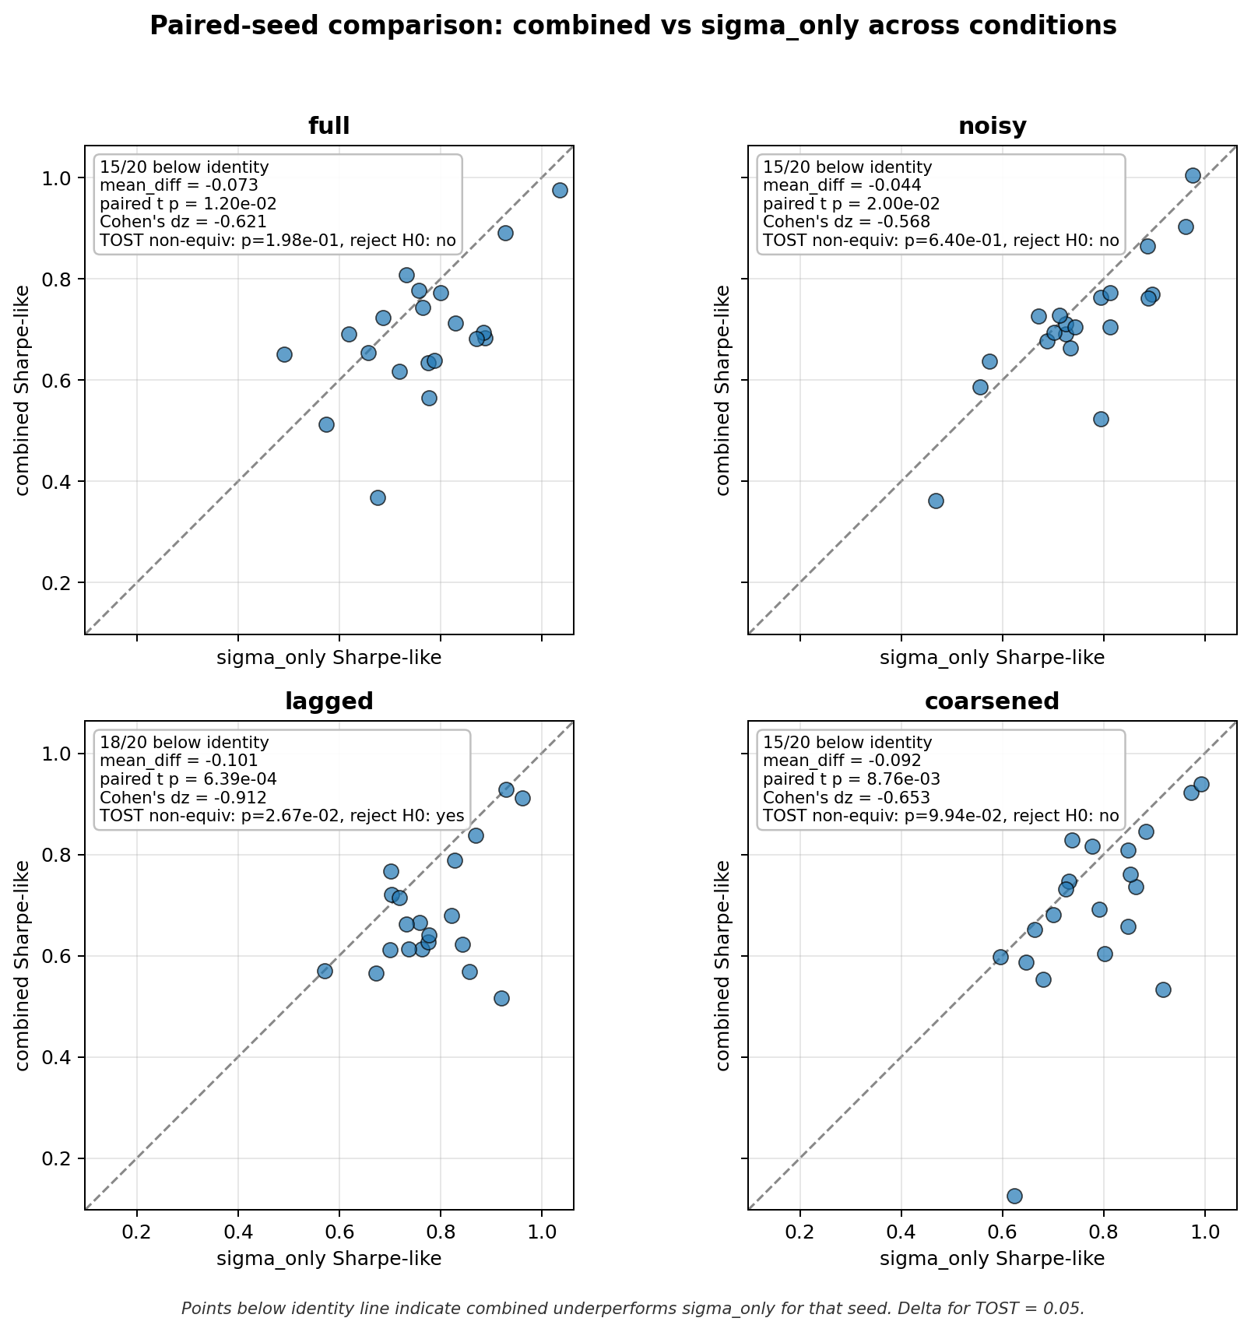
Figure 9. WP6 paired-seed combined versus sigma_only: combined is directionally below sigma_only in informative conditions.
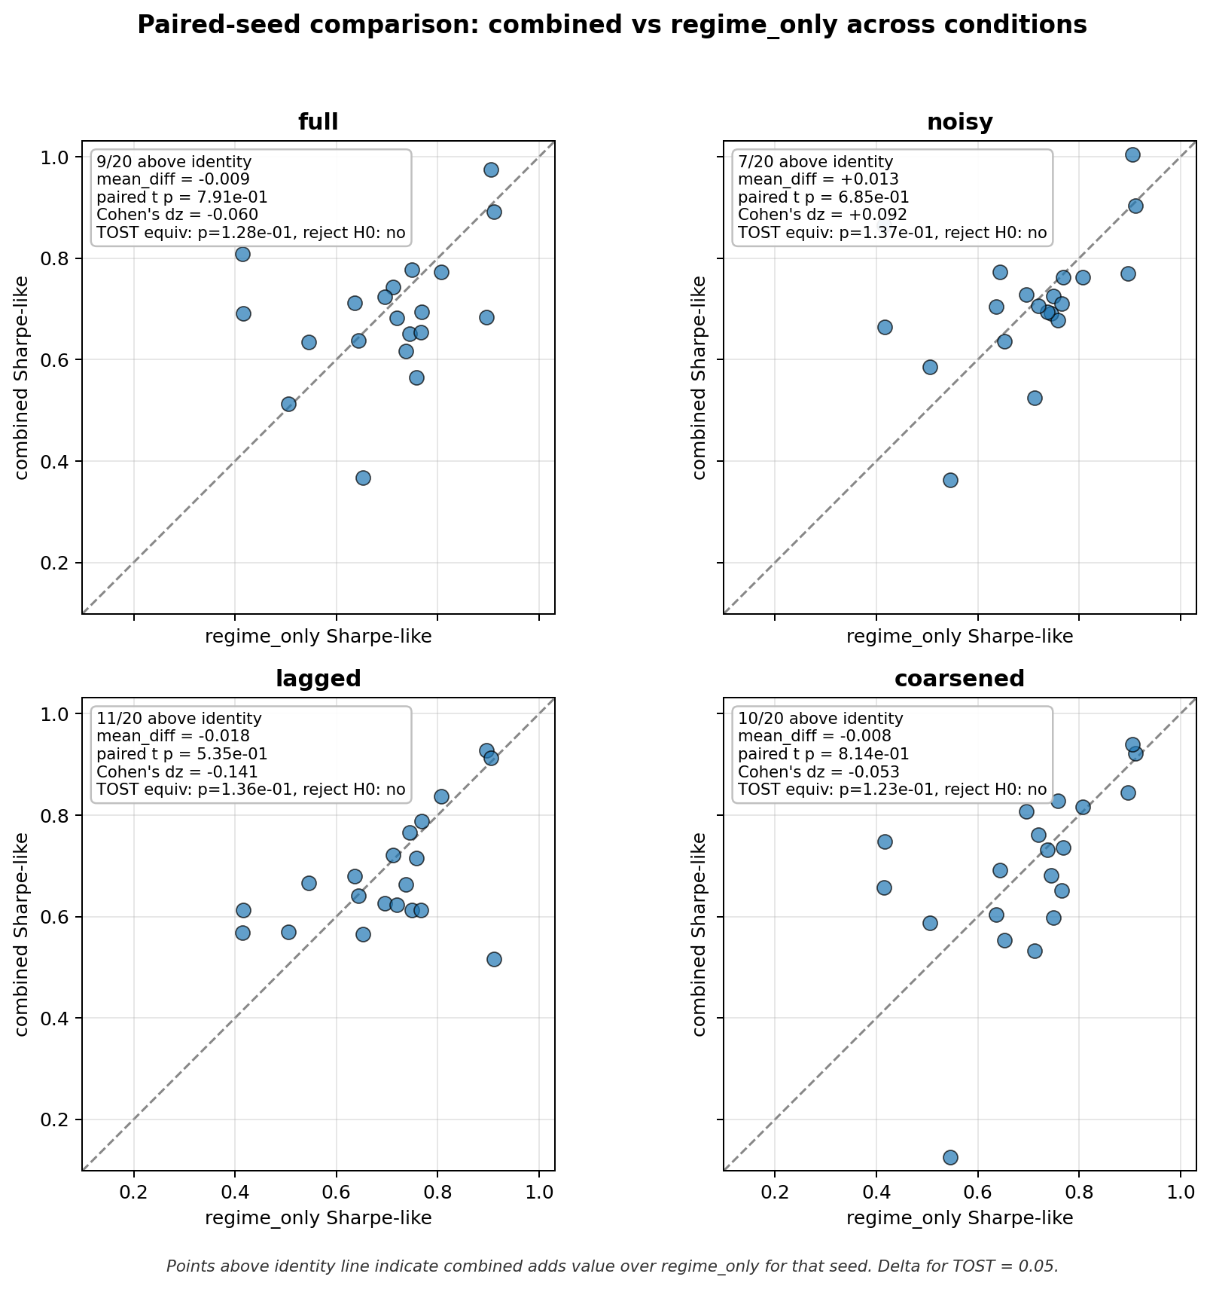
Figure 10. WP6 paired-seed combined versus regime_only: this diagnostic bounds how much sigma_hat is used inside the combined variant.

9 Evaluation Metrics

9.1 Final Equity
Final equity is the terminal marked-to-market wealth. It is economically meaningful but not sufficient alone because high raw equity can be earned by taking large inventory risk.

9.2 Sharpe-Like Ratio
(16) Sharpe-like = mean(g_t) / std(g_t)
Here g_t denotes the logged per-step PnL or return-like series used by the project metric convention. This is the primary risk-adjusted performance metric.

9.3 Inventory Tail Risk
(17) inv_p99 = percentile_99(|q_t|)
Here q_t is inventory. inv_p99 is a practical tail-risk diagnostic for whether a strategy earns returns by carrying large inventory.

9.4 Fill Rate
(18) fill_rate = filled quote opportunities / total quote opportunities
The numerator and denominator follow the logged project convention. Fill rate is diagnostic rather than the primary thesis metric.

9.5 Paired t-Tests
(19) t = mean(d_i) / (sd(d_i) / sqrt(n))
Here d_i is the paired seed-level difference between two strategies, sd(d_i) is its sample standard deviation, and n is the number of paired seeds.

9.6 TOST Equivalence Tests
TOST evaluates whether the plausible range of a paired difference lies inside a pre-specified practical-equivalence band. At alpha = 0.05, the corresponding equivalence reading uses the 90% confidence interval. WP5 uses TOST to support practical equivalence for sigma_only versus oracle_full; WP6 also uses related paired tests to examine non-equivalence and mean indistinguishability patterns.

10 Discussion

10.1 Main Interpretation: Signal Redundancy
In the tested controlled synthetic HFMM environment, explicit categorical volatility-regime labels do not provide robust incremental value once sigma_hat is already observed by the PPO policy. The results are consistent with signal redundancy.
The interpretation is that the continuous realized-volatility proxy already supplies the economically useful volatility information needed by the policy in this environment. The categorical label may be coarser or redundant when presented alongside sigma_hat.

10.2 Why the Result Is Not a Weak Null
The conclusion does not rest only on p > 0.05. It is supported by detector robustness, oracle labels, TOST equivalence, reward-channel checks, mild misspecification, and WP6 degradation tests.

10.3 Synthetic-Market Boundary
The result is bounded to the tested synthetic HFMM simulator. It does not imply that volatility-regime structure lacks importance in finance or that categorical signals cannot help in other market-making designs.

10.4 Risks to Interpretation
Risk | Mitigation
Overclaiming mechanism | Use signal-redundancy and categorical-channel degradation as interpretations, not proofs of PPO internals.
Detector causality confusion | State that rv_baseline is the main causal detector and rv_dwell is auxiliary/offline.
Synthetic external validity | Frame all claims as controlled synthetic-market claims.
Template over-compression | Keep the literature and evidence spine, but map it into template headings.

10.5 Future Work
- Evaluate stronger regime-dependent execution misspecification.
- Test real or richer limit-order-book data after thesis scope, not as a claim of this report.
- Run representation-level diagnostics only as future mechanism work.
- Explore alternative observation encodings and policy architectures.

11 Reproducibility Checklist
Item | Status in thesis_32
Frozen baseline | thesis-v29-frozen tag; commit 9681faa; thesis_29 remains untouched.
Template draft | thesis_32 is a new template-adapted draft, not a replacement for thesis_29 or thesis_30.
Run ID structure | YYYYMMDD-HHMMSS_seed<S>_<TAG>_<COMMIT>.
Config snapshots | Every run snapshots config; config_snapshot_all.md inventories active config files.
Seeds | WP5 main uses seeds 1-20; WP6 full uses seeds 42-61.
Train/test split | 70/30 chronological split on exogenous synthetic series.
Evidence manifest | EVIDENCE_MANIFEST.md records protected evidence and remediation invariants.
Protected CSV hashes | Listed below and verified by file hash checks.
Codebase snapshot | docs/internal/codebase_snapshot.py.
No-rerun policy | No PPO/WP5/WP6 reruns and no frozen evidence-figure regeneration; only the methodology-only synthetic-environment illustration was generated.

Protected artifact | Expected SHA256 | Check
results/metrics_detector_compare.csv | 28E7AD40BB47... | MATCH
docs/internal/wp6_sweep_full/summary_condition_variant.csv | 6DD627E81637... | MATCH
docs/internal/wp6_sweep_full/summary_paired_combined_vs_sigma.csv | 4BABCAAACE1D... | MATCH
docs/internal/wp6_sweep_full/summary_paired_combined_vs_regime.csv | 2087FEFBE5DC... | MATCH

Reproducibility command | Purpose
python -m venv .venv | Create environment.
& .\.venv\Scripts\Activate.ps1 | Activate environment on Windows PowerShell.
pip install -r requirements.txt | Install dependencies.
python run.py --config config/w5_main.json | Run main WP5 evaluation.
python run.py --config config/w6_sweep_full.json | Run WP6 sweep.
python run.py --config config/w6_sweep_full.json --resume <run_id> | Resume WP6 sweep.
ruff check src/ | Lint source code.

These commands document reproducibility paths only; thesis_32 adaptation did not rerun experiments.

12 Conclusion
This template-adapted report preserves the thesis finding while reorganizing the manuscript into the requested technical-report structure. PPO learns strong risk-adjusted quoting behavior in the synthetic HFMM simulator, but the explicit categorical regime channel does not provide robust incremental value beyond sigma_hat. The result is best defended as evidence consistent with signal redundancy in the tested controlled environment.

References
Avellaneda, M., & Stoikov, S. (2008). High-frequency trading in a limit order book. Quantitative Finance, 8(3), 217-224. https://doi.org/10.1080/14697680701381228
Gueant, O., Lehalle, C.-A., & Fernandez-Tapia, J. (2013). Dealing with the inventory risk: a solution to the market making problem. Mathematics and Financial Economics, 7, 477-507. https://doi.org/10.1007/s11579-012-0087-0
Spooner, T., Fearnley, J., Savani, R., & Koukorinis, A. (2018). Market Making via Reinforcement Learning. Proceedings of the 17th International Conference on Autonomous Agents and MultiAgent Systems, 434-442.
Spooner, T., & Savani, R. (2020). Robust market making via adversarial reinforcement learning. Proceedings of the Twenty-Ninth International Joint Conference on Artificial Intelligence, 4590-4596. https://doi.org/10.24963/ijcai.2020/633
Gasperov, B., & Kostanjcar, Z. (2021). Market Making With Signals Through Deep Reinforcement Learning. IEEE Access, 9, 61611-61622. https://doi.org/10.1109/ACCESS.2021.3074782
Gasperov, B., Begusic, S., Posedel Simovic, P., & Kostanjcar, Z. (2021). Reinforcement Learning Approaches to Optimal Market Making. Mathematics, 9(21), 2689. https://doi.org/10.3390/math9212689
Gasperov, B., & Kostanjcar, Z. (2022). Deep Reinforcement Learning for Market Making Under a Hawkes Process-Based Limit Order Book Model. IEEE Control Systems Letters, 6, 2485-2490. https://doi.org/10.1109/LCSYS.2022.3166446
Schulman, J., Wolski, F., Dhariwal, P., Radford, A., & Klimov, O. (2017). Proximal Policy Optimization Algorithms. arXiv:1707.06347.
Lakens, D. (2017). Equivalence tests: A practical primer for t tests, correlations, and meta-analyses. Social Psychological and Personality Science, 8(4), 355-362. https://doi.org/10.1177/1948550617697177
Lakens, D., Scheel, A. M., & Isager, P. M. (2018). Equivalence testing for psychological research: A tutorial. Advances in Methods and Practices in Psychological Science, 1(2), 259-269. https://doi.org/10.1177/2515245918770963

Appendix A Code Appendix
Area | Files
Run management | run.py; src/run_context.py
Simulation | src/wp1/sim.py; src/wp1/w1_as_baseline.py
Regimes | src/wp2/synth_regime.py; src/wp2/job_w2_synth.py
Environment | src/wp3/env.py; src/wp3/w3_sanity.py
PPO training | src/wp4/job_w4_ppo.py
Evaluation | src/wp5/job_w5_eval.py; src/wp5/job_w5_detector_compare.py
Signal audit and sweep | src/wp5_5/*; src/wp6/job_w6_sweep_full.py

Canonical commands
python run.py --config config/w5_main.json
python run.py --config config/w5_detector_full.json
python run.py --config config/w5_eta_regime.json
python run.py --config config/w5_misspec_mild.json
python run.py --config config/w6_sweep_full.json

Appendix B Sanity Checks and Unit Tests
Check | Purpose
tests/test_csv_metric_logger.py | Verifies stable CSV metric schema behavior.
tests/test_resume_validation.py | Verifies resume-mode config validation.
WP3 sanity checks | Exercises naive, AS, and random policies through the Gymnasium environment.
Figure/path checks | Ensures thesis_32 references existing frozen figure files.
Forbidden phrase scan | Guards against overclaims in the generated draft.

Appendix C Extended Evidence Tables
This appendix contains diagnostic material demoted from the main body to keep the report template focused.
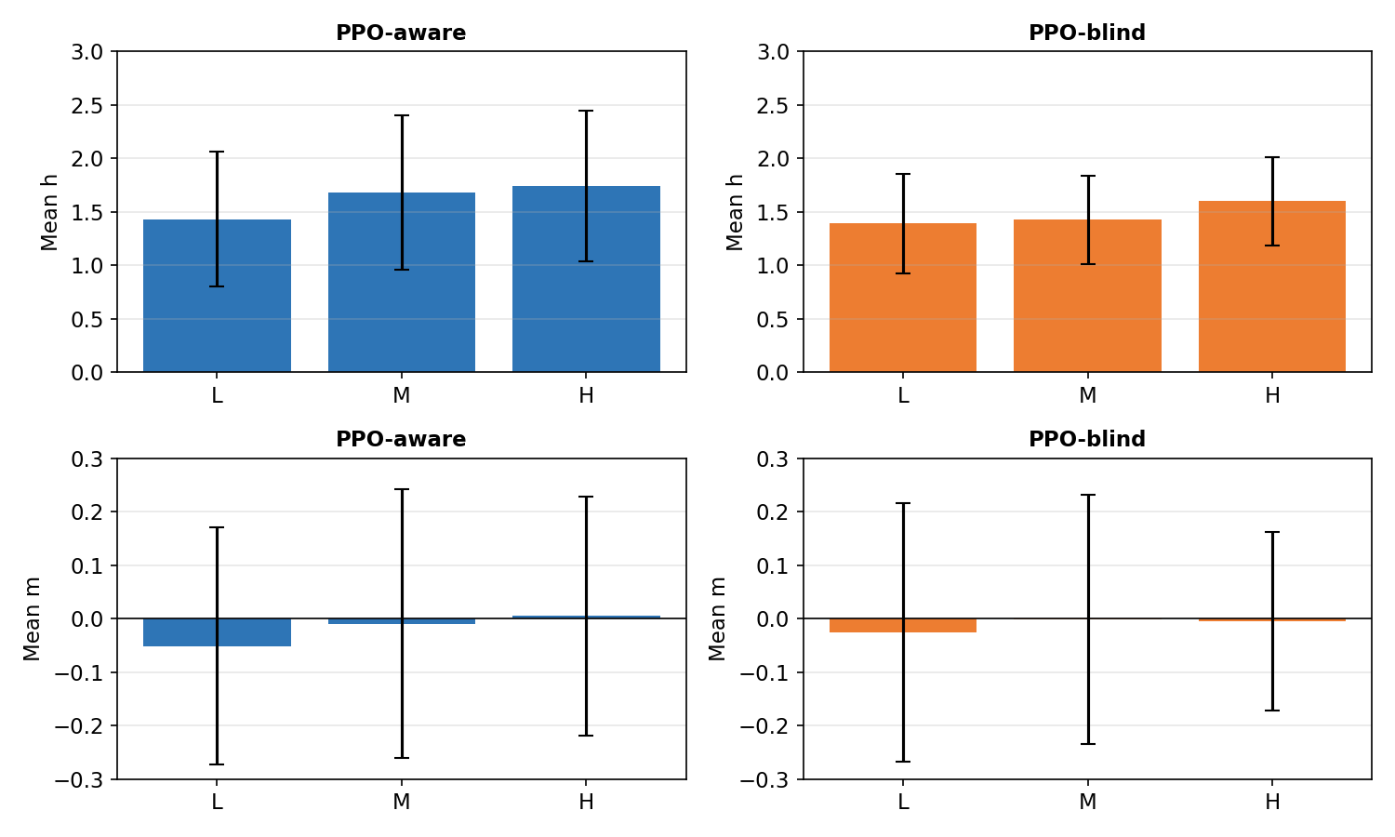
Appendix Figure C1. Regime-wise action distribution diagnostic.
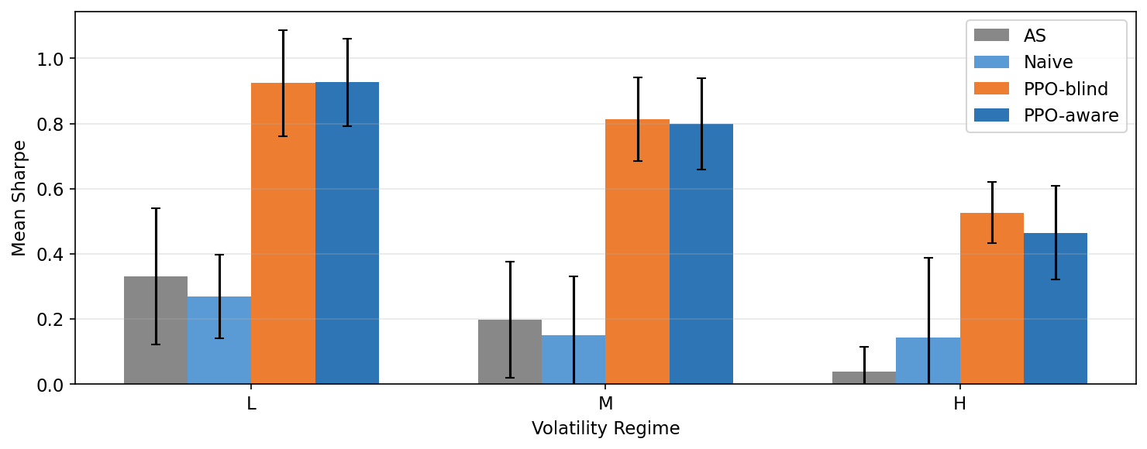
Appendix Figure C2. Regime-wise Sharpe diagnostic.

The table below summarizes supporting diagnostics. These items support interpretation and provenance; they do not replace the canonical WP5/WP6 evidence chain used for the main claims.
Diagnostic | Status | Interpretation
Post-hoc signal diagnostics | Supporting only | Consistent with signal redundancy but not primary evidence.
WP5.5 signal audit | Offline calibration | Supports WP6 degradation design; no PPO training.
Detector robustness statistics | Protected evidence | Addresses poor-detector objection without changing main detector caveat.
WP6 paired summaries | Protected evidence | Supports refined interpretation of the signal-informativeness sweep.

This separation keeps the appendix readable while preserving the boundary between primary experiment evidence and supporting diagnostics.

