HECTOR School
Executive Master Program: [CONFIRM: official programme name]
Master Thesis
High-Frequency Market Making via Reinforcement Learning under Different Volatility Regimes

Field | Value
Student | Onur Emiroglu
Home Address | [CONFIRM: home address]
Country | [CONFIRM: country]
Company | [CONFIRM: company name]
Department | [CONFIRM: department]
Company / Address | [CONFIRM: company/address]
Institution | Karlsruhe Institute of Technology
Supervisor | Prof. Dr. Maxim Ulrich
Advisor / Co-supervisor | Ardalan Azarnejad
Matriculation No. | 2643340
Course / Module | MSc Thesis
Date of submission | [CONFIRM: submission date]

Declaration
Field | Value
Student | Onur Emiroglu
Home Address | [CONFIRM: home address]
Country | [CONFIRM: country]
Date of birth, Location | [CONFIRM: date of birth, location, country]
Number of matriculation | 2643340
I sincerely affirm to have composed this thesis work autonomously, to have indicated completely and accurately all aids and sources used and to have marked anything taken from other works, with or without changes. Furthermore, I affirm to have observed the constitution of the KIT for the safeguarding of good scientific practice, as amended.
[CONFIRM: location and date] [CONFIRM: signature] ________________________________

Confidentiality Statement
[CONFIRM: confidentiality statement, if any]

Acknowledgement
[CONFIRM: acknowledgement text]

Abstract
This thesis studies whether explicit volatility-regime information improves a Proximal Policy Optimization (PPO)-based high-frequency market-making (HFMM) agent in a controlled synthetic limit-order-book (LOB) environment. The simulator uses an arithmetic Brownian-motion mid-price, a sticky Markov volatility-regime process, rolling realized-volatility detection, and Poisson-arrival fills. The PPO agent chooses bid and ask quotes through a discrete half-spread and skew parameterization, and it is compared with a fixed-spread strategy and an Avellaneda-Stoikov analytical baseline.
In the tested controlled synthetic HFMM environment, explicit categorical volatility-regime labels do not provide robust incremental value once sigma_hat is already observed by the PPO policy. The results are consistent with signal redundancy. The evidence comes from the canonical experiments: out-of-sample evaluation, detector robustness, oracle-label ablations, regime-conditional reward shaping, mild model misspecification, and a signal-informativeness sweep. The strongest interpretation is conditional and synthetic-market bounded: the explicit regime label mostly repackages volatility information already present in the continuous signal. The thesis makes no live-trading deployment claim and does not claim to prove the internal PPO mechanism.

Keywords
market making; reinforcement learning; PPO; volatility regimes; signal redundancy; limit order book; equivalence testing

Table of Contents
Abstract
Keywords
List of Figures
List of Abbreviations / Symbols
1 Introduction
2 State of the Art
3 Approach of Thesis / Methodology
4 Results
5 Evaluation and Discussion
6 Conclusion and Outlook
Literature
Appendix A Reproducibility and Implementation Notes
Appendix B Author Contribution Statement

List of Figures
Figure 3.1. Illustrative synthetic HFMM environment path. The upper panel shows the generated mid-price path. The middle panel compares the rolling realized-volatility signal observed by the policy with the true regime-dependent volatility level. The lower panel shows the latent Markov volatility-regime sequence. The dashed vertical line marks the chronological 70/30 train-test split used for out-of-sample evaluation. This figure is a methodology illustration, not a regenerated performance artifact.
Figure 3.2. Methodology-only HFMM evaluation pipeline. Synthetic market paths produce sigma_hat and regime_hat signals, which feed the Gymnasium environment, PPO variants, baselines, and out-of-sample metrics. This illustration is not performance evidence.
Figure 4.1. Experiment 1 main OOS results: PPO variants dominate naive and AS on risk-adjusted performance, while AS carries much larger inventory tail risk.
Figure 4.2. Seed-paired PPO-aware versus PPO-blind comparison: the estimated regime channel does not create a robust Sharpe-like advantage.
Figure 4.3. Five-variant ablation summary: sigma_only is the strongest mean Sharpe-like variant, and adding categorical labels does not improve it.
Figure 4.4. Oracle-label paired-seed comparison: even true regime labels do not reliably improve on sigma_hat alone.
Figure 4.5. Detector robustness: rv_baseline, rv_dwell, and HMM all fail to create a reliable regime-aware PPO advantage.
Figure 4.6. Regime-conditional eta summary: changing the reward channel by regime still favors sigma_only over combined.
Figure 4.7. Mild model-misspecification summary: sigma_only and oracle_full remain close under regime-dependent execution parameters.
Figure 4.8. Experiment 5 monotonic-gap plot: the expected narrowing of the sigma_only versus combined gap does not appear in the tested calibration band.
Figure 4.9. Experiment 5 paired-seed combined versus sigma_only: combined is directionally below sigma_only in informative conditions.
Figure 4.10. Experiment 5 paired-seed combined versus regime_only: this diagnostic bounds how much sigma_hat is used inside the combined variant.

List of Abbreviations / Symbols
Symbol | Meaning
$${S_t}_{}$$ | Mid-price at time step t.
$${q_t}_{}$$ | Inventory after step t.
$${X_t}_{}$$ | Cash account after step t.
$${W_t}_{}$$ | Marked-to-market wealth or equity, W_t = X_t + q_t S_t.
$$sigma_hat$$ | Rolling realized-volatility estimate observed by the PPO policy.
$${R_t}_{}$$ | Reward at time t.
$$h$$ | Quoted half-spread in ticks.
$$m$$ | Quote skew in ticks.
$$A, k$$ | Poisson fill-intensity scale and decay parameters.
$$eta$$ | Inventory penalty coefficient.
$$gamma$$ | Avellaneda-Stoikov inventory-risk aversion parameter.
$$tau$$ | Remaining horizon.
$lambda(delta$) | Poisson fill intensity at quote distance delta.
$$delta, delta_bid, delta_ask$$ | Quote distance variables.
$$rho_t(theta){}_{}$$ | PPO probability ratio.
$$A_hat_t$$ | Advantage estimate.
$$epsilon_t{}_{}$$ | Standard-normal innovation in the mid-price process.
$${z_t}_{}$$ | Latent volatility regime.
$${P_ij}_{}$$ | Markov transition probability.

Abbreviation | Meaning
$$ABM$$ | Arithmetic Brownian motion.
$$AS$$ | Avellaneda-Stoikov baseline.
$$HFMM$$ | High-frequency market making.
$$OOS$$ | Out-of-sample evaluation.
$$PPO$$ | Proximal Policy Optimization.
$$RV$$ | Realized volatility.
$$TOST$$ | Two One-Sided Tests equivalence procedure.
$$WP$$ | Work package.

Term | Definition
$$Regime-aware PPO$$ | PPO policy variant that receives a categorical regime one-hot channel.
$$Regime-blind PPO$$ | PPO policy variant that omits the regime one-hot but still observes sigma_hat.
$$sigma_only$$ | Ablation variant using the continuous volatility signal without categorical regime labels.
$$combined$$ | Ablation variant using sigma_hat and estimated categorical regime labels.
$$oracle_full$$ | Ablation variant using sigma_hat and the true regime label.
$$regime_only$$ | Ablation variant using estimated categorical regime labels without sigma_hat.
$$oracle_pure$$ | Ablation variant using the true regime label without sigma_hat.

1 Introduction

1.1 Problem Statement and Motivation
Market makers continuously choose bid and ask quotes while balancing spread capture against inventory risk. When volatility changes, the same quote width can become either too passive or too exposed. A natural response is to provide a learning agent with regime labels such as low, medium, and high volatility. The central question is whether that categorical label adds decision-relevant information when the policy already observes a continuous volatility estimate.

1.2 Research Objective
The objective is to test the incremental value of explicit categorical volatility-regime labels in PPO market making under a controlled synthetic environment. The comparison is intentionally information-design focused: the regime label is evaluated against a continuous sigma_hat signal, not against an observation space with no volatility information.

1.3 Contributions
- A controlled HFMM simulator with Poisson-arrival fills, fees, latency, and Markov volatility regimes.
- A Gymnasium environment in which PPO controls quote half-spread and skew.
- An OOS comparison of fixed-spread, Avellaneda-Stoikov, regime-aware PPO, and regime-blind PPO strategies.
- A five-variant ablation separating continuous volatility information from estimated and oracle regime labels.
- Detector, reward-shaping, misspecification, and signal-informativeness checks that bound the interpretation.

1.4 Scope and Limitations
The thesis is a controlled synthetic-market study. It does not claim production deployment viability, real-order-book external validity, or a proven PPO representation mechanism. The result is conditional on the simulator, signal design, PPO hyperparameters, and degradation calibration tested here.

1.5 Thesis Structure
Section 2 reviews the state of the art. Section 3 presents the methodology, including the mathematical model, use-case scenario, system architecture, algorithmic protocol, and experimental setup. Section 4 reports the results. Section 5 evaluates and discusses the evidence. Section 6 concludes with the thesis outlook.

2 State of the Art

2.1 Background and Related Work
The literature relevant to this thesis falls into four connected strands: classical inventory-aware market making, reinforcement-learning market making, volatility regimes and non-stationarity, and statistical interpretation of small or practically negligible differences. The purpose of the review is not to claim a new analytical quoting rule or a new reinforcement-learning algorithm. It is to locate a narrower information-design question inside an established market-making literature.
Classical market-making models provide the inventory-risk and quote-placement foundation. A market maker earns spread income by posting bid and ask quotes, but stochastic execution creates inventory exposure whose value changes with the mid-price. Avellaneda and Stoikov (2008) formalize this tradeoff through a reservation price and spread term that depend on inventory, risk aversion, volatility, remaining horizon, and order-arrival intensity. Guéant, Lehalle and Fernandez-Tapia (2013) extend this inventory-control view and provide tractable approximations for optimal quotes under inventory constraints.
This analytical literature motivates the thesis design in two direct ways: it explains why inventory, volatility, quote distance, and fill intensity are central state variables, and it supplies the Avellaneda-Stoikov baseline used as a non-learning comparator. Related preprints by Fodra and Labadie (2012, 2013) are useful additional context for inventory-constrained and state-dependent market-making models, but they are treated cautiously as preprints. The thesis does not attempt to derive a new closed-form quoting rule; it uses the analytical tradition to frame the simulation and benchmark design.
A second strand replaces closed-form rules with learned policies. Spooner et al. (2018) demonstrate that reinforcement learning can learn market-making behavior in a simulated limit-order-book setting and show why reward design and inventory control matter. Spooner and Savani (2020) extend the discussion toward robustness under adversarially varied market conditions. These studies support the use of simulator-based evaluation for learned quoting policies, while also showing that market-making performance can be sensitive to the assumptions used to generate training and evaluation episodes.
Deep reinforcement-learning studies with market signals are closest to the present information-design question. Gašperov and Kostanjčar (2021) study market making with signals through deep reinforcement learning; Gašperov et al. (2021) review reinforcement-learning approaches to optimal market making; and Gašperov and Kostanjčar (2022) train agents in a richer Hawkes-process limit-order-book simulator. This literature motivates learned quoting, state representation, reward shaping, robustness checks, and simulator-based evidence. The present thesis is narrower: PPO is used as a controlled testbed for whether one additional volatility-regime channel has incremental value, not as a claim of algorithmic optimality.
Volatility regimes and non-stationarity are economically meaningful. A high-volatility state can increase inventory risk, change fill-risk tradeoffs, and make a quote width that was appropriate in a calm period too aggressive in a turbulent period. The thesis therefore models a latent three-state Markov volatility process and a causal rolling realized-volatility detector. This design should not be read as a claim that volatility regimes are irrelevant. The tested question is more specific: whether categorical regime labels add incremental value once the policy already observes a continuous realized-volatility estimate.
The key state-representation issue is redundancy. The continuous signal sigma_hat gives the PPO policy a graded estimate of recent realized volatility. A low/medium/high label derived from related volatility information may help if it summarizes latent structure that sigma_hat does not expose, but it may add little if the continuous signal already contains the useful variation for quote placement. This gives the exact gap addressed by the thesis: When a PPO market-making policy already observes a continuous realized-volatility estimate, does adding an explicit categorical volatility-regime label improve out-of-sample performance in a controlled synthetic HFMM environment?
Finally, the empirical interpretation requires care because the thesis evaluates an incremental signal, not the existence of volatility effects in general. Lakens (2017) and Lakens, Scheel and Isager (2018) motivate equivalence testing as a way to distinguish a merely non-significant difference from evidence that a difference is small relative to a pre-specified practical bound. The TOST framing is therefore used as background for the later statistics section; it does not by itself prove that labels contain no information.

3 Approach of Thesis / Methodology

3.1 Mathematical Formulation

Synthetic Mid-Price Process
(1) S_{t+1} = S_t + sigma_t sqrt(dt) epsilon_t
Here S_t is the mid-price, sigma_t is the step volatility in ticks or price units according to the simulator configuration, dt is the time step, and epsilon_t is an independent standard-normal shock.

Markov Volatility-Regime Process
(2) P(z_{t+1}=j | z_t=i) = P_ij
Here z_t is the latent volatility regime at step t, L/M/H denote low, medium, and high volatility, and P_ij is the sticky transition probability from regime i to regime j.
$$(2a) P = [[0.9967, 0.0023, 0.0010], [0.0042, 0.9917, 0.0041], [0.0010, 0.0030, 0.9960]]$$
Rows correspond to the current regime L/M/H, and columns correspond to the next regime L/M/H. The large diagonal probabilities make the regimes persistent, or sticky, so volatility states tend to last for many steps rather than switching erratically.
This persistence matters because rolling realized-volatility detection is only meaningful when regime-dependent volatility differences last long enough to be observed through a finite window.
The regime controls the volatility multiplier applied to the base sigma parameter. The canonical full experiments use sigma multipliers $[0.6, 1.0, 1.8]$ for L, M, and H.

Realized Volatility Signal and Regime Detection
(3) sigma_hat_t = sqrt((1/w) * sum_{i=t-w+1}^{t} (Delta S_i)^2)
Here sigma_hat_t is the rolling realized-volatility signal, w is the rolling window length, Delta S_i is the mid-price increment over step i, and the summation runs over the most recent w increments.
Estimated regime labels are assigned by thresholding sigma_hat after a warmup period. The main reported training and evaluation pipelines use the causal rv_baseline detector. The rv_dwell detector is retained only as an auxiliary/offline robustness comparison, while the HMM detector is an additional robustness variant.

Illustrative Synthetic Environment Path
This subsection visualizes one deterministic synthetic path generated under the canonical HFMM environment configuration. The figure is included to make the simulated market environment transparent: the mid-price evolves under a regime-switching arithmetic Brownian-motion process, the realized-volatility signal is computed from rolling mid-price changes, and the latent Markov regime switches between low, medium, and high volatility states. The dashed vertical line marks the chronological $70/30$ train-test split used in the out-of-sample protocol. The figure is illustrative of the methodology only and is not a new performance result.
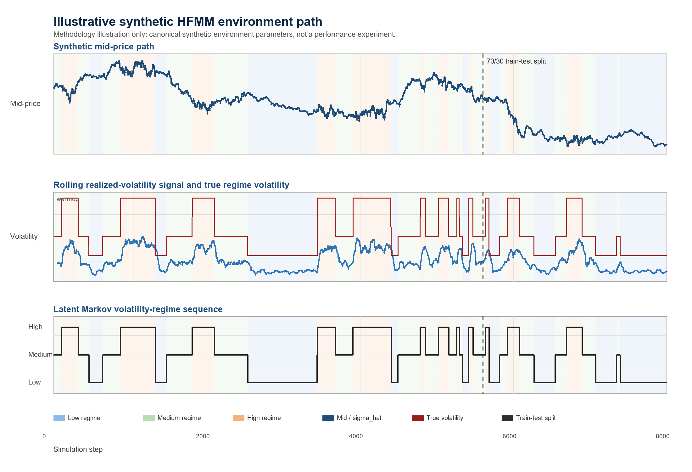
Figure 3.1. Illustrative synthetic HFMM environment path. The upper panel shows the generated mid-price path. The middle panel compares the rolling realized-volatility signal observed by the policy with the true regime-dependent volatility level. The lower panel shows the latent Markov volatility-regime sequence. The dashed vertical line marks the chronological 70/30 train-test split used for out-of-sample evaluation. This figure is a methodology illustration, not a regenerated performance artifact.

Limit-Order Fill Model
(4) lambda(delta) = A exp(-k delta)
Here lambda(delta) is the fill intensity at quote distance delta, A is the baseline arrival scale, and k controls the exponential decay as quotes move farther from the mid-price.
Intuitively, quotes closer to the mid-price fill more often because they are more attractive to incoming market orders. Quotes farther away earn more spread if they fill, but the exponential intensity makes those fills less likely.
(5) P(fill | delta) = 1 - exp(-lambda(delta) dt)
Here P(fill | delta) is the per-step fill probability and dt is the simulator step length.

Quote Parameterization
(6) h = h_idx + 1, m = m_idx - 2
Here h_idx and m_idx are the two discrete PPO action components, h is the half-spread in ticks, and m is the quote skew in ticks.
The half-spread $h$ controls quote width and aggressiveness: small $h$ is more aggressive and large $h$ is more passive. The skew m shifts the bid and ask distances asymmetrically, allowing the policy to lean against inventory or other state pressure while still quoting both sides.
(7) delta_bid = max(1, h + m), delta_ask = max(1, h - m)
Here delta_bid and delta_ask are the bid and ask quote distances in ticks. The max operator enforces a minimum quote distance of one tick.

Inventory, Cash, Equity, and Reward
(8) q_{t+1} = q_t + F_t^bid - F_t^ask
Here q_t is inventory, F_t^bid is the bid-side fill indicator or count, and F_t^ask is the ask-side fill indicator or count.
(9) X_{t+1} = X_t - F_t^bid P_t^bid + F_t^ask P_t^ask - fees_t
Here X_t is cash, P_t^bid and P_t^ask are the executed bid and ask prices, and fees_t denotes transaction costs.
(10) W_t = X_t + q_t S_t
Here W_t is mark-to-market wealth or equity, X_t is cash, q_t is inventory, and S_t is the mid-price.
The equity measure is marked to the mid-price for consistency across simulated strategies. This is an evaluation convention inside the controlled simulator and should not be interpreted as immediately liquidatable wealth in a real limit-order book. In practice, liquidating inventory would generally require crossing the spread, facing queue priority and available depth, and potentially incurring additional adverse-selection or market-impact costs. These effects are part of the real-market boundary discussed later, not part of the current controlled experiment.
(11) R_t = W_{t+1} - W_t - eta q_{t+1}^2
Here R_t is the reward and eta is the inventory-penalty coefficient. Fees are included in the cash update and are not counted a second time in the reward.
The eta q^2 term discourages the agent from earning apparent PnL by accumulating large directional inventory. It connects the learning objective to market-making risk control rather than pure speculation on the mid-price path.

Avellaneda-Stoikov Baseline
(12) r_t = S_t - q_t gamma sigma^2 tau
Here r_t is the reservation price, gamma is inventory-risk aversion, sigma is volatility, and tau is remaining horizon.
(13) delta_AS = 0.5 gamma sigma^2 tau + (1/gamma) ln(1 + gamma/k)
Here delta_AS is the Avellaneda-Stoikov half-spread and k is the same fill-intensity decay parameter used in the execution model. The implemented deltas are clipped to configured minimum and maximum bounds.

PPO Objective
The clipped PPO objective follows Schulman et al. (2017); it is included here as the training-objective reference for the PPO implementation, not as a new algorithmic contribution.
(14) rho_t(theta) = pi_theta(a_t | s_t) / pi_theta_old(a_t | s_t)
Here rho_t(theta) is the PPO probability ratio, pi_theta is the current policy, pi_theta_old is the behavior policy used to collect the rollout, a_t is the action, and s_t is the state.
(15) L_CLIP(theta) = E_t[min(rho_t(theta) A_hat_t, clip(rho_t(theta), 1-epsilon, 1+epsilon) A_hat_t)]
Here theta denotes policy parameters, rho_t(theta) is the PPO probability ratio, A_hat_t is the advantage estimate, and epsilon is the clipping parameter. The thesis uses this only as a concise training-objective reference.
PPO is used because the thesis needs a stable, widely used policy-gradient algorithm for stochastic sequential control, not because it claims PPO is the best possible market-making RL algorithm. The action is discrete but two-dimensional MultiDiscrete: the agent chooses half-spread $h$ and skew $m$, which together form a 25-action quote grid. DQN would require value-based handling of this grid and is less natural for the policy-gradient control framing used here; SAC is more naturally aligned with continuous actions and would expand the scope; and A2C is simpler but often less stable or sample-efficient than PPO. PPO therefore provides a reliable baseline algorithm for controlled ablation of the observation channels.

3.2 Synthetic HFMM Use-Case Scenario

Synthetic HFMM Scenario
The use case is a synthetic market maker posting one bid and one ask quote at each step. The environment supplies mid-price dynamics, volatility estimates, and regime labels; the agent receives stochastic fills and is evaluated on wealth, risk-adjusted performance, inventory tails, and fill behavior.

Trading Agents and Strategy Variants
Table 3.1 Strategy variants
Strategy or variant | Observed information | Purpose
Naive | No learned state dependence | Fixed-spread baseline.
Avellaneda-Stoikov | Inventory, volatility, horizon | Analytical inventory-risk baseline.
ppo_aware | sigma_hat and estimated regime one-hot | Original regime-aware PPO.
ppo_blind | sigma_hat without regime one-hot | Original regime-blind PPO.
sigma_only | Continuous sigma_hat only | Tests whether sigma_hat alone carries the signal.
combined | sigma_hat and estimated regime one-hot | Tests estimated categorical incremental value.
oracle_full | sigma_hat and true regime one-hot | Tests perfect-label incremental value.
regime_only / oracle_pure | Categorical labels without sigma_hat | Anchor label-only variants.

Information-Design Question
The information-design question is: when a PPO market-making policy already observes a continuous realized-volatility estimate, does adding an explicit categorical volatility-regime label improve out-of-sample performance in a controlled synthetic HFMM environment?
The canonical evidence answers this question negatively in the tested setting. Explicit categorical volatility-regime labels do not provide robust incremental value once sigma_hat is already observed by the PPO policy. The results are consistent with signal redundancy.

3.3 System Architecture

Run Lifecycle and Reproducibility Layer
`run.py` dispatches jobs from JSON configuration files, creates a timestamped run directory, snapshots the config, records git metadata, writes logs and metrics, and finalizes run status. Long WP6 jobs support resume validation against the saved config snapshot.

Synthetic Market and Detector Layer
`src/wp1/sim.py` implements the fill and inventory simulator. `src/wp2/synth_regime.py` generates synthetic regime paths, mid-prices, rolling realized volatility, and detector outputs.

Gymnasium Environment Layer
`src/wp3/env.py` wraps the simulator as a Gymnasium environment. The observation vector is [q_norm, sigma_hat, tau, regime_L, regime_M, regime_H]. Warmup, invalid, or disabled regime labels produce a zero one-hot vector rather than an artificial medium label.

Strategy and Training Layer
The training layer fits PPO policies, the main evaluation layer compares strategies and ablations, and the signal-informativeness layer tests whether regime labels gain value as sigma_hat is degraded. The fixed-spread and AS baselines provide non-learning comparators.

Evaluation and Evidence Layer
Evaluation records metrics, figures, and summaries for the reported experiments. The manuscript cites the existing canonical outputs and keeps document migration separate from experiment execution.

Methodology Pipeline Illustration
Figure 3.2 summarizes the evidence pipeline at a methodological level. A synthetic path generates the latent volatility regime and mid-price sequence; rolling realized volatility and detector labels form the observed signals; the Gymnasium environment converts these signals, inventory, time, quotes, and fills into sequential observations and rewards; PPO variants and analytical baselines are then evaluated on held-out out-of-sample metrics. The figure is included only to clarify the workflow and is not a regenerated performance artifact.
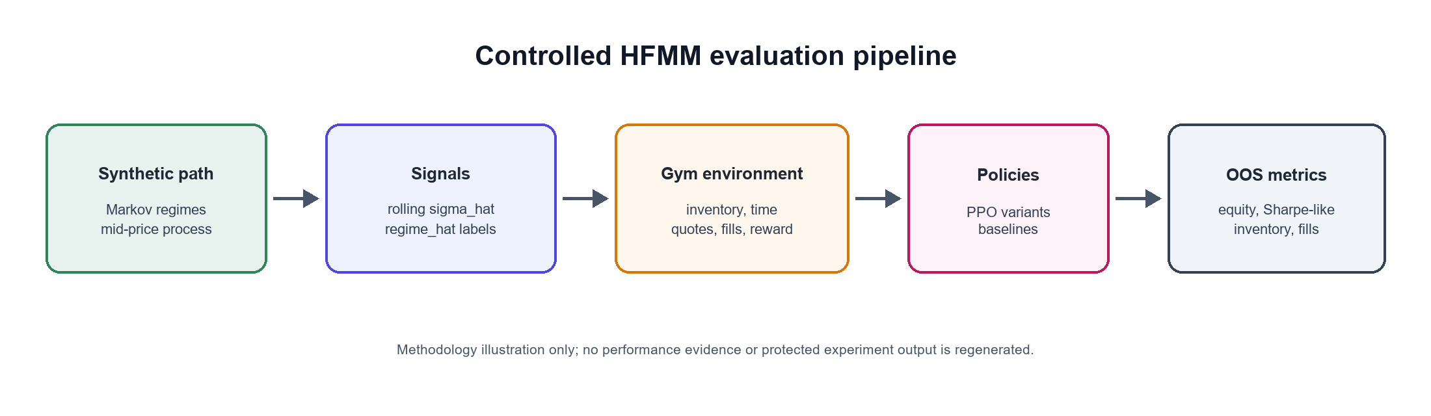
Figure 3.2. Methodology-only HFMM evaluation pipeline. Synthetic market paths produce sigma_hat and regime_hat signals, which feed the Gymnasium environment, PPO variants, baselines, and out-of-sample metrics. This illustration is not performance evidence.

3.4 Layered Experimental Model
The preceding architecture description is restated here as a conceptual layered experimental model.

Layer 1: Market State Generation
Generate Markov regimes and mid-price paths under controlled volatility multipliers.

Layer 2: Signal Construction
Construct sigma_hat from rolling realized volatility and derive estimated regime labels.

Layer 3: Observation Encoding
Encode inventory, volatility, time-to-horizon, and optional regime one-hot channels.

Layer 4: Action and Execution
Decode PPO actions into bid/ask quote distances and sample Poisson-arrival fills.

Layer 5: Learning and Evaluation
Train PPO on the chronological train segment and evaluate deterministic policies OOS.

3.5 Algorithm Specification and Pseudocode

Plain-Language Overview
The experiment creates a synthetic market path, estimates volatility signals, trains policies on the first $70\%$ of the path, and evaluates all strategies on the held-out $30\%$. Ablations modify which volatility channels the PPO policy can observe.

Synthetic Market and Regime Generation
Algorithm 1: Synthetic market and regime generation
Input: seed, transition matrix P, base volatility, volatility multipliers, n_steps
Initialize z_0 and S_0
For t = 0 ... n_steps - 1:
sample z_{t+1} from P[z_t]
set sigma_t = base_sigma * multiplier[z_t]
sample mid-price increment and update S_{t+1}
Compute rolling sigma_hat after warmup window
Calibrate thresholds on warmup data and assign regime_hat
Output: exogenous table with mid, sigma_hat, regime_true, regime_hat

Market-Making Environment Step
Algorithm 2: Market-making environment step
Input: action (h_idx, m_idx), current simulator state, exogenous row
Decode h = h_idx + 1 and m = m_idx - 2
Set delta_bid = max(1, h + m), delta_ask = max(1, h - m)
Compute fill intensities and per-step fill probabilities
Sample bid and ask fills
Update inventory and cash, including fees
Advance mid-price and compute W_{t+1}
Return observation, reward = delta_equity - eta * inventory^2, done flag, info

PPO Training and OOS Evaluation Protocol
Algorithm 3: PPO training and OOS evaluation protocol
For each seed and variant:
generate one exogenous synthetic path
split path chronologically into train and test segments
configure observation channels for the variant
train PPO on the train segment for the configured timesteps
evaluate the deterministic policy on the test segment
log Sharpe-like ratio, final equity, inventory p99, fill rate, and per-regime metrics
Aggregate seed-paired statistics across variants

Experiment 5: Signal-Informativeness Sweep
Algorithm 4: Signal information-value sweep
For each degradation condition in {full, noisy, lagged, coarsened, none}:
transform sigma_hat according to the condition
for each valid variant and seed:
train PPO and evaluate OOS
Aggregate condition-variant means and paired comparisons
Test whether combined gains value as sigma_hat is degraded

Reference Implementation Map
Table 3.2 Reference implementation map
Component | Reference file
Run lifecycle | src/run_context.py, run.py
Simulator | src/wp1/sim.py
Regime generation and detectors | src/wp2/synth_regime.py
Gymnasium environment | src/wp3/env.py
PPO training | src/wp4/job_w4_ppo.py
WP5 evaluation | src/wp5/job_w5_eval.py
WP6 sweep | src/wp6/job_w6_sweep_full.py

Complexity Analysis
Simulation and deterministic evaluation are linear in the number of environment steps. PPO training cost is approximately linear in total timesteps, policy-network forward/backward passes, and the number of seed-variant cells. The WP6 full sweep is expensive because it multiplies conditions, variants, and seeds; this is why its outputs are treated as canonical evidence.
The implementation prioritizes reproducibility and auditability over maximum simulation throughput. Future versions could improve runtime through vectorized environments, parallel rollouts, or lower-level simulator components for the execution loop.

3.6 Experimental Setup

Canonical Configuration Protocol
Canonical experiments are driven by JSON configs under `config/`. Shared parameters include $mid0 = 100.0$,$tick_size = 0.01$, dt = 0.2, $baseline sigma_mid_ticks = 0.8$, $A = 5.0$, $k = 1.5$, $fee_bps = 0.2$, and $latency_steps = 1$.
Market context. The simulator is asset-class agnostic and uses normalized price units. It should be read as a stylized liquid electronic limit-order-book market rather than as a calibrated model of a specific venue such as equities, futures, crypto, or BIST. The fee and latency parameters are controlled friction assumptions used to make strategy comparisons internally consistent. They are not intended to identify a particular exchange microstructure.

Data Generation and Preprocessing
Each run generates synthetic mid-price and regime paths, computes rolling realized volatility, and assigns detector labels. The main reported pipelines use causal rv_baseline labels.

Train/Test Split
The main out-of-sample evaluation and signal-informativeness sweep use a chronological 70/30 split on the exogenous series. PPO trains on the first segment and is evaluated deterministically on the held-out OOS segment.

Strategy Variants
Experiment 1, the Main Out-of-Sample Evaluation, evaluates naive, AS, ppo_aware, and ppo_blind. Experiment 2, the Five-Variant Signal Ablation, and Experiment 5, the Signal-Informativeness Sweep, use sigma_only, regime_only, combined, oracle_pure, and oracle_full.

Detector Variants
Table 3.3 Detector variants
Detector | Role | Caveat
rv_baseline | Main causal detector | Rolling RV threshold; used in main WP4/WP5/WP6 pipelines.
rv_dwell | Auxiliary robustness detector | Offline dwell smoothing; not the main causal detector.
hmm | Robustness detector | Higher classification accuracy but no reliable PPO advantage.

PPO Hyperparameters

Hyperparameter Selection Protocol
The thesis does not perform a broad hyperparameter optimization campaign. This is intentional because the central comparison is signal-channel design, not PPO tuning.
PPO hyperparameters are held fixed across PPO variants to avoid giving one information condition a tuning advantage.
eta = 0.001 is the canonical inventory-penalty scale selected after the earlier inventory-penalty ablation.
No separate validation set is introduced because the study uses a fixed train/OOS evaluation protocol; this should be treated as a limitation and a future extension if full tuning is pursued.
This is a methodological choice, not a claim that the PPO settings are globally optimal.

Table 3.4 PPO hyperparameters
Hyperparameter | Canonical full-run value
total_timesteps | 1,000,000
learning_rate | 3e-4
n_steps | 2048
batch_size | 256
n_epochs | 10
gamma | 0.999
clip_range | 0.2
ent_coef | 0.01 for full WP5/WP6 runs
eta | 0.001

4 Results

4.1 Experiment 1: Main Out-of-Sample Evaluation
Experiment 1, the 20-seed Main Out-of-Sample Evaluation, shows that PPO variants produce much higher risk-adjusted performance than the fixed-spread and AS baselines. AS can produce higher raw equity, but with substantially larger inventory exposure.

Table 4.1 Main OOS strategy metrics
Strategy | Sharpe-like | Final equity | inv_p99 | Fill rate
ppo_aware | $$0.715$$ | $$4.10$$ | $$2.00$$ | $$0.236$$
ppo_blind | $$0.740$$ | $$4.42$$ | $$2.05$$ | $$0.232$$
AS | $$0.105$$ | $$5.05$$ | $$29.95$$ | $$0.444$$
naive | $$0.127$$ | $$4.49$$ | $$21.20$$ | $$0.119$$

AS has higher raw equity but carries substantially larger inventory tail risk; therefore, the main comparison is risk-adjusted performance and inventory control, not raw equity alone.
The AS implementation is used as a canonical analytical inventory-aware comparator rather than as an exhaustively optimized trading system. The PPO-versus-AS comparison establishes a reference point for learned quoting and inventory control, but the central thesis claim is the within-PPO signal-design comparison between sigma_hat, estimated labels, and oracle labels. The AS comparator is a fixed analytical baseline with a configured inventory-risk aversion gamma and configured quote-clipping bounds; its high inv_p99 therefore reflects this chosen fixed comparator under the simulator rather than a defective implementation.

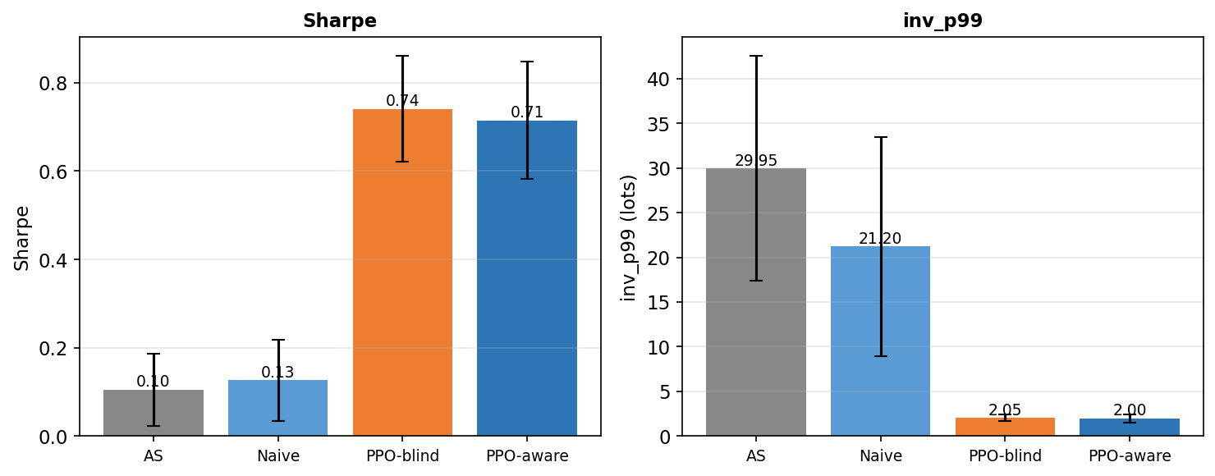
Figure 4.1. Experiment 1 main OOS results: PPO variants dominate naive and AS on risk-adjusted performance, while AS carries much larger inventory tail risk.

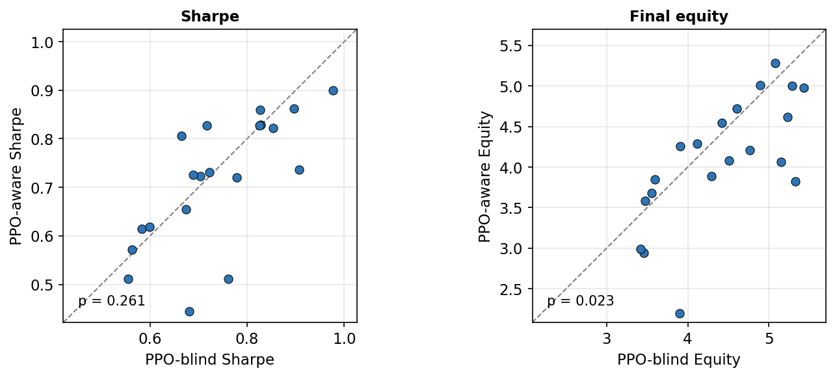
Figure 4.2. Seed-paired PPO-aware versus PPO-blind comparison: the estimated regime channel does not create a robust Sharpe-like advantage.
The paired-seed view shows that the aware policy does not dominate the blind policy seed by seed. The equity panel even favors the blind policy in the canonical paired test.

4.2 Experiment 2: Five-Variant Ablation
Table 4.2 Five-variant ablation metrics
Variant | Signals | Sharpe-like | Final equity | inv_p99
ppo_sigma_only | sigma_hat only | $$0.753$$ | $$4.548$$ | $$1.950$$
ppo_oracle_full | sigma_hat + regime_true | $$0.722$$ | $$4.068$$ | $$2.050$$
ppo_regime_only | regime_hat only | $$0.698$$ | $$4.005$$ | $$2.150$$
ppo_combined | sigma_hat + regime_hat | $$0.696$$ | $$3.905$$ | $$1.800$$
ppo_oracle_pure | regime_true only | $$0.684$$ | $$3.925$$ | $$1.950$$

The strongest ablation result is that sigma_only has the highest mean Sharpe-like value, while oracle_full does not significantly beat it. TOST supports practical equivalence under the ±0.10 Sharpe-like bound.
The label-quality objection is also bounded by the oracle_pure result. oracle_pure receives the true categorical regime label but not sigma_hat, yet it remains below sigma_only in mean Sharpe-like performance in the five-variant ablation. This suggests that the limitation is not only detector noise: in this calibration, the continuous volatility signal is more useful for quote control than the discretized regime category. The small oracle_pure versus regime_only gap in this group is well within the overlapping seed-level confidence intervals reported for these variants and is not statistically distinguishable.

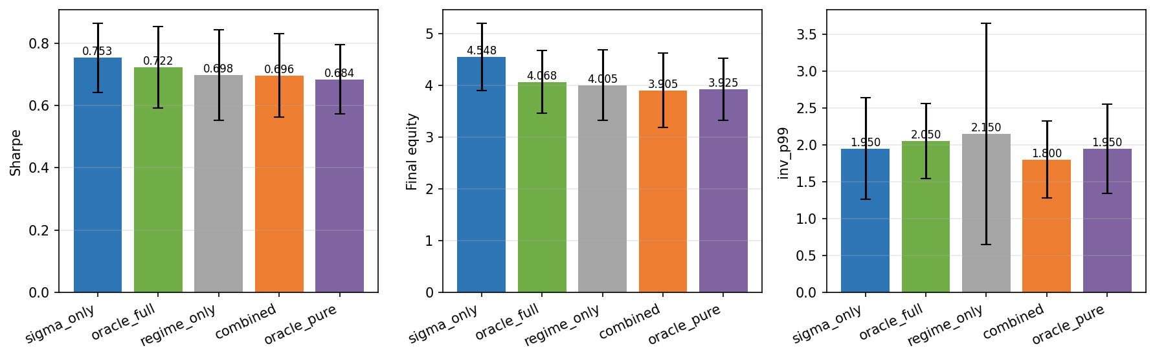
Figure 4.3. Five-variant ablation summary: sigma_only is the strongest mean Sharpe-like variant, and adding categorical labels does not improve it.
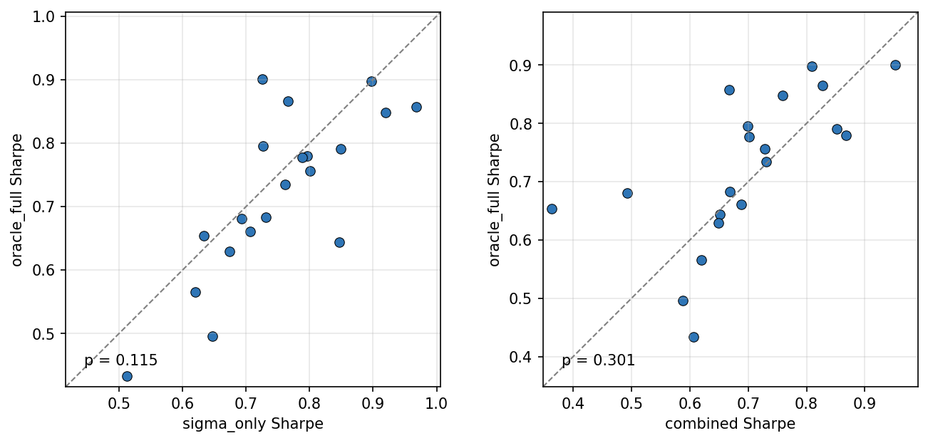
Figure 4.4. Oracle-label paired-seed comparison: even true regime labels do not reliably improve on sigma_hat alone.

The compact statistical summary below collects the canonical paired tests used to interpret the ablation and robustness results.
Table 4.3 Compact statistical summary
Comparison | Metric or test | Canonical result | Interpretation
PPO-aware vs PPO-blind | Sharpe-like paired t-test | p = 0.261 | No significant Sharpe improvement.
PPO-aware vs PPO-blind | Final equity paired t-test | p = 0.023 | Favors PPO-blind.
ppo_sigma_only vs ppo_oracle_full | Sharpe-like paired t-test | p = 0.115 | No oracle-label Sharpe improvement.
ppo_sigma_only vs ppo_oracle_full | TOST ±0.10 | p = 0.00067; 90% CI [-0.001, +0.063] | Practical equivalence supported.
HMM detector | Detector accuracy | $$81.8\%$$ | Higher accuracy does not create advantage.
Detector robustness | ANOVA | F = 0.0034, p = 0.9966 | Detector choice does not explain result.
Regime-conditional eta | sigma_only vs combined Sharpe | p = 0.0016 | Favors sigma_only.
Mild misspecification | sigma_only vs oracle_full Sharpe t-test | p = 0.881 | No significant Sharpe difference.
Mild misspecification | TOST ±0.05 | p = 0.042 | Practical equivalence supported.
ppo_oracle_full vs ppo_combined | Sharpe-like paired t-test | p = 0.301 | No robust oracle-label advantage over the estimated-label combined variant.

The t-test results show no significant Sharpe improvement from explicit regime labels, while the TOST result provides positive evidence of practical equivalence under the stated bound.

4.3 Experiment 3: Detector Robustness
Table 4.4 Detector robustness summary
Detector | Aware vs blind conclusion | Key statistic
rv_baseline | No reliable aware Sharpe advantage | p = 0.1142
rv_dwell | No reliable aware Sharpe advantage | p = 0.1095
hmm | No reliable aware Sharpe advantage despite higher accuracy | p = 0.0822
ANOVA | Detector choice does not explain the result | F = 0.0034, p = 0.9966

The ANOVA statistic is retained as a descriptive robustness summary across detector-specific PPO-aware Sharpe values. Because the same seeds are shared across detector conditions, the primary inferential evidence remains the seed-paired detector-specific tests; the ANOVA should not be read as the sole formal test of a repeated-measures design.
The detector robustness table comes from Experiment 3, the Detector Robustness experiment (w5_detector_full), while the main OOS table in Section 4.1 comes from Experiment 1 (w5_main). Small differences in PPO-aware/blind means therefore reflect distinct canonical experiment batches, not an inconsistency.
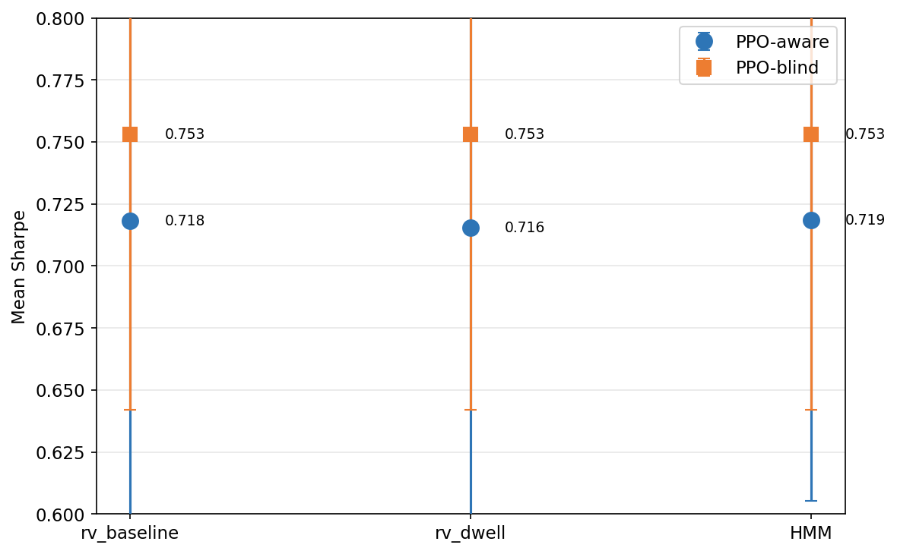
Figure 4.5. Detector robustness: rv_baseline, rv_dwell, and HMM all fail to create a reliable regime-aware PPO advantage.

4.4 Experiment 4: Reward-Shaping and Misspecification Checks
The regime-conditional eta run tests whether explicit labels become useful when the reward penalizes high-volatility inventory more strongly. By design this run sets the high-volatility inventory penalty to five times the low-volatility penalty (eta_H = 5 × eta_L). sigma_only still beats combined on Sharpe-like performance (p = 0.0016). Under mild regime-dependent execution misspecification, sigma_only and oracle_full remain statistically indistinguishable and practically equivalent under the specified TOST bound.
In the misspecification check, the mean difference between sigma_only and oracle_full is very small, but the ±0.05 TOST result is close to the threshold; it should therefore be read as supportive but less decisive than the main five-variant ablation equivalence result.
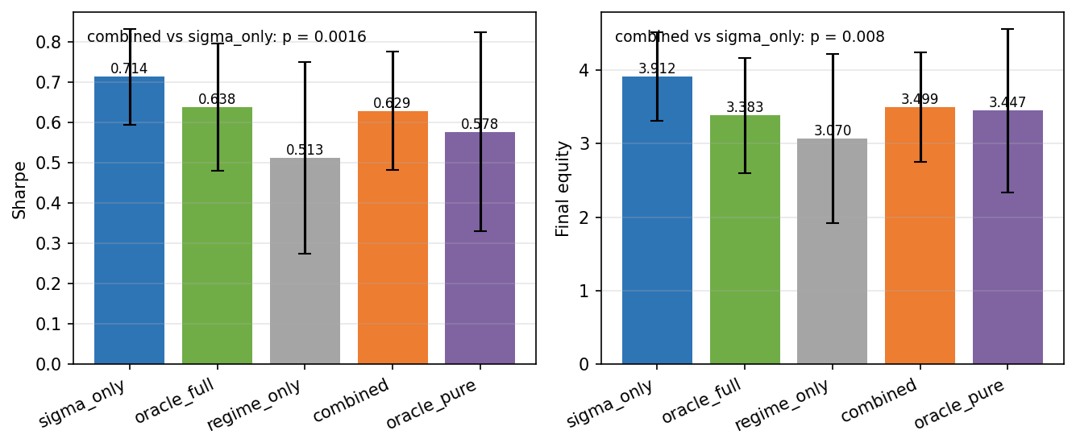
Figure 4.6. Regime-conditional eta summary: changing the reward channel by regime still favors sigma_only over combined.
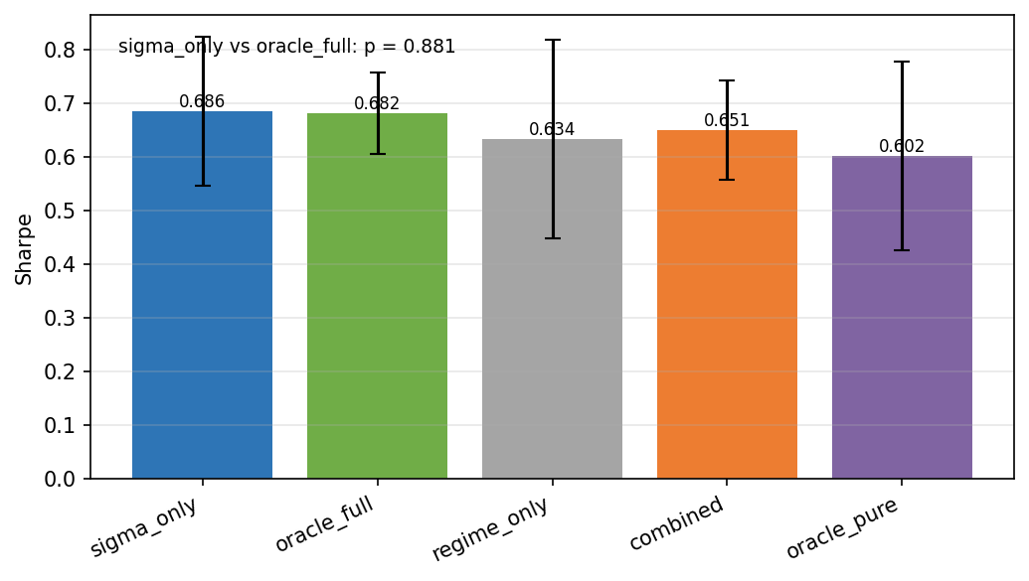
Figure 4.7. Mild model-misspecification summary: sigma_only and oracle_full remain close under regime-dependent execution parameters.

4.5 Experiment 5: Signal-Informativeness Sweep
Table 4.5 Signal information-value sweep
condition | sigma_only | combined | regime_only | oracle_full | oracle_pure
full | $$0.7626 ± 0.0596$$ | $$0.6898 ± 0.0607$$ | $$0.6991 ± 0.0668$$ | $$0.6811 ± 0.0697$$ | $$0.6632 ± 0.0769$$
noisy | $$0.7563 ± 0.0616$$ | $$0.7125 ± 0.0628$$ | $$0.6991 ± 0.0668$$ | $$0.6736 ± 0.1013$$ | $$0.6632 ± 0.0769$$
lagged | $$0.7822 ± 0.0454$$ | $$0.6812 ± 0.0536$$ | $$0.6991 ± 0.0668$$ | $$0.7264 ± 0.0686$$ | $$0.6632 ± 0.0769$$
coarsened | $$0.7827 ± 0.0533$$ | $$0.6908 ± 0.0827$$ | $$0.6991 ± 0.0668$$ | $$0.7447 ± 0.0549$$ | $$0.6632 ± 0.0769$$
none | $$undefined$$ | $$0.6991 ± 0.0668$$ | $$0.6991 ± 0.0668$$ | $$0.6632 ± 0.0769$$ | $$0.6632 ± 0.0769$$

Entries are mean $± 95\%$ confidence-interval half-width across $20$ seeds, not standard deviations.
Experiment 5, the Signal-Informativeness Sweep, did not support the original informativeness-threshold hypothesis within the tested calibration band. sigma_only remained high under informative conditions, while combined was directionally below sigma_only.
Table 4.2 and Table 4.5 come from distinct canonical experiment batches: Table 4.2 is the WP5 five-variant ablation, while Table 4.5 is the WP6 signal-informativeness sweep. Matching variant names under the full-information condition are therefore comparable in pattern but are not expected to take identical numeric values across the two batches. The confidence intervals of the middle-group variants (for example combined, regime_only, oracle_full, and oracle_pure) overlap substantially, so the exact rank ordering among those variants is sensitive to seed noise across batches. The robust pattern that holds in both tables is that sigma_only has the highest mean Sharpe-like value and the categorical regime label does not improve on it.
The Signal-Informativeness Sweep figures should be read as a refinement of the main finding rather than a new mechanism proof: they show that the tested sigma_hat degradation path did not reveal a regime-label advantage.
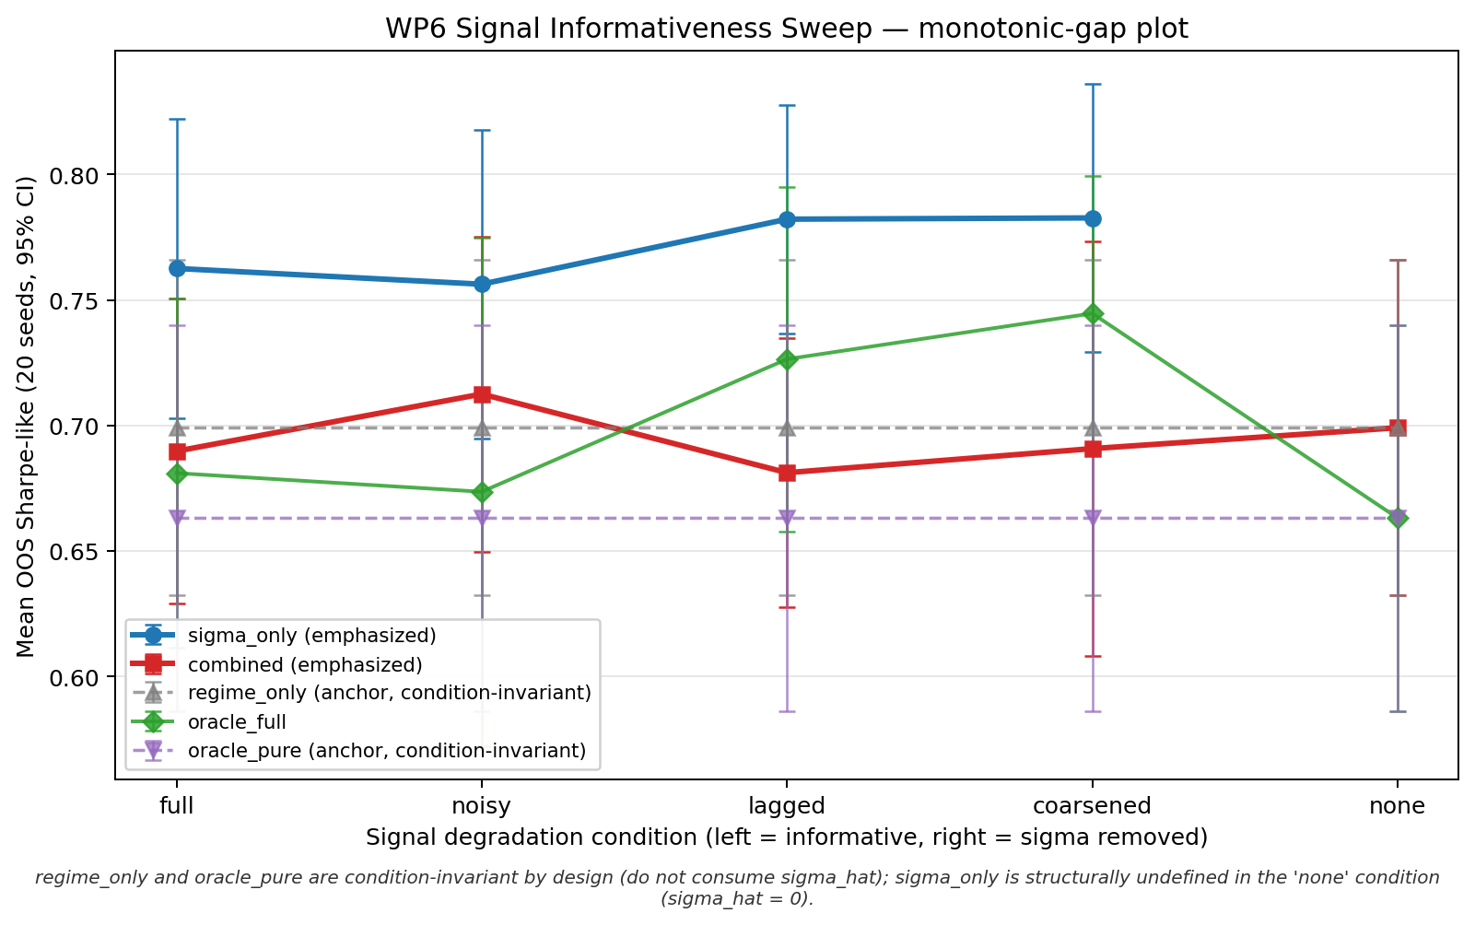
Figure 4.8. Experiment 5 monotonic-gap plot: the expected narrowing of the sigma_only versus combined gap does not appear in the tested calibration band.
One possible interpretation is that the degraded continuous signal still preserves enough ordinal volatility information for quote-width adaptation, whereas the categorical label is coarser and does not add useful variation in this calibration. In noisy or lagged settings, the categorical regime channels carry non-zero content rather than being zero-filled, but this additional categorical channel content does not improve the control-relevant signal. This should be read as a performance pattern in the tested calibration band, not as proof of the PPO policy's internal representation mechanism.
The strongest degradation pattern appears in the lagged condition, where combined is materially below sigma_only (mean difference about $-0.101$; Cohen's dz about $-0.91$). This suggests that, in the lagged condition, the categorical channel does not add control-relevant volatility information and is associated with lower Sharpe-like performance than sigma_only.
The paired-seed views below show whether aggregate differences are broad across seeds or driven by a few runs.
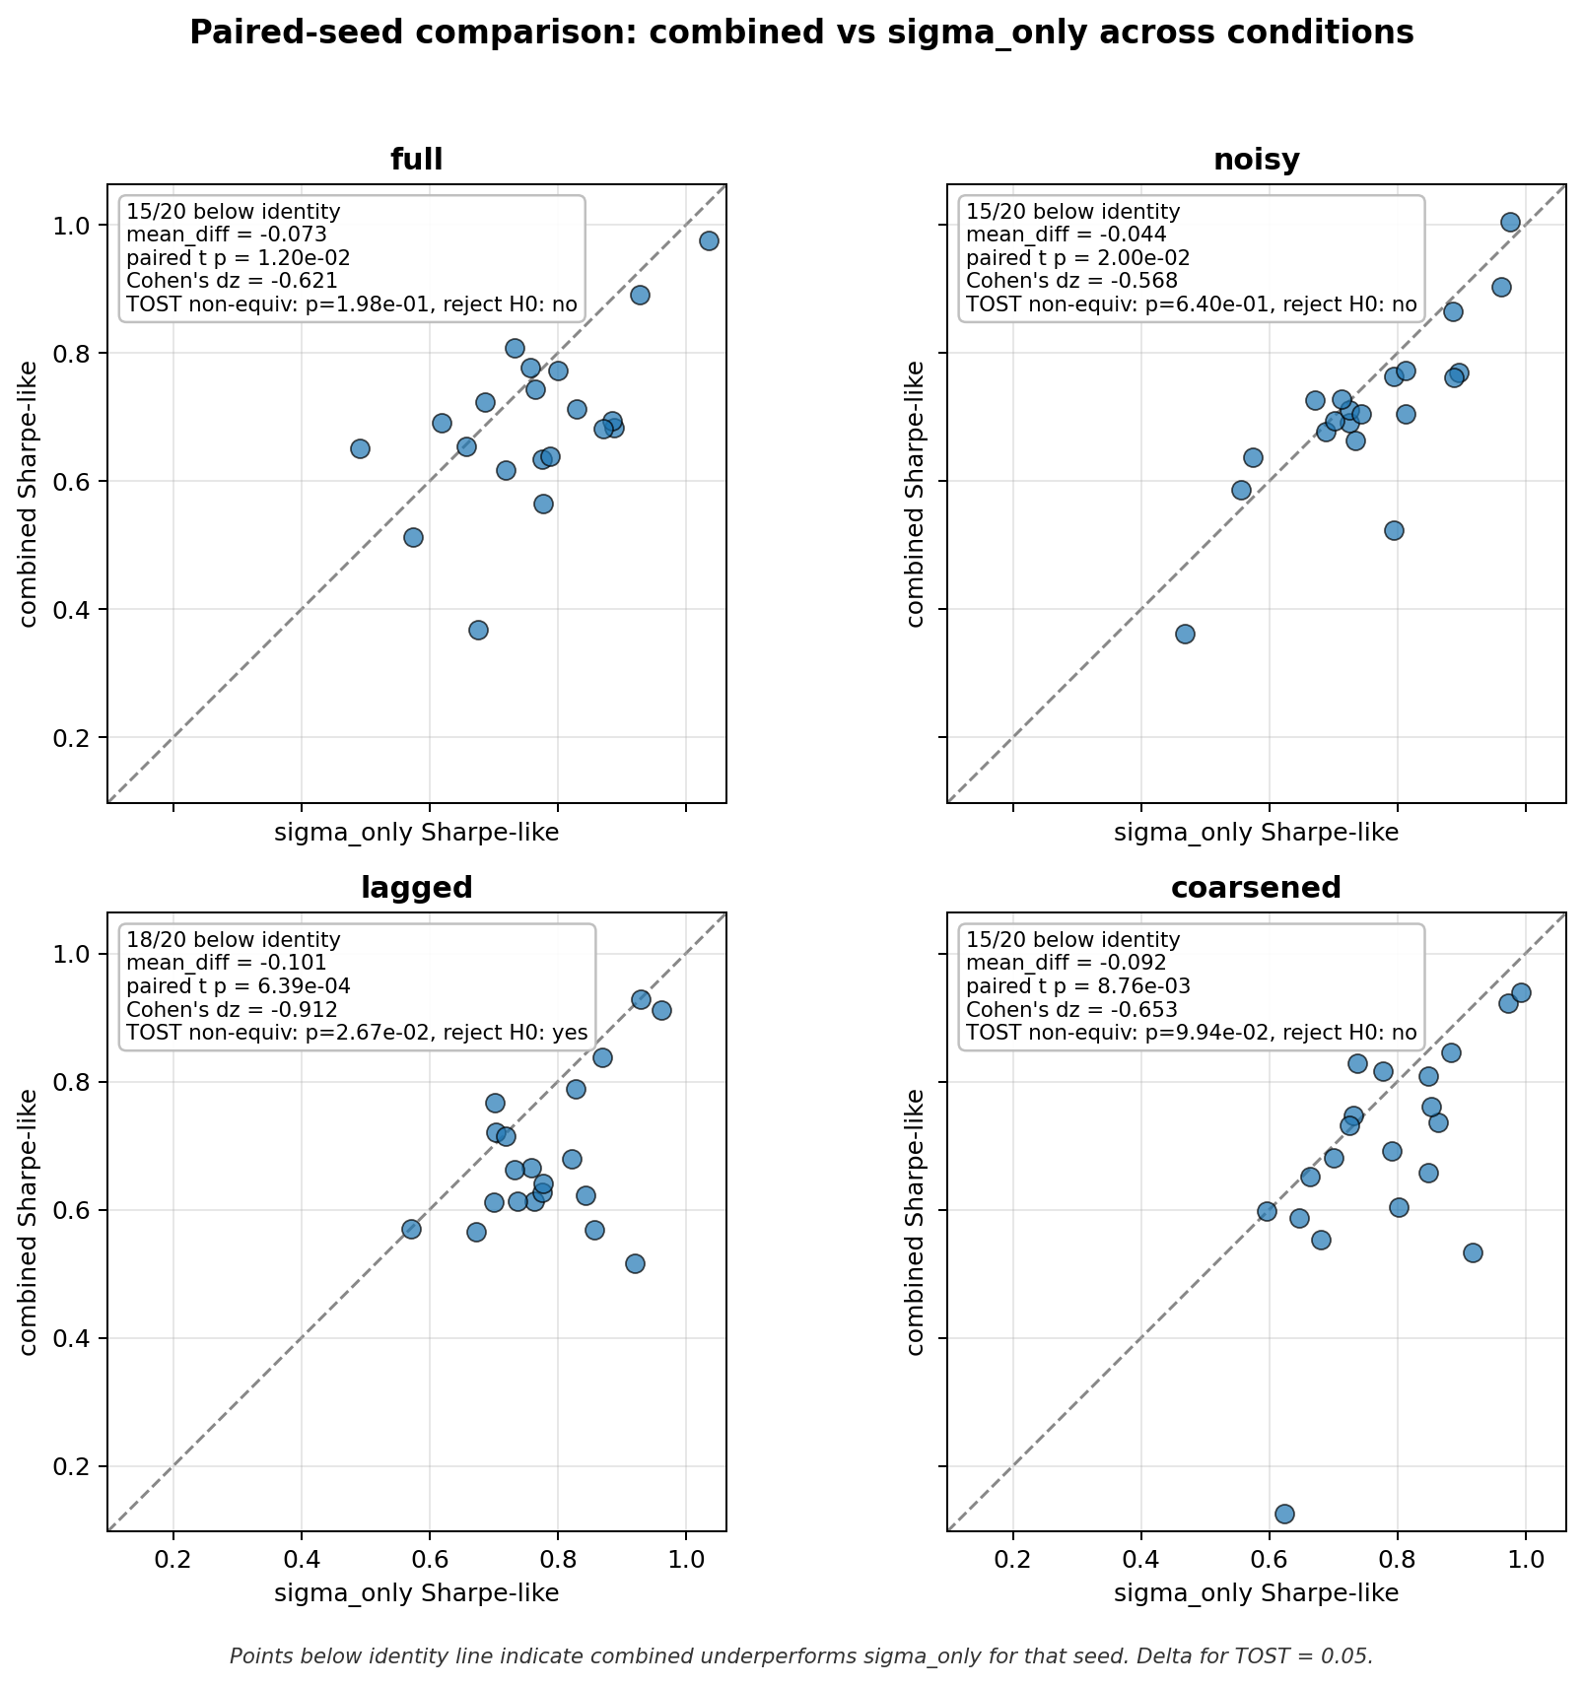
Figure 4.9. Experiment 5 paired-seed combined versus sigma_only: combined is directionally below sigma_only in informative conditions.
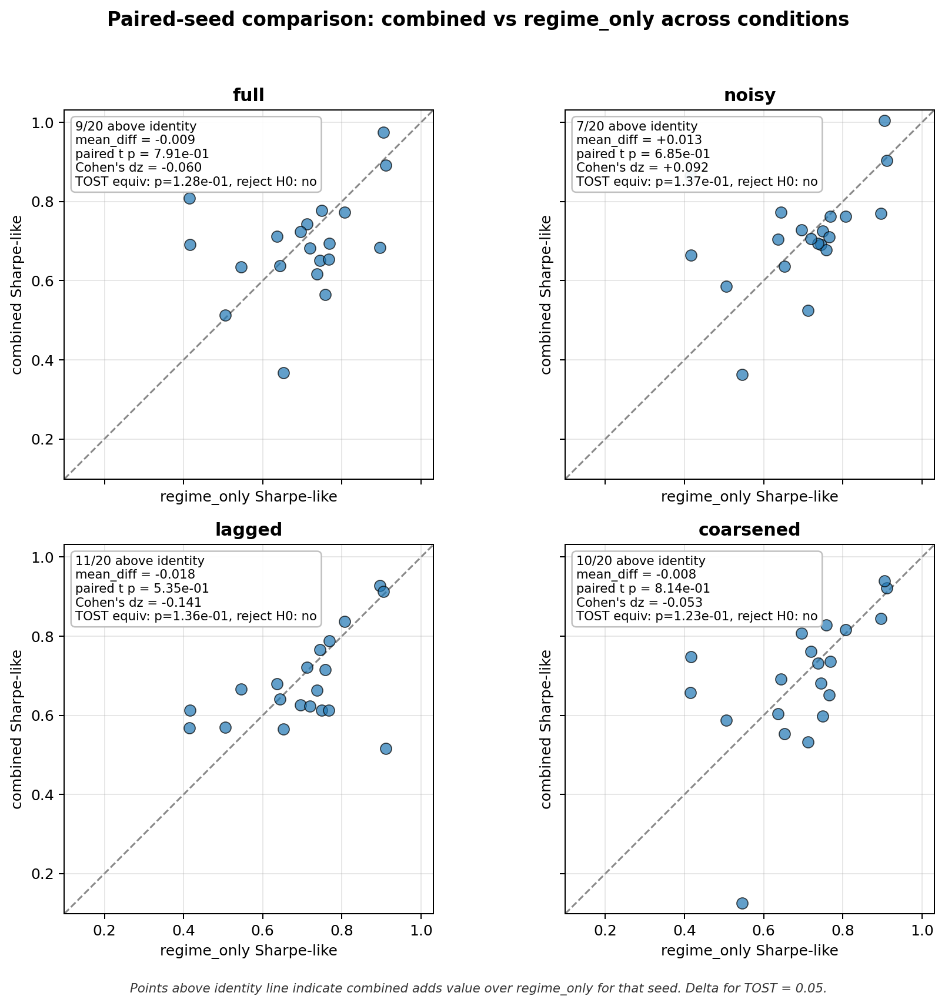
Figure 4.10. Experiment 5 paired-seed combined versus regime_only: this diagnostic bounds how much sigma_hat is used inside the combined variant.

5 Evaluation and Discussion

5.1 Evaluation Metrics

Final Equity
Final equity is the terminal marked-to-market wealth. It is economically meaningful but not sufficient alone because high raw equity can be earned by taking large inventory risk.

Sharpe-Like Ratio
(16) Sharpe-like = mean(Delta W_t) / std(Delta W_t) * sqrt(1/dt)
Let Delta W_t = W_t - W_{t-1}. The reported Sharpe-like metric is computed as mean(Delta W_t) / std(Delta W_t), using the sample standard deviation with ddof = 1, multiplied by sqrt(1/dt) when the standard deviation is positive; otherwise, it is reported as 0.

Inventory Tail Risk
(17) inv_p99 = percentile_99(|q_t|)
Here q_t is inventory. inv_p99 is a practical tail-risk diagnostic for whether a strategy earns returns by carrying large inventory.

Fill Rate
(18) fill_rate = filled quote opportunities / total quote opportunities
The numerator and denominator follow the logged project convention. Fill rate is diagnostic rather than the primary thesis metric.

Paired t-Tests
(19) t = mean(d_i) / (sd(d_i) / sqrt(n))
Here d_i is the paired seed-level difference between two strategies, sd(d_i) is its sample standard deviation, and n is the number of paired seeds.
Because the manuscript reports several paired comparisons, isolated marginal p-values should be read descriptively rather than as a stand-alone familywise discovery claim. The main conclusion is based on the repeated pattern across the main OOS evaluation, detector robustness, oracle ablations, reward-shaping, misspecification, and signal-informativeness diagnostics.

TOST Equivalence Tests
TOST evaluates whether the plausible range of a paired difference lies inside a pre-specified practical-equivalence band. At alpha = 0.05, the corresponding equivalence reading uses the 90% confidence interval.
The equivalence bounds should be read as practical smallest-effect-size thresholds for the Sharpe-like metric, not as universal constants. A wider specified TOST bound of +/-0.10 is used for the main five-variant ablation; a narrower +/-0.05 bound is used for tighter robustness checks. The +/-0.10 band was specified in advance as the practical smallest-effect-size threshold for the Sharpe-like metric in the main five-variant ablation; relative to a mean Sharpe-like level around 0.75, a 0.10 difference is roughly a 13% relative deviation, which is treated as practically negligible in this market-making context. The band choice is not outcome-determining, because equivalence still held under the tighter +/-0.05 band in the mild-misspecification check (p = 0.042), although that margin is narrower and is therefore read as supportive rather than decisive. TOST is not treated as a stand-alone proof; it is reported alongside the paired t-tests, the confidence intervals, and the directional seed-level evidence.

5.2 Main Interpretation: Signal Redundancy
In the tested controlled synthetic HFMM environment, explicit categorical volatility-regime labels do not provide robust incremental value once sigma_hat is already observed by the PPO policy. The results are consistent with signal redundancy.
The interpretation is that the continuous realized-volatility proxy already supplies the economically useful volatility information needed by the policy in this environment. The categorical label may be coarser or redundant when presented alongside sigma_hat.
The evidence should therefore be read slightly more precisely than pure redundancy. If a categorical label only repeated the useful information in sigma_hat, combined and sigma_only would be expected to be approximately indistinguishable. In several experiments, however, combined is directionally below sigma_only. This pattern is consistent with signal redundancy plus mild categorical-channel degradation: the label may be coarser than the continuous volatility estimate, may contribute an additional active categorical signal channel, or may interact with policy learning without adding control-relevant information. This is an interpretation of the observed performance pattern, not a proof of the PPO policy's internal mechanism.

5.3 Why the Result Is Not a Weak Null
The conclusion does not rest only on p > 0.05. It is supported by detector robustness, oracle labels, TOST equivalence, reward-channel checks, mild misspecification, and signal-degradation tests.

5.4 Synthetic-Market Boundary
The result is bounded to the tested synthetic HFMM simulator. The simulator deliberately isolates quote distance, Poisson-arrival fills, fees, latency, inventory, and volatility regimes so that the incremental information value of the regime channel can be tested cleanly.
Real limit-order books include additional mechanisms that are outside the main simulator: queue position, execution priority, adverse selection, order-book imbalance, richer latency effects, clustered or self-exciting order arrivals, non-stationary liquidity, and exchange-specific transaction-cost and microstructure rules. These mechanisms can change both the value of volatility information and the way a categorical regime label interacts with execution risk.
For that reason, the thesis should be read as controlled synthetic evidence, not as a real-market external validity claim. Richer LOB simulators, Hawkes-process LOB models, queue-reactive execution, and real-data evaluation are natural future work and could change the incremental value of regime labels.
The out-of-sample protocol should also be interpreted carefully. It is a chronological 70/30 temporal hold-out within the same synthetic data-generating process, not a distributional-shift test across fundamentally different markets. Multiple seeds improve robustness to simulation randomness, but they do not establish external validity beyond the controlled synthetic environment.

5.5 Risks to Interpretation
Table 5.1 Risks to interpretation
Risk | Mitigation
Overclaiming mechanism | Use signal-redundancy and categorical-channel degradation as interpretations, not proofs of PPO internals.
Detector causality confusion | State that rv_baseline is the main causal detector and rv_dwell is auxiliary/offline.
Synthetic external validity | Frame all claims as controlled synthetic-market claims.
Template over-compression | Keep the literature and evidence spine, but map it into template headings.
Mid-price mark-to-market assumption | Report it as a simulator evaluation convention; real liquidation would require spread/depth/queue/adverse-selection considerations.

5.6 Future Work
Evaluate stronger regime-dependent execution misspecification and richer non-stationary liquidity settings.
Test richer limit-order-book simulators with queue position, order-book imbalance, latency priority, adverse selection, and self-exciting order flow.
Use Hawkes-process LOB models and real-data evaluation in future work, not as current claims of this thesis.
Run representation-level diagnostics only as future mechanism work.
Explore alternative observation encodings and policy architectures.
Containerized environment specifications and external CI checks are natural reproducibility extensions for a later submission or public-release version.

6 Conclusion and Outlook
This thesis investigated whether explicit categorical volatility-regime labels improve PPO-based high-frequency market making when the policy already observes a continuous realized-volatility estimate. The study was deliberately framed as an information-design question rather than as a search for a new reinforcement-learning algorithm or a production-ready trading system. Within the controlled synthetic HFMM simulator, PPO learns strong risk-adjusted quoting behavior relative to the fixed-spread and Avellaneda-Stoikov baselines. The learned policies are able to adapt quote width and skew while keeping inventory exposure substantially more controlled than the analytical and naive comparators.
The central result is that explicit categorical volatility-regime labels do not provide robust incremental value once sigma_hat is already included in the PPO observation space. This conclusion is supported by the canonical evidence chain: the main out-of-sample evaluation, the five-variant ablation, detector robustness checks, oracle-label comparisons, regime-conditional reward shaping, mild model misspecification, and the signal-informativeness sweep. The five-variant ablation is especially important because sigma_only achieves the strongest mean Sharpe-like performance, while oracle_full does not deliver a statistically significant or practically meaningful improvement over the continuous volatility signal alone. This pattern indicates that the categorical regime label mostly repackages information already carried by the realized-volatility proxy.
The result should be interpreted carefully. It does not imply that volatility regimes are economically irrelevant, nor does it prove that PPO internally ignores regime information. Instead, the evidence supports a narrower claim: in the tested synthetic environment and observation design, the continuous volatility signal is already sufficiently informative for the quoting problem, and adding a coarse categorical label does not improve the policy in a robust way. In some experiments, the combined label-and-sigma variants are even directionally below sigma_only, which is consistent with signal redundancy together with possible categorical-channel degradation, the presence of an additional active categorical signal channel, or coarser categorical representation.
The thesis also clarifies the boundary of the evidence. The simulator isolates the mechanisms needed for a controlled comparison: Markov volatility regimes, rolling realized-volatility detection, Poisson-arrival fills, fees, latency, inventory, and quote-distance decisions. This makes the incremental information value of regime labels testable, but it also limits external validity. Real limit-order books include queue position, adverse selection, order-book imbalance, clustered order flow, exchange-specific costs, richer latency effects, and non-stationary liquidity. These mechanisms may change the value of categorical regime information, especially if the label captures market structure not already summarized by realized volatility.
Overall, the strongest defensible conclusion is conditional and synthetic-market bounded. PPO is effective as a learned quoting policy in the controlled HFMM setting, but explicit categorical volatility-regime labels do not add robust decision-relevant information beyond sigma_hat in this experiment. Future work should therefore focus less on simply adding regime labels and more on richer sources of non-redundant state information: order-book imbalance, queue-reactive execution, Hawkes-style order-flow dynamics, stronger regime-dependent execution frictions, and real-data evaluation. Containerized environments, external CI checks, and representation-level diagnostics would also strengthen future reproducibility and mechanism analysis.

Literature
Avellaneda, M., & Stoikov, S. (2008). High-frequency trading in a limit order book. Quantitative Finance, 8(3), 217-224. https://doi.org/10.1080/14697680701381228
Fodra, P., & Labadie, M. (2012). High-frequency market-making with inventory constraints and directional bets. arXiv preprint arXiv:1206.4810.
Fodra, P., & Labadie, M. (2013). High-frequency market-making for multi-dimensional Markov processes. arXiv preprint arXiv:1303.7177.
Gašperov, B., Begušić, S., Posedel Šimović, P., & Kostanjčar, Z. (2021). Reinforcement learning approaches to optimal market making. Mathematics, 9(21), 2689. https://doi.org/10.3390/math9212689
Gašperov, B., & Kostanjčar, Z. (2021). Market making with signals through deep reinforcement learning. IEEE Access, 9, 61611-61622. https://doi.org/10.1109/ACCESS.2021.3074782
Gašperov, B., & Kostanjčar, Z. (2022). Deep reinforcement learning for market making under a Hawkes process-based limit order book model. IEEE Control Systems Letters, 6, 2485-2490. https://doi.org/10.1109/LCSYS.2022.3165511
Guéant, O., Lehalle, C.-A., & Fernandez-Tapia, J. (2013). Dealing with the inventory risk: A solution to the market making problem. Mathematics and Financial Economics, 7, 477-507.
Lakens, D. (2017). Equivalence tests: A practical primer for t tests, correlations, and meta-analyses. Social Psychological and Personality Science, 8(4), 355-362. https://doi.org/10.1177/1948550617697177
Lakens, D., Scheel, A. M., & Isager, P. M. (2018). Equivalence testing for psychological research: A tutorial. Advances in Methods and Practices in Psychological Science, 1(2), 259-269. https://doi.org/10.1177/2515245918770963
Schulman, J., Wolski, F., Dhariwal, P., Radford, A., & Klimov, O. (2017). Proximal policy optimization algorithms. arXiv preprint arXiv:1707.06347.
Spooner, T., Fearnley, J., Savani, R., & Koukorinis, A. (2018). Market making via reinforcement learning. Proceedings of the 17th International Conference on Autonomous Agents and MultiAgent Systems, 434-442.
Spooner, T., & Savani, R. (2020). Robust market making via adversarial reinforcement learning. Proceedings of the Twenty-Ninth International Joint Conference on Artificial Intelligence, 4590-4596.

Appendix A Reproducibility and Implementation Notes
This appendix records reproducibility context in abbreviated form. It is included for review and future reproduction, not as part of this template migration execution.
The implementation uses Python, JSON configuration files, fixed random seeds, chronological train/test splits, per-run configuration snapshots, stable metric schemas, and resume validation for long signal-informativeness sweeps.
The document migration did not execute PPO training, WP5/WP6 evaluation, detector experiments, ablations, or signal sweeps.
Representative setup and validation commands are: python -m venv .venv; pip install -r requirements.txt; ruff check src/; pytest -q.
Representative experiment entry points are documented in the project configuration files and should only be rerun deliberately for an approved reproduction or new evidence version.

Appendix B Author Contribution Statement
This thesis is submitted as a single-author MSc thesis by Onur Emiroglu. The reported implementation, experiments, documentation, and interpretation are organized in the accompanying project workspace and manuscript artifacts.

