SMART HOME SECURITY SYSTEM

**Lecture**

BMI2223 Database Management Systems

By Prof. Dr. İbrahim ARPACI

**Authors**

Adem BURAN - 2211504033

Burak SARAN - 2211504067

Melisa ÖNAL - 2111504026

Onur KUTAN - 2211504038

16. Smart Home Security System

It is requested to create a database for Smart Home Security System. Each user should have a unique number, name, surname and email address. Each user resides in a smart home. Houses have a unique number, address and landlord. The number, type, status(*active,inactive*) of the security devices (*camera, motion sensor, door lock, etc.*) in each house should be kept. The number, type, date, and time of events from the devices should be kept. A unique number, status(*on, off*) and alarm date and time are recorded for alarms that occur as a result of events in homes.

**1.** Draw an E-R (Entity-Relationship) diagram based on the information given above. On the diagram, show the primary key, multinomial and derived attributes and their cardinality ratios (such as M, N).

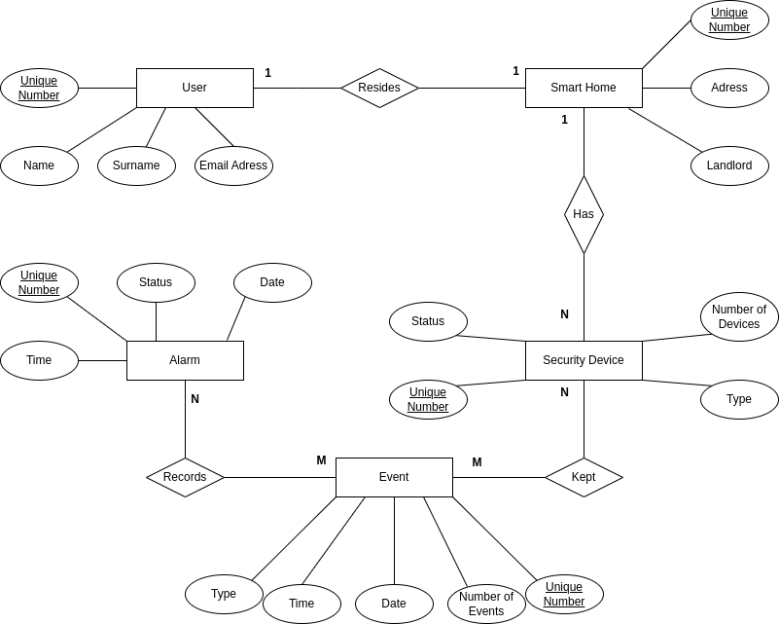

**2.** Create relational tables (*7-steps*) appropriate to the E-R diagram using ER-to-Relational Mapping algorithms and show the relationships between the tables.

STEP 1: Mapping of strong entities types

User

|  |  |  |  |
| --- | --- | --- | --- |
| Unique Number | Name | Surname | Email Adress |

Smart Home

|  |  |  |
| --- | --- | --- |
| Unique Number | Adress | Landlord |

Security Device

|  |  |  |  |
| --- | --- | --- | --- |
| Unique Number | Number of Devices | Type | Status |

Event

|  |  |  |  |  |
| --- | --- | --- | --- | --- |
| Unique Number | Number of Events | Date | Time | Type |

Alarm

|  |  |  |  |
| --- | --- | --- | --- |
| Unique Number | Status | Date | Time |

STEP 2: Mapping of weak entities types

There is no weak entity type.

STEP 3: Mapping of binary 1:1 relation types

User

|  |  |  |  |
| --- | --- | --- | --- |
| Unique Number | Name | Surname | Email Adress |

Smart Home

|  |  |  |
| --- | --- | --- |
| Unique Number | Adress | Landlord |

Resides

|  |  |
| --- | --- |
| User Unique Number | Smart Home Unique Number |

STEP 4: Mapping of binary 1:N relation types

Smart Home

|  |  |  |
| --- | --- | --- |
| Unique Number | Adress | Landlord |

Security Device

|  |  |  |  |  |
| --- | --- | --- | --- | --- |
| Unique Number | Number of Devices | Type | Status | Smart Home Unique Number |

STEP 5: Mapping of binary N:M relation types

Security Device

|  |  |  |  |
| --- | --- | --- | --- |
| Unique Number | Status | Type | Number of devices |

Event

|  |  |  |  |  |
| --- | --- | --- | --- | --- |
| Unique Number | Type | Date | Time | Number of events |

Kept

|  |  |
| --- | --- |
| Events Unique Number | Security Devices Unique Number |

Event

|  |  |  |  |  |
| --- | --- | --- | --- | --- |
| Unique Number | Type | Date | Time | Number of events |

Alarm

|  |  |  |  |
| --- | --- | --- | --- |
| Unique Number | Status | Date | Time |

Record

|  |  |
| --- | --- |
| Events Unique Number | Alarms Unique Number |

STEP 6: Mapping of multi-valued attributes

There is no multi-valued attributes.

STEP 7: Mapping of N-ary attributes relationship types

There is no N-ary relationship types.

Relationships among tables can be shown as follows:

User

|  |  |  |  |
| --- | --- | --- | --- |
| Unique Number | Name | Surname | Email Adress |

Smart Home

|  |  |  |
| --- | --- | --- |
| Unique Number | Adress | Landlord |

Resides

|  |  |
| --- | --- |
| User Unique Number | Smart Home Unique Number |

Security Device

|  |  |  |  |  |
| --- | --- | --- | --- | --- |
| Unique Number | Number of devices | Type | Status | Smart Home Unique Number |

Event

|  |  |  |  |  |
| --- | --- | --- | --- | --- |
| Unique Number | Type | Date | Time | Number of events |

Alarm

|  |  |  |  |
| --- | --- | --- | --- |
| Unique Number | Status | Date | Time |

Kept

|  |  |
| --- | --- |
| Events Unique Number | Security Devices Unique Number |

Record

|  |  |
| --- | --- |
| Events Unique Number | Alarms Unique Number |

**3.** Normalize your tables (*3NF*).

**3NF :**

Security Device:

RelationSecDevX RelationSecDevY

|  |  |  |  |  |
| --- | --- | --- | --- | --- |
| Security Devices Unique Number | Type | Status | Smart Home Unique Number | Number of Devices |

RelationSecDevX

|  |  |  |
| --- | --- | --- |
| Security Devices Unique Number | Type | Status |

RelationSecDevY

|  |  |  |
| --- | --- | --- |
| Security Devices Unique Number | Smart Home Unique Number | Number of Devices |

**4.** Using SQL Server Management Studio (SSMS), create the database using SQL commands.

create DATABASE smart_home_security_system;

use smart_home_security_system;

create table user_(

uid int primary key NOT NULL,

first_name varchar(64),

last_name varchar(64),

email_Adress varchar(64));

create table smart_home(

hid int primary key NOT NULL,

adress varchar(256),

landlord varchar(64));

create table RelationSecDevX(

did int primary key NOT NULL,

type_ varchar(64),

status_ enum('on','off') NOT NULL);

create table RelationSecDevY(

numberofdevices int,

home_id int NOT NULL,

device_id int primary key NOT NULL,

foreign key(home_id) references smart_home(hid) on delete cascade,

foreign key(device_id) references RelationSecDevX(did) on delete cascade);

create table event_(

numberofevents int,

eid int primary key NOT NULL,

type_ varchar(64),

event_date date,

event_time time);

create table alarm(

aid int primary key NOT NULL,

status_ enum('on','off') NOT NULL,

alarm_date date,

alarm_time time);

create table kept(

event_id int NOT NULL,

device_id int NOT NULL,

foreign key(event_id) references event_(eid) on delete cascade,

foreign key(device_id) references RelationSecDevX(did) on delete cascade);

create table records(

event_id int NOT NULL,

alarm_id int NOT NULL,

foreign key(event_id) references event_(eid) on delete cascade,

foreign key(alarm_id) references alarm(aid) on delete cascade);

create table resides(

user_id int NOT NULL,

home_id int NOT NULL,

foreign key(user_id) references user_(uid) on delete cascade,

foreign key(home_id) references smart_home(hid) on delete cascade);

5. Develop a user interface to your database project using any programming language and platform (Optional).

-  
6. Populate your tables with insert command.

INSERT INTO user_ (uid, first_name, last_name, email_Adress) VALUES

(1, 'Onur', 'Kutan', 'onurkutan@gmail.com'),

(2, 'Burak', 'Saran', 'buraksaran@gmail.com'),

(3, 'Adem', 'Buran', 'ademburan@gmail.com'),

(4, 'Melisa', 'Onal', 'melisaonal@gmail.com');

INSERT INTO smart_home (hid, adress, landlord) VALUES

(1, '17 eylül mah.', 'Melisa Önal'),

(2, 'paşakent mah.', 'Onur Kutan'),

(3, 'paşabayır mah.', 'Adem Buran'),

(4, 'paşakonak mah.', 'Burak Saran');

INSERT INTO RelationSecDevX (did, type_, status_) VALUES

(1, 'Kamera', 'on'),

(2, 'Hareket Sensörü', 'off'),

(3, 'Kapı Kilidi', 'on'),

(4, 'Duman Dedektörü', 'off'),

(5, 'Basınç Sensörü' , 'on');

INSERT INTO RelationSecDevY (home_id, device_id) VALUES

(1, 3),

(1, 1),

(2, 2),

(3, 4);

UPDATE `smart_home_security_system`.`RelationSecDevY` SET `numberofdevices` = '2' WHERE (`device_id` = '3');

UPDATE `smart_home_security_system`.`RelationSecDevY` SET `numberofdevices` = '2' WHERE (`device_id` = '1');

UPDATE `smart_home_security_system`.`RelationSecDevY` SET `numberofdevices` = '1' WHERE (`device_id` = '2');

UPDATE `smart_home_security_system`.`RelationSecDevY` SET `numberofdevices` = '1' WHERE (`device_id` = '4');

INSERT INTO event_ (eid, numberofevents, type_, event_date, event_time) VALUES

(1, 5, 'Kamerada Hareket Algılandı', '2024-05-07', '10:30:00'),

(4, 5, 'Hareket Algılandı', '2024-05-07', '11:15:00'),

(5, 5, 'Kapı Açıldı', '2024-05-07', '12:00:00'),

(2, 5, 'Kapı Kapandı', '2024-05-07', '12:00:00'),

(3, 5, 'Duman Algılandı', '2024-05-08', '09:00:00');

INSERT INTO alarm (aid, status_, alarm_date, alarm_time) VALUES

(1, 'on', '2024-05-07', '10:35:00'),

(2, 'off', '2024-05-07', '11:20:00'),

(3, 'on', '2024-05-07', '12:05:00'),

(4, 'on', '2024-05-08', '09:10:00');

INSERT INTO kept (event_id, device_id) VALUES

(1, 1),

(4, 2),

(5, 3),

(2, 3),

(3, 4);

INSERT INTO records (event_id, alarm_id) VALUES

(1, 1),

(2, 2),

(3, 3),

(4, 4);

INSERT INTO resides (user_id, home_id) VALUES

(1, 2),

(2, 4),

(3, 3),

(4, 1);7. Test select, insert, delete and update commands.

select * from user_;

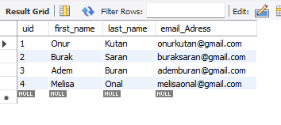

INSERT INTO `smart_home_security_system`.`user_` (`uid`, `first_name`, `last_name`, `email_Adress`) VALUES ('5', 'Ahmet', 'Yılmaz', 'ahmetyilmaz@gmail.com');

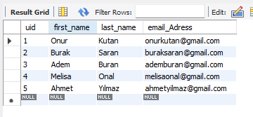

UPDATE `smart_home_security_system`.`user_` SET `first_name` = 'Ali' WHERE (`uid` = '5');

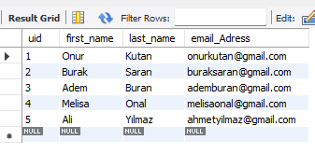

DELETE FROM `smart_home_security_system`.`user_` WHERE (`uid` = '5');

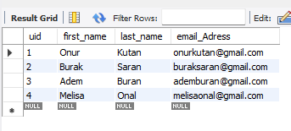

select * from smart_home;

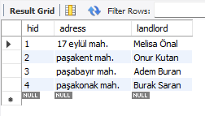

INSERT INTO `smart_home_security_system`.`smart_home` (`hid`, `adress`, `landlord`) VALUES ('5', 'Yeni mah.', 'Ahmet Yılmaz');

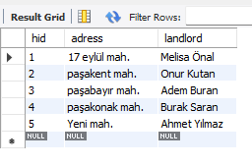

UPDATE `smart_home_security_system`.`smart_home` SET `landlord` = 'Ali Yılmaz' WHERE (`hid` = '5');

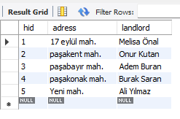

DELETE FROM `smart_home_security_system`.`smart_home` WHERE (`hid` = '5');

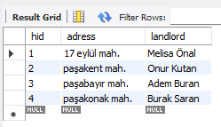

select * from RelationSecDevY;

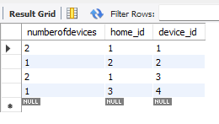

INSERT INTO `smart_home_security_system`.`RelationSecDevY` (`numberofdevices`, `home_id`, `device_id`) VALUES ('1', '4', '5');

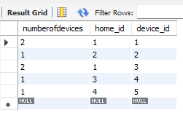

UPDATE `smart_home_security_system`.`RelationSecDevY` SET `home_id` = '2' WHERE (`device_id` = '5');

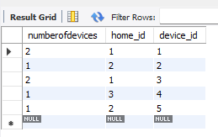

DELETE FROM `smart_home_security_system`.`RelationSecDevY` WHERE (`device_id` = '5');

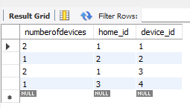

select * from event_;

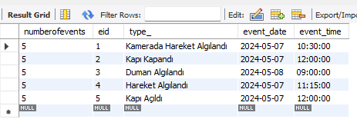

INSERT INTO `smart_home_security_system`.`event_` (`numberofevents`, `eid`, `type_`, `event_date`, `event_time`) VALUES ('5', '6', 'Kapı Kapandı', '2024-05-07', '13:00:00');

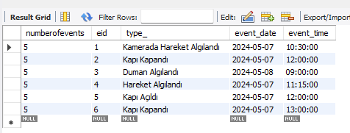

UPDATE `smart_home_security_system`.`event_` SET `event_time` = '14:00:00' WHERE (`eid` = '6');

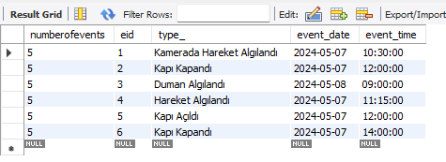

DELETE FROM `smart_home_security_system`.`event_` WHERE (`eid` = '6');

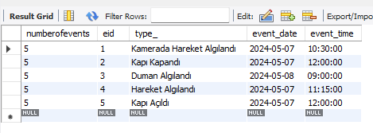

select * from alarm;

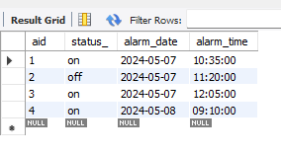

INSERT INTO `smart_home_security_system`.`alarm` (`aid`, `status_`, `alarm_date`, `alarm_time`) VALUES ('5', 'on', '2024-05-08', '12:00:00');

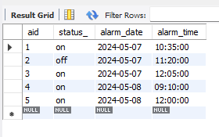

UPDATE `smart_home_security_system`.`alarm` SET `status_` = 'off' WHERE (`aid` = '5');

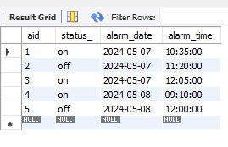

DELETE FROM `smart_home_security_system`.`alarm` WHERE (`aid` = '5');

