Nigerian Voice Assistant
Technical design document: prototype and production

An Alexa-style smart speaker that listens and replies in Yoruba, Hausa, Igbo and Nigerian-accented English, built on open Nigerian speech and language models.
Covers: what we are building and why · system architecture for both phases · how every model works · latency engineering · the maths behind the numbers · hardware · cost · evaluation · risks · further reading.
Version 1.0 · 29 September 2026 · Status: Phase 1 (prototype) code written, not yet run on GPU

Contents

If the table of contents is empty, right-click it in Word and choose Update Field.

1. Summary
We are building a voice assistant for Nigerian homes. A person says a wake word, asks a question in Yoruba, Hausa, Igbo or Nigerian English, and the device answers out loud in the same language. The work is split into two phases:
 | Phase 1 — Prototype | Phase 2 — Real use
Goal | Prove the language chain works: can we understand people and answer well in all four languages? | A physical device people use daily at home
Input/output | Laptop mic and speaker, push-to-talk | ESP32-S3 device: mic, speaker, wake word, LEDs
Server | One rented 24 GB GPU, plain HTTP over an SSH tunnel | One GPU, WebSocket streaming, TLS, device auth
Latency target | < 5 s from end of speech to first sound | < 2.5 s (aim for ~2 s)
Cost | ~$2–15 total for the whole phase | Target < ₦5 per interaction
Done when | Native speakers rate it usable on a 160-question test set | 3–5 testers use it unprompted for 2 weeks

The pipeline is the same in both phases. Only the plumbing around it changes:
- Language ID — which of the four languages is this? (Meta MMS-LID)
- Speech recognition (ASR) — turn the audio into text, using the NCAIR model for that language.
- Language model (LLM) — write a short reply in the same language. (N-ATLaS, an 8-billion-parameter Llama-3 model tuned for Nigerian languages)
- Text-to-speech (TTS) — speak the reply in a Nigerian voice. (YarnGPT2)
The key question
The single most important unknown is quality in the local languages, especially whether N-ATLaS writes good Yoruba (its own model card says Yoruba is its weakest language). Phase 1 exists to answer that cheaply before we spend money on hardware.

2. Why we are building this

2.1 The problem
Mainstream assistants (Alexa, Google Assistant, Siri) either do not support Yoruba, Hausa and Igbo at all, or support them poorly, and they often mis-hear Nigerian-accented English. Tens of millions of people are more comfortable speaking a Nigerian language than English, and many of them are exactly the people who benefit most from a voice interface: older relatives, people who read little, people who don't type comfortably on phones.

2.2 Why now
- NCAIR (Nigeria's National Centre for AI and Robotics) released open models in 2025: speech recognisers for Yoruba, Hausa, Igbo and Nigerian English, and N-ATLaS, a language model for the same languages.
- YarnGPT2 is an open text-to-speech model trained on Nigerian voices in all four languages, released under Apache-2.0.
- Cheap rented GPUs mean we can run all of this for well under a dollar an hour, instead of buying a $2,000 GPU.
- ESP32-S3 chips cost a few dollars and are capable enough to handle wake word detection and audio streaming.

2.3 Guiding principles
- Prove the hard part first. Language quality is the risk; hardware is a solved problem. So the prototype has no hardware.
- Measure, don't guess. Every turn is logged with per-stage timings, and native speakers score the output.
- Keep the device dumb, the server smart. The device only wakes, streams and plays. All intelligence lives on the server where we can update it instantly.
- Own the stack. Self-host open models rather than depend on third-party APIs whose terms can change (YarnGPT's hosted API changed owners in June 2026).

3. Audio fundamentals (the maths you need)
Everything downstream depends on how sound becomes numbers. This chapter explains the few ideas that explain most of the design choices.

3.1 Sampling and why 16 kHz
A microphone produces a continuous voltage. We measure it many times a second (the sample rate) and store each measurement as a number. The Nyquist theorem says that to capture a frequency f you must sample at least twice as fast:
fₛ ≥ 2 · f_max
fₛ = sample rate, f_max = highest frequency you want to keep
Almost all of what makes speech intelligible lives below 8 kHz, so 16 kHz sampling is the standard for speech recognition. All our ASR models and the language-ID model expect 16 kHz input. Music uses 44.1 or 48 kHz because instruments go higher. YarnGPT outputs at 24 kHz, slightly higher quality for playback.

3.2 How much data is that?
bit rate = sample rate × bits per sample × channels
16,000 × 16 × 1 = 256,000 bits/s = 32 KB/s
raw 16-bit mono audio at 16 kHz
A 5-second question is therefore about 160 KB of raw audio. That is trivial on Wi-Fi, but in Phase 2 we compress with the Opus codec, which gives near-identical speech quality at about 16–24 kbit/s, roughly 10–15× smaller. This matters on weak connections and mobile data.

3.3 From waveform to spectrogram
Models do not look at raw samples directly. Whisper-style ASR slices audio into short overlapping windows and measures how much energy there is at each frequency: a spectrogram. Whisper uses:
- a 25 ms window (400 samples at 16 kHz), moved forward 10 ms (160 samples) at a time, giving 100 frames per second;
- 80 mel bins per frame. The mel scale squashes high frequencies together, mimicking how human hearing works:
m = 2595 · log₁₀(1 + f / 700)
f in Hz, m in mels; equal steps in m sound like equal steps in pitch to a human
So 30 seconds of audio becomes a 80 × 3,000 grid of numbers: a picture of the sound that the model "reads".

3.4 Detecting speech and silence (VAD)
A voice activity detector decides, every 10–30 ms, whether someone is talking. The simplest version compares frame energy against a threshold:
E = (1/N) · Σ x[n]² speech if E > θ
Real systems (e.g. Silero VAD, a tiny neural network) are much more robust to noise such as fans, generators and TVs. The critical parameter is the silence timeout: how long we wait after the last speech frame before deciding the user has finished. This is pure dead time added to every reply:
Silence timeout | Effect
300 ms | Snappy, but cuts off people who pause mid-sentence
500–700 ms | Typical sweet spot for commands and short questions
1,000 ms+ | Safe but feels sluggish

The prototype avoids this problem with push-to-talk (you press Enter to stop). Phase 2 must tune it with real users.

4. The models: what each one does and how it works

4.1 Language identification: MMS-LID-126
What: a model from Meta's Massively Multilingual Speech project that listens to a clip and outputs a score for each of 126 languages. It is built on wav2vec 2.0, a network that learned general features of human speech by listening to huge amounts of unlabelled audio, then was fine-tuned to classify languages. About 1 billion parameters.
How we use it: we only support four languages, so we throw away the other 122 scores and re-normalise the remaining four with a softmax restricted to our set S = {eng, yor, hau, ibo}:
pᵢ = exp(zᵢ) / Σⱼ∈S exp(zⱼ)
zᵢ = raw model score (logit) for language i; the four pᵢ sum to 1
Why restrict: Nigerian-accented English can look statistically similar to other English-based or West African languages. Without the restriction the model might answer "Nigerian Pidgin" or "Ewe", for which we have no ASR model. Restricting forces a choice among languages we can actually handle.
Watch out
Code-switching ("Mo fẹ́ lọ sí market today") has no single right answer. Phase 1 measures how often this breaks things. Fallback if LID is unreliable: run all four ASR models and choose the transcript the models are most confident in (see §6.4).

4.2 Speech recognition: NCAIR Whisper-small models
What: four separate models (Yoruba, Hausa, Igbo, Nigerian-accented English), each a fine-tuned version of OpenAI's Whisper-small (244 million parameters, ~0.5 GB in fp16).
How Whisper works: it is an encoder–decoder transformer. The encoder turns the 80 × 3,000 spectrogram into 1,500 vectors that describe the sound. The decoder then writes the transcript one token (word-piece) at a time, each time looking back at the encoder output through attention (§4.3), like a person listening and taking dictation.
Design consequence
Whisper always pads input to 30 seconds. A 3-second question costs the encoder the same as a 30-second one. That is fine for our short queries (~0.1–0.3 s on a modern GPU) but is why streaming ASR models exist for longer dictation.

How we measure ASR quality: Word Error Rate. Compare the transcript to what the speaker actually said:
WER = (S + D + I) / N
S = substituted words, D = deleted words, I = inserted words, N = words in the reference
Example: the speaker said 10 words; the ASR got one word wrong and missed one. WER = (1 + 1 + 0) / 10 = 20%. Lower is better. WER can exceed 100% if the model hallucinates lots of extra words. For Yoruba and Igbo, decide up front whether a missing tone mark counts as an error (we suggest reporting both: with and without diacritics).

4.3 The language model: N-ATLaS 8B
What: an 8-billion-parameter model built on Meta's Llama 3, fine-tuned by Awarri and NCAIR on Nigerian language data. It reads the transcript plus our instructions and writes the reply.

How a transformer LLM generates text
Text is split into tokens (roughly word pieces). The model reads all tokens so far and outputs a probability for every possible next token; we pick one, append it, and repeat. The core operation is self-attention, where each token decides how much to "look at" every other token:
Attention(Q, K, V) = softmax( Q·Kᵀ / √dₖ ) · V
Q, K, V = query, key and value vectors computed from the tokens; dₖ = their dimension
Temperature controls randomness when picking the next token. The model's scores zᵢ are divided by T before the softmax:
pᵢ = exp(zᵢ / T) / Σⱼ exp(zⱼ / T)
Low T (we use 0.1) makes the model pick the most likely token almost always: consistent and factual, good for an assistant. High T (≈1) is more creative and more error-prone.

How much GPU memory does it need?
memory for weights = parameters × bytes per parameter
Precision | Bytes / param | N-ATLaS 8B weights | Fits on 24 GB with everything else?
fp16 / bf16 | 2 | ≈ 16 GB | Barely — too tight with 5 other models
8-bit | 1 | ≈ 8 GB | Yes
4-bit (NF4) | 0.5 | ≈ 4–5.5 GB (incl. overhead) | Yes, comfortably — prototype default

Quantisation stores each weight in fewer bits. 4-bit NF4 (from the QLoRA paper) places its 16 possible values where neural-network weights actually cluster (a normal distribution), so quality loss is usually small. On a ≥ 40 GB GPU the prototype loads full fp16 automatically.
The model also needs memory for the KV cache: stored keys and values for every token so far, so it doesn't recompute them. For Llama-3-8B (32 layers, 8 key/value heads, 128 dimensions each, fp16):
KV per token = 2 × layers × kv_heads × head_dim × bytes = 2 × 32 × 8 × 128 × 2 = 131,072 B ≈ 128 KB
A 1,000-token conversation needs ~128 MB of KV cache: small for one user, but it adds up quickly when serving many devices at once, which is why Phase 2 uses vLLM (§7.4).

Why generation speed is limited by memory bandwidth
To produce each new token, the GPU must read every weight once. For a single user, the GPU spends most of its time waiting on memory, not doing maths. A good upper-bound estimate:
tokens per second ≲ memory bandwidth ÷ size of weights
GPU | Bandwidth | Ceiling, fp16 (16 GB) | Ceiling, 4-bit (~5 GB)
RTX A5000 | 768 GB/s | ~48 tok/s | ~150 tok/s
RTX 4090 | 1,008 GB/s | ~63 tok/s | ~200 tok/s
L4 | 300 GB/s | ~19 tok/s | ~60 tok/s

Watch out
These are theoretical ceilings. The bitsandbytes 4-bit library used in the prototype is convenient but slow at generation, often reaching only a fraction of the ceiling. Phase 2 switches to AWQ/GPTQ kernels in vLLM, which get much closer. Measure, don't assume.

Reply time is then:
T_LLM = TTFT + N_tokens / r
TTFT = time to first token (reading the prompt), N = reply length in tokens, r = tokens per second
Example: an 80-token reply at 35 tok/s with a 0.1 s TTFT takes 0.1 + 80/35 ≈ 2.4 s. This is why the system prompt demands 1–3 sentences: every token you don't generate is latency you don't pay.

4.4 Text-to-speech: YarnGPT2
What: a small (360 million parameter) language model, fine-tuned from SmolLM2, that writes audio tokens instead of text tokens. A separate decoder, WavTokenizer, turns those tokens into a waveform.
How it works:
- The text is cleaned: numbers become words, and it is romanised to plain a–z with uroman.
- A short recording of a reference speaker (e.g. yoruba_male2), already converted to audio tokens, is placed in the prompt. The model continues in that voice.
- The model generates audio tokens one at a time, exactly like an LLM generates words.
- WavTokenizer decodes the tokens into 24 kHz audio.
WavTokenizer uses 75 tokens per second of audio, each representing 320 samples:
24,000 samples/s ÷ 75 tokens/s = 320 samples per token
So 8 seconds of speech requires ~600 generated audio tokens. The real-time factor (RTF) measures synthesis speed:
RTF = synthesis time / audio duration = 75 / r_tts
r_tts = audio tokens generated per second. RTF < 1 means faster than real time
If YarnGPT generates 250 tokens/s, RTF = 0.3: 8 s of speech takes 2.4 s to make. As long as RTF < 1 and we synthesise sentence by sentence, the speaker never runs dry once it starts playing.
Important limitation
Because of the uroman step, YarnGPT ignores Yoruba and Igbo tone marks. "ọkọ" (husband), "ọkọ̀" (vehicle) and "ọkọ́" (hoe) all become "oko". The tones you hear come from what the model learned from context, not from the text. Tone errors in the spoken output should be scored separately in Phase 1.

Why sentence by sentence: YarnGPT quality drops on long inputs and it has a 4,000-token limit (the reference voice already uses part of it). Chunking also lets us start playing sentence 1 while sentence 2 is still being generated (§6).

5. Phase 1: the prototype

5.1 What it is
A laptop records your question, sends it to a rented GPU, and plays back the reply. No hardware, no wake word, no streaming: the simplest thing that tests the whole language chain end to end.
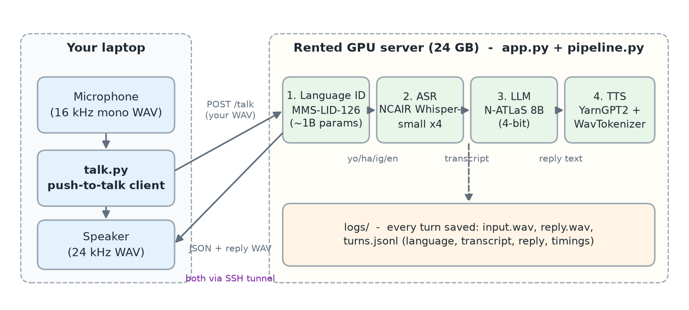
Figure 1 — Prototype architecture

5.2 Code structure
File | Runs on | Purpose
server/pipeline.py | GPU | Loads all models once; run(audio) does LID → ASR → LLM → TTS and records a timing for each stage. Can also be run directly on a WAV file for testing.
server/app.py | GPU | FastAPI web server. POST /talk accepts a WAV, returns JSON (language, scores, transcript, reply, timings) plus the reply audio. Logs every turn to logs/.
server/setup.sh | GPU | One-time install: dependencies, YarnGPT code, WavTokenizer weights, and pre-downloads all ~25 GB of model weights.
client/talk.py | Laptop | Push-to-talk: Enter to start, Enter to stop. Sends the audio, prints the result, plays the reply. --lang skips LID, --file sends a WAV.
test_questions.md | — | 40 questions + recording instructions for native speakers.

5.3 Design decisions and why
Decision | Why
Rented GPU, not a laptop | N-ATLaS needs a CUDA GPU with ≥ 12 GB. On a Mac CPU it would take minutes per reply.
Self-host YarnGPT, not its API | No 80-requests/day limit; no dependency on an API whose owner and pricing just changed; same code works in Phase 2.
Plain HTTP, one request per turn | Simplest possible transport. Streaming is a Phase 2 optimisation; first we need to know the answers are good.
SSH tunnel instead of a public port | The server listens only on 127.0.0.1, so nobody on the internet can reach it or run up our GPU bill. No passwords or TLS setup needed.
LID restricted to 4 languages | Forces a decision among languages we can handle (§4.1).
--lang override | Lets us separate "LID picked wrong" from "ASR is bad" when debugging.
4-bit LLM on < 40 GB GPUs | Fits everything on a cheap 24 GB card (§4.3).
Fixed voice per language | A consistent assistant personality; also removes one variable from testing.
Short replies (1–3 sentences, ≤150 tokens) | Latency scales with reply length (§4.3, §4.4); long spoken answers are also tiring to listen to.
Log everything | The logs are the test set: audio in, audio out, transcript, reply and timings, ready for scoring.

5.4 Running it
# On the GPU box (once)
export HF_TOKEN=hf_... # after accepting the NCAIR model terms
./setup.sh
python pipeline.py test.wav # smoke test
uvicorn app:app --host 127.0.0.1 --port 8000

# On the laptop
ssh -p <port> -N -L 8000:localhost:8000 root@<gpu-host> # terminal 1
python talk.py # terminal 2

5.5 Test plan and metrics
Four native speakers (or more) each record the 40 questions in test_questions.md, giving 160+ utterances, plus optional mixed-language ones. Each file comes with a text file of exactly what was said.
Metric | How to compute | Prototype target
LID accuracy | correct languages ÷ total utterances | ≥ 90%
ASR usable | native speaker: "is the transcript close enough to answer?" yes/no. Also compute WER with jiwer | ≥ 80% usable
Reply quality | native speaker scores 1–5 (rubric below) | average ≥ 3.5
Voice naturalness | native speaker scores 1–5, noting tone errors | average ≥ 3.5
Latency | end of speech → first sound; report p50 and p90 | p50 < 5 s

Scoring rubric for replies: 5 = correct, natural, right language · 4 = correct, slightly awkward · 3 = understandable but clumsy or partly wrong · 2 = mostly wrong or partly in the wrong language · 1 = useless or wrong language.
Why percentiles
Report the p90 (the time 90% of turns beat), not just the average. Users remember the slow turns. An assistant that averages 2 s but takes 8 s one time in ten feels broken.

5.6 Cost
Community-cloud rental prices in 2026 are roughly $0.16/hr (RTX A5000) to $0.34/hr (RTX 4090) on RunPod. Check current prices before renting. Realistic usage for the whole prototype phase is 10–40 GPU-hours, so $2–15 in total. The main waste is leaving the machine running between sessions: stop it every time.

6. Latency: where the time goes and how we cut it

6.1 What we measure
The number that matters to a user is time to first audio (TTFA): from the moment they stop talking to the moment they hear the first sound of the reply. It does not matter how long the full reply takes to generate, as long as the speaker never falls silent mid-answer.

6.2 The latency equation
In the prototype, every stage waits for the previous one to finish completely:
TTFA_sequential = T_up + T_LID + T_ASR + T_LLM(all) + T_TTS(all) + T_down
In Phase 2, stages overlap. The speaker starts as soon as the first sentence is synthesised:
TTFA_streamed = T_silence + T_LID/ASR + TTFT + n₁/r_llm + T_TTS(sentence 1) + T_net
where n₁ is the number of tokens in the first sentence. The whole reply's length no longer appears in the equation. That is the single biggest win available.
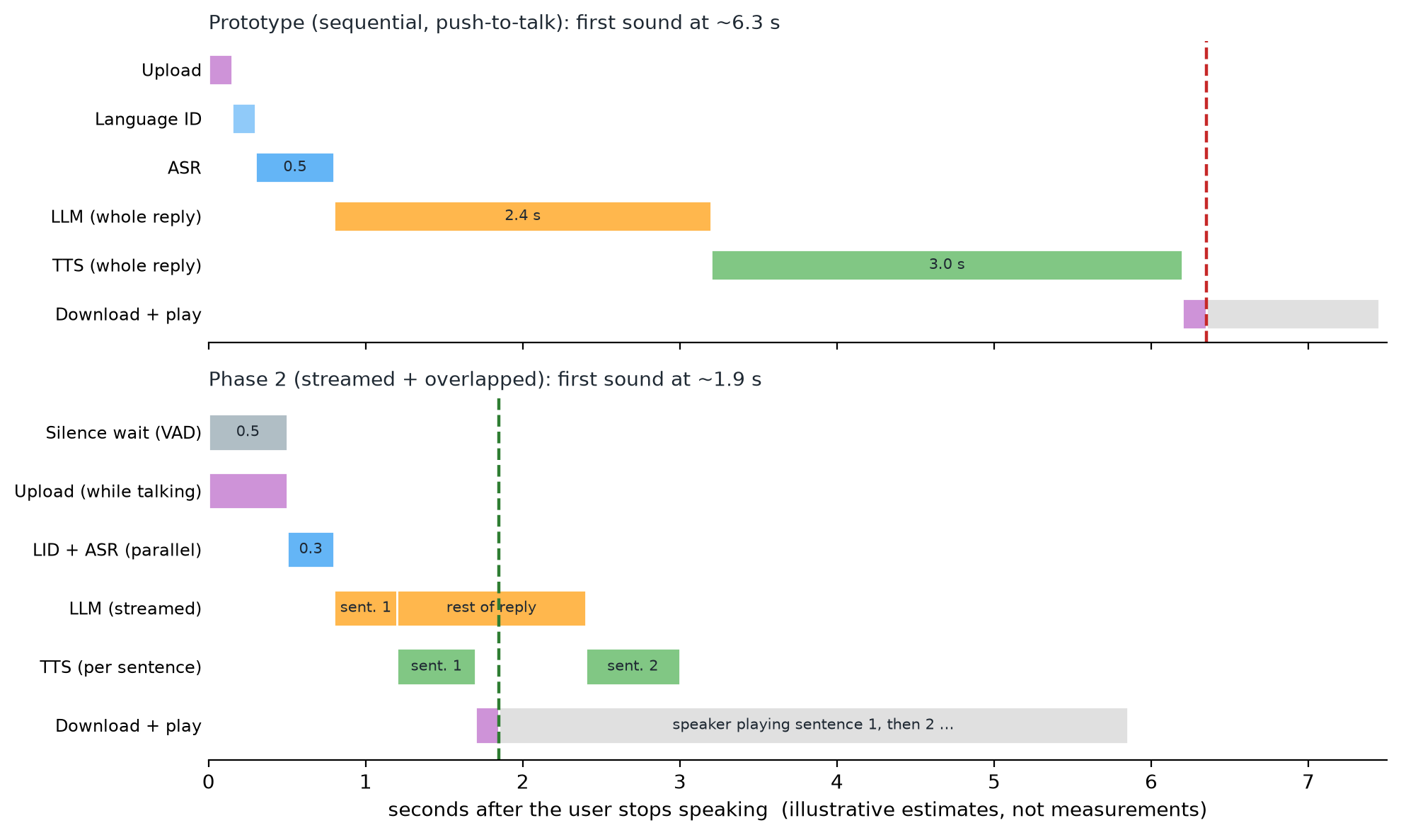
Figure 2 — Sequential vs streamed pipeline (illustrative estimates)

6.3 Latency budget
Stage | Prototype (estimate) | Phase 2 target | How we get there
Silence detection | 0 (push-to-talk) | 0.4–0.6 s | Tuned VAD timeout
Upload | ~0.15 s | ~0 s | Stream audio while the user is still talking
Language ID | ~0.15 s | 0.05–0.1 s | fp16, run in parallel with ASR
ASR | ~0.5 s | 0.2–0.3 s | faster-whisper (CTranslate2), warm models
LLM to 1st sentence | (whole reply) ~2.4 s | 0.3–0.5 s | vLLM + AWQ, stream tokens, short first sentence
TTS 1st sentence | (whole reply) ~3 s | 0.4–0.6 s | Sentence streaming, cached voice prompt, torch.compile
Download/network | ~0.1 s | ~0.1–0.15 s | Server region close to Nigeria; Opus
Time to first audio | ≈ 6 s | ≈ 1.5–2.3 s

Watch out
The prototype numbers are estimates from typical hardware performance. The prototype may miss the < 5 s target at first. That's fine: Phase 1's job is to measure real numbers so we optimise the right stage.

6.4 The techniques, in order of impact
- Stream the LLM into the TTS sentence by sentence. Removes the full reply length from TTFA. Typically saves several seconds.
- Keep replies short and ask for a short first sentence. Latency is proportional to tokens generated (§4.3).
- Stream audio up while the user is talking, so the upload is done the instant they stop.
- Use a faster LLM runtime: vLLM with AWQ 4-bit kernels instead of bitsandbytes. Often several times faster.
- Faster ASR: convert the Whisper fine-tunes to CTranslate2 (faster-whisper). Commonly 2–4× faster at the same accuracy.
- Run LID and ASR in parallel: start the English ASR speculatively while LID runs; if LID says English, the transcript is already done. Or run all four ASR models as a batch, which also fixes code-switching problems (pick the most confident).
- Cache the TTS voice prompt: the reference-speaker tokens are identical every call, so their KV cache can be computed once and reused.
- Tune the silence timeout with real users. Every 100 ms here is 100 ms on every turn.
- Server location: a round trip from Nigeria to a European data centre is roughly 100 ms or more; to the US more. Pick the closest region with GPUs.
- Perceived latency tricks: play a short "thinking" chime or light up the LEDs the instant speech ends. Users tolerate delay much better when they know they were heard.

7. Phase 2: the real device

7.1 What changes
The laptop is replaced by a small ESP32-S3 device with a microphone, speaker and LED ring. It listens for a wake word locally, then streams audio to the server over an encrypted WebSocket and plays the reply as it arrives.
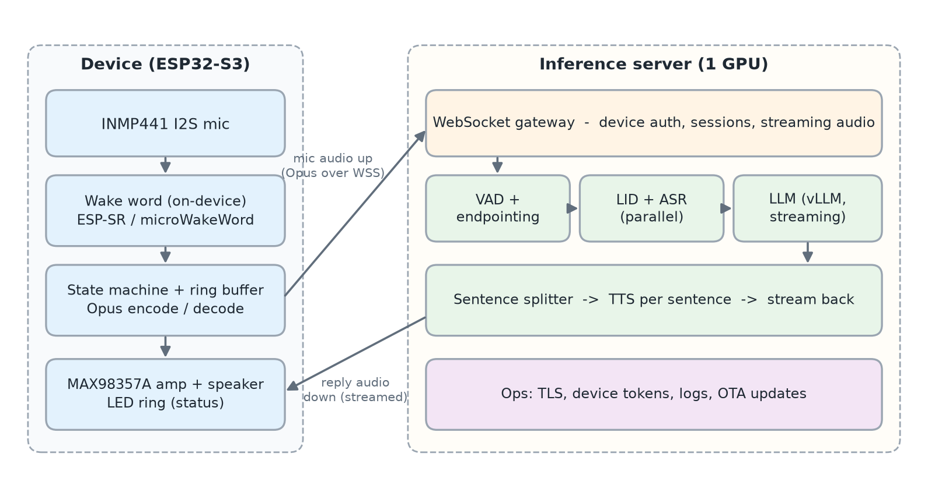
Figure 3 — Phase 2 architecture

7.2 Why ESP32-S3 (and why nothing runs locally)
- The ESP32-S3 has two 240 MHz cores, vector instructions for small neural networks, Wi-Fi, and I2S audio interfaces. With 8 MB of PSRAM it can run a wake-word model and buffer audio comfortably. A plain ESP32 lacks the AI instructions and memory: use the S3.
- The models in the pipeline total ~7–20 GB and need a GPU. An ESP32 has kilobytes to a few megabytes of RAM. No ESP32 can run them; the device is the ears and mouth, the server is the brain.
- Advantage: all intelligence lives on the server, so we can improve the assistant without touching the devices.

7.3 Hardware
Part | Role | Approx. cost
ESP32-S3 DevKit (N16R8: 16 MB flash, 8 MB PSRAM) | Brain of the device: wake word, Wi-Fi, audio I/O | $8–12
INMP441 I2S MEMS microphone | Digital mic, 24-bit, no analogue noise | $2–4
MAX98357A I2S amplifier | 3 W class-D amp, drives the speaker directly from I2S | $3–5
3 W, 4 Ω speaker | Output | $2–4
WS2812 LED ring | Status: listening / thinking / speaking | $2–4
5 V 2 A USB-C supply + enclosure | Power and case | $5–10
Total (DIY) |  | ≈ $20–40
Alternative: ESP32-S3-BOX-3 dev kit | All-in-one: two mics, speaker, screen, echo-cancellation support | ≈ $45–55

Prices are rough and vary by supplier. Start with the BOX-3 for speed, and move to the DIY build for cost once the firmware works.

7.4 Device firmware
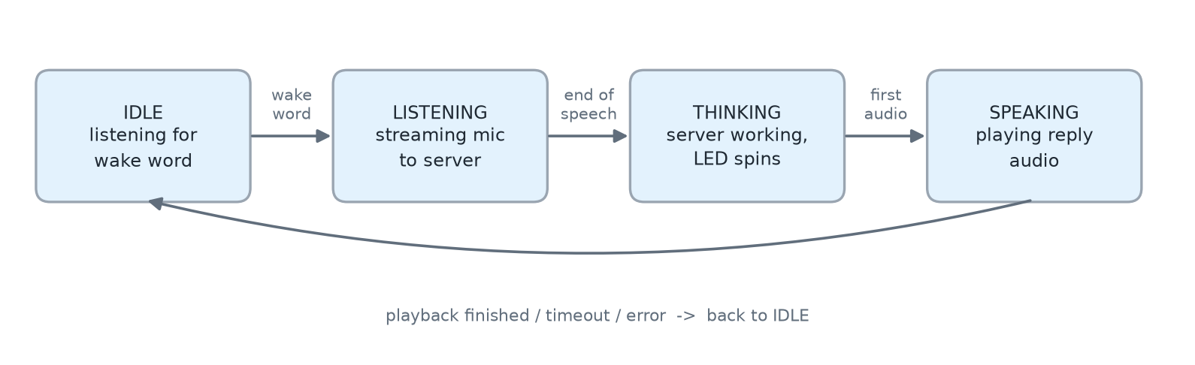
Figure 4 — Device state machine
- Wake word: Espressif's ESP-SR (WakeNet) or microWakeWord runs continuously on-device. Nothing is sent to the server until the wake word fires, which is good for privacy and bandwidth.
- Pre-roll ring buffer: keep the last ~0.5 s of audio in memory so the first word after the wake word isn't cut off.
- Streaming: send 20 ms Opus frames over a WebSocket (WSS, i.e. TLS-encrypted) as soon as the wake word fires.
- Playback: decode incoming audio chunks into an I2S output buffer; start playing as soon as the first chunk arrives.
- OTA updates: firmware can be updated over Wi-Fi without opening the case.

Wake word maths: the two kinds of error
A wake-word detector outputs a confidence score and fires above a threshold. Raising the threshold trades one error for another:
Error | Meaning | Typical target
False reject rate (FRR) | You said the wake word, it ignored you | < 5%
False accepts per hour (FA/h) | It woke up when nobody said it (e.g. from the TV) | < 1 per 10 hours

Start with a stock wake word; training a custom Nigerian-named one (e.g. in Yoruba) is a later project that needs a few hundred recordings of the word.

7.5 Server changes
Area | Prototype | Phase 2
Transport | HTTP POST, whole clip | WebSocket: binary audio frames + JSON control messages, both directions
End of speech | User presses Enter | Server-side VAD (e.g. Silero) with tuned timeout
LLM runtime | transformers + bitsandbytes | vLLM with AWQ-quantised N-ATLaS; token streaming; batching many devices
ASR runtime | transformers Whisper | faster-whisper (CTranslate2)
TTS | whole reply, sentence chunks concatenated | sentence-level streaming back to the device
Security | SSH tunnel | TLS, per-device tokens, rate limits
Observability | turns.jsonl | Per-stage latency metrics (p50/p90), error rates, dashboards

WebSocket protocol sketch
device → server {"type":"hello", "device_id":"...", "token":"..."}
device → server {"type":"start"} # wake word fired
device → server <binary Opus frames, 20 ms each>
server → device {"type":"listening_done"} # VAD detected end of speech
server → device {"type":"transcript", "lang":"yoruba", "text":"..."}
server → device <binary reply audio chunks> # sentence 1, 2, ...
server → device {"type":"done"}

7.6 Cost at scale
A GPU rented 24/7 at $0.34/hr costs about $245 per month whether it is busy or idle. What matters is how many interactions share that cost:
cost per interaction = monthly GPU cost ÷ interactions per month
Worked example: 100 devices × 10 questions/day × 30 days = 30,000 interactions/month. $245 ÷ 30,000 ≈ $0.008 per interaction, comfortably inside the < ₦5 target. The GPU is nowhere near its limit: at ~4 GPU-seconds per turn one GPU can serve ~900 turns an hour even without batching, and vLLM batching raises that further.
Capacity check: peak load matters more than daily average. If 10% of daily traffic lands in the busiest hour, 30,000/30 × 10% = 100 turns in that hour, far below capacity.

7.7 Echo cancellation (later)
If the device is speaking and the user interrupts ("barge-in"), the microphone hears the device's own voice. Acoustic echo cancellation (AEC) subtracts a filtered copy of what the speaker is playing from the mic signal. ESP-SR's audio front-end supports AEC given a reference signal; the BOX-3 provides this loopback in hardware. Out of scope for v1: the device simply doesn't listen while it's talking.

8. Risks, licensing and open questions

8.1 Risks
Risk | Likelihood | Mitigation
N-ATLaS writes weak Yoruba (its own card says so) | High | Measure in Phase 1; compare against a general API LLM on the same transcripts; consider fine-tuning later
LID confuses languages, especially with code-switching | Medium | --lang override for debugging; fallback to running all four ASR models
TTS tone errors (tone marks are stripped) | Medium | Score tone separately; feed back to YarnGPT maintainers; evaluate other TTS later
Latency too high | Medium | Streaming + runtime upgrades in §6.4
Noisy homes (generators, TV) | Medium | Record some test audio in real noise; VAD tuning; better mic placement
Model terms or hosting change | Low–Med | Self-host open weights; pin versions

8.2 Licensing
Component | License | What it means for us
NCAIR ASR models + N-ATLaS | Open-Source Research and Innovation License | Free for research and pilots. Cap of 1,000 active end users; commercial use needs a separate licence from Awarri. Attribution to Awarri Technologies and the Federal Government of Nigeria required. Prohibits surveillance and discriminatory uses.
YarnGPT2 | Apache-2.0 | Commercial use allowed with attribution
MMS-LID-126 | CC-BY-NC 4.0 | Non-commercial. Fine for the prototype; for a commercial product, replace or licence it
Whisper (base architecture) | MIT | Permissive

Watch out
Before moving past a pilot, confirm every licence on its current model card and start the conversation with Awarri about commercial terms.

8.3 Open questions
- Product name and wake word?
- Should the assistant ever reply in English when spoken to in another language (e.g. on request)?
- Multi-turn memory: should it remember the previous question?
- Which data centre region gives the best latency from where the testers live?

9. References and further reading
Grouped from beginner-friendly to deep. Papers are on arXiv and free to read.

9.1 Start here (intuition first)
- Hugging Face Audio Course: free, hands-on course on audio data, ASR, TTS and spectrograms — https://huggingface.co/learn/audio-course
- Jay Alammar, "The Illustrated Transformer": the clearest visual explanation of attention — https://jalammar.github.io/illustrated-transformer/
- Andrej Karpathy, "Let's build GPT: from scratch, in code" (video): how LLMs generate text, built step by step — https://www.youtube.com/watch?v=kCc8FmEb1nY
- Jurafsky & Martin, Speech and Language Processing (3rd ed. draft): free textbook; see chapters on ASR, TTS and transformers — https://web.stanford.edu/~jurafsky/slp3/

9.2 The models we use
- Radford et al., 2022. Robust Speech Recognition via Large-Scale Weak Supervision (Whisper) — https://arxiv.org/abs/2212.04356
- Baevski et al., 2020. wav2vec 2.0: A Framework for Self-Supervised Learning of Speech Representations — https://arxiv.org/abs/2006.11477
- Pratap et al., 2023. Scaling Speech Technology to 1,000+ Languages (MMS, including MMS-LID) — https://arxiv.org/abs/2305.13516
- Llama Team, Meta, 2024. The Llama 3 Herd of Models (base of N-ATLaS) — https://arxiv.org/abs/2407.21783
- Ji et al., 2024. WavTokenizer: an Efficient Acoustic Discrete Codec Tokenizer for Audio Language Modeling — https://arxiv.org/abs/2408.16532
- Allal et al., 2025. SmolLM2: When Smol Goes Big (base of YarnGPT2) — https://arxiv.org/abs/2502.02737
- NCAIR models on Hugging Face (Yoruba-ASR, Hausa-ASR, Igbo-ASR, NigerianAccentedEnglish, N-ATLaS) — https://huggingface.co/NCAIR1
- YarnGPT2 model card and code — https://huggingface.co/saheedniyi/YarnGPT2
- uroman: universal romaniser used by YarnGPT (Hermjakob et al., ACL 2018) — https://github.com/isi-nlp/uroman

9.3 Making it fast
- Vaswani et al., 2017. Attention Is All You Need (the transformer) — https://arxiv.org/abs/1706.03762
- Dettmers et al., 2023. QLoRA (introduces the NF4 4-bit format we use) — https://arxiv.org/abs/2305.14314
- Lin et al., 2023. AWQ: Activation-aware Weight Quantization (Phase 2 quantisation) — https://arxiv.org/abs/2306.00978
- Kwon et al., 2023. Efficient Memory Management for LLM Serving with PagedAttention (vLLM) — https://arxiv.org/abs/2309.06180
- Dao et al., 2022. FlashAttention — https://arxiv.org/abs/2205.14135
- faster-whisper (CTranslate2 Whisper runtime) — https://github.com/SYSTRAN/faster-whisper
- Silero VAD — https://github.com/snakers4/silero-vad

9.4 Hardware and protocols
- Espressif ESP-SR: wake word (WakeNet), audio front-end, AEC — https://github.com/espressif/esp-sr
- microWakeWord: open wake-word models for ESP32 — https://github.com/kahrendt/microWakeWord
- ESP-IDF I2S driver documentation — https://docs.espressif.com/projects/esp-idf/en/latest/esp32s3/api-reference/peripherals/i2s.html
- RFC 6716: the Opus audio codec — https://www.rfc-editor.org/rfc/rfc6716
- RFC 6455: the WebSocket protocol — https://www.rfc-editor.org/rfc/rfc6455

9.5 Measuring quality
- jiwer: Python library to compute WER — https://github.com/jitsi/jiwer

Appendix A. Glossary
Term | Meaning
ASR | Automatic speech recognition: audio → text
TTS | Text-to-speech: text → audio
LID | Language identification: which language is being spoken
LLM | Large language model: generates text one token at a time
Token | A word piece; the unit models read and write. Also used for audio codes in YarnGPT
VAD | Voice activity detection: is someone speaking right now?
Endpointing | Deciding the user has finished speaking
TTFT | Time to first token from the LLM
TTFA | Time to first audio: end of user speech → first sound of reply. Our main latency metric
RTF | Real-time factor: synthesis time ÷ audio length. < 1 is faster than real time
WER | Word error rate: (substitutions + deletions + insertions) ÷ reference words
p50 / p90 | Median / 90th-percentile latency: half / 90% of turns are faster than this
Quantisation | Storing weights in fewer bits (e.g. 4-bit) to save memory and bandwidth
KV cache | Stored attention keys/values so the LLM doesn't recompute past tokens
fp16 / bf16 | 16-bit floating-point number formats used on GPUs
I2S | Digital audio bus between chips (mic → ESP32 → amplifier)
PSRAM | Extra external RAM on ESP32 boards
Opus | Compressed audio codec designed for real-time speech
WebSocket (WSS) | A persistent two-way connection over the web; WSS is the encrypted version
AEC | Acoustic echo cancellation: removes the device's own voice from the mic signal
Code-switching | Mixing languages in one sentence

