VALUEMAX 2026
Zuri Electronics — Sales Performance Dashboard
Project documentation and presentation guide
Prepared by Emmanuel Ajibola · Power BI Desktop and Power BI Service · Source: Zuri_Electronics.xlsx

1. Overview
Zuri Electronics is a US retailer selling Furniture, Office Supplies and Technology. Management supplied three deliberately messy exports and asked for one interactive dashboard answering four questions: are we growing, what drives profit, where are discounts hurting margin, and how fast do we ship?
All cleaning was done in Power Query rather than in Excel or the report layer, so the pipeline re-runs automatically on every refresh. The result is a single-page report published to the Power BI Service with a daily refresh and a row-level security role.

2. Part 1 — Cleaning in Power Query
The Orders sheet arrived with inconsistent Ship Mode casing, Sales mixing plain numbers with currency text such as $3,104.92, Discount mixing decimals with text percentages, and blank Ship Date and Cost cells.
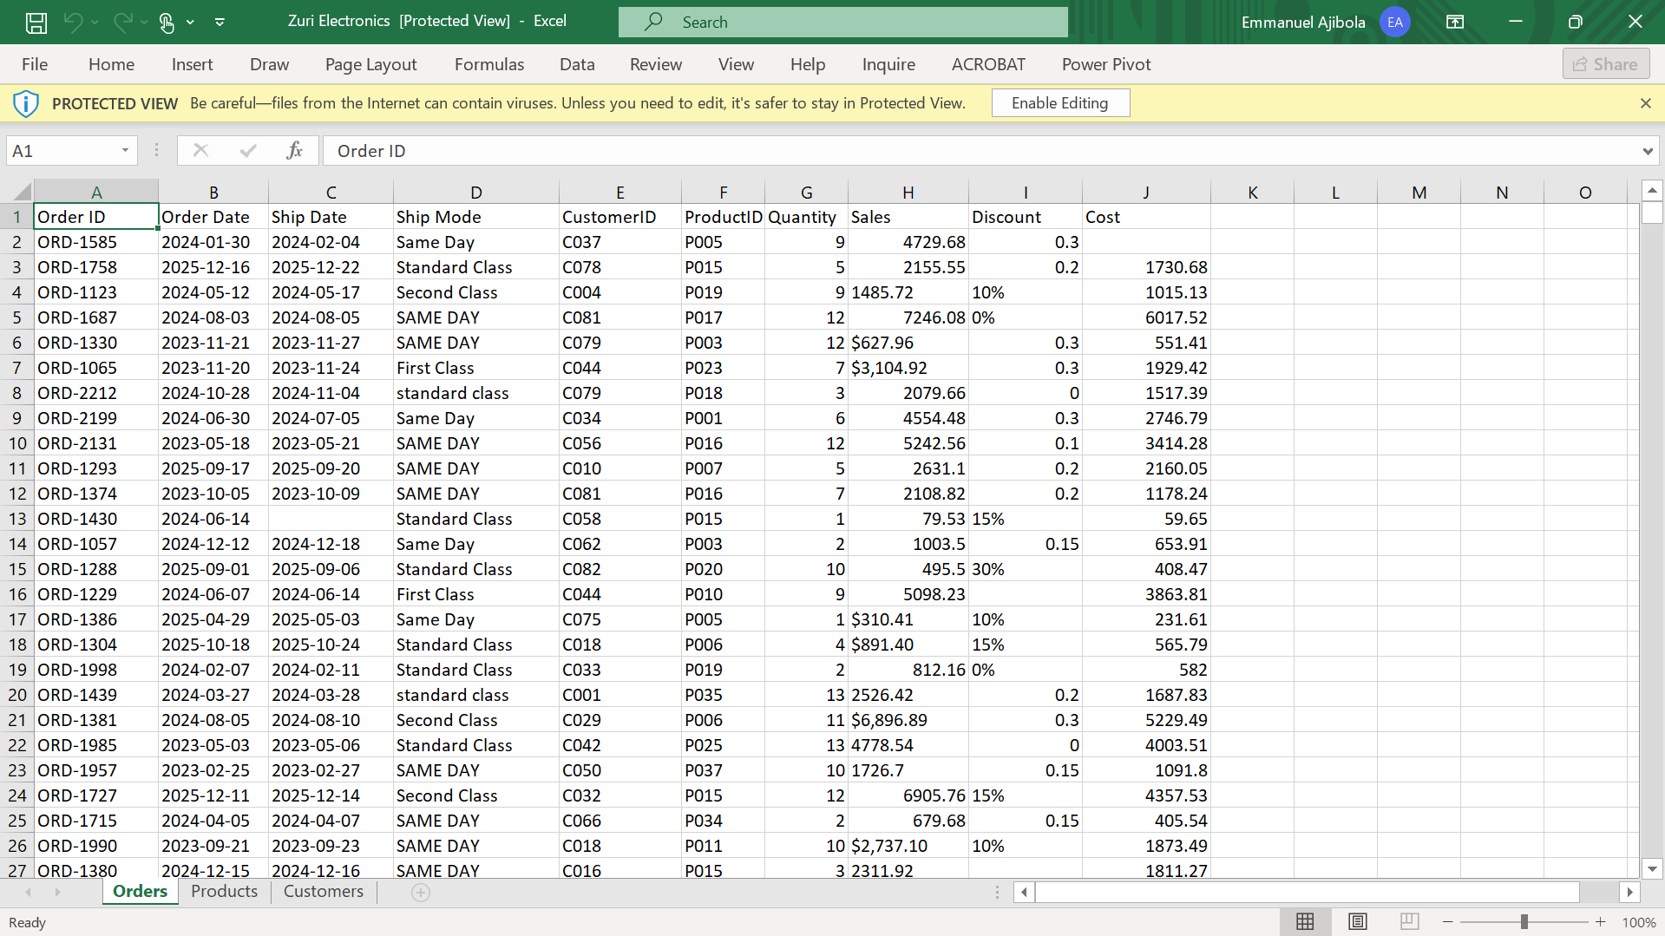
Figure 1 — The raw workbook before cleaning.
Every fix below lives as a named applied step, which is the audit trail for the whole transformation.
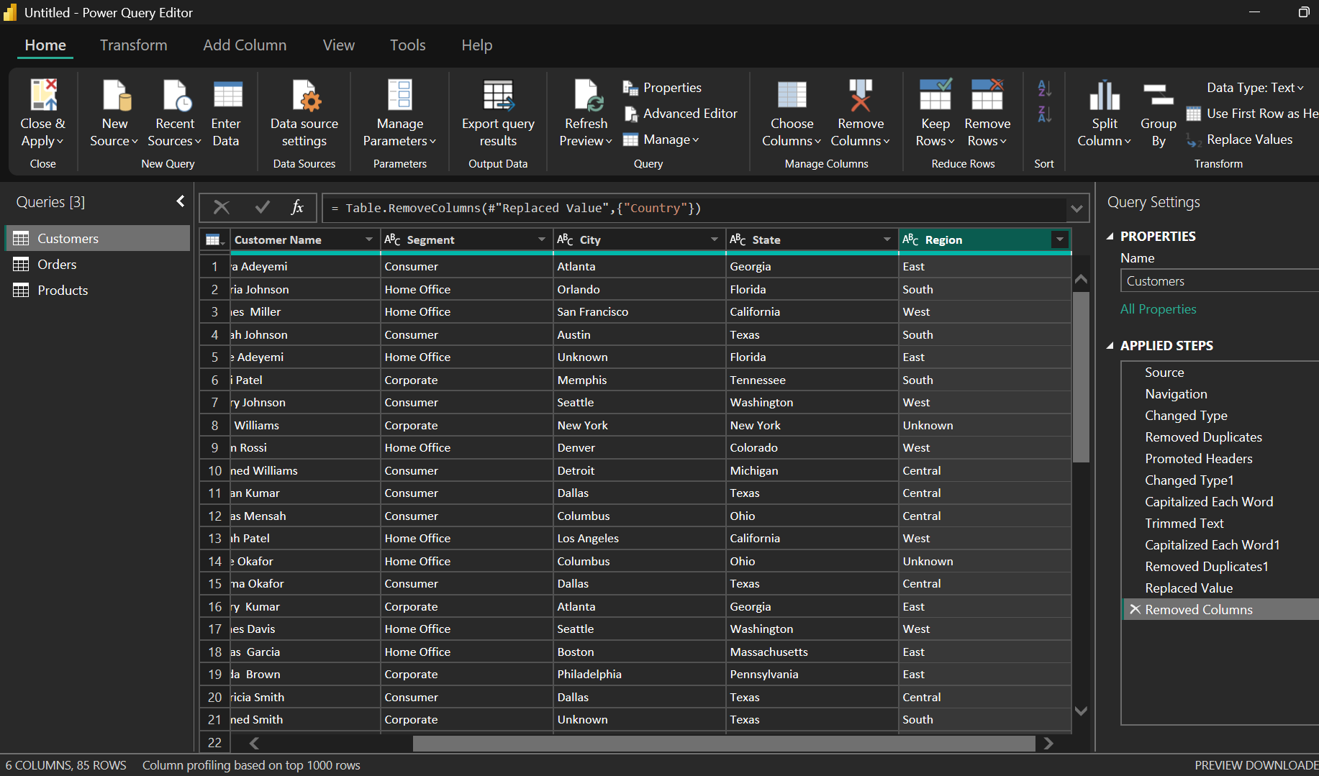
Figure 2 — Power Query Editor: three named queries and readable applied steps.

Sheet | Issue | Fix and why
Orders | Exact duplicate rows | Remove Duplicates across all columns. Duplicates would inflate Total Sales and Total Orders
Orders | Dates imported as text | Changed type to Date. Text dates cannot relate to the Date table and break all time intelligence
Orders | Sales mixed with $, commas, trailing spaces | Trimmed, replaced $ and , then set Decimal Number. Any stray character keeps the column as text, and text cannot be summed
Orders | Discount mixed: 0.2, 10%, blanks | Removed %, divided those by 100, replaced blanks with 0, set Decimal Number. If 10% stayed as 10 it would read as a 1000% discount
Orders | Cost had nulls | Replaced with 0 so Profit still calculates. Documented limitation: margin is slightly overstated on that subset, but deleting the rows would lose real revenue
Orders | Ship Mode casing (SAME DAY, standard class) | Trimmed then Capitalize Each Word, so one shipping method is not counted as three separate categories
Orders | Missing Ship Date | Left as null. Nulls drop out of Average Days to Ship; inventing a date would fabricate a delivery
Products | Category inconsistent (tech, TECHNOLOGY) | Trimmed, capitalised, then Replace Values to fold into Furniture, Office Supplies, Technology. Four spellings would split one category across four slices
Products | Product Name casing and padding | Trimmed and capitalised so each product appears once, not as near-duplicates
Customers | Customer Name double spaces and casing | Trimmed, collapsed double spaces, capitalised. The same customer written two ways counts as two
Customers | Segment inconsistent (consumer, CONSUMER) | Standardised to Consumer, Corporate, Home Office — Segment drives a slicer
Customers | City and Region nulls | Replaced with "Unknown" rather than deleting. Keeps real revenue in the totals and makes the gap visible

The Country column was removed from Customers because every row held the same value.

3. Parts 2–4 — Model, columns and measures

Data model
A star schema: Orders as the fact table, with Customers, Products and a DAX Date table as dimensions. All three relationships are many-to-one, single direction — which keeps filter paths unambiguous and avoids silently wrong totals.
From | To | Type
Orders[CustomerID] | Customers[CustomerID] | Many-to-one, single direction
Orders[ProductID] | Products[ProductID] | Many-to-one, single direction
Orders[Order Date] | DateTable[Date] | Many-to-one, single direction

DateTable = CALENDARAUTO()
Marked as a date table via Table tools > Mark as date table. A separate date table gives one continuous calendar including days with no sales, so a quiet month shows as zero instead of vanishing from the trend line — and TOTALYTD and SAMEPERIODLASTYEAR only work correctly against one.

Calculated columns
Column | DAX
Profit | Profit = Orders[Sales] - Orders[Cost]
Price Per Unit | Price Per Unit = DIVIDE(Orders[Sales], Orders[Quantity])
Days to Ship | Days to Ship = DATEDIFF(Orders[Order Date], Orders[Ship Date], DAY)
Discount Band | Discount Band = SWITCH(TRUE(), Orders[Discount]=0, "No Discount", Orders[Discount]<=0.1, "Low", Orders[Discount]<=0.2, "Medium", "High")
Date table | Year = YEAR([Date]) · Month Name = FORMAT([Date],"MMMM") · Month Number = MONTH([Date]) · Quarter = "Q" & QUARTER([Date])

Month Name is sorted by Month Number, otherwise the trend line runs April, August, December alphabetically. Discount Band is a column rather than a measure because it has to work as an axis and a filter.

Measures
Measure | DAX
Total Sales | Total Sales = SUM(Orders[Sales])
Total Cost | Total Cost = SUM(Orders[Cost])
Total Profit | Total Profit = SUM(Orders[Profit])
Profit Margin % | Profit Margin % = DIVIDE([Total Profit], [Total Sales])
Total Orders | Total Orders = DISTINCTCOUNT(Orders[Order ID])
Total Quantity | Total Quantity = SUM(Orders[Quantity])
Average Order Value | Average Order Value = DIVIDE([Total Sales], [Total Orders])
Average Days to Ship | Average Days to Ship = AVERAGE(Orders[Days to Ship])
Sales YTD | Sales YTD = TOTALYTD([Total Sales], DateTable[Date])
Sales Last Year | Sales Last Year = CALCULATE([Total Sales], SAMEPERIODLASTYEAR(DateTable[Date]))
YoY Growth % | YoY Growth % = DIVIDE([Total Sales] - [Sales Last Year], [Sales Last Year])
% of Total Sales | % of Total Sales = DIVIDE([Total Sales], CALCULATE([Total Sales], ALL(Orders)))

DIVIDE is used throughout instead of / because it returns blank on a zero denominator rather than an error that breaks the visual. Total Orders uses DISTINCTCOUNT because one order can span several product lines.

4. Part 5 — The dashboard
One page at 1280 x 720 on a custom Executive Slate theme, laid out the way an executive reads: headline numbers first, then the trend, then the breakdowns.
Zone | Contents
Left rail | Dark panel with the Zuri Electronics wordmark, a Filters heading, four slicers (Category, Year, Region, Segment) and an Insights navigation button
Header band | Report title "Executive sales performance" with the period and scope on the right
KPI row | Total Sales, Total Profit, Profit Margin %, Total Orders, Average Order Value
Middle row | Monthly sales trend line (wide, left) and Sales by Region bar chart (right)
Bottom row | Category and sub-category breakdown (left) and Sales by Category donut (right)

Why each visual is there
- KPI cards answer "how are we doing overall?" — the numbers a manager checks first, so they sit at the top in the largest type.
- A line chart for the trend rather than bars, because the eye reads slope and direction faster than it compares bar heights.
- Sales by Region sorted descending, so the strongest and weakest markets are obvious without reading labels.
- A donut for category mix — appropriate with only three categories, where the question is share of the whole rather than precise comparison.
- All four slicers grouped in one rail rather than scattered, giving the charts more vertical space and one predictable place to look for controls.
- Everything aligned to a grid, one palette from the theme, and no scrolling — which is what makes it usable on a projector.

5. Part 6a — Publishing and scheduled refresh
Published from Power BI Desktop with Home > Publish. Because the source is a local Excel workbook, a personal data gateway was installed and bound to the dataset so the Service has a route back to the file.
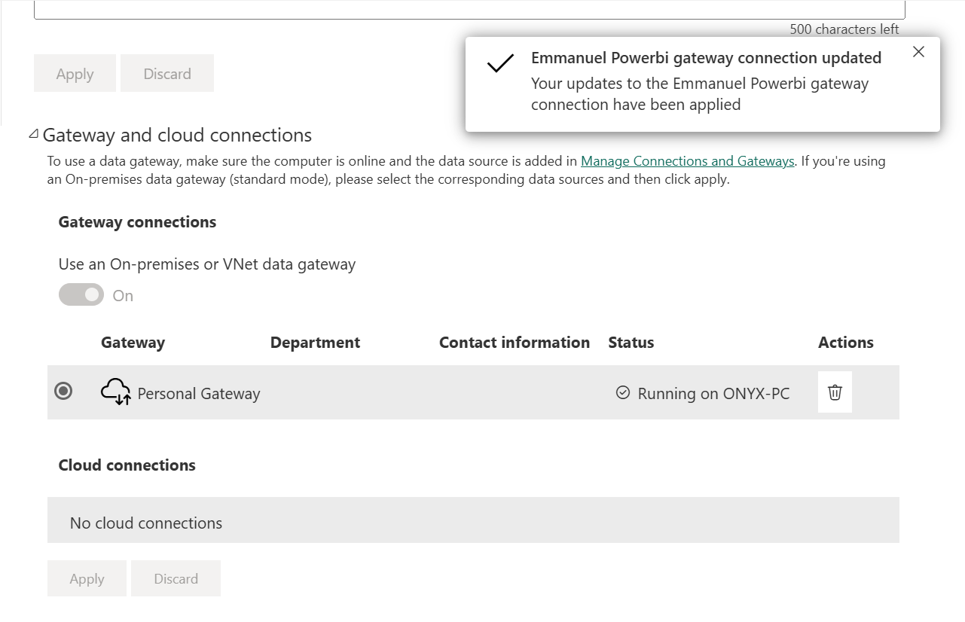
Figure 3 — Gateway connection applied; Personal Gateway shows as Running.
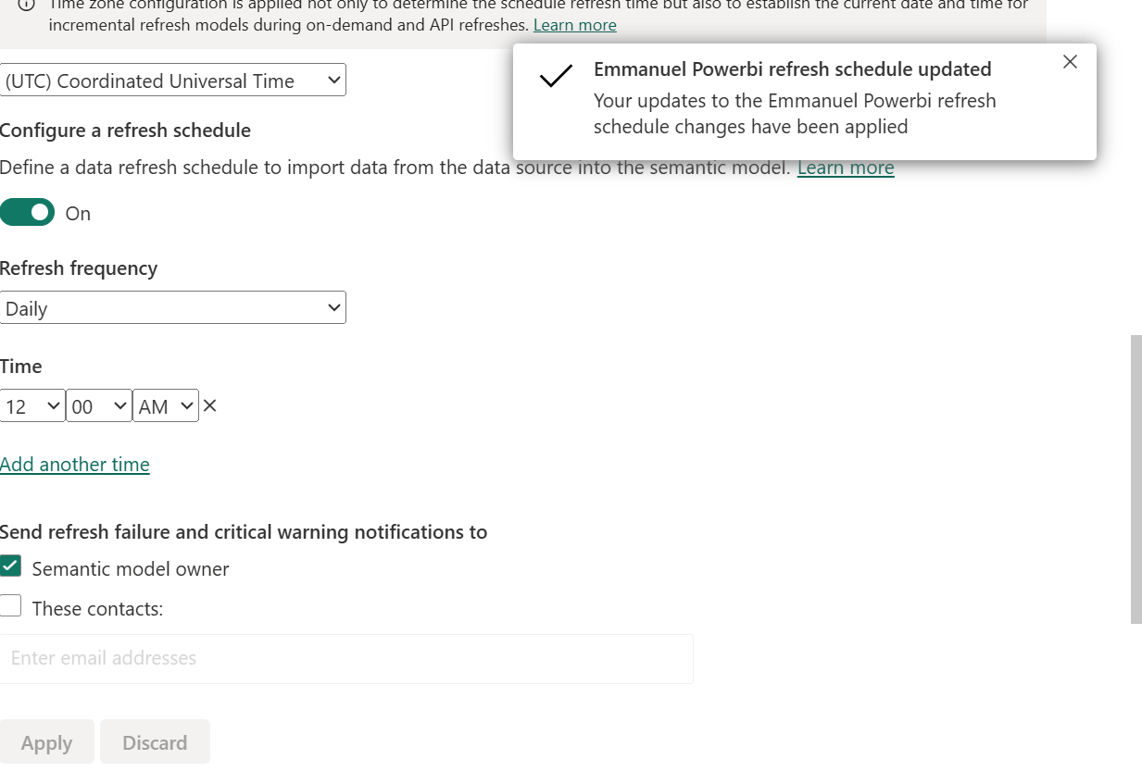
Figure 4 — Daily refresh at 12:00 AM UTC, failure notifications to the model owner.

Why 12:00 AM
- After the business day closes, so the refresh picks up a complete day rather than a partial one.
- Outside working hours, so nobody reads a half-refreshed report.
- Lowest server load, reducing the chance of queuing or timeout.
- Daily is enough — the report answers strategic questions about trend, margin and region, none of which change hour to hour.
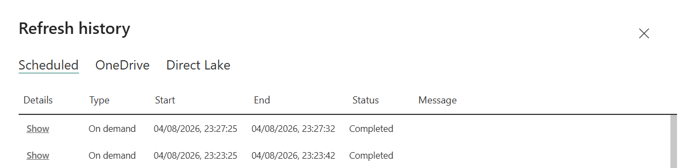
Figure 5 — Refresh history confirming successful runs.

6. Part 6b — Row-level security
One role, RegionManager, created via Modelling > Manage roles, filtering the Customers table:
[Region] = "West"
The filter sits on the Customers dimension. Because the relationship runs Orders to Customers in a single direction, filtering the dimension filters every order belonging to customers outside that region — and therefore every card, chart and total on the page.
Tested with Modelling > View as roles: Total Sales, Total Profit and Total Orders all dropped to the West subset and the Region chart showed a single bar. Exiting the role restored full figures.
What it hides and why it matters: a regional manager sees only their own region's customers, orders, sales, profit and margin. Other regions are filtered out of every calculation, so national totals cannot be inferred by subtraction. Margin data reveals pricing strategy and customer lists are commercially valuable, so one report can be published once and shared widely instead of maintaining a separate file per region.

7. Part 6c — Insights for management
These three sit on a dedicated page reachable from the Insights button. Each names a finding and what follows from it.
- High discounting erodes profit. Discounts above 20% lift order volume but reduce margin by more than the extra volume recovers, so the discount ceiling should be capped on the affected product lines.
- Standard Class shipping is a bottleneck at five to seven days, noticeably slower than Same Day or First Class — the tier most likely to drive complaints and repeat-purchase drop-off. Renegotiate carrier terms or steer customers to faster tiers at checkout.
- Corporate and Consumer carry the business, generating most net profit, while Home Office is weakest on both revenue and contribution. Concentrate marketing on the two segments that already convert.

8. How to present it
Step | What to say and do
Open (30 sec) | Lead with the business question, not the tool: "Management wanted to know four things — are we growing, what drives profit, where are discounts hurting margin, and how fast do we ship. This page answers all four."
KPIs (45 sec) | Read the five cards in order. Explain margin in plain language. Then stop — do not explain how each measure is written unless asked
Trend (45 sec) | Describe the shape rather than the values: rising, flat, seasonal. Mention the Date table is what makes year-on-year possible
Breakdowns (60 sec) | Left to right: Region answers where the money is, the category visual answers what is selling, the donut answers the mix. Name the strongest and weakest in each
Interactivity (60 sec) | Do it live. Click one region and let them watch every visual recalculate. Cross-filter by clicking a bar. Say: "nothing here is a static picture — any manager can ask their own question of this page"
Security (30 sec) | One sentence on RegionManager: a regional manager sees only their region and every total recalculates, so other regions cannot be inferred
Close (45 sec) | Click Insights and read the three conclusions as recommendations. End on discounting — it is the one with money attached

Have ready: the report open with slicers cleared, the Service tab on refresh history, View as roles ready to demo, and Power Query open in a second window in case you are asked to show the applied steps.

