

Design Document

**12/8/2014**

***v1.0***

**JUDGE FROG**

# Revision History

|  |  |  |
| --- | --- | --- |
| Version | Changes | Edited |
| 1.0 | * Initial Draft | November 25, 2014 |
|  |  |  |
|  |  |  |
|  |  |  |

# Revision Sign-Off

By signing the following, the team member is stating that he has read the entire document and has concluded that the information contained within this document is accurate, relevant to the project, and void of errors.

|  |  |  |
| --- | --- | --- |
| Name | Signature | Date Signed |
| Brice Boula |  |  |
| Collin Duncan |  |  |
| David Tomlinson |  |  |
| Landon Westrom |  |  |

# Table of Contents

Revision History ii

Revision Sign-Off iii

Table of Contents iv

1. Introduction 1

1.1 Purpose 1

1.2 Project Background 1

1.3 Section Overview 1

2. Design Constraints 2

2.1 Assumptions and Dependencies 2

2.2 General Constraints 2

2.3 Development Environment 3

3. System Architecture 4

3.1 Database 4

3.2 Web Application 4

4. Database Design 5

4.1 Case Table 6

4.2 Judge 7

4.3 Case_has_Judge 7

4.4 Case_has_Defendant 7

4.5 Case_has_OrganizedCrimeGroup 7

4.6 Defendant 7

4.7 Bail 8

4.8 Victims 9

4.9 Sentence 10

4.10 Charge 11

4.11 Arrest Charge Details 12

5. UML Models 14

5.1 Sequence Diagrams 14

5.1.1 Admin Create Sequence 14

5.1.2 Admin Edit Sequence 15

5.1.3 Admin Delete Sequence 16

5.1.4 Admin Uploads Sequence 17

6. User Interface Prototype 18

7. Glossary of Terms 22

# Introduction

## Purpose

This document provides a complete description of the Judge Frog system design. Included in this document are design constraints, system architecture, user interface design, and Unified Modeling Language (UML) diagrams (state, class, and sequence).

## 1.2 Project Background

Judge Frog is designed to be a fully functional web application with a user-friendly user interface. The application shall provide an efficient database containing significant human trafficking data inserted by the client. The end user shall be presented with visual graphs and charts to sort and analyze the data using various filters. Concluding the user’s data analysis, the user shall have the option of exporting the visual data.

## 1.3 Section Overview

**Section 2 – Design Constraints**: Describes assumptions and dependencies, general constraints, and developmental methods for the Judge Frog web application.

**Section 3 – System Architecture**: Displays a model of the architecture and major component descriptions.

**Section 4 – File Design**: Describes how data from sensors is stored on the smartphone and the on-board control unit (OBCU).

**Section 5 – UML Models**: Displays the state, class and sequence diagrams.

**Section 6** **–** **User Interface**: Gives screenshots from the prototype of the smartphone application.

**Section 7 – Glossary of Terms**: Defines technical and project-specific terms used in this document.

# Design Constraints

## 2.1 Assumptions and Dependencies

The Judge Frog Web application will assume the following:

* The user shall access the Web application from a desktop computer
* The user can use the Web application after instruction

## 2.2 General Constraints

* Time
  + Development must be completed by the end of the school year in May 2015.
* Data storage
  + Finite amount of storage space on server used for storage
* Communication
  + Requires continuous Internet access to use the application
* Browser
  + Internet Explorer version 9 or higher
  + Google Chrome version 40 or higher
  + Mozilla Firefox version 33 or higher
  + Safari version 5 or higher

## 2.3 Development Environment

**Programming Environment**

* MySQLWorkbench 6.2 CE
* PHP 5
* CakePHP Framework
* GitHub.com
* phpMyAdmin 4.0.4.2
* MySQL 5.6.14
* Microsoft-IIS/8.5
* Bootstrap 3.1.1

**Productivity Software**

* Microsoft Visio 2013
* Microsoft Word 2013
* Microsoft PowerPoint 2013
* Microsoft Excel 2013

# System Architecture



## Database

Our database will store human trafficking data collected by the National Institute of Justice. The well-designed database is stored on our server to be interacted with the web application. The database is developed with the Extended Entity-Relationship model using MySQL Workbench. The database is structured much differently than the data our client provided us to allow for more efficient use of resources and quicker response times.

## Web Application

The developed Web application will connect to the database to insert and retrieve human trafficking data to create analysis for the user. The Web application will provide a detailed tutorial on the functionality and navigation present in the application. There shall be a separate portal for administrative access to database functions.

# Database Design

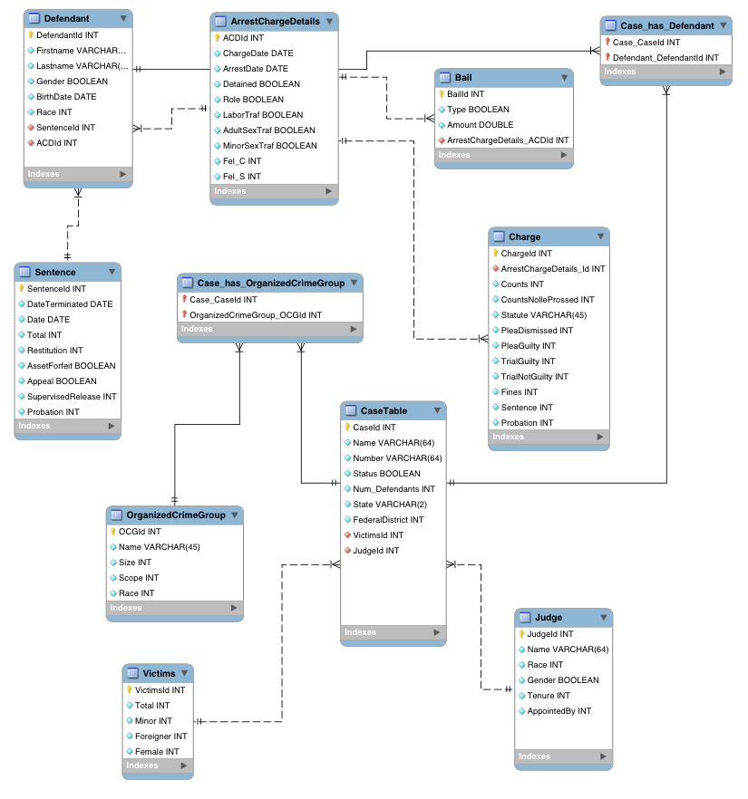

## 4.1 Case Table

|  |  |  |
| --- | --- | --- |
|  |  |  |
| ***Variable Name*** | ***Type*** | ***Description*** |
| CaseId | INT | The key unique to each case |
| Name | VARCHAR(64) | The case name, which is usually USA v. LAST NAME OF FIRST DEFENDANT.  Use case name as listed on the docket. |
| Number | VARCHAR(64) | This is the criminal case number from the US District Court.  Be sure that the case number has cr (criminal) in the middle and not mj (magistrate). We want the CRIMINAL case number only.  Obtain the number at the top of the docket. |
| Status | BOOLEAN | The Status of the case is either open or closed. |
| Num_Defendants | INT | Total number of defendants in the case.  Count the number of defendants listed on the docket. |
| State | VARCHAR(2) | Two letter code for the state in which the case is being heard. |
| FederalDistrict | INT | The federal district number for the state in which the case is being heard.  Look on federal district court map online to determine what federal district a state is in. |
| CourtId | INT | ID of the court |
| DefenseId | INT | ID of the defense |
| VictimsId | INT | ID of the Victim |
| ACDId | INT | ID of the Arrest & Charge Details |
| SentenceId | INT | ID of the sentence |

## 4.2 Judge

|  |  |  |
| --- | --- | --- |
| ***Variable Name*** | ***Type*** | ***Description*** |
| JudgeId | INT | Primary key unique to each judge |
| Name | VARCHAR(64) | Name of the US federal district court judge hearing the case. |
| Race | INT | Google the name of the judge and either look at picture or read bio to determine the race of the judge. Code judge’s race with the following numbers: 0=White 1=Black 2=Hispanic 3=Asian 4=Indian 5=Other |
| Gender | BOOLEAN | Determine the gender of the judge either based on name itself or, if it is a unisex name, based on the judge’s picture.  0=Male; 1=Female. |
| Tenure | INT | The year the judge was appointed as a federal district judge.  Obtain this information from the judge’s bio online. |
| AppointedBy | INT | This is the partisan identity of the president who appointed the judge.  0=Republican; 1=Democrat. |

## 4.3 Case_has_Judge

|  |  |  |
| --- | --- | --- |
| ***Variable Name*** | ***Type*** | ***Description*** |
| Case_CaseId | INT |  |
| Judge_JudgeId | INT |  |

## 4.4 Case_has_Defendant

|  |  |  |
| --- | --- | --- |
| ***Variable Name*** | ***Type*** | ***Description*** |
| Case_CaseId | INT |  |
| Defendant_DefendantId | INT |  |

## 4.5 Case_has_OrganizedCrimeGroup

|  |  |  |
| --- | --- | --- |
| ***Variable Name*** | ***Type*** | ***Description*** |
| Case_CaseId | INT |  |
| OrganizedCrimeGroup_OCGId | INT |  |

## 4.6 Defendant

|  |  |  |
| --- | --- | --- |
| ***Variable Name*** | ***Type*** | ***Description*** |
| DefendantId | INT | Primary key unique to each defendant |
| Firstname | VARCHAR(45) | First name of the defendant |
| Lastname | VARCHAR(45) | Last name of the defendant |
| Gender | BOOLEAN | The gender of the defendant.  Can be determined by name.  If it is not discernable by the name, read indictment to determine how it refers to defendant (he/she). |
| BirthDate | DATE | The defendant’s birthdate.  Sometimes the birthdate of the defendant can be found in the indictment. |
| Race | INT | The race of the defendant.  This may require googling the name and looking at Google images, or searching for news articles on the case.  Sometimes this information is also indicated in the indictment. |

## 4.7 Bail

|  |  |  |
| --- | --- | --- |
|  |  |  |
| ***Variable Name*** | ***Type*** | ***Description*** |
| BailId | INT | Primary key unique to the bail |
| Type | BOOLEAN | Type of bail the defendant was required to pay, if any.  If the defendant was detained, then code 0=No Bail.  If the defendant was released, the docket will indicate if they are required to post bail.  If the docket indicates a surety bond, then code 1.  If the bond is non-surety, then code 2.  If the bail is “personal recognizance” then code 0=no bail. |
| Amount | DOUBLE | The bail amount the defendant is required to pay.  Do not include dollar sign or comma in the bail amount.  If the bail amount is $10,000, then code 10000. |
| ArrestChargeDetails_ACDId | INT |  |

## 4.8 Victims

|  |  |  |
| --- | --- | --- |
| ***Variable Name*** | ***Type*** | ***Description*** |
| VictimId | INT | Primary key unique to each victim |
| Total | INT | Total number of victims.  This information is obtained via the last indictment that was filed in the case.  Sometimes the indictments list all the victims (which makes it easy), other times you have to read through the indictment to determine the total number of victims.  The number of victims is the number of victims specified in the indictment, though it is the MINIMUM number of victims known to the prosecution, not necessarily all of the victims. |
| Minor | INT | Number of victims that were minors.  The indictment indicates which of the victims are “minor” or “child” victims, sometimes listed and sometimes not.  The number of victims that were minors is based on those known in the indictment and should be considered the MINIMUM number of minor victims. |
| Foreigner | INT | Number of victims that are not natural born citizens of the United States.  If there is no mention in the indictment of a nationality, then assume none are foreign born. |
| Female | INT | Number of victims that are female.  Obtain this information from the indictment.  May need to infer from pronouns used in indictment referring to victims. |

## 4.9 Sentence

|  |  |  |
| --- | --- | --- |
| ***Variable Name*** | ***Type*** | ***Description*** |
| SentenceId | INT | Primary key unique to each sentence |
| DateTerminated | DATE | Date when sentence was terminated |
| Date | DATE | This is the date the defendant was sentenced.  You should search the docket for “sentencing hearing as to FIRST LAST” |
| Total | INT | This is the total number of months sentenced (if consecutive, then adds up all consecutive sentences, if concurrent, then total concurrent months).  This can be found in the “Disposition” column next to the defendant’s name. |
| Restitution | INT | This is the total amount defendant is required to pay in restitution.  This can be found in the “Disposition” column next to the defendant’s name.  Do not include a dollar sign or commas in the restitution column.  For example, if defendant is to pay restitution in the amount of $100,000, then you would code 100000. |
| AssetForfeit | BOOLEAN | If defendant has been required to forfeit any assets at all, then code 1. If the defendant is not required to forfeit any assets, then code 0.  This can be found in the “Disposition” column next to the defendant’s name. |
| Appeal | BOOLEAN | The top of the docket will have the appeals court case number if the case has been appealed.  However, that does not mean that all defendants have appealed their sentence.  Thus, to determine whether a specific defendant has appealed, search in docket “Notice of appeal by FIRST LAST” |
| SupervisedReleased | INT | Total number of months the defendant received supervised release. |
| Probation | INT | The total number of months a defendant received probation.  This is NOT the same as supervised release.  If a defendant received probation for life, then code 1200 months (100 years). |

## 4.10 Charge

|  |  |  |
| --- | --- | --- |
| ***Variable Name*** | ***Type*** | ***Description*** |
| ChargeId | INT | Primary key unique to the charge |
| ArrestChargeDetails_Id | INT |  |
| Count | INT | Number of counts charged under the statute.  You count only the charges from the most recent indictment (indicated by s after the statute number).  Some cases have no superseding indictments, and some cases have four+ (indicated by ssss).  You need to make sure that you are coding based on the most recent superseding indictment (if one exists).  You count the number of times the defendant is charged in the last superseding indictment under that particular statute. |
| CountsNolelProssed | INT |  |
| Statue | VARCHAR(45) | States whether the defendant was charged under this federal statute |
| PleaDismissed | INT | The number of counts dismissed pursuant to a plea bargain. |
| PleaGuilty | INT | The number of counts to which the defendant plead guilty. |
| TrialGuilty | INT | The number of counts to which the defendant has received a guilty verdict in a trial. |
| TrialNotGuilty | INT | The number of counts to which the defendant has received a not guilty verdict by trial. |
| Fines | INT | This is an actual fine assessed to the defendant.  Do not include a dollar sign or commas in the fine.  For example, if the fine is $100,000, then you would code 100000.  This is NOT the special assessment.  Almost all defendants have to pay a special assessment of $100, but this is NOT a fine. |
| Sentence | INT |  |
| Probation | INT | This is the number of months a defendant got probation.  If they got probation for life, then code for 100 years, or 1200 months.  Probation is often imposed as a substitute for imprisonment.  This is NOT the same as supervised release, which is imposed in addition to imprisonment.  Here we are coding only for probation, not for supervised release. |

## 4.11 Arrest Charge Details

|  |  |  |
| --- | --- | --- |
| ***Variable Name*** | ***Type*** | ***Description*** |
| ACDId | INT | Primary key unique to each arrest charge detail |
| ChargeDate | DATE | Date the government filed the charges/indictment.  Search the docket for “Indictment” and report the date that the original indictment was filed (no need to report the subsequent dates of the superseding indictment(s)). |
| ArrestDate | DATE | Date the defendant was arrested.  Search the docket for “arrest as to” or for “warrant returned executed” and report the date of the arrest/warrant executed. |
| Detained | BOOLEAN | Indicate if the defendant was detained between arrest and first hearing, or if they were released.  Search the docket for “order of detention” and/or “conditions of release”  0=released; 1=detained. |
| Role | BOOLEAN | Indicates if the defendant was a primary offender or a secondary offender in the trafficking operation.  You should be able to get a sense of the defendant’s role from reading the indictment.  You may also get a sense of the role from the number of felonies charged to the defendant compared to the number of felonies of other defendants in the case. |
| LaborTraf | BOOLEAN | Indicates whether this was a labor trafficking case or not.  If it is labor trafficking, then code 1.  If it is not a labor trafficking case, then code 0.  You must read the indictment to obtain this information (or it can be discerned from the case summary). It is possible for a case to be more than one type of trafficking—the categories of labor trafficking, adult sex trafficking, and minor sex trafficking are not mutually exclusive. |
| AdultSexTraf | BOOLEAN | Indicates whether this was a case of sex trafficking adult victims.  If it is adult sex trafficking, then code 1.  If it is not an adult sex trafficking case, then code 0.  You must read the indictment to obtain this information (or it can be discerned from the case summary).  It is possible for a case to be more than one type of trafficking—the categories of labor trafficking, adult sex trafficking, and minor sex trafficking are not mutually exclusive. |
| MinorSexTraf | BOOLEAN | Indicates whether this was a case of sex trafficking minor victims.  If it is minor sex trafficking, then code 1.  If it is not a minor sex trafficking case, then code 0.  You must read the indictment to obtain this information (or it can be discerned from the case summary).  It is possible for a case to be more than one type of trafficking—the categories of labor trafficking, adult sex trafficking, and minor sex trafficking are not mutually exclusive. |
| Fel_C | INT | The total number of felonies charged.  Obtain this information from the docket.  Under each defendant’s name, there are pending charges and/or terminated charges.  Count the total number of DIFFERENT federal statutes (pending and/or terminated) under which the defendant is being charged (we are not interested in the number of counts for each statute here—only the number of different statutes) from the last superseding indictment.  You count only the charges from the most recent indictment (indicated by s after the statute number).  Some cases have no superseding indictments, and some cases have four+ (indicated by ssss).  You need to make sure that you are coding based on the most recent |
| Fel_S | INT | The total number of felonies sentenced.  Obtain this information from the docket in the disposition column to the right of the pending/terminated charges column.  If the disposition for a charge has any sort of sentence (prison time, fines, restitution, etc.) indicating that they have either pleaded guilty are have otherwise been found guilty of this charge, then count that as a felony sentenced.  If the disposition column indicates that the charge has been dismissed or terminated or defendant has otherwise been found not guilty, then DO NOT count this in the count of felonies sentenced.  If the defendant has not yet been sentenced and/or the case is still pending, then code 999. |

# UML Models

## 5.1 Sequence Diagrams

### 5.1.1 Admin Create Sequence



### 5.1.2 Admin Edit Sequence



### 5.1.3 Admin Delete Sequence



### 5.1.4 Admin Uploads Sequence



# User Interface Prototype

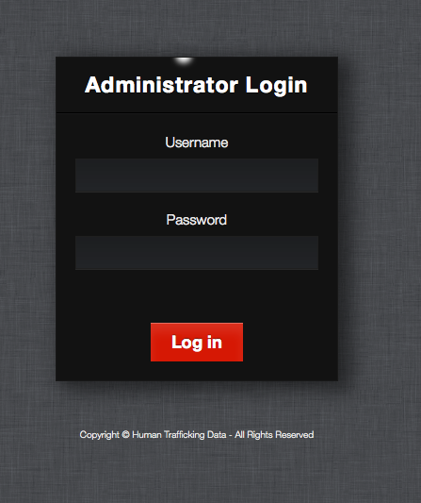

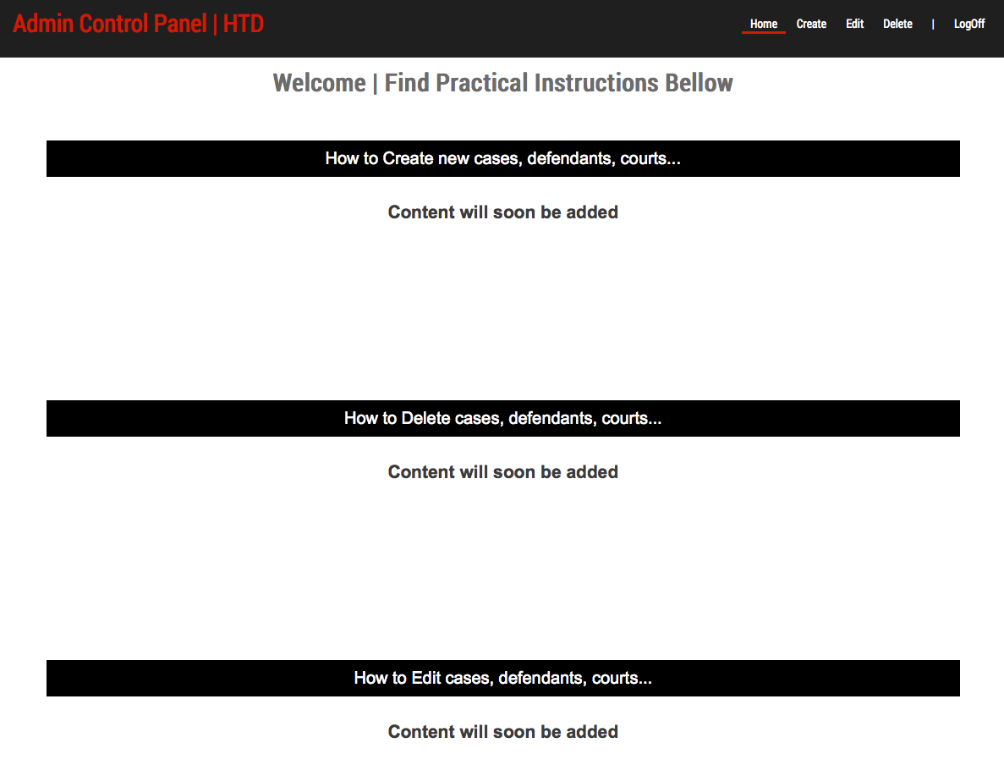

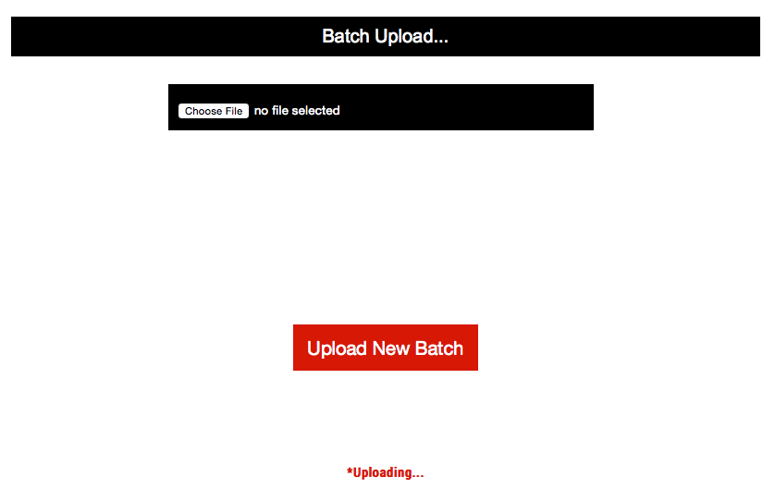

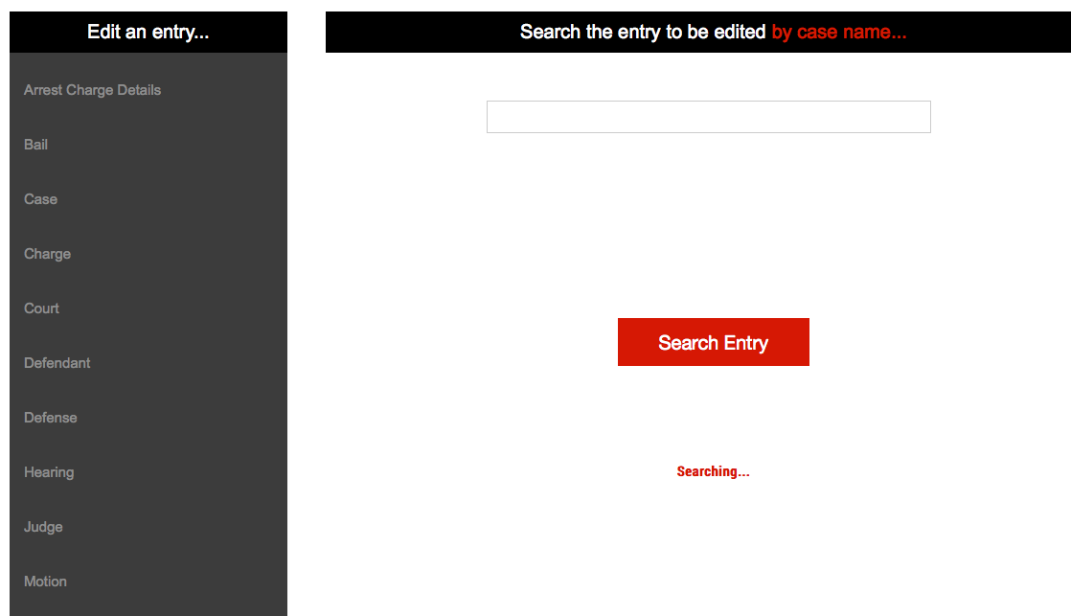

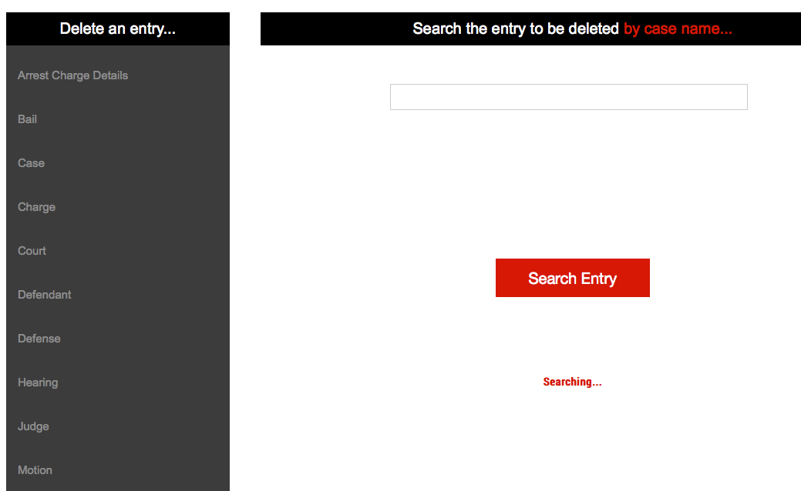

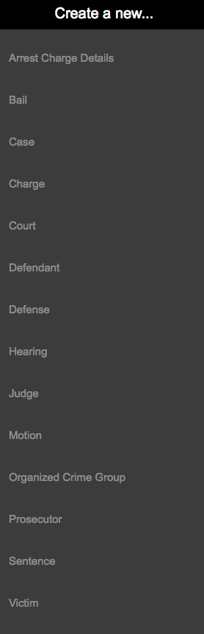

# Glossary of Terms

**Prototype** – simulates only a few aspects of, and may be completely different from, the final product.

**UML** – Unified Modeling Language; a modeling language designed to provide a standard way to visualize the design of a system.