

Design Document

**1/16/2015**

***v1.1***

**JUDGE FROG**

# Revision History

|  |  |  |
| --- | --- | --- |
| Version | Changes | Edited |
| 1.0 | * Initial Draft | November 25, 2014 |
| 1.1 | * Database Schema Updated * Modified Development Environment | January 16, 2015 |
|  |  |  |
|  |  |  |

# Revision Sign-Off

By signing the following, the team member is stating that he has read the entire document and has concluded that the information contained within this document is accurate, relevant to the project, and void of errors.

|  |  |  |
| --- | --- | --- |
| Name | Signature | Date Signed |
| Brice Boula |  |  |
| Collin Duncan |  |  |
| David Tomlinson |  |  |
| Landon Westrom |  |  |

# Table of Contents

Revision History ii

Revision Sign-Off iii

Table of Contents iv

1. Introduction 1

1.1 Purpose 1

1.2 Project Background 1

1.3 Section Overview 1

2. Design Constraints 2

2.1 Assumptions and Dependencies 2

2.2 General Constraints 2

2.3 Development Environment 3

3. System Architecture 4

3.1 Database 4

3.2 Web Application 4

4. Database Design 5

4.1 CaseObject Table 6

4.2 Judge Table 6

4.3 Victim Table 7

4.4 Defendant Table 7

4.5 Case\_has\_Defendant Table 7

4.6 OrganizedCrimeGroup Table 8

4.7 Case\_has\_OrganizedCrimeGroup Table 8

4.8 AggregateSentence Table 8

4.9 ArrestChargeDetail Table 9

4.10 Charge Table 10

5. UML Models 11

5.1 Sequence Diagrams 11

5.1.1 Admin Create Sequence 11

5.1.2 Admin Edit Sequence 12

5.1.3 Admin Delete Sequence 13

5.1.4 Admin Uploads Sequence 14

6. User Interface Prototype 15

6.1 Homepage 15

6.2 Search Interface 16

6.3 Admin Panel 18

7. Glossary of Terms 22

# Introduction

## Purpose

This document provides a complete description of the Judge Frog system design. Included in this document are design constraints, system architecture, user interface design, and Unified Modeling Language (UML) diagrams (state, class, and sequence).

## 1.2 Project Background

Judge Frog is designed to be a fully functional web application with a user-friendly user interface. The application shall provide an efficient database containing significant human trafficking data inserted by the client. The end user shall be presented with visual graphs and charts to sort and analyze the data using various filters. Concluding the user’s data analysis, the user shall have the option of exporting the visual data.

## 1.3 Section Overview

**Section 2 – Design Constraints**: Describes assumptions and dependencies, general constraints, and developmental methods for the Judge Frog web application.

**Section 3 – System Architecture**: Displays a model of the architecture and major component descriptions.

**Section 4 – File Design**: Describes how data from sensors is stored on the smartphone and the on-board control unit (OBCU).

**Section 5 – UML Models**: Displays the state, class and sequence diagrams.

**Section 6** **–** **User Interface**: Gives screenshots from the prototype of the smartphone application.

**Section 7 – Glossary of Terms**: Defines technical and project-specific terms used in this document.

# Design Constraints

## 2.1 Assumptions and Dependencies

The Judge Frog Web application will assume the following:

* The user shall access the Web application from a desktop computer
* The user can use the Web application after instruction

## 2.2 General Constraints

* Time
  + Development must be completed by the end of the school year in May 2015.
* Data storage
  + Finite amount of storage space on server used for storage
* Communication
  + Requires continuous Internet access to use the application
* Browser
  + Internet Explorer version 9 or higher
  + Google Chrome version 40 or higher
  + Mozilla Firefox version 33 or higher
  + Safari version 5 or higher

## 2.3 Development Environment

**Programming Environment**

* MySQLWorkbench 6.2 CE
* PHP 5.6
* CakePHP 2.5.1
* GitHub
* phpMyAdmin 4.0.4.2
* MySQL 5.6.14
* Microsoft-IIS/8.5

**Productivity Software**

* Microsoft Visio 2013
* Microsoft Word 2013
* Microsoft PowerPoint 2013
* Microsoft Excel 2013

# System Architecture



## Database

Our database will store human trafficking data collected by the National Institute of Justice. The well-designed database is stored on our server to be interacted with the web application. The database is developed with the Extended Entity-Relationship model using MySQL Workbench. The database is structured much differently than the data our client provided us to allow for more efficient use of resources and quicker response times.

## Web Application

The developed Web application will connect to the database to insert and retrieve human trafficking data to create analysis for the user. The Web application will provide a detailed tutorial on the functionality and navigation present in the application. There shall be a separate portal for administrative access to database functions.

# Database Design

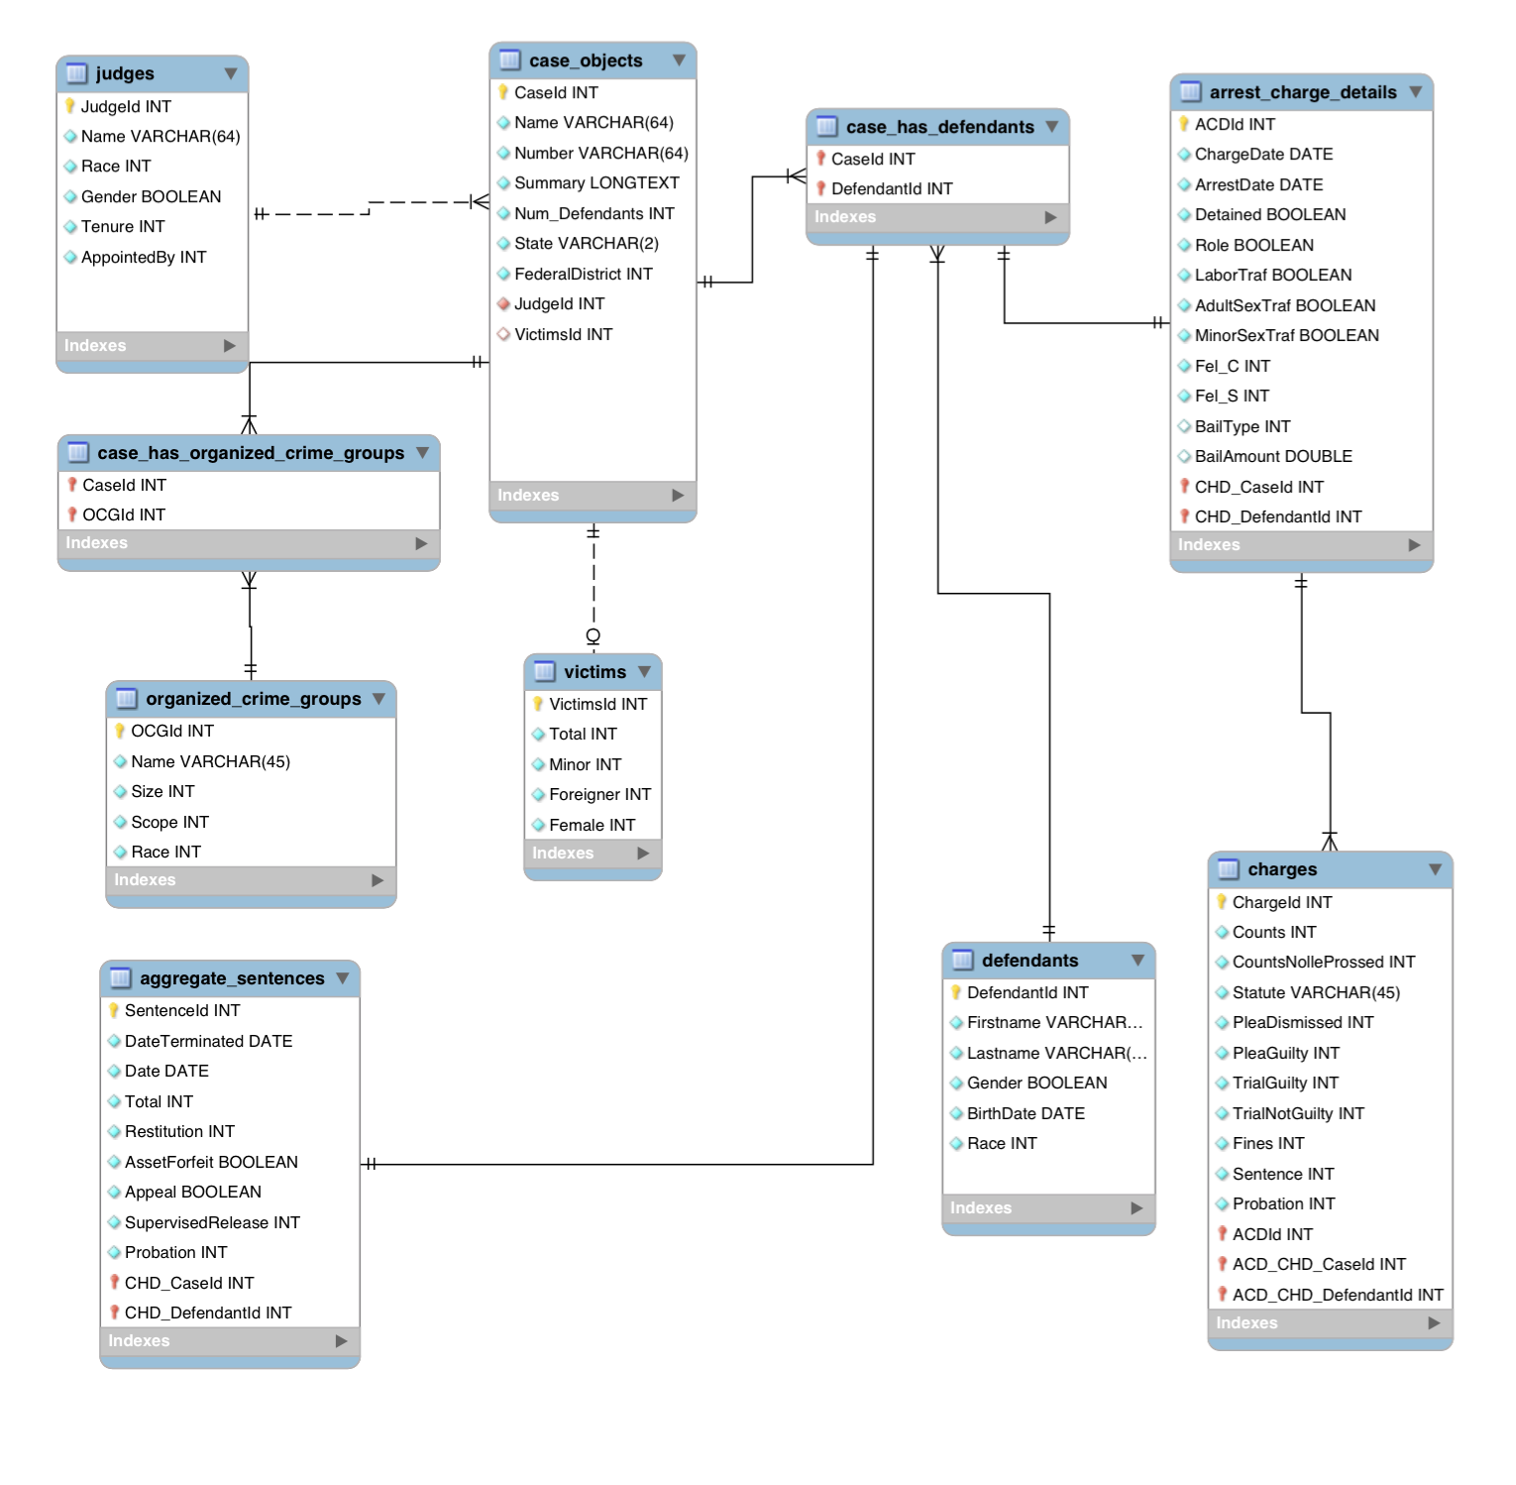

## 4.1 CaseObject Table

|  |  |  |
| --- | --- | --- |
|  |  |  |
| ***Variable Name*** | ***Type*** | ***Description*** |
| CaseId | INT | Primary key for each case within the database. |
| Name | VARCHAR(64) | The case name, which is usually USA v. LAST NAME OF FIRST DEFENDANT.  Use case name as listed on the docket. |
| Number | VARCHAR(64) | This is the criminal case number from the US District Court.  Be sure that the case number has cr (criminal) in the middle and not mj (magistrate). We want the CRIMINAL case number only.  Obtain the number at the top of the docket. |
| Summary | LONGTEXT | The detailed description of case information. |
| Num\_Defendants | INT | Total number of defendants in the case.  Count the number of defendants listed on the docket. |
| State | VARCHAR(2) | Two letter code for the state in which the case is being heard. |
| FederalDistrict | INT | The federal district number for the state in which the case is being heard.  Look on federal district court map online to determine what federal district a state is in. |
| JudgeId | INT | Foreign key. ID of the last judge to hear the case. |
| VictimsId | INT | Foreign key. ID corresponding to the case’s victims. |

## 4.2 Judge Table

|  |  |  |
| --- | --- | --- |
| ***Variable Name*** | ***Type*** | ***Description*** |
| JudgeId | INT | Primary key for each judge. |
| Name | VARCHAR(64) | Name of the US federal district court judge hearing the case. |
| Race | INT | The race of the judge. Coded with the following values: 0=White; 1=Black; 2=Hispanic; 3=Asian; 4=Native American; 5=Other. |
| Gender | BOOLEAN | The gender of the judge. Coded with the following values: 0=Male; 1=Female. |
| Tenure | INT | The year the judge was appointed as a federal district judge. |
| AppointedBy | INT | This is the partisan identity of the president who appointed the judge.  0=Republican; 1=Democrat. |

## 4.3 Victim Table

|  |  |  |
| --- | --- | --- |
| ***Variable Name*** | ***Type*** | ***Description*** |
| VictimId | INT | Primary key for each victim set. |
| Total | INT | Total number of victims involved in a case. |
| Minor | INT | Number of victims that were minors. |
| Foreigner | INT | Number of victims that are not natural born citizens of the United States. |
| Female | INT | Number of victims that are female. |

## 4.4 Defendant Table

|  |  |  |
| --- | --- | --- |
| ***Variable Name*** | ***Type*** | ***Description*** |
| DefendantId | INT | Primary key for each defendant. |
| Firstname | VARCHAR(45) | First name of the defendant. |
| Lastname | VARCHAR(45) | Last name of the defendant. |
| Gender | BOOLEAN | The gender of the defendant. |
| BirthDate | DATE | The defendant’s birthdate. |
| Race | INT | The race of the defendant. |

## 4.5 Case\_has\_Defendant Table

|  |  |  |
| --- | --- | --- |
| ***Variable Name*** | ***Type*** | ***Description*** |
| CaseId | INT | Foreign key to CaseObject.CaseId |
| DefendantId | INT | Foreign key to Defendant.DefendantId |

## 4.6 OrganizedCrimeGroup Table

|  |  |  |
| --- | --- | --- |
| ***Variable Name*** | ***Type*** | ***Description*** |
| OCGId | INT | Primary key for each organized crime group. |
| Name | VARCHAR(45) | The name of the organized crime group. |
| Size | INT | The size of the organized crime group. Coded with the following values: 1 = “Mom & Pop”; 2 = “Street Gang”; 3 = Cartel/Syndicate/Mafia; 5 = Prison Gang; 6 = Other. |
| Scope | INT | The scope of the organized crime group’s activities. Coded with the following values: 1 = Local Only; 2 = Interstate; 3 = International. |
| Race | INT | The predominant race of the organized crime group. Coded with the following values: 0 = None; 1 = Black; 2 = White; 3 = Hispanic; 4 = Asian; 5 = Other. |

## 4.7 Case\_has\_OrganizedCrimeGroup Table

|  |  |  |
| --- | --- | --- |
| ***Variable Name*** | ***Type*** | ***Description*** |
| CaseId | INT | Foreign key to CaseObject.CaseId |
| OCGId | INT | Foreign key to OrganizedCrimeGroup.OCGId |

## 4.8 AggregateSentence Table

|  |  |  |
| --- | --- | --- |
| ***Variable Name*** | ***Type*** | ***Description*** |
| SentenceId | INT | Primary key for each sentence. |
| DateTerminated | DATE | The date the sentence is complete. |
| Date | DATE | The date the defendant was sentenced. |
| Total | INT | The total number of months the defendant was sentenced. |
| Restitution | INT | The total amount defendant is required to pay in restitution. |
| AssetForfeit | BOOLEAN | Represents whether the defendant is required to forfeit assets by the court. |
| Appeal | BOOLEAN | Represents whether the defendant has lodged an appeal. |
| SupervisedReleased | INT | Total number of months the defendant received under supervised release. |
| Probation | INT | The total number of months a defendant received probation. |

## 4.9 ArrestChargeDetail Table

|  |  |  |
| --- | --- | --- |
| ***Variable Name*** | ***Type*** | ***Description*** |
| ACDId | INT | Primary key for each defendant’s arrest report in each case. |
| ChargeDate | DATE | The date any charges or indictments were filed. |
| ArrestDate | DATE | The date the defendant was arrested. |
| Detained | BOOLEAN | Represents whether the defendant was detained between arrest and first hearing. |
| Role | BOOLEAN | Represents whether the defendant was a primary offender or a secondary offender in the trafficking operation. |
| LaborTraf | BOOLEAN | Represents whether the case was a labor trafficking case. |
| AdultSexTraf | BOOLEAN | Represents whether the case involved adult sex trafficking. |
| MinorSexTraf | BOOLEAN | Represents whether the case involved sex trafficking of minors. |
| Fel\_C | INT | The total number of felonies charged. |
| Fel\_S | INT | The total number of felonies sentenced. |
| BailType | INT | The type of the bail in the case. Coded with the following values: 0 = no bail; 1 = surety bail; 2 = non-surety bail. |
| BailAmount | DOUBLE | The amount of the bail set by the judge. |
| CHD\_CaseId | INT | The foreign key specifying the CaseObject entry the arrest report corresponds to. |
| CHD\_DefendantId | INT | The foreign key specifying the Defendant entry the arrest report corresponds to. |

## 4.10 Charge Table

|  |  |  |
| --- | --- | --- |
| ***Variable Name*** | ***Type*** | ***Description*** |
| ChargeId | INT | Primary key for the charges under a statute. |
| Counts | INT | The number of counts charged under a federal statute. |
| CountsNolleProssed | INT | The number of counts dropped. |
| Statute | VARCHAR(45) | The statute under which the defendant was charged. |
| PleaDismissed | INT | The number of counts dismissed pursuant to a plea bargain. |
| PleaGuilty | INT | The number of counts to which the defendant pled guilty. |
| TrialGuilty | INT | The number of counts to which the defendant has received a guilty verdict in a trial. |
| TrialNotGuilty | INT | The number of counts to which the defendant has received a not guilty verdict by trial. |
| Fines | INT | The fine levied on the defendant. |
| Sentence | INT | The number of months of prison time the defendant was sentenced for the charge. |
| Probation | INT | The number of months on probation the defendant was sentenced for the charge. |
| ACDId | INT | The foreign key specifying the ArrestChargeDetails entry the charge corresponds to. |
| ACD\_CHD\_CaseId | INT | The foreign key specifying the CaseObject entry the charge corresponds to. |
| ACD\_CHD\_DefendantId | INT | The foreign key specifying the Defendant entry the charge corresponds to. |

# UML Models

## 5.1 Sequence Diagrams

### 5.1.1 Admin Create Sequence



### 5.1.2 Admin Edit Sequence



### 5.1.3 Admin Delete Sequence



### 5.1.4 Admin Uploads Sequence



# User Interface Prototype

## 6.1 Homepage

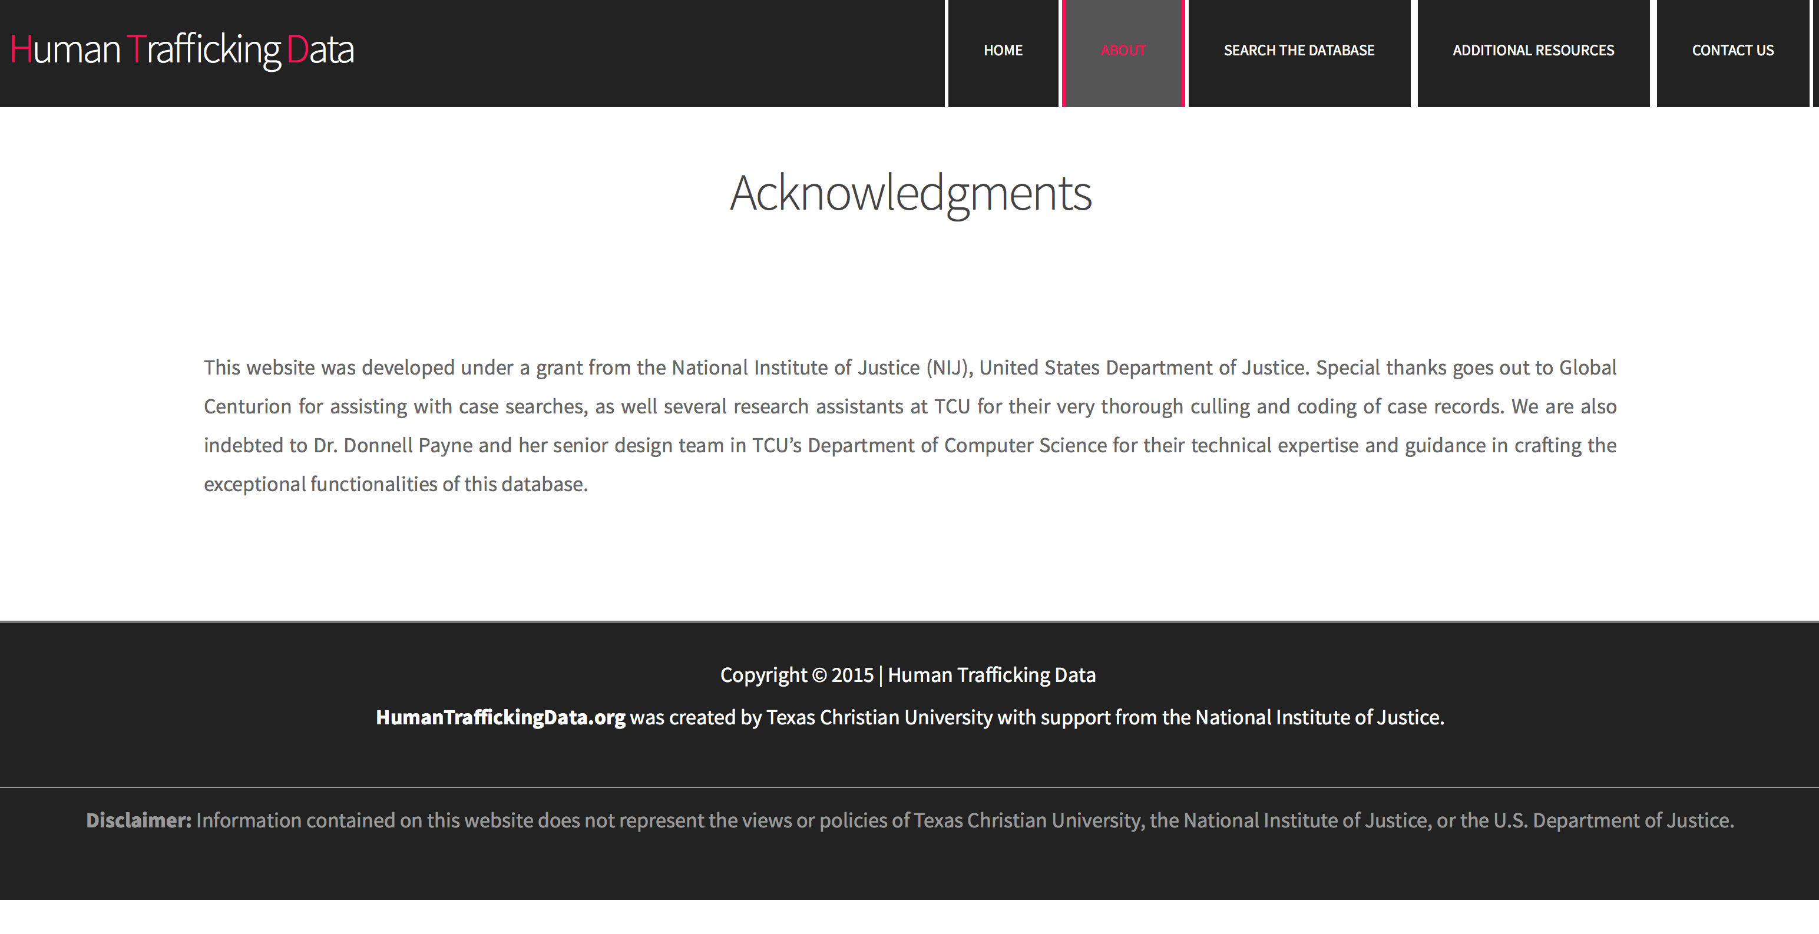

## 6.2 Search Interface

## U:\screen shots\temp_design\1.png

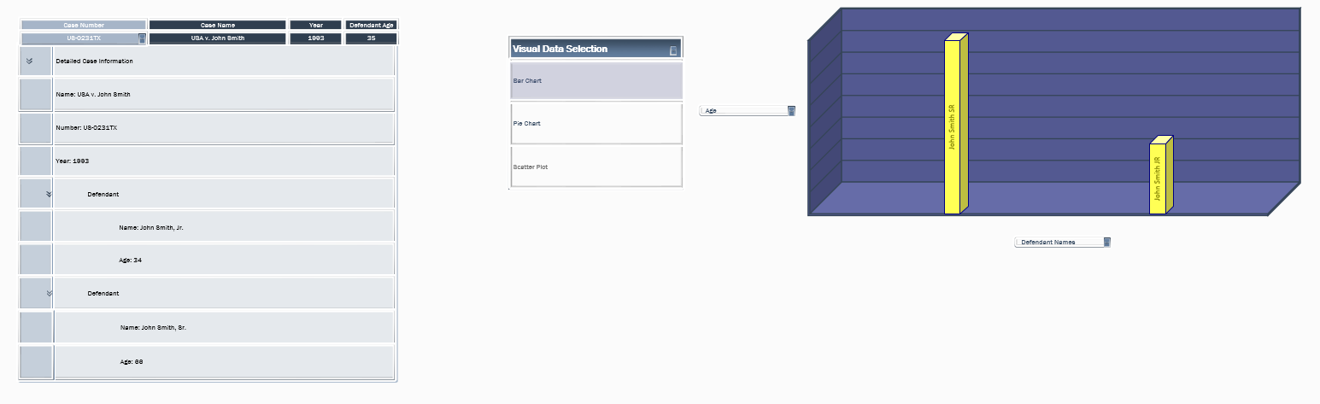

## 6.3 Admin Panel

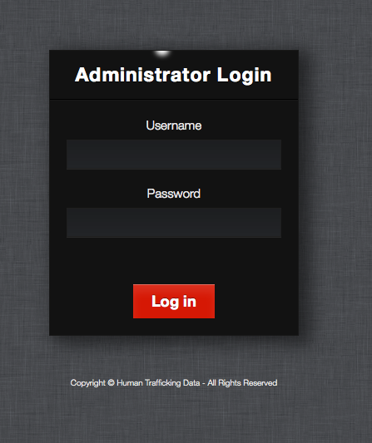

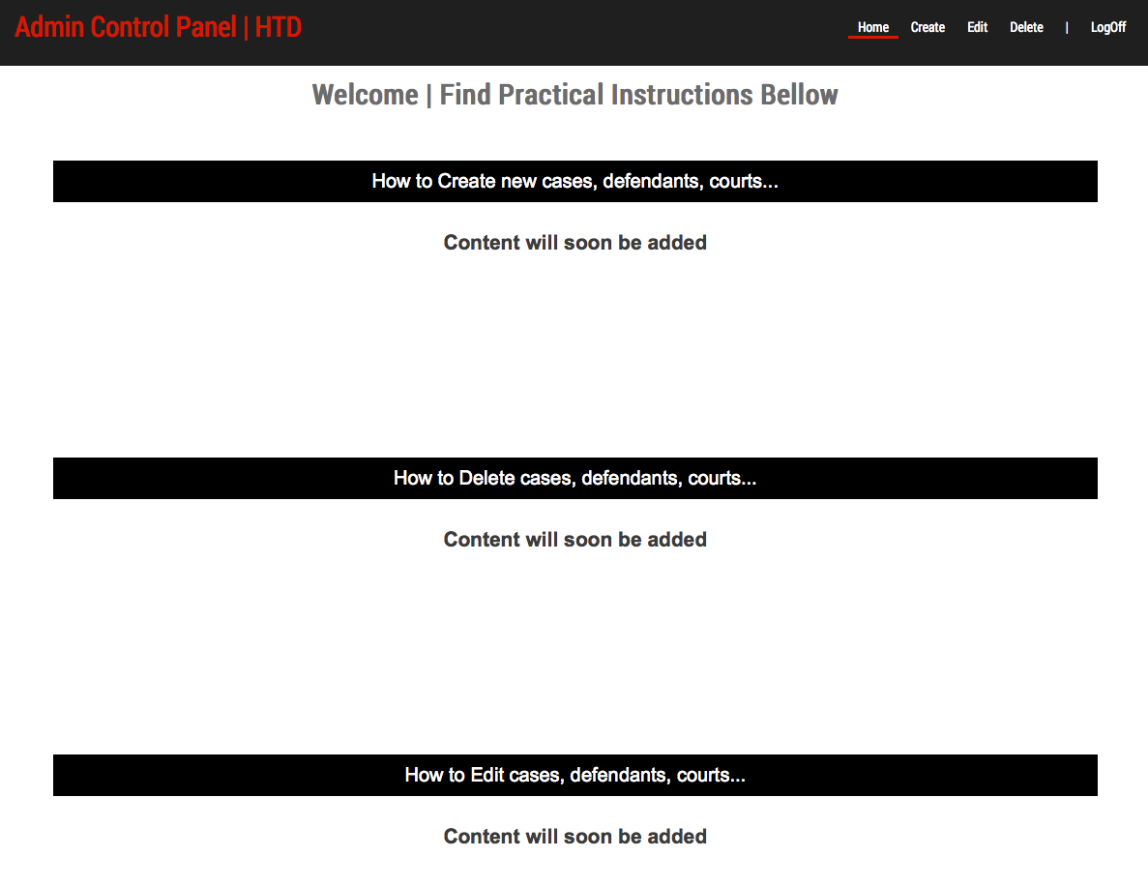

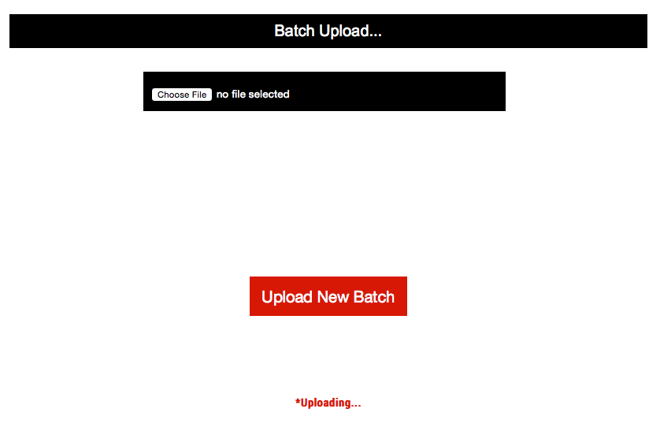

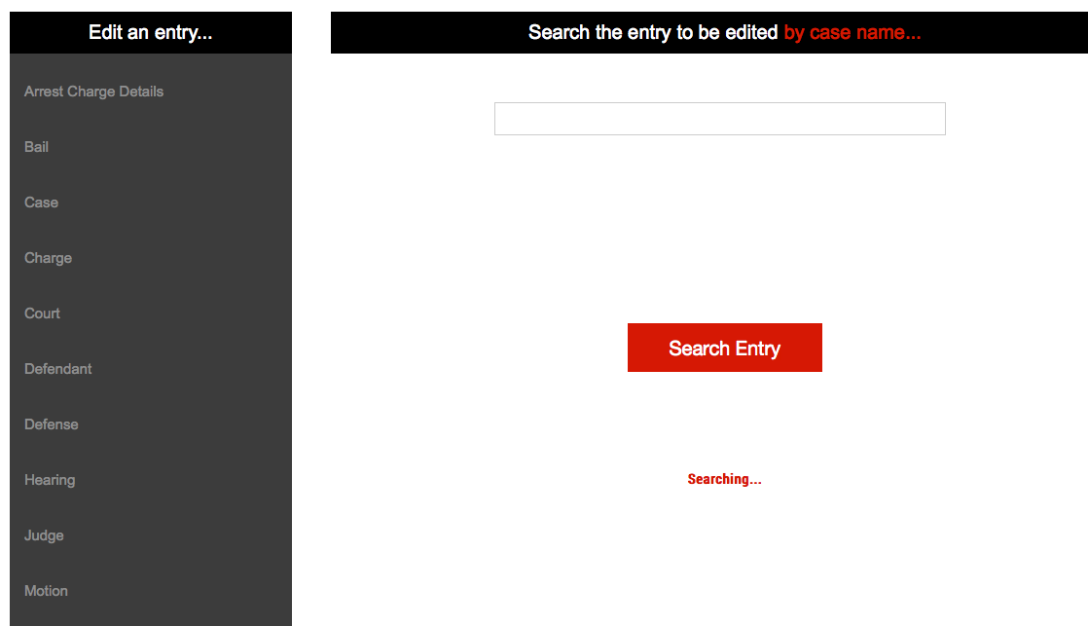

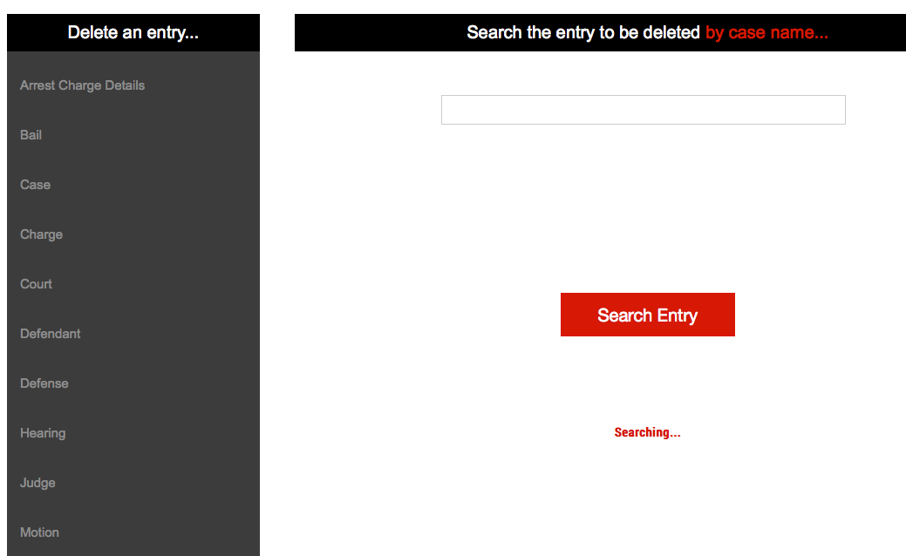

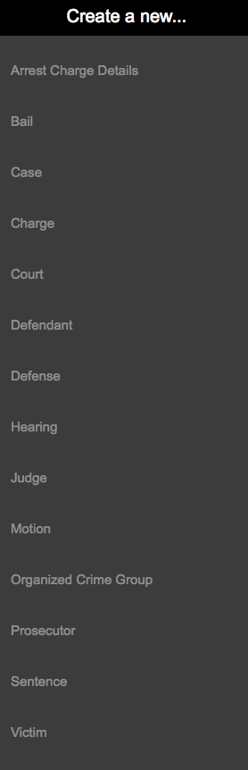

# Glossary of Terms

**Prototype** – simulates only a few aspects of, and may be completely different from, the final product.

**UML** – Unified Modeling Language; a modeling language designed to provide a standard way to visualize the design of a system.

**Primary Key** – Uniquely identifies each record in the table.

**Foreign Key** – A field in one table that uniquely identifies a row of another table.

**TCU** – Texas Christian University