

**JUDGE FROG**

User Manual

***V1.0***

**4/23/2015**

# Revision History

|  |  |  |
| --- | --- | --- |
| Version | Changes | Edited |
| 1.0 | * Initial Draft | March 15, 2015 |
| 1.1 | * System Walkthrough | April 23, 2015 |

# Revision Sign-Off

By signing the following, the team member is stating that he has read the entire document and has verified that the information contained within this document is accurate, relevant to the project, and void of errors.

|  |  |  |
| --- | --- | --- |
| Name | Signature | Date Signed |
| Brice Boula |  |  |
| Collin Duncan |  |  |
| David Tomlinson |  |  |
| Landon Westrom |  |  |

# Table of Contents

* 1. User Manual 1

Revision History 2

Revision Sign-Off 2

Table of Contents 3

1.1 Purpose 4

1.2 Project Overview 4

1.3 Overview 4

2. System Components 5

2.1 System Components 5

2.1.2 Compatible Web Browser 5

3. System Walkthrough 6

3.1 System Overview 6

3.1.1 Searching the Database 6

3.1.2 Graph Analysis 6

3.1.3 Admin Panel 6

4. Glossary of Terms 9

## 1.1 Purpose

The purpose of this document is to provide the user with a complete overview and explanation of all aspects of the Judge Frog system. This manual will cover an overview of the required system components and a detailed walk through of the system.

## 1.2 Project Overview

Every year, there are thousands of cases involving human trafficking in dozens of courts across the United States. With data from the cases scattered across different judicial districts, it can be difficult to analyze a large amount of cases. Our supporting clients have received a grant from the National Institute of Justice to help fulfill the analysis needed of the vast amount of human trafficking crime in the United States. Judge Frog, a 2014-2015 capstone project, consists of a web application that no one has achieved before to allow the public to tap into this vast amount of data for visual and textual analysis.

## 1.3 Overview

This document includes the following sections.

**Section 2 – System Components:** Lists and describes the required components for operating Judge Frog web application.

**Section 3 – System Walkthrough:** Provides walkthroughs of the features that are provided by the system.

**Section 4 – Glossary of Terms:** Includes a list of abbreviations and their technical terms and their associated definitions.

# 2. System Components

## 2.1 System Components

Judge Frog is comprised of two components; Judge Frog web application and a compatible web browser.

**2.1.1 Judge Frog Web Application**

The web application is hosted on a server that can be accessed by three different domains; humantraffickingdata.org, humantraffickingdata.net, and humantraffickingdata.com.

### 2.1.2 Compatible Web Browser

* Internet Explorer version 11 or higher
* Google Chrome version 40 or higher
* Mozilla Firefox Version 33 or higher
* Safari version 5 or higher

# System Walkthrough

## 3.1 System Overview

The user will be presented with the following options when accessing the web application.

### 3.1.1 Searching the Database

1. Select 47 search variables from 9 categories to filter your search results and submit search by pressing the magnifying glass.
2. Select a case to view. A modal window will appear for the case selected.
3. 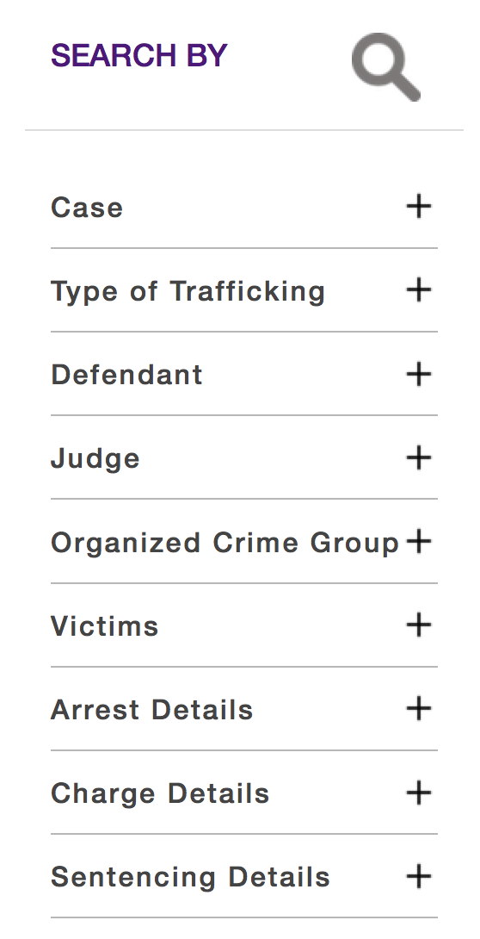By default the case will be filtered according to the criteria entered for the search. Toggle the “Filtered Results” button at the top right to view all results of the selected case.

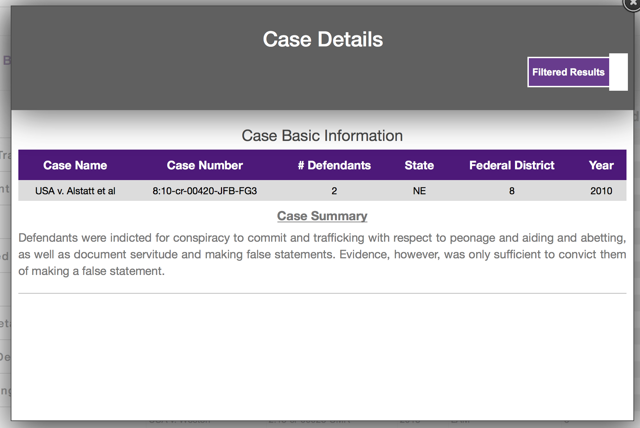

### 3.1.2 Graph Analysis

1. After the user has completed a successful search. The user will select the “Analyze” button. This button will present the user with a separate page that will contain the last search results the user received.
2. Within the graph menu, select the desired graph for analysis.
3. 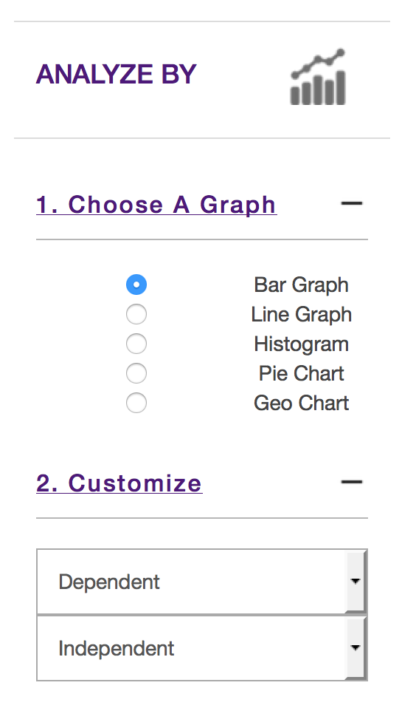Within the customize menu, select the according dependent and independent variables for your desired chart.

### 3.1.3 Admin Panel

1. Upload
   1. Select the “CSV file to upload button” and choose the desired CSV docket file of human trafficking cases to upload.
   2. Select the submit button to proceed for cases to be inserted into database
2. Create and Edit
   1. Download
      1. Select the button to download the most current data from the database that will be saved in CSV file format
   2. Add New Case
      1. Select the button displayed to proceed to add a new case
      2. Complete the case fields as necessary (Case name and case number are required)
      3. Add a new defendant by selecting the button shown
      4. Complete the defendant fields as necessary (defendant last name and charge date fields are required)
   3. Submit Case for Review
      1. Access the desired case from the incomplete tab. The user will be displayed the “Case Pending Competition” section.
      2. Select “edit” for the desired case to be submitted for review.
      3. At the button of the page of the case. Select the checkbox “Submit Case for Review?” and select submit to finalize that case for the administrator to review the case.
   4. Review (admin access only)
      1. Select the desired case to review from the table on the left.
      2. If case information is successfully inputted, then select the airplane icon to submit the case into the database for users to search the case.
3. Manage Users (admin access only)
   * 1. Create a user by completing user fields. (all fields are required)
        1. Password shall be 6 characters or more
        2. Privilege level Access

|  |  |  |
| --- | --- | --- |
| Feature | Admin | Research Assistant |
| Upload | X |  |
| Download | X | X |
| Create Case | X | X |
| Edit All Cases | X |  |
| Edit Incomplete Case | X | X |
| Delete Case | X |  |
| Review | X |  |
| User Management | X |  |

# 4. Glossary of Terms

**Administrator** – privileged user capable of performing major changes to database.

**Application** – Group of programs designed to supply an end-user with expected functionality.

**CakePHP** – A free, open-source, rapid development framework for PHP.

**Control** **Panel** – interface specifically designed to allow administrators to easily perform their tasks.

**Database** – A structured set of data held in a computer, accessible in various ways.

**Deliverable** – A product, not necessarily finished, related to the project given to the client.

**End-User** – A person or persons who will be using the web application for the specified purpose of our project.

**Foreign Key** – A field in one table that uniquely identifies a row of another table.

**GitHub** – A Web service for software version control.

**Host** – A website on a server accessible over the Internet.

**Milestone** – A point at which project progress can be assessed.

**PHP** – A general-purpose scripting language that is especially suited to server-side web development.

**Primary Key** – Uniquely identifies each record in the table.

**Prototype** – simulates only a few aspects of, and may be completely different from, the final product.

**TCU** – Texas Christian University

**UML** – Unified Modeling Language; a modeling language designed to provide a standard way to visualize the design of a system.

**Walk-through** – Points during the project where the team describes significant project components with clients and individuals within the team.

**Web Application** – Application that is accessed by visiting a specific URL.