

**JUDGE FROG**

User Manual

***V3.0***

**5/5/2015**

# Revision History

|  |  |  |
| --- | --- | --- |
| Version | Changes | Edited |
| 1.0 | * Initial draft | March 15, 2015 |
| 1.1 | * System Walkthrough | April 23, 2015 |
| 2.0 | * Draft revisions | May 3, 2015 |
| 3.0 | * Overhauled document structure * Updated system components * Added screenshots | May 5, 2015 |

# Revision Sign-Off

By signing the following, the team member is stating that he has read the entire document and has verified that the information contained within this document is accurate, relevant to the project, and void of errors.

|  |  |  |
| --- | --- | --- |
| Name | Signature | Date Signed |
| Brice Boula |  |  |
| Collin Duncan |  |  |
| David Tomlinson |  |  |
| Landon Westrom |  |  |

# Table of Contents

Revision History ii

Revision Sign-Off iii

Table of Contents iv

1. Introduction 1

1.1 Purpose 1

1.2 Project Overview 1

1.3 Overview 1

2. System Components 2

2.1 System Components 2

2.2 Web Application 2

2.3 Database 2

2.4 Compatible Web Browser 2

3. Admin Panel 3

3.1 Upload 3

3.2 Create & Edit 4

3.2.1 Download 4

3.2.2 All Cases 4

3.2.3 Incomplete Cases 4

3.2.4 Create Case 4

3.2.5 Edit Case 7

3.2.6 Delete Case 7

3.2.7 Search 7

3.3 Review 8

3.4 Manage Users 9

4. Searching the Database 11

5. Analyzing the Data 13

6. Glossary of Terms 14

# Introduction

## 1.1 Purpose

The purpose of this document is to provide the user with a complete overview and explanation of all aspects of the Judge Frog system. This manual will cover an overview of the required system components and a detailed walk through of the system.

## 1.2 Project Overview

Every year, there are thousands of cases involving human trafficking in dozens of courts across the United States. With data from the cases scattered across different judicial districts, it can be difficult to analyze a large amount of cases. Our supporting clients have received a grant from the National Institute of Justice to help fulfill the analysis needed of the vast amount of human trafficking crime in the United States. Judge Frog, a 2014-2015 capstone project, consists of a web application that no one has achieved before to allow the public to tap into this vast amount of data for visual and textual analysis.

## 1.3 Overview

This document includes the following sections.

**Section 2 – System Components:** Lists and describes the required components for operating Judge Frog web application.

**Section 3 – System Walkthrough:** Provides walkthroughs of the features that are provided by the system.

**Section 4 – Glossary of Terms:** Includes a list of abbreviations and their technical terms and their associated definitions.

# System Components

## 2.1 System Components

Judge Frog is comprised of two components: the **Web Application** and the **Database**. To access the **Web Application**, a user must open a **compatible web browser** (**Section 2.4**) and navigate to any of the following URLs: <http://www.humantraffickingdata.org>, <http://www.humantraffickingdata.com>, or <http://www.humantraffickingdata.net>.

## 2.2 Web Application

The web application is available to any user who navigates to any of the URLs listed above and is broken down into 3 parts: an Admin Panel, a Search function, and an Analyze function. Each of the parts is detailed more in the following sections.

## 2.3 Database

The database contains a user table which records all of the information needed to manage users; all secure information is salted and hashed before inserted into the database. The database also includes a pending data table and a finalized data table. The pending table contains all of the cases which are still being created or cases which have been edited. The final data table contains all of the cases from the pending data table which have been submitted and consequently approved by administrators.

## 2.4 Compatible Web Browser

* Internet Explorer version 9 or higher
* Google Chrome version 40 or higher
* Mozilla Firefox version 33 or higher
* Safari version 5 or higher

# Admin Panel

The **Admin Panel** contains the functionality to create, edit, and delete cases from the database. It also allows for managing user accounts. To access the **Admin Panel**, scroll to the bottom of any page. Click on the word **here** (**Figure 3.1**)to be taken to a login prompt. A valid user account is required to access the **Admin Panel**; see the project administrator for a valid user account.

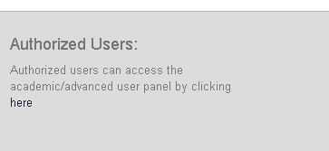

Figure 3.1

After logging into the **Admin Panel**, various functionalities can be accessed via the menu bar.



Figure 3.2

## 3.1 Upload

The **Upload** functionality is restricted to **Administrators**. This is intended for batch uploads of large numbers of cases.

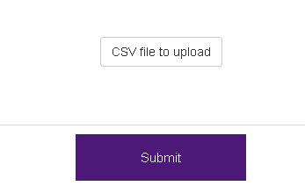

Figure 3.3

Files must be in **Comma-Separated Value** (**CSV**) format. To upload a file, click the **CSV file to upload** button in **Figure 3.3** above. A dialog will appear; please select the desired **CSV** file for uploading. The **CSV** file must be in a specific structure; for a detailed breakdown of this structure, please see the project administrator.

## 3.2 Create & Edit

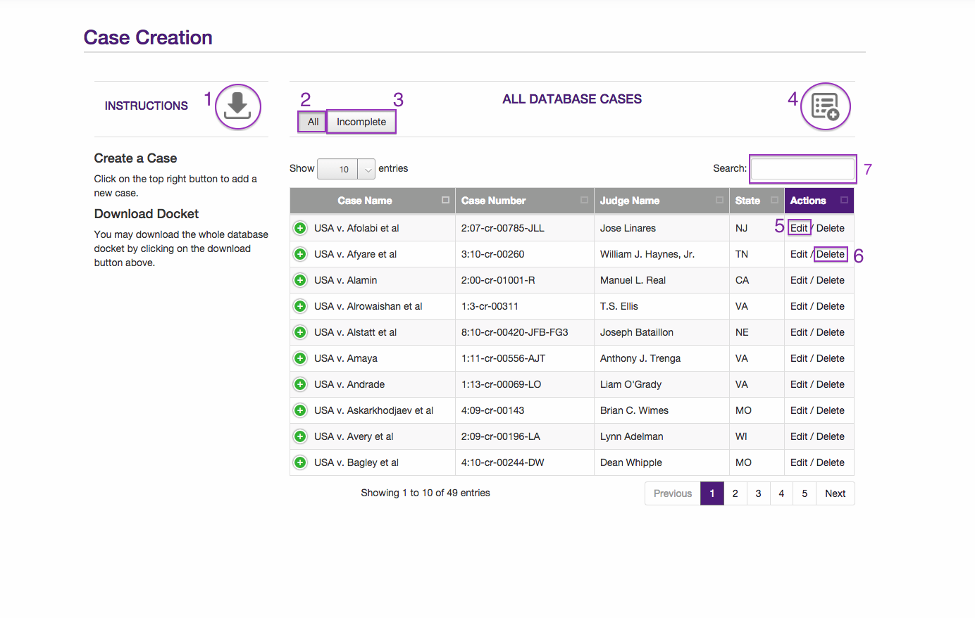

Figure 3.4

The above **Figure 3.4** depicts the **Create & Edit** page of the **Admin Panel**.

### 3.2.1 Download

To download a **CSV** file containing data in the finalized table, click the **Download** button (**Figure 3.4 #1**).

### 3.2.2 All Cases

To display all cases in the finalized table, click the **All** button (**Figure 3.4 #2**).

### 3.2.3 Incomplete Cases

Cases which are not finalized and are still under review or editing can be displayed by clicking the **Incomplete** button (**Figure 3.4 #3**).

### 3.2.4 Create Case

To create a new case, click the **Create New Case** button (**Figure 3.4 #4**) to begin the process.

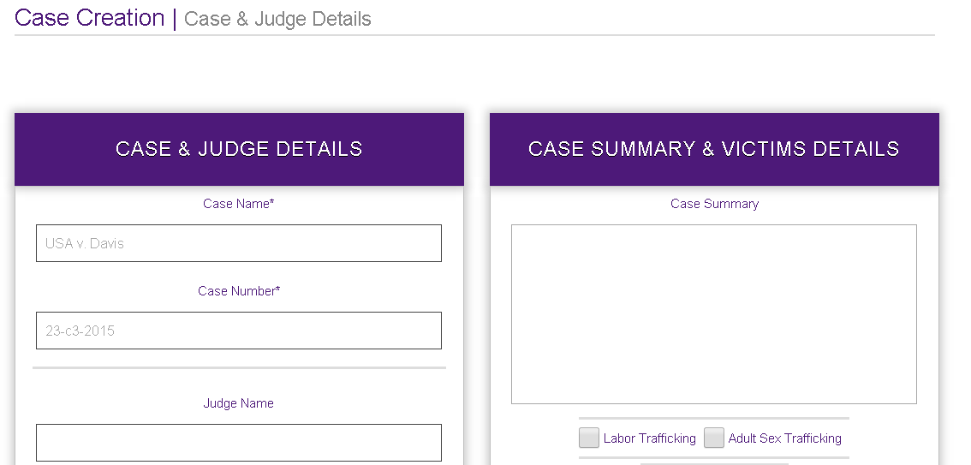

Figure 3.5

The case creation process begins with the above **Figure 3.5**. Case details, such as case name, number, judge details, and a summary of the case, can be entered on this screen. Note that case name and case number are required. After entering the case information, scroll down to the bottom and click the **Submit** button to submit the new case.

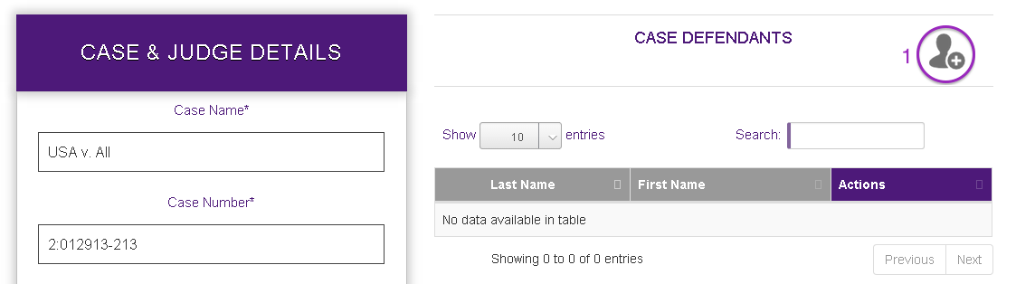

Figure 3.6

After submitting the new case, you will be taken to the above screen in **Figure 3.6**. To the left is a column containing the case information you just entered. To the right is a table displaying defendants currently associated with the case. To add a new defendant, click on the **Add New Defendant** button (**Figure 3.6 #1**).

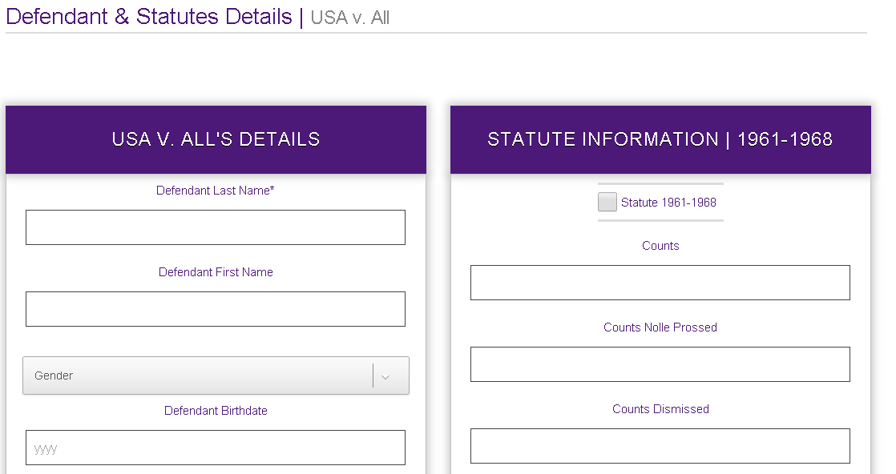

Figure 3.7

After clicking the **Add New Defendant** button, you will be taken to the screen depicted above in **Figure 3.7**. On the left is a column for all defendant personal information, arrest, charge, and sentencing details. On the right is a column for the statutes the defendant is charged under. If a defendant is charged under a statute, click the checkbox at the top and enter the relevant number of counts for that statute. After completing the defendant’s information, scroll down to the bottom of the page and click the **Submit** button.

After finalizing all case information and adding all defendants relevant to the case, you must mark the case as ready for review. To do so, click the **Submit Case For Review** checkbox (**Figure 3.8 #1**), then click the **Submit** button to actually submit the case. If the case is still being edited, the checkbox can be left unchecked. Hit the **Submit** button anyway to save your current progress.

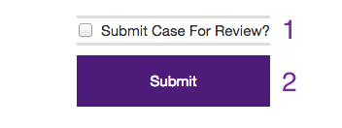

Figure 3.8

### 3.2.5 Edit Case

To edit a case, click the **Edit** button (**Figure 3.4 #5**). This will take you to a similar screen as described in **Section 3.2.4** for creating a new case.

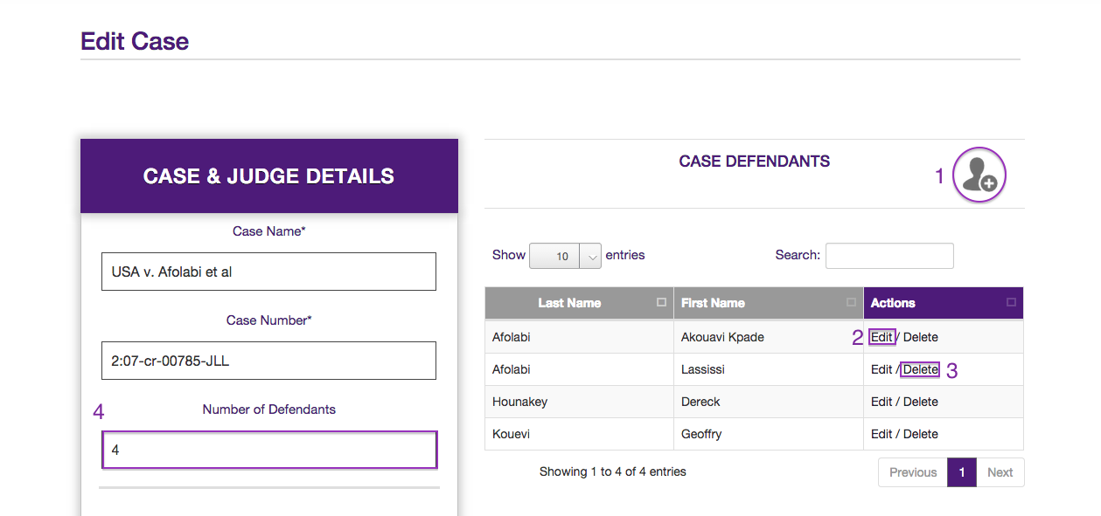

Figure 3.9

The case information is pre-populated in the column on the left for editing. To the right is a table with all defendants associated with the case. To add a new defendant to a case, click the **Add New Defendant** button (**Figure 3.9 #1**) again. This will begin the process of adding a new defendant described in **Section 3.2.4**.

To edit a defendant, click the **Edit** button (**Figure 3.9 #2**) to be taken to the same screen as the new defendant screen. Instead, this time the fields will be pre-populated with that defendant’s information. As before, click the **Submit** button at the bottom of the screen to finalize that defendant’s information.

To delete a defendant, click the **Delete** button (**Figure 3.9 #3**) to delete the defendant from the case. **This action cannot be undone**, so please be certain you want to delete the defendant.

After completing all edits for the case, click the **Submit Case For Review** checkbox (**Figure 3.8 #1**), then click the **Submit** button to actually submit the case. If the case is still being edited, the checkbox can be left unchecked. Hit the **Submit** button anyway to save your current progress. This is the same as adding a new case.

### 3.2.6 Delete Case

To delete a case, click the **Delete** button (**Figure 3.4 #6**). Please be certain you want to delete the case. **This action cannot be undone**.

### 3.2.7 Search

There exists a search bar (**Figure 3. 4 #7**) to filter the data seen in the table. This filters data based on whatever is typed in the field.

## 3.3 Review

All cases must be reviewed by **Administrators** prior to being available in the finalized table. To access this page, click the **Review** button in the **Admin Panel** menu bar (**Figure 3.2**). 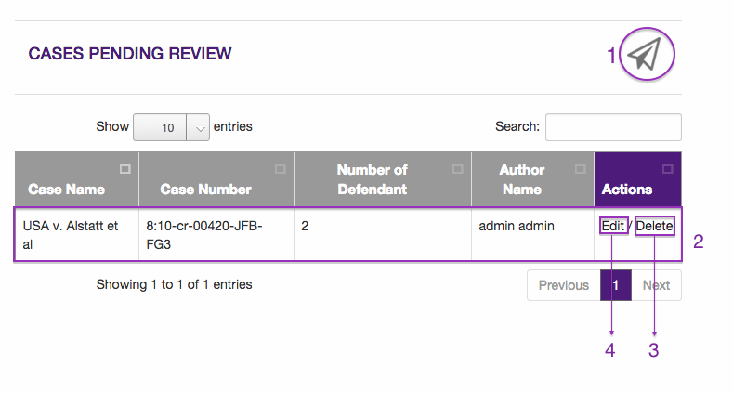

Figure 3.10

A list of all cases currently marked for review is displayed above. To publish the case to the finalized table, click the **Publish** button (**Figure 3.10 #1**). Clicking on each row will show detailed information for each case, shown below in **Figure 3.11**.

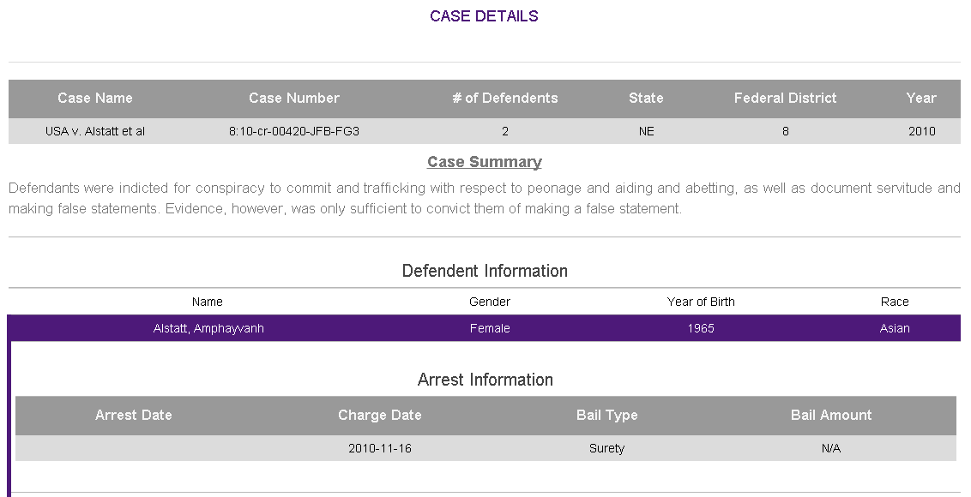

Figure 3.11

A **Delete** button (**Figure 3.10 #3**) is included for convenience here. To delete a case, click the button. This behaves similarly to the process described in **Section 3.2.6**. To edit a case, click the **Edit** button (**Figure 3.10 #4**). This will take you to the edit process described in **Section 3.2.5**.

## 3.4 Manage Users

To manage user accounts, click the **Manage Users** button in the **Admin Panel** menu bar (**Figure 3.2**). This page is restricted to **Administrators** only.

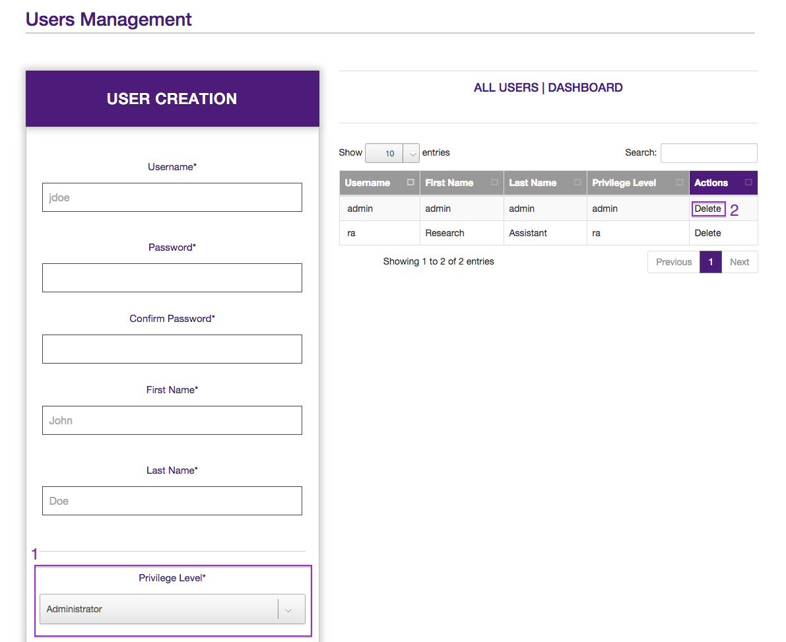

Figure 3.12

To create a user account, enter a username, password, and the first and last name of the user in the column on the left. The account’s privilege level can be selected from two options: **Administrator** and **Research Assistant**. **Figure 3.13** displays user permissions.

|  |  |  |  |  |  |  |  |
| --- | --- | --- | --- | --- | --- | --- | --- |
|  | Batch Upload | Download | Create | Edit | Delete | Review | Manage Users |
| Administrator | X | X | X | X | X | X | X |
| Research Assistant |  | X | X | X | X |  |  |

Figure 3.13

The table to the right displays all user accounts. To delete a user, click the **Delete** button (**Figure 3.12 #2**). Please be certain you want to delete the user. **This action cannot be undone**.

# 4. Searching the Database

The **Searching the Database** functionality allows any user who accesses our web application to perform a search on all of the cases in the final data table of the database.

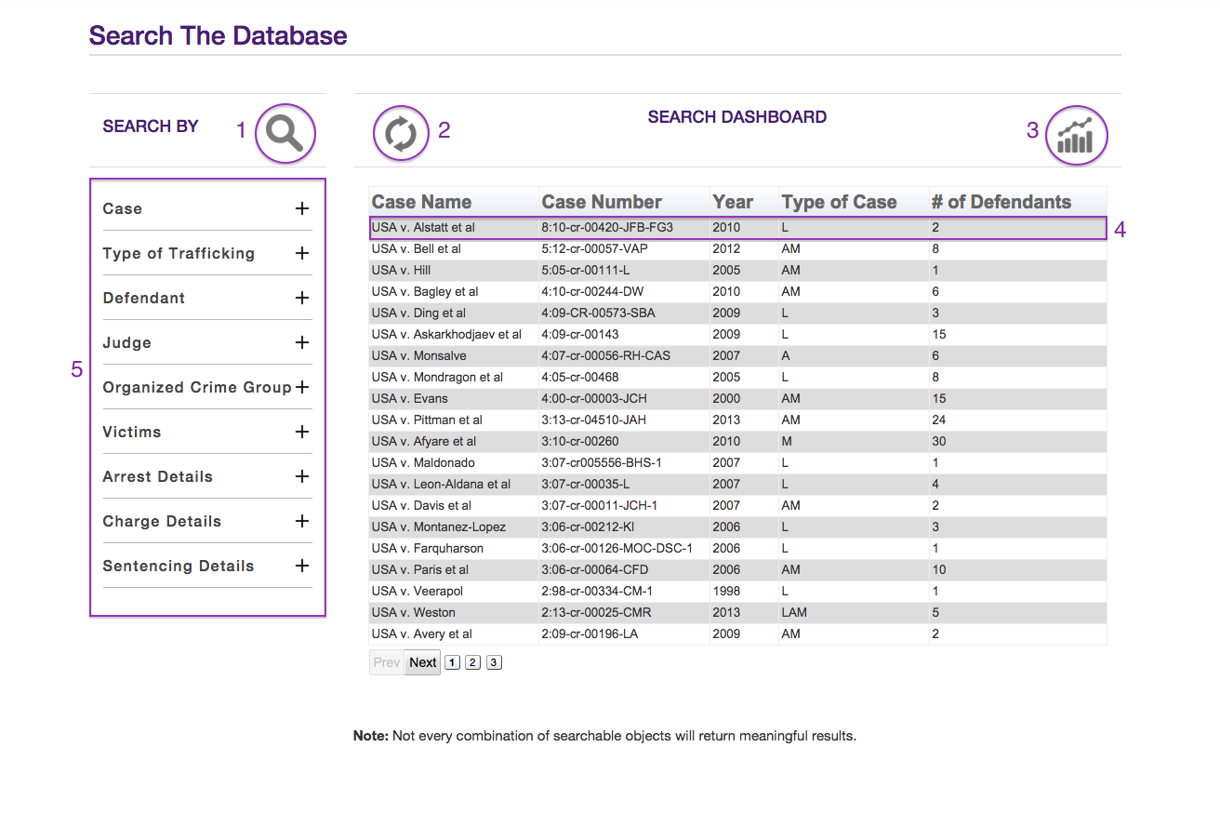

Figure 4.1

To begin **Searching the Database**, start by expanding any of the necessary categories in the left column (**Figure 4.1 #5**) and filling out the relevant fields. Some of the fields which require strings to be input have an **autocomplete** function added to aid in inserting correct text. After the search parameters have been edited, users can perform a search by clicking the **Search** button (**Figure 4.1 #1**). This requests the application to search the final data for all of the cases which fit the search parameters supplied. After the search has been performed, the results get displayed in the table where each row represents an individual case (**Figure 4.1 #4**). Also, the previous search parameters are saved in the left column (**Figure 4.1 #5**) and an asterisk is added to each category name which contains the saved parameters. To clear the results and the previous search criteria, select the **Reset** button (**Figure 4.1 #2**). After the searching has been completed, users can then transition to Analyzing the Data (Section 5) and analyze all of the cases displayed in the results table.

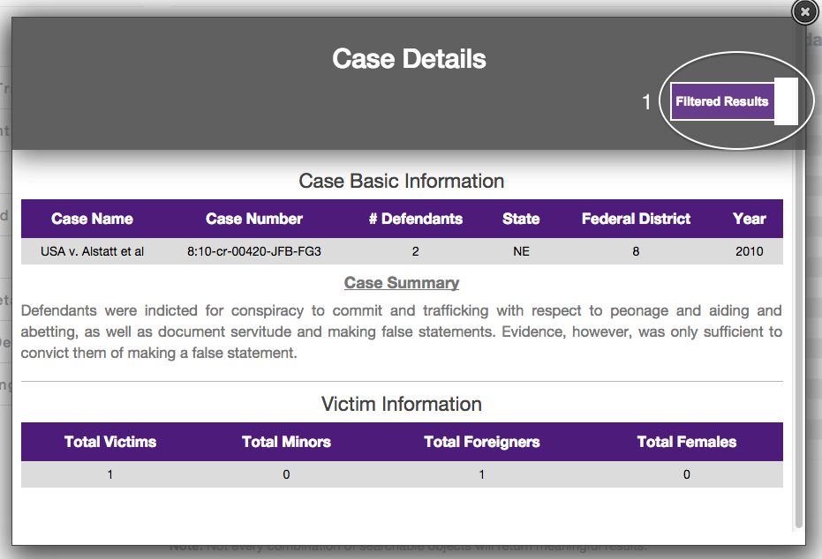

Figure 4.2

To view the detailed case information, click on an individual row (**Figure 4.1 #4**) and a **Case Details Modal** (**Figure 4.2**) will be displayed. By default, the modal filters the visible data to only display tables of information which correspond to the categories which contained valid search parameters, e.g. if under the **Victim** category a user sets **Total Victims** to 10-30 the **Victim Information** table will be a filtered result in the **Case Details Modal**. To disable the filter and view all detailed case information, click the **Filtered Results** switch (**Figure 4.2 #1**) and the switch will update to match the lack of filter applied.

# 5. Analyzing the Data

This section explains how a user would **Analyze the Data**. The data supplied to this part of the application is the same information that is listed in the search results table (see **Section 4** for more information).

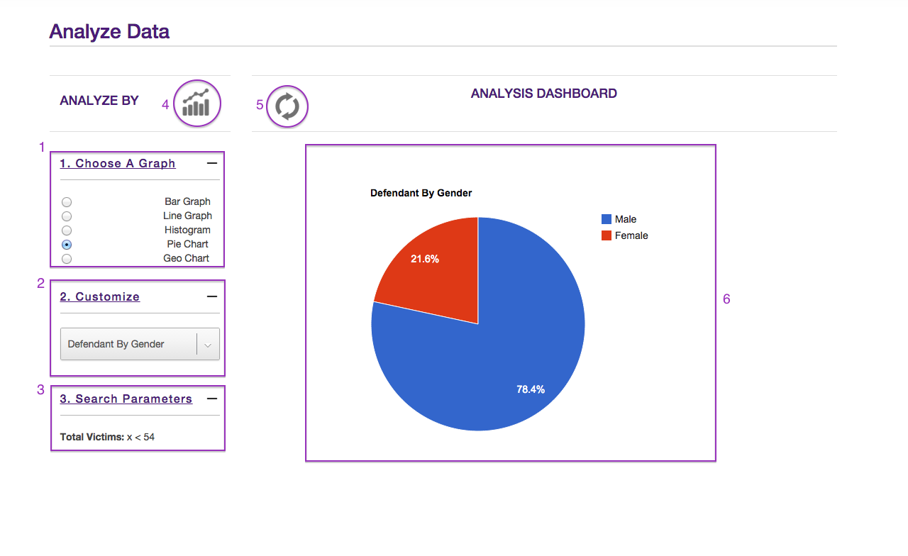

Figure 5.1

To begin the graphing process, a user must select which type of graph to create in the menu labeled **1. Choose A Graph** (**Figure 5.1 #1**). This menu displays 5 different graphs for the user to choose and after selecting an individual graph, the user must choose the variable(s) in **2. Customize** (**Figure 5.1 #2**). Some types require 1 variable and some require 2, make sure to select a variable for all the available boxes. After the type and variables for the graph have been selected, a graph can be generated by clicking the **Generate Graph** button (**Figure 5.1** **#4**). This will generate and display a customized graph in the **Graph Canvas** (**Figure 5.1 #6**). The graph has several features such as hovering over different parts of the graph to uncover more in-depth information for this specified graph. To clear the graph as well as reset the type and variables of the generated graph, click the **Reset** button (**Figure 5.1 #5**).  
To view all of the search parameters which generated the subset of data for this graph, expand **3. Search Parameters** (**Figure 5.1 #3**).

# Glossary of Terms

**CSV File** **–** A CSV file or a Coma Separated Values file also sometimes called Character-Separated Values file stores tabular data (numbers and text) in plain-text form. In this case, the data in the file ought to be in a valid and acceptable form to be uploaded via the upload portal.

**Filtered Results** **–** Case details displayed in the modal window are filtered by default. In other words, the details shown are from the search parameters selected under the 9 different categories.

**Modal** – A popup window that’s populated by case details.

**Search Parameters –** criteria chosen by the user to query the database for cases.