

Design Document

**4/26/2015**

***V3.0***

**JUDGE FROG**

# Revision History

|  |  |  |
| --- | --- | --- |
| Version | Changes | Edited |
| 1.0 | * Initial Draft | November 25, 2014 |
| 1.1 | * Database Schema Updated * Modified Development Environment | January 16, 2015 |
| 2.0 | * Updated Prototypes * Updated Database schema | February 15, 2015 |
| 2.1 | * Updated Glossary of Terms * Updated Prototypes * Updated Database description | February 16, 2015 |
| 2.2 | * Database Hierarchy Model Added * Database Table Descriptions Updated * Data Flow Model Added | February 19, 2015 |
| 3.0 | * Updated database tables, prototypes, glossary | April 26, 2015 |

# Revision Sign-Off

By signing the following, the team member is stating that he has read the entire document and has concluded that the information contained within this document is accurate, relevant to the project, and void of errors.

|  |  |  |
| --- | --- | --- |
| Name | Signature | Date Signed |
| Brice Boula |  |  |
| Collin Duncan |  |  |
| David Tomlinson |  |  |
| Landon Westrom |  |  |

# Table of Contents

Revision History ii

Revision Sign-Off iii

Table of Contents iv

1. Introduction 1

1.1 Purpose 1

1.2 Project Background 1

1.3 Section Overview 1

2. Design Constraints 2

2.1 Assumptions and Dependencies 2

2.2 General Constraints 2

2.3 Development Environment 3

3. Data Flow 4

3.1 Database 5

3.2 Web Application 5

4. Database Design 6

4.1 Data/Data In Progress Table 8

4.2 Users Table 11

5. UML Models 12

5.1 Sequence Diagrams 12

5.1.1 Admin Create Sequence 12

5.1.2 Admin Edit Sequence 13

5.1.3 Admin Delete Sequence 14

5.1.4 Admin Uploads Sequence 15

6. User Interface Prototype 16

6.1 Search Interface 16

6.2 Analyze 17

6.3 Admin Panel 18

7. Glossary of Terms 25

# Introduction

## Purpose

This document provides a complete description of the Judge Frog system design. Included in this document are design constraints, system architecture, user interface design, and Unified Modeling Language (UML) diagrams (state, class, and sequence).

## 1.2 Project Background

Judge Frog is designed to be a fully functional web application with a user-friendly user interface. The application shall provide an efficient database containing significant human trafficking data inserted by the client. The end user shall be presented with visual graphs and charts to sort and analyze the data using various filters. Concluding the user’s data analysis, the user shall have the option of exporting the visual data.

## 1.3 Section Overview

**Section 2 – Design Constraints**: Describes assumptions and dependencies, general constraints, and developmental methods for the Judge Frog web application.

**Section 3 – System Architecture**: Displays a model of the architecture and major component descriptions.

**Section 4 – Database Design**: Models the design of the database and describes the attributes of each table in the database.

**Section 5 – UML Models**: Displays the state, class and sequence diagrams.

**Section 6** **–** **User Interface**: Gives screenshots from the prototype of the smartphone application.

**Section 7 – Glossary of Terms**: Defines technical and project-specific terms used in this document.

# Design Constraints

## 2.1 Assumptions and Dependencies

The Judge Frog Web application will assume the following:

* The user shall access the Web application from a desktop computer
* The user can use the Web application after instruction

## 2.2 General Constraints

* Time
  + Development must be completed by the end of the school year in May 2015.
* Data storage
  + Finite amount of storage space on server used for storage
* Communication
  + Requires continuous Internet access to use the application
* Browser
  + Internet Explorer version 9 or higher
  + Google Chrome version 40 or higher
  + Mozilla Firefox version 33 or higher
  + Safari version 5 or higher

## 2.3 Development Environment

**Programming Utilities**

* MySQLWorkbench 6.2 CE
* PHP 5.5
* CakePHP 2.5.1
* GitHub
* phpMyAdmin 4.0.4.2
* MySQL 5.6.14
* Apache 2.2
* Bootstrap 3.1.1

**General Utilities**

* Microsoft Word
* Microsoft PowerPoint
* Google Drive
* Notepad++ 6.7.4
* Sublime Text Editor 2
* CoreFTP 2.2

# Data Flow



## Database

Our database stores human trafficking data collected by the National Institute of Justice. The well-designed database is stored on our server to be interacted with the web application. The database is developed with the Extended Entity-Relationship model using MySQL Workbench.

## Web Application

The developed Web application connects to the database to insert and retrieve human trafficking data to create analysis for the user. The Web application provides a detailed tutorial on the functionality and navigation present in the application. There is a separate portal for administrative access to database functions.

# Database Design

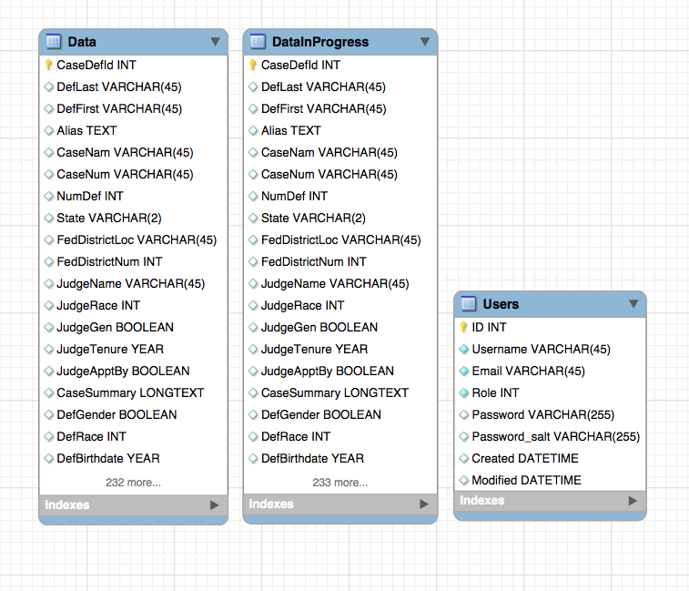



## 4.1 Data/Data In Progress Table

|  |  |  |
| --- | --- | --- |
|  |  |  |
| ***Variable Name*** | ***Type*** | ***Description*** |
| CaseId | INT | Primary key for each case within the database. |
| Created | DATETIME | Timestamp recording when the case was created. |
| Modified | DATETIME | Timestamp recording when the case was last modified |
| AuthorId | INT | Author id which links to the user which last edited this case. |
| Name | VARCHAR(64) | The case name, which is usually USA v. LAST NAME OF FIRST DEFENDANT.  Use case name as listed on the docket. |
| Number | VARCHAR(64) | This is the criminal case number from the US District Court.  Be sure that the case number has cr (criminal) in the middle and not mj (magistrate). We want the CRIMINAL case number only.  Obtain the number at the top of the docket. |
| Summary | LONGTEXT | The detailed description of case information. |
| Num_Defendants | INT | Total number of defendants in the case.  Count the number of defendants listed on the docket. |
| State | VARCHAR(2) | Two letter code for the state in which the case is being heard. |
| FederalDistrict | INT | The federal district number for the state in which the case is being heard.  Look on federal district court map online to determine what federal district a state is in. |
| FederalDistrictLocation | VARCHAR(64) | The region within the specified Federal District, i.e. North, South, Central, etc. |
| JudgeName | VARCHAR(64) | Name of the US federal district court judge hearing the case. |
| JudgeRace | INT | The race of the judge. Coded with the following values: 0=White; 1=Black; 2=Hispanic; 3=Asian; 4=Native American; 5=Other. |
| JudgeGender | BOOLEAN | The gender of the judge. Coded with the following values: 0=Male; 1=Female. |
| JudgeTenure | INT | The year the judge was appointed as a federal district judge. |
| JudgeAppointedBy | INT | This is the partisan identity of the president who appointed the judge.  0=Republican; 1=Democrat. |
| Total | INT | Total number of victims involved in a case. |
| Minor | INT | Number of victims that were minors. |
| Foreigner | INT | Number of victims that are not natural born citizens of the United States. |
| Female | INT | Number of victims that are female. |
| DefFirstname | VARCHAR(45) | First name of the defendant. |
| DefLastname | VARCHAR(45) | Last name of the defendant. |
| DefGender | BOOLEAN | The gender of the defendant. |
| DefBirthDate | DATE | The defendant’s birthdate. |
| DefRace | INT | The race of the defendant. |
| OCGName | VARCHAR(45) | The name of the organized crime group. |
| OCGSize | INT | The size of the organized crime group. Coded with the following values: 1 = “Mom & Pop”; 2 = “Street Gang”; 3 = Cartel/Syndicate/Mafia; 5 = Prison Gang; 6 = Other. |
| OCGScope | INT | The scope of the organized crime group’s activities. Coded with the following values: 1 = Local Only; 2 = Interstate; 3 = International. |
| OCGRace | INT | The predominant race of the organized crime group. Coded with the following values: 0 = None; 1 = Black; 2 = White; 3 = Hispanic; 4 = Asian; 5 = Other. |
| DateTerminated | DATE | The date the sentence is complete. |
| DateSentenced | DATE | The date the defendant was sentenced. |
| TotalSentence | INT | The total number of months the defendant was sentenced. |
| Restitution | INT | The total amount defendant is required to pay in restitution. |
| AssetForfeit | BOOLEAN | Represents whether the defendant is required to forfeit assets by the court. |
| SupervisedReleased | INT | Total number of months the defendant received under supervised release. |
| Probation | INT | The total number of months a defendant received probation. |
| ChargeDate | DATE | The date any charges or indictments were filed. |
| ArrestDate | DATE | The date the defendant was arrested. |
| Detained | BOOLEAN | Represents whether the defendant was detained between arrest and first hearing. |
| LaborTraf | BOOLEAN | Represents whether the case was a labor trafficking case. |
| AdultSexTraf | BOOLEAN | Represents whether the case involved adult sex trafficking. |
| MinorSexTraf | BOOLEAN | Represents whether the case involved sex trafficking of minors. |
| Fel_C | INT | The total number of felonies charged. |
| Fel_S | INT | The total number of felonies sentenced. |
| BailType | INT | The type of the bail in the case. Coded with the following values: 0 = no bail; 1 = surety bail; 2 = non-surety bail. |
| BailAmount | DOUBLE | The amount of the bail set by the judge. |
| Counts | INT | The number of counts charged under a federal statute. |
| CountsNolleProssed | INT | The number of counts dropped. |
| Statute | VARCHAR(45) | The statute under which the defendant was charged. |
| PleaDismissed | INT | The number of counts dismissed pursuant to a plea bargain. |
| PleaGuilty | INT | The number of counts to which the defendant pled guilty. |
| TrialGuilty | INT | The number of counts to which the defendant has received a guilty verdict in a trial. |
| TrialNotGuilty | INT | The number of counts to which the defendant has received a not guilty verdict by trial. |
| Fines | INT | The fine levied on the defendant. |
| Sentence | INT | The number of months of prison time the defendant was sentenced for the charge. |
| Probation | INT | The number of months on probation the defendant was sentenced for the charge. |

## 4.2 Users Table

|  |  |  |
| --- | --- | --- |
| ***Variable Name*** | ***Type*** | ***Description*** |
| Username | VARCHAR(45) | User’s username that is used to login. |
| Email | VARCHAR(45) | The user’s email where user will receive an email to setup login. |
| Role | INT | Indicates permission level of user. |
| Password | VARCHAR(255) | The password the user will use to login. |
| Created | DATETIME | When the user’s account was created. |
| Modified | DATETIME | When the user’s account was modified. |

# UML Models

## 5.1 Sequence Diagrams

### 5.1.1 Admin Create Sequence



### 5.1.2 Admin Edit Sequence



### 5.1.3 Admin Delete Sequence



### 5.1.4 Admin Uploads Sequence



# User Interface Prototype

## 6.1 Search Interface

## U:\pics\search2.PNGU:\pics\search3.PNGU:\pics\search1.PNG

## 6.2 Analyze

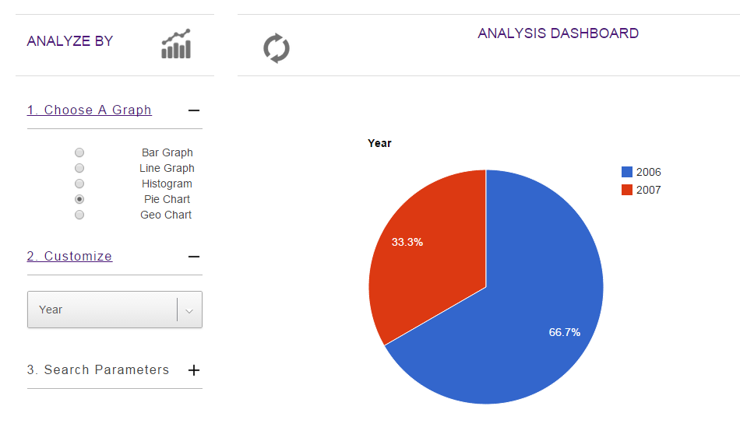

## 6.3 Admin Panel

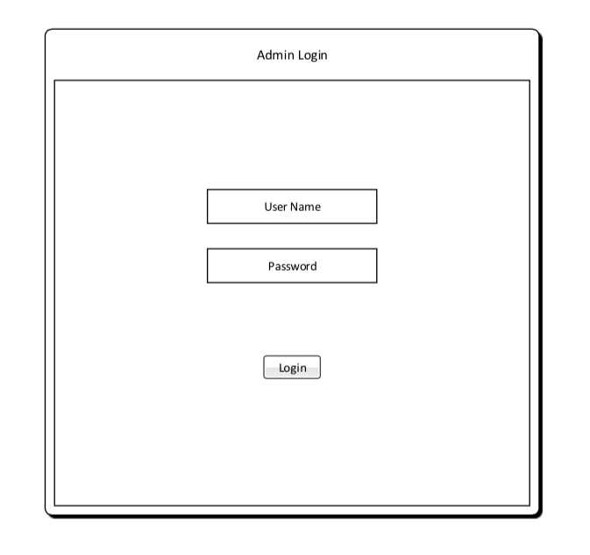

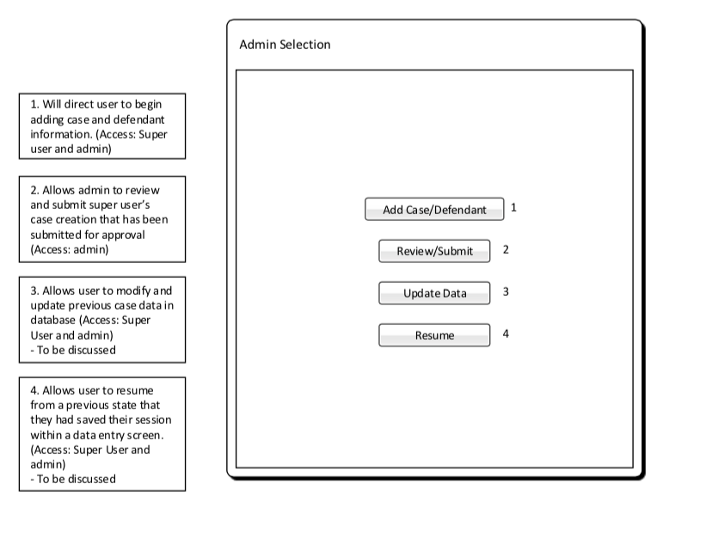

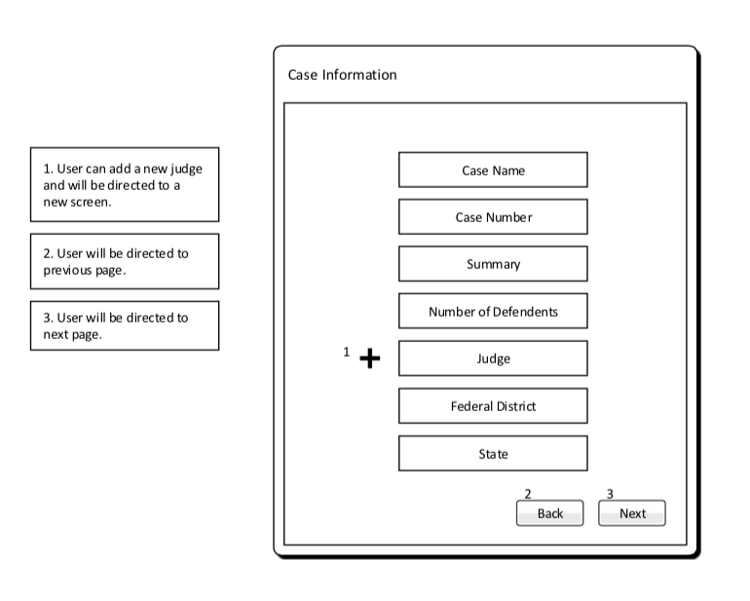

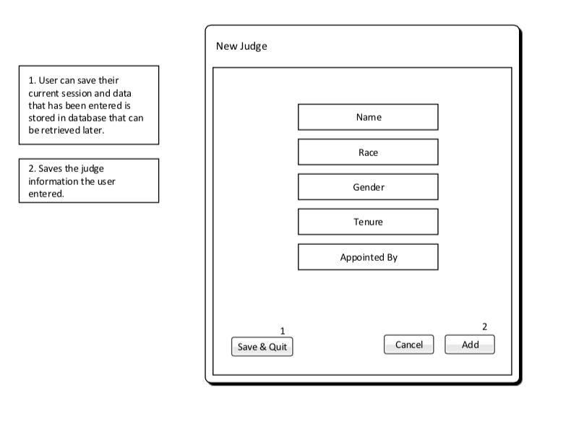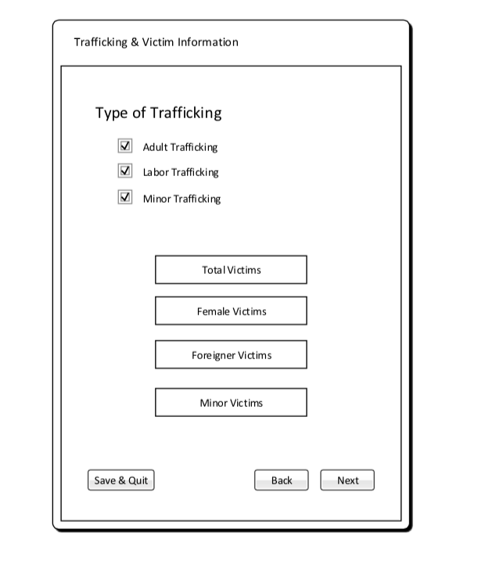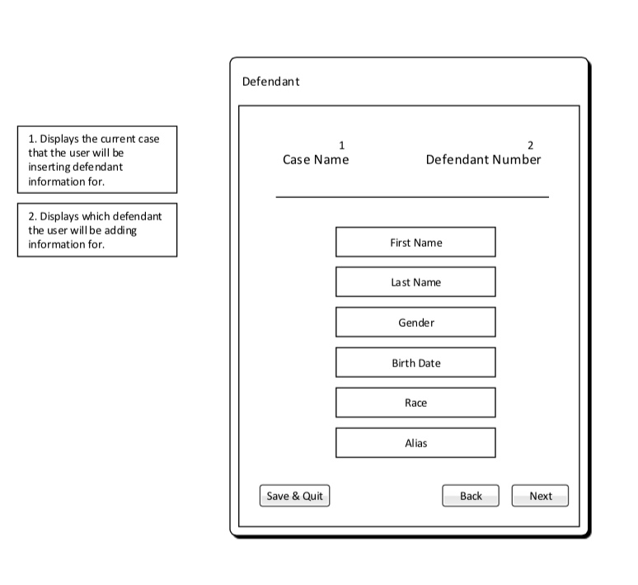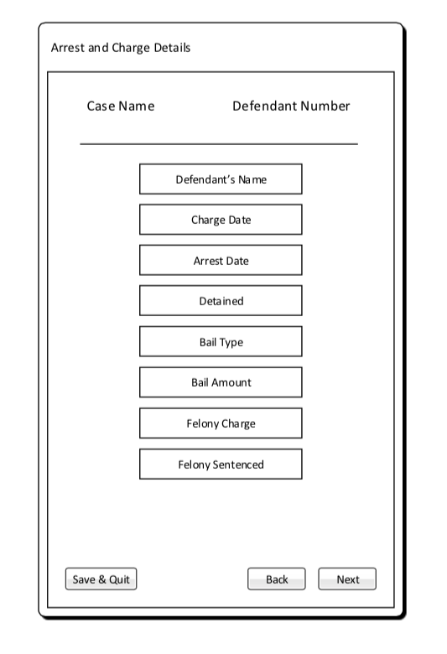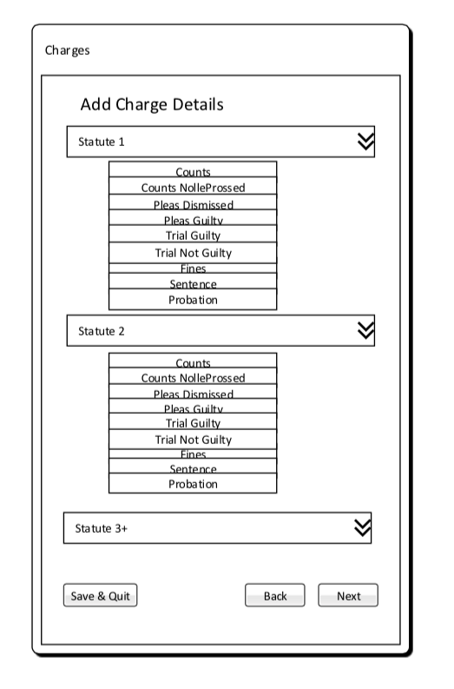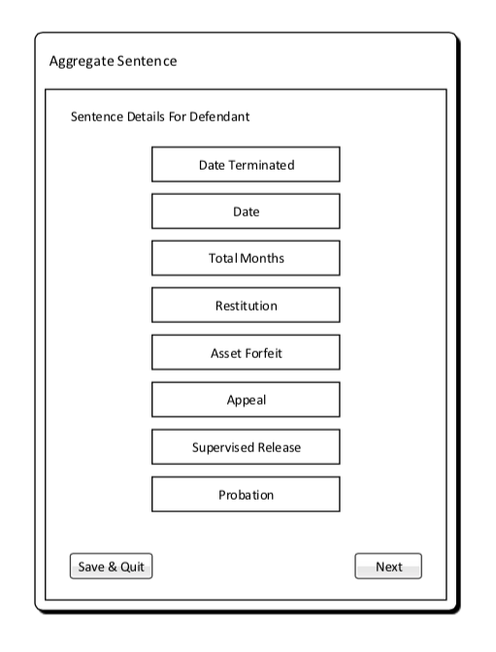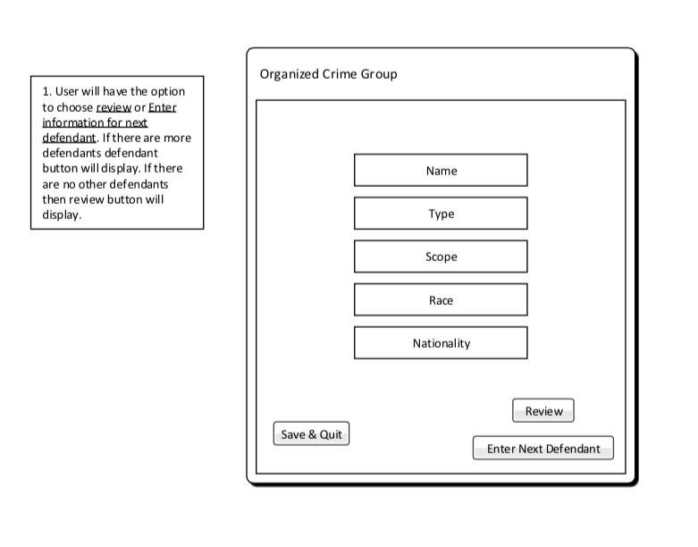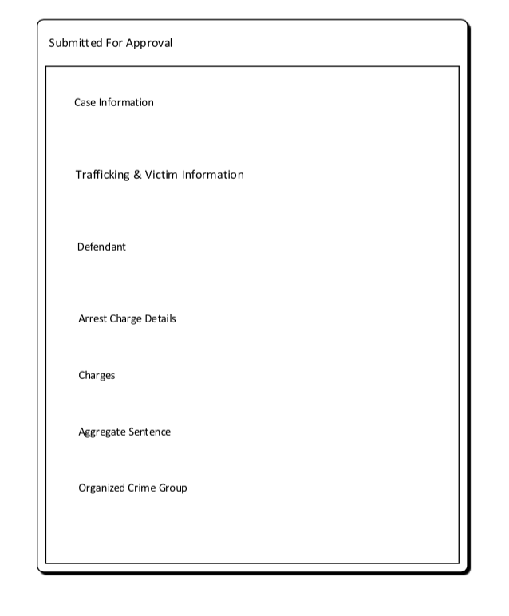

# Glossary of Terms

**Administrator** – Privileged user capable of performing major changes to database.

**Application** – Group of programs designed to supply an end-user with expected functionality.

**CakePHP** – A free, open-source, rapid development framework for PHP.

**Control** **Panel** – An interface specifically designed to allow administrators to easily perform their tasks.

**CRUD –** Create, read, update, delete operations that query database.

**Database** – A structured set of data held in a computer, accessible in various ways.

**Deliverable** – A product, not necessarily finished, related to the project given to the client.

**End-User** – A person or persons who will be using the web application for the specified purpose of our project.

**Foreign Key** – A field in one table that uniquely identifies a row of another table.

**GitHub** – A Web service for software version control.

**Host** – A website on a server accessible over the Internet.

**Milestone** – A point at which project progress can be assessed.

**PHP** – A general-purpose scripting language that is especially suited to server-side web development.

**Primary Key** – Uniquely identifies each record in the table.

**Prototype** – Simulates only a few aspects of, and may be completely different from, the final product.

**TCU** – Texas Christian University

**UML** – Unified Modeling Language; a modeling language designed to provide a standard way to visualize the design of a system.

**Walk-through** – Points during the project where the team describes significant project components with clients and individuals within the team.

**Web Application** – Application that is accessed by visiting a specific URL.