

**JUDGE FROG**

Project Requirements

***V3.0***

**4/26/2015**

# Revision History

|  |  |  |
| --- | --- | --- |
| Version | Changes | Edited |
| 1.0 | * Initial Draft | October 27, 2014 |
| 1.1 | * Revised Appendices |  |
| 1.2 | * Added User Interface Prototypes | January 24, 2015 |
| 2.0 | * Updated Project Prototypes * Updated Project Database Schema | February 15, 2015 |
| 2.1 | * Updated Glossary of Terms * Updated Website Requirements * Updated Performance Requirements * Updated Prototypes | February 16, 2015 |
| 2.2 | * Updated the System Architecture to Data Flow Model * Uses Cases Have Been Updated * Database hierarchy model added | February 19, 2015 |
| 2.3 | * Updated Use Cases | April 7, 2015 |
| 3.0 | * Updated Glossary, prototypes, and small grammar mistakes | April 26, 2015 |

# Revision Sign-Off

By signing the following, the team member is stating that he has read the entire document and has verified that the information contained within this document is accurate, relevant to the project, and void of errors.

|  |  |  |
| --- | --- | --- |
| Name | Signature | Date Signed |
| Brice Boula |  |  |
| Collin Duncan |  |  |
| David Tomlinson |  |  |
| Landon Westrom |  |  |

# Table of Contents

Revision History ii

Revision Sign-Off iii

Table of Contents iv

1. Introduction 1

1.1 Purpose 1

1.2 Intended Audience 1

1.3 Scope and Objectives 1

1.4 References 1

1.5 Overview 2

2. Project Overview 3

2.1 Product Perspective 3

2.2 Product Functions 3

2.3 User Characteristics 3

2.4 Constraints 4

2.5 Operating Environment 4

2.6 Assumptions and Dependencies 4

3. System Architecture 5

4. External Interface Requirements 6

4.1 User Interfaces 6

4.2 Software Interfaces 6

4.3 Communication Interfaces 6

4.4 Monitoring and Reporting Mechanisms 6

5. Functional Requirements 7

5.1 General Requirements 7

5.2 Website Requirements 7

5.3 Database Requirements 7

6. Non-functional Requirements 8

6.1 Performance Requirements 8

6.2 External Requirements 8

7. User Interface Prototype 9

7.1 Search Interface 9

7.2 Analyze 10

7.3 Admin Panel 11

8. Glossary of Terms 18

9. Appendices 19

Appendix A – User Use-Case Diagram 19

Appendix B – User Use-Case Scenario 20

Appendix C – Admin Use-Case Diagram 21

Appendix D – Admin Use-Case Scenario 22

Appendix E –RA User Use-Case Diagram 26

Appendix F – Database Model (EER) 29

# Introduction

## 1.1 Purpose

This document contains all functional and non­functional requirements of the Judge Frog project. In addition, this document contains use-case diagrams and a simple model of the system to show each interaction between different components. All requirements shall be delivered in various aspects to the development team by the project clients or Dr. Donnell Payne.

## 1.2 Intended Audience

The creation of this document is to provide the development team of Judge Frog necessary and intended requirements which have been specified by the project clients. This document can also be reviewed by the clients to provide additional requirements and provide essential feedback to the development team as they are developing this project.

## 1.3 Scope and Objectives

The main objective of Judge Frog is to provide vast amounts of data on human trafficking to the general public through a highly efficient and appealing user interface website along with the ability to search, analyze and provide statistics on the data. All data shall be obtained from public information of Federal cases regarding human trafficking.

## 1.4 References

MySQL Developer Zone – <http://dev.mysql.com/>

Grant Proposal NIJ-2013-3457 – available by request

Grant Award 2013-R2-CX-0049 – available by request

Software Engineering Resources – <http://ifs.host.cs.st-andrews.ac.uk/Books/SE9/Presentations/index.html>

CakePHP Cookbook – <http://book.cakephp.org/2.0/en/index.html>

## 1.5 Overview

**Section 2** – This section contains the overall description of the product, including its characteristics, functions, operation requirements, and assumptions and dependencies.

**Section 3** – This section specifies the architecture of the system used by the product.

**Section 4 –** This section details all external interfaces that the system is required to interact with.

**Section 5 –** This section contains the functional requirements of the software system.

**Section 6 –** This section contains the non-functional requirements of the software system.

**Section 7 –** This section lists definitions of terms used in this document.

# Project Overview

## 2.1 Product Perspective

The perspective of this product is to enable our clients to perform the needed operations to complete the purposes listed in their grant proposal. The purpose being the ‘creation of comprehensive database of organized crime cases involving human trafficking’, more specifically, to search and obtain records from the database, add records to the database, analyze data stored in database, and host the database in such a way that the general public can access this data.

## 2.2 Product Functions

Our product contains 2 main components: the database and the web application. The web application interfaces with the database to allow administrators to perform CRUD operations on said database and allow users to read specified sets of data and request certain analysis to be performed and subsequently displayed in a textual or graphical representation. This output can then be requested to be downloaded by the current user. All of this data will be inserted initially by our clients who obtained the data from publicly available, federal human trafficking cases.

|  |  |  |
| --- | --- | --- |
| Feature | Admin | Research Assistant |
| Upload | X |  |
| Download | X | X |
| Create Case | X | X |
| Edit All Cases | X |  |
| Edit Incomplete Case | X | X |
| Delete Case | X |  |
| Review | X |  |
| User Management | X |  |

## 2.3 User Characteristics

## 2.4 Constraints

* Time
  + Development must end by April 2015.
* Data storage
  + Finite amount of storage space on server used for storage
* Communication
  + Requires continuous Internet access to use the application
* Browser
  + Internet Explorer version 9 or higher
  + Google Chrome version 40 or higher
  + Mozilla Firefox version 33 or higher
  + Safari version 5 or higher

## 2.5 Operating Environment

Judge Frog shall be a web application which can be accessed by any device with a modern browser at one of the three URLs: humantraffickingdata.org, humantraffickingdata.com, humantraffickingdata.net.

## 2.6 Assumptions and Dependencies

We assume that the user will have modern browsers and will be on a desktop computer with mouse and keyboard along with a 1Mbps Internet connection.

# System Architecture

The system can currently be represented by the following diagram showing the interactions between different components of the web application:



# External Interface Requirements

## 4.1 User Interfaces

The user shall interface with our product by accessing the website humantraffickingdata.org.

There shall be a search or browse function that allows the user to select data for analysis.

There shall be a method for selecting the type of analysis to be performed.

There shall be a method to upload data for insertion.

There shall be a method to download the results of all the analysis.

For authorized users, there shall be a “control panel” for the insertion, deletion, and updating of data contained in the database.

No login information shall be required unless the user is accessing the previously mentioned “control panel.”

As progress develops, screenshots will be added to the Appendix featuring the user interface.

## 4.2 Software Interfaces

The website shall interface appropriately with all modern browsers (see 2.4).

## 4.3 Communication Interfaces

The system shall communicate to devices through the Internet to provide the application.

## 4.4 Monitoring and Reporting Mechanisms

The system will enable the administrator to monitor data inserted into the database.

# Functional Requirements

## 5.1 General Requirements

The system shall be available for any modern browser client (see section 2.4).

The system shall allow access to data in database and provide analytics based on user input.

## 5.2 Website Requirements

The website shall allow search input for searching the database for results.

The website shall allow input for selecting the various types of analysis to perform on the selected data.

The website shall provide a visual and textual representation of the results of the analysis on the selected data.

The website shall allow for administrators to query for inserts, deletes, or updates on the database, and also adding new users.

## 5.3 Database Requirements

The database shall allow insert, delete, or update queries with proper values.

The database shall allow select queries to be performed on all tables.

# Non-functional Requirements

## 6.1 Performance Requirements

The system shall not require any credentials to be accessed, except for restricted actions.

The system shall effortlessly allow the retrieval of convicted felons’ data.

Data shall be dynamically transposed on to charts (or other modeling forms) for a comprehensive/statistical understanding of the data.

The website shall be accessible as much as reasonably possible, allowing for issues with the hosting provider.

## 6.2 External Requirements

NIJ shall be credited for providing the data and the funding needed to build the system.

All data shall be publicly accessible to anyone who accesses the site.

# User Interface Prototype

## 7.1 Search Interface

## U:\pics\search2.PNGU:\pics\search3.PNGU:\pics\search1.PNG

## 7.2 Analyze

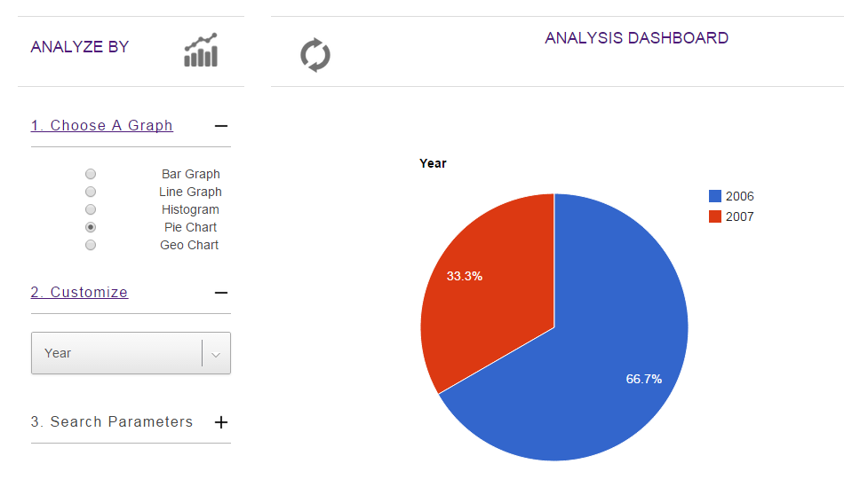

## 7.3 Admin Panel

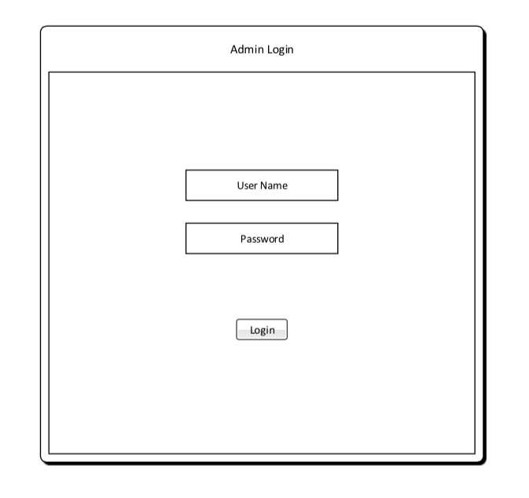

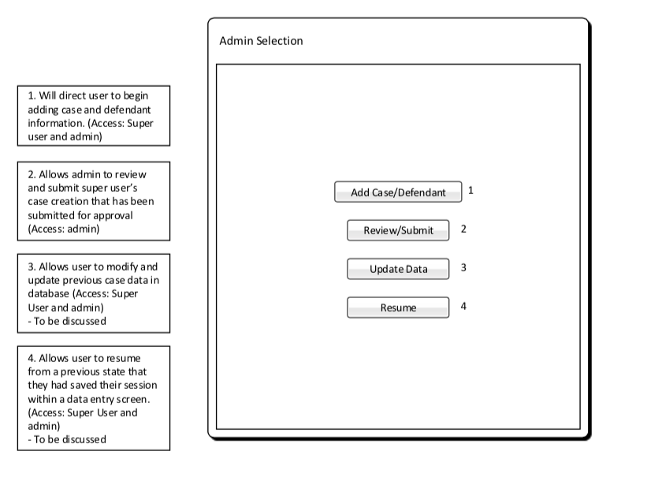

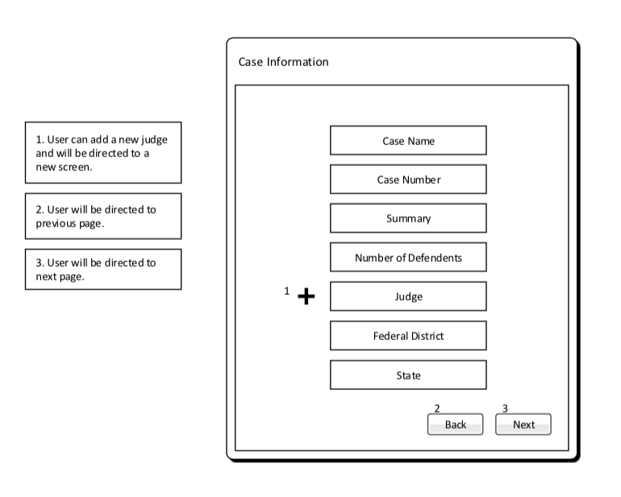

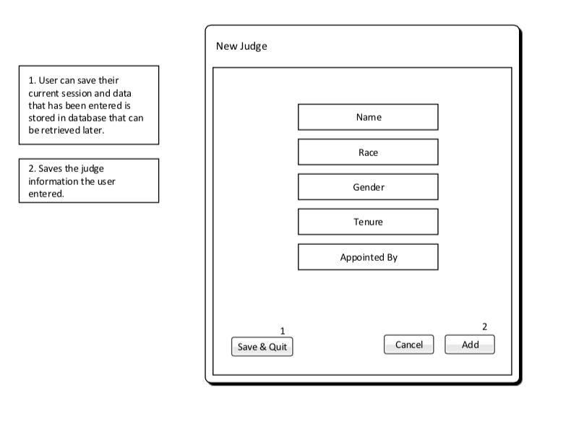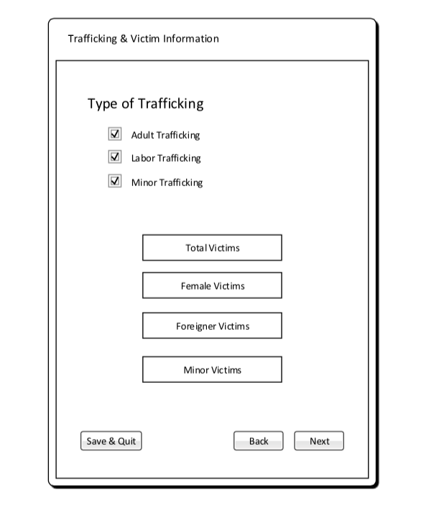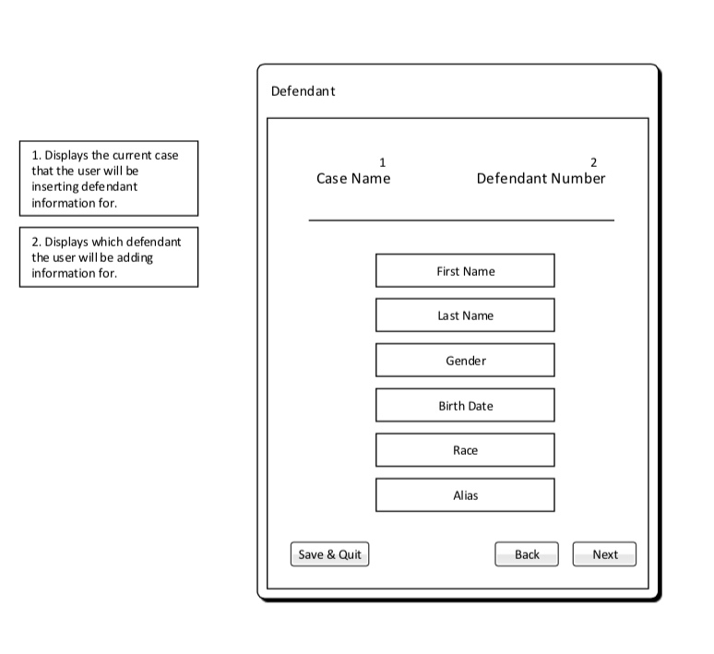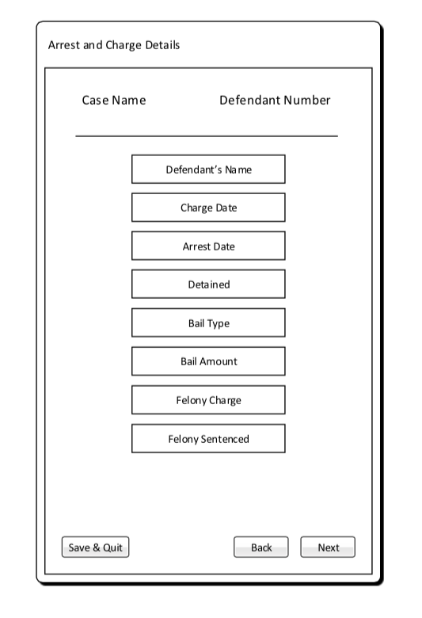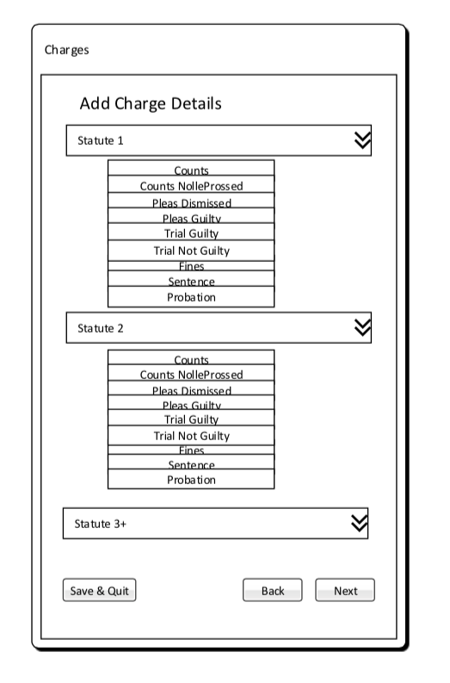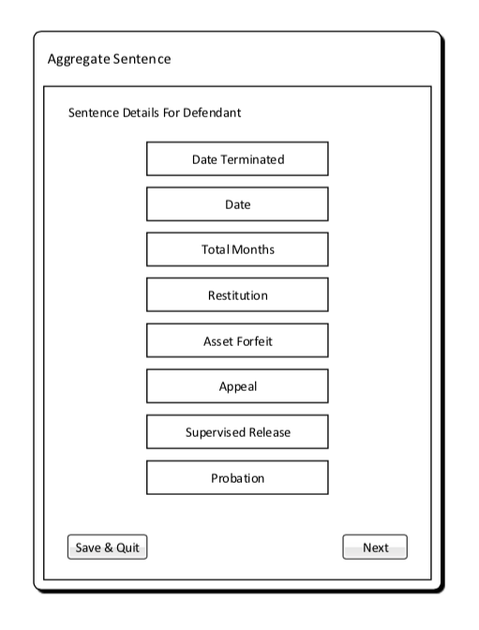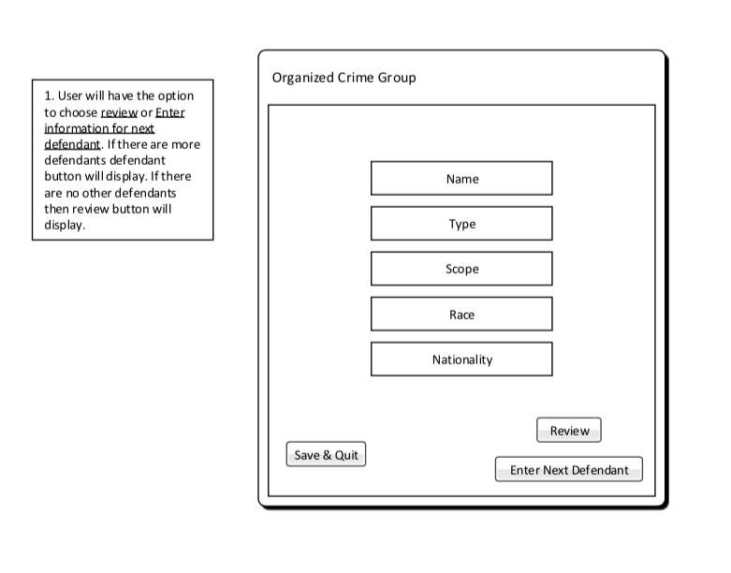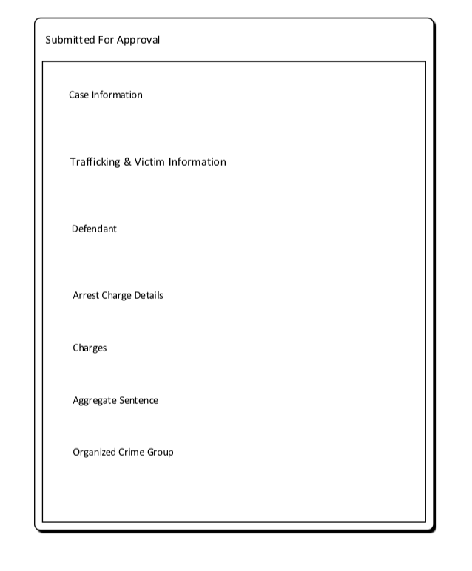

# Glossary of Terms

**Administrator** – Privileged user capable of performing major changes to database.

**Application** – Group of programs designed to supply an end-user with expected functionality.

**CakePHP** – A free, open-source, rapid development framework for PHP.

**Control** **Panel** – An interface specifically designed to allow administrators to easily perform their tasks.

**CRUD –** Create, read, update, delete operations that query database.

**Database** – A structured set of data held in a computer, accessible in various ways.

**Deliverable** – A product, not necessarily finished, related to the project given to the client.

**End-User** – A person or persons who will be using the web application for the specified purpose of our project.

**Foreign Key** – A field in one table that uniquely identifies a row of another table.

**GitHub** – A Web service for software version control.

**Host** – A website on a server accessible over the Internet.

**Milestone** – A point at which project progress can be assessed.

**PHP** – A general-purpose scripting language that is especially suited to server-side web development.

**Primary Key** – Uniquely identifies each record in the table.

**Prototype** – Simulates only a few aspects of, and may be completely different from, the final product.

**TCU** – Texas Christian University

**UML** – Unified Modeling Language; a modeling language designed to provide a standard way to visualize the design of a system.

**Walk-through** – Points during the project where the team describes significant project components with clients and individuals within the team.

**Web Application** – Application that is accessed by visiting a specific URL.

# Appendices

## Appendix A – User Use-Case Diagram

This represents a use-case diagram for the default user who interacts with the web application:



## Appendix B – User Use-Case Scenario

This appendix represents the use-case scenario for the use-case diagram in Appendix A.

|  |  |
| --- | --- |
| **Search** | |
| **Actors** | User |
| **Description** | A user can query the database to display certain subsets of the database based on a variety of filters. |
| **Data** | Variables to search for; value of variable |
| **Pre-Conditions** | The database contains data |
| **Triggers** | Submitting search from form on website |
| **Events** | 1. Web application performs a SELECT query on database 2. Database returns result set of performed query 3. Web application returns a new view with the requested data |

|  |  |
| --- | --- |
| **Analyze** | |
| **Actors** | User |
| **Description** | A user can request that some analysis be performed on the data that they have been given after a search operation |
| **Data** | Type of analysis; data to be analyzed |
| **Pre-Conditions** | User has selected some data (from search use-case) |
| **Triggers** | Submitting analysis request from form field on web application |
| **Events** | 1. Web application runs a method which corresponds to each type of analysis 2. Web application generates results 3. Web application returns a new view with the resulting data |

## Appendix C – Admin Use-Case Diagram

This appendix represents a use-case diagram for any user classified as an administrator inside of our system and allows the user to perform administrative tasks



## Appendix D – Admin Use-Case Scenario

This appendix represents the use-case scenarios for the use-case diagram shown in Appendix C.

|  |  |
| --- | --- |
| **Insert** | |
| **Actors** | Administrator |
| **Description** | The administrator requests for more data to be inserted into the database through the admin control panel |
| **Data** | Type of data to be inserted; required attributes for given type of data |
| **Pre-Conditions** | All required fields in form are completed |
| **Triggers** | Submitting insertion in form |
| **Events** | 1. Web application performs an INSERT query on database with given data. 2. Database returns the new object’s ID to web application 3. If the ID returned is greater than 0, display a success notification to user and return to control panel. |

|  |  |
| --- | --- |
| **Delete** | |
| **Actors** | Administrator |
| **Description** | The administrator requests for existing data to be deleted from the database through the admin control panel |
| **Data** | ID of data to be deleted; type of data to be deleted |
| **Pre-Conditions** | Data must exist in correct table |
| **Triggers** | Submitting deletion in form |
| **Events** | 1. Web application performs a DELETE query on database with given id and table name. 2. Database returns true or false, where true corresponds to success. 3. If true, display success notification to user, else display invalid request. |

|  |  |
| --- | --- |
| **Update** | |
| **Actors** | Administrator |
| **Description** | Administrator wishes to change an existing entry in the database to contain new values |
| **Data** | ID of data; type of data; new values for data |
| **Pre-Conditions** | Data exists in database |
| **Triggers** | Submitting update in form |
| **Events** | 1. Web application performs an UPDATE query on database with given data. 2. Database returns -1, 0, or 1. Where -1 represents the entry doesn’t exist; 0 represents invalid data; 1 represents successful update occurred. 3. Display notification to user depicting the results of the query. |

|  |  |
| --- | --- |
| **Upload CVS** | |
| **Actors** | Administrator |
| **Description** | Administrator wishes to upload case docket into database |
| **Data** | Type of data to be inserted; required attributes for given type of data |
| **Pre-Conditions** | All required fields in form are completed and are correct variable type |
| **Triggers** | Submitting file through upload interface |
| **Events** | 1. Web application runs a script to convert data in case docket into database 2. Web application either returns confirmation of successful upload or error in case docket CSV |

|  |  |
| --- | --- |
| **Download CVS** | |
| **Actors** | Administrator |
| **Description** | Administrator wishes to download case docket from database into CSV format |
| **Data** | Type of data to be retrieved from database |
| **Pre-Conditions** | User must be admin |
| **Triggers** | Interacting with the download button |
| **Events** | 1. Web application runs a script to retrieve everything from database and inserts it into the according column and row in CSV file 2. User will be presented with CVS file |

|  |  |
| --- | --- |
| **Add Admin/RA** | |
| **Actors** | Administrator |
| **Description** | Administrator wishes to add another account which can make administrative changes to the database |
| **Data** | Account details (name and password) |
| **Pre-Conditions** | Name cannot exist already; password must meet requirements |
| **Triggers** | Submit through account create form |
| **Events** | 1. Web application inserts new record into admin table in database 2. Database returns 0 for fail and 1 for pass 3. Display notification accordingly |

|  |  |
| --- | --- |
| **Delete Admin/RA** | |
| **Actors** | Administrator |
| **Description** | Administrator wishes to delete another account which can make administrative changes to the database |
| **Data** | Account name |
| **Pre-Conditions** | Name must exist already |
| **Triggers** | Submit through account delete form |
| **Events** | 1. Web application deletes existing record from admin table in database 2. Database returns 0 for fail and 1 for pass 3. Display notification accordingly |

|  |  |
| --- | --- |
| **Search** | |
| **Actors** | User |
| **Description** | A user can query the database to display certain subsets of the database based on a variety of filters. |
| **Data** | Variables to search for; value of variable |
| **Pre-Conditions** | The database contains data |
| **Triggers** | Submitting search from form on website |
| **Events** | 1. Web application performs a SELECT query on database 2. Database returns result set of performed query 3. Web application returns a new view with the requested data |

|  |  |
| --- | --- |
| **Analyze** | |
| **Actors** | User |
| **Description** | A user can request that some analysis be performed on the data that they have been given after a search operation |
| **Data** | Type of analysis; data to be analyzed |
| **Pre-Conditions** | User has selected some data (from search use-case) |
| **Triggers** | Submitting analysis request from form field on web application |
| **Events** | 1. Web application runs a method which corresponds to each type of analysis 2. Web application generates results 3. Web application returns a new view with the resulting data |

|  |  |
| --- | --- |
| **Download** | |
| **Actors** | User |
| **Description** | A user can prompt the web application to display the results of an analysis in various formats: text, graph, map |
| **Data** | Result data from analysis; type of report |
| **Pre-Conditions** | Analysis has been performed on a subset of data |
| **Triggers** | Submitting report action in field on web application |
| **Events** | 1. Web application gets request to generate a report 2. Web application generates report and returns a new view with data 3. [Optional] User prompts for download and web application returns a (.CSV, .PNG, etc.) depending on user specification and type of report. |

## Appendix E –RA User Use-Case Diagram



|  |  |
| --- | --- |
| **Download CVS** | |
| **Actors** | Super User |
| **Description** | Super User wishes to download case docket from database into CSV format |
| **Data** | Type of data to be retrieved from database |
| **Pre-Conditions** | User must be admin |
| **Triggers** | Interacting with the download button |
| **Events** | 1. Web application runs a script to retrieve everything from database and inserts it into the according column and row in CSV file 2. User will be presented with CVS file |

|  |  |
| --- | --- |
| **Insert** | |
| **Actors** | Super User |
| **Description** | The Super User requests for more data to be inserted into the database through the admin control panel |
| **Data** | Type of data to be inserted; required attributes for given type of data |
| **Pre-Conditions** | All required fields in form are completed |
| **Triggers** | Submitting insertion in form |
| **Events** | 1. Web application performs an INSERT query on database with given data to a temporary table. 2. Data is stored in temporary table in the database is waited for approval by administrator to migrate to the primary database table |

|  |  |
| --- | --- |
| **Save** | |
| **Actors** | Super User |
| **Description** | The data the Super User enters in insert fields is saved as the user presses the next button to go to the next insert window |
| **Data** | Type of data to be inserted; required attributes for given type of data |
| **Pre-Conditions** | All required fields in form are completed |
| **Triggers** | User pressing next button |
| **Events** | 1. Web application performs an INSERT query on database with given data to a temporary table 2. Data is stored in temporary table in the database |

|  |  |
| --- | --- |
| **Retrieve Stored State** | |
| **Actors** | Super User |
| **Description** | The Super User requests to retrieve previous stored information in temporary table in database |
| **Data** | All data that was inserted previously by user |
| **Pre-Conditions** | Must have saved a state previously |
| **Triggers** | Selecting previous state |
| **Events** | 1. Web application performs an SELECT query on database with given data from the temporary table. 2. Data in temporary table is placed into its according fields for user to continue entry |

|  |  |
| --- | --- |
| **Search** | |
| **Actors** | Super User |
| **Description** | A user can query the database to display certain subsets of the database based on a variety of filters. |
| **Data** | Variables to search for; value of variable |
| **Pre-Conditions** | The database contains data |
| **Triggers** | Submitting search from form on website |
| **Events** | 1. Web application performs a SELECT query on database 2. Database returns result set of performed query 3. Web application returns a new view with the requested data |

|  |  |
| --- | --- |
| **Analyze** | |
| **Actors** | Super User |
| **Description** | A user can request that some analysis be performed on the data that they have been given after a search operation |
| **Data** | Type of analysis; data to be analyzed |
| **Pre-Conditions** | User has selected some data (from search use-case) |
| **Triggers** | Submitting analysis request from form field on web application |
| **Events** | 1. Web application runs a method which corresponds to each type of analysis 2. Web application generates results 3. Web application returns a new view with the resulting data |

## Appendix F – Database Model (EER)

This appendix represents the current model of our database as an extended entity-relation model using MySQL Workbench.

