Game Design Document

Fill up the Following document

1. Write the title of your project.

Zombies

1. What is the goal of the game?

To survive the zombies for as long as possible

1. Write a brief story of your game?

There are zombies trying to get to the people in a building so you have to hold them off for as long as you can

1. Which are the playing characters of this game?

* Playing characters are the ones which respond to the user based on the input from the user
* Cars, monkeys, dinos, wizards etc, are the playing characters in the game.

|  |  |  |
| --- | --- | --- |
| Number | Character Name | What can this character do? |
| 1 | Person | Shoot the zombies |
| 2 | Zombies | Hurt the player and reach the building to end the game |
| 3 |  |  |
| 4 |  |  |
| 5 |  |  |
| 6 |  |  |
| 7 |  |  |
| 8 |  |  |

1. Which are the Non Playing Characters of this game?

* Non Playing characters are the ones which don't have an action or a behaviour when the user interacts with the game.
* Hurdles, stones, bananas, coins, etc are non playing characters in the game.

|  |  |  |
| --- | --- | --- |
| Number | Character Name | What can this character do? |
| 1 | building | Gets attacked by zombies to end the game |
| 2 | platforms | Are shorter than the ground so zombies go less distance |
| 3 |  |  |
| 4 |  |  |
| 5 |  |  |
| 6 |  |  |
| 7 |  |  |
| 8 |  |  |

Draw your imagination of this game. What does this game look like?

* Draw the game either on your computer or on paper,
* Add images of scenes of the game to show each of the playing and non-playing characters at least once.

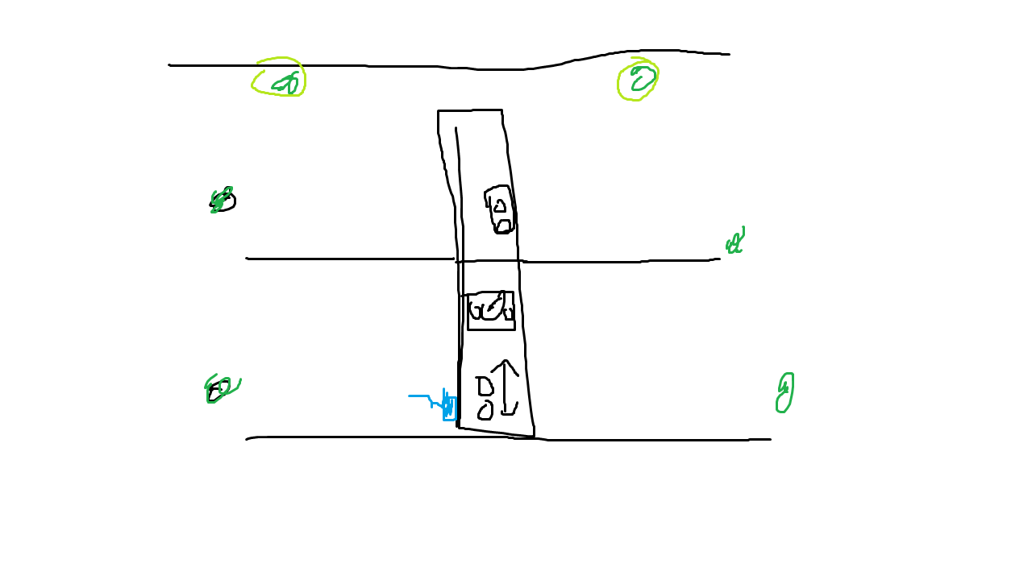

How do you plan to make your game engaging?

It will be an infinite game and also after a while zombies will spawn from the top platforms and will have to go less distance to get to the building because they can “jump”