**Automate Login and Dashboard Validation**

**for CiviCRM Demo Site**

***“Task Documentation”***

**Introduction:**

This project aims to automate the login process to the CiviCRM demo site using Playwright with JavaScript, focusing on verifying the correct display of the dashboard post-login. Through automated testing, the script will navigate to the site, authenticate using provided credentials, and validate successful login by confirming the presence of specific dashboard elements. The project assesses proficiency in utilizing automated testing tools, web page navigation, and application state validation, with key objectives including writing a Playwright test script, ensuring accurate login automation, and verifying dashboard display post-login.  
**Step-by-step instructions on how to run the Script:**

1. Initializing a new Playwright project using the **“npm init playwright@latest”** command in the **auth** folder.
2. Writing the script in **“example.spec.js”** file which automates the login process to the CiviCRM demo site using Playwright with JavaScript. After successful login, it verifies the presence of the dashboard. Code snipped with proper comments is given below:

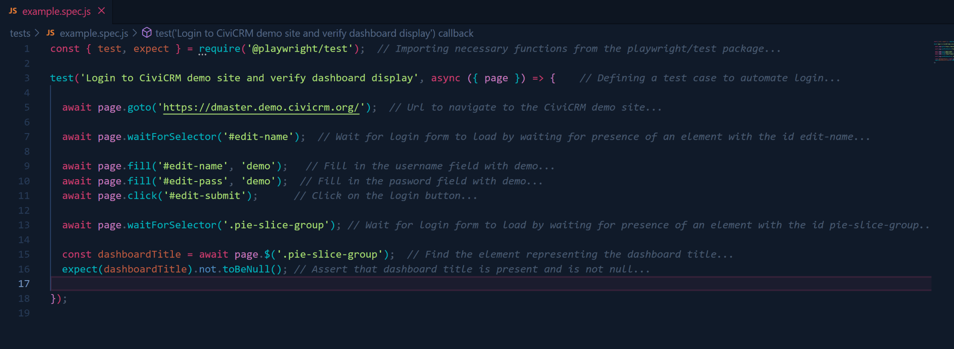

1. Executing the script using command **“npx playwright test --ui”** which will open up a graphical interface in another window to execute Playwright tests and show them in real time. *Screenshot is attached below:*

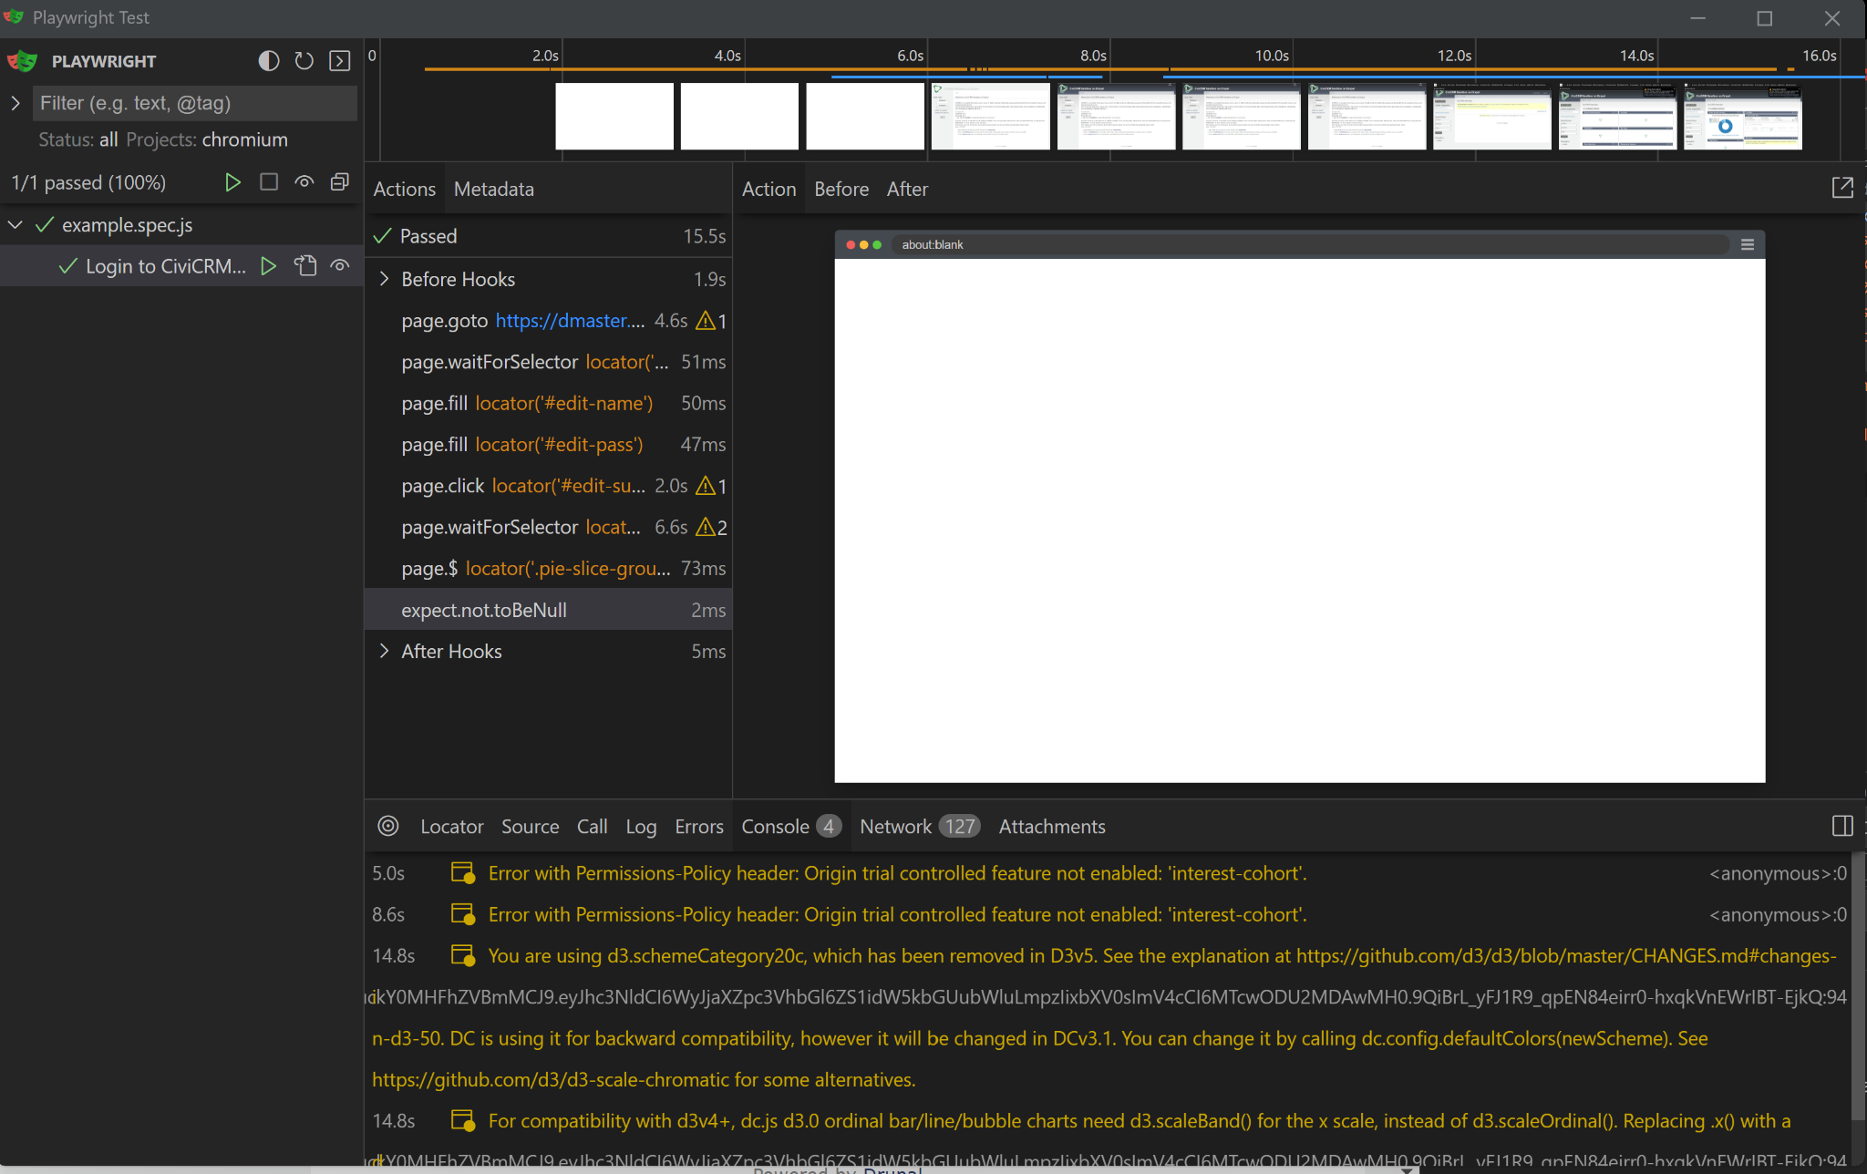

1. Pushing it on Github and sharing the link of the git repository.   
   <https://github.com/OogwayKP/TechCredz_Assessment_Task>

**Prerequisites:**

1. Node.js version: v21.6.2
2. Playwright version: playwright@1.41.2

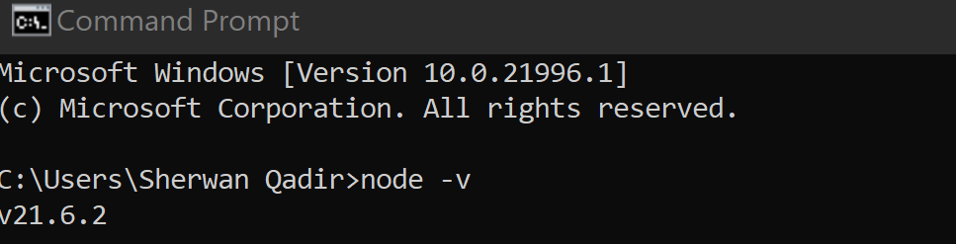

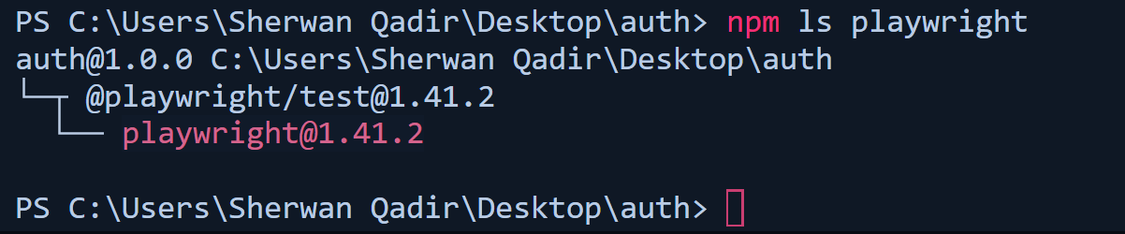

***References:***

1. <https://www.npmjs.com/package/@playwright/test>
2. <https://www.w3schools.com/css/css_selectors.asp>