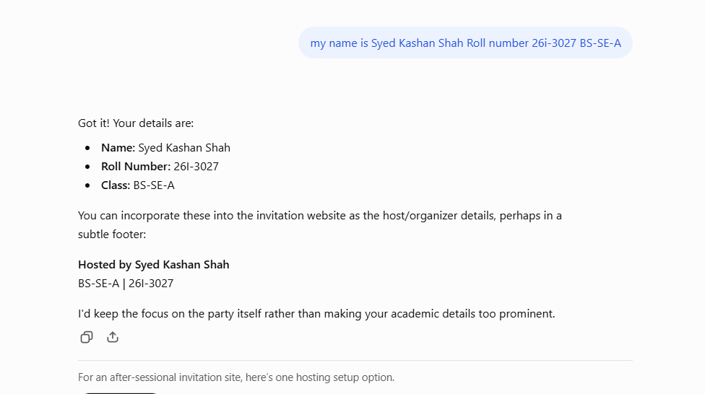

Generated a professional prompt using chatgpt:

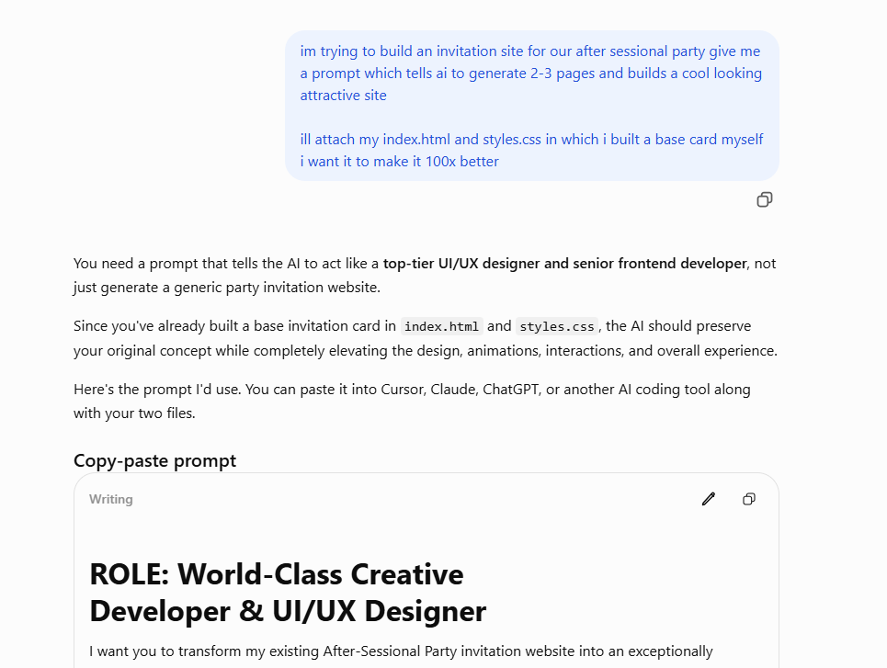
im trying to build an invitation site for our after sessional party give me a prompt which tells ai to generate 2-3 pages and builds a cool looking attractive site ill attach my index.html and styles.css in which i built a base card myself i want it to make it 100x better

Chat gpt gave me this prompt

ROLE: World-Class Creative Developer & UI/UX Designer
I want you to transform my existing After-Sessional Party invitation website into an exceptionally beautiful, modern, interactive, and visually impressive experience.
I will provide two existing files:
- index.html
- styles.css
These files contain a basic invitation card that I have designed myself. Treat them as the starting point, not the final design.
Your job is to make the website 100x better while retaining the original concept and making the experience feel premium, exciting, and memorable.

1. Overall Creative Direction
Think of this as a high-end party invitation designed by an award-winning creative agency.
The website should feel:
- Visually stunning and aesthetically polished.
- Youthful, energetic, stylish, and exciting.
- Premium rather than like a generic event template.
- Interactive, immersive, and full of personality.
- Designed to make guests genuinely excited to attend.
Use bold typography, beautiful gradients, sophisticated color combinations, layered elements, subtle textures, lighting effects, and creative visual details.
Avoid generic website templates and boring layouts.

2. Build 2–3 Connected Pages/Sections
Create a cohesive experience with 2–3 distinct pages or screens.
PAGE 1 — The Invitation (Landing Experience)
- A visually striking first impression.
- An upgraded version of my existing invitation card.
- Beautiful typography and an eye-catching headline.
- Event title: After-Sessional Party.
- Space for date, time, venue, and other event details.
- A prominent interactive "Open Invitation" or "Let's Party" button.
- Smooth entrance animations and sophisticated transitions.
- A beautiful hero section that immediately grabs attention.
PAGE 2 — The Party Details
- Present the event details in a creative and visually appealing layout.
- Include date, time, location, dress code, and other relevant information.
- Add interactive elements and animated details.
- Include a countdown timer to the party.
- Add a stylish location/map section with a placeholder for the venue.
- Make the information easy to understand without compromising aesthetics.
PAGE 3 — RSVP / Final Experience (Optional)
- Create a beautiful RSVP experience.
- Include interactive Yes/No attendance options.
- Add a name input field.
- Show an attractive confirmation screen after submission.
- Include a fun final message that builds excitement for the party.
If only two pages make more sense, combine the RSVP experience into the second page.

3. Design & Visual Effects
Push the visual design as far as possible while maintaining good taste.
Explore:
- Smooth page transitions.
- Beautiful hover effects.
- Micro-interactions.
- Floating decorative elements.
- Subtle particle or sparkle effects.
- Animated gradients.
- Glassmorphism where appropriate.
- Creative card layouts.
- Smooth scrolling.
- Modern typography.
- Beautiful buttons with hover and click animations.
- Scroll-triggered animations.
- Layered backgrounds and depth.
Don't add effects randomly. Every animation should feel intentional and contribute to the overall experience.

4. Technical Requirements
- Use clean, maintainable HTML, CSS, and JavaScript.
- Keep the project lightweight and fast.
- Make everything fully responsive.
- Ensure it looks exceptional on mobile phones, since most guests will open the invitation on their phones.
- Use smooth transitions and optimized animations.
- Make all buttons and interactive elements functional.
- Avoid unnecessary dependencies.
- Ensure there are no broken links, missing assets, or console errors.

5. IMPORTANT: Work With My Existing Files
Before making changes:
- Carefully inspect my existing index.html and styles.css.
- Understand my current invitation card design, structure, colors, and layout.
- Identify what works and what can be improved.
- Preserve the original concept while dramatically upgrading the execution.
- Do not simply discard my work and replace it with a generic template.
You have creative freedom to restructure the layout, redesign components, add new sections, and introduce new visual elements.

6. Quality Expectations
I don't want something that merely looks acceptable.
I want something that makes people say:
"WAIT, YOU MADE THIS WEBSITE JUST FOR A PARTY?!"
Think like a creative director, not someone completing a basic HTML assignment.
Prioritize:
- Visual impact.
- Creativity and originality.
- User experience.
- Smooth animations.
- Mobile responsiveness.
- Clean implementation.

7. Final Instructions
First analyze my attached files, then explain your design direction briefly.
After that, implement the complete website.
Provide all updated files and any additional files required to run the project.
Do not stop at giving suggestions or mockups. Actually build the website.
Make the result feel like a premium, custom-designed digital party invitation that people will remember.
then I passed this prompt to GEMINI 3.6 thinking mode which built the site, furthermore I told it to parse them all into separate html css and js files and put them into a zip.


