## Project Plan

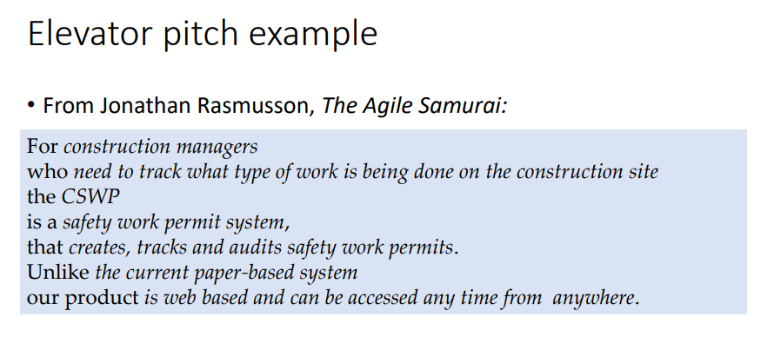

**Vision: Deliver project documentation that satisfies the client’s needs and wants**

For Ms Kamala and her colleagues

who needs to display data from different sources

the [product name]

is a widget based on a multi-layered MVC

that is versatile? And display different types of data

Unlike [primary competitive alternative]

our product [statement of primary differentiation]

**Team members:**

| **Name** | **Email** |
| --- | --- |
| Bryan Lim | clim0100@student.monash.edu |
| Er Tian Ru | terr0001@student.monash.edu |
| Jason The | jthe0005@student.monash.edu |
| Sami Hussein | shus0013@student.monash.edu |
| Shuta Gunraku | sgun0027@student.monash.edu |
| Pan Wei Hung | wpan0017@student.monash.edu |

**Methods of Communication:**

1. Slack
2. Whatsapp

**Roles:**

1. **Scrum Master:** Shuta Gunraku

The Scrum master’s role is to “lead” the team by helping them come to consensus in decisions and moderating the team. They also organize the sprint activities (product review, retrospective etc.) and help the product owner in managing the backlog.

1. **Product Owner:** Sami Hussein

Interacts with the client to identify product specifications to be put into the product backlog. Their main role is to maintain the product backlog by deciding on its content and the priority of each product backlog item. They’re responsible for informing the team what to build on each iteration.

1. **Development Team:**

(Responsible for developing product functionalities and product testing. Each member is self-managing and cross-functional.)

* 1. Er Tian Ru
  2. Jason The
  3. Bryan Lim
  4. Pan Wei Hung

**Team’s process model:**

The process model chosen for this project is based on the agile-based scrum process model. Some differences however are that instead of holding scrum meetings and artefacts updates daily it will be biweekly, once during the tutorial and once on the weekends. Each sprint will last two weeks.

**Definition of Done**

* Pass test cases
* Deliver a feature with no known bugs
* Working software that fulfils client’s requirements
* Complete user stories

**How will the team allocate tasks to members**:

Each member picks an item from the sprint backlog to complete

**How your team will keep track of progress on your project**:

* **Slack:** For communication related to tasks.
* **Trello:** Overview of tasks.
* **Gitlab Issue tracker:** Description of each task, and tracking issues.

**How your team will store and manage your backlogs**:

* Trello
* Gitlab Issue Tracker

**How your team will keep track of time spent on project tasks**:

Use the time tracking feature on the Gitlab Issue Tracker. Team members can comment on any issue with /estimate and /spend to specify how long the issue might take to be resolved and how much time they spent on it.

## Risk Register

Want number of risk

Risk, likelihood, impact, monitoring strategy, contingency plan

| **ID** | **Risk description** | **Likelihood of risk occurring** | **Impact of the risk occurring** | **Monitoring strategy** | **Contingency plan** |
| --- | --- | --- | --- | --- | --- |
| 1 | Project purpose and need is not well defined | Medium | High |  |  |
| 2 | Project design and deliverable definition is not compatible |  |  |  |  |
| 3 | Project schedule is not clearly defined or well understood |  |  |  |  |
| 4 | Client’s requirements are undefined or not well understood |  |  |  |  |
| 5 | Project scope does not suit the group or not clearly defined |  |  |  |  |
| 6 | Project group members not working together well |  |  |  |  |
| 7 | No in house expertise with chosen development software |  |  |  |  |
| 8 | Lack of client availability |  |  |  |  |
| 9 | Team members facing health issues? not available (sick, dead etc.) |  |  |  |  |
| 10 | A team member resign from job |  |  |  |  |
| 11 | Conflict between members |  |  |  |  |
| 12 | Budget change |  |  |  |  |
| 13 | Misunderstanding with Customer’s needs/wants/requirements |  |  |  |  |
| 14 | Customer suddenly propose big changes |  |  |  |  |
| 15 | Customer requests last minute changes |  |  |  |  |
|  | Customer pulling out of project |  |  |  |  |
|  | Customer requirements exceed the provided budget |  |  |  |  |
|  | Customer insists on unrealistic requirements |  |  |  |  |
|  | Servers went down |  |  |  |  |
|  | Faulty communications equipment, computers, internet connection or hardware |  |  |  |  |
|  | Saved file corrupted |  |  |  |  |
|  | Members not competent with chosen software |  |  |  |  |
|  | The software provider stops providing their service |  |  |  |  |
|  | Software library used revealed to be unstable → security flaw etc. |  |  |  |  |
|  | Libraries got deprecated |  |  |  |  |
|  | legal/regulatory environment  Misuse of data |  |  |  |  |

**Monitoring Strategy**

**Mitigation plan**

