
In collaboration with Peninsula College

School of Technology & Engineering
BSc (Hons) Computer Science (Cyber Security)
(N/0613/6/0002)(04/2027)(MQA/PA15604)
MAL2020 – Computing Group Project
Author:  BSCS2509254  BSCS2509259  BSCS2509260  BSCS2509261 | Module Leader:  Mr. Kong Kok Wah @ Eric
Nov 19, 2025
Table Of Contents
Background and Problem Statement 5
Objective 5
Scope of the Project 6
Literature Review 6
4.1 End-to-End Encryption for Secure File Sharing 6
4.2 Existing Secure Sharing Platform 6
LSEP (Legal, Social, Ethical, Professional) 8
5.1 Legal Compliance 8
5.2 Ethical Guidelines 8
5.3 Social Impact 8
5.4 Professionalism 9
5.5 Risks 9
5.6 Sustainability 9
5.7 Continuity 10
Methodology 10
6.1 System Architecture 10
6.2 Security Approach 11
6.3 Development Stages 11
6.4 Testing Plan 11
Expected Deliverables 11
Project Timeline 12
Resource Required 12
Expected Outcome and Significance 13
10.1 Expected Outcomes 14
10.2 Significance 14
Individual Contributions to the Group Project 14
Personal Reflection 18
REFERENCES 19
Appendices 20

Code Repository
Github | https://github.com/OoiWeiChyeh/MAL2020_SecureFileSharingWebApp_E2EE.git
Pebblepad | https://v3.pebblepad.co.uk/spa/#/public/mtw79ZbnmcwzfZhW78ZZbZjspW
Prototype | https://file-share-f8260.web.app/login
Presentation | https://youtu.be/pZ3IU6vVbHs

Word Count : 2764 words

Background and Problem Statement
In academic institutions, examination papers constitute highly confidential documents that require high security measures during creation, transfer and storage. Currently, the Examination Unit in The Ship Campus faces significant challenges in managing examination papers securely. The existing workflow relies on physical transfer methods like Universal Serial Bus (USB) to move examination papers between lecturers, Heads of School (HOS) and the Examination Unit (EU) for printing and distribution.
This approach presents few critical vulnerabilities. Physical storage devices such as USB drives are susceptible to loss, theft or unauthorized duplication, maybe compromising examination integrity. Furthermore, the lack of audit ways makes it difficult to track who accessed the documents and when modifications occurred. The absence of encryption means that if a USB drive falls into the wrong hands, examination content is immediately exposed. Additionally, the current system lacks version control which lead to potential confusion regarding which document represents the final approved version.
Traditional digital solution such as standard email systems could fail to provide adequate security as they typically lack end-to-end encryption, making confidential examination papers vulnerable to interception during transmission. There exists an urgent need for a dedicated web-based platform that facilitates secure transfer of examination papers through end-to-end encryption (E2EE) which have confidentiality, integrity and authenticity of examination materials whilst maintaining a chain of custody.

Objective
The primary objectives of this project are:
- To ensure data privacy by implementing end-to-end encryption techniques, preventing unauthorized access to messages during transmission and storage.
- To verify user authenticity through secure user authentication protocols, preventing impersonation or unauthorized access.
- To design a user-friendly mobile interface that provides secure communication without sacrifice usability.

Scope of the Project
This project expect the design, development and implementation of a web-based secure file sharing system with E2EE called “Kunchee” is designed for academic campus or university. The system will support the workflow of exam papers securely from creation through printing. Moreover, user hierarchy followed by EU staff (Admin) to HOS, then goes to lecturers (User).

Literature Review
When handling with confidential documents like exam paper and personal information, three security assessments need to be consider:
- Keeping the content private
- Making sure it hasn’t be tampered with
- Confirming who sent it.
Everyone knows that it’s importance in campus where exam security directly affects the credibility of a student coursework.

4.1 End-to-End Encryption for Secure File Sharing
E2EE is a ways that data stays encrypted from the moment it leaves the sender until it reaches the intended recipient. IBM (n.d.) explains that E2EE makes sure only the people communicating can read the messages, even if someone intercepts them during transmission. However, this is useful for exam paper transfer because different people (Lecturers, HOS, EU) need to access the documents at different stages.
Nonetheless, Perkasa et al. (2025) studied how combining Diffie-Hellman key exchange with AES-256 encryption can create secure messaging systems. They shows that having strong encryption isn't enough. They also need to manage the encryption keys properly. For exam paper system, this means still need to think about how to handle keys for different users while keeping the system simple enough for lecturers and staff who might not be tech-savvy.

4.2 Existing Secure Sharing Platform
Looking at existing secure file sharing applications helps to understand what features work well and what gaps need to be filled. Table 1 compares three popular platforms that use encryption for secure sharing.
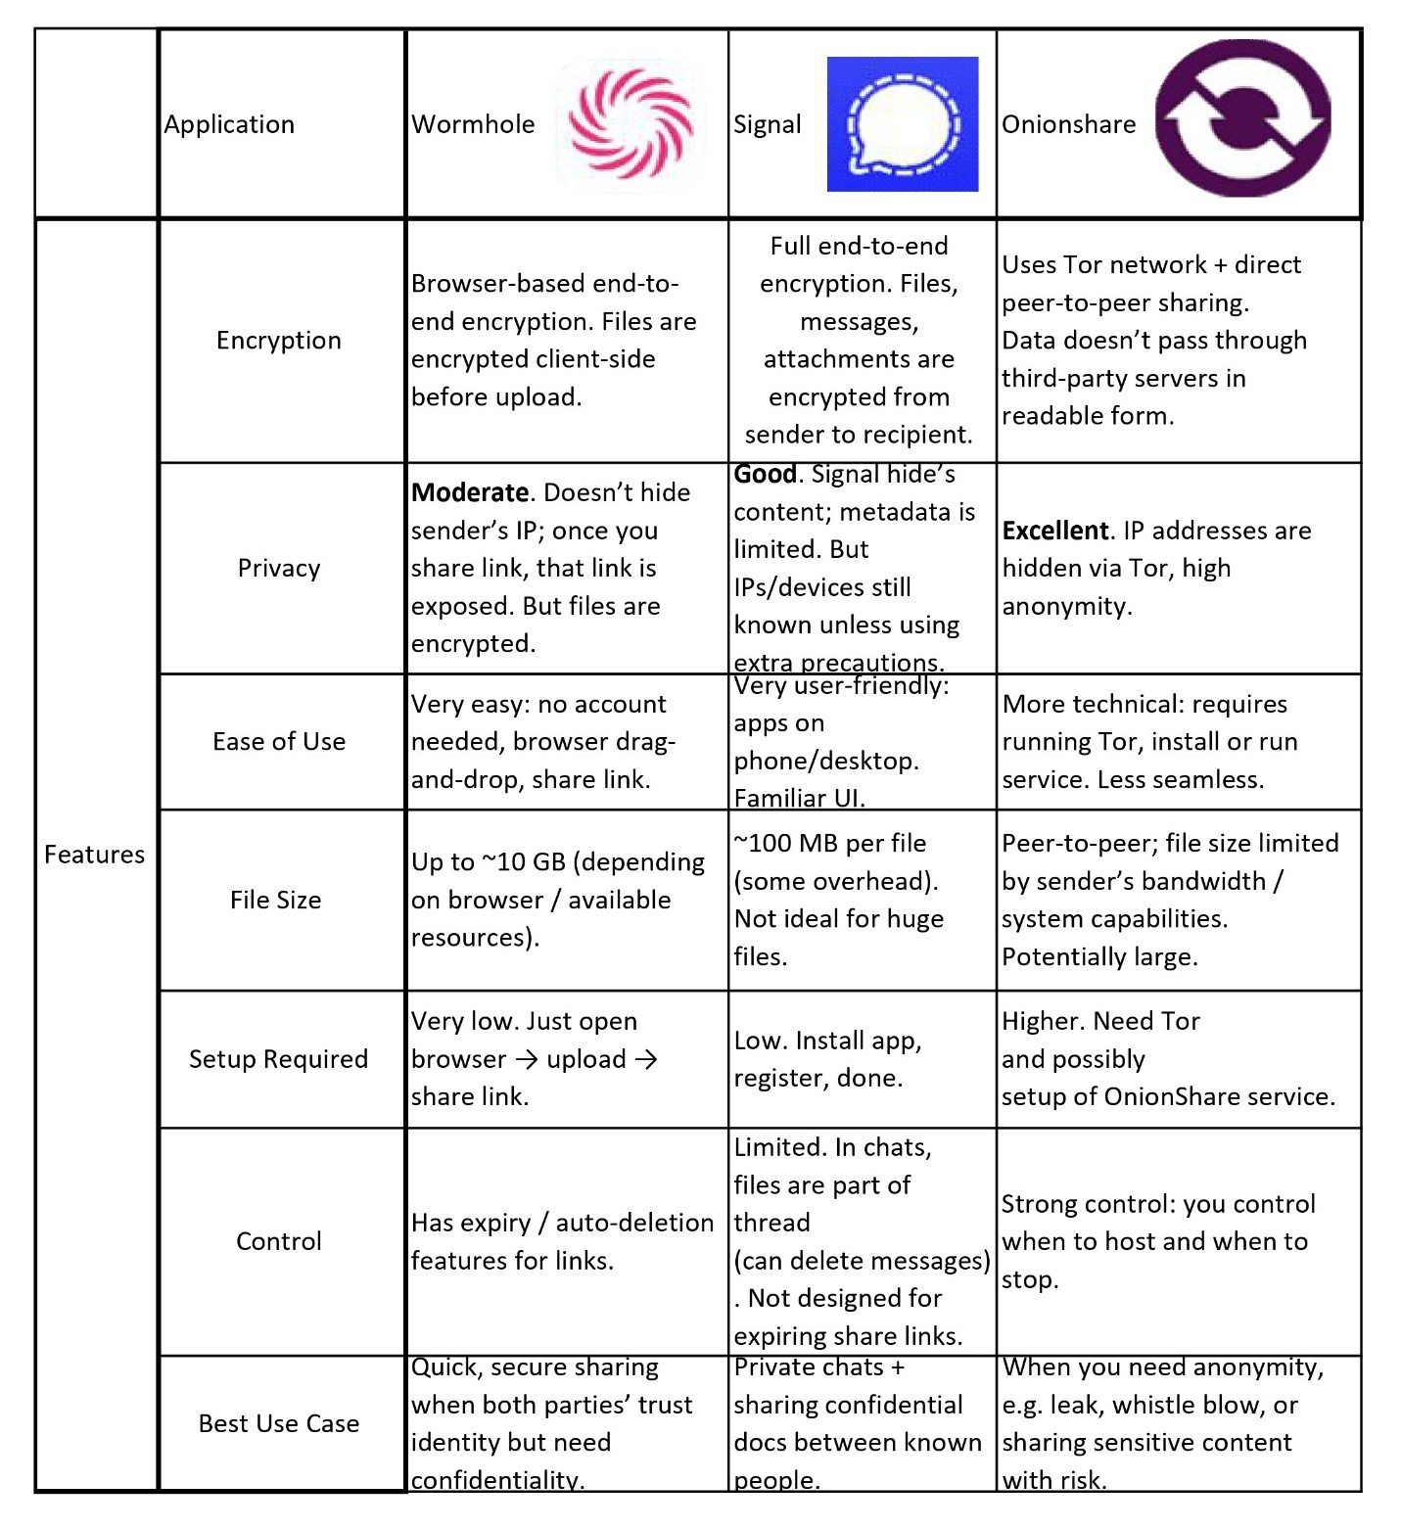
Table 1 : Comparison with existing solutions

LSEP (Legal, Social, Ethical, Professional)

5.1 Legal Compliance
Since we’re working within a Malaysian context, the design follows the general principles of the PDPA that is mainly around limiting unnecessary data collection, restricting access based on user roles and keeping sensitive information encrypted so it can’t be misused.
We also pay attention to intellectual property concerns. Exam papers belong to the university, so we avoid storing or distributing them in ways that could look like unauthorized copying. Every dummy uploaded into the system remains encrypted end-to-end, so even the server can’t view the content which may help reduce risks of accidental copyright breaches.
There’s also a practical side like tools, frameworks, and libraries used in the system—such as React, Node.js, and libsodium are all under open-source licenses we’re allowed to use for academic purposes.
Safety-wise, no special government permissions are required, but we still act as if the exam unit is the “data controller”, and the system should support whatever internal policies the campus already uses for exam confidentiality.

5.2 Ethical Guidelines
We designed the system with the intention of treating all users fairly, regardless of their position in the workflow. For example, lecturers shouldn’t feel pressured by a system that exposes more data than necessary, so we only show information that is strictly relevant to their role.
Another point we considered is transparency. While we can’t show users every technical detail (that would overwhelm most people), the system can still explain, in simple terms, how files are encrypted and who can view them.
Lastly, we respect confidentiality not just through technology but by making sure audit logs aren’t misused. Logs track actions, not personal opinions or private behaviour. The goal is accountability, not surveillance.

5.3 Social Impact
By replacing USB-based transfer, the system reduces the risk of exam leaks which helps protect the integrity of the university.
There’s also a time factor such as approval processes that previously took days due to physical handovers might now speed up significantly.
Of course, every system has potential downsides. Some staff who are less comfortable with technology might feel overwhelmed at first. To reduce that problem, we kept the ”K.I.S.S.” (Keep it simple, stupid) principle by engineer Kelly Johnson (Linda, 2017), so people don’t feel like they're “breaking something” by clicking the wrong button. Another concern is if the network goes down, progress may slow. Still, compared to the risks of USB drives, the trade-off seems worth it.

5.4 Professionalism
As a team, we tried to follow the kind of professional behaviour expected in real development environments. We set our own version of “mini-deadlines” so that progress didn’t pile up at the end, although we’ll admit some sprints took longer than expected.
Communication was something we took seriously. When someone got stuck on an issue like encryption flow or a React component not rendering correctly. We shared updates instead of silently struggling.
We also aimed to keep our documentation honest. If something didn’t work perfectly, we reported it rather than pretending it was flawless.

5.5 Risks
Several risks appeared throughout the project, and we tried to address them in realistic ways.
- Technical risks: Encryption implementation can fail silently if done incorrectly.
- System failure or data loss: Since everything is encrypted, corrupted keys could lock out legitimate users.
- Operational risks: Users might accidentally upload the wrong version of an exam paper. Audit logs and version history help trace these mistakes.
- Security risks: Even with E2EE, users could still fall victim to phishing. We can’t fully control that.
None of these risks disappear completely, but acknowledging them helps us design around them instead of pretending they don’t exist.

5.6 Sustainability
Using cloud services like Firebase reduces the need for physical storage hardware, which indirectly cuts down on energy usage and electronic waste.
In terms of long-term usability, the system can scale if the university ever decides to include more departments or new document types. We kept the architecture modular, so future teams can replace components like authentication flows or database structures without rebuilding everything from scratch.

5.7 Continuity
To ensure the system can continue after development, we prepared documentation that outlines setup steps, key procedures, and troubleshooting tips. This should make it easier for the next team or the campus IT department to take over.
In terms of cost, the solution currently relies on mostly free or low-cost technologies, but we did highlight where paid extensions might appear (e.g., increased cloud storage). Planning ahead avoids the “surprise bill” situation common in cloud-based projects.

Methodology
Project using an Agile development methodology to show iterative development with user feedback and ability to adapt throughout the system lifecycle. Besides, Agile framework enables incremental enhancement of system by organizing development into time-boxed sprints. For example, each focused on specific outcomes like user authentication, workflow management and etc.

6.1 System Architecture
- Frontend (User Interface):
  - Built with React.js for a responsive web interface
  - Users can easily upload, view and manage exam papers
  - Works on different browsers and screen sizes
- Backend (Server):
  - Built with Node.js and Express.js
  - Handles user authentication and file storage
  - Manages the workflow between different users
- Database:
  - Firebase will store encrypted exam papers and user information
  - Only encrypted files are stored
  - Stores activity logs for auditing

6.2 Security Approach
All encryption and decryption happen on the user's computer (client-side) using Web Crypto API and libsodium.js. This means:
- Exam papers are encrypted before being uploaded.
- The server only stores encrypted files.
- Only authorized users with the right keys can decrypt and read the papers.
- Even if someone hacks the database, they can't read the exam papers.

6.3 Development Stages
- Requirements gathering - Understanding what the Exam Unit needs.
- System design - Creating diagrams and planning the database structure.
- Development - Building the system in sprints (2-3 weeks each).
- Testing - Checking if everything works correctly and securely.
- Documentation - Writing guides for users and technical documentation.

6.4 Testing Plan
We'll test the system in several ways:
- Unit testing - Testing individual features (login, upload, download).
- Integration testing - Making sure all parts work together.
- Security testing - Following OWASP guidelines to check for vulnerabilities.
- User testing - Having lecturers and staff try the system and give feedback.

Expected Deliverables
The project will produce the following deliverables:
- Functional Web Application: Fully operational examination paper transfer system featuring user authentication, role-based access control, end-to-end encryption, workflow management for the examination approval chain and audit logging capabilities.
- System Documentation: Technical documentation including system architecture diagrams, database schema specifications, encryption workflow descriptions, API documentation and deployment guidelines.
- User Documentation: User guides of different stakeholder roles (lecturers, moderators, Heads of School, and Examination Unit administrators) explaining system features, workflow procedures and practices.
- Evaluation Report: Assessment results documenting usability testing outcomes, security audit findings, performance benchmarks and recommendations for future improvements.
- Project Report: Final report encompassing literature review, detailed methodology, system design documentation, implementation details, testing results and project conclusions.
- Source Code Repository: Source code maintained in a version control system (GitHub) with clear commit histories and deployment instructions.

Project Timeline
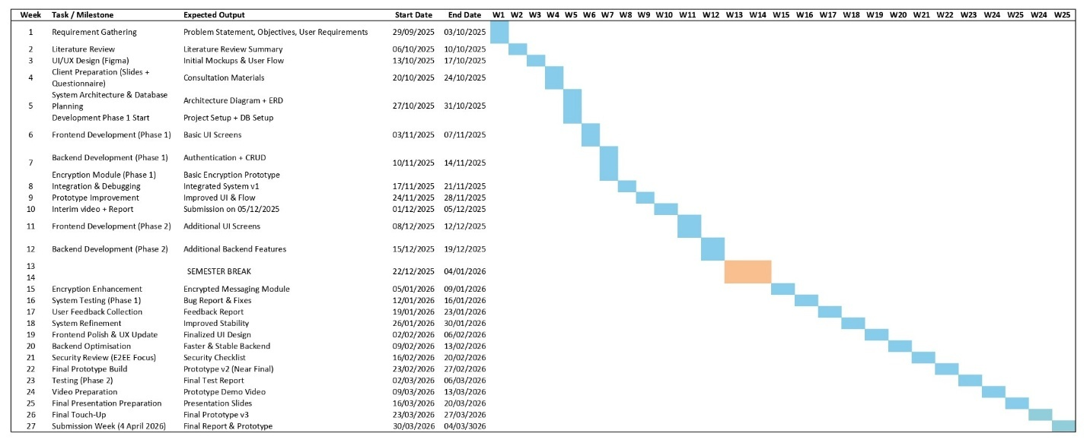
Table 2 : Gantt Chart of Group Project

Resource Required
Following table below summarizes all software and hardware with supporting materials used in the group project.
Category | Resources | Description / Purpose
Hardware | Personal Computer (PC/Laptop) | Used for system development, coding, and testing in the local environment. The system should have at least an Intel i5 or AMD Ryzen 5 processor, 8 GB RAM, and 500 GB storage to handle local servers and database simulations efficiently.
Software | React.js | Frontend framework for building a responsive and interactive user interface.
Software | Node.js with Express.js | Backend framework for handling server-side logic and API communication.
Software | Firebase | Cloud-based database for storing encrypted notes and metadata.
Software | WebCrypto API & libsodium.js | Cryptographic libraries for implementing client-side end-to-end encryption.
Development Tools | Visual Studio Code | Integrated Development Environment (IDE) for code editing and debugging.
Development Tools | GitHub | Version control and collaborative code management platform.
Testing Tools | Jest & Mocha | Used for unit and integration testing to ensure functionality and reliability.
Testing Tools | OWASP ZAP | Security testing tool for identifying vulnerabilities and verifying E2EE implementation.
Documentation Tools | Draw.io | Used for creating diagrams and UML models.
Documentation Tools | Microsoft Word | For report writing, documentation and formatting of project deliverables.
Network Resources | Internet Connection | Required for accessing APIs, databases and deployment environments.

Expected Outcome and Significance

10.1 Expected Outcomes
The successful completion of this project will yield:
- Working web-based system for secure exam paper transfer with E2EE
- Replacement of the unsafe USB drive method with a digital encrypted solution.
- Clear tracking of who accessed or modified exam papers at each stage.
- Faster approval process from lecturer to HOS to Exam Unit.
- Better security for confidential exam content.

10.2 Significance
This project solves security problem faced by the EU. Currently, using USB to transfer exam papers is risky because they can be lost, stolen or copied without anyone knowing. Our system provides a safer digital alternative that's specifically designed for the university's exam paper approval workflow which most file sharing apps don't support maybe.
Next, project demonstrates how encryption technology can be implemented in university settings without making things complicated for non-technical staff like lecturers and administrators. Like focusing on usability alongside security, we show that strong protection doesn't have to mean difficult-to-use systems. This is important because many secure solutions fail simply because users find them too complicated.
Beyond exam papers, this system can serve as a foundation for other confidential document handling in the university. The same security approach could be applied to student records, confidential meeting minutes or research proposals. This makes the project valuable not just for the Exam Unit, but potentially for multiple departments that handle sensitive information.
Finally, the project will make daily work easier for lecturers and administrators by providing a simple, secure way to handle exam papers. They won't need to worry about losing USB or wondering if someone accessed files without permission, since everything is logged and tracked automatically. This would increase both security and peace of mind for everyone involved in the exam paper process.

Individual Contributions to the Group Project
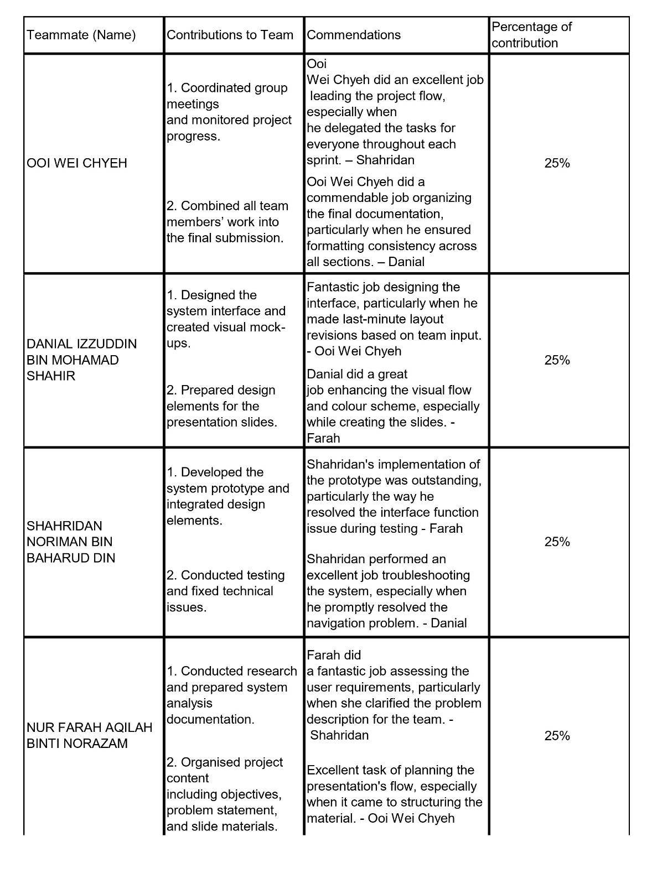
Table 3 : Contribution Table

All group members agree to acknowledge the above contributions. (Yes/No)
*We understand that if we answered No to the above, we will be called for a viva with the Module Leader to mediate the dispute.

Signatures
OOI WEI CHYEH | 
DANIAL IZZUDDIN BIN MOHD SHAHIR | 
SHAHRIDAN NORIMAN BIN BAHARUD DIN | 
NUR FARAH AQILAH BINTI NORAZAM | 

1. OOI WEI CHYEH
Role: Team Leader
Main Task:
- Coordinated all group meetings and ensured every member understood their tasks.
- Monitored the project progress.
- Consolidated all group work into the final project submission.
Impact to Project:
- Ensured the project ran smoothly and stayed on schedule.
- Increased team productivity by giving clear instructions and reminders.
- Helped maintain consistency and quality in all deliverables.
Collaboration Efforts:
- Regularly communicated with team members.
- Provided guidance and support whenever issues arose.
- Encouraged teamwork and resolved conflicts.

2. DANIAL IZZUDDIN BIN MOHAMAD SHAHIR
Role: Designer
Main Task:
- Designed the project mock-ups and visual elements for the KUNCHEE system.
- Created the UI layout based on the team’s requirements.
- Produced graphics and visual materials for presentation.
Impact to Project:
- Improved the aesthetic and usability of the system.
- Helped the team visualize the outcome early in the project.
- Enhanced the quality of the final presentation.
Collaboration Efforts:
- Discussed and revised design ideas based on team feedback.
- Worked closely with the programmer to ensure design matched functionality.
- Contributed to group discussions and decision-making.

3. SHAHRIDAN NORIMAN BIN BAHARUD DIN
Role: Programmer
Main Task:
- Developed the system features according to the project requirements.
- Integrated the design into a functional prototype.
- Tested the system to ensure smooth operation.
Impact to Project:
- Delivered a working prototype that reflected the core idea of KUNCHEE.
- Ensured the system’s core functions met requirements.
- Helped the team demonstrate a practical and usable solution.
Collaboration Efforts:
- Actively collaborated with the designer and analyst for accurate implementation.
- Fixed issues and improved features based on team feedback.
- Shared progress updates during meetings.

4. NUR FARAH AQILAH BINTI NORAZAM
Role: Analyst
Main Task:
- Gathered and analysed user requirements for the KUNCHEE project.
- Conducted research and identified problems faced by users.
- Prepared documentation including problem statement, objectives, and system scope.
Impact to Project:
- Ensured the system was designed based on accurate and relevant user needs.
- Helped create a strong foundation for system design and development.
- Improved the clarity and direction of the project.
Collaboration Efforts:
- Shared findings with the team to support design and development decisions.
- Worked closely with the leader to refine project requirements.
- Helped teammates with content for slides and documentation

Personal Reflection
- OOI WEI CHYEH

- DANIAL IZZUDDIN BIN MOHAMAD SHAHIR

- SHAHRIDAN NORIMAN BIN BAHARUD DIN

- NUR FARAH AQILAH BINTI NORAZAM

REFERENCES
Ali, A. H. and Sagheer, A. M. (2017) ‘Design of Secure Chatting Application’, Iraqi Journal for Computers and Informatics (IJCI), 43(1), pp. 22 27. Available at: https://ijci.uoitc.edu.iq/index.php/ijci/article/view/73/33 (Accessed: 2 Oct 2025)

IBM (no date) What Is End to End Encryption (E2EE)? Available at: https://www.ibm.com/think/topics/end-to-end-encryption (Accessed: 2 Oct 2025)

Knibbs, K. (2014) ‘Meet OnionShare, the File Sharing App the Next Snowden Era Hero’, Gizmodo. Available at: https://gizmodo.com/meet-onionshare-the-file-sharing-app-the-next-snowden-1597056567 (Accessed: 2 Oct 2025).

Mann, B. (2025) Signal Review 2025: Secure Messenger (Pros and Cons). CyberInsider. Available at https://cyberinsider.com/secure-encrypted-messaging-apps/signal/ (Accessed: 2 Oct 2025).

Linda, A. (2017) Universal Principles Of Design, Academia.edu. Available at: https://www.academia.edu/34494159/Universal_Principles_Of_Design (Accessed: 4 Oct 2025).
‌
Perkasa, M. J. P., Ramdan, H. M., Maliki, A. J. and Somantri (2025) ‘Implementation of Secure End to End Encrypted Chat Application Using Diffie–Hellman Key Exchange and AES 256 in a Microservice Architecture’, Engineering Proceedings, 107(1), p. 98. Available at: https://www.mdpi.com/2673-4591/107/1/98 (Accessed: 2 Oct 2025).

Seon (2021) What Are the Risks of Business Email Compromise & How Can You Prevent Them? Available at: https://seon.io/resources/business-email-compromise-risks-and-prevention/ (Accessed: 3 Oct 2025).

Schliep, M. and Hopper, N. (2018) ‘End to End Secure Mobile Group Messaging with Conversation Integrity and Deniability’, Cryptology ePrint Archive, 2018/1097. Available at: https://eprint.iacr.org/2018/1097 (Accessed: 3 Oct 2025).

Wormhole (2024) Wormhole – Frequently Asked Questions. Available at: https://wormhole.app/faq (Accessed: 4 Oct 2025).

Appendices
Appendix A : Meeting Picture with Group Member
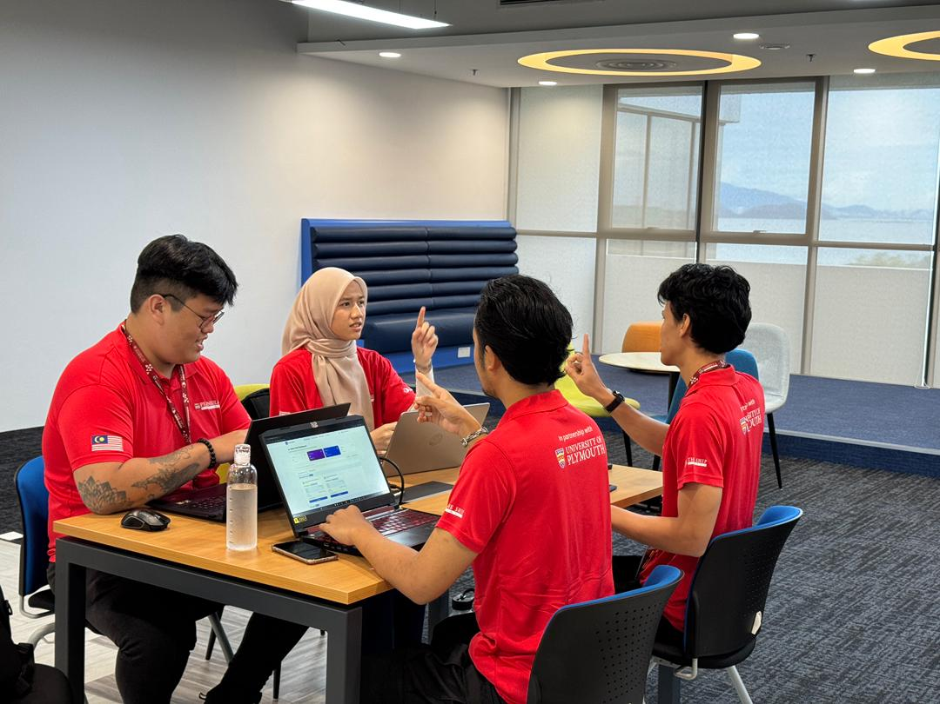

Appendix B : Online Zoom Meetings with Group Member
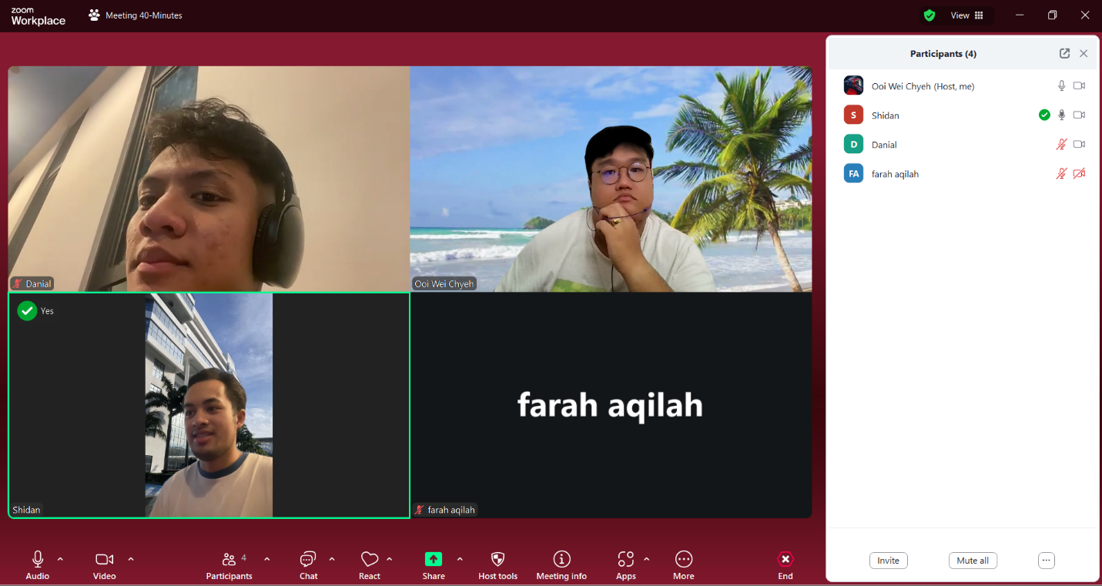

Appendix C : Regular project meetings on sprints
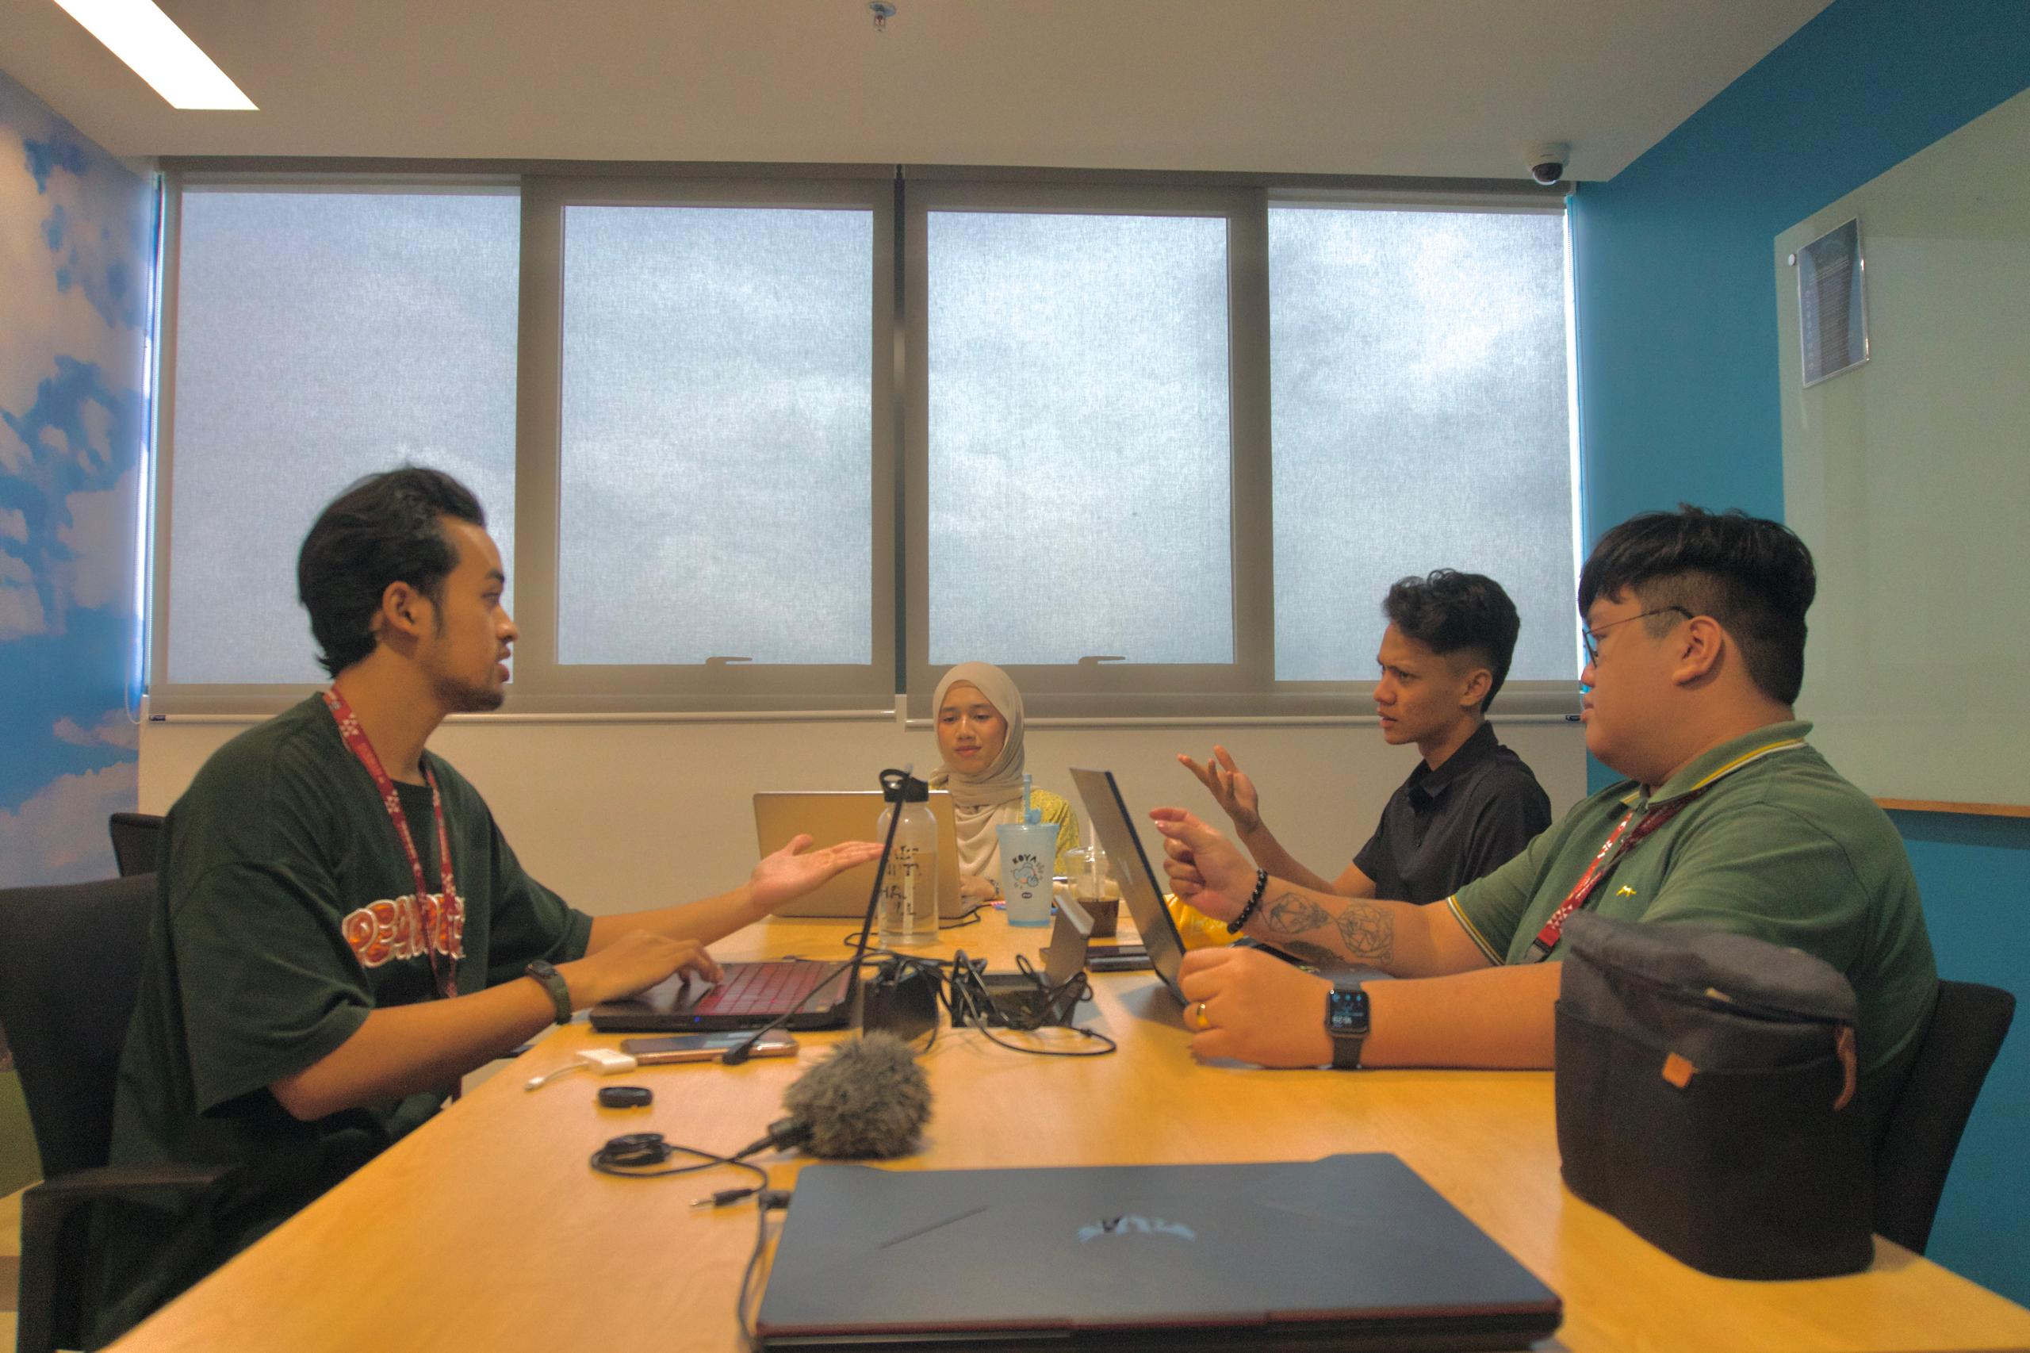
Appendix D : Meetings with our stakeholders (The Ship Campus Exam Unit representatives)
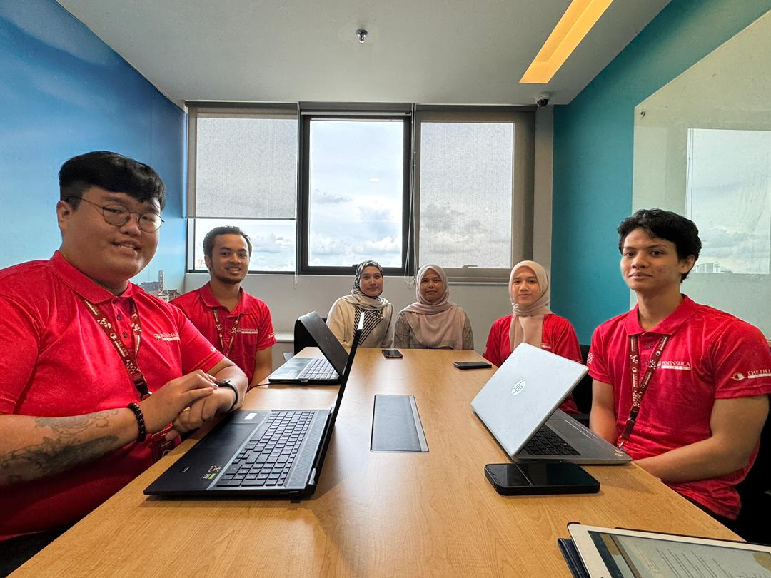

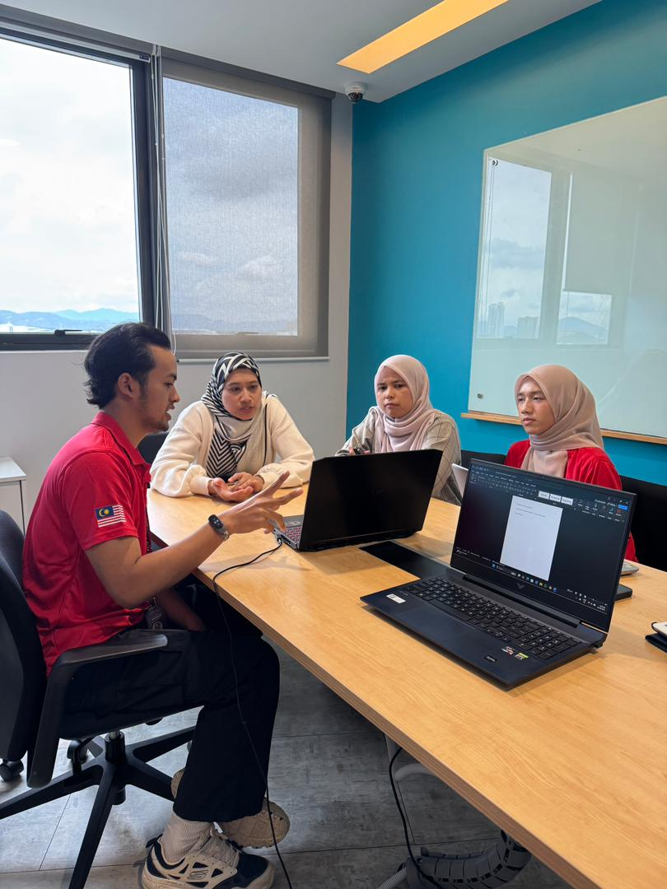
Appendix E : Minutes of meetings done when meetings with stakeholders

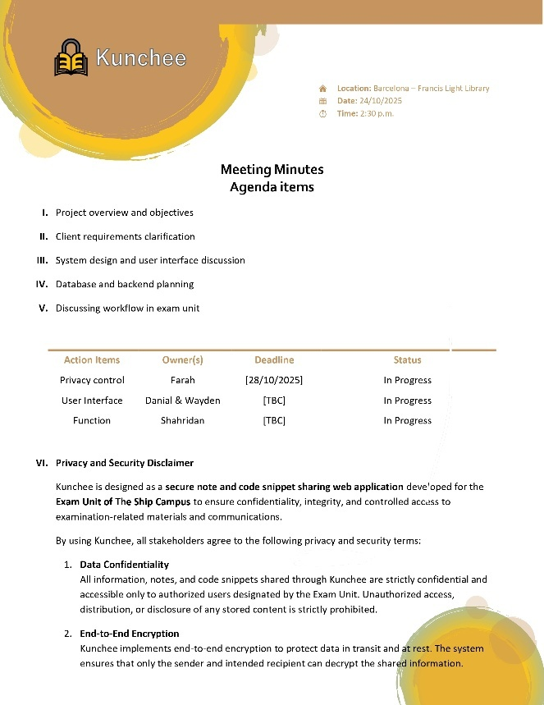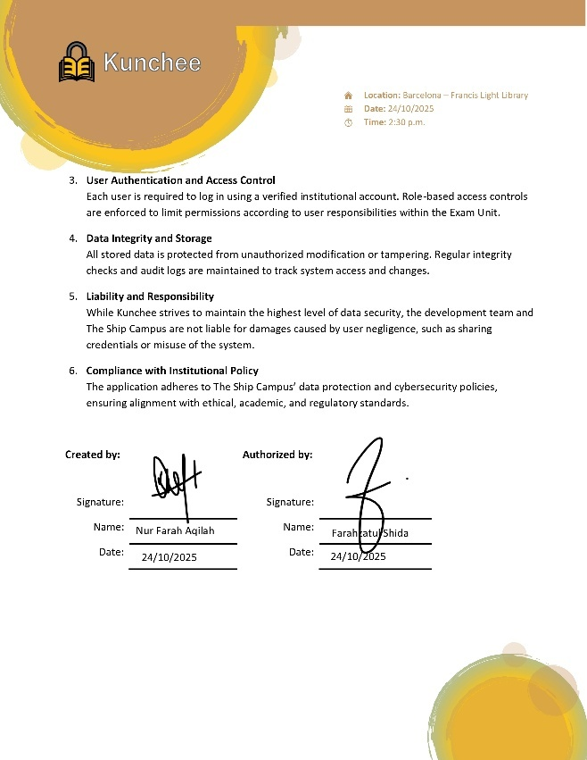
Figure 1 : Minutes of meetings (24/10/25)

Appendix F : Minutes of meetings done when meetings with stakeholders
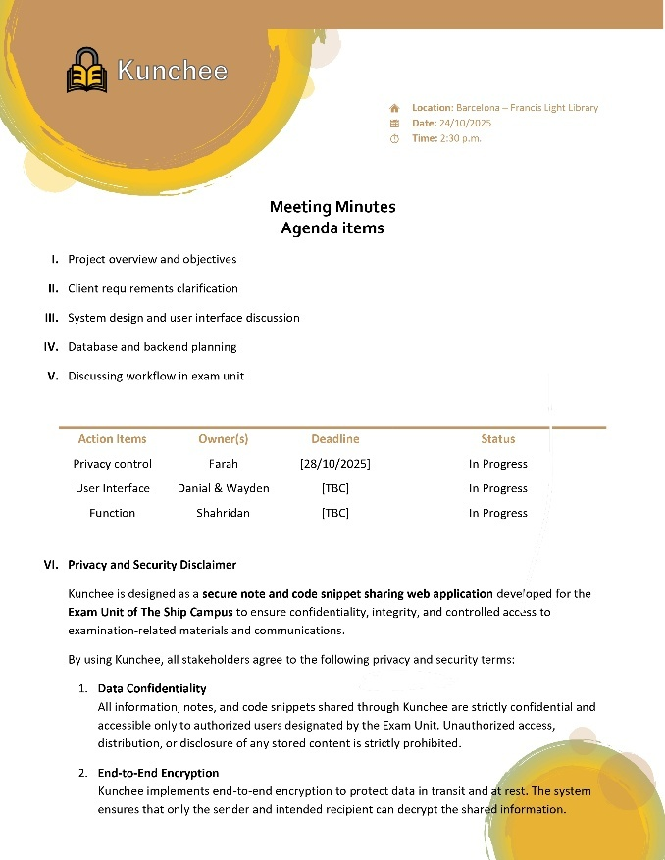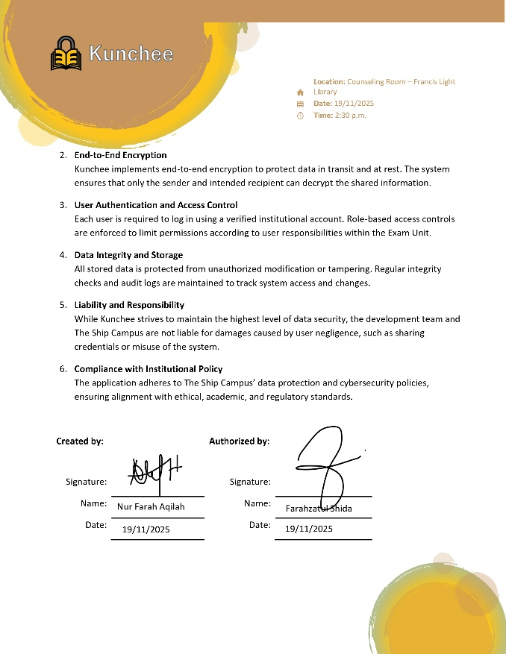
Figure 2 : Minutes of meetings (19/11/25)

