Flight Controls
F1 |  | 1 | Forward (front) view |  | V | External views ²
F2 |  | 2 | Aft (rear) view |  | Z | Cycle IFF Scanner zoom ³
F3 |  | 3 | Port (left) view | ⇫ | Z | Reset IFF Scanner zoom
F4 |  | 4 | Starboard (right) view |  | \ | Cycle Space Compass target ^{† 4}  †
↑ |  | ↓ | Pitch down (dive) / up (climb) | ⇫ | L | Contact Station Traffic Control ⁵
← |  | → | Roll clockwise / anticlockwise |  | C | Activate Docking Computer †  †
, |  | . | Yaw (turn) left / right | ⇫ | C | Activate Fast Docking Computer ^{† 6}  †
W |  | S | Speed increase / decrease |  | S | Turn off the music while docking  †
I |  |  | Witchspace Fuel Injectors † |  | D | Dump one cargo canister ⁷  †
J |  |  | Engage Jump (torus) drive | ⇫ | R | Rotate through the manifest ⁷  †
H |  |  | Hyperspace jump |  | ` | Show the communication log
G |  |  | Galactic Hyperspace jump ^{† 1}

Combat Controls
A |  |  |  |  | Fire laser | + |  | - | Cycle to next / previous target †
T |  |  |  |  | Missile target seek | R |  |  | Activate ID recognition
M |  |  |  |  | Fire missile (if locked) | E |  |  | Activate ECM system †
U |  |  |  |  | Unlock missile target | 0 |  |  | Activate Specialist Equipment ^{† 8}
Y |  |  |  |  | Cycle through available missiles † | Esc |  | Esc | Launch Escape Capsule †
Tab |  |  |  |  | Fire Energy Bomb † | _ |  |  | Toggle weapon lockdown
⇫ |  | T |  |  | Target nearest incoming missile

Ship, Systems & Status Controls
F1 |  | 1 | Launch the ship |  | F2 |  | 2 |  |  | Game Menu ‡
F3 |  | 3 | Ship Outfitting ‡ | F3 | F3 |  | 3 |  | 3 | Ships For Sale ‡
F5 |  | 5 | Commander’s Profile | F5 | F5 |  | 5 |  | 5 | Ship’s Manifest
↑ |  | ↓ | Move cursor up / down the list ‡ | ⇫ | Ctrl | N |  | Previous selectable equipment†
Enter |  |  | Select the highlighted entry | ⇫ | N |  |  | Next selectable equipment†
 |  |  |  | N |  |  |  | Activate selectable equipment†

Navigation Controls
F6 | F6 |  | 6 | 6 | Galactic Chart | ↑ |  | ↓ |  | Move cursor around the charts
 | F6 |  | 6 |  | Short Range Chart | ← |  | →
 | F7 |  | 7 |  | Data on Planet | Home |  |  |  | Return cursor to current system
I | System information in the Short Range Chart |  |  |  |  | ^ | Advanced Navigation Array – shortest †
? | Toggle to the Carrier Market Screen ‡ |  |  |  |  | Ctrl | ^ |  | Advanced Navigation Array - fastest †
Note: typing a planet’s name while in the Galactic Chart will automatically move the cursor to the world matching the text. When more than one planet matches the text, use shift-arrow keys to move the cursor to the next highlighted world.

Commodities Market Controls
F8 |  | 8 | Commodities Market | ↑ |  | ↓ | Move cursor up / down the list ‡
Enter |  |  | Buy / sell maximum amount ‡ | ← |  | → | Buy / sell one unit of commodity ‡

Carrier Market Controls ‡
F8 | F8 |  | 8 | 8 | Carrier Market | ↑ |  | ↓ | Move cursor up / down the list
Enter |  | Agree to the contract |  |  |  | F5 | Display current Contracts
? | Display the contract’s destination on the Galactic Chart

Other Controls – All Systems
 | P | Pause the game | O |  | N |  | Turn the HUD off / on while paused
⇫ | F | Toggle the game frame rate | * | Capture a screen shot
⇫ | M | Toggle mouse flight control in full  P | ⇫ | Ctrl |  | M |  | Toggle mouse flight control in full
 |  | screen mode (roll on x-axis) |  | screen mode (yaw on x-axis)

Other Controls – Mac Specific
⌘ | F | Toggle window / full screen mode | ⌘ | Q | Quit the game

Other Controls – PC & Linux Specific
F12 |  | Toggle window / full screen mode | ⇫ | Q | Quit the game

Notes
X | X | Tap this key twice
F2 | Function key
⇫ | Shift key
⌘ | Mac Command key
Ctrl | Ctrl key
Control (Ctrl) key
† | This function is only available when the appropriate equipment is installed.
‡ | Only GCW Stations support all of these functions. Other anchorages may only carry a limited range.
1 | Galactic Hyperdrives are one time use only. To jump again another drive must be bought.
2 | The key cycles through the available external views of your craft. Ships featured in OXPs may not have external views available.
3 | The key cycles through the five magnification setting of the IFF Scanner.
4 | See the Space Compass section on the next page for more information.
5 | The key requests a docking window from station launch control. Use the same key to cancel or renew a request.
6 | Some non-GCW Stations might not allow docking without sequence.
7 | Unless the cargo is selected by the commander, the ship’s computer will dump one unit from the first commodity listed in your manifest.
8 | Should specialist equipment become available to the commander, it is tied to this console key.
This reference sheet makes several references to 'OXPs'. Oolite eXpansion Packs can add extra missions, equipment, ships or change the game mechanics. These packs are not part of the standard game and will not be covered by this sheet. For more information on them and how to install them, visit the Oolite Wiki.
Attention non-UK keyboard users
Some keys may vary from the ones listed here. If you are having issues, check both Oolite Wiki and Oolite BBS for information and advice.

1 | Speed
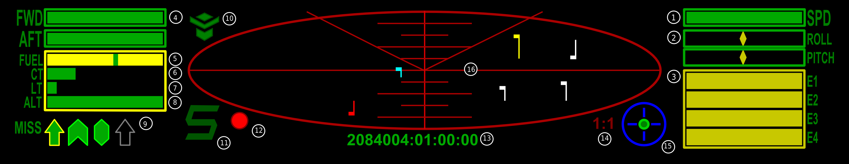
This is a percentage gauge showing how fast the ship is travelling relative to its maximum speed.

2 | Roll and Pitch
The diamonds show how much the ship is anti/clockwise rolling and climbing/diving.
Some ships and HUDs may also feature a Yaw indicator. It functions exactly the same way as the Roll and Pitch units.

3 | Energy Banks
The multiple meters of the Energy Banks show how much energy you have available for ship systems. Recharging your shields, firing your lasers or ECM and direct hits to the ship’s hull will drain the banks. If completely drained, the collapse of the energy banks destroys the ship. The number and size of energy banks installed is dependent on the model of ship being flown.

4 | Shields
The front (FWD) and rear (AFT) shields, where the bar length equals the shield strength. As the shields weaken, the risk of weapons fire penetrating the shield increases. Any penetration will result in energy drain, along with the risk of equipment damage and the destruction of cargo.

5 | Fuel
A gauge displaying how much witchspace fuel is available. If a destination has been selected for a hyperspace jump, a marker line will show how much you need to activate the drive.

6 | Cabin Temperature
This gauge shows the ship’s life support temperature. Exposure to excessive amounts of heat will overload the life support resulting in the crew’s death.

7 | Laser Temperature
Displays the heat level of the active laser. Continuous fire raises the laser temperature. An overheated laser will shut down, requiring a cool-down period before it will fire again.

8 | Altitude
Shows the proximity of a nearby planet or sun. Exposure to excessive atmospheric and gravitational pressures of such bodies will destroy the ship.

9 | Missiles
These icons show what types of, and how many, missiles or other pylon-mounted devices you are carrying, and which one is active (yellow border). When a weapon has been locked on to the target, its icon turns red.
 | Empty pylon
 | Active standard missile
 | Target seeking ECM hardened missile
 | Quirium cascade mine target locked
Should you see a yellow/red square replacing the missile information, this means that you have used ID Recognition without a missile being active. Installing additional equipment will allow you to keep a target lock with one missile while target seeking with another.
OXPs may add additional pylon-based equipment for purchase. See the OXP documentation for more information.

10 | Fuel Scoop
The Fuel Scoop icon will be added to the HUD when one is fitted to the ship. When the fuel scoop is active, the icon strobes. If the tail of the icon becomes red, then your cargo bay is full and any new object scooped will be destroyed.

11 | Station Aegis
The Station Aegis is the area of space around a GCW station where its Vipers will provide protection to your ship should you come under attack.

12 | Threat Indicator
This is an indicator showing the current level of risk to your ship. When green, there are no other ships within scanner range. Yellow indicates that there are objects within scanner range. When the indicator turns red, other ships have targeted you.

13 | Date and Time
The current date and time, set to Galactic Cooperative of Worlds Mean Time.

14 | Scanner Zoom
The zoom ratio displays the current magnification setting of the IFF scanner.

15 | Space Compass
The Space Compass shows the direction of the target relative to the direction of the ship. The default target of the space compass is the planet. When inside the GCW Station Aegis, the compass will target the station.
Fore |  | Target position relative to the ship | Aft
 |  | Planet or GCW Station
 |  | Sun †
 |  | GCW Stations †
 |  | Navigation beacon †
 |  | Witchspace beacon †
 |  | Active target †
Additional compass targets may become available with the installation of OXPs. Refer to the individual OXPs documentation for more information.

† This compass target requires the Advanced Space Compass equipment to be installed in order to become selectable.

16 | IFF Scanner
The IFF Scanner Grid shows the relative positions of all objects within scanner range of the ship. The V lines show which direction you are currently viewing. The rule lines show the scale the scanner is working in.
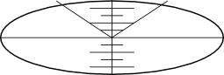 |  | 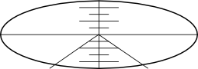
Forward (front) View |  | Aft (rear) View
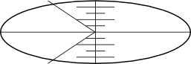 |  | 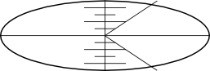
Port (left) View |  | Starboard (right) View
Each object is represented by a colour-coded flag and pole. The length and position of the flag pole represents the object’s direction and distance from your ship. The flag’s position on the pole indicates whether the object is above or below your ship.
 | Non-powered objects ¹
 | Civilian craft
 | Hostile craft
 | Police/Government craft
 | Police/Government craft on intercept
 | Thargoid craft
 | Missile ²
 | Mine about to detonate ²
 | Space stations and other anchorages
 | Navigation and witchpoint beacons
 | Witchspace cloud
The twin colour flags are the colours that those IFF flags cycle through.
1 | Non-powered objects include asteroids, cargo pods, escape pods, and abandoned craft.
2 | Certain OPXs will add extra types of munitions to Oolite. The game will use the missile or mine IFF flag to show them.

Note: The layout shown here is for the Falcon deLacy Cobra Mk III which you are issued with at the start of the game. Other vessels may have alternative instrument configurations.

Equipment Guide
Item | TL | Cost ₢
Advanced Navigational Array | 7 | 2250
Advanced Space Compass | 8 | 650
Beam Laser | 5 | 1000
Docking Computers | 10 | 1500
ECM Hardened Missile | 10 | 350
ECM System | 3 | 600
Energy Bomb | 8 | 900
Escape Capsule | 7 | 1000
External Heat Shielding | 5 | 1500
Extra Energy Unit | 9 | 1500
Fuel | All | Varies
Fuel Scoop | 6 | 525
Galactic Hyperdrive | 11 | 5000
Large Cargo Bay | 2 | 400
Maintenance Overhaul | 7 | Varies
Military Laser | 11 | 6000
Military Shield Enhancement | 14 | 47550
Mining Laser | 11 | 800
Missile | 2 | 30
Multi-Targeting System | 6 | 325
Passenger Berth | 6 | 825
Pulse Laser | 4 | 400
Quirium Cascade Mine | 7 | 2500
Remove Passenger Berth | 2 | 100
Scanner Targeting Enhancement | 12 | 450
Shield Boosters | 11 | 14750
Target System Memory Expansion | 9 | 1250
Unmount and sell all pylon-mounted weapons | 2 | 20
Witchdrive Fuel Injectors | 11 | 600
Wormhole Scanner | 10 | 2395
Any equipment damage can only be repaired in systems of that Tech Level or better. The listed prices apply only to GCW station shipyards. Prices may vary in other anchorages. Additional equipment can be obtained by installing OXPs. See the individual OXP documentation for more information on their cost and use.

Commodities Guide
Commodities | Price ₢ |  |  | per
Commodities | Min | Avg | Max | per
Food | 2.0 | 5.0 | 8.0 | t
Textiles | 5.2 | 7.2 | 9.2 | t
Radioactives | 17.6 | 23.2 | 28.8 | t
Slaves † | 2.0 | 15.2 | 28.4 | t
Liquor/Wines | 19.2 | 29.2 | 39.2 | t
Luxuries | 78.0 | 90.2 | 102.0 | t
Narcotics † | 0.4 | 51.0 | 101.6 | t
Computers | 61.6 | 81.8 | 102.0 | t
Machinery | 46.8 | 56.6 | 66.4 | t
Alloys | 31.2 | 38.8 | 46.4 | t
Firearms † | 49.6 | 69.2 | 88.8 | t
Furs | 45.2 | 70.46 | 95.6 | t
Minerals | 10.0 | 12.0 | 14.0 | t
Gold | 36.0 | 38.8 | 41.6 | kg
Platinum | 62.8 | 71.8 | 80.8 | kg
Gem-stones | 15.2 | 19.6 | 24.0 | g
Alien Items | 21.2 | 43.6 | 66.0 | t
† Trafficking in these commodities is illegal in all GCW member systems.

Combat Rank
Rank | Kills
Harmless | 0
Mostly Harmless | 8
Poor | 16
Average | 32
Above Average | 64
Competent | 128
Dangerous | 512
Deadly | 2560
Elite | 6400

Government Guide
Risk | Icon | Type
Negligible |  | Corporate State
▲  Low  ▼ |  | Democracy
▲  Low  ▼ |  | Confederacy
▲  Medium  ▼ |  | Communist
▲  Medium  ▼ |  | Dictatorship
▲  High  ▼ |  | Multi-Government
▲  High  ▼ |  | Feudal
Extreme |  | Anarchy

Economy Guide
Produces | Icon | Type
Advanced technology |  | Rich Industrial
▲  Basic technology and  Advance Materials  ▼ |  | Average Industrial
▲  Basic technology and  Advance Materials  ▼ |  | Poor Industrial
▲  Mixture of both  ▼ |  | Mainly Industrial
▲  Mixture of both  ▼ |  | Mainly Agricultural
▲  Advanced organics and Refined Materials  ▼ |  | Rich Agricultural
▲  Advanced organics and Refined Materials  ▼ |  | Average Agricultural
Basic organics and  Raw Materials |  | Poor Agricultural
Legal Status
Status | The commander can expect
Clean  ▼ | Free travel and access to GCW Stations. Full protection by GALCOP Vipers.
Offender  ▼ | Free travel and access to GCW Stations. Limited protection by GALCOP Vipers. Small bounty on the commander.
Fugitive | Limited travel and access to GCW Stations. Actively targeted by GALCOP Vipers. Large bounty on the commander.
All commanders start as Clean, with any criminal acts reducing their legal standing. Performing services for the GCW will repair their reputation.

GCW Orbital Laws
Services
Defence Of GCW Space
By providing assistance to the Galactic Navy by the destruction of Thargoid Invasion Fleet craft.
Space Lane Hazard Clearance
Destruction of navigation hazards from the space lanes, i.e. asteroids and wreckage.
Termination Of Criminals
By providing assistance to the GALCOP by the destruction of Offender and Fugitive rated craft.
Crimes
Murder
The destruction of any law-abiding vessel with the resulting loss of life.
Piracy
Attacking any law-abiding craft to force them to discharge cargo.
Property Destruction
Attacking a Galactic Cooperative of Worlds Station, Rock Hermitage or other anchorages.
Trafficking
Leaving a GCW station with any of the following commodities on-board: Slaves, Narcotics or Firearms.

Career Choices
Bounty Hunting
Collect bounties for pirate/fugitive craft destroyed. Bounties are also paid if you capture/rescue the escape pods of the criminals/victims.
No additional equipment required. Recommend minimum of: Beam Laser, ECM, Fuel Scoop and Shield Booster be fitted before attempting this profession.
Carrier Service
With a big enough ship you can get paid for moving someone else’s bulk goods from A to B. Contracts are available through the Carrier Market screen.
Requires a ship with larger cargo bays. Recommend an Advanced Navigation Array be fitted.
Mining
Blast asteroids, scoop up the fragments and sell the minerals on the commodities market.
Requires a Fuel Scoop and Mining Laser. Recommend a Cargo Bay Expansion be fitted.
Passenger Service
With a passenger berth fitted, you take a traveller from point A to point B for profit. Contracts are available through the Carrier Market screen.
Requires a Passenger Berth. Recommend an Advanced Navigation Array be fitted.
Piracy
Attack other ships and steal their cargo, which will make you a fugitive very quickly. You will then have GALCOP, bounty hunters and opportunist commanders after you.
Requires a Fuel Scoop and upgraded combat systems. Recommend fitting an Escape Pod.
Trading
Buy low-priced commodities on one world and sell at a higher price on another.
No additional equipment required. Recommend a Cargo Bay Expansion be fitted.
Trafficking In Illegal Goods
Illegal goods can be traded for massive profit. Doing so will eventually make you a fugitive and limit the systems you can trade in.
No additional equipment required. Recommend a Cargo Bay Expansion and upgraded combat systems be fitted.
Additional careers can be added by installing OXPs. Refer to the Oolite Wiki for more details.

Game Settings
Autosave – on / off
Automatically saves your game as ‘autosave’ before you leave a GCW Station.
Music – off / on / iTunes
Turns the in-game music on and off. The iTunes option is Mac only and will play selected iTunes playlist. (You can make playlists that will play under certain conditions, e.g. ‘Oolite-Docked’.)
Volume – sliding scale
Volume slider controls both in-game music and sound effects.
Show Growl Messages Mac only
Select which level of incoming Growl notifications should be displayed (full screen only). See http://growl.info for more information about Growl.
Spoken Messages – off / on
Makes the computer read all messages.
Play in Strict Mode
In strict mode, all game features and items not part of the original Elite will be unavailable. Any OXP-based equipment and ships you have purchased will be unavailable.
Full Screen Mode width x height
Rotate through screen resolutions choices for full screen mode.
Play in Window PC & Linux
Toggle between playing the game in the full screen or a window (on a Mac, use command-F).
Reduce Detail – on / off
Switching on this setting will improve the game performance.
Wireframe Graphics – on / off
Play Oolite with visuals reminiscent of the original Elite. This visual style does not alter the game speed.
Detailed Planets – off / on
Enables procedurally generated textures for the planets. Use off to improve game speed.
Shader Effects – off / simple / full
Changes the methods used to produce shading on in-game objects. Use simple or off to improve game performance.
Joystick Configuration
Assign many of the game actions to your joystick.

Joystick Flight Controls
Roll
Direction axis for roll anti/clockwise.
Pitch
Direction axis for dive/climb.
Yaw
Direction axis for turn left/right.
Increase Thrust / Decrease Thrust
Buttons or direction axis to fly faster or slower.
Primary Weapon
Button to fire the energy weapon.
Secondary Weapon
Button to fire currently active pylon-mounted weapon or equipment.
Arm Secondary
Button to activate / target seek currently highlighted pylon-mounted weapon or equipment.
Disarm Secondary
Button to deactivate highlighted pylon-mounted weapon or equipment.
Cycle Secondary
Button to rotate through the available range of pylon-mounted weapons or equipments.
Target Incoming Missile
Buton to automatically target the incoming missile nearest to the player ship.
Weapons online toggle
Button to toggle weapons online / offline mode.
Prime equipment
Button to cycle through selectable equipment.
Activate Equipment
Button to activate primed selectable equipment.
ECM
Button to activate the Electronic Counter-Measure Systems.
Toggle ID
Button to activate the ID Recognition System.
Fuel Injection
Button to activate the Witchspace Fuel Injectors.
Hyperspeed
Button to activate the Torus drive Hyperspeed systems.
Roll/pitch precision toggle
Button to toggle the degree of thrust relative to angle of the joystick.
Escape Pod
Button to activate the Escape Pod, if installed. Requires fast double press.
Joystick Flight Controls (continued)
Specialist Equipment
Button to toggle Specialist Equipment on / off
View forward / aft / port / starboard
Buttons or axies to change the view screen direction.
Mouse Flight Controls
Fly by mouse control is only available when the game is in Full Screen mode.
Move Mouse Up and Down
Ship dives and climbs.
Move Mouse Left and Right
Roll anticlockwise and clockwise.
Left Mouse Button
Fire primary weapon.
Right Mouse Button
Zero flight roll and pitch.

Adder |  |  | 34w x 8h x 35l m
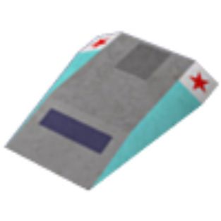 | Speed/Thrust (lm) | 0.24/0.030 | Banks & Charge | C20
 | Roll & Pitch | NJ | Weapon Mounts | F M1
 | Cargo Space (t) | 2 | Hyperspace | yes
 | Sold at Tech Level | 4 | Base Price (cr) | 65000
 | Base Equipment | Pulse Laser, 1 Missile
An agile compact ship favoured by couriers, customisers and professional racers.

Anaconda |  |  | 75w x 54h x 170l m
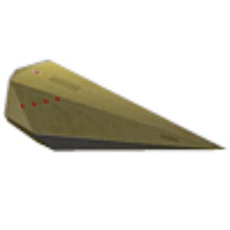 | Speed/Thrust (lm) | 0.14/0.014 | Banks & Charge | P30
 | Roll & Pitch | DB | Weapon Mounts | All M7
 | Cargo Space (t) | 750 | Hyperspace | yes
 | Sold at Tech Level | 8 | Base Price (cr) | 650000
 | Base Equipment | Pulse Laser, 3 Missiles
The biggest mass produced freighter available, built like an asteroid and steers like one.

Asp Mk II |  |  | 75w x 54h x 170l m
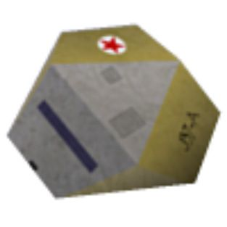 | Speed/Thrust (lm) | 0.40/0.050 | Banks & Charge | P30
 | Roll & Pitch | JE | Weapon Mounts | FA M1
 | Cargo Space (t) | N/A | Hyperspace | yes
 | Sold at Tech Level | 10 | Base Price (cr) | 375000
 | Base Equipment | Pulse Laser, 1 Missile, MTS, STE
The civilian version of the Galactic Navy’s premier long range scouting / commando craft.

Boa |  |  | 71w x 60h x 115l m
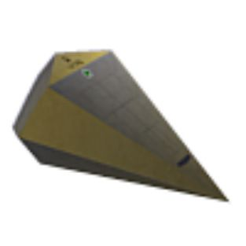 | Speed/Thrust (lm) | 0.24/0.036 | Banks & Charge | P30
 | Roll & Pitch | NE | Weapon Mounts | All M4
 | Cargo Space (t) | 125 | Hyperspace | yes
 | Sold at Tech Level | 6 | Base Price (cr) | 450000
 | Base Equipment | Pulse Laser, 3 Missiles
The replacement for the ageing Python, with better performance and capacity.

Boa Cruiser / Mk II |  |  | 92w x 92h x 228l m
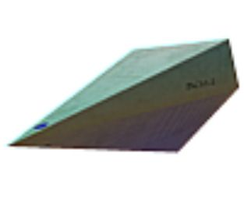 | Speed/Thrust (lm) | 0.31/0.040 | Banks & Charge | P32
 | Roll & Pitch | LE | Weapon Mounts | All M5
 | Cargo Space (t) | 175 | Hyperspace | yes
 | Sold at Tech Level | 8 | Base Price (cr) | 495000
 | Base Equipment | Pulse Laser, 5 Missiles
The long haul version of the Boa, trading some agility for more capacity and speed.
Cobra Mk I |  |  | 70w x 13h x 47l m
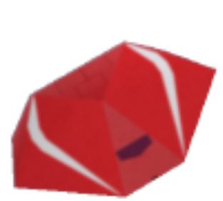 | Speed/Thrust (lm) | 0.26/0.025 | Banks & Charge | E25
 | Roll & Pitch | JF | Weapon Mounts | FA M1
 | Cargo Space (t) | 10 | Hyperspace | yes
 | Sold at Tech Level | 4 | Base Price (cr) | 100000
 | Base Equipment | Pulse Laser, 1 Missile
The first truly effective solo fighter/trader ship, but now superseded by the Mk III.

Cobra Mk III |  |  | 131w x 26h x 59l m
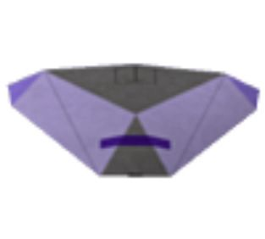 | Speed/Thrust (lm) | 0.35/0.032 | Banks & Charge | H40
 | Roll & Pitch | JE | Weapon Mounts | All M4
 | Cargo Space (t) | 20 | Hyperspace | yes
 | Sold at Tech Level | 6 | Base Price (cr) | 150000
 | Base Equipment | Pulse Laser, 3 Missiles
The most successful medium size ship ever built and an excellent fighter/trader.

Constrictor † |  |  | 108w x 20h x 120l m
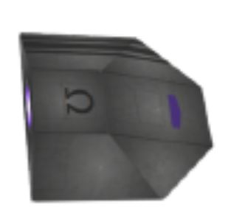 | Speed/Thrust (lm) | 0.60/0.050 | Banks & Charge | ?
 | Roll & Pitch | LH | Weapon Mounts | All M3
 | Cargo Space (t) | Unknown | Hyperspace | yes
 | Sold at Tech Level | N/A | Base Price (cr) | N/A
 | Base Equipment | Unknown
Currently under test by the Galactic Navy, the rumours say it’s extremely deadly.

Escape Capsule |  |  | 6w x 6h x 7l m
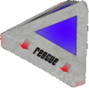 | Speed/Thrust (lm) | 0.05/0.005 | Banks & Charge | P30
 | Roll & Pitch | AA | Weapon Mounts | N/A
 | Cargo Space (t) | N/A | Hyperspace | no
 | Sold at Tech Level | 6 | Base Price (cr) | 1000
 | Base Equipment | N/A
Only technically a ship, the Escape Capsule is the primary lifeboat system of GCW ships.

Fer-de-Lance |  |  | 75w x 54h x 170l m
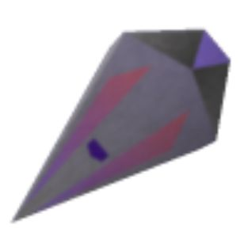 | Speed/Thrust (lm) | 0.30/0.025 | Banks & Charge | H45
 | Roll & Pitch | RE | Weapon Mounts | All M2
 | Cargo Space (t) | 12 | Hyperspace | yes
 | Sold at Tech Level | 8 | Base Price (cr) | 485000
 | Base Equipment | Beam Laser, 2 Missiles, MTS, STE
An agile and deadly assault class ship favoured by bounty hunters and the well-to-do.
Gecko † |  |  | 70w x 12h x 37l m
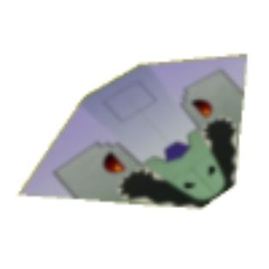 | Speed/Thrust (lm) | 0.30/0.045 | Banks & Charge | H40
 | Roll & Pitch | OG | Weapon Mounts | F M1
 | Cargo Space (t) | 3 | Hyperspace | no
 | Sold at Tech Level | N/A | Base Price (cr) | N/A
 | Base Equipment | Beam Laser, 1 Missile
Produced in unlicensed shipyards, this fighter is a favourite of pirates and assassins.

Krait † |  |  | 90w x 18h x 73l m
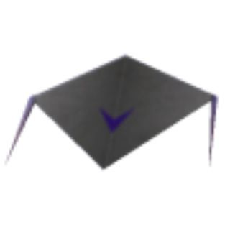 | Speed/Thrust (lm) | 0.30/0.035 | Banks & Charge | H25
 | Roll & Pitch | MG | Weapon Mounts | F M0
 | Cargo Space (t) | 4 | Hyperspace | no
 | Sold at Tech Level | 8 | Base Price (cr) | N/A
 | Base Equipment | Beam Laser
A discontinued fighter design finding a new life in the professional racing circuit.

Mamba † |  |  | 64w x 8h x 48l m
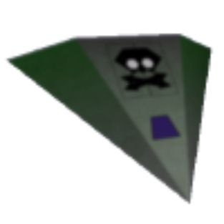 | Speed/Thrust (lm) | 0.32/0.032 | Banks & Charge | H30
 | Roll & Pitch | JG | Weapon Mounts | F M0
 | Cargo Space (t) | 4 | Hyperspace | no
 | Sold at Tech Level | N/A | Base Price (cr) | N/A
 | Base Equipment | Beam Laser
Originally used in professional racing, this fighter is used by pirates and escorts alike.

Moray Star Boat |  |  | 40w x 23h x 53l m
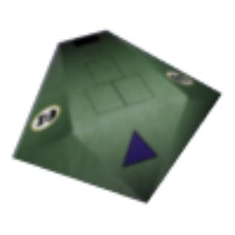 | Speed/Thrust (lm) | 0.30/0.032 | Banks & Charge | H30
 | Roll & Pitch | JG | Weapon Mounts | All M2
 | Cargo Space (t) | 7 | Hyperspace | yes
 | Sold at Tech Level | 5 | Base Price (cr) | 126000
 | Base Equipment | Pulse Laser, 3 Missiles
A multi-role ship, often seen as a medical or tourist craft. It’s popular with pirates too.

Orbital Shuttle † |  |  | 20w x 20h x 31l m
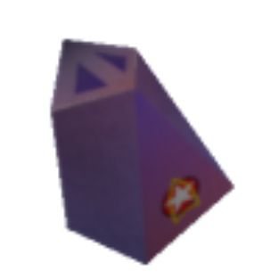 | Speed/Thrust (lm) | 0.08/0.016 | Banks & Charge | D10
 | Roll & Pitch | JD | Weapon Mounts | N/A
 | Cargo Space (t) | 30 | Hyperspace | no
 | Sold at Tech Level | N/A | Base Price (cr) | N/A
 | Base Equipment | None
Often unmanned, this ship is the GCW’s primary in-system heavy cargo hauler.
Python |  |  | 74w x 37h x 130l m
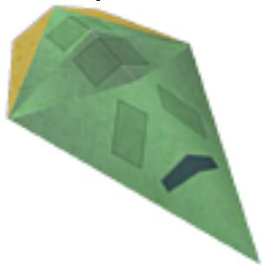 | Speed/Thrust (lm) | 0.20/0.020 | Banks & Charge | N25
 | Roll & Pitch | JD | Weapon Mounts | All M2
 | Cargo Space (t) | 100 | Hyperspace | yes
 | Sold at Tech Level | 4 | Base Price (cr) | 200000
 | Base Equipment | Pulse Laser, 1 Missile
An ageing design that’s still popular with commanders needing a simple robust freighter.

Sidewinder Scout Ship † |  |  | 64w x 13h x 32l m
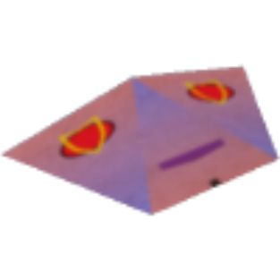 | Speed/Thrust (lm) | 0.37/0.037 | Banks & Charge | H25
 | Roll & Pitch | NH | Weapon Mounts | F M0
 | Cargo Space (t) | N/A | Hyperspace | no
 | Sold at Tech Level | N/A | Base Price (cr) | N/A
 | Base Equipment | Beam Laser
A tough compact fighter popular with racers, freighter escorts and pirates alike.

Thargoid Warship † |  |  | 328w x 56h x 328l m
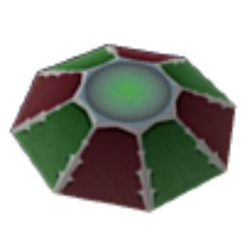 | Speed/Thrust (lm) | 0.50/0.050 | Banks & Charge | S40
 | Roll & Pitch | JE | Weapon Mounts | All M5
 | Cargo Space (t) | N/A | Hyperspace | yes
 | Sold at Tech Level | N/A | Base Price (cr) | N/A
 | Base Equipment | Thargoid Laser, ECM, 5 Robotic fighters
The primary vessel of the Thargoid Invasion Fleet. Deadly and fights without fear.

Thargoid Robotic Fighter † |  |  | 19w x 5h x 18l m
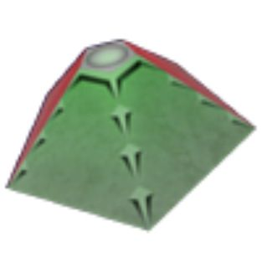 | Speed/Thrust (lm) | 0.45/0.040 | Banks & Charge | E30
 | Roll & Pitch | JE | Weapon Mounts | F M0
 | Cargo Space (t) | N/A | Hyperspace | no
 | Sold at Tech Level | N/A | Base Price (cr) | N/A
 | Base Equipment | Pulse Laser
Small remote-controlled fighters designed to swarm their victims.

Transporter † |  |  | 30w x 8h x 25l m
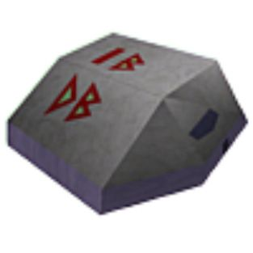 | Speed/Thrust (lm) | 0.10/0.020 | Banks & Charge | E30
 | Roll & Pitch | JE | Weapon Mounts | All M0
 | Cargo Space (t) | 12 | Hyperspace | no
 | Sold at Tech Level | N/A | Base Price (cr) | N/A
 | Base Equipment | None
Predating the GCW, this ship serves as shuttle, cargo hauler and industrial platform.
Viper † |  |  | 96w x 32h x 96l m
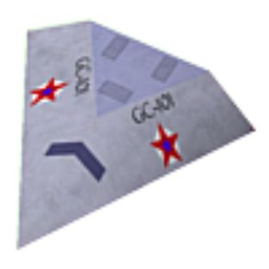 | Speed/Thrust (lm) | 0.32/0.032 | Banks & Charge | F40
 | Roll & Pitch | NI | Weapon Mounts | F M1
 | Cargo Space (t) | N/A | Hyperspace | no
 | Sold at Tech Level | N/A | Base Price (cr) | N/A
 | Base Equipment | Beam Laser, ECM, 1 Missile
GALCOP’s mainstay patrol vessel, capable of dealing with the most deadly threat.

Viper Interceptor † |  |  | 96w x 32h x 96l m
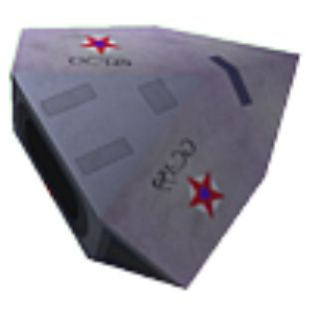 | Speed/Thrust (lm) | 0.52/0.050 | Banks & Charge | I60
 | Roll & Pitch | UJ | Weapon Mounts | F M3
 | Cargo Space (t) | N/A | Hyperspace | yes
 | Sold at Tech Level | N/A | Base Price (cr) | N/A
 | Base Equipment | Military Laser, ECM, 3 Missiles
GALCOP’s best pilots fly these ships to fight threats of an interstellar scale.

Worm † |  |  |  |  | 26w x 12h x 30l m
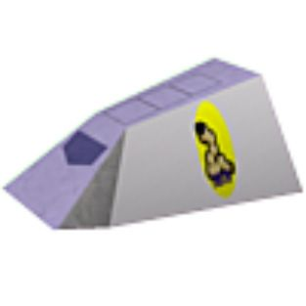 |  |  | Speed/Thrust (lm) | 0.11/0.012 | Banks & Charge | C20
 |  |  | Roll & Pitch | JE | Weapon Mounts | F M0
 |  |  | Cargo Space (t) | 2 | Hyperspace | no
 |  |  | Sold at Tech Level | N/A | Base Price (cr) | N/A
 |  |  | Base Equipment | None
A simple support craft, often seen as a ship’s launch, lifeboat or miner.
Notes
† | Ships which are unavailable for purchase at the GCW station shipyards for the following reasons:
 | • | GCW shipyards specialise in currently manufactured models fitted with hyperspace drives.
 | • | GCW shipyards will not deal in craft from unlicensed manufacturers.
 | • | It is illegal for civilians to own Local Government, Galactic Navy and GALCOP ships. It is also illegal for civilians to be in possession of craft constructed outside of the Galactic Cooperative of Worlds.
• | MTS stands for Multi-Target System. ETS stands for Enhanced Targeting Scanner.
• | Speed is measured against Light Mach, which is the maximum velocity a ship can reach before suffering relativistic effects.
• | The ships’ banks and charge rate are graded on the KeZecky scale. The higher letter (A being the lowest) and number value, the larger and faster charging the energy bank is.
• | A vessel’s agility is measured using the Holdstock method. The higher value of each letter (A being the lowest) the better the performance.
• | Ships have laser mounts in the Forward, Aft, or All view screen directions. The number of pylons is shown by the M value.
• | Cargo space is measured in GCW standardised 1 ton cargo canisters.
• | The base price is calculated for craft with the base equipment fitted. Ships available for sale may be fitted with extra equipment, with a corresponding increase in price.
• | Images shown here are not to scale and measurements are listed in metres.
Stations and Other Anchorages
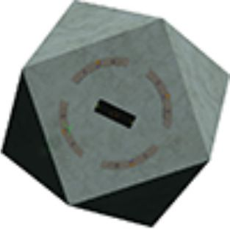 | 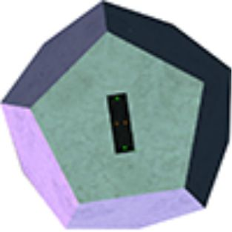 | 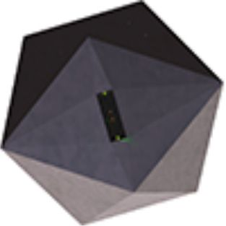 | 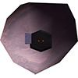
Coriolis Station | Dodo Station | Ico Station | Rock Hermit

Other Objects
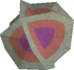 | 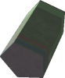 |  | 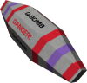
Beacon | Cargo Canister | Missile | Quirium Cascade Mine
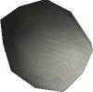 |  |  | 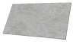
Asteroid | Boulder | Splinter | Metal Fragment
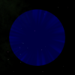
Witchcloud

Oolite Reference Sheet by KZ9999.
Inspired by the OoliteRS by Darkbee / another_commander / Commander McLane
Checking by: Disembodied, _ds_, Kaks, Commander McLane, ,Ahruman, Micha, another_commander and others.
Released under the Creative Commons – BY – NC – SA 3.0
This document was created using OpenOffice 3.0, Inkscape, Paint.net and IrfanView.
Typefaces are the Deja Vu family.
Solar System – Galaxy |  | Commander Status |  | Manifest
GCW MT |  | Ship |  | Commodity | Quantity | Buy Price |  | Sell Price
Present System | Destination System | Credits | Cargo Capacity
Government | Government | Legal Status: | Combat Rating:
Economy | Economy | Outstanding Contracts
Tech Level | Tech Level
Notes
Solar System – Galaxy |  | Commander Status |  | Manifest
GCW MT |  | Ship |  | Commodity | Quantity | Buy Price |  | Sell Price
Present System | Destination System | Credits | Cargo Capacity
Government | Government | Legal Status | Combat Rating
Economy | Economy | Outstanding Contracts
Tech Level | Tech Level
Notes

