**README:**

The visual and auditory SL experiments in this folder mix the structured and random sequences from linguistic and non-linguistic domains.

**Setting up:**

To download the right version of psychopy, here is the link:

<https://github.com/psychopy/psychopy/releases/tag/1.85.6>

Please make sure not to upgrade the program. Just ignore the update message whenever it pops out by closing the message window.

A few other instructions to make sure you can run the program smoothly on your end:

1. If psychopy is crashing or not starting up, search for these two files in your file browser:

appData.cfg

userPrefs.cfg

Delete them and try starting Psychopy again.

2. It is crucial to manually change the preference (located at the menu bar: File->Preference) of the sound library to **['pygame','pyo']**from ['pyo','pygame'] before you start running the experiment.

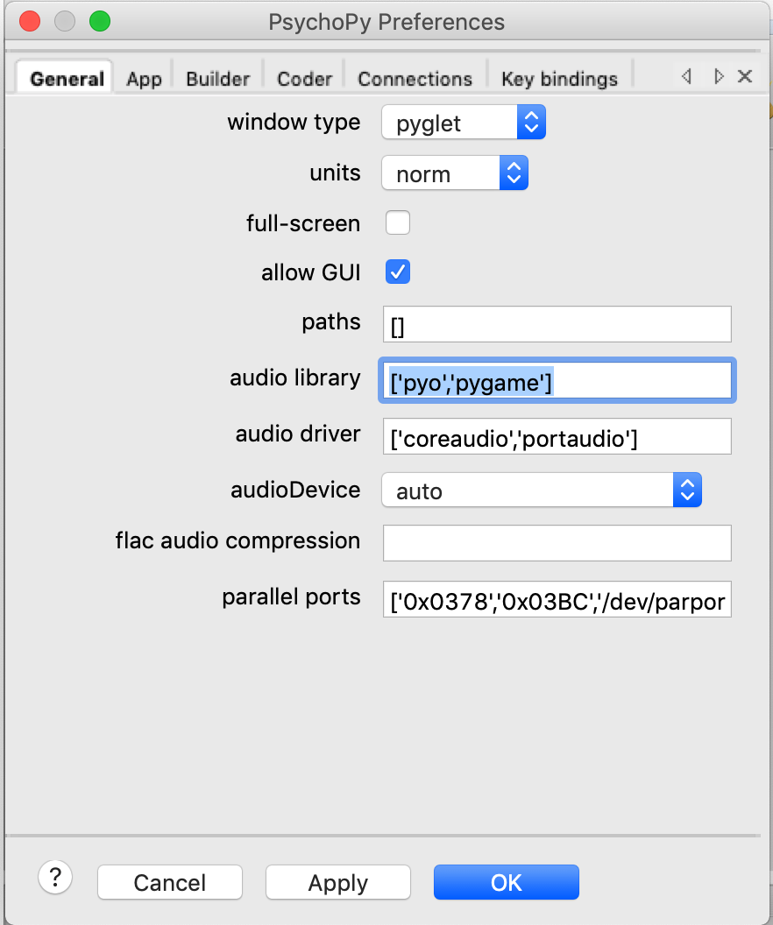

**Run experiments:**

Use a numpad or a regular keyboard. Put a green sticker on top of the number 3 button and a red sticker on top of the number 4 button.

Use Coder's view when running the experiment.

Open the .py files in the following order and press the green running man button on PsychoPy for each python file to start the experiment. You will be expected to enter subject ID and the target stimuli for each task (please see information below). **Make sure you enter the same targets across the four runs for each participant and counter balance these targets across participants.**

* Press number 5 button when you see “Are you ready for the game?”.
* Participants are expected to press number 3 or number 4 on the keyboard.
* Before each test session, make sure the participant understands the instruction completely. Then press number 5 button to proceed.
* For auditory task:
  + /sl_for_li/modified_auditory/auditory_instruction.py
  + /sl_for_li/modified_auditory/auditory _fmri_run1.py
  + /sl_for_li/modified_auditory/auditory_fmri_run2.py (containing the test session for the **speech** task)
  + /sl_for_li/modified_auditory/auditory_fmri_run3.py
  + /sl_for_li/modified_auditory/auditory_fmri_run4.py (containing the test session for the **tone** task)
  + starget: choose one out of the following four options:
    - bi
    - da
    - du
    - pu
  + ttarget: choose one out of the following two options:
    - 1C
    - 2C
* For visual task:
  + /sl_for_li/modified_visual/visual_instruction.py
  + /sl_for_li/modified_visual/visual_fmri_run1.py
  + /sl_for_li/modified_visual/visual_fmri_run2.py (containing the test session for the **letter** task)
  + /sl_for_li/modified_visual/visual_fmri_run3.py
  + /sl_for_li/modified_visual/visual_fmri_run4.py (containing the test session for the **image** task)
  + ltarget: choose one out of the following four options:
    - B
    - F
    - G
    - H
  + vtarget: choose one out of the following two options:
    - 15
    - 18
    - 21
    - 24

The resulting data are saved in the data folder inside of modified_visual / modified_auditory.

If you have any questions, please contact Violet at [vkozloff@udel.edu](mailto:vkozloff@udel.edu).