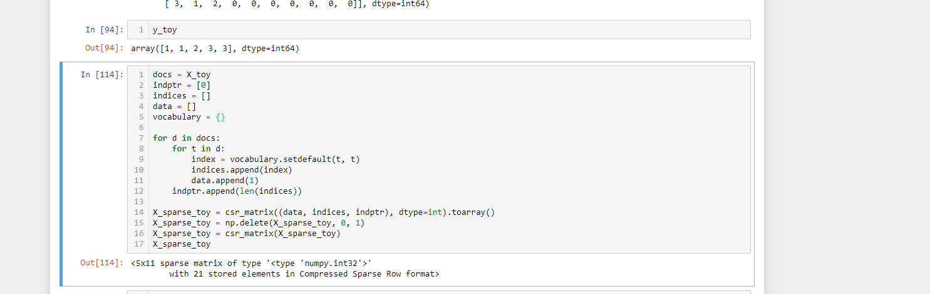

docs = X_toy

indptr = [0]

indices = []

data = []

vocabulary = {}

for d in docs:

for t in d:

index = vocabulary.setdefault(t, t)

indices.append(index)

data.append(1)

indptr.append(len(indices))

X_sparse_toy = csr_matrix((data, indices, indptr), dtype=int).toarray()

X_sparse_toy = np.delete(X_sparse_toy, 0, 1)

X_sparse_toy = csr_matrix(X_sparse_toy)

X_sparse_toy

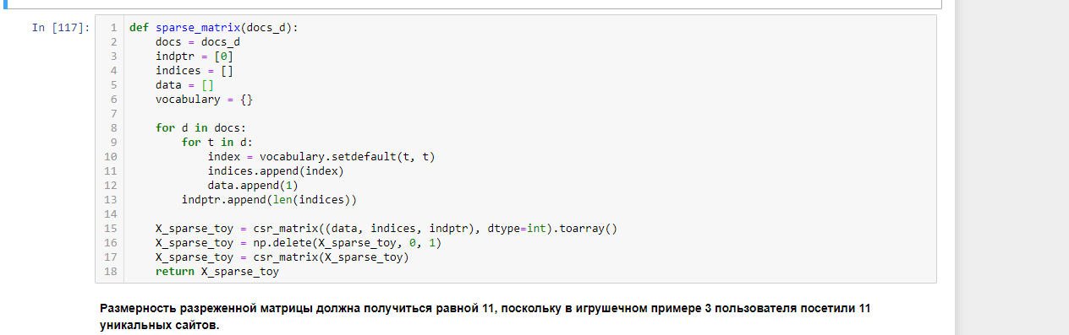

def sparse_matrix(docs_d):

docs = docs_d

indptr = [0]

indices = []

data = []

vocabulary = {}

for d in docs:

for t in d:

index = vocabulary.setdefault(t, t)

indices.append(index)

data.append(1)

indptr.append(len(indices))

X_sparse_toy = csr_matrix((data, indices, indptr), dtype=int).toarray()

X_sparse_toy = np.delete(X_sparse_toy, 0, 1)

X_sparse_toy = csr_matrix(X_sparse_toy)

return X_sparse_toy

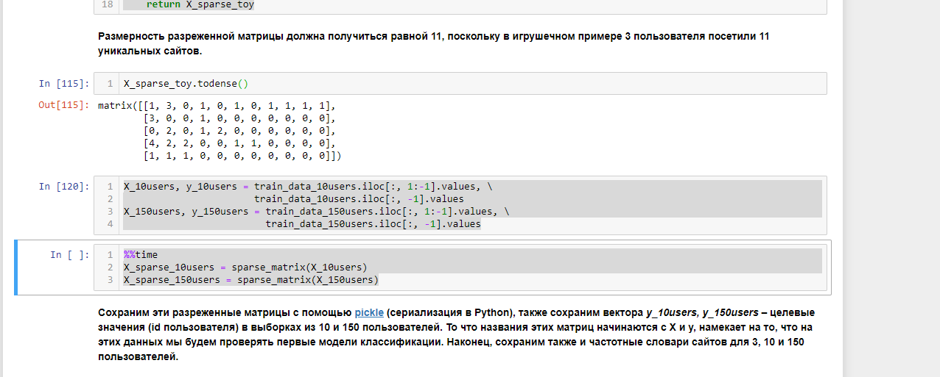

%%time

X_sparse_10users = sparse_matrix(X_10users)

X_sparse_150users = sparse_matrix(X_150users)