**RT 760 Assignment 1**

1. Plot 10 samples, spaced uniformly in range [0, 1], with the function sin(2 $πx$) with Gaussian noise like below.

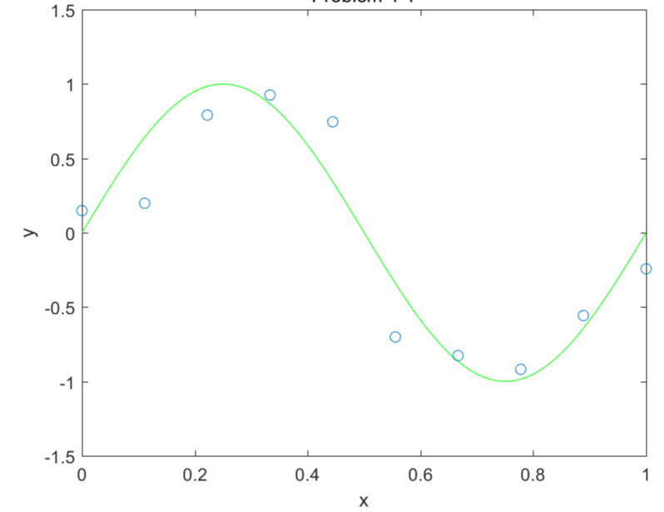

2. Generate regression lines with polynomial basis function with order 1, 3, 5, and 9.

3. Plot 100 samples and then generate the regression lines

4. Generate the regression lines with a quadratic regularization term with order 1, 3, 5, and 9. Show how the lines are changed with respect to $λ$.