**Monitoring/Tracking Devices**

***Position Tracker Infrared Array***

**3D Printed Pieces**

An equal amount of 3mm and 5mm LED array pieces

Array corner pieces x4

Array holder/brace pieces x4

**Hardware/Electronics**

Ribbon cable (with at least as many wires as number of photodetectors)

2 wire + 4 wire cable (4 different colors of 24g wire will suffice)

22g (red [jumper]) & 28g (black [common ground]) Wire

Electrical and lab tape

8mm pin pairs

Narrow IR emitter LEDs (enough for all but two 5mm holes)

Photodetectors (enough for all but two 3mm holes)

Array PCBs (if using)

IDC connectors (three more than number of photodetectors; all but four should be pass-through)

IDC stress relievers for all IDC pieces

**Tools**

Needle nose pliers

Wire cutters + strippers

Soldering iron + Solder

Breadboard

**Fit Array pieces together**

Make sure the narrower holes face towards the inside of the array. Two adjacent sides should have only 3mm holes and the opposite sides should have only 5mm holes so each L-shaped half of the array is homogeneous. Be sure there is minimal overhang at connection points for best z-axis consistency.

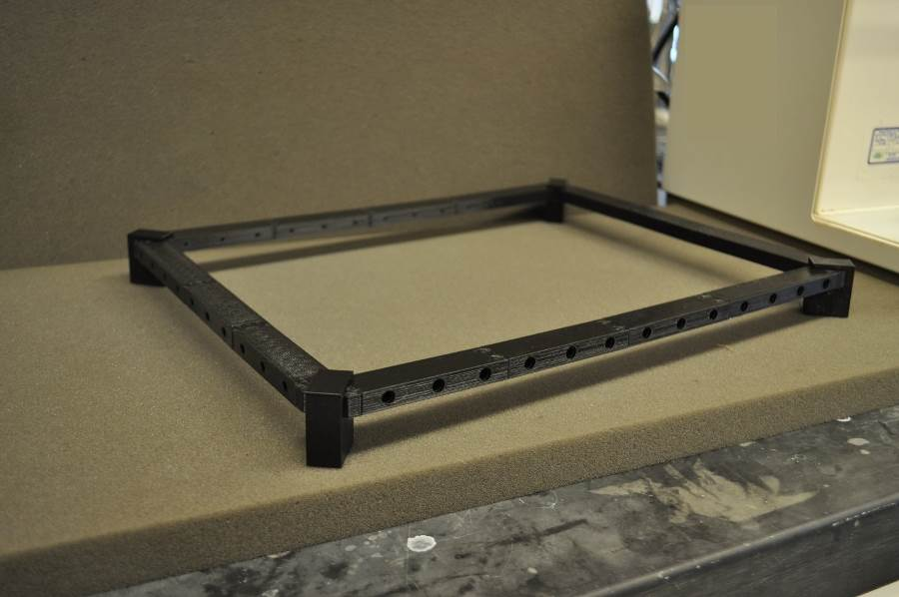

**Fit Narrow IR emitter LEDs into 5mm Holes**

One LED hole per side will be unused so that chambers can fit in without having to be especially snug; we typically make these the "frontmost" and the "leftmost" spots for consistency. A pair of needle nose pliers may be helpful for fitting LEDs into particularly tight sleeves. When placing LEDs, it is easiest to align the legs vertically and keep the top the anode. Then, moving along a side, the anode leg from one can be bent and twisted to the cathode leg of the next. A jumper wire (we use the 22g red wire here) can be used to connect legs around a corner of the array (you may want to cover connections here with heat shrink tubing). Then these groups of LEDs can be powered in series by two wires connecting the anode from one end and the cathode from the other end to the power circuit. We typically do this in groups of 7 emitters for power purposes.

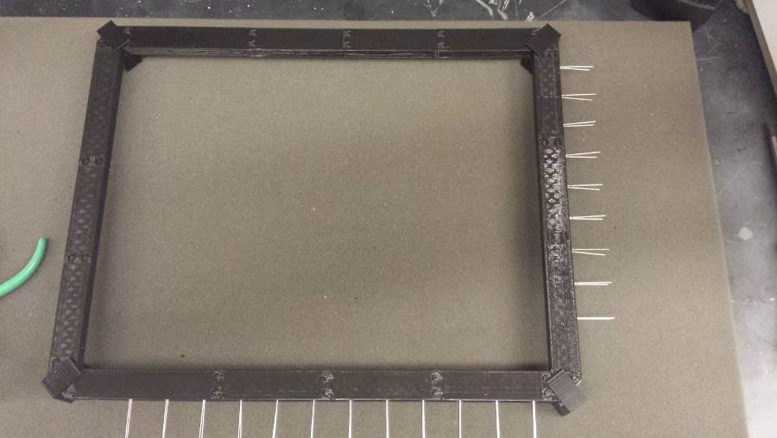

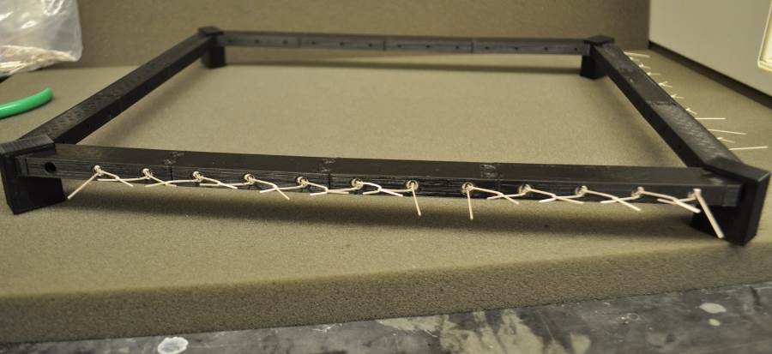

**Solder IR emitter LED series**

Solder the LEDs at the points where the emitter legs are twisted. Cut pieces of 2 wire and 4 wire cable (long enough to span between array and power source) and strip one end to solder to free anode/cathode legs of emitter series. Fit the non-stripped ends into 2 pin IDC connectors (each series gets its own connector). Cover exposed soldered legs with pieces of electrical tape. Lab tape may also be used on top to hold electrical tape in place as it doesn't stick nicely to the plastic of the array. (We left the tape off until the end for clearer pictures).

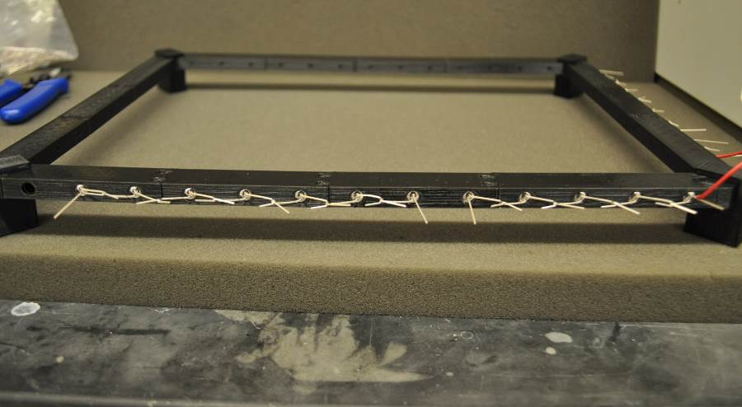

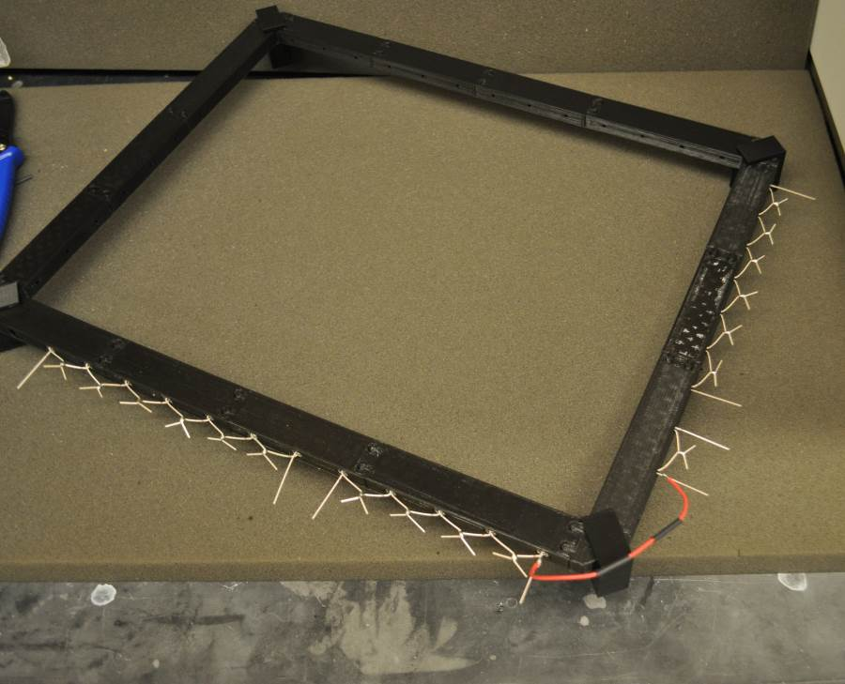

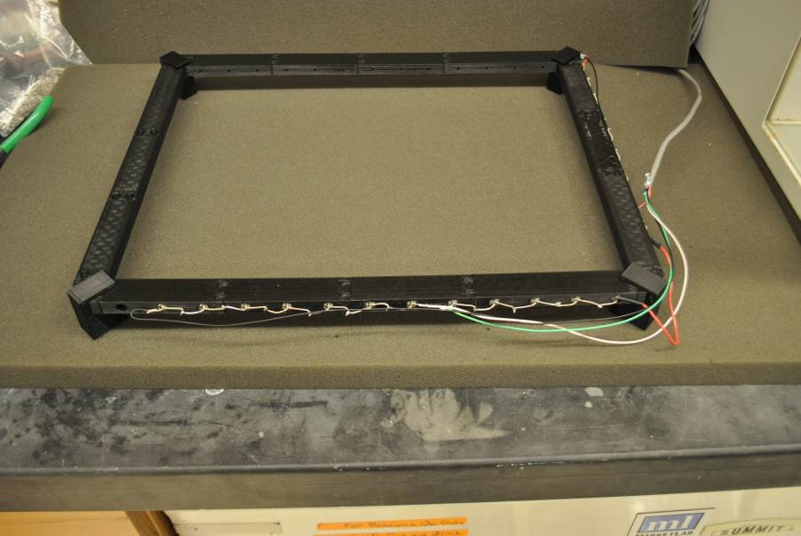

**Fit photodetectors into 3mm holes**

The two holes opposite the two empty emitter holes will be unused. Keep the legs aligned vertically again and be consistent which leg is top (we typically have anode on the bottom for these, though consistency is more important than orientation).

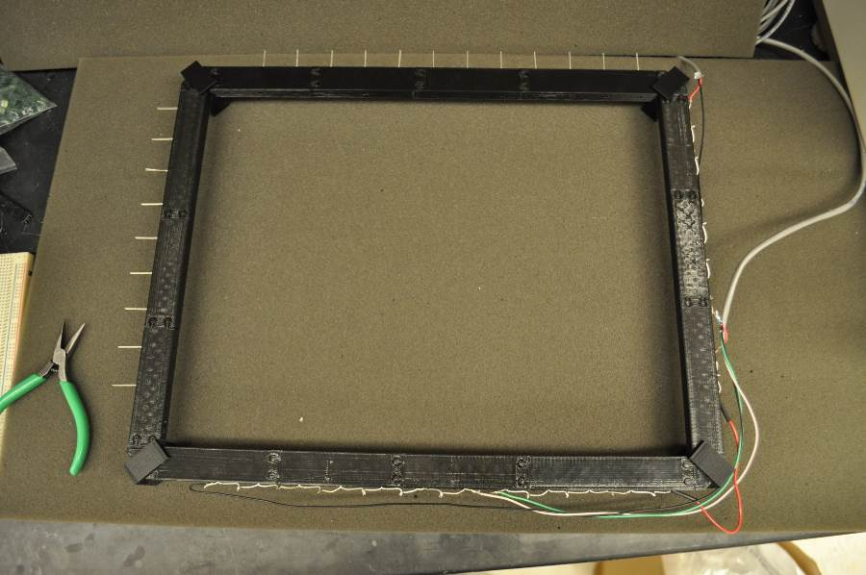

(Follow steps 3.6-3.8 if using tracker PCBs. Otherwise, skip to step 3.8)

**Install PCBs**

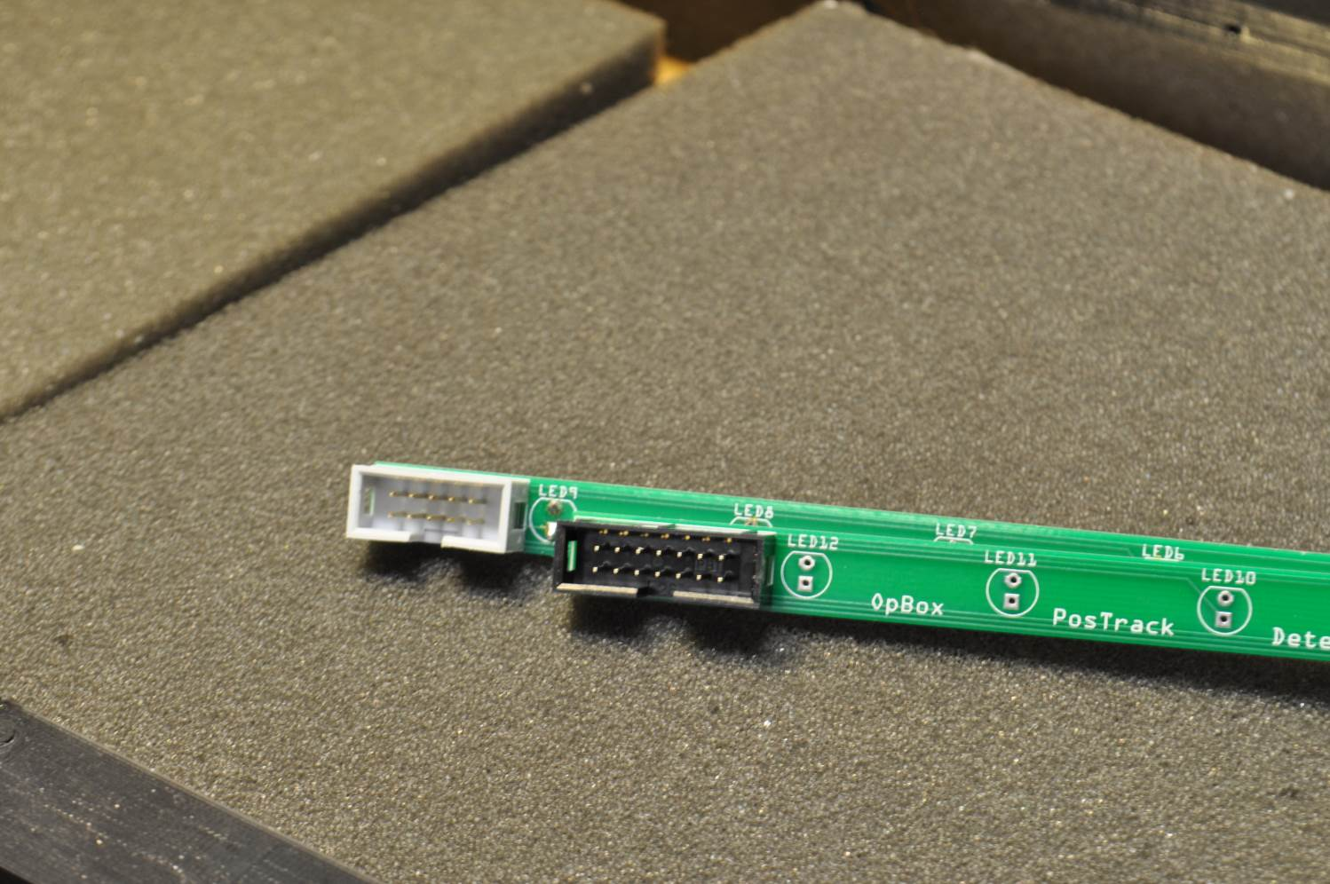

Solder box headers onto PCBs with gap on bottom. Slide PCB onto legs of detectors.  Solder to board and trim legs with wire cutters.

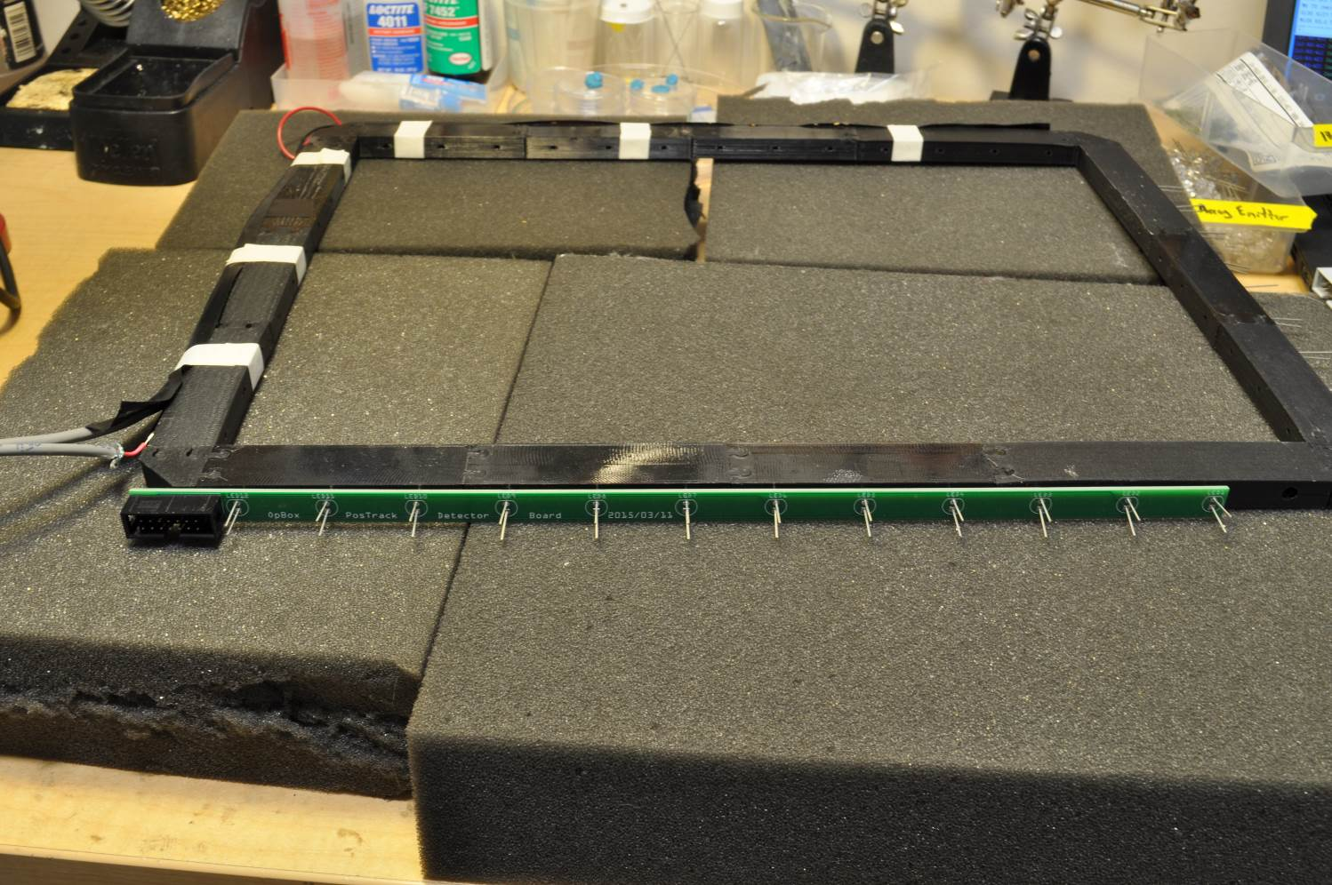

**Make ribbon cable**

Tease away number of active channels for each board from large ribbon, then use hookup wire (or unused ribbon cable channel) for shared ground. The channel marked with an arrow on the connector (noted with red arrow in photos) corresponds to LED #1 on each board. The opposite side will be ground.

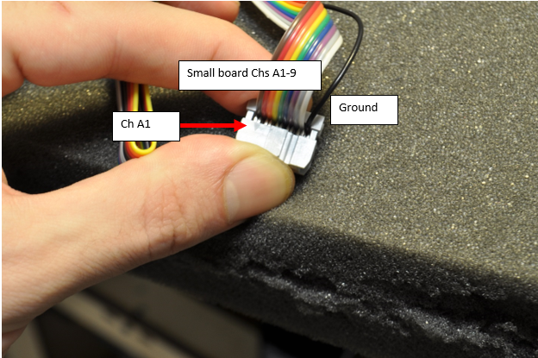

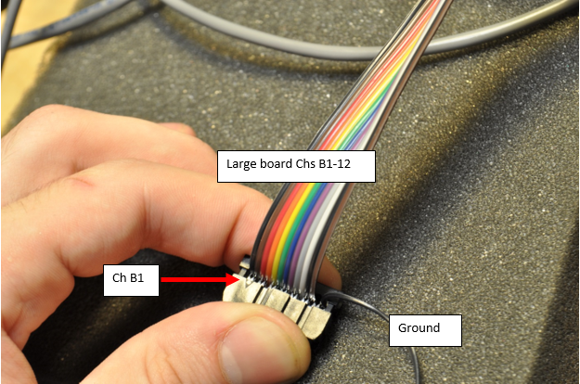

The other end of the ribbon cable should go to a single connector. The first 9 channels will be from the smaller board, immediately proceeded by the 12 channels from the larger board. Thus, Ch 1 from the large board goes to position 10 on the shared ribbon connector (as depicted in photo). Ground wires will go to a separate IDC connector.

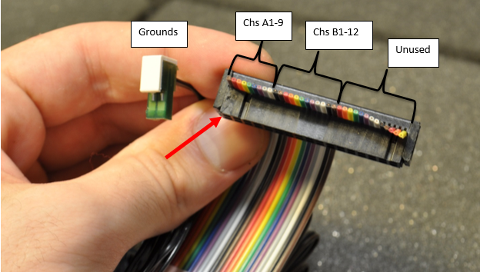

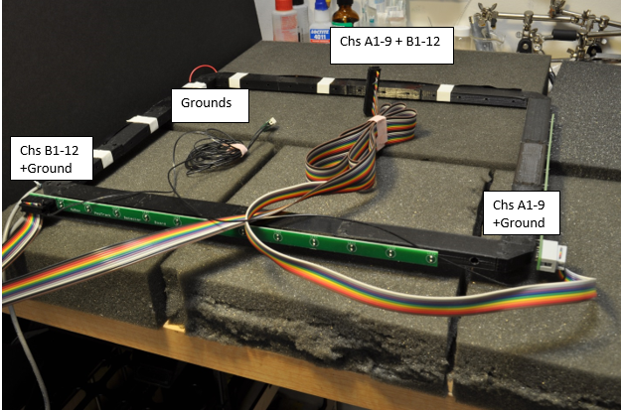

(skip to step 3.10 if using tracker PCBs)

**Make photodetector cable**

Fit 8mm pin pairs onto breadboard 1 inch apart (for standard breadboards this is 10 spaces, so pins will go in at 1, 11, 21, etc.) and fit IDC connectors onto these pins (first will be end connector, the rest will be pass-through). Tease away the first wire from one end of the ribbon cable and press fit into one side of the IDC end connector. Tease away the next wire and press fit into the same side of the second IDC connector. Continue until each photodetector is accounted for with its own ribbon cable wire + connector. Use wire cutters to remove the free-hanging end of each wire (the end that doesn't rejoin with the rest of the ribbon). The spacing around corners will be greater than 1 inch, so be sure to leave more slack between those two connectors. After, use the same length of 22g wire along each second half of the connectors to act as a common ground. You should be left with staggered IDC connectors, one half all on the same common ground and the other half with a dedicated ribbon cable wire. The intact end of the ribbon cable should be terminated with a connector made for that ribbon cable. The wire used for the first photodetector should correspond to pin 1 on the connector. Use strain relieving pieces on IDC connector tops to prevent photodetector pins from pushing out wires from contact points when installing cable.

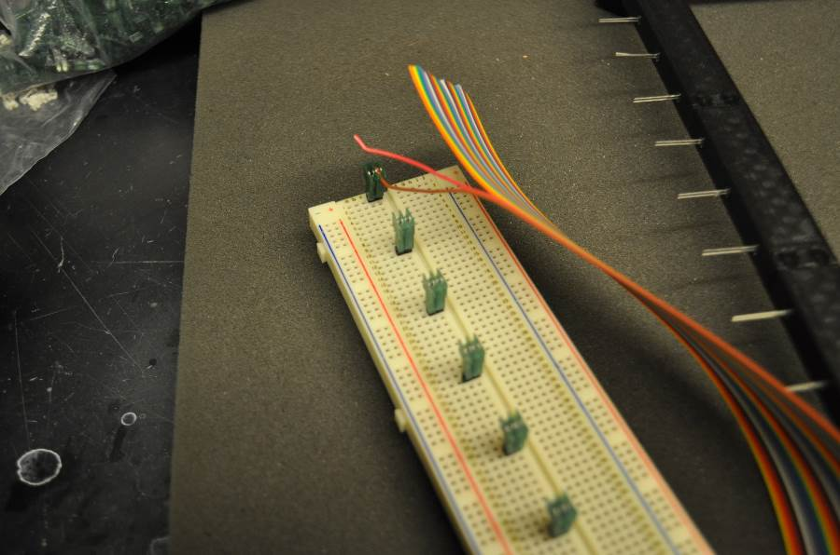

Wire 1 (brown) fit into first IDC connector and second wire (red) teased away ready to be fit into connector 2.

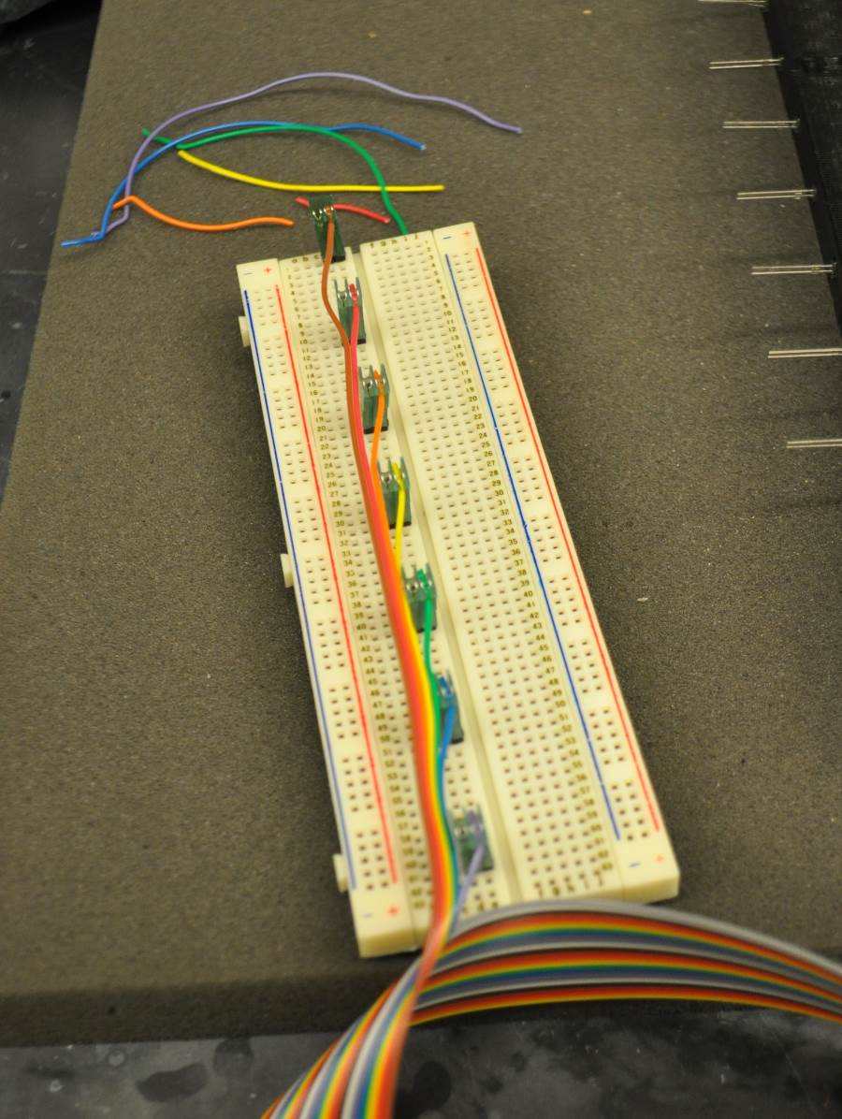

First 7 connectors with free-hanging ends cut

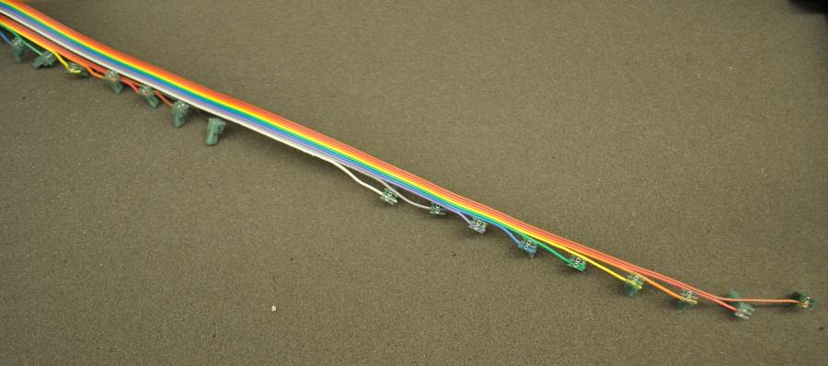

Showing the gap for going around the corner of the array

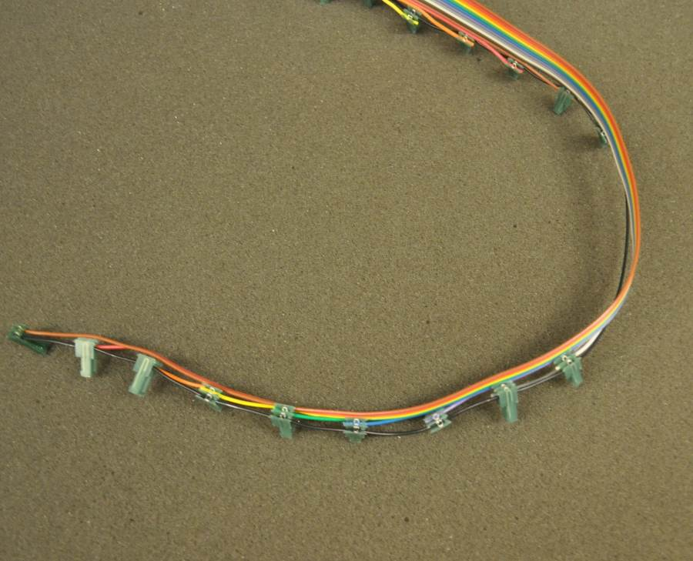

Common ground wire fit into other half of connectors

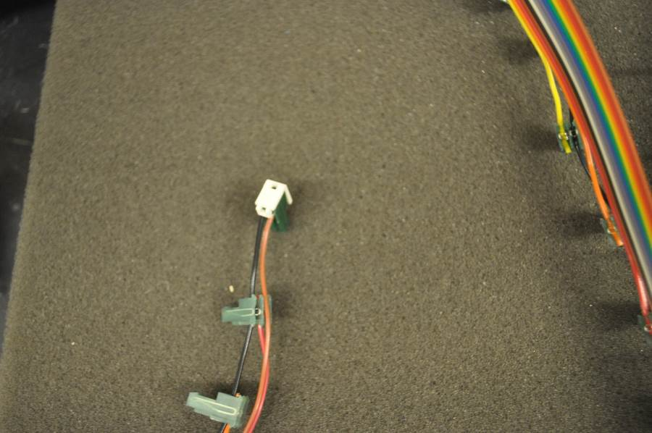

First stress-relieving piece attached to first connector

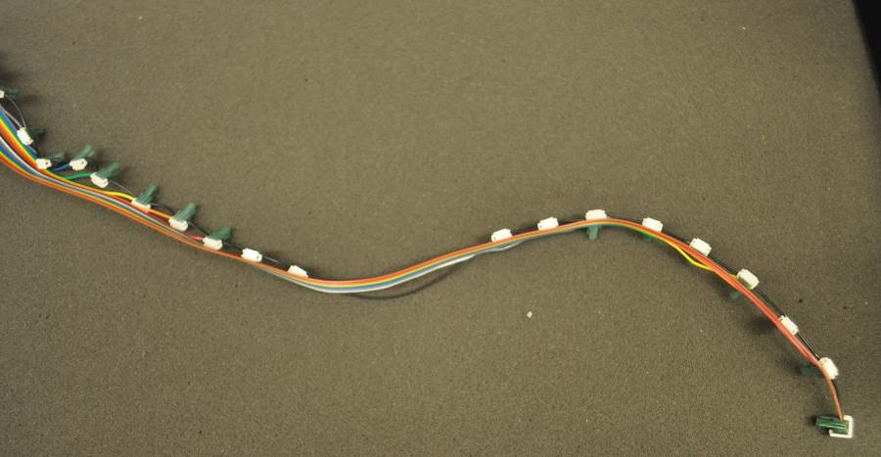

Stress-relieving pieces attached to all connectors

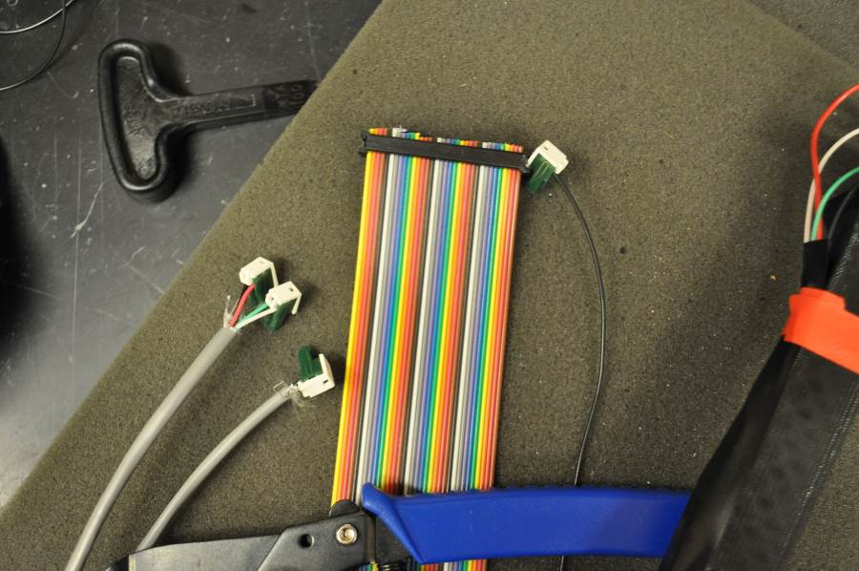

From left to right: Grey cables for powering emitters; ribbon cable for photodetector signal (far right = pin 1) and common ground wire for photodetectors (half of this IDC is unused)

**Wire up**

Fit each subsequent IDC connector to photodetectors in order. Fit connector end and grounding wire onto breadboard or Arduino shield. Test array by using a hand to block beams at the corners and make sure the corresponding corner of the tracker in software is activated.

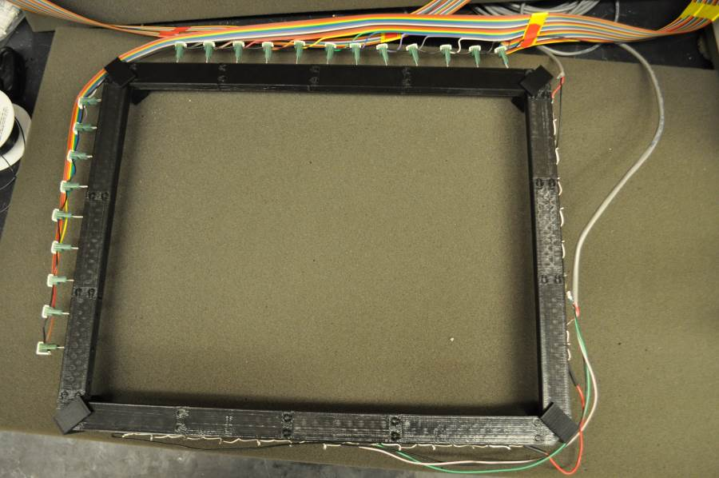

All wired up

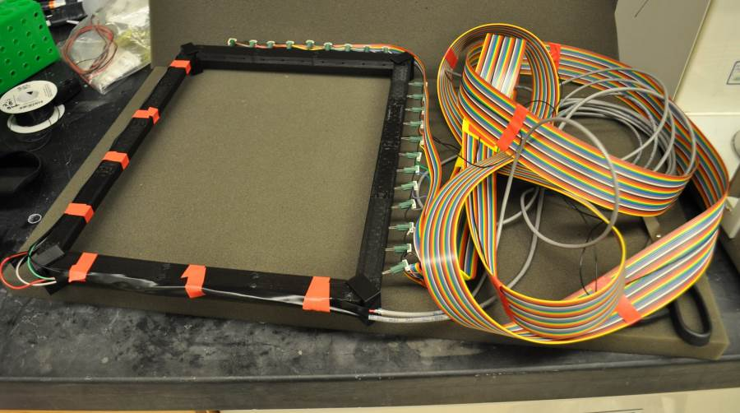

Tape added around exposed emitter legs (be sure no emitter holes are blocked if you wrap the tape around as shown)

**Hook up to Arduino**

Attach emitter power cables, detector ribbon connector, and detector grounds to Arduino shield as shown.

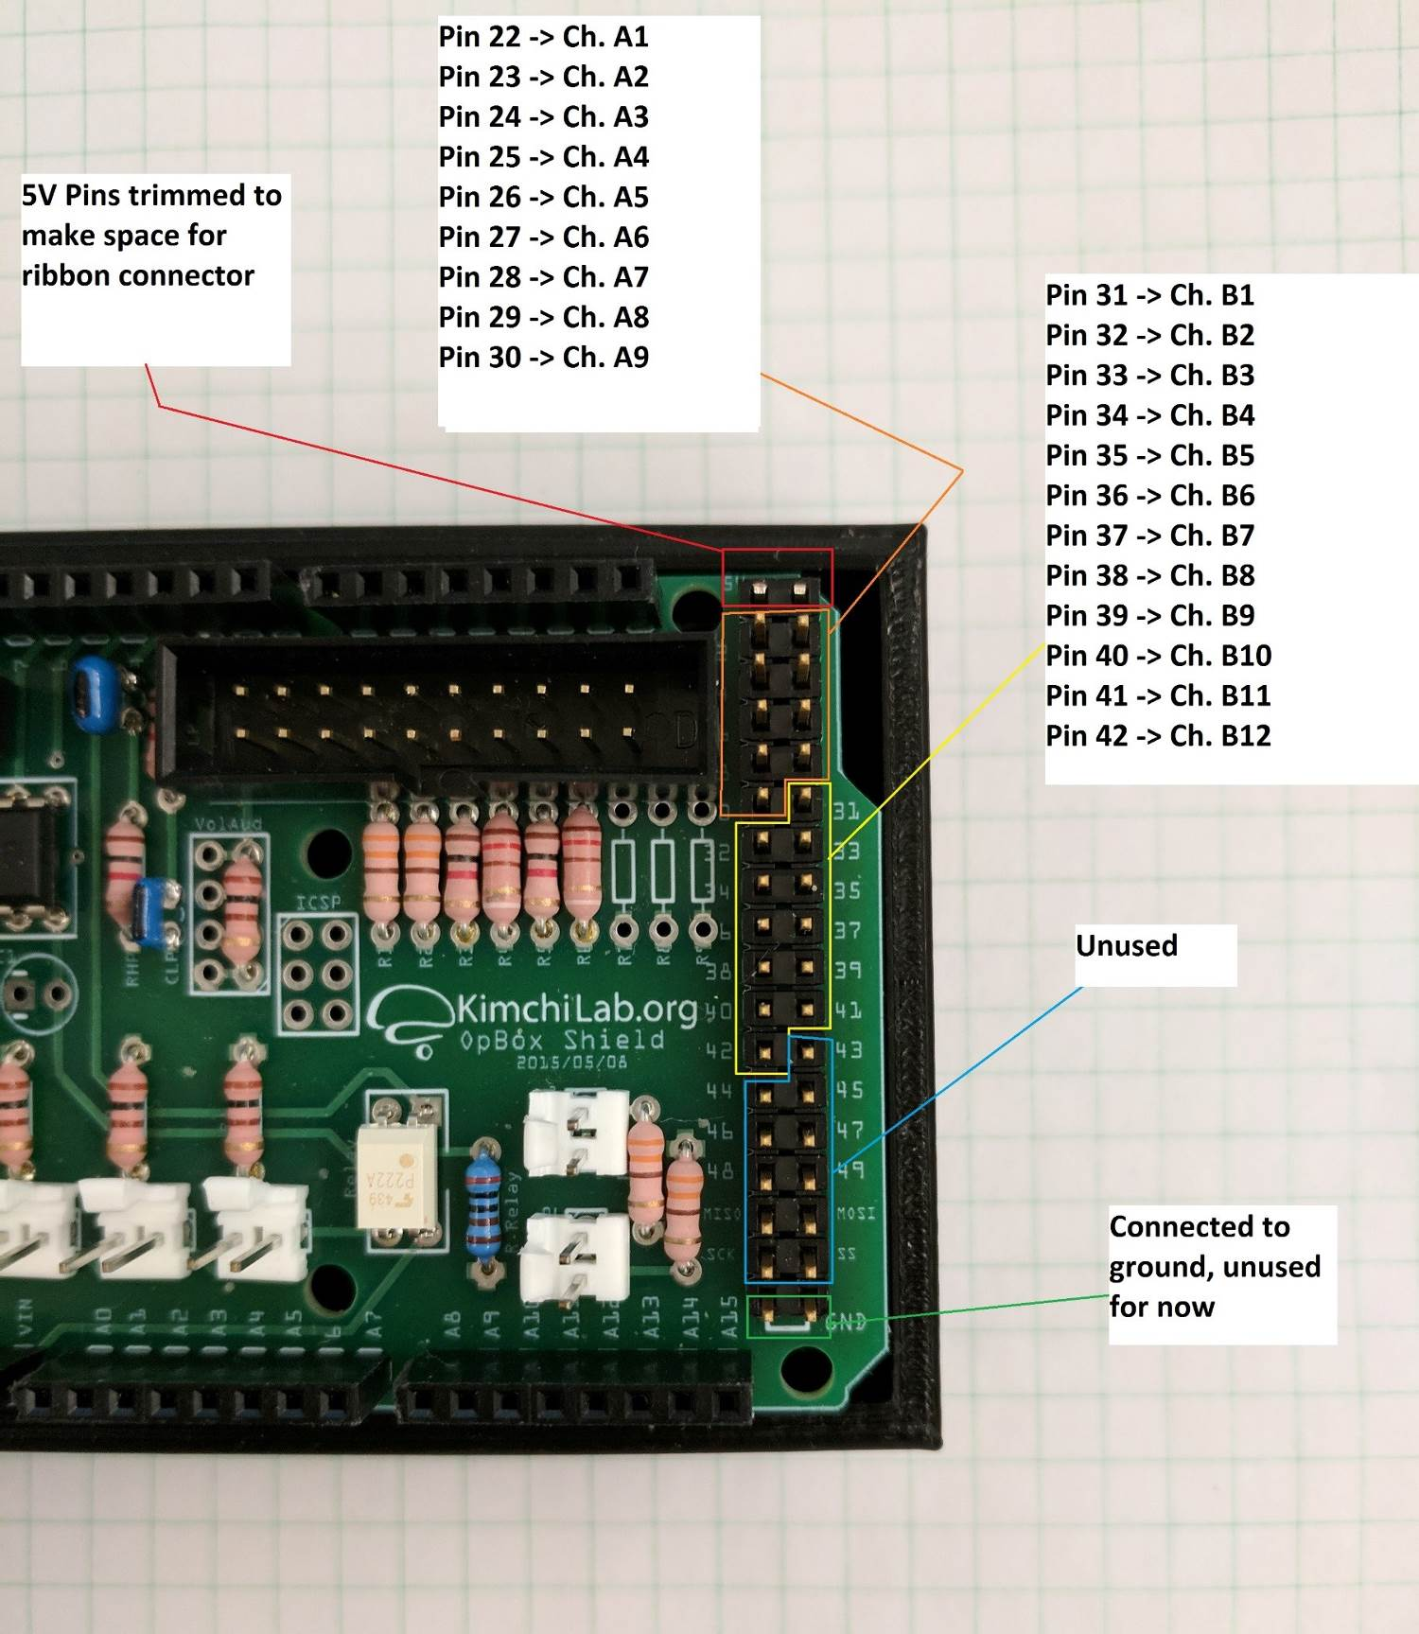

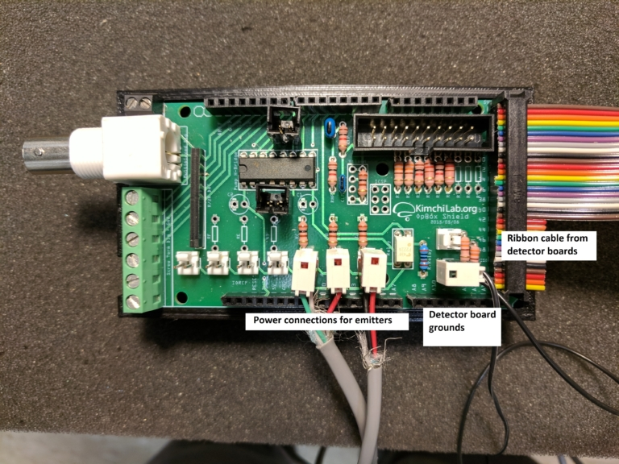

**Test array**

Run OpBoxMonitor and using your hand to break beams in each corner. The corresponding corner of the locomotor tracker in the GUI should be active