**Imaging Devices (Cameras)**

***Webcam: How to convert a webcam for Infrared Multiple Camera recordings on Windows***

**Materials**

Webcam: Micro Innovations ChatCam 4310100

Flathead Screwdriver

Small Phillips Screwdriver

Tweezers or Needle Nose pliers

23 Gauge Needle

**Optional, but Helpful**

Canned Air

Dissecting Microscope

**Remove the IR Filter**

Remove camera base manually

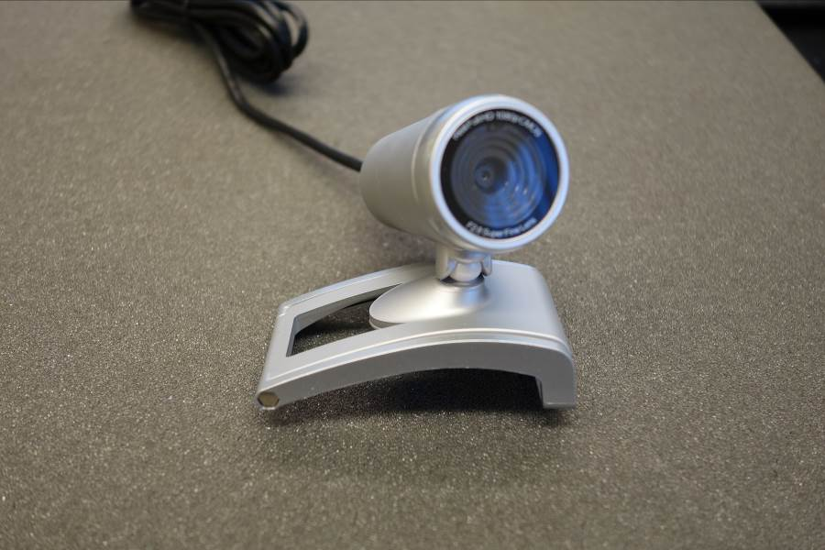

Open camera case by pressing on the small tab within the socket from where the based was removed. Push down and forward.

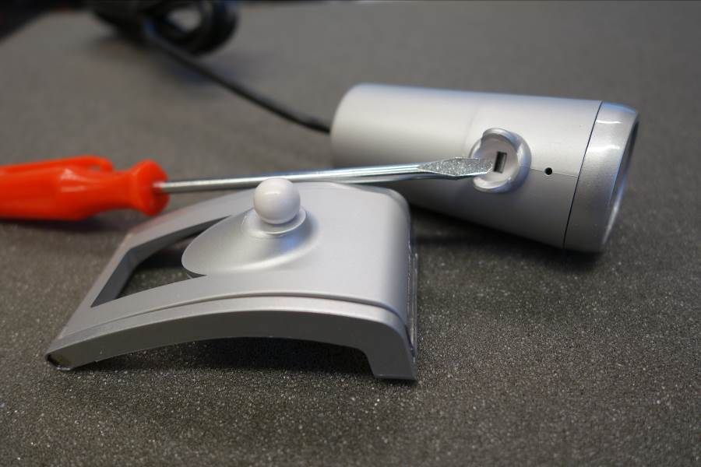

Pull front of camera forward

Remove 2 small Phillips head screws to release the circuit board

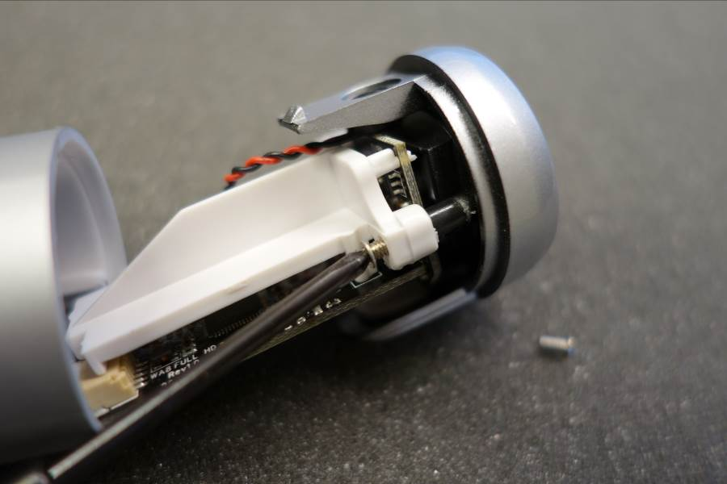

Note how low the lens casing is, then unscrew it

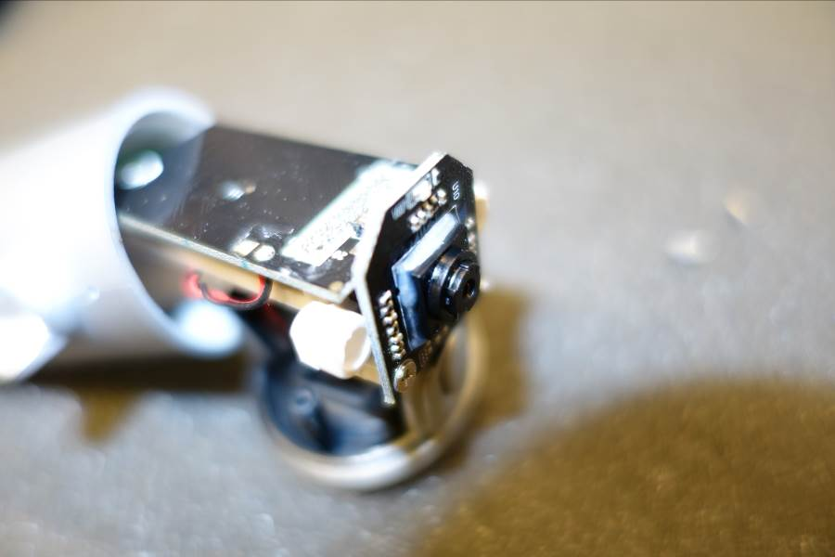

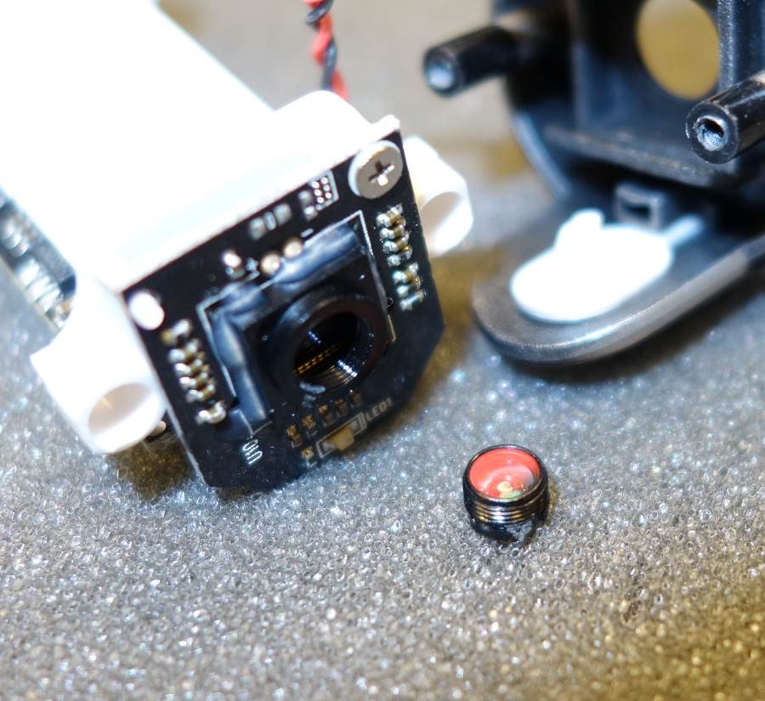

Flips lens casing over so you are looking at the larger/more exposed piece of glass. This circular piece of glass has an Infrared Filter, which can be seen when you tilt the glass against the light.

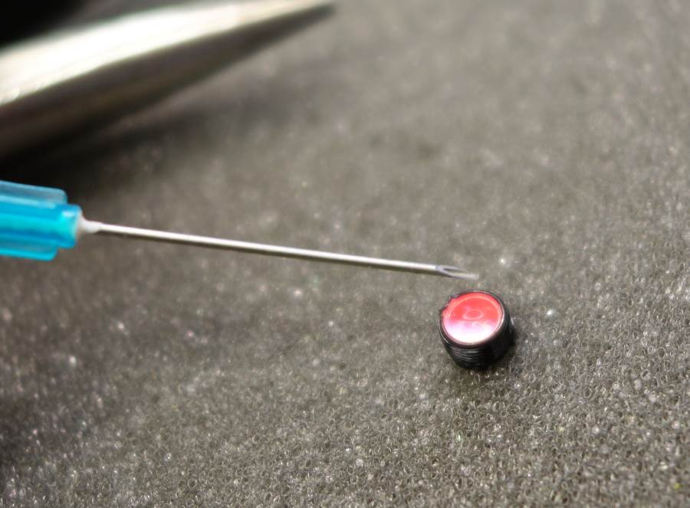

Use needle to push the plastic around the glass away. Take care not to scratch the underlying lens. Once you have worked about halfway around the glass, you will be able to remove it in 1 or a few pieces.

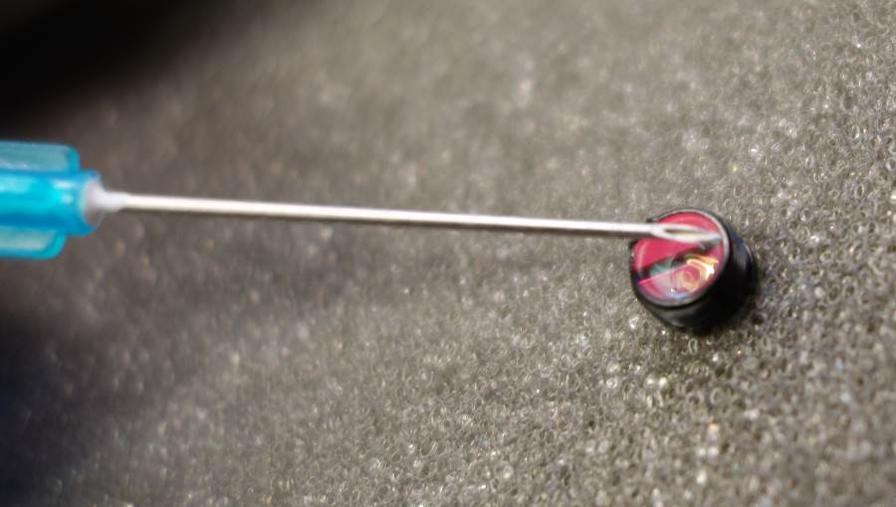

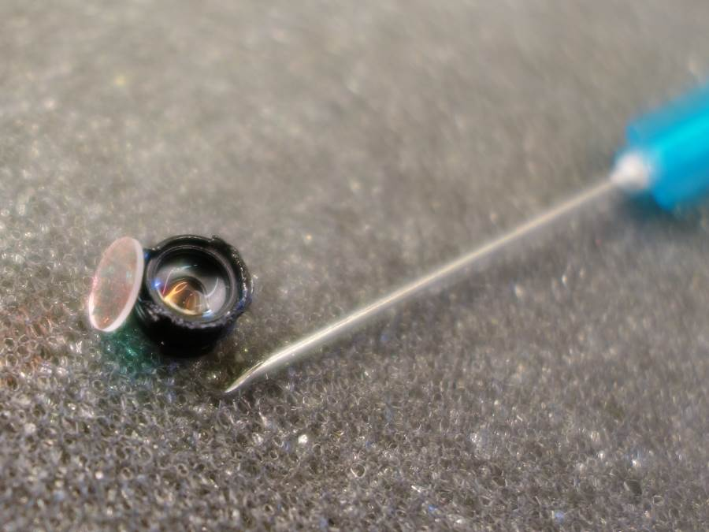

Use the canned air to blow away any remaining glass shards/dust

If desired, scrape off the blue LED1. This will not affect the camera function, but will prevent light during recordings.

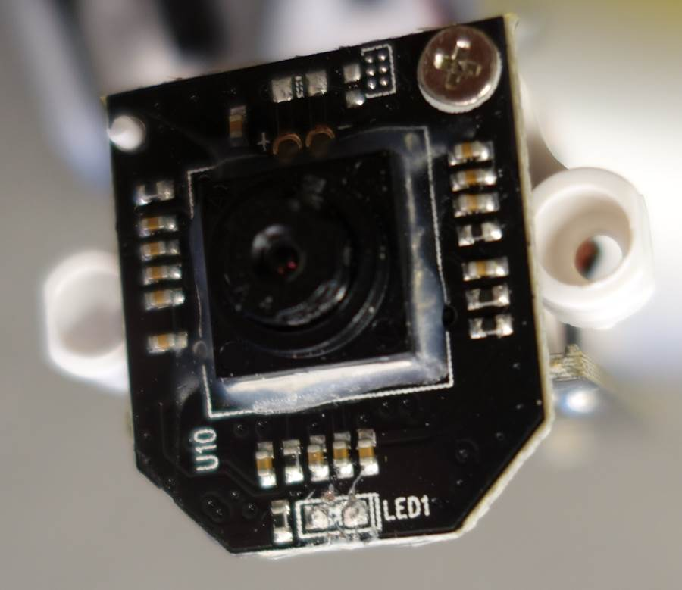

Rescrew the lens back onto the circuit board, back to where it was before removal.

It may be helpful to plug the camera in to the computer and start a viewer during the final steps to adjust the fine focus to the desired focal length. Take care not to touch any exposed electronics components.

Screw the camera circuit board onto the plastic front.

Push the front back onto the body so that the initial latch engages.

It may be helpful to mark the camera as modified: IR + LED Mod

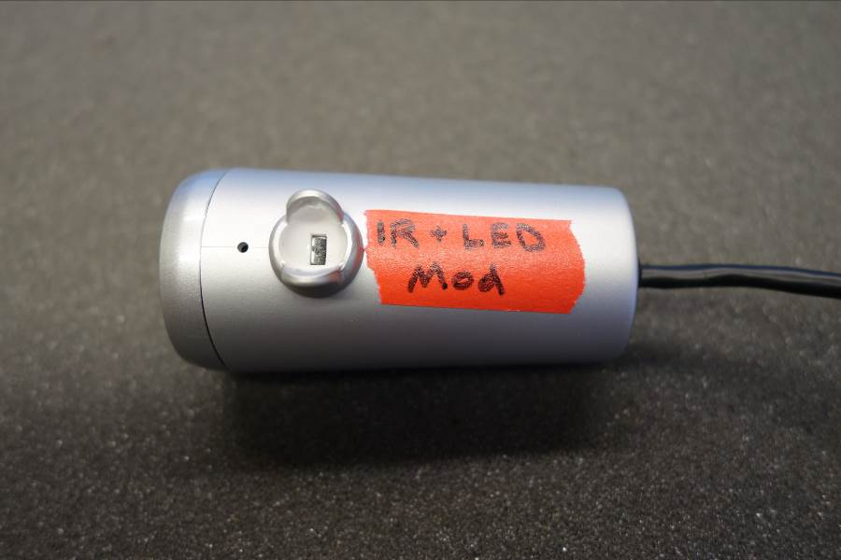

**Software configuration**

In order to use multiple cameras in Windows 7, each camera must be on an internally independent USB port in order to be used simultaneously with other cameras. If two cameras share a USB controller, once the first has been started attempts to start the second will cause errors or blank screens.

In order to use multiple cameras in Processing, each has to be assigned a unique “Friendly name” in the windows registry. We have made the following changes on a Windows 7 machine. We recommend backing up the windows registry before making any changes very carefully. Here are some possible steps to change the associated “Friendly name” for a given camera and USB port. Please note that the name is associated with both the camera model and the native USB port. Moving the renamed camera to a new port will not carry forward the friendly name. However, plugging in a new camera of the same model on the same port will yield the same friendly name.

* Plug the camera in
* Open device manager from the control panel
* Highlight the camera and then right click and choose properties.
* Find the driver key for the camera and copy it.
* Open the Registry Editor as an administrator (Start -> Run: regedit.exe)
* Go to Computer -> HKEY_LOCAL_MACHINE -> SYSTEM -> ControlSet001 -> Enum and then Edit->Find the Camera Driver Key value (easiest to paste the previously copied value)
* Right click on the folder on the left in which the Driver key has been found and choose Permissions
* Change the Full Control setting to Allow, then click Advanced
* Click the Owner tab, and then set the Current owner to the current account
* Click OK twice to return to the key settings
* Double click on FriendlyName to change the friendly name of the Camera to something unique: e.g. Webcam_1
* Close the registry editor when done with all cameras.
* Cameras will show up under their new Friendly names in Device Manager, though not in Devices and Printers

***Webcam Testing***

We have tested several brands of webcams for use with our system and include our notes for reference below. In general, our preferred camera above has the appropriate balance of desired factors. All of the cameras tested are relatively inexpensive (most less than $20) and lack TTL triggering inputs or outputs.

|  |  |  |  |  |  |  |  |  |  |
| --- | --- | --- | --- | --- | --- | --- | --- | --- | --- |
| **Webcam Name** | **Distributor** | **Manual Focus?** | **Ease of removing IR filter?** | **Field of view?** | **Mounting?** | **LEDs** | **Audio** | **Stability?** | **Pref** |
| di ChatCam | PC Connection | Internal | Can do | Almost whole chamber | Tall but flat bottom | 0 | Combined in USB | Not bad | 1 |
| V7 Web Cam | PC Connection | Yes | Surprisingly easy, pops right off after removing lens | Restricted, less than di ChatCam | Flat, though somewhat wobbly | 0 | Combined in USB | Not bad | 2 |
| Logitech C170 | TigerDirect | No | Hard to put back together | Almost whole chamber | Hard: round bottom | 0 | Combined in USB | Great | 3 |
| Sabrent IR Camera | TigerDirect | Yes | No need: no filter | More than whole chamber | Not super easy | 6 IR, need to be splayed | Separate 3.5mm | Doesn't work on native Dell XPS 8700 USB ports though works on StarTech PCI/e USB 2.0 card | 3 |
| Dynamode USB Multi-megapixel Web Camera | MCM Electronics | Yes | Can do | Very restricted | Flat, would be good | 6 Visible? | Separate 3.5mm | ? | 4 |
| 300K Pixel USB 2.0 Mini Webcam | RobotShop | Yes | Can do | Very restricted | Not terrible | 0 | ? | Not bad | 4 |
| Adesso CyberTrack Q1 | PC Connection | Yes | Not fully tested due to restricted field of view | Very restricted: Only 1/2 chamber | Snapped base a little too easily, somewhat flat front | 6 Visible? | Combined in USB | Not very good | 4 |
| Genius WideCam F100 | PC Connection | Yes | Not fully tested | Very wide: 120 degrees |  |  |  |  | ? |