Fluid Reservoir
Parts are listed in the OpBoxPartsLIst spreadsheet, under SystemPart: Behavior: Fluid

Parts/Tools
Drill and 13/64" drill bit
50mL Falcon tube
Silicone tubing from pump
reducing 1/8" to 1/16" ID barbed connector
1/16" ID tubing connected to spout

Prep cap and tubing
Take cap off centrifuge (Falcon) tube
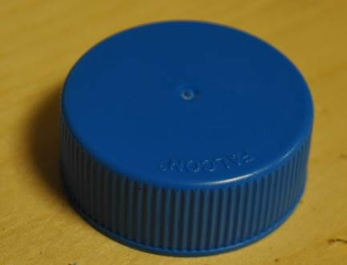
Drill 2 holes on cap (one for silicone tube and one for airflow/pressure purposes) and clear bits of excess plastic.
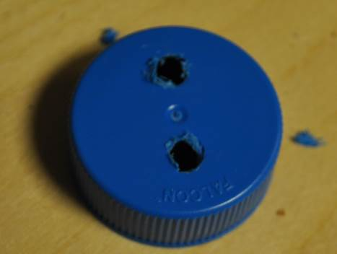
Thread the silicone tubing through the hole. The fit should be snug, but not pinching.
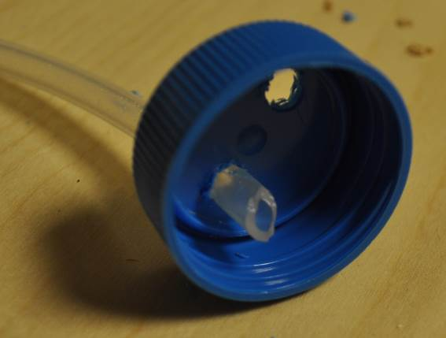
Thread the silicone tubing until it reaches bottom of the 50ml tube
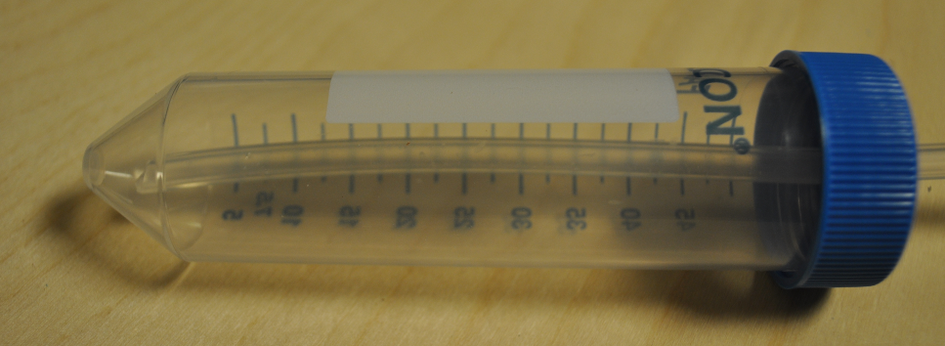

Connect Pump
Place pump in 3D printed holder
One of silicone tubing coming from the centrifuge (Falcon) tube is already connected.
Disconnect tubing from the other side and connect a reducing 1/8" to 1/16" ID barbed connector
Connect 1/16" ID tubing and run to spout.
