Enclosures

Wooden sound isolation boxes

Materials
Wood panels (pre-cut to size)
Contact paper for panel faces
Drill
Bits: 1 1/4" for holes, 3/32", 1/16"
Wood screws for panels: #6 x 1"
Piano Hinge
Wood screws for piano hinge: #3 x 1/2"
Velcro for latch
White duct tape for edges

Add contact paper to panels
Put contact paper on panels: easiest to do on ground with overlap on both ends
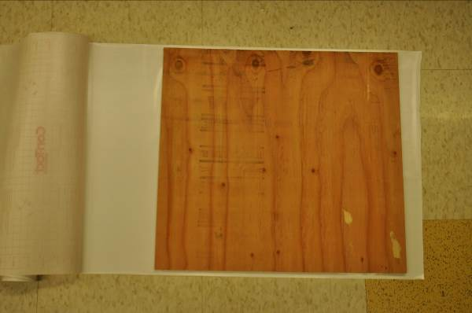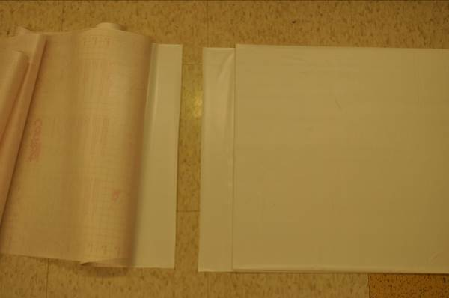
Cut off edges with blade & put some contact paper across to hold it together

Drill cable and air holes

Drill 2x 1 1/4" holes in each back panel (1 back panel per box, but there is an extra similar sized panel for the front) to use for cables and some ventilation

Screw panels together
Drill tap holes (3/32" bit) for #6 wood screws x 1". Put at least 3 on each side, careful to stay straight so screws aren’t exposed.
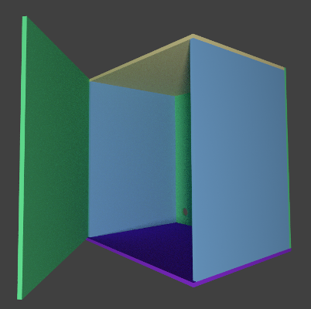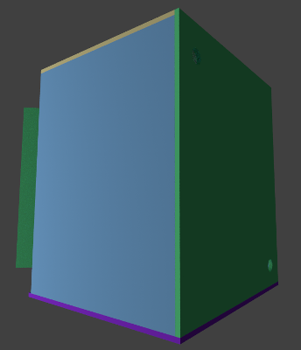

Attach door and add finishing touches
Drill tapping holes (1/16" bit) for #3 1/2" brass wood screws using hinge as a guide. Screw hinge on.
Put soft half of Velcro (loop) on box door and right side, and hard Velcro (hook) across for latch.
Cover exposed edges with white duct tape.

