

Report

**CSE 3212 : COMPILER DESIGN LABORATORY**

**­submitted to:**

|  |  |
| --- | --- |
| Dola Das  Lecturer  Department of Computer Science and Engineering  Khulna University of Engineering and Technology, Khulna | Md. Ahsan Habib Nayan  Lecturer  Department of Computer Science and Engineering  Khulna University of Engineering and Technology, Khulna |

**Submitted by:**

Md. Likhon Sarker

Roll: 1607069

Third year, second semester

Department of computer science and engineering

Khulna university of engineering and technology, khulna

**Submission date:** 08-06-2021

**LEX:**

Lex is a program that generates lexical analyzer. It is used with YACC parser generator. The lexical analyzer is a program that transforms an input stream into a sequence of tokens. It reads the input stream and produces the source code as output through implementing the lexical analyzer in the C program.

### **The function of Lex is as follows:**

1.Firstly lexical analyzer creates a program. suppose its lex.1 in the Lex language. Then Lex compiler runs the lex.1 program and produces a C program lex.yy.c.

2.Finally C compiler runs the lex.yy.c program and produces an object program a.out.

3.a.out is lexical analyzer that transforms an input stream into a sequence of tokens.

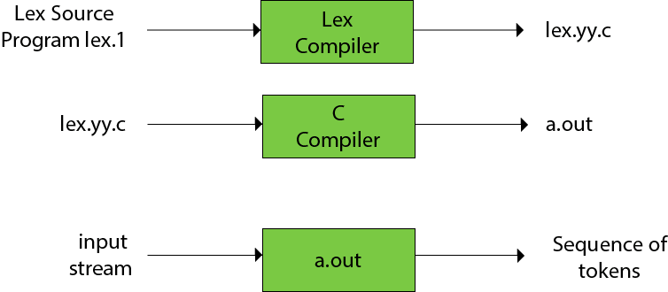

**Bison:**

Bison is a general-purpose parser generator that converts a grammar description for an LALR(1) context-free grammar into a C program to parse that grammar. Bison is upward compatible with Yacc. YACC stands for **Yet Another Compiler Compiler**. YACC provides a tool to produce a parser for a given grammar. YACC is a program designed to compile a LALR (1) grammar. It is used to produce the source code of the syntactic analyzer of the language produced by LALR (1) grammar. The input of YACC is the rule or grammar and the output is a C program.

In bison file

1.main program calls yyparse( ).

2.yyparse( ) calls yylex when it wants a token.

3.yylex returns the type of the token.

4.yylex puts the value of the token in a global variable named yylval.

5. creates 2 new files, suppose its x.tab.h and x.tab.c

6. The file x.tab.h contains declarations.

**Manual:**

**1. Variable declaration**

|  |  |
| --- | --- |
| Rule | Details |
| integer a,b,value; | Variable a,b,value is created  All are integer type |

**2. Variable initialization:**

|  |  |
| --- | --- |
| Rule | Details |
| integer a=5,b=20,value=100; | Variable a is initialized to 5  b is initialized to 20  value is initialized to 100 |

**3.Assign value to a variable**

|  |  |
| --- | --- |
| Rule | Details |
| integer value;  value=100; | 100 is assigned to a variable named “value” |

**4. Arithmetic operation**

|  |  |  |
| --- | --- | --- |
| Operator | Operation | Details |
| + | Value=a plus b | Equivalent to value=a+b |
| - | Value=a minus 5 | Equivalent to value=a-5 |
| * | Value=a mul b | Equivalent to value=a*b |
| / | Value=a div b | Equivalent to value=a/b |

**5. For loop**

|  |  |
| --- | --- |
| Rule | Details |
| lb | Left brace ‘{’ |
| rb | Right brace ‘}’ |
| for_loop(a,b,c)  lb  value=value plus 5  rb | For loop starts from a and continues till b, every time it will increment its value by c  Inside for loop value=value+5 will be executed every time |

**6. While loop**

|  |  |
| --- | --- |
| Rule | Details |
| while_loop(var less_than num )  lb  var= var plus 4;  rb | This loop will continue till variable var is less than num. inside loop, value of the variable will be incremented by 4 each time. |

**7. Comment**

|  |  |  |
| --- | --- | --- |
| Type | Rule | Details |
| single line comment | comment: this is a comment |  |
| multiple line comment | Comment  lb  This  Is  comment  rb | Inside lb and rb, anything will be considered as a multiple line comment |

**8. If Else condition**

|  |  |
| --- | --- |
| Rule | Details |
| less_than | Its equivalent to ‘<’ |
| greater_than | Its equivalent to ‘>’ |
| if (a less_than b) | Condition inside if will be true when a<b |
| if (a greater_than b) | Condition inside if will be true when a>b |
| if(a less_than b)  lb  a=a mul 6  rb  else  lb  a=a div b  rb | If a<b a will be multiplied by 6 otherwise a will be divided by b |

**9. Switch Case**

|  |  |
| --- | --- |
| Rule | Details |
| lb | Left brace ‘{’ |
| rb | Right brace ‘}’ |
| switch  case (a less_than b):  a=a plus b  case ( a greater_than b):  a=a mul b  default: a=a div 10 | Inside switch case, there can be multiple cases. if any of the case condition become true, its corresponding expression will be executed and no other cases will be checked. If no case become true, then default case will be executed |

**10. Function**

|  |  |
| --- | --- |
| Rule | Details |
| main function () | Whole program will be executed inside this function |
| print(variable) | It takes a single parameter and print its value |
| binary(num) | It takes a number/variable and print its binary representation |
| log(num) | It takes a number/variable and display its logarithmic value in base ‘e’ |
| factorial(num) | It takes a number/variable and print its factorial.  N factorial=1*2*3…….*N |
| check_prime(variable) | It takes a number/variable and check whether it’s a prime number or not |
| show_gcd(a,b) | It takes two number/variable and print their gcd  gcd=greatest common divisor |
| show_lcm(a,b) | It takes two number/variable and print their lcm  lcm=least common multiple |
| log10(a) | It takes a number/variable and print its logarithmic value in base ‘10’ |
| sin(angle) | It takes an angle in degree and print its corresponding sin value |
| cos(angle) | It takes an angle in degree and print its corresponding cos value |
| tan(angle) | It takes an angle in degree and print its corresponding tan value |
| bigmod(a,b,m) | It takes three parameter ,suppose they are a,b,m. this function print (a^b)%m |
| get_remainder(a%b) | It takes two parameter and print remainder of these two. remainder=a%b; |