Steps to follow in committing local repository to github

**Working with local repository**

1. **Touch**

To create a file in the local repository.

touch app.js

touch app.docx

touch app.html

1. **Git init**

To initialize the repository in the folder

1. **Git config**

To add your name and email address to git

Example: git config –global user.name ‘Abdulahi Opejin’

git config –global user.email ‘opejinabdulahi.ay@gmail.com’

1. **Git add**

To add a recently edited or newly created file to the staging area

Example: git add app.html

Note: (a) git add *.hmtl could be used to add all the html files into the staging area

(b) git add (i.e., git add dot) to add everything or all the files in the local repository to the staging area.

1. **Git status**

To check the status of the repository

1. **Git remove**

To remove file from staging area

Example: git rm –cached app.html

1. **Git commit**

To commit all the change in the local repository

Example: git commit

Note: (a) this would pop-up a film editor and if we type anything is not going work. What we need to do is to press I and that will make it go into the insert mode, now typing is possible. Then, you can add a comment. Pressing ESC will take it out of the insert mode and the type “:wq” and press Enter.

(b) the editor mode (i.e., a) can be skipped by this line of code: git commit -m ‘Change app.html’ and press Enter

1. **Git ignore**

Git ignore can be created to ignore some files that we do not want to commit.

Example: touch .gitignore to create “gitignore file” in the local repository and the name of file that we do not want to include in the local repository can be put inside the gitignore file. And an entire directory can be add to “git ignore” and it would ignore the whole directory. E.g., “/dir2”

1. **Git branch**

To create new branch

Example: git branch login

Note: this would not do anything unless you switch from the default master branch and to switch, you have to checkout to the new branch. i.e., use the ‘git checkout login’

1. **Git checkout**

git checkout login

This would help to switch from master to login branch. And all files in the master branch would also be found in the login branch.

1. **Git merge**

Example: git merge login

To merge login branch to master branch. There is need to switch to master branch first, the type ‘git merge login’ and all the files in the login branch be updated to the master branch.

**Working with remote repository**

1. Create github account and login to the account.
2. Navigate to upper right corner to click on A blue and black rectangle with a plus and arrow

   Description automatically generatedcreate a new repository. Check the below image for the configuration.

Then, click “Create repository.”

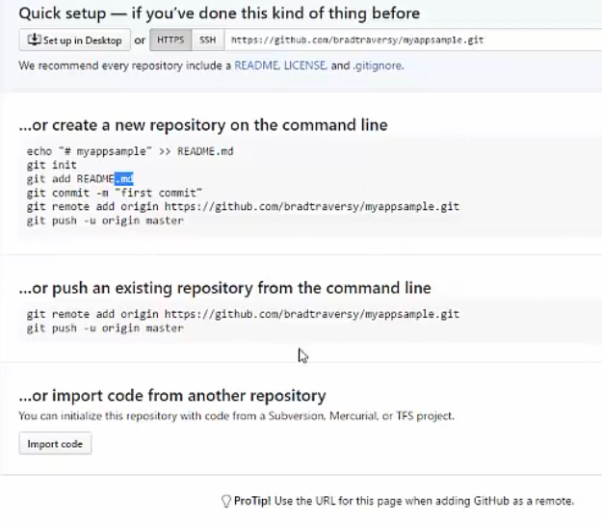

You can add ReadMe file if you want.

1. Git remote

To add local repository to origin

Example: git remote add origin <https://github.com/bradtraversy/myappsample.git>

However, git remote will list the remote repository.

1. Git push

To push the repository to origin master branch of the remote repository

1. Git clone

To download anybody’s work from github

Example: git clone <https://github.com/bradtraversy/myappsample.git>

1. Git pull

To update or pull every updated project/files from remote repository to your local repository before your start work on updating