**Fundamentals of Materials Science Homework 16**

**Name: Xiao，Liyang Date: 04/16/2017 Student #: 15090215**

**Homework Problems:**

**Cartridge brass has the approximate composition of 70 wt % Cu and 30 wt % Zn. As discussed in class, the recrystallization temperature for most of the metals are in between 1/3 and 1/2 of the melting temperature of the metals. Please plot, using a software you are mostly familiar with, the estimated temperature range for recrystallization of Cu−Zn alloys as a function of composition over the entire range from pure Cu to pure Zn. The Cu-Zn phase diagram is enclosed for you.**

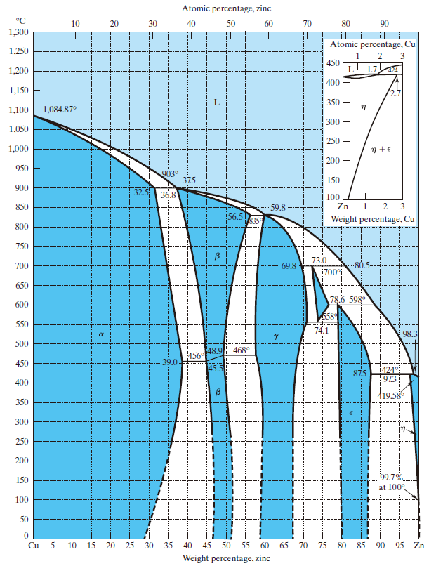

**Figure 1 Cu-Zn Phase Diagram**

**Solution:**

|  |  |  |  |
| --- | --- | --- | --- |
| **Cu(%)** | **T(℃)** | **1/2T(℃)** | **1/3T(℃)** |
| 0 | 1084.87 | 542.4 | 361.6 |
| 36.8 | 903 | 451.5 | 301 |
| 59.8 | 835 | 417.5 | 278.3 |
| 73 | 700 | 350 | 233.3 |
| 78.6 | 598 | 299 | 199.3 |
| 98.3 | 424 | 212 | 141.3 |
| 100 | 419.58 | 209.79 | 139.86 |

**Fundamentals of Materials Science Homework 17**

**Name: Xiao，Liyang Date: 04/24/2017 Student #: 15090215**

**Homework Problems:**

1. **Given here are the solidus and liquidus temperatures for the germanium-silicon system. Construct the phase diagram for this system and label each region.**

|  |  |  |
| --- | --- | --- |
| **Composition**  **(wt% Si)** | **Solidus Temperature**  **(°C)** | **Liquidus Temperature**  **(°C)** |
| **0** | **938** | **938** |
| **10** | **1005** | **1147** |
| **20** | **1065** | **1226** |
| **30** | **1123** | **1278** |
| **40** | **1178** | **1315** |
| **50** | **1232** | **1346** |
| **60** | **1282** | **1367** |
| **70** | **1326** | **1385** |
| **80** | **1359** | **1397** |
| **90** | **1390** | **1408** |
| **100** | **1414** | **1414** |

**Solution:**

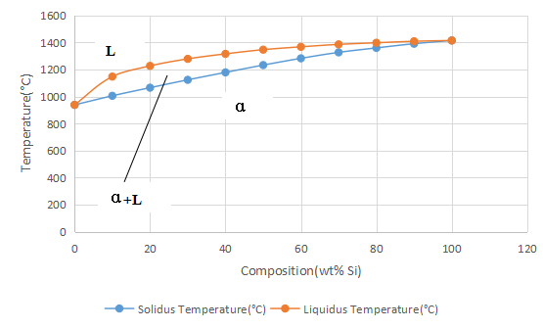

1. **A copper-nickel alloy of composition 70 wt% Ni-30 wt% Cu is slowly heated from a temperature of 1300°C (2370°F).**

**(a) At what temperature does the first liquid phase form?**

**(b) What is the composition of this liquid phase?**

**(c) At what temperature does complete melting of the alloy occur?**

**(d) What is the composition of the last solid remaining prior to complete melting?**

**Solution:**

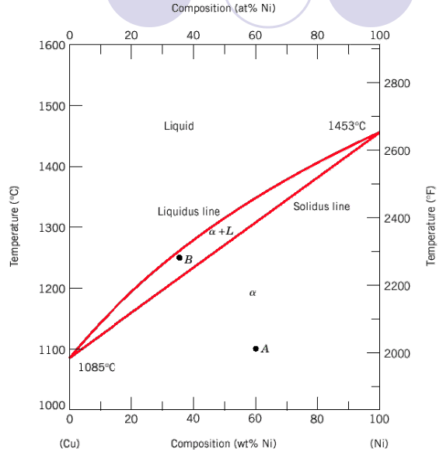

1. from the figure:1340℃
2. 58 wt% Ni-42 wt% Cu
3. from the figure:1380℃
4. 79 wt% Ni-21 wt% Cu
5. **For an alloy of composition 74 wt% Zn-26 wt% Cu, cite the phases present and their compositions at the following temperatures: 850°C, 750°C, 680°C, 600°C, and 500°C.**

**Solution:**



**850℃:** CL=74 wt% Zn-26 wt% Cu

**750℃:** Cγ=67.5 wt% Zn-32.5 wt% Cu ;CL=76.5 wt% Zn-23.5 wt% Cu

**680℃:** Cδ=73 wt% Zn-27 wt% Cu ;CL=82 wt% Zn-18 wt% Cu

**600℃:** Cδ=74 wt% Zn-26 wt% Cu

**500℃:** Cγ= 69 wt% Zn-31 wt% Cu ;Cε=80 wt% Zn-20 wt% Cu

1. **Cite the phases that are present and the phase compositions for the following alloys:**

**(a) 90 wt% Zn-10 wt% Cu at 400°C (750°F)**

**(b) 75 wt% Sn-25 wt% Pb at 175°C (345°F)**

**(c) 55 wt% Ag-45 wt% Cu at 900°C (1650°F)**

**(d) 30 wt% Pb-70 wt% Mg at 425°C (795°F)**

**(e) 2.12 kg Zn and 1.88 kg Cu at 500°C (930°F)**

**(f) 37 lbm Pb and 6.5 lbm Mg at 400°C (750°F)**

**(g) 8.2 mol Ni and 4.3 mol Cu at 1250°C (2280°F)**

**(h) 4.5 mol Sn and 0.45 mol Pb at 200°C (390°F)**

**Solution:**

1. Cε=87wt% Zn-13 wt% Cu ; Cη=97wt% Zn-3 wt% Cu
2. Cα=16 wt% Sn-84 wt% Pb ; Cβ= 97 wt% Sn-3 wt% Pb
3. CL= 55 wt% Ag-45 wt% Cu.
4. Cα= 30 wt% Pb-70 wt% Mg.
5. Cβ= 49 wt% Zn-51 wt% Cu ; Cγ= 58 wt% Zn-42 wt% Cu.
6. CMg2Pd= 81 wt% Pd- 19 wt% Mg ; CL= 93 wt% Pd- 7 wt% Mg.
7. 64 wt%Ni-36 wt% Cu

(h)CL=74 wt% Sn-26 wt% Pd ; Cβ=97wt% Sn-3 wt% Pd

1. **Determine the relative amounts (in terms of mass fractions) of the phases for the alloys and temperatures given in Problem 4.**

**Solution:**

(a); (b);

(c) ; (d);

(e); (f);

(g);

(h).

**Fundamentals of Materials Science Homework 19**

**Name: Xiao，Liyang Date: 05/07/2017 Student #: 15090215**

**Homework Problems:**

1. **Compute the mass fraction of α ferrite and cementite in pearlite.**

**Solution:**





1. **What is the carbon concentration of an iron-carbon alloy in which the mass fractions of total ferrite is 0.94?**

**Solution:**

 ; ∴C0=0.42

1. **The proeutectoid phase could be proeutectoid ferrite or proeutectoid cementite depending on the different C content. What is the proeutectoid phase for an iron-carbon alloy in which the mass fractioin of total ferrite and total cementite are 0.92 and 0.08, respectively? Why?**

**Solution:**

** ; ∴**C0=0.56

∴the proeutectoid phase is proeutectoid ferrite.

1. **Consider 1.0 kg of austenite containing 1.15 wt% C, cooled to below 727oC (1341oF).**

**(a) What is the proeutectoid phase?**

**(b) How many kilograms each of total ferrite and cementite form?**

**(c) How many kilograms each of pearlite and the proeutectoid phase form?**

**(d) Schematically sketch and label the resulting microstructure.**

**Solution:**

(a)1.15 wt% C is between 0.76 and 2.14 wt% C, so the proeutectoid phase is

proeutectoid cementite.

(b).







(c).



So, 



(d)

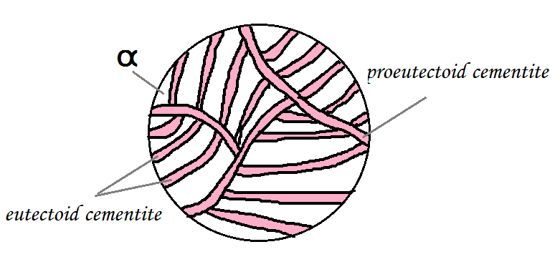

1. **Compute the mass fractions of proeutectoid ferrite and pearlite that form in an iron–carbon alloy containing 0.25 wt% C.**

**Solution:**





1. **Consider 2.0 kg of a 99.6 wt% Fe–0.4 wt% C alloy that is cooled to a temperature just below the eutectoid. (a) How many kilograms of proeutectoid ferrite form? (b) How many kilograms of eutectoid ferrite form? (c) How many kilograms of cementite form?**

**Solution:**

(a) 



(b) 

0.45



(c) 



1. **For an iron–carbon alloy of composition 5 wt% C–95 wt% Fe, make schematic sketches of the microstructure that would be observed for conditions of very slow cooling at the following temperatures: 1175oC (2150oF), 1145oC (2095oF), and 700oC (1290oF). Label the phases and indicate their compositions (approximate).**

**Solution:**

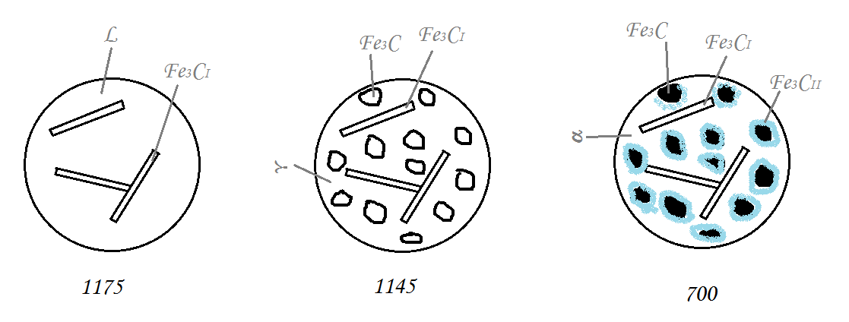

1. **总结各种铁碳合金的室温平衡显微组织是什么，填写在下表中。**

|  |  |  |  |  |  |  |
| --- | --- | --- | --- | --- | --- | --- |
| **铁碳合金** | **亚共析钢** | **共析钢** | **过共析钢** | **亚共晶白口铁** | **共晶白口铁** | **过共晶白口铁** |
| **室温平衡显微组织** | **铁素体**  **+**  **珠光体** | **珠光体** | **珠光体**  **+**  **二次渗碳体** | **珠光体**  **+**  **二次渗碳体**  **+**  **变态莱氏体** | **莱氏体** | **莱氏体**  **+**  **一次渗碳体** |

1. **自己画一个铁碳相图，可以用计算机绘制，也可以用笔和尺子绘制，看谁画得最professional。但是不能去网上复制一个或者复印扫描书上的，一定是你自己亲笔画的。请在你绘制的铁碳相图中标出下面内容：**

**（1）液相线和固相线**

**（2）三个恒温反应：包晶，共析，共晶。三个重要温度：1495oC, 1148 oC, 727 oC.**

**（3）固溶线：C在奥氏体中和C在铁素体中的固溶线。**

**（4）单相区和两相区**

**（5）五个重要的成分点：含碳量为0.22%, 0.77%, 2.11%, 4.3%, 6.7%的点。**

**Solution:**

1. **在亚共析钢、共析钢、过共析钢、亚共晶白口铁、共晶白口铁、过共晶白口铁六种典型的铁碳合金中，选择一个论述其平衡凝固过程中显微组织的演变，并描绘其结晶过程的示意图。**

**Solution:**

共析钢：0.76wt%C降温至1480℃时，液相中出现奥氏体。降低至1400℃左右，液相全部变为奥氏体相。继续降温至727℃，发生共析。奥氏体共析出铁素体和渗碳体，铁素体、渗碳体薄层交错相叠成为珠光体。

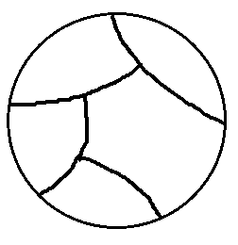 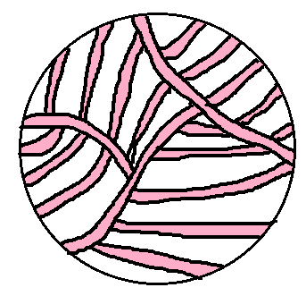

**Fundamentals of Materials Science Homework 20**

**Name: Xiao，Liyang Date: 05/10/2017 Student #: 15090215**

**Homework Problems:**

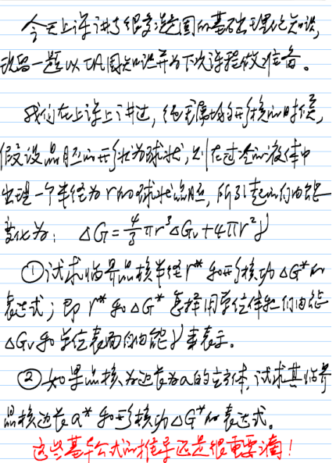

**Solution:**

1. 



** **

1. **∵立方体**





** **

**One More Problem:**

***Calculation of Critical Radius for the Solidification of Copper***

**Calculate the size of the critical radius and the number of atoms in the critical nucleus when solid copper forms by homogeneous nucleation. Comment on the size of the nucleus and assumptions we made while deriving the equation for the radius of the nucleus. The elemental data of Cu can be found in your textbook.**

**Solution:**







=1.25nm



unit cells

atoms/unit cells

Fundamentals of Materials Science

Homework 21, SS 2017

Name: Du Yihui Date: 05/12/2017 Student #: 15090211



This homework assignment continues with a practice on homogenous nucleation for its thermodynamic and structural conditions. The derivation of the critical radius and activation energy for nucleation is very important with the assumption of a spherical solid as the starting nucleation piece. It is also desirable that you understand the concepts of critical undercooling and its relationship with the nuclei radius. The problem statements seem to be longer than usual, but it is a context for which each problem is posed.

1. Do it again and again for it is very important. Below *Tm, Gv* is positive so that the free energy change associated with the formation of a small volume of solid has a negative contribution due to the lower free energy of a bulk solid, but there is also a positive contribution due to the creation of a solid/liquid interface. The excess free energy associated with the solid particle can be minimized by the correct choice of particle shape. If *γSL* is isotropic this is a sphere of radius *r.* Then we can arrive at the equation discussed in class like

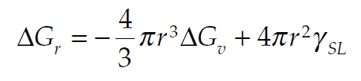

! (Eq. 1) Show that differentiation of Equation 1 leads to Equations 2 and 3 below.

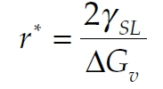

! (Eq. 2)

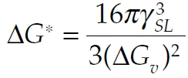

" (Eq. 3)

Solution

When the differentiation of Equation 1 is equal to 0, we can get r*,

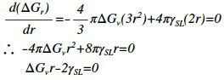

Thus,



Substitute r* into Equation 1, we can get △G*,

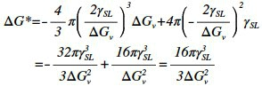

1. To understand how it is possible for a stable solid nucleus to form homogeneously from the liquid it is first necessary to examine the atomic structure of the liquid phase. From dilatometric measurements it is known that at the melting point the liquid phase has a volume 2–4% greater than the solid. Therefore, there is a great deal more freedom of movement of atoms in the liquid and when averaged over a period of time the atom positions appear completely random. However, an instantaneous picture of the liquid would reveal the presence of many small close-packed clusters of atoms which are temporarily in the same crystalline array as in the solid, as shown in Fig. 1 below. On average the number of spherical clusters of radius r is given by

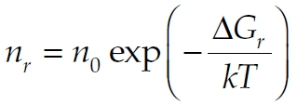

" (Eq. 4)

where *n*0 is the total number of atoms in the system, *Gr* is the excess free energy associated with

the cluster, Equation 1, and *k* is Boltzmann’s constant. For a liquid above *Tm* this relationship applies for all values of *r.* Below *Tm* it only applies for *r* ≤ *r*\* because clusters greater than the critical size are stable nuclei of solid and no longer part of the liquid. Since *nr* decreases exponentially with *Gr* (which itself increases rapidly with *r*) the probability of finding a given cluster decreases very rapidly as the cluster size increases. For example, by combining Equations 1 and 4 it can be shown that 1 mm3 of copper at its melting point (∼1020 atoms) should on average contain ∼1014 clusters of 0.3 nm radius (i.e. ∼10 atoms) but only ∼10 clusters with a radius of 0.6 nm (i.e. ∼60 atoms). These numbers are of course only approximate. Such small clusters of atoms cannot be considered to be spherical, and even more important the effective value ofγused in calculating *Gr* (equation 1) is very probably a function of the cluster size. However, the above calculations do illustrate how sensitively cluster density depends on their size.

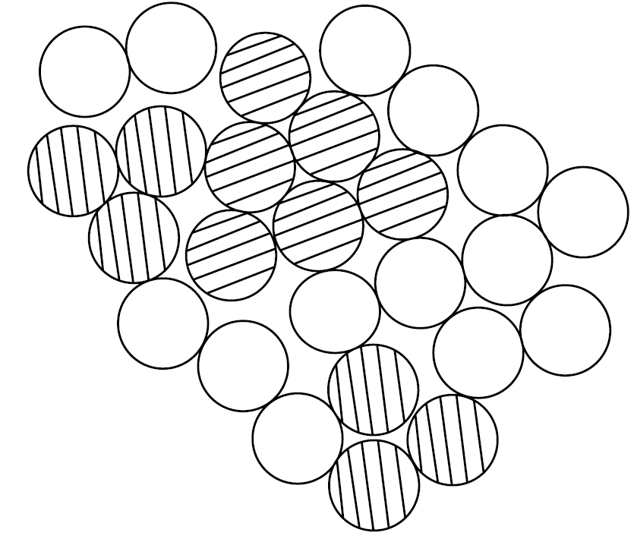

!

**Figure 1** A two-dimensional representation of an instantaneous picture of the liquid structure. Many close-packed crystal-likeclusters (shaded) are present.

Use Equations 1 and 4 to estimate the number of crystal-like clusters in 1 mm3 of copper at its melting point for spherical clusters containing (a) 10 atoms, (b) 60 atoms. What volume of liquid copper is likely to contain one cluster of 100 atoms? The atomic volume of liquid copper is 1.6*X*10−29 m3, *γSL* is 0.177 J m−2, *k* = 1.38X10−23 J K−1, *Tm* = 1356 K.

***Solution***

Since it is at melting point for spherical clusters, △Gv is equal to 0, thus,



r can be calculated by

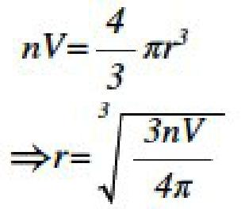

Thus, △Gv is equal to,



(a)When n is equal to 10,

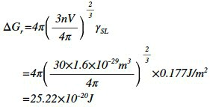

Thus, according to the Equation 4, the number of clusters per mm3 is equal to,

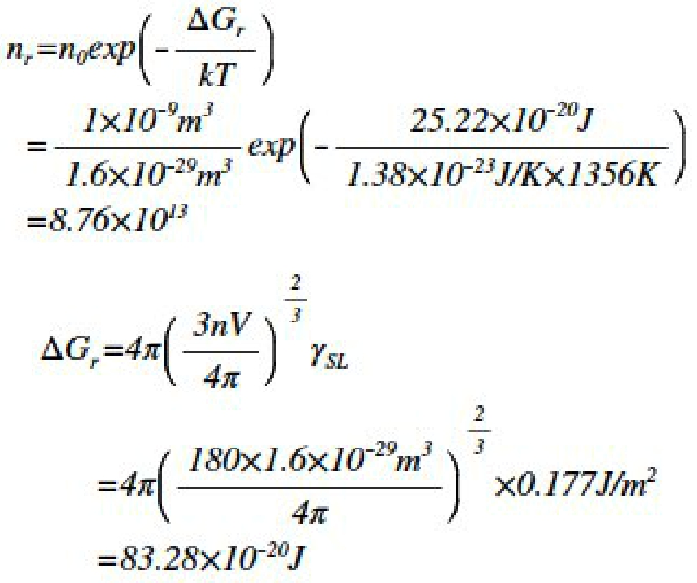

(b)When n is equal to 60,

Thus, according to the Equation 4, the number of clusters per mm3 is equal to,

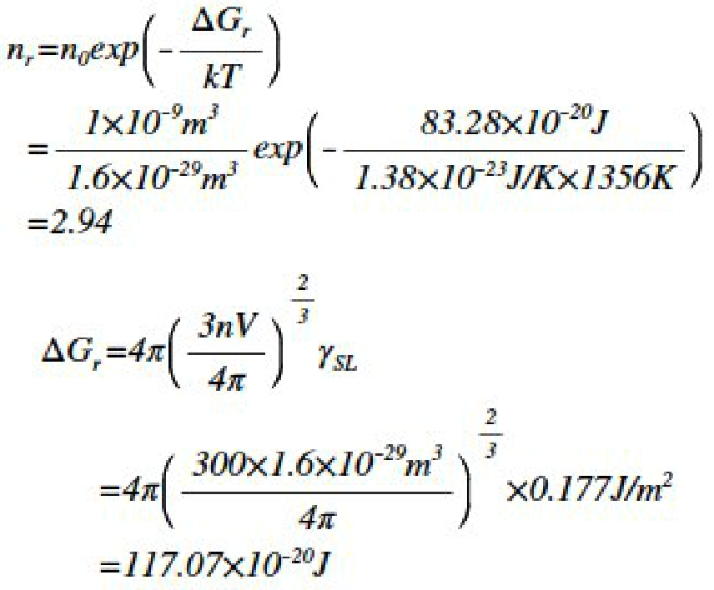

(c)When n is equal to 100,

Thus, according to the Equation 4, the number of clusters per mm3 is equal to,

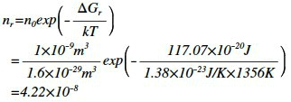

The volume of liquid copper contain one cluster of 100 atoms is,



1. Continued from Problem 2, it can be seen that there is effectively a maximum cluster size, ∼100

atoms, which has a reasonable probability of occurring in the liquid. The same sort of calculations can be made at temperatures other than *Tm.* Below *Tm* there is an increasing contribution from

*Gv* in Equation 1 as the solid becomes progressively more stable and this has the effect ofincreasing the ‘maximum’ cluster size somewhat. Figure 2 shows schematically how *r*max varies with *T*. Of course larger clusters than *r*max are possible in large enough systems or given sufficient time, but the probability of finding clusters only slightly larger than *r*max is extremely small. The critical nucleus size *r\** is also shown in Fig. 2. It can be seen that at small undercoolings, *r\** is so large that there will be virtually no chance of forming a stable nucleus. But as *T* increases *r\** and *G\** decrease, and for supercoolings of *TN* or greater there is a very good chance of some clusters reaching *r\** and growing into stable solid particles. In the small droplet experiment, therefore, homogeneous nucleation should occur when the liquid is undercooled by ∼ *TN*. The question to this problem is thus: Why does *r*max in Fig. 2 vary with

*T*?

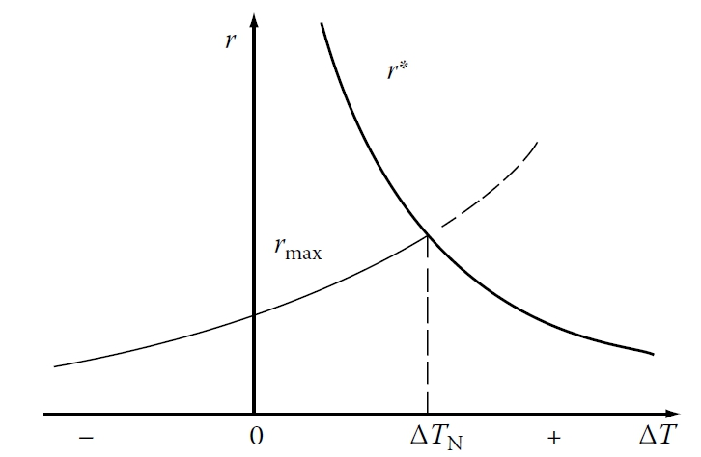

!

**Figure 2** The variation of r* and rmaxwith undercooling T.

***(?) Solution***

*r*maxis considered as the biggest radius particle that can exist at the given temperature, thefigure shows when the r* curve is beyond the critical undercooling, the critical radii of nuclei becomes smaller than the clusters that would form because of the thermal fluctuations. Thus, the probability of these clusters turning into nuclei are large.

4.Calculate the homogeneous nucleation rate in liquid copper at undercoolings of 180, 200 and 220 K, using the following data:

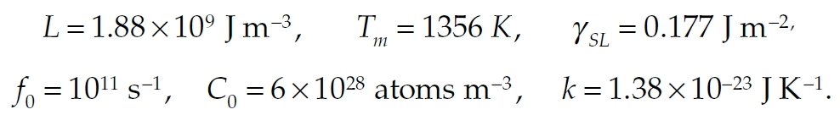

!

***Solution***

The homogeneous nucleation rate N can be calculated by

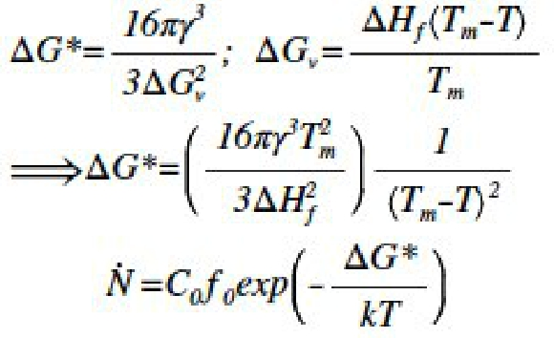

(a) When the homogeneous nucleation rate in liquid copper at undercoolings of 180K,

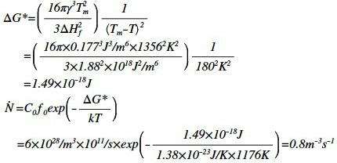

(b) When the homogeneous nucleation rate in liquid copper at undercoolings of 200K,

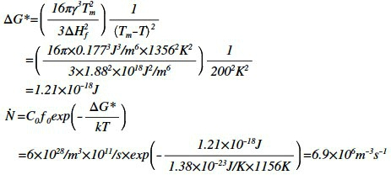

(c) When the homogeneous nucleation rate in liquid copper at undercoolings of 220K,

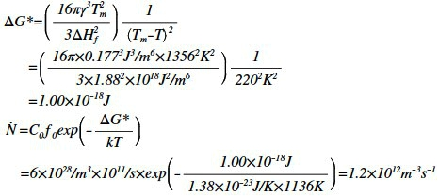

**Fundamentals of Materials Science Homework 22**

**Name: Xiao，Liyang Date: 05/23/2017 Student #: 15090215**

**Homework Problems:**

1. **Suppose that liquid nickel is undercooled until homogeneous nucleation occurs. Calculate**

**(a) the critical radius of the nucleus required; and**

**(b) the number of nickel atoms in the nucleus.**

**Assume that the lattice parameter of the solid FCC nickel is 0.356 nm.**

**Solution:**

**(a)**



**(b)**







∴ the number of nickel atoms in the nucleus are about 72.

1. **换个中文写法，上题中假设金属镍以均匀形核的方式凝固，稳定晶核的数目为每立方米106 个。试分别计算过冷度为200 K和300 K时的临界晶核半径及稳定晶核的数目。你计算的结果能说明什么问题？**

**Solution:**

当过冷度为200 K，T2=1528K；当过冷度为300 K，T3=1428K

当金属镍以均匀形核的方式凝固时，T1=1136k，由题目可知，此时形核率为106 个每立方米













计算结果说明：过冷度越大，越有利于形核，形成的晶核数目越多。

1. **再换个出法：Suppose that solid nickel was able to nucleate homogeneously with an undercooling of only 22oC.**

**How many atoms would have to group together spontaneously for this to occur? Assume that the lattice parameter of the solid FCC nickel is 0.356 nm.**

**Solution:**

∵△T=22℃









1. **试证明，均匀形核时，形成临界晶核的与其体积之间的关系式为。小测验题！**

**Solution:**

，

。

1. **试比较均匀形核与非均匀形核的异同点。**

**Solution:**

相同点：1.临界晶核半径相等

2.形核率变化的趋势一样，即随着过冷度的增大，先增加。当达到一定过冷度以后，开始降低。

3.结构起伏和能量起伏是形核的基础

不同点：均匀形核所需要的过冷度很高，而非均匀形核所需要的过冷度比较低。

1. **请阐述晶粒细化的方法。上课讲了三种，请稍微详细论述一下每种是怎么回事儿。**

**Solution:**

1.增大过冷度。

当过冷度增大时，成核率N升高，会产生更多的晶核。与此同时，由扩散控 制的长大速率G将会降低，使得形成的晶核无法长大，从而达到了晶粒细化 的效果。

2.机械振动或搅拌

通过物理方法将大的晶粒打碎形成小的晶粒

3.孕育处理

向液态金属中加入某些杂质，进行非自发形核过程，以达到晶粒细化的目的。

1. **为什么金属结晶时一定要有过冷度？影响过冷度的因素是什么？固态金属熔化时是否会出现过热？为什么？**

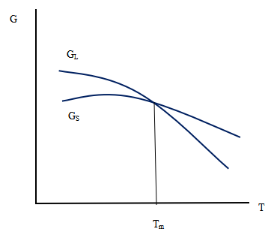**Solution:**

晶体结晶的条件是（GS-GL）<0,要想达到这个 条件，要求T<Tm，所以会出现实际凝固点的 温度比理论凝固点的温度要低一些，他们的差 值就表现为一定的过冷度。

冷却速度影响了过冷度，冷却速度越大，过冷 度也越大。

不会出现过热因为熔化本来就是要让金属达到 （超过）其固相线温度。