**Fundamentals of Materials Science Homework 3**

**Name: Xiao，Liyang Date: 01/31/2017 Student #: 15090215**

Checklist before you start this homework. (The boxes are clickable.)

🗹I have read the atomic structure related portion (p.18-26) of the chapter.

🗹I have worked on the Example Problems and Concept Check questions.

**Homework Problems:**

1. **Chemical analysis in materials science laboratories is frequently done by means of the scanning electron microscope. In this instrument, an electron beam generates characteristic x-rays that can be used to identify chemical elements. This instrument samples a roughly cylindrical volume at the surface of a solid material. Calculate the number of atoms sampled in a 1 m-diameter by 1 m-deep cylinder in the surface of solid copper.**

**Solution:**

Atomic radius of copper:0.128nm

Surface area:





1. **One mole of solid MgO occupies a cube 22.37 mm on a side. Calculate the density of MgO (in g/cm3).**

**Solution:**







1. **Calculate the dimensions of a cube containing 1 mole of solid magnesium.**

**Solution:**

amu=24.31 ρ=1.74g/cm ³





**Fundamentals of Materials Science Homework 4**

**Name: Xiao，Liyang Date: 01/31/2017 Student #: 15090215**

Checklist before you start this homework. (The boxes are clickable.)

🗹I have read the atomic structure related portion (p.18-26) of the chapter.

I have worked on the Example Problems and Concept Check questions.

**Homework Problems:**

1. **Calculate the number of atoms contained in a cylinder 1 m in diameter by 1 m deep of (a) magnesium and (b) lead.**

**Solution:**

Density: Mg 1.74g/cm3 Pb 11.34g/cm3

Amu: Mg 24.31amu Pb 207.21amu

 

 

1. **Using the density of MgO calculated in Problem 2 of Homework 3, calculate the mass of an MgO refractory (temperature-resistant) brick with dimensions 50 mm X 100 mm X 200 mm.**

**Solution:**

ρ=3.6g/cm3



1. **Calculate the dimensions of (a) a cube containing 1 mol of copper and (b) a cube containing 1 mol of lead.**

**Solution:**

Density: Cu 8.92g/cm3 Pb 11.34g/cm3

Amu: Cu 63.54amu Pb 207.21amu

** **

** **

1. **Silicon has three naturally-occurring isotopes: 92.23% of 28Si, with an atomic weight of 27.9769 amu, 4.68% of 29Si, with an atomic weight of 28.9765 amu, 3.09% of 30Si, with an atomic weight of 29.9738 amu. On the basis of these data, confirm that the average atomic weight of Si is 28.0854 amu.**

**Solution:**





 

1. **Allowed values for quantum numbers of electrons are as follows:**

***n*=1, 2, 3, …**

***l*=0, 1, 2, 3, …, n-1**

***ml*=0,±1,±2,±3, … ,±l**

***ms*=**

**The relationship between n and the shell designation are noted in Table 2.1. Relative to the subshells,**

***l*=0 corresponds to an *s* subshell**

***l*=1 corresponds to a *p* subshell**

***l*=2 corresponds to a *d* subshell**

***l*=3 corresponds to an *f* subshell**

**For the *K* shell, the four quantum numbers for each of the two electrons in the 1s state, in the order of *nlmlms*, are 100() and 100(-).**

**Write the four quantum numbers for all of the electrons in the *L* and *M* shells, and note which correspond to the *s*, *p*, and *d* subshells.**

**Solution:**

**L shell :**

2s subshell: 

2p subshell: 

**M shell:**

3s subshell:

3p subshell:

3d subshell:



1. **Give the electron configurations for the subshells of the following ions: Fe2+, Fe3+, Cu+, Ba2+, Br-, and S2-.**

**Solution:**

Fe2+——1s²2s²2p63s²3p63d6

Fe3+——1s²2s²2p63s²3p63d5

Cu+ ——1s²2s²2p63s²3p63d10

Ba2+——1s²2s²2p63s²3p63d104s²4p64d105s²5p6

Br- ——1s²2s²2p63s²3p63d104s²4p6

S2- ——1s²2s²2p63s²3p6

**Fundamentals of Materials Science Homework 5**

**Name: Xiao，Liyang Date: 02/8/2017 Student #: 15090215**

**Homework Problems:**

1. **(a) Using the ionic radii data in your textbook, calculate the coulombic force of attraction between Na+ and Cl- in NaCl. You may want to check the structure of NaCl to figure out the separation distance between the ions.**

**(b) What is the repulsive force in this case?**

**Solution:**

1. r(Na+)=0.102nm r(Cl-)=0.181nm r=0.102nm+0.181nm=0.283nm



=

=

(b)

1. **(a) A common way to describe the bonding energy curve for secondary bonding is the “6–12” potential, which states that**

**,**

**where *KA*and *KR* are constants for attraction and repulsion, respectively. This relatively simple form is a quantum mechanical result for this relatively simple bond type. Given  and , calculate the bond energy and bond length for argon.**

**(b) Plot *E* as a function of *a* over the range 0.33 to 0.80 nm.**

**Solution:**

**(a)**









**(b)**

|  |  |  |  |  |  |  |
| --- | --- | --- | --- | --- | --- | --- |
| a/(×10-10m) | 3.3 | 4 | 5 | 6 | 7 | 8 |
| E/J | 1.66×10-21 | -1.57×10-21 | -5.97×10-22 | -2.15×10-22 | -8.70×10-23 | -3.93×10-23 |

1. **The net potential energy between two adjacent ions, *EN*, may be represent by the sum of Equations 2.9 and 2.11, that is,**



**Calculate the bonding energy *E0* in terms of the parameters *A*, *B*, and *n* using the following procedure:**

1. **Different *EN* with respect to *r*, and then set the resulting expression equal to zero, since the curve of *EN* versus r is a minimum at *E0.***
2. **Solve for *r* in terms *A*, *B*, and *n*, which yields *r0*, the equilibrium interionic spacing.**
3. **Determine the expression for *E0* by substitution of *r0* into Equation 2.17**

**Solution:**

**(1)**



1. ** ; **



1. 
2. **For the Na+-Cl- ion pair, attractive and repulsive energies *EA* and *ER*, respectively, depend on the distance between the ions *r*, according to**





**For these expressions, energies are expressed in electron volts per Na+-Cl- pair, and *r* is the distance in nanometers. The net energy *EN* is just the sum of the two expressions above.**

1. **Superimpose on a single plot *EN*, *ER*, and *EA* versus *r* up to 1.0 nm.**
2. **On the basis of this plot, determine (i) the equilibrium spacing r0 between the Na+ and Cl- ions, and (ii) the magnitude of the bonding energy E0 between the two ions.**
3. **Mathematically determine the r0 and E0 values using the solutions to Problem 2.14 and compare these with the graphical results from part (b).**

**Solution:**

**(a)**

|  |  |  |  |  |  |  |  |  |  |  |
| --- | --- | --- | --- | --- | --- | --- | --- | --- | --- | --- |
| r/nm | 0.15 | 0.2 | 0.3 | 0.4 | 0.5 | 0.6 | 0.7 | 0.8 | 0.9 | 1.0 |
| Ea/ev | -9.57 | -7.18 | -4.79 | -3.59 | -2.87 | -2.39 | -2.05 | -1.80 | -1.60 | -1.436 |
| Er/ev | 28.56 | 2.859 | 0.1116 | 0.01117 | 0.001874 | 0.0004358 | 0.0001270 | 0.00004363 | 0.00001700 | 0.000007320 |
| En/ev | 18.99 | -4.321 | -4.6784 | -3.57883 | -2.868126 | -2.3895642 | -2.049873 | -1.79995637 | -1.599983 | -1.43599268 |

**(b)** From the plots above：

r0=0.25nm ; E0=-5.5eV

**(c)**





=

**Fundamentals of Materials Science Homework 6**

**Name: Xiao，Liyang Date: 02/14/2017 Student #: 15090215**

**Homework Problems:**

1. **What type(s) of bonding would be expected for each of the following materials: solid xenon, calcium fluoride (CaF2), bronze, cadmium telluride (CdTe), rubber, and tungsten?**

**Solution:**

solid xenon——van der Waals bond

calcium fluoride (CaF2)——Ionic Bonding

bronze——Metallic Bonding

cadmium telluride (CdTe)——Covalent Bonding

ubber——Covalent Bonding

tungsten——Metallic Bonding

1. **Which of the following electron configurations is for an inert gas?**
   * 1. **1s22s22p63s23p6**
     2. **1s22s22p63s2**
     3. **1s22s22p63s23p64s1**
     4. **1s22s22p63s23p63d24s2**

**Solution:**

1. .Ar**√** b)Mg c)K d)Ca
2. **Make a plot of bonding energy versus melting temperature for the metals listed in Table**
   1. **Using this plot, approximate the bonding energy for molybdenum, which has a melting temperature of 2617oC.**

**Solution:**









1. **Beryllium and magnesium, both in the 2A column of the periodic table, are lightweight metals. Which would you expect to have the higher modulus of elasticity? Explain, considering binding energy and atomic radii and using appropriate sketches of force versus interatomic spacing.**

**Solution:**

The relationship between the elastic modulus of pure metal and the atomic



Radius:

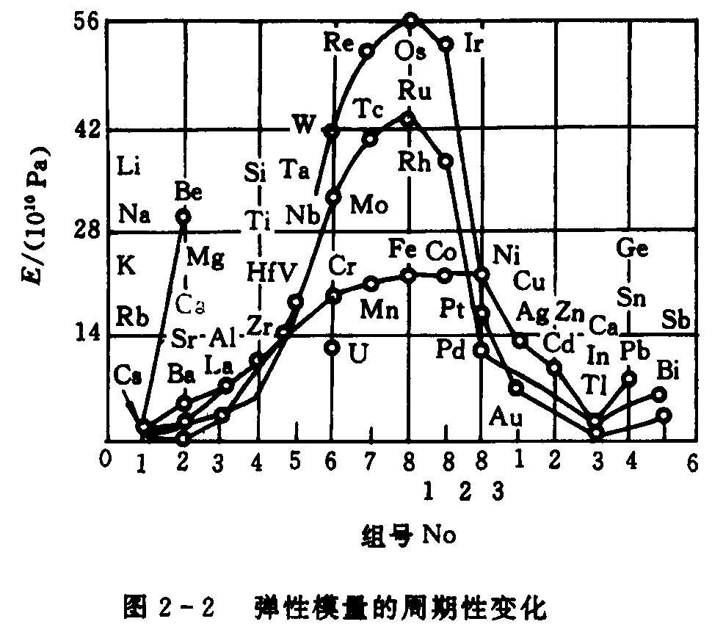

Atomic radii of beryllium: 0.114nm

Atomic radii of magnesium: 0.160nm



1. **The following questions concern two hypothetical materials, R and B, with these curves (see figure below) showing the net interatomic forces as a function of interatomic separation.**
   * 1. **Which material will have a higher modulus of elasticity, and why?**
     2. **Which material will have a higher melting point, and why?**
     3. **Which material will have a larger coefficient of thermal expansion, and why?**

***Hint*: You can integrate graphically.**

**n**

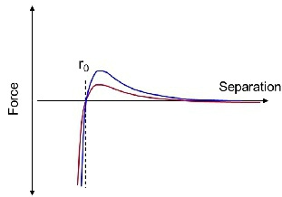

**Solution:**

(a) **B** will have a higher modulus of elasticity.

The larger the E0, the higher the modulus of elasticity. 

(b) **B** will have a higher melting point.

The larger the bonding energies, the higher the melting temperatures.

(c) **R** will have a larger coefficient of thermal expansion.

a deep and narrow “trough”, which typically occurs for materials having large bonding energies, normally correlates with a low coefficient of thermal expansion.