**Fundamentals of Materials Science Homework 14**

**Name: Xiao，Liyang Date: 04/08/2017 Student #: 15090215**

**Homework Problems:**

1. **Consider two edge dislocations of opposite sign and having slip planes that are separated by several atomic distances as indicated in the diagram. Briefly describe the defect that results when these two dislocations become aligned with each other.**

**Solution:**

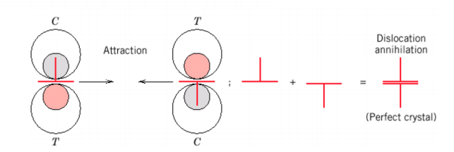

The strain fields around dislocations cause them to interact. they attract if they have the opposite sign,When they are in the same plane.

1. **Is it possible for two screw dislocations of opposite sign to annihilate each other? Explain your answer.**

**Solution:**

It is possible for two screw dislocations of opposite sign to annihilate each other if there dislocation lines are parallel.

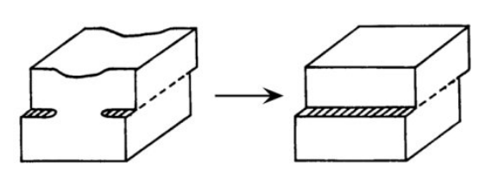

1. **For each of edge, screw, and mixed dislocations, cite the relationship between the direction of the applied shear stress and the direction of dislocation line motion.**

**Solution:**

|  |  |
| --- | --- |
| dislocations | Direction(α) |
| *Edge dislocations* | *Parallel（α=0°）* |
| *Screw dislocations* | *Perpendicular（α=90°）* |
| *Mixed dislocations* | *Neither parallel nor perpendicular*  *（α≠0°&α≠90°）* |

***For the following problems, it is recommended that you read the sample problems in the lecture notes and textbook before working on them.***

1. **One slip system for the BCC crystal structure is {110}<111>. In a manner similar to the Figure provided below, sketch a {110} type plane for the BCC structure, representing atom positions with circles. Now, using arrows, indicate two different<111>slip directions within this plane.**



**Solution:**

1. **Determine the magnitude of the Schmidt factor for an FCC single crystal oriented with its [100] direction parallel to the loading axis.**

**Solution:**

****theslip plane is (111)

As shown on the right figure





1. **A single crystal of aluminum is oriented for a tensile test such that its slip plane normal makes an angle of 28.1o with the tensile axis. Three possible slip directions make angles of 62.4 o, 72.0 o, and 81.1 o with the same tensile axis.**

**(a) Which of these three slip directions is most favored?**

**(b) If plastic deformation begins at a tensile stress of 1.95 MPa (280 psi), determine the critical resolved shear stress for aluminum.**

**Solution:**

(a)



∴the most favored slip sirection is 62.4°.

(b)

1. **Consider a single crystal of silver oriented such that a tensile stress is applied along a [001] direction. If slip occurs on a (111) plane and in a [101] direction, and is initiated at an applied tensile stress of 1.1 MPa (160 psi), compute the critical resolved shear stress.**

**Solution:**

As shown on the right figure







1. **The critical resolved shear stress for iron is 27 MPa (4000 psi). Determine the minimum possible yield strength for a single crystal of Fe pulled in tension.**

**Solution:**



1. **How many grams of aluminum, with a dislocation density of 1014 m/m3, are required to give a total dislocation length that would stretch from Mohe, Heilongjiang Province to Guangzhou, Guangdong Province (4,828 km)?**

**Solution:**

∵, . .