**Fundamentals of Materials Science Homework 15**

**Name: Xiao，Liyang Date: 04/09/2017 Student #: 15090215**

**Homework Problems:**

1. **(a) From the plot of yield strength versus (grain diameter)–1/2 for a 70 Cu–30 Zn cartridge brass, Figure 9.15, determine values for the constants σ0 and ky in Equation 9.7.**

**(b) Now predict the yield strength of this alloy when the average grain diameter is 2.010-3 mm.**

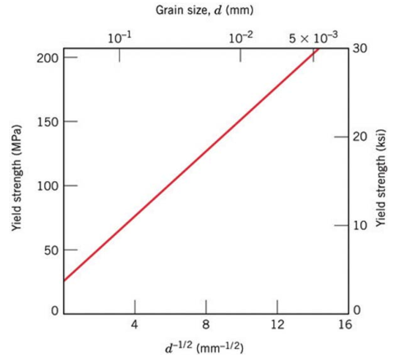**Solution:**

(a)From the plot:







** **

(b)****



1. **Design a manufacturing process to produce a 0.1-cm-thick copper plate having at least 448 MPa tensile strength, 414 MPa yield strength, and 5% elongation.**

**Solution:**

Design a manufacturing process:

tensile strength——495MPa

yield strength——450MPa

%El——5%

%CW——50%

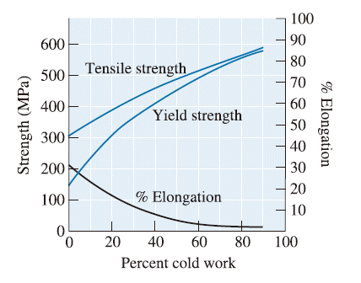

**Figure 1 Effects of Percent Cold Work on Properties of Cu**

1. **The lower yield point for an iron that has an average grain diameter of 6 × 10–2 mm is 135 MPa. At a grain diameter of 8 × 10–3 mm, the yield point increases to 260 MPa. At what grain diameter will the lower yield point be 205 MPa?**

**Solution:**



1. **A cylindrical rod of copper originally 16.0 mm in diameter is to be cold worked by drawing; the circular cross section will be maintained during deformation. A cold-worked yield strength in excess of 250 MPa and a ductility of at least 12%EL are desired. Furthermore, the final diameter must be 11.3 mm. Explain how this may be accomplished.**

**Solution:**



From the plot

50%CW——5%El——yield strength is 340MPa

The ductilitydoesn’t meet the requirements.

12%El——23%CW

yield strength is 250MPa——21%CW

∴The range of %CW is 21% to 23%

；

So the diameter after secondary stretching is 12.8mm

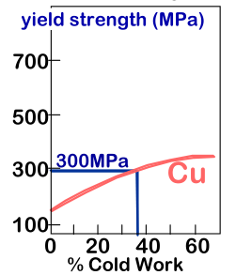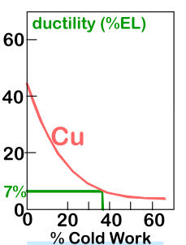

1. **In the manner of Figures 9.17b and 9.18b, indicate the location in the vicinity of an edge dislocation at which an interstitial impurity atom would be expected to be situated. Now briefly explain in terms of lattice strains why it would be situated at this position.**

**Solution:**

impurities tend to diffuse into strained regions around the dislocation leading to partial cancellation of impurity-dislocation lattice strains. in such a way as to reduce the overall strain energy.

1. **(a) Show, for a tensile test, that**



**if there is no change in specimen volume during the deformation process (i.e., *A0l0 = Adld*).**

**(b) Using the result of part (a), compute the percent cold work experienced by naval brass (the stress-strain behavior of which is shown in Figure 8.12) when a stress of 400 MPa is applied.**

**Solution:**

1. 



(b) From the Figure 8.12, when a stress of 400 MPa, the 



1. **What are the major practices for grain size reduction in real applications?**

**Solution:**

1. ***加大过冷度***
2. ***机械振动或搅拌***
3. ***变质（孕育）处理***