**Fundamentals of Materials Science Homework 16**

**Name: Xiao，Liyang Date: 04/16/2017 Student #: 15090215**

**Homework Problems:**

**Cartridge brass has the approximate composition of 70 wt % Cu and 30 wt % Zn. As discussed in class, the recrystallization temperature for most of the metals are in between 1/3 and 1/2 of the melting temperature of the metals. Please plot, using a software you are mostly familiar with, the estimated temperature range for recrystallization of Cu−Zn alloys as a function of composition over the entire range from pure Cu to pure Zn. The Cu-Zn phase diagram is enclosed for you.**

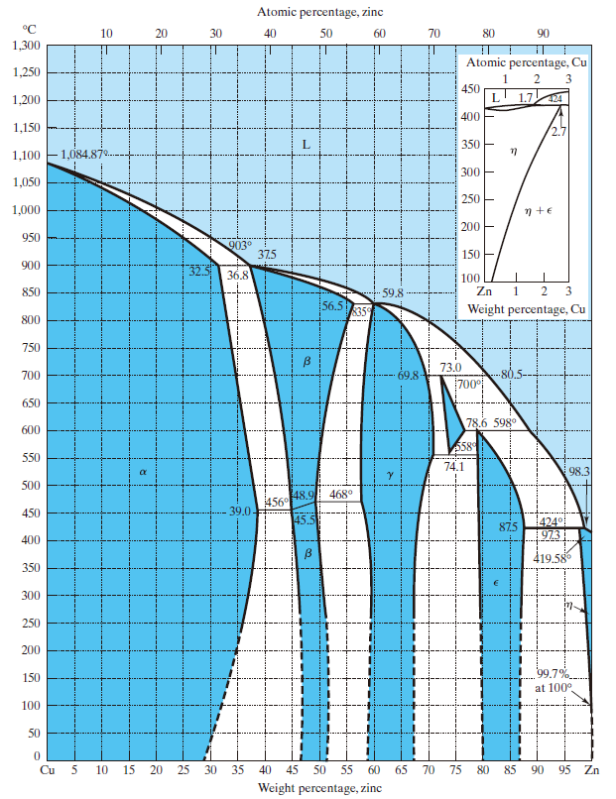

**Figure 1 Cu-Zn Phase Diagram**

**Solution:**

|  |  |  |  |
| --- | --- | --- | --- |
| **Cu(%)** | **T(℃)** | **1/2T(℃)** | **1/3T(℃)** |
| 0 | 1084.87 | 542.4 | 361.6 |
| 36.8 | 903 | 451.5 | 301 |
| 59.8 | 835 | 417.5 | 278.3 |
| 73 | 700 | 350 | 233.3 |
| 78.6 | 598 | 299 | 199.3 |
| 98.3 | 424 | 212 | 141.3 |
| 100 | 419.58 | 209.79 | 139.86 |