**Fundamentals of Materials Science Homework 17**

**Name: Xiao，Liyang Date: 04/24/2017 Student #: 15090215**

**Homework Problems:**

1. **Given here are the solidus and liquidus temperatures for the germanium-silicon system. Construct the phase diagram for this system and label each region.**

|  |  |  |
| --- | --- | --- |
| **Composition**  **(wt% Si)** | **Solidus Temperature**  **(°C)** | **Liquidus Temperature**  **(°C)** |
| **0** | **938** | **938** |
| **10** | **1005** | **1147** |
| **20** | **1065** | **1226** |
| **30** | **1123** | **1278** |
| **40** | **1178** | **1315** |
| **50** | **1232** | **1346** |
| **60** | **1282** | **1367** |
| **70** | **1326** | **1385** |
| **80** | **1359** | **1397** |
| **90** | **1390** | **1408** |
| **100** | **1414** | **1414** |

**Solution:**

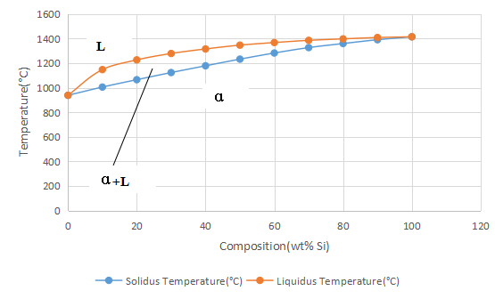

1. **A copper-nickel alloy of composition 70 wt% Ni-30 wt% Cu is slowly heated from a temperature of 1300°C (2370°F).**

**(a) At what temperature does the first liquid phase form?**

**(b) What is the composition of this liquid phase?**

**(c) At what temperature does complete melting of the alloy occur?**

**(d) What is the composition of the last solid remaining prior to complete melting?**

**Solution:**

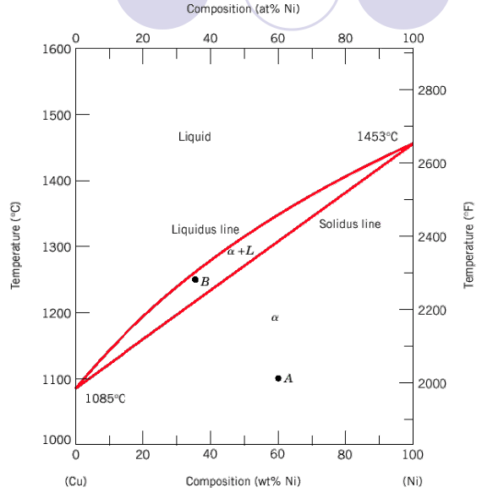

1. from the figure:1340℃
2. 58 wt% Ni-42 wt% Cu
3. from the figure:1380℃
4. 79 wt% Ni-21 wt% Cu
5. **For an alloy of composition 74 wt% Zn-26 wt% Cu, cite the phases present and their compositions at the following temperatures: 850°C, 750°C, 680°C, 600°C, and 500°C.**

**Solution:**

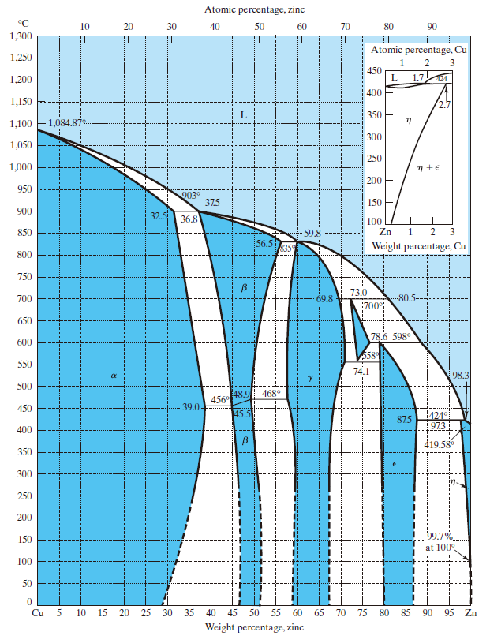

**850℃:** CL=74 wt% Zn-26 wt% Cu

**750℃:** Cγ=67.5 wt% Zn-32.5 wt% Cu ;CL=76.5 wt% Zn-23.5 wt% Cu

**680℃:** Cδ=73 wt% Zn-27 wt% Cu ;CL=82 wt% Zn-18 wt% Cu

**600℃:** Cδ=74 wt% Zn-26 wt% Cu

**500℃:** Cγ= 69 wt% Zn-31 wt% Cu ;Cε=80 wt% Zn-20 wt% Cu

1. **Cite the phases that are present and the phase compositions for the following alloys:**

**(a) 90 wt% Zn-10 wt% Cu at 400°C (750°F)**

**(b) 75 wt% Sn-25 wt% Pb at 175°C (345°F)**

**(c) 55 wt% Ag-45 wt% Cu at 900°C (1650°F)**

**(d) 30 wt% Pb-70 wt% Mg at 425°C (795°F)**

**(e) 2.12 kg Zn and 1.88 kg Cu at 500°C (930°F)**

**(f) 37 lbm Pb and 6.5 lbm Mg at 400°C (750°F)**

**(g) 8.2 mol Ni and 4.3 mol Cu at 1250°C (2280°F)**

**(h) 4.5 mol Sn and 0.45 mol Pb at 200°C (390°F)**

**Solution:**

1. Cε=87wt% Zn-13 wt% Cu ; Cη=97wt% Zn-3 wt% Cu
2. Cα=16 wt% Sn-84 wt% Pb ; Cβ= 97 wt% Sn-3 wt% Pb
3. CL= 55 wt% Ag-45 wt% Cu.
4. Cα= 30 wt% Pb-70 wt% Mg.
5. Cβ= 49 wt% Zn-51 wt% Cu ; Cγ= 58 wt% Zn-42 wt% Cu.
6. CMg2Pd= 81 wt% Pd- 19 wt% Mg ; CL= 93 wt% Pd- 7 wt% Mg.
7. 64 wt%Ni-36 wt% Cu

(h)CL=74 wt% Sn-26 wt% Pd ; Cβ=97wt% Sn-3 wt% Pd

1. **Determine the relative amounts (in terms of mass fractions) of the phases for the alloys and temperatures given in Problem 4.**

**Solution:**

(a); (b);

(c) ; (d);

(e); (f);

(g);

(h).