**Fundamentals of Materials Science Homework 18**

**Name: Xiao，Liyang Date: 04/29/2017 Student #: 15090215**

**Homework Problems:**

1. **用中文配合Cu-Ni二元相图描述在非平衡凝固过程中，显微组织和组元的成分是如何演变的，显微偏析形成过程和原因是什么，如何消除这种枝晶偏析？**

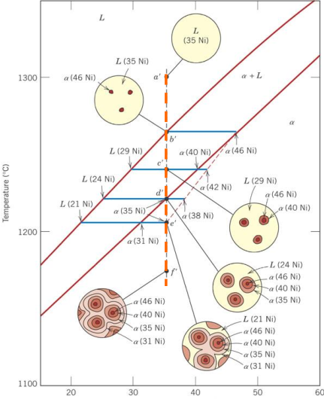

**Solution:**

**显微组织和组元的成分演变：**

假设从液相区a’点开始冷却，冷却过程通过液相区时无变化。

当冷却过程到达液相线时（b’），开始形成少量α相微粒，通过等温连接线可确定其成分。

温度进一步降低，冷却过程到达c’点，然而由于温度下降速度过快，固体α相中扩散缓慢，于是一个新的Cu-Ni成分会包在原b’点的固相成分，形成成分偏析。

以此类推，温度持续降低至冷却过程到达e’点，液相才能完全转变为固相，非平衡凝固过程结束。

**消除枝晶偏析：**

进行扩散退火或者均匀化退火处理。

1. **A 1.5-kg specimen of a 90 wt% Pb–10 wt% Sn alloy is heated to 250°C (480°F); at this temperature it is entirely an -phase solid solution. The alloy is to be melted to the extent that 50% of the specimen is liquid, the remainder being the  phase. This may be accomplished either by heating the alloy or changing its composition while holding the temperature constant.**

**(a) To what temperature must the specimen be heated?**

**(b) How much tin must be added to the 1.5-kg specimen at 250°C to achieve this state?**

**Solution:**

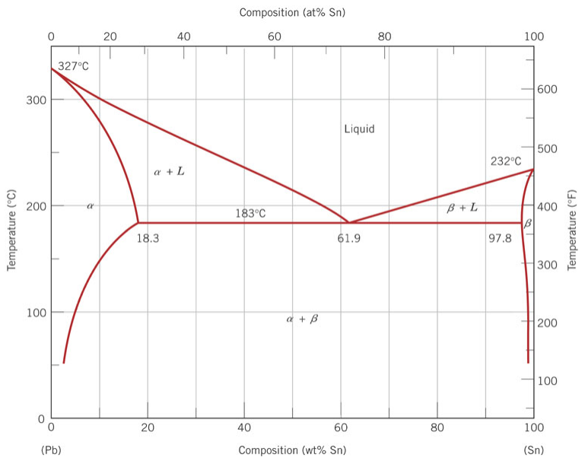

(a)** **



From the phase diagram，the temperature is about 290°C.

(b)



 





1. **Determine the relative amounts (in terms of volume fractions) of the phases for the alloys and temperatures given below in (a), (b), and (c). Below are also given the approximate densities of the various metals at the alloy temperatures:**

**(a) 90 wt% Zn-10 wt% Cu at 400°C (750°F)**

**(b) 75 wt% Sn-25 wt% Pb at 175°C (345°F)**

**(c) 55 wt% Ag-45 wt% Cu at 900°C (1650°F)**

|  |  |  |  |
| --- | --- | --- | --- |
| **Metal** | **Temperature (°C)** | | **Density (g/cm3)** |
| ***Ag*** | ***900*** | ***9.97*** | |
| ***Cu*** | ***400*** | ***8.77*** | |
| ***Cu*** | ***900*** | ***8.56*** | |
| ***Pb*** | ***175*** | ***11.20*** | |
| ***Sn*** | ***175*** | ***7.22*** | |
| ***Zn*** | ***400*** | ***6.83*** | |

**Solution:**

1. From the phase diagram:

 ; 





 ; 

(b) From the phase diagram:

 ; 





 ; 

(c) There are only liquids phases. So .

1. **A magnesium-lead alloy of mass 5.5 kg consists of a solid α phase that has a composition that is just slightly below the solubility limit at 200°C (390°F).**

**(a) What mass of lead is in the alloy?**

**(b) If the alloy is heated to 350°C (660°F), how much more lead may be dissolved in the α phase without exceeding the solubility limit of this phase?**

**Solution:**

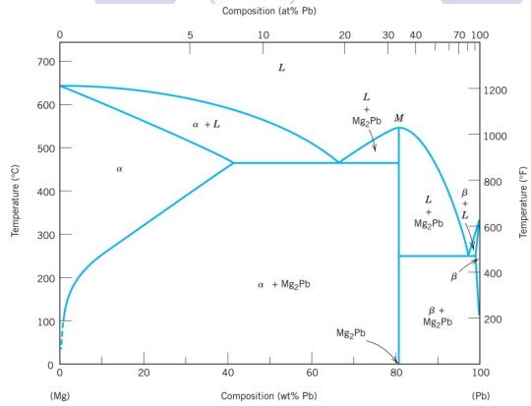

1. From the phase diagram:the compositions of lead in the solidus line at 200°C is 4wt%.

So, the mass of lead is 

(b) From the phase diagram: the compositions of lead in the solidus line at 350℃ is 25wt%.



1. **A 30 wt% Sn-70 wt% Pb alloy is heated to a temperature within the α + liquid phase region. If the mass fraction of each phase is 0.5, estimate:**

**(a) The temperature of the alloy**

**(b) The compositions of the two phases**

**Solution:**



(a)∵The mass fraction of each phase is 0.5,

∴

∵

∴

From the phase diagram,the temperature of the alloy is 230℃.

(b)From the phase diagram:

Inphase region:16 wt%Sn-84 wt%Pb

In liquids region:42 wt%Sn-58 wt%Pb

1. **For a copper-silver alloy of composition 25 wt% Ag-75 wt% Cu and at 775°C (1425°F) do the following:**

**(a) Determine the mass fractions of α and β phases.**

**(b) Determine the mass fractions of primary α and eutectic microconstituents.**

**(c) Determine the mass fraction of eutectic α.**

**Solution:**

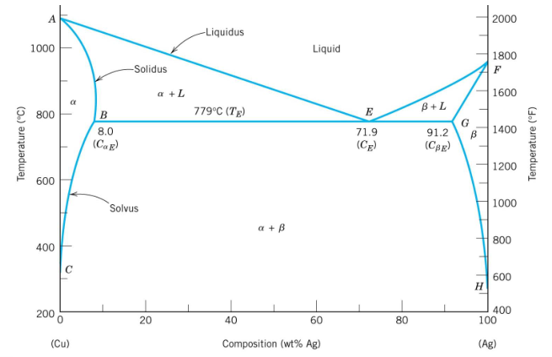

(a)Inphase region:8 wt%Ag-92 wt%Cu,in phase region:92 wt%Ag-8 wt%Cu

, 

(b)The composition of eutectic microconstituents is 71.9 wt%Ag-28.1 wt%Cu

,

(c).

1. **The microstructure of a lead-tin alloy at 180°C (355°F) consists of primary β and eutectic structures. If the mass fractions of these two microconstituents are 0.57 and 0.43, respectively, determine the composition of the alloy.**

**Solution:**

From the phase diagram 



Then the composition of the alloy is 82.363%Sn-17.637%Pb

1. **For an 85 wt% Pb-15 wt% Mg alloy, make schematic sketches of the microstructure that would be observed for conditions of very slow cooling at the following temperatures:** **600°C (1110°F), 500°C (930°F), 270°C (520°F), and 200°C (390°F). Label all phases and indicate their approximate compositions. 这个题目自己好好画，显微组织的视野画在圆圈内即可，注意清晰标注！**

**Solution:**

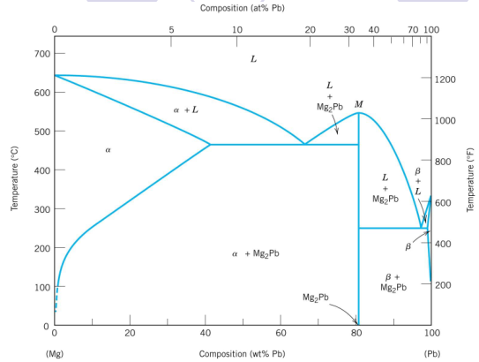

Mg2Pb(81wt%Pb)

Mg2Pb(81wt%Pb)

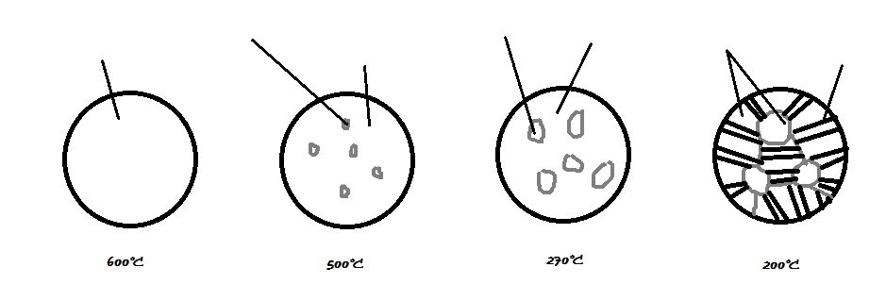

Mg2Pb(81wt%Pb)

L(85wt%Pb)

β(99wt%Pb)

L(97wt%Pb)

L(86.5wt%Pb)

1. **What is the principal difference between congruent and incongruent phase transformations?**

**Solution:**

**Congruent phase transformation:**A transformation of one phase to another of the same composition.

**Incongruent phase transformation:**The phase experience a change in composition.

1. **The Figure below is the aluminum-neodymium phase diagram, for which only single-phase regions are labeled. Specify temperature-composition points at which all eutectics, eutectoids, peritectics, and congruent phase transformations occur. Also, for each, write the reaction upon cooling.**

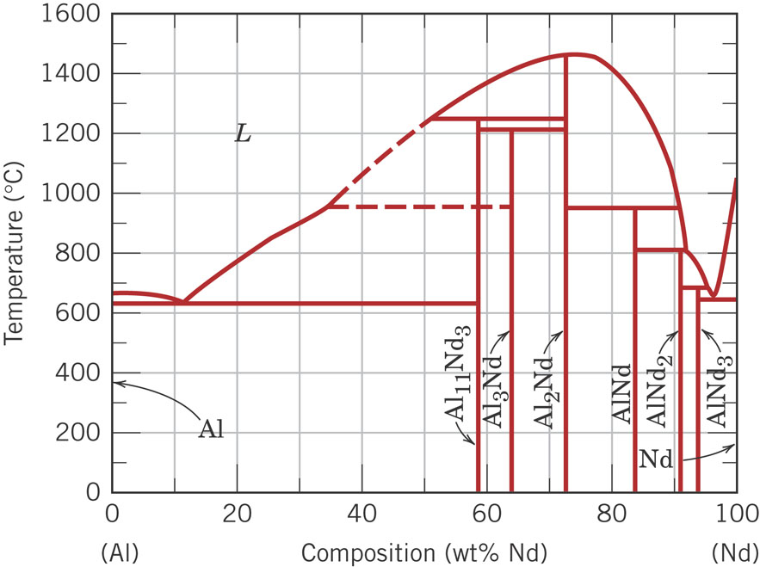

**Solution:**

Eutectics：

At 625℃,12wt% Nd - 88wt% Al, ;

At 640℃,97wt% Nd - 3wt% Al, .

Peritectics:

At 1250℃,59wt% Nd - 41wt% Al, ;

At 950℃,84wt% Nd - 16wt% Al, ;

At 805℃,91wt% Nd - 9wt% Al, ;

At 690℃,94wt% Nd - 6wt% Al, .

Congruent:

At 1460℃,73wt% Nd - 27wt% Al, .