**Fundamentals of Materials Science Homework 19**

**Name: Xiao，Liyang Date: 05/07/2017 Student #: 15090215**

**Homework Problems:**

1. **Compute the mass fraction of α ferrite and cementite in pearlite.**

**Solution:**





1. **What is the carbon concentration of an iron-carbon alloy in which the mass fractions of total ferrite is 0.94?**

**Solution:**

 ; ∴C0=0.42

1. **The proeutectoid phase could be proeutectoid ferrite or proeutectoid cementite depending on the different C content. What is the proeutectoid phase for an iron-carbon alloy in which the mass fractioin of total ferrite and total cementite are 0.92 and 0.08, respectively? Why?**

**Solution:**

** ; ∴**C0=0.56

∴the proeutectoid phase is proeutectoid ferrite.

1. **Consider 1.0 kg of austenite containing 1.15 wt% C, cooled to below 727oC (1341oF).**

**(a) What is the proeutectoid phase?**

**(b) How many kilograms each of total ferrite and cementite form?**

**(c) How many kilograms each of pearlite and the proeutectoid phase form?**

**(d) Schematically sketch and label the resulting microstructure.**

**Solution:**

(a)1.15 wt% C is between 0.76 and 2.14 wt% C, so the proeutectoid phase is

proeutectoid cementite.

(b).







(c).



So, 



(d)

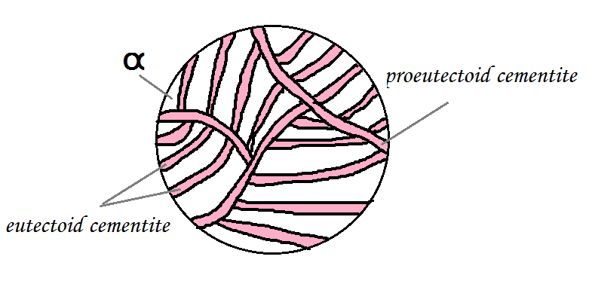

1. **Compute the mass fractions of proeutectoid ferrite and pearlite that form in an iron–carbon alloy containing 0.25 wt% C.**

**Solution:**





1. **Consider 2.0 kg of a 99.6 wt% Fe–0.4 wt% C alloy that is cooled to a temperature just below the eutectoid. (a) How many kilograms of proeutectoid ferrite form? (b) How many kilograms of eutectoid ferrite form? (c) How many kilograms of cementite form?**

**Solution:**

(a) 



(b) 

0.45



(c) 



1. **For an iron–carbon alloy of composition 5 wt% C–95 wt% Fe, make schematic sketches of the microstructure that would be observed for conditions of very slow cooling at the following temperatures: 1175oC (2150oF), 1145oC (2095oF), and 700oC (1290oF). Label the phases and indicate their compositions (approximate).**

**Solution:**

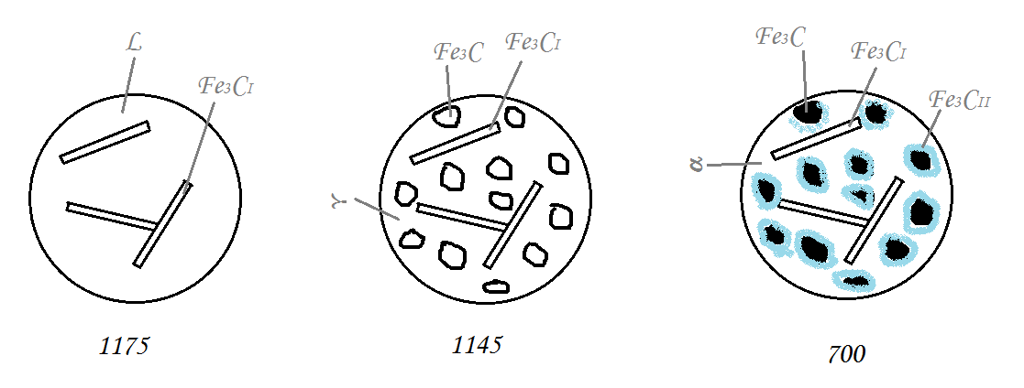

1. **总结各种铁碳合金的室温平衡显微组织是什么，填写在下表中。**

|  |  |  |  |  |  |  |
| --- | --- | --- | --- | --- | --- | --- |
| **铁碳合金** | **亚共析钢** | **共析钢** | **过共析钢** | **亚共晶白口铁** | **共晶白口铁** | **过共晶白口铁** |
| **室温平衡显微组织** | **铁素体**  **+**  **珠光体** | **珠光体** | **珠光体**  **+**  **二次渗碳体** | **珠光体**  **+**  **二次渗碳体**  **+**  **变态莱氏体** | **莱氏体** | **莱氏体**  **+**  **一次渗碳体** |

1. **自己画一个铁碳相图，可以用计算机绘制，也可以用笔和尺子绘制，看谁画得最professional。但是不能去网上复制一个或者复印扫描书上的，一定是你自己亲笔画的。请在你绘制的铁碳相图中标出下面内容：**

**（1）液相线和固相线**

**（2）三个恒温反应：包晶，共析，共晶。三个重要温度：1495oC, 1148 oC, 727 oC.**

**（3）固溶线：C在奥氏体中和C在铁素体中的固溶线。**

**（4）单相区和两相区**

**（5）五个重要的成分点：含碳量为0.22%, 0.77%, 2.11%, 4.3%, 6.7%的点。**

**Solution:**

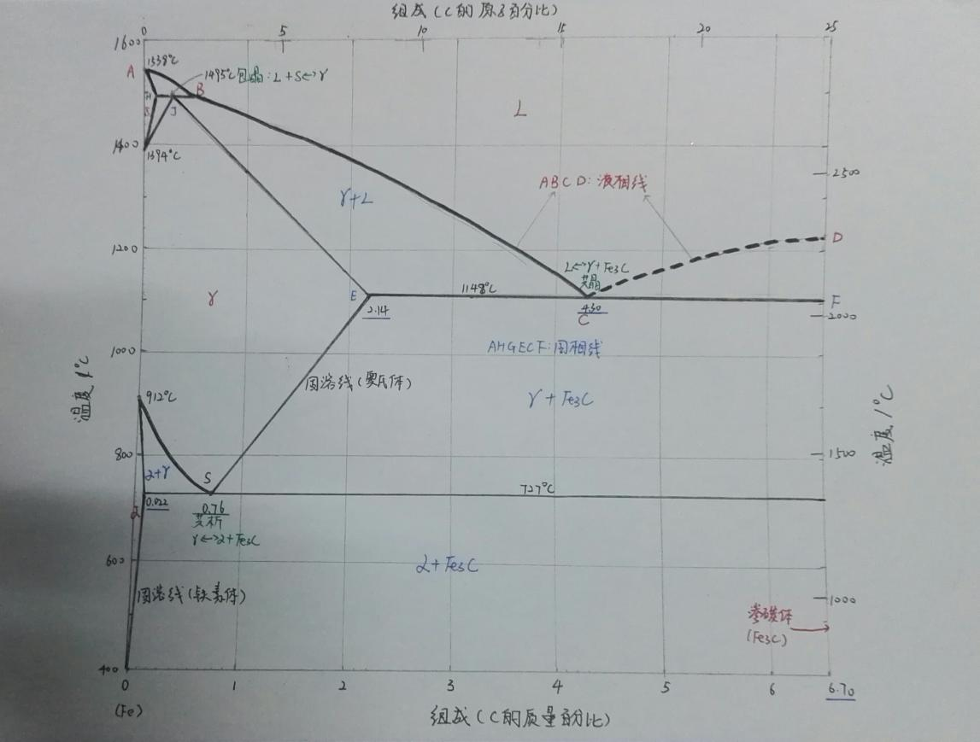

1. **在亚共析钢、共析钢、过共析钢、亚共晶白口铁、共晶白口铁、过共晶白口铁六种典型的铁碳合金中，选择一个论述其平衡凝固过程中显微组织的演变，并描绘其结晶过程的示意图。**

**Solution:**

共析钢：0.76wt%C降温至1480℃时，液相中出现奥氏体。降低至1400℃左右，液相全部变为奥氏体相。继续降温至727℃，发生共析。奥氏体共析出铁素体和渗碳体，铁素体、渗碳体薄层交错相叠成为珠光体。

