**1.** Checklist before you start this homework. (The boxes are clickable.)

I have finished reading Chapter 1 (p. 1~15) of the textbook.

**2. Military body armor**

The item selected for studying is the military body armor.The body armor is is a kind of clothing that can absorb and dissipate the kinetic energy of warhead, fragment and prevent penetration and effectively protect the body of human body.It is required excellent ballistic performance and wearability.

Military body armor divided into software hardware and soft and hard composite body armor.The materials of software are mainly high-performance fibers which have strong energy absorption capacity.And since this body armor is generally used in the structure of textiles, it has considerable flexibility.

The main bulletproof material of the hardware body armor are metal materials(i.e.

special steel plate,Super aluminum alloy)and hard non-metallic materials (i.e.Al2O3,

SiC) which don’t have pliability.The pliability of soft and hard composite body armor is between the two types, which is lined with soft material and hard material as panel and reinforcement material. It is a compound body armor.

Apart from these traditional body armor,liquid body armor is becoming the most preferred research.Shear thickening fluid(STF) is a new smart nanomaterial which is a

environmental product with non-toxic and no pollution.Normally, TBS is like other li-

quids, very soft and can be deformed. However, once the projectile or warhead touch-

ed it, the liquid can be instantaneous into a hard material to prevent the projectile thr-

ough.

In summary, body armor in different materials have different characteristics.With the advent of science and technology,the performance of the body armor will be improved as more materials are developed.

**3. Key:**The best material is copper which has corrosion resistance and ease of processing.

**Stainless steel kettle:**Made from stainless steel which does not readily corrode.

**Door and window:**One of the most common materials is aluminium alloy which is relatively stiff and strong.

**4. Metal:(a)(f)**

Metal are composed of one or more metallic elements.

**Ceramic:(b)(e)**

Ceramic are compounds between metallic and nonmetallic elements;they are most frequently oxides,nitrides,carbides and clay minerals,as well as cement and glass.

**Polymer:(d)(c)**

Polymer include the familiar plasic and rubber materials.Many of them are organic compounds that are chemically based on carbon,hydrogen,and other nonmentallic elements.

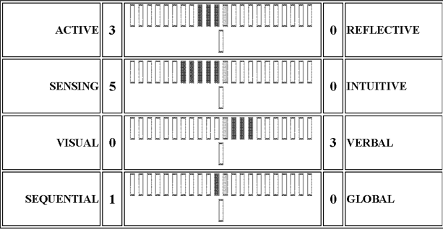

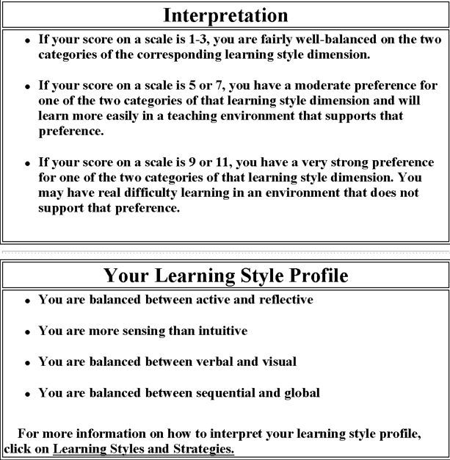

**5. The solution**

**active and reflective**

As I can see from the result, I am balanced between active and reflective. So I should have some time for discussion or problem-solving activities and for thinking about new information. When I work in a group, I will be active to discuss with each other and have my own time to think alone.

**sensing and intuitive**

In this part, I am more sensing than intuitive. I should ask my instructor for specific examples of concepts and procedures, and find out how the concepts apply in practice. If the teacher does not provide enough specifics, try to find some in my course text or other references or by brainstorm-

ing with friends or classmates.

**visual and verbal**

In this part, I am balanced.I should write summaries or outlines of course material in my own words. Working in groups can be particularly effective: I gain understanding of material by hearing classmates' explanations and learn even more when I do the explaining.

**sequential and global**

In this part, I am balanced too. Before learning, I will skim through the entire chapter to get an overview and outline the lecture material to help myself to learning.

Xiaoliyang 15090215