**Fundamentals of Materials Science Homework 20**

**Name: Xiao，Liyang Date: 05/10/2017 Student #: 15090215**

**Homework Problems:**

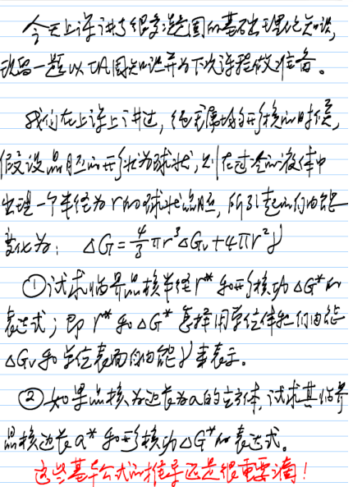

**Solution:**

1. 



** **

1. **∵立方体**





** **

**One More Problem:**

***Calculation of Critical Radius for the Solidification of Copper***

**Calculate the size of the critical radius and the number of atoms in the critical nucleus when solid copper forms by homogeneous nucleation. Comment on the size of the nucleus and assumptions we made while deriving the equation for the radius of the nucleus. The elemental data of Cu can be found in your textbook.**

**Solution:**







=1.25nm



unit cells

atoms/unit cells