**Fundamentals of Materials Science Homework 21**

**Name: Xiao，Liyang Date: 05/14/2017 Student #: 15090215**

**Homework Problems:**

1. **Do it again and again for it is very important. Below *Tm,* Δ*Gv* is positive so that the free energy change associated with the formation of a small volume of solid has a negative contribution due to the lower free energy of a bulk solid, but there is also a positive contribution due to the creation of a solid/liquid interface. The excess free energy associated with the solid particle can be minimized by the correct choice of particle shape. If *γSL* is isotropic this is a sphere of radius *r.* Then we can arrive at the equation discussed in class like**

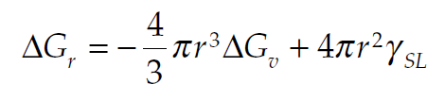 **(Eq. 1)**

**Show that differentiation of Equation 1 leads to Equations 2 and 3 below.**

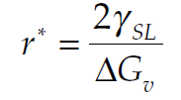 **(Eq. 2)**

** (Eq. 3)**

**Solution:**





** **

1. **To understand how it is possible for a stable solid nucleus to form homogeneously from the liquid it is first necessary to examine the atomic structure of the liquid phase. From dilatometric measurements it is known that at the melting point the liquid phase has a volume 2–4% greater than the solid. Therefore, there is a great deal more freedom of movement of atoms in the liquid and when averaged over a period of time the atom positions appear completely random. However, an instantaneous picture of the liquid would reveal the presence of many small close-packed clusters of atoms which are temporarily in the same crystalline array as in the solid, as shown in Fig. 1 below. On average the number of spherical clusters of radius r is given by**

** (Eq. 4)**

**where *n*0 is the total number of atoms in the system, Δ*Gr* is the excess free energy associated with the cluster, Equation 1, and *k* is Boltzmann’s constant. For a liquid above *Tm* this relationship applies for all values of *r.* Below *Tm* it only applies for *r* ≤ *r*\* because clusters greater than the critical size are stable nuclei of solid and no longer part of the liquid. Since *nr* decreases exponentially with Δ*Gr* (which itself increases rapidly with *r*) the probability of finding a given cluster decreases very rapidly as the cluster size increases. For example, by combining Equations 1 and 4 it can be shown that 1 mm3 of copper at its melting point (∼1020 atoms) should on average contain ∼1014 clusters of 0.3 nm radius (i.e. ∼10 atoms) but only ∼10 clusters with a radius of 0.6 nm (i.e. ∼60 atoms). These numbers are of course only approximate. Such small clusters of atoms cannot be considered to be spherical, and even more important the effective value ofγused in calculating Δ*Gr* (equation 1) is very probably a function of the cluster size. However, the above calculations do illustrate how sensitively cluster density depends on their size.**

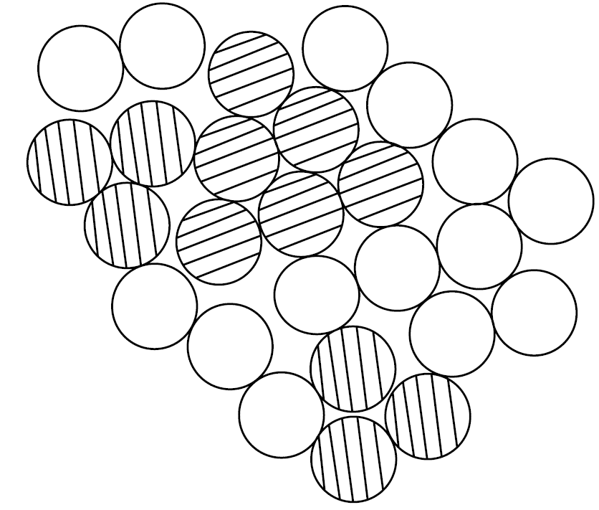

**Figure 1 A two-dimensional representation of an instantaneous picture of the liquid structure. Many close-packed crystal-like clusters (shaded) are present.**

**Use Equations 1 and 4 to estimate the number of crystal-like clusters in 1 mm3 of copper at its melting point for spherical clusters containing (a) 10 atoms, (b) 60 atoms. What volume of liquid copper is likely to contain one cluster of 100 atoms? The atomic volume of liquid copper is 1.6*X*10−29 m3, *γSL* is 0.177 J m−2, *k* = 1.38X10−23 J K−1, *Tm* = 1356 K.**

**Solution:**



1. **Continued from Problem 2, it can be seen that there is effectively a maximum cluster size, ∼100 atoms, which has a reasonable probability of occurring in the liquid. The same sort of calculations can be made at temperatures other than *Tm.* Below *Tm* there is an increasing contribution from Δ*Gv* in Equation 1 as the solid becomes progressively more stable and this has the effect of increasing the ‘maximum’ cluster size somewhat. Figure 2 shows schematically how *r*max varies with Δ*T*. Of course larger clusters than *r*max are possible in large enough systems or given sufficient time, but the probability of finding clusters only slightly larger than *r*max is extremely small. The critical nucleus size *r\** is also shown in Fig. 2. It can be seen that at small undercoolings, *r\** is so large that there will be virtually no chance of forming a stable nucleus. But as Δ*T* increases *r\** and Δ*G\** decrease, and for supercoolings of Δ*TN* or greater there is a very good chance of some clusters reaching *r\** and growing into stable solid particles. In the small droplet experiment, therefore, homogeneous nucleation should occur when the liquid is undercooled by ∼Δ*TN*. The question to this problem is thus: Why does *r*max in Fig. 2 vary with Δ*T*?**

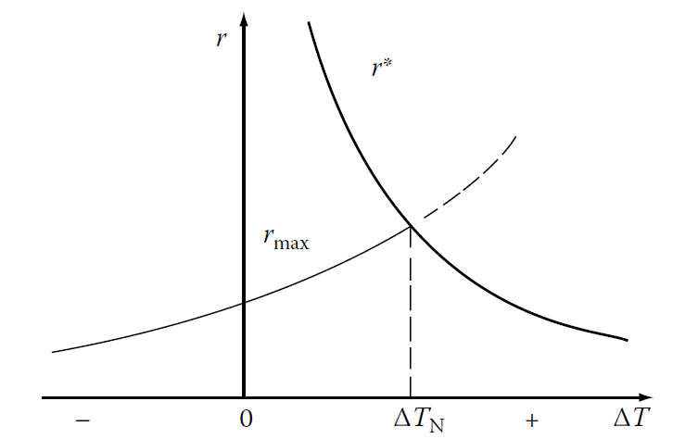

**Figure 2 The variation of r* and rmax with undercooling ΔT.**

1. **Calculate the homogeneous nucleation rate in liquid copper at undercoolings of 180, 200 and 220 K, using the following data:**

