**Fundamentals of Materials Science Homework 24**

**Name: Xiao，Liyang Date: 06/12/2017 Student #: 15090215**

**Homework Problems:**

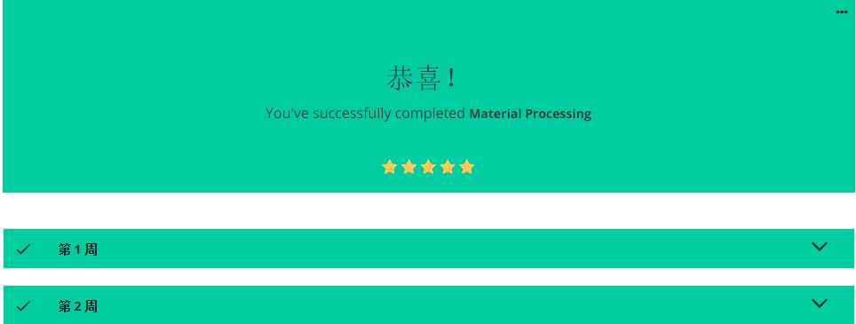

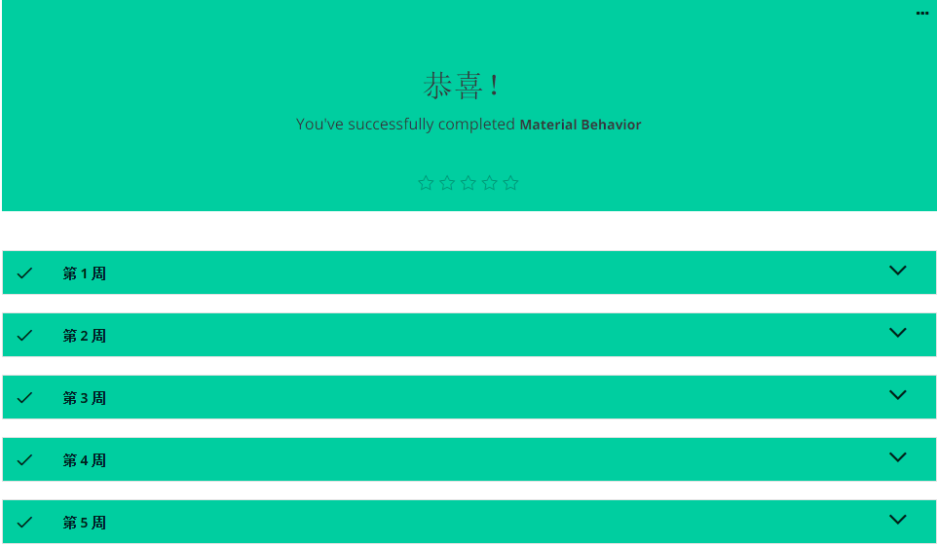

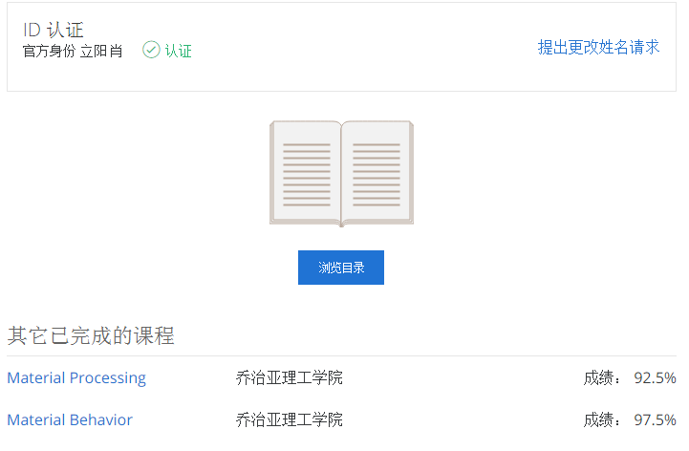

感谢郭老板这一学期的陪伴，老师辛苦啦！

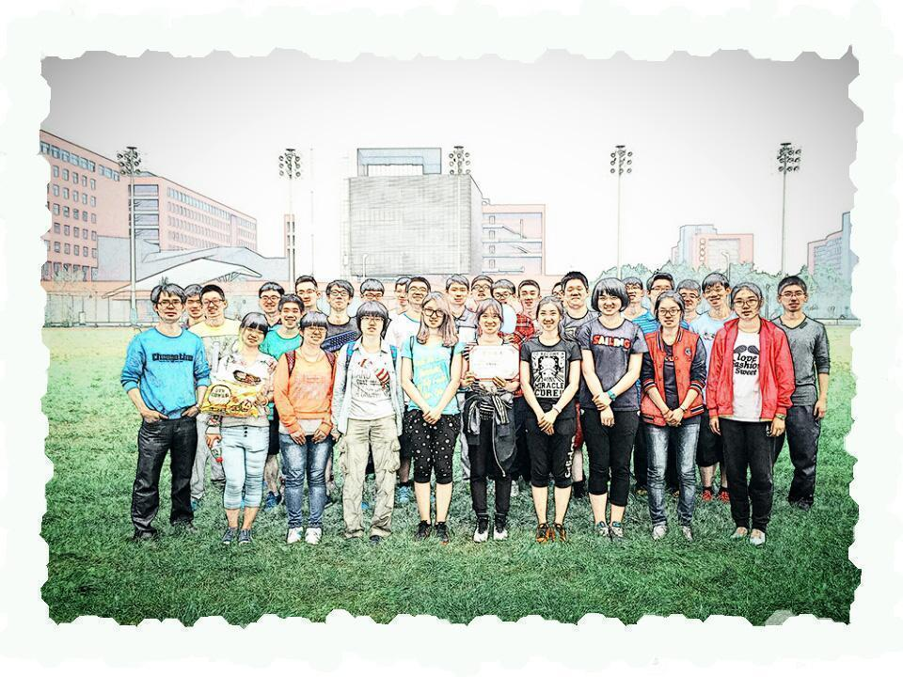

送上150902班合照一张（原图在下边）

