**Fundamentals of Materials Science Homework 6**

**Name: Xiao，Liyang Date: 02/14/2017 Student #: 15090215**

**Homework Problems:**

1. **What type(s) of bonding would be expected for each of the following materials: solid xenon, calcium fluoride (CaF2), bronze, cadmium telluride (CdTe), rubber, and tungsten?**

**Solution:**

solid xenon——van der Waals bond

calcium fluoride (CaF2)——Ionic Bonding

bronze——Metallic Bonding

cadmium telluride (CdTe)——Covalent Bonding

ubber——Covalent Bonding

tungsten——Metallic Bonding

1. **Which of the following electron configurations is for an inert gas?**
   * 1. **1s22s22p63s23p6**
     2. **1s22s22p63s2**
     3. **1s22s22p63s23p64s1**
     4. **1s22s22p63s23p63d24s2**

**Solution:**

1. .Ar**√** b)Mg c)K d)Ca
2. **Make a plot of bonding energy versus melting temperature for the metals listed in Table**
   1. **Using this plot, approximate the bonding energy for molybdenum, which has a melting temperature of 2617oC.**

**Solution:**









1. **Beryllium and magnesium, both in the 2A column of the periodic table, are lightweight metals. Which would you expect to have the higher modulus of elasticity? Explain, considering binding energy and atomic radii and using appropriate sketches of force versus interatomic spacing.**

**Solution:**

The relationship between the elastic modulus of pure metal and the atomic



Radius:

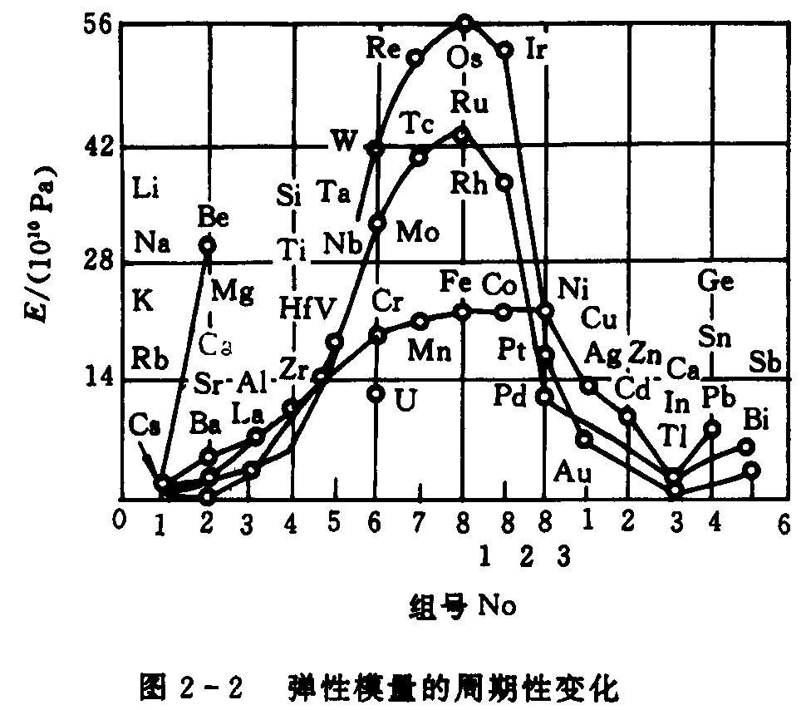

Atomic radii of beryllium: 0.114nm

Atomic radii of magnesium: 0.160nm



1. **The following questions concern two hypothetical materials, R and B, with these curves (see figure below) showing the net interatomic forces as a function of interatomic separation.**
   * 1. **Which material will have a higher modulus of elasticity, and why?**
     2. **Which material will have a higher melting point, and why?**
     3. **Which material will have a larger coefficient of thermal expansion, and why?**

***Hint*: You can integrate graphically.**

**n**

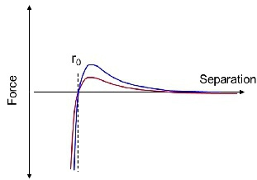

**Solution:**

(a) **B** will have a higher modulus of elasticity.

The larger the E0, the higher the modulus of elasticity. 

(b) **B** will have a higher melting point.

The larger the bonding energies, the higher the melting temperatures.

(c) **R** will have a larger coefficient of thermal expansion.

a deep and narrow “trough”, which typically occurs for materials having large bonding energies, normally correlates with a low coefficient of thermal expansion.